English – Early Stage 1 – Unit 19
Contents
Unit overview and instructions for use 3
Teacher notes 4
Outcomes and content – Component A 5
Outcomes and content – Component B 7
Week 1 10
Component A teaching and learning 10
Component B teaching and learning 11
Lesson 1: Exploring imagery 12
Lesson 2: Identifying types of wordplay and using onomatopoeia 14
Lesson 3: Identifying and using alliteration 15
Lesson 4: Using vocabulary and wordplay 17
Lesson 5: Creating imagery through wordplay 18
Week 2 20
Component A teaching and learning 20
Component B teaching and learning 21
Lesson 6: Identifying and using rhyme and rhythm 22
Lesson 7: Using nouns, verbs and adjectives to write a description 24
Lesson 8: Planning 25
Lesson 9: Composing 26
Lesson 10: Feedback, editing and reflecting 27
Resource 1: Boarding pass 29
Resource 2: Senses 30
Resource 3: Onomatopoeia 31
Resource 4: Dinosaurs 32
Resource 5: Writing template 33
Resource 6: Picture stimulus 34
Resource 7: Planning template 35
Resource 8: Exemplar text 36
References 37

Unit overview and instructions for use
This two-week unit is comprised of Component A and Component B. Connecting learning across both components is encouraged.
Teaching and learning | Component A | Component B
Suggested duration | 60 minutes | 45 minutes
Explicit teaching focus areas | - Phonological awareness  - Print conventions  - Phonic knowledge  - Reading fluency  - Reading comprehension  - Spelling  - Handwriting | - Oral language and communication  - Vocabulary  - Reading comprehension  - Creating written texts  - Understanding and responding to literature
To prepare for teaching and learning: | - Refer to Outcomes and content – Component A, K-2 – Instructional sequence – grapheme–phoneme correspondences [PDF 825KB], and the teaching advice documents (hyperlinked in Component A teaching and learning table).  - Based on student needs identified through ongoing assessment data, plan and document how you will sequence teaching and learning in whole class and targeted teaching groups across the two-week cycle. | - Familiarise yourself with Outcomes and content – Component B, Textual concepts information and videos, English Textual Concepts and Learning Processes (2016), and the teaching and learning sequence.  - Based on student needs identified through ongoing assessment data, determine how you will support students in whole class and targeted teaching groups across the two-week cycle as required.
English K–10 Syllabus © 2022 NSW Education Standards Authority (NESA) for and on behalf of the Crown in right of the State of New South Wales.

Teacher notes
- Imagery, symbol and connotation extend words and symbols beyond their literal meaning. They are used to provide deeper meaning, evoke emotion and enhance enjoyment in texts – English Textual Concepts and Learning Processes (2016).
- Understanding of imagery, symbol and connotation can be supported through watching the department’s video: Understanding connotation, imagery and symbol (6:06).
- While imagery, symbol and connotation is the mentor concept for the conceptual component of this unit, the supporting concept of context can be explored using the supporting text Perfect by Danny Parker.
- For information on Tier 3 words, imagery, wordplay refer to the NESA Glossary.
- Consider prior student knowledge of imagery and creative wordplay.
- Reflect on student learning and engagement in activities and record differentiation and adjustments within the unit to inform future teaching and learning. One way of doing this could be to add comments to the digital file.
- Content points are linked to the National Literacy Learning Progression version (3).
Levels and indicators sourced from National Literacy Learning Progression © Australian Curriculum, Assessment and Reporting Authority (ACARA), (accessed 8 March 2023) and was not modified. See references for more information.

Outcomes and content – Component A
The table below outlines the focus outcomes and content. Content is linked to the National Literacy Learning Progression version (3).
Focus area and outcome | Content points and National Literacy Learning Progression
Phonological awareness  ENE-PHOAW-01 – identifies, blends, segments and manipulates phonological units in spoken words as a strategy for reading and creating texts  - As needed | N/A
Print conventions  ENE-PRINT-01 – tracks written text from left to right and from top to bottom of the page and identifies visual and spatial features of print  - As needed | N/A
Phonic knowledge  ENE-PHOKW-01 – uses single-letter grapheme–phoneme correspondences and common digraphs to decode and encode words when reading and creating texts | - decode words containing split digraphs and vowel digraphs (PKW5)  - experiment with encoding high-frequency words containing split digraphs and vowel digraphs
Reading fluency  ENE-REFLU-01 – reads decodable texts aloud with automaticity | - know that fluent reading involves recognising and reading words accurately and automatically  - know that pace and expression vary when reading, according to the audience and purpose
Reading comprehension  ENE-RECOM-01 – comprehends independently read texts using background knowledge, word knowledge and understanding of how sentences connect | - understand how adjectives describe a noun and verbs identify actions in a sentence  - recognise how the position of words in a sentence changes its meaning  - clarify own purpose for reading a text
Spelling  ENE-SPELL-01 – applies phonological, orthographic and morphological generalisations and strategies to spell taught familiar and high-frequency words when creating texts | - segment multisyllabic words into syllables and phonemes as a strategy for spelling  - experiment with some vowel digraphs and split digraphs to spell taught high-frequency words and/or personally significant words
Handwriting  ENE-HANDW-01 – produces all lower-case and upper-case letters to create texts | - apply taught handwriting skills when creating texts

Outcomes and content – Component B
The table below outlines the focus outcomes and content. Content is linked to the National Literacy Learning Progression version (3).
Focus area and outcome | Content points and National Literacy Learning Progression
Oral language and communication  ENE-OLC-01 – communicates effectively by using interpersonal conventions and language with familiar peers and adults | - listen for a purpose by agreeing or disagreeing, adding to the comment of others, or sharing thoughts and feelings  - use imaginative, verbal language in structured and unstructured activities
Vocabulary  ENE-VOCAB-01 – understands and effectively uses Tier 1 words and Tier 2 words in familiar contexts | - experiment with and create wordplay and poems  - use and understand Tier 3 words that are of personal interest
Reading comprehension  ENE-RECOM-01 – comprehends independently read texts using background knowledge, word knowledge and understanding of how sentences connect | - use known vocabulary to build a mental model of the content of a text  - understand how adjectives describe a noun and verbs identify actions in a sentence  - recognise how the position of words in a sentence changes its meaning  - understand that informative and imaginative texts have different structures, features and forms (UnT5)  - use background knowledge when identifying connections between a text, own life, other texts and/or the world (UnT4)
Creating written texts  ENE-CWT-01 – creates written texts that include at least 2 related ideas and correct simple sentences | - include recognisable structural features for text purpose (CrT5)  - identify and use verbs in simple sentences, including in own writing (GrA2)  - write a simple sentence with correct subject–verb–object structure to convey an idea (GrA2, GrA3, CrT4)  - intentionally select nouns, verbs, adjectives and articles in own writing  - understand they can improve their writing based on feedback from teachers  - edit their texts after receiving feedback
Understanding and responding to literature  ENE-UARL-01 – understands and responds to literature read to them | - identify how words and word order influence meaning in texts  - experiment with creative play with language in own texts  - identify and discuss how creative language and/or symbols enhance enjoyment in texts  - identify aspects of their own world represented in texts

Week 1

Component A teaching and learning
The table below can be used to plan and document lessons that address Component A outcomes and content. Both the detailed example [DOC 529KB] of a two-week teaching and learning cycle and brief example [DOC 66KB] may support you in your planning.
Focus Areas | Lesson 1 | Lesson 2 | Lesson 3 | Lesson 4 | Lesson 5
Phonological awareness and
Phonic knowledge
15 minutes
Spelling and Handwriting
15 minutes
Print conventions,
Reading comprehension and Reading fluency
30 minutes

Component B teaching and learning
The following teaching and learning sequence has been designed to address Component B outcomes and content. Adapt the sequence as required to best meet the needs of your students.

Learning intention and success criteria
Learning intentions and success criteria are best co-constructed with students.

Learning intention
Students are learning to understand how authors use language to create imagery and enhance the enjoyment of texts.

Success criteria
Students can:
- use vocabulary to build a mental model
- identify types of creative wordplay
- experiment with creative wordplay
- identify and use verbs to describe actions.

Resources
- Lester A (2005) Imagine, A&U Children’s, Australia. ISBN: 9781741147124
- Resource 1: Boarding pass
- Resource 2: Senses
- Resource 3: Onomatopoeia
- Resource 4: Dinosaurs
- Resource 5: Writing template

Lesson 1: Exploring imagery
- Display the words ‘imagery’ and ‘imagine’. Explore the etymology and connections between the 2 words. Explain that authors use imagery to enhance how readers enjoy texts. Explain that students will explore this in the text Imagine.
- Read the part of the blurb that says, ‘Imagine yourself deep in the jungle...under the sea...in a land of ice and snow...on a farm...in the moonlit bush...on an African plain...in a prehistoric swamp.’ Provide students with one ticket from Resource 1: Boarding pass. Explain that students will imagine what they would discover in the environment.
- Using Resource 2: Senses, guide students to picture their environment in their mind. Ask students to think about what they can see, hear, touch, smell, and taste in their environment. For example:
- I can see huge ferns and crocodiles lurking in rivers (the jungle)
- I can feel the hot sun burning my skin (the farm)
- I can hear ice cracking and falling into the sea (land of ice and snow)
- I can smell the scent of eucalyptus leaves drift through the air (the bush)
- I can taste the saltiness of the water on my tongue (under the sea).
- Students form groups with peers that hold the same boarding pass. In their group, students take turns to orally share what they imagine in their environment. Encourage students to use their 5 senses to comment and build on the ideas of others.
- Provide students with a copy of Resource 2: Senses. Students use their ideas from activity 4 to write about their environment. Encourage students to use nouns, verbs and adjectives to describe their environment.
Too hard? Students draw and label their environment.
- Display the front cover of Imagine and ask students what they notice about the animals inside the circle. For example, they are toys, the children are playing with them. Discuss if the animals inside the circle are similar or different to those outside the circle. Draw students’ attention to the ‘real’ and ‘imagined’ parts on the front cover.
- Read the text and stop at the page that describes the animals in the bush. Have students close their eyes so that they cannot see the illustrations. Explain that, instead, students should use the vocabulary from the text to build a mental modal of the environment. Ask:
- What can you see? For example, a moon, bandicoots, wallabies, wombats, kangaroos.
- What do you hear? For example, wombats digging, kangaroo’s tail thumping on the ground.
- Continue reading the text.
- In small groups, students use their ideas from Resource 2: Senses to compare their imagined environment to the illustrations from the text. For example, ‘I can see a monkey in the illustration and in my environment.’
Early Stage 1 Assessment task 1 – Observations from this lesson allow students to demonstrate achievement towards the following syllabus outcomes and content points:
ENE-OLC-01 – communicates effectively by using interpersonal conventions and language with familiar peers and adults
- listen for a purpose by agreeing or disagreeing, adding to the comment of others, or sharing thoughts and feelings.
ENE-RECOM-01 – comprehends independently read texts using background knowledge, word knowledge and understanding of how sentences connect
- use known vocabulary to build a mental model of the content of a text.

Lesson 2: Identifying types of wordplay and using onomatopoeia
- Revise the term ‘wordplay’ and explain that authors experiment with language to create imagery and make texts enjoyable. Re-read Imagine.
- Create a retrieval chart of different types of creative wordplay used in the text. For example:
- Repetition – the repetition of words or phrases. For example, ‘Imagine if we were…’
- Rhyme – the repetition of similar speech sounds in the final syllable of words. For example, prowl/howl, dash/crash.
- Simile – a figure of speech that compares 2 different things using the words ‘like’ or ‘as’. For example, ‘We were like fish in the ocean’.
- Onomatopoeia – words that imitate sounds. For example, squawk, crash.
- Alliteration – repetition of the same letter or sound at the beginning of words. For example, stegosaurs stomp.
- Display the retrieval chart for students to refer to throughout the unit.
- Explain that the author, Alison Lester, used onomatopoeia to create a sensory experience for the reader, allowing them to ‘hear’ the sounds being described. Display Resource 3: Onomatopoeia and, as a class, read the onomatopoeic words. In small groups, students use the cards to match the animals to the onomatopoeic words from the text.
- Flick through the text and use the illustrations to create a list of other animals. For example, boa constrictors, tree frogs, polar bears, elephant seals. Choose an animal from the list and use an onomatopoeic word to describe the sound it makes. For example, boa constrictors hiss, tree frogs croak, polar bears growl, elephant seals bark.
- In pairs, students choose animals from the text and experiment using onomatopoeia. Share ideas as a class.
- Using ideas from activity 4, model writing a sentence using onomatopoeia. For example, In the jungle, boa constrictors hiss and tree frogs croak.
- Students write sentences about animals in the text using onomatopoeia.
Too hard? Co-construct sentences using onomatopoeia.

Lesson 3: Identifying and using alliteration
- Explain that Alison Lester, the author of Imagine, uses verbs to create imagery and help the reader imagine the animals’ actions. Re-read phrases from the text and ask students to perform each action. For example, jaguars prowl, hammerheads glide, horses gallop, stegosaurs stomp, bandicoots nibble. Students act out each animal movement, then identify the noun (animal) and action verb.
- Re-read the page that describes the dinosaurs. Review the retrieval chart of creative wordplay from Lesson 1. Identify examples of creative wordplay. For example, rhyme (smash/gnash), onomatopoeia (swoop, smash, stomp, gnash), alliteration (stegosaurs stomp).
- Display the page with the illustration of the dinosaurs in the prehistoric swamp. Display Resource 4: Dinosaurs and read the dinosaur names (Tier 3 words). As a class, search and find the dinosaurs in the text.
- Explain that students will re-create the page from the text using different dinosaurs and action verbs. Using Resource 4: Dinosaurs, brainstorm a list of action verbs and display in the classroom. For example, pounce, hunt, defend, prey, investigate, play, attack, ambush, battle. Use ‘Think-alouds’ to match an action verb to a dinosaur name with the same letter or sound, creating two-word alliteration. For example, ‘ankylosaurs attack’, ‘ichthyosaurs investigate’, ‘diplodocus defend’, ‘brachiosaurs battle’. In pairs, students experiment using alliteration. Share student responses.
- Display an enlarged copy of Resource 5: Writing template. As a class, use interactive writing to re-create the page from Imagine using examples from activity 4. For example:
Imagine
if we were
surrounded by beasts
where diplodocus destroy
and brontosaurs bite
where protoceratops prowl
and elasmosaurs explore...
- Display in the classroom and explain that students will re-create the text about another environment in Lesson 4.
Early Stage 1 Assessment task 2 – Observations from this lesson allow students to demonstrate achievement towards the following syllabus outcomes and content points:
ENE-OLC-01 – communicates effectively by using interpersonal conventions and language with familiar peers and adults
- use imaginative, verbal language in structured and unstructured activities.
ENE-VOCAB-01 – understands and effectively uses Tier 1 words and Tier 2 words in familiar contexts
- use and understand Tier 3 words that are of personal interest.

Lesson 4: Using vocabulary and wordplay
- Discuss the use of onomatopoeia and alliteration as a type of creative wordplay that creates imagery and enhances readers’ enjoyment of texts. Revise the jointly constructed text from Lesson 3, activity 5. Explain that students will re-create a page from Imagine using a different environment explored in the text. For example, the farm.
- Display the illustrated page of the farm. Read the animal names along the border and locate them in the picture. Choose one animal, such as a swan, and ask students to perform an action that the animal might do in their environment. For example, swim, dive, splash, flap. Share responses and create an anchor chart of action verbs. Continue with other animals from the page.
- Provide students with a copy of Resource 5: Writing template. Students re-create the text using nouns and action verbs. Encourage students to experiment with creating wordplay, using two-word alliteration and onomatopoeia. For example:
Imagine
if we were
out in the country
where swans splash
and drakes dive
where chicks chirp
and bulls buck...
Too easy? Students re-create the text using a different page from the text, Imagine.
- Students illustrate their text and share their writing with a partner.

Lesson 5: Creating imagery through wordplay
- Ask students to close their eyes and use vocabulary to build a mental modal or picture in their mind. Read the following text aloud, ‘Imagine a place where clowns clap and balloons burst, where children cheer and ponies perform’. In pairs, students share their mental modal and identify the place being described. For example, a circus or fun park. Students explain how they worked out what was being described.
- Repeat the activity with the following prompt, ‘Imagine a place where people paddle and seagulls snap, where seaweed smells and umbrellas flap’. In pairs, students share their mental modal and guess what place is being described. For example, the beach. Students explain how they worked out what was being described.
- As a class, brainstorm and record ideas of other locations or places that could be described. For example, a shopping centre, playground, zoo or sporting stadium.
- Ask students to select one place from the list and close their eyes. Guide students to picture the scene in their minds using their 5 senses. Ask students what they could see, hear, smell, touch and taste at their location. Encourage students to imagine who or what would be there with them.
- Students draw a picture of their imagined place. For example, a sporting stadium. Students write about their imagined place using Resource 5: Writing template. Encourage students to experiment with creative wordplay, such as alliteration. For example, ‘Imagine a place where players perform and crowds cheer, where teams tackle and spectators scream.’
Too hard? Students draw and label their imagined place with nouns and verbs.
Too easy? Students experiment using other language features, such as rhyming words and onomatopoeia.
- In small groups, students share their writing. Students take turns guessing the location being described.

Week 2

Component A teaching and learning
The table below can be used to plan and document lessons that address Component A outcomes and content. Both the detailed example [DOC 529KB] of a two-week teaching and learning cycle and brief example [DOC 66KB] may support you in your planning.
Focus Areas | Lesson 6 | Lesson 7 | Lesson 8 | Lesson 9 | Lesson 10
Phonological awareness and
Phonic knowledge
15 minutes
Spelling and Handwriting
15 minutes
Print conventions,
Reading comprehension and Reading fluency
30 minutes

Component B teaching and learning
The following teaching and learning sequence has been designed to address Component B outcomes and content. Adapt the sequence as required to best meet the needs of your students.

Learning intention and success criteria
Learning intentions and success criteria are best co-constructed with students.

Learning intention
Students are learning to use their understanding of imagery and context to create written texts.

Success criteria
Students can:
- identify aspects of their own worlds in texts
- understand how word order can change meaning
- experiment with creative wordplay
- use feedback to edit and improve writing.

Resources
- Parker D (2017) Perfect (F Blackwood, illus) Hardie Grant Children’s Publishing, Australia. ISBN: 9781760501402
- Beanbag or soft ball
- Resource 6: Picture stimulus
- Resource 7: Planning template
- Resource 8: Exemplar text

Lesson 6: Identifying and using rhyme and rhythm
- Revise ways authors create imagery through creative wordplay. For example, repetition, alliteration, onomatopoeia.
- Display the front cover of the text Perfect. Discuss what the word ‘perfect’ means and whether everyone’s idea of perfect is the same. Students share their ideas and explain why or why not.
- Read the text. Discuss the type of text (imaginative) and ask students what they noticed about the language the author used. Highlight the use of rhyme throughout the text. Explain that rhyme is the repetition of similar speech sounds in the final syllable of words.
- Read and compare 2 lines from the text. As a class, identify the number of syllables in each line (there are 9 syllables in each line of the text). Explain that the author has used rhyme and rhythm to make the text enjoyable because it creates a musical pattern.
- Re-read the text while students clap along to the syllable structure on each page. Create a list of rhyming words from the text and display in the classroom. For example, nibble/scribble, scheming/dreaming, cuddle/puddle. Using one of the rhyming words, model changing the position of words in the sentence. For example, ‘Something to nibble and some sunshine.’ Ask students if the number of syllables or the meaning of the sentence has changed. Discuss why the author intentionally chose to end the sentence with the word ‘nibble’ (to create rhythm and rhyme).
- Students stand in the classroom. Say a word for students to rhyme. For example, pan. Pass around a beanbag or soft ball. As students catch the beanbag or ball, they share a rhyming word (fan, can, man). Continue the activity by providing other rhyming words.
- Explain that students will create sentences using rhythm and rhyme. Write the sentence ‘Some friendships and games to play’. Explain that students will write a second sentence using a word that rhymes with ‘play’. As a class, brainstorm rhyming words for ‘play’. For example, clay, pay, sway, spray, stay.
- Using words from activity 6, students write a second sentence that rhymes with ‘Some friendships and games to play’. For example, ‘Some friendships and games to play, my favourite is using clay.’
Too hard? Provide students with familiar words to rhyme. For example, fun, sit, win.
Too easy? Students create their own sentences using rhythm and rhyme.
- In small groups, students share their rhyming sentence.
Early Stage 1 Assessment task 3 – Observations from this lesson allow students to demonstrate achievement towards the following syllabus outcomes and content points:
ENE-RECOM-01 – comprehends independently read texts using background knowledge, word knowledge and understanding of how sentences connect
- recognise how the position of words in a sentence changes its meaning
- understand that informative and imaginative texts have different structures, features and forms.
ENE-UARL-01 – understands and responds to literature read to them
- identify how words and word order influence meaning in texts.

Lesson 7: Using nouns, verbs and adjectives to write a description
- Revise the concept of context and explain that authors may use aspects of their own world to create texts. Re-read the text Perfect and discuss if the text reflects aspects of students’ lives or their perfect day. In pairs, students make connections to the text by sharing similarities or differences between the perfect day presented in the text and their own lives. Share student responses.
- Revise the purpose of nouns, verbs and adjectives. Create a class display with the titles ‘Nouns,’ ‘Verbs’ and ‘Adjectives.’ Using words from the text, identify and record words under the correct heading. Discuss and highlight how the characters engage in different types of activities over the course of the day. For example, activities for wet and dry days and activities that are inside and outside.
- Display Resource 6: Picture stimulus. In pairs, students discuss the images and identify their favourite activities. Share student responses.
- Model writing a sentence with correct subject–verb–object structure using one of the images from Resource 6: Picture stimulus. For example, ‘I flew a kite’. Identify the subject ‘(I), verb (flew) and object (a kite)’. Discuss how the verb (flew) identifies the action in the sentence.
- Display the sentence, ‘I flew my new kite in the clear blue sky’. Ask:
- What are the nouns and adjectives in the sentence?
- What is the purpose of an adjective?
- What other adjectives could be used to describe the nouns in the sentence?
- Using Resource 6: Picture stimulus, students draw and write a short description about their favourite activities.
- Students deconstruct their sentence by circling the nouns, underlining the verbs and putting a box around the adjectives. In pairs, students share their writing.
Early Stage 1 Assessment task 4 – Observations and work samples from this lesson allow students to demonstrate achievement towards the following syllabus outcomes and content points:
ENE-RECOM-01 – comprehends independently read texts using background knowledge, word knowledge and understanding of how sentences connect
- understand how adjectives describe a noun and verbs identify actions in a sentence
- use background knowledge when identifying connections between a text, own life, other texts and/or the world.
ENE-CWT-01 – creates written texts that include at least 2 related ideas and correct simple sentences
- identify and use verbs in simple sentences, including in own writing
- write a simple sentence with correct subject–verb–object structure to convey an idea
- intentionally select nouns, verbs, adjectives and articles in own writing.
ENE-UARL-01 – understands and responds to literature read to them
- identify aspects of their own world represented in texts.

Lesson 8: Planning
- Ask students what activities made up the characters’ ‘perfect day’ in the text Perfect. For example, the children were drawing with chalk and baking in the kitchen.
- Discuss how authors use creative wordplay to create imagery and engage the reader. Explain that students will adapt the text by experimenting with creative wordplay to write about their own perfect day. In pairs, students discuss activities they would include in their perfect day.
- Students use Resource 7: Planning template to draw activities they would include in their perfect day. Students label their drawings with nouns, verbs and adjectives.
- Display Resource 8: Exemplar text. Read the text and ask students what activities were included in the perfect day (painting, singing, reading). Deconstruct the text and identify examples of creative wordplay. For example, repetition (some), alliteration (pretty, pictures, paint), rhyme (play, day).
- Co-construct success criteria for writing. Display success criteria in the classroom to use in Lesson 9.

Lesson 9: Composing
- Display Resource 8: Exemplar text and success criteria from Lesson 8. Revise ways authors use creative wordplay to create imagery and engage the audience.
- Students use their planned ideas from Lesson 8 to write about their perfect day. Encourage students to experiment with creative wordplay.
Too hard? Students draw a picture of their perfect day and orally share their ideas.
Early Stage 1 Assessment task 5 – Collecting work samples from this lesson allow students to demonstrate achievement towards the following syllabus outcomes and content points:
ENE-VOCAB-01 – understands and effectively uses Tier 1 words and Tier 2 words in familiar contexts
- experiment with and create wordplay and poems.
ENE-CWT-01 – creates written texts that include at least 2 related ideas and correct simple sentences
- include recognisable structural features for text purpose.
ENE-UARL-01 – understands and responds to literature read to them
- experiment with creative play with language in own texts.

Lesson 10: Feedback, editing and reflecting
- Discuss the importance of using success criteria and feedback to edit and improve writing. Display the success criteria from Lesson 8 and discuss different peer feedback strategies. For example, ‘Two stars and a wish’.
- Sit students in a circle with their writing samples from Lesson 9. Read through each success criteria statement while students reflect on their writing. Discuss and share examples of students’ work that meet the success criteria.
- Using the success criteria, students provide peer feedback by identifying 2 strengths and an area for improvement. Provide time for students to apply feedback and edit their work.
- Use exit slips to reflect on the textual concepts explored in the unit. For example:
- Why do authors use imagery in texts? How do authors create imagery?
- What are some types of creative wordplay authors use to create imagery? Can you give examples of creative wordplay in texts you have read?
- Can you give an example of how you have experimented with creative wordplay in your own writing?
Stage 1 Assessment task 6 – Observations and work samples from this lesson allow students to demonstrate achievement towards the following syllabus outcomes and content points:
ENE-CWT-01 – creates written texts that include at least 2 related ideas and correct simple sentences
- understand they can improve their writing based on feedback from teachers
- edit their texts after receiving feedback.
ENE-UARL-01 – understands and responds to literature read to them
- identify and discuss how creative language and/or symbols enhance enjoyment in texts.

Resource 1: Boarding pass
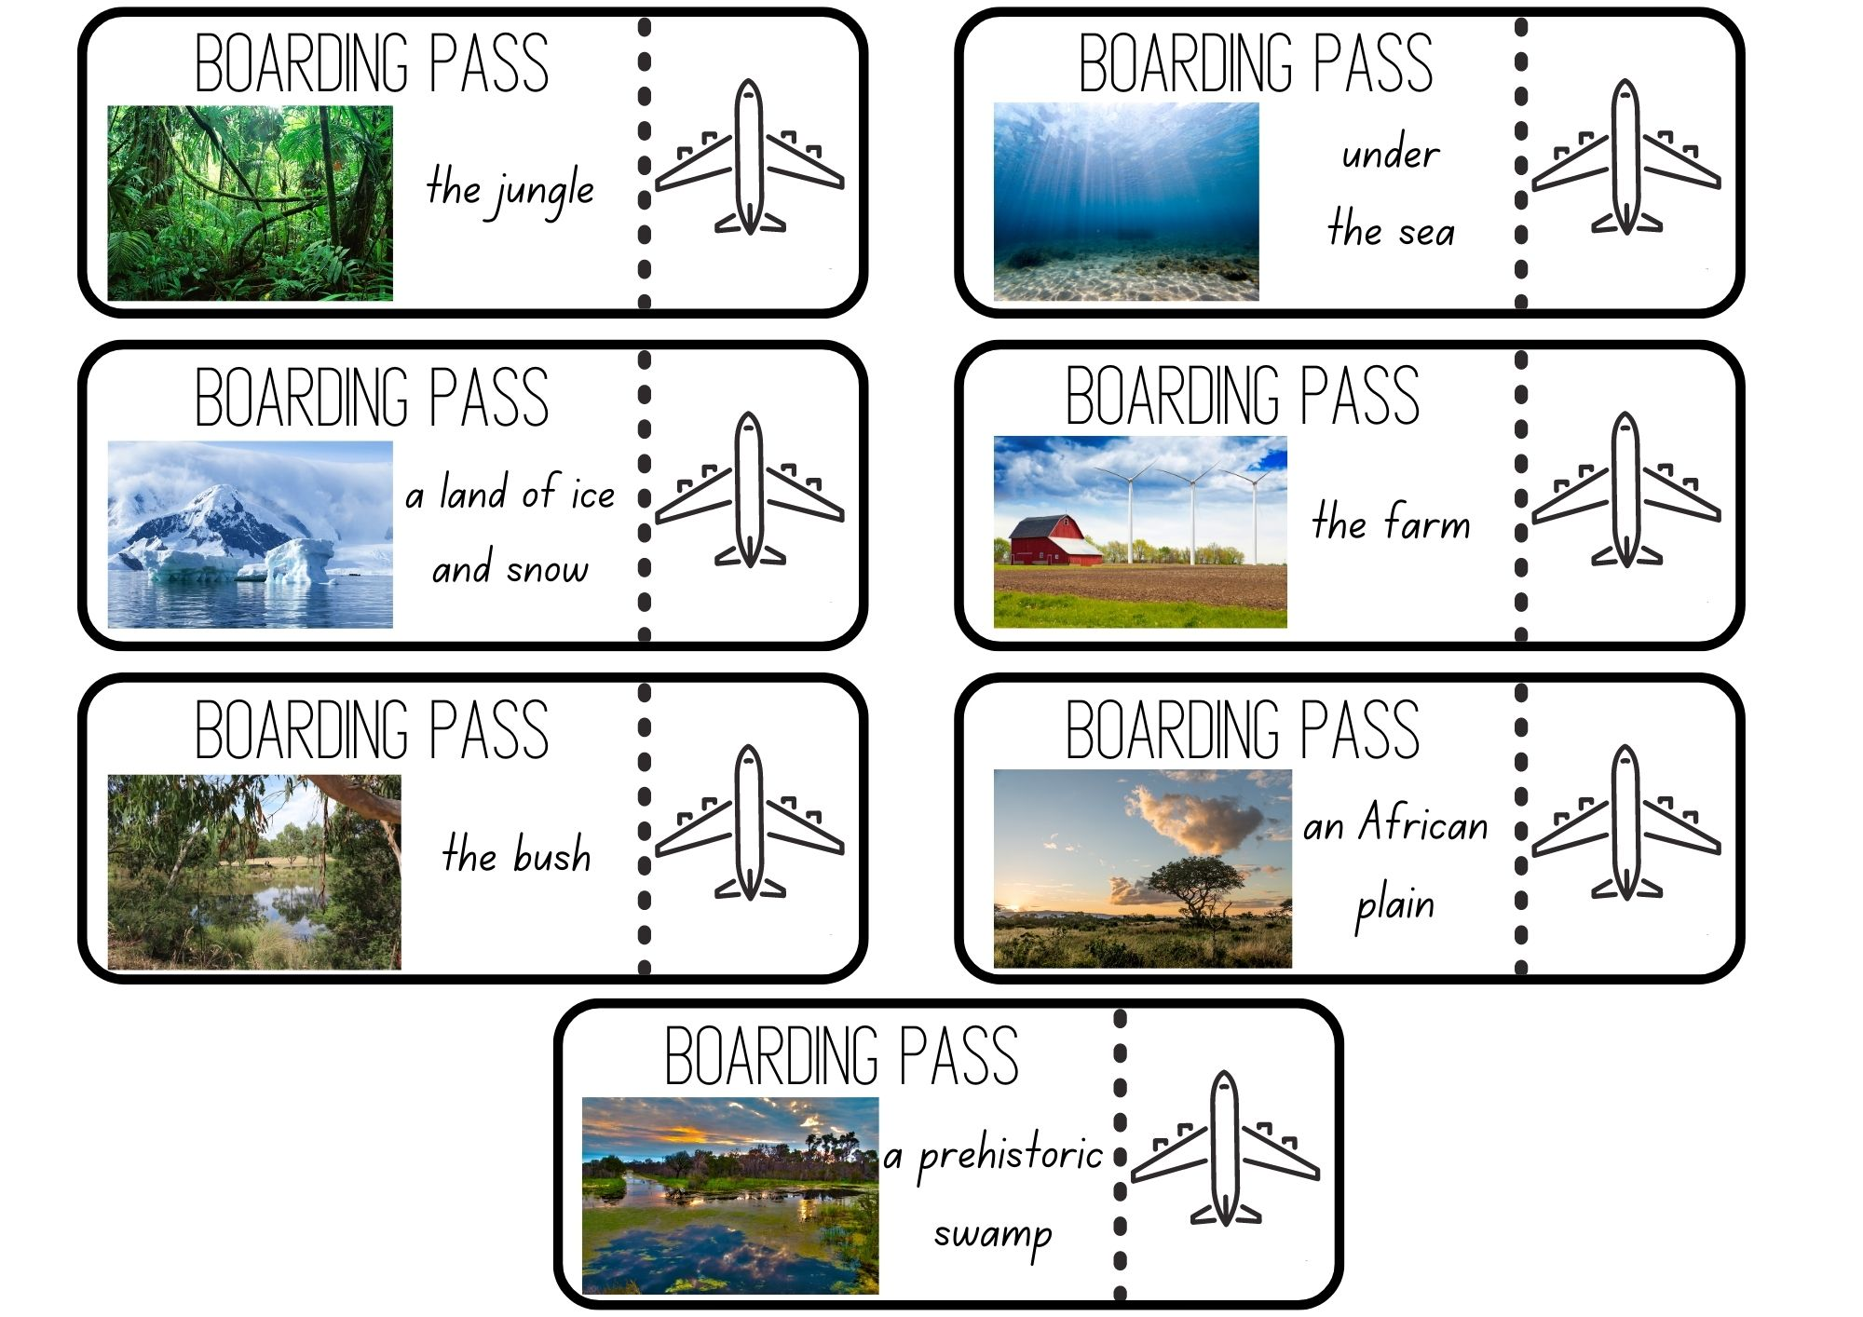
Images sourced from Canva and used in accordance with the Canva Content License Agreement.

Resource 2: Senses
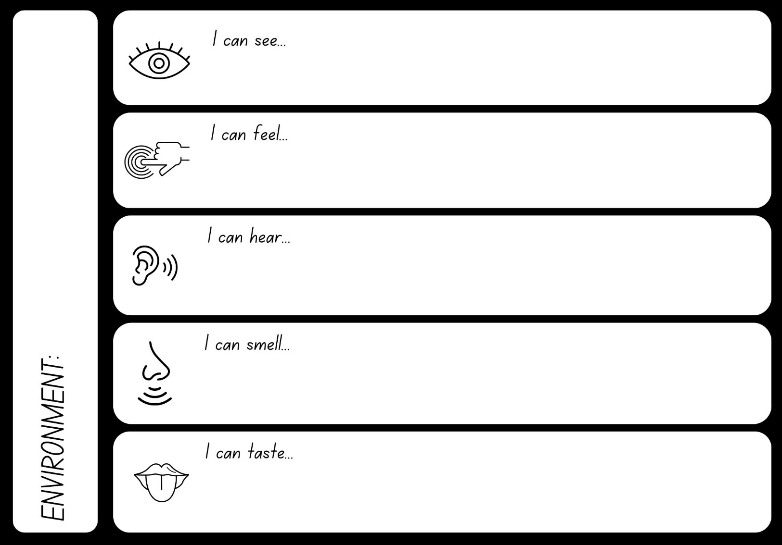
Images sourced from Canva and used in accordance with the Canva Content License Agreement.

Resource 3: Onomatopoeia
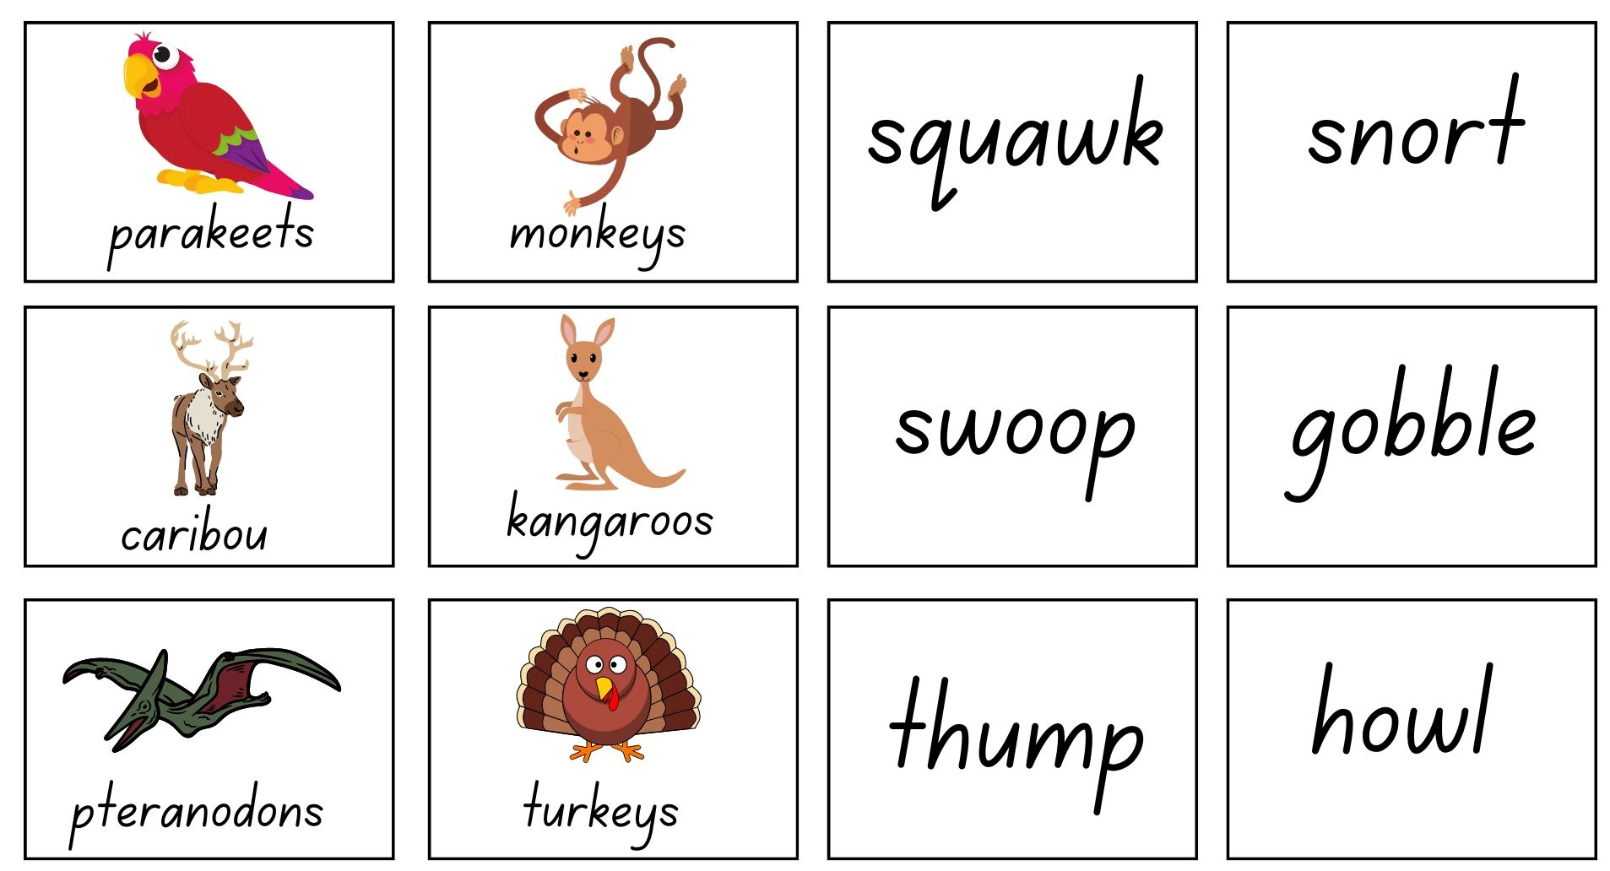
Images sourced from Canva and used in accordance with the Canva Content License Agreement.

Resource 4: Dinosaurs
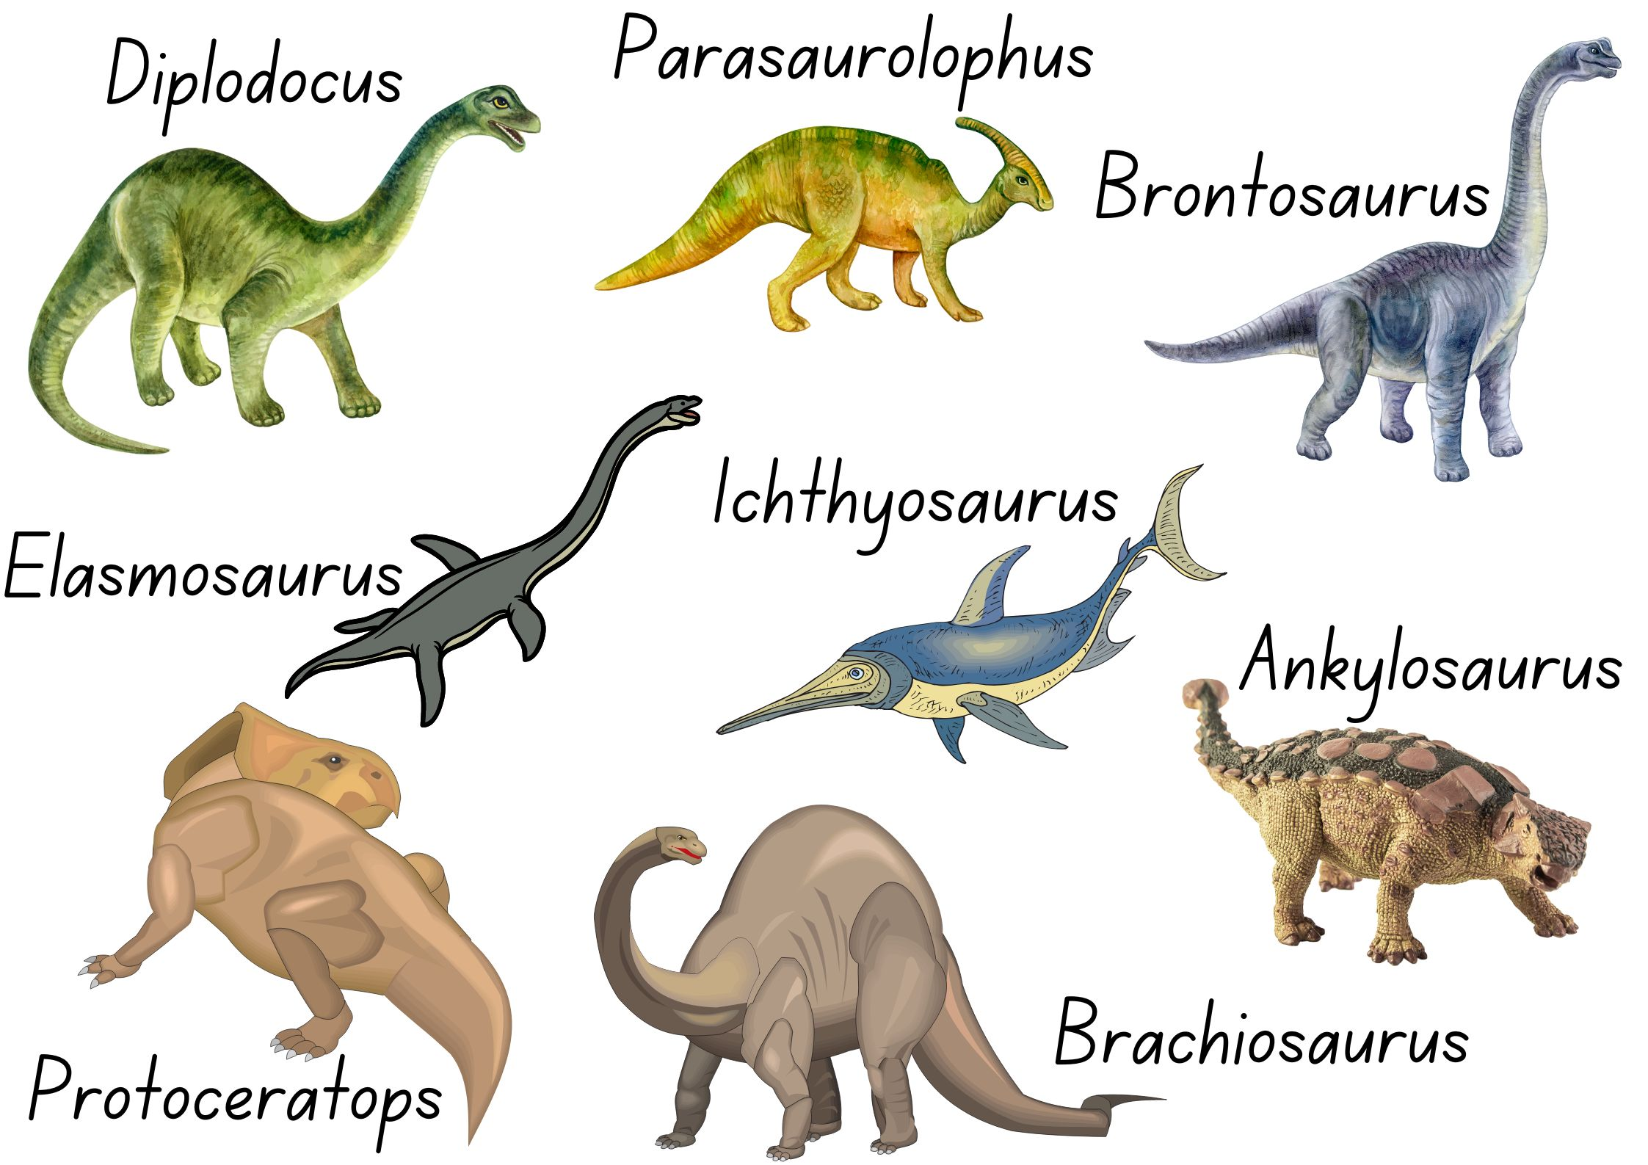
Images sourced from Canva and used in accordance with the Canva Content License Agreement.

Resource 5: Writing template
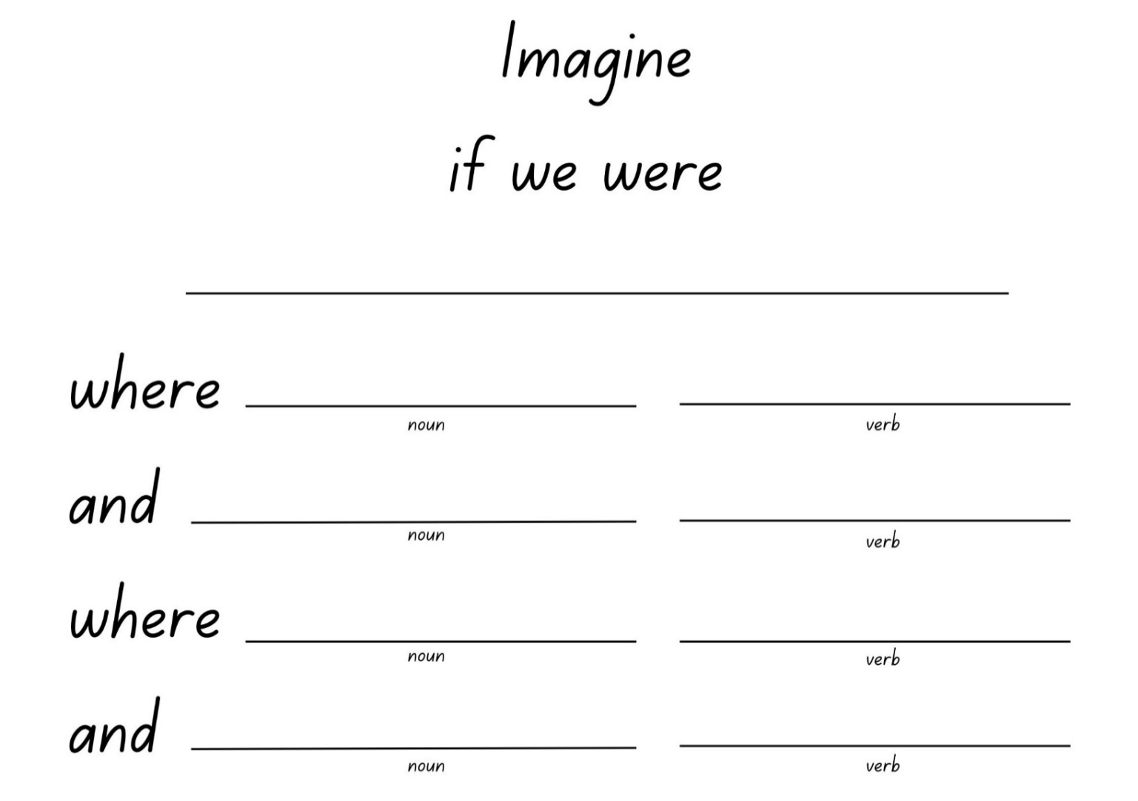

Resource 6: Picture stimulus
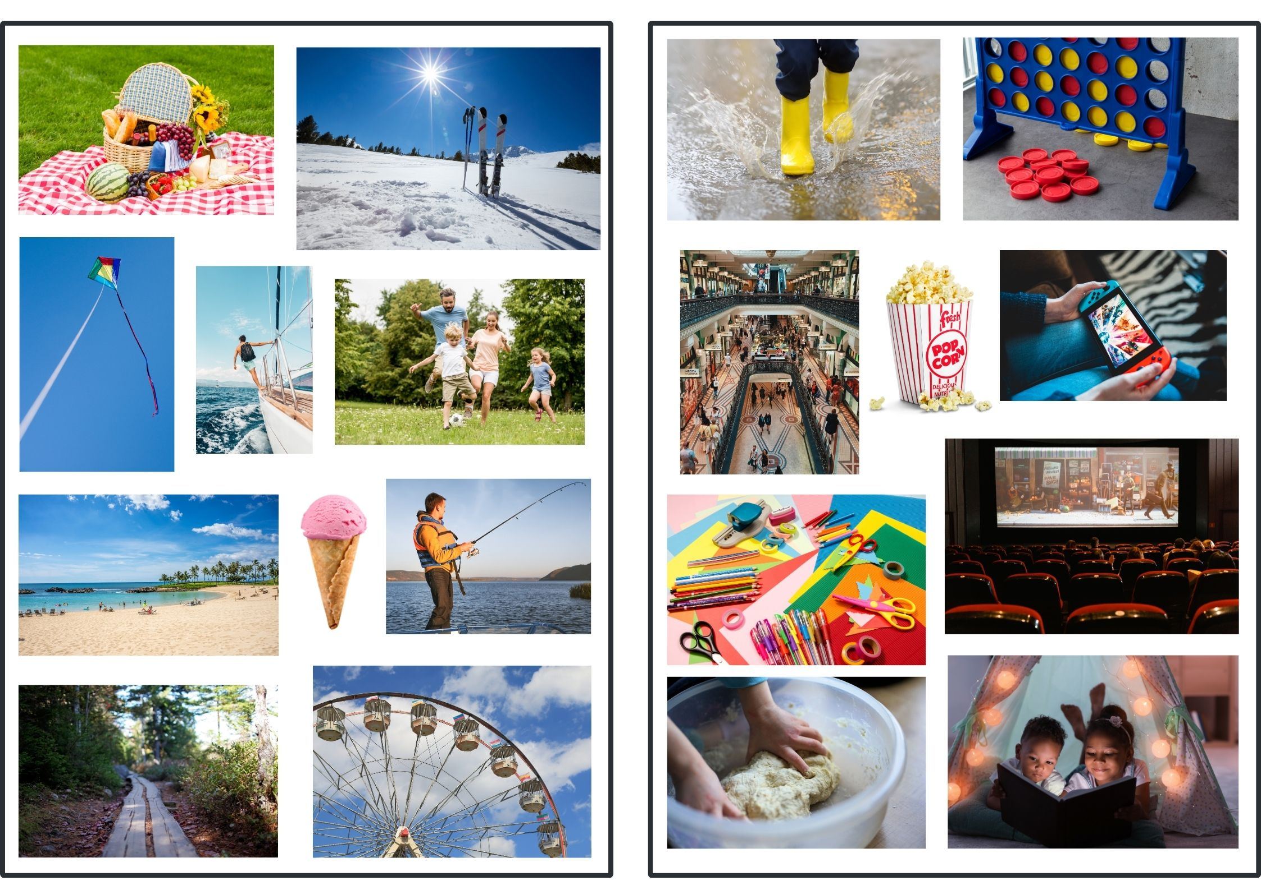
Images sourced from Canva and used in accordance with the Canva Content License Agreement.

Resource 7: Planning template
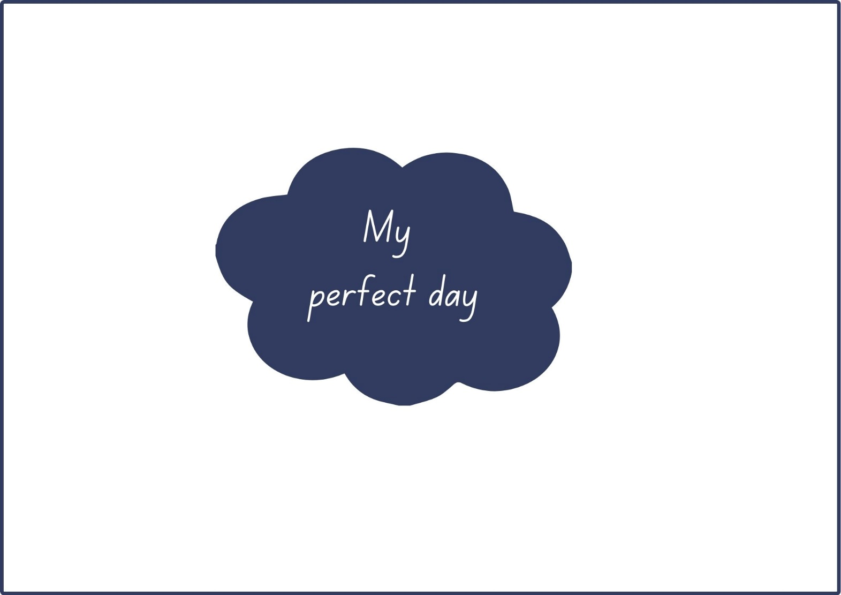

Resource 8: Exemplar text
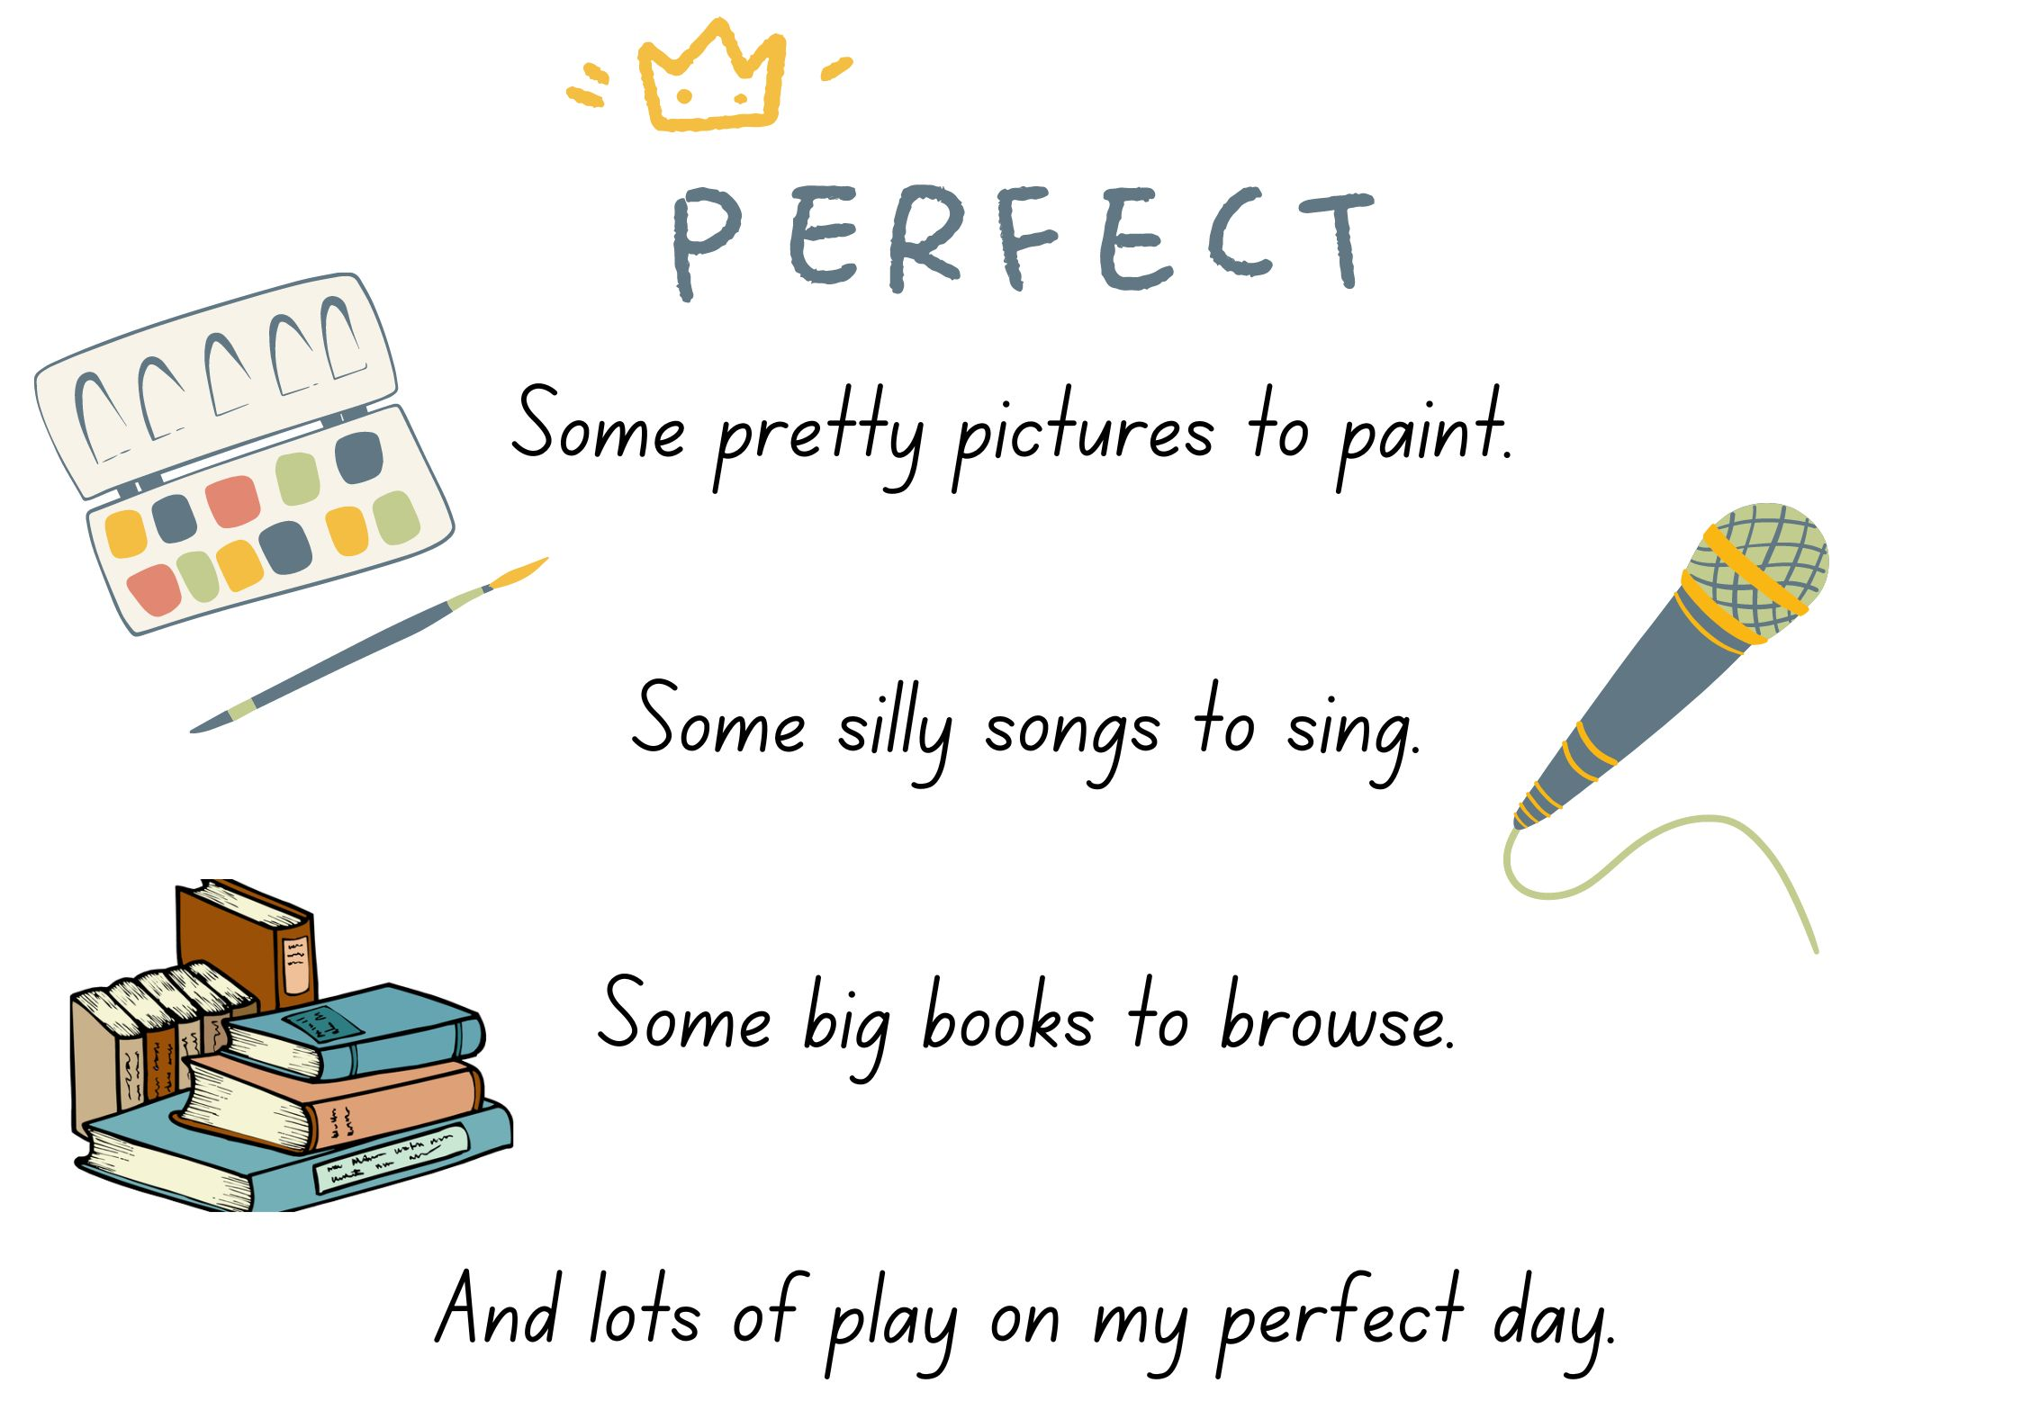
Images sourced from Canva and used in accordance with the Canva Content License Agreement.

References
Links to third-party material and websites
Please note that the provided (reading/viewing material/list/links/texts) are a suggestion only and implies no endorsement, by the New South Wales Department of Education, of any author, publisher, or book title. School principals and teachers are best placed to assess the suitability of resources that would complement the curriculum and reflect the needs and interests of their students.
If you use the links provided in this document to access a third-party's website, you acknowledge that the terms of use, including licence terms set out on the third-party's website apply to the use which may be made of the materials on that third-party website or where permitted by the Copyright Act 1968 (Cth). The department accepts no responsibility for content on third-party websites.
Except as otherwise noted, all material is © State of New South Wales (Department of Education), 2023 and licensed under the Creative Commons Attribution 4.0 International License. All other material (third-party material) is used with permission or under licence. Where the copyright owner of third-party material has not licensed their material under a Creative Commons or similar licence, you should contact them directly for permission to reuse their material.
English K–10 Syllabus © 2022 NSW Education Standards Authority (NESA) for and on behalf of the Crown in right of the State of New South Wales.
© 2022 NSW Education Standards Authority. This document contains NSW Curriculum and syllabus content. The NSW Curriculum is developed by the NSW Education Standards Authority. This content is prepared by NESA for and on behalf of the Crown in right of the State of New South Wales. The material is protected by Crown copyright.
Please refer to the NESA Copyright Disclaimer for more information.
NESA holds the only official and up-to-date versions of the NSW Curriculum and syllabus documents. Please visit the NSW Education Standards Authority (NESA) website and the NSW Curriculum website.
National Literacy Learning Progression © Australian Curriculum, Assessment and Reporting Authority (ACARA) 2010 to present, unless otherwise indicated. This material was downloaded from the Australian Curriculum website (National Literacy Learning Progression) (accessed 5 April 2023) and was not modified. The material is licensed under CC BY 4.0. Version updates are tracked in the ‘Curriculum version history’ section on the 'About the Australian Curriculum' page of the Australian Curriculum website.
ACARA does not endorse any product that uses the Australian Curriculum or make any representations as to the quality of such products. Any product that uses material published on this website should not be taken to be affiliated with ACARA or have the sponsorship or approval of ACARA. It is up to each person to make their own assessment of the product, taking into account matters including, but not limited to, the version number and the degree to which the materials align with the content descriptions and achievement standards (where relevant). Where there is a claim of alignment, it is important to check that the materials align with the content descriptions and achievement standards (endorsed by all education Ministers), not the elaborations (examples provided by ACARA).
ETA (English Teachers Association) and NSW Department of Education (2016) The Textual Concepts and Processes resource, English Textual Concepts website, accessed 8 March 2023.
Lester A (2005) Imagine, A&U Children’s, Australia.
Parker D (2017) Perfect (F Blackwood, illus.), Hardie Grant Children’s Publishing, Australia.

