English – Early Stage 1 – Unit 18
Contents
Unit overview and instructions for use 3
Teacher notes 4
Outcomes and content – Component A 5
Outcomes and content – Component B 7
Week 1 10
Component A teaching and learning 10
Component B teaching and learning 11
Lesson 1: Understanding character feelings 12
Lesson 2: Forming an opinion about a character 13
Lesson 3: Understanding a character’s actions 15
Lesson 4: Describing characters actions using nouns and verbs 16
Lesson 5: Using vocabulary to describe characters and animals 18
Week 2 20
Component A teaching and learning 20
Component B teaching and learning 21
Lesson 6: Understanding a character’s traits through their actions 22
Lesson 7: Joint construction 23
Lesson 8: Planning 24
Lesson 9: Composing 25
Lesson 10: Feedback, editing and sharing 25
Resource 1: Images 27
Resource 2: Feeling cards 28
Resource 3: Sheep images 29
Resource 4: Character trait cards 30
Resource 5: Planning template 31
References 32

Unit overview and instructions for use
This two-week unit is comprised of Component A and Component B. Connecting learning across both components is encouraged.
Teaching and learning | Component A | Component B
Suggested duration | 60 minutes | 45 minutes
Explicit teaching focus areas | - Phonological awareness  - Print conventions  - Phonic knowledge  - Reading fluency  - Reading comprehension  - Spelling  - Handwriting | - Oral language and communication  - Vocabulary  - Reading comprehension  - Creating written texts  - Understanding and responding to literature
To prepare for teaching and learning: | - Refer to Outcomes and content – Component A, K-2 – Instructional sequence – grapheme–phoneme correspondences [PDF 825 KB], and the teaching advice documents (hyperlinked in Component A teaching and learning table).  - Based on student needs identified through ongoing assessment data, plan and document how you will sequence teaching and learning in whole class and targeted teaching groups across the two-week cycle. | - Familiarise yourself with Outcomes and content – Component B, Textual concepts information and videos, English Textual Concepts and Learning Processes (2016), and the teaching and learning sequence.  - Based on student needs identified through ongoing assessment data, determine how you will support students in whole class and targeted teaching groups across the two-week cycle as required.
English Syllabus K–10 © 2022 NSW Education Standards Authority (NESA) for and on behalf of the Crown in right of the State of New South Wales.

Teacher notes
- Character is traditionally viewed as a description of a fictional identity. It is made up of verbal and visual statements about what a character does, says and thinks, and what other fictional characters and the author of the text say about them. Analysis of characters can contribute to our own personal judgements about self, morals and values. – English Textual Concepts and Learning Processes (2016).
- Understanding of character can be supported through watching the department’s video: Understanding character video (2:31).
- While character is the mentor concept for the conceptual component of this unit, the supporting concept of perspective can be explored using the mentor text Koala Lou by Mem Fox.
- For information on Tier 3 words refer to the NESA Glossary.
- Reflect on student learning and engagement in activities and record differentiation and adjustments within the unit to inform future teaching and learning. One way of doing this could be to add comments to the digital file.
- Content points are linked to the National Literacy Learning Progression version (3).
Levels and indicators sourced from National Literacy Learning Progression © Australian Curriculum, Assessment and Reporting Authority (ACARA), (accessed 14 February 2023) and was not modified. See references for more information.

Outcomes and content – Component A
The table below outlines the focus outcomes and content. Content is linked to the National Literacy Learning Progression version (3).
Focus area and outcome | Content points and National Literacy Learning Progression
Phonological awareness  ENE-PHOAW-01 – identifies, blends, segments and manipulates phonological units in spoken words as a strategy for reading and creating texts | N/A
Print conventions  ENE-PRINT-01 – tracks written text from left to right and from top to bottom of the page and identifies visual and spatial features of print | N/A
Phonic knowledge  ENE-PHOKW-01 – uses single-letter grapheme–phoneme correspondences and common digraphs to decode and encode words when reading and creating texts | - decode words containing split digraphs and vowel digraphs (PKW5)  - experiment with encoding high-frequency words containing split digraphs and vowel digraphs
Reading fluency  ENE-REFLU-01 – reads decodable texts aloud with automaticity | - read words automatically then apply to texts  - know that pace and expression vary when reading, according to the audience and purpose
Reading comprehension  ENE-RECOM-01 – comprehends independently read texts using background knowledge, word knowledge and understanding of how sentences connect | - use known vocabulary to work out or refine the meaning of unknown words  - ask a question or make a statement to clarify meaning (UnT3, UnT4)  - use information or events from different parts of the text to form an opinion
Spelling  ENE-SPELL-01 – applies phonological, orthographic and morphological generalisations and strategies to spell taught familiar and high-frequency words when creating texts | - segment multisyllabic words into syllables and phonemes as a strategy for spelling  - experiment with some vowel digraphs and split digraphs to spell taught high-frequency words and/or personally significant words
Handwriting  ENE-HANDW-01 – produces all lower-case and upper-case letters to create texts | - use a stable posture when handwriting or drawing by sitting comfortably with feet flat on the floor, the writing arm resting on a table, with the opposite hand resting on the paper, and shoulders relaxed

Outcomes and content – Component B
The table below outlines the focus outcomes and content. Content is linked to the National Literacy Learning Progression version (3).
Focus area and outcome | Content points and National Literacy Learning Progression
Oral language and communication  ENE-OLC-01 – communicates effectively by using interpersonal conventions and language with familiar peers and adults | - listen for a purpose by agreeing or disagreeing, adding to the comment of others, or sharing thoughts and feelings  - use a combination of sentences to elaborate and connect ideas (SpK3)
Vocabulary  ENE-VOCAB-01 – understands and effectively uses Tier 1 words and Tier 2 words in familiar contexts | - identify, name and describe a range of objects, characters, animals, people and places when given visual and/or auditory prompts (GrA1)  - use vocabulary that is specific to key learning areas (SpK3, CrT3)  - use and understand Tier 3 words that are of personal interest
Reading comprehension  ENE-RECOM-01 – comprehends independently read texts using background knowledge, word knowledge and understanding of how sentences connect | - use known vocabulary to work out or refine the meaning of unknown words  - identify conjunctions in a compound sentence, their meaning and purpose  - use information or events from different parts of the text to form an opinion
Creating written texts  ENE-CWT-01 – creates written texts that include at least 2 related ideas and correct simple sentences | - create a text including at least 2 related ideas (CrT5)  - use personal pronouns in own writing (CrT7)  - experiment with writing compound sentences and recognise that each clause makes meaning by itself (GrA4)  - explain the purpose of a verb, a noun and an adjective in own writing (GrA2, GrA3)  - intentionally select nouns, verbs, adjectives and articles in own writing  - use capital letters when writing proper nouns (PuN3, CrT5)  - identify differences between spoken and written language  - edit their texts after receiving feedback
Understanding and responding to literature  ENE-UARL-01 – understands and responds to literature read to them | - identify and discuss language used to describe characters in narratives  - identify and discuss character features and actions (UnT3)  - reason using background knowledge as to why a character has acted in a certain way (UnT4)  - compare opinions of a text or characters with peers (InT2)

Week 1

Component A teaching and learning
The table below can be used to plan and document lessons that address Component A outcomes and content. Both the detailed example [DOC 529KB] of a two-week teaching and learning cycle and brief example [DOC 66KB] may support you in your planning.
Focus Areas | Lesson 1 | Lesson 2 | Lesson 3 | Lesson 4 | Lesson 5
Phonological awareness and
Phonic knowledge
15 minutes
Spelling and Handwriting
15 minutes
Print conventions,
Reading comprehension and Reading fluency
30 minutes

Component B teaching and learning
The following teaching and learning sequence has been designed to address Component B outcomes and content. Adapt the sequence as required to best meet the needs of your students.

Learning intention and success criteria
Learning intentions and success criteria are best co-constructed with students.
Learning intention
Students are learning to identify how characters are described in texts.

Success criteria
Students can:
- describe characters’ feelings and actions
- use information from texts to form opinions about characters
- compare opinions of characters with peers
- explain why characters act in certain ways
- identify nouns, verbs and adjectives and explain their purpose.

Resources
- Fox M (1988) Koala Lou (Lofts P, illus), Puffin, Australia. ISBN: 9780140540635
- Dunstan K (2018) Nannie Loves, Working Title Press, Australia. ISBN: 9781921504846
- Resource 1: Images – A3 version
- Resource 2: Feelings cards
- Resource 3: Sheep images
- Bowl
- Mini whiteboards

Lesson 1: Understanding character feelings
- Cut up Resource 1: Images and place in a bowl. Take out one image at a time, read the label and display it in the classroom. Explain that the images will give clues about the text. Pause to discuss the images and allow time for students to discuss what the text could be about. Continue until all the images have been taken out the bowl. On mini whiteboards, students record their predictions. Read the blurb at the back of the book and allow time for students to refine or add details to their predictions.
- Read the text and discuss the meaning of new or unknown words. For example, compete, longed, splendid, blossom, spectators, hope. Revisit and discuss students’ predictions from activity 1.
- Revise the concept of character and discuss Koala Lou’s character features. For example, she is an animal that displays human characteristics including feelings and emotions. Ask students how Koala Lou felt during the story and how they knew. Pose questions, such as:
- How did Koala Lou feel at the beginning of the story?
- What caused Koala Lou to question how her mother felt about her?
- What motivated Koala Lou to compete in the Bush Olympics?
- How did Koala Lou feel after competing in the Bush Olympics?
- What did Koala Lou learn at the end of the story?
- Display Resource 2: Feelings cards. Explain that students will match Koala Lou’s feelings to an example from the text. Model matching one feeling word with an example, such as ‘lonely’ matches with ‘Koala Lou’s mother was busy and had no time for her’.
- Point to the blank feeling and example on the resource. As a class, brainstorm possible feelings that could describe the picture. For example, upset, sad, heartbroken. Students Think-Pair-Share when Koala Lou felt that way and identify examples from the text.
- In pairs, students use Resource 2: Feeling cards to match Koala Lou’s feelings to the examples from the text. Students write a missing feeling word and an example from the text. For example, ‘upset’ matches with ‘Koala Lou coming second in the gumtree climbing event’. Students discuss how and why Koalas Lou’s feelings changed throughout the text.
Too easy? Students draw a story map of how Koala Lou’s feelings changed throughout the text. Students use information and events from the text to write about why her feelings changed.
- Optional: In small groups, students take photos of themselves displaying facial expressions that represent the emotions Koala Lou felt throughout the text. Students match their facial expressions and photos to the examples from Resource 2: Feeling cards.

Lesson 2: Forming an opinion about a character
- On card, write the character traits ‘brave’ and ‘scared’ and display in the classroom. Ask students which word best describes Koala Lou’s character. Discuss the reasons why. For example, ‘I think Koala Lou is brave because she walked down the track by herself.’
- On card, write the character traits ‘determined’, ‘strong’, ‘weak’, ‘lazy’, ‘hard working’, ‘caring’ and display in the classroom. Students Think-Pair-Share which word best describes Koala Lou’s character and explain why. Use think-alouds to model a combination of sentences to elaborate and connect ideas. For example, ‘Koala Lou is strong because she trained for the Bush Olympics, Koala Lou shows she is strong by training for the Bush Olympics.’
- Revise the concept of perspective and the term ‘opinion’. Explain that students will form an opinion using information and events from the text to describe the character traits of Koala Lou.
- Using student ideas from activity 2, model writing an opinion about which word best describes Koala Lou. For example, ‘I think Koala Lou is determined because she competed in the Bush Olympics.’ Highlight the use of capital letters when writing proper nouns for a name (Koala Lou) and the title of something (Bush Olympics).
- Students write their opinion about which word best describes Koala Lou and why. Ensure students use capital letters when writing proper nouns.
- In small groups, students take turns sharing their opinion about which word best describes Koala Lou. Students show if they agree or disagree with an opinion using ‘thumbs up’ or ‘thumbs down’. Students make comments and share their thoughts and feelings about their peers’ opinions.
Early Stage 1 Assessment task 1 – Observations and work samples from this lesson allow students to demonstrate achievement towards the following syllabus outcomes and content points:
ENE-OLC-01 – communicates effectively by using interpersonal conventions and language with familiar peers and adults
- listen for a purpose by agreeing or disagreeing, adding to the comment of others, or sharing thoughts and feelings
- use a combination of sentences to elaborate and connect ideas.
ENE-RECOM-01 – comprehends independently read texts using background knowledge, word knowledge and understanding of how sentences connect
- use information or events from different parts of the text to form an opinion.
ENE-CWT-01 – creates written texts that include at least 2 related ideas and correct simple sentences
- use capital letters when writing proper nouns.
ENE-UARL-01 – understands and responds to literature read to them
- compare opinions of a text or characters with peers.

Lesson 3: Understanding a character’s actions
- Display the double page spread from Koala Lou that shows her sitting alone on a branch looking at her family. Ask:
- How is Koala Lou feeling? For example, lonely, jealous, upset.
- Why is she feeling that way? For example, her mother is too busy and doesn’t have time for her.
- What does Koala Lou do next? For example, Koala Lou enters the Bush Olympics.
Discuss student responses.
- Identify and discuss phrases from the text that provide further information about Koala Lou’s feelings and actions. For example, ‘She longed for her to say it again’.
- In pairs, students discuss why Koala Lou entered the Bush Olympics. Share students’ ideas and discuss similarities and differences between responses.
- Model writing a sentence about why Koala Lou entered the Bush Olympics. For example, Koala Lou entered the Bush Olympics because she felt sad and thought her mother did not love her.
- Students use ideas discussed in activity 1 to independently write about why Koala Lou entered the Bush Olympics.
Too hard? Co-construct sentences about why Koala Lou entered the Bush Olympics.
- In pairs, students participate in a Hot seat activity. Students ask questions and respond from the perspective of Koala Lou. Provide students with questions to ask, such as:
- How did you feel when your brothers and sisters were born?
- Why did you enter the Bush Olympics?
- How did you feel after the climbing competition?
Early Stage 1 Assessment task 2 – Observations and work samples from this lesson allow students to demonstrate achievement towards the following syllabus outcome and content points:
ENE-UARL-01 – understands and responds to literature read to them.
- reason giving background knowledge as to why a character has acted in a certain way
- identify and discuss character features and actions.

Lesson 4: Describing characters actions using nouns and verbs
- Introduce the text Nannie Loves. Revise the concept of character. Explain that students will be exploring a new character in this text. Read the title of the text and ask students who they think the character might be. Discuss the meaning of the word ‘Nannie’. Students share the different names they call their grandparents.
- Display the wordless double page spread from Nannie Loves that shows the character silhouettes walking over the hill. As a class, discuss who the characters (people and animals) are and where the story is set.
- Read the text and use known vocabulary to work out or clarify the meaning of unknown words. For example, paddock, shoos, graze, peck, wander.
- Revise the purpose of a noun (a word used to represent people, places, things and feelings). Using a coloured marker, create an anchor chart of things (nouns) that Nannie loves. For example, dog, sheep, cows, chooks. Revise the purpose of a verb (a doing or action word that tells the reader what is happening). Using a different coloured marker, record Nannie’s actions for each noun on the anchor chart. For example, pats dog, shoos sheep, herds cows, calls chooks.
- Explain that students will play a guessing game using Nannie’s actions from the text. Model performing one of Nannie’s actions and ask students to guess what she loves to do using complete sentences. For example, Nannie loves to pat her dog.
- In small groups, students take turns choosing something Nannie loves to do and performing it for their peers. Students guess what action is performed using complete sentences.
- Using the anchor chart from activity 4, students draw and write about something Nannie loves to do on her farm.
Too hard? Students draw and label their picture using nouns and verbs.
Too easy? Students use compound sentences to combine ideas together.
- In pairs, students share their writing. Using different coloured pencils, students circle the nouns and underline the verbs in their sentence and discuss the purpose of each.

Lesson 5: Using vocabulary to describe characters and animals
- Review the anchor chart of nouns and verbs from Lesson 4. Revise the purpose of an adjective and how it is used to describe someone or something. Display the sentence ‘Nannie pats her bouncy dog’ from Nannie Loves. Deconstruct the sentence and identify the nouns (Nannie, dog), verb (pats) and adjective (bouncy). Discuss the use of the personal pronoun ‘her’. Ask students who ‘her’ is referring to. Explain that a personal pronoun is used to replace a noun that refers to a person or people in a sentence.
- Record the sentence ‘Nannie works in her garden’ on the board. Deconstruct the sentence and identify the noun/s and verb. Brainstorm adjectives to describe Nannie’s garden. For example, large, beautiful, shady, sunny. Rewrite the sentence using an adjective. Repeat with the sentence ‘Nannie laughs with her family.’ On mini whiteboards, students rewrite the sentence using an adjective. For example, Nannie laughs with her happy family. Students circle the nouns, underline the verbs and put a box around the adjective, then explain the purpose of each.
- Display the double page spread that shows Nannie shooing her sheep in the paddock. Ask students if they know the names (tier 3 words) for a male (ram), female (ewe) or baby sheep (lamb). Discuss student responses.
- Display an enlarged copy of Resource 3: Sheep images. Discuss and label the images with nouns, verbs and adjectives. For example, large horns, little pink ears, climb hills, eat grass.
- Display the page from Nannie Loves that reads ‘Nannie shoos her sheep. They are white and woolly and love to graze in her vegetable patch. Nannie loves her sheep.’ Model substituting nouns, verbs and adjectives from the text with words from the labelled diagram in activity 4. For example, ‘Nannie shoos her rams. They have large horns and they love to climb hills. Nannie loves her rams.’
- Students use modelled vocabulary from activity 4 to re-create the text about a lamb.
Too hard? Students label an image of a lamb using nouns, verbs and adjectives.
Too easy? Students add adjectives to further describe the lamb. For example, Nannie loves her soft lamb.
- Students share their sentences with their peers, discussing the purpose of the verbs, nouns and adjectives in their writing.
Early Stage 1 Assessment task 3 – Observations and work samples from this lesson allow students to demonstrate achievement towards the following syllabus outcomes and content points:
ENE-VOCAB-01 – understands and effectively uses Tier 1 words and Tier 2 words in familiar contexts
- identify, name and describe a range of objects, characters, animals, people and places when given visual and/or auditory prompts
- use vocabulary that is specific to key learning areas
- use and understand Tier 3 words that are of personal interest.
ENE-RECOM-01 – comprehends independently read texts using background knowledge, word knowledge and understanding of how sentences connect
- use known vocabulary to work out or refine the meaning of unknown words.
ENE-CWT-01 – creates written texts that include at least 2 related ideas and correct simple sentences
- explain the purpose of a verb, a noun and an adjective in own writing.

Week 2

Component A teaching and learning
The table below can be used to plan and document lessons that address Component A outcomes and content. Both the detailed example [DOC 529KB] of a two-week teaching and learning cycle and brief example [DOC 66KB] may support you in your planning.
Focus Areas | Lesson 6 | Lesson 7 | Lesson 8 | Lesson 9 | Lesson 10
Phonological awareness and
Phonic knowledge
15 minutes
Spelling and Handwriting
15 minutes
Print conventions,
Reading comprehension and Reading fluency
30 minutes

Component B teaching and learning
The following teaching and learning sequence has been designed to address Component B outcomes and content. Adapt the sequence as required to best meet the needs of your students.

Learning intention and success criteria
Learning intentions and success criteria are best co-constructed with students.

Learning intention
Students are learning to use their understanding of character to create written texts.

Success criteria
Students can:
- describe characters actions and traits
- use nouns, verbs and adjectives to describe characters
- use compound sentences
- use personal pronouns and proper nouns
- use feedback to edit and improve writing.

Resources
- Dunstan K (2018) Nannie Loves, Working Title Press, Australia. ISBN: 9781921504846
- Resource 4: Character trait cards
- Resource 5: Planning template

Lesson 6: Understanding a character’s traits through their actions
- Re-read Nannie Loves and revise some of Nannie’s actions from the text.
- Revise the term ‘character traits’ and how they describe a character's personality or qualities. Display Resource 4: Character trait cards. Explain that students will match Nannie’s character traits to an example from the text. Model matching one character trait with its example. Re-read the sentence using the conjunction ‘because’. For example, ‘Nannie is energetic because she herds the brown cows.’
- In pairs, students use Resource 4: Character trait cards to match Nannie’s traits to the examples from the text. Students re-read the sentences using the conjunction ‘because’ to join 2 ideas together.
- Choose an example from Resource 4: Character trait cards and deconstruct the sentence. Identify personal pronouns, articles, nouns, verbs and adjectives in the sentence. For example, Nannie (noun), herds (verb) the (article) brown (adjective) cows (noun).
- In pairs, students choose a sentence to deconstruct from activity 3. Using different coloured pencils students highlight the personal pronoun or article. Students identify the nouns, verb and adjective and explain the purpose of each.
- Model writing a compound sentence describing Nannie’s character traits. For example, Nannie is hard working because she picks the delicious fruit. As a class, identify the conjunction and discuss how it joins 2 independent clauses.
- Students experiment using compound sentences to write about Nannie’s character traits.
Early Stage 1 Assessment task 4 – Observations and work samples from this lesson allow students to demonstrate achievement towards the following syllabus outcomes and content points:
ENE-RECOM-01 – comprehends independently read texts using background knowledge, word knowledge and understanding of how sentences connect
- identify conjunctions in a compound sentence, their meaning and purpose.
ENE-UARL-01 – understands and responds to literature read to them
- identify and discuss language used to describe characters in narratives.

Lesson 7: Joint construction
- Re-read Nannie Loves highlighting the structure and layout of the text, as well as the language choices to describe the character Nannie, such as the use of nouns, verbs and adjectives. Explain that the class will adapt the text, Nannie Loves to create a text about a new character (their teacher). The text will be called Teacher Loves.
- Ask students what their teacher loves to do. In pairs, students discuss things their teacher loves to do. For example, teaching the class, singing, painting, reading, playing sport. Share student responses.
- Model using Resource 5: Planning template to draw things the teacher loves to do. Label the drawings with nouns, verbs and adjectives.
- Use interactive writing to jointly construct a text using the same structure and layout of Nannie Loves. For example, (Teacher name) teaches his/her crazy class. (Class name) read funny books and they love playing in the green grass. (Teacher name) loves his/her class. Display in the classroom to support student writing in Lesson 9.
- Deconstruct the sentences from activity 4. Highlight the nouns, verbs and adjectives. Identify the compound sentence, circle the conjunction and discuss how each clause makes meaning by itself. Discuss the use of personal pronouns and capital letters when writing proper nouns.
- Co-construct success criteria for writing. For example:
- include at least 2 related ideas
- use capital letters for proper nouns
- use personal pronouns
- use articles, nouns, verbs and adjectives
- use compound sentences.
- Display the success criteria in the classroom to use in Lesson 9.

Lesson 8: Planning
- Explain that students will adapt the text, Nannie Loves, to write about a new character and what they love. The character will be based on someone who is important them. For example, a sister, friend, uncle, grandparent. In pairs, students discuss who their character will be and what they love to do. Share student responses.
- Using Resource 5: Planning template, students identify someone who is important to them and draw things they love to do. Students label their drawing using nouns, verbs and adjectives.
- In small groups, students share their planning template. Students describe what they love to do by elaborating on and joining their ideas together. Students add to their peers’ comments by sharing their thoughts about the similarities and differences between their characters and actions.
- Explain that students will use their planned ideas to compose their text in Lesson 9.

Lesson 9: Composing
- Display the jointly constructed text from Lesson 7. Revise the purpose for writing, as well as the structure and layout of the text and highlight how it is similar to the text Nannie Loves.
- Using Resource 5: Planning template from Lesson 8 and the success criteria from Lesson 7, students write about what their character loves to do.
Early Stage 1 Assessment task 5 – Collecting work samples from this lesson allow students to demonstrate achievement towards the following syllabus outcome and content points:
ENE-CWT-01 – creates written texts that include at least 2 related ideas and correct simple sentences
- create a text including at least 2 related ideas
- use personal pronouns in own writing
- experiment with writing compound sentences and recognise that each clause makes meaning by itself
- intentionally select nouns, verbs, adjectives and articles in own writing
- use capital letters when writing proper nouns.

Lesson 10: Feedback, editing and sharing
- Using the success criteria from Lesson 7, students provide peer feedback on their writing. Provide time for students to apply feedback and edit their work.
- Optional: students create an artwork to illustrate their writing. Collate work samples to create a class book.
- Explain that students will orally share their writing. Revise and discuss the differences between written and spoken language. For example, written language uses letters, words and punctuation, while spoken language uses intonation and pauses between sentences.
- In small groups, students orally share their work. Encourage students to use intonation and pauses when speaking aloud.
Early Stage 1 Assessment task 6 – Observations and work samples from this lesson allow students to demonstrate achievement towards the following syllabus outcome and content points:
ENE-CWT-01 – creates written texts that include at least 2 related ideas and correct simple sentences
- identify differences between spoken and written language
- edit their texts after receiving feedback.

Resource 1: Images
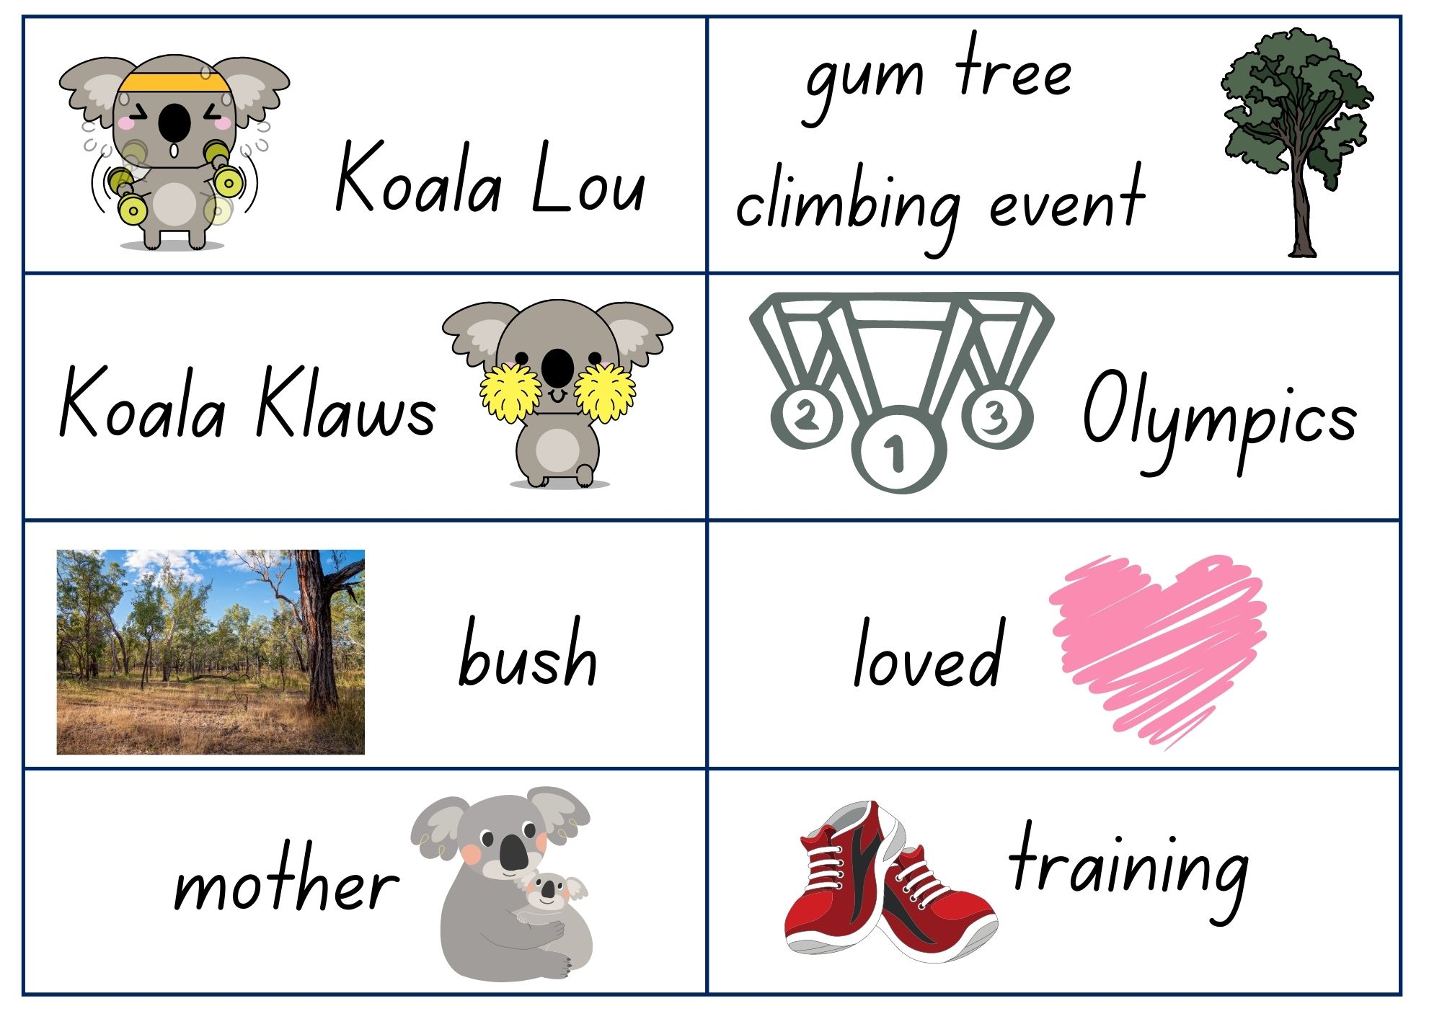
Images sourced from Canva and used in accordance with the Canva Content License Agreement.

Resource 2: Feeling cards
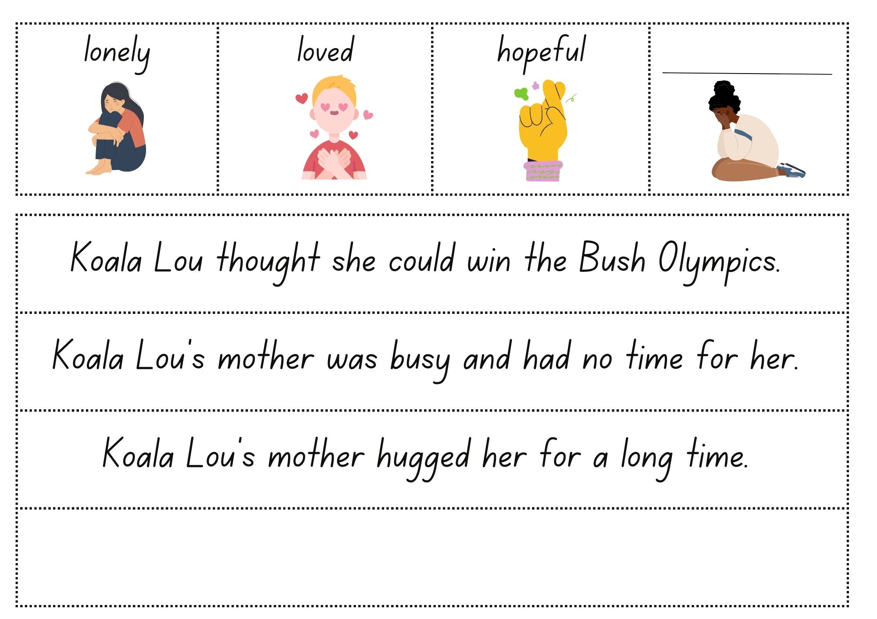
Images sourced from Canva and used in accordance with the Canva Content License Agreement..

Resource 3: Sheep images
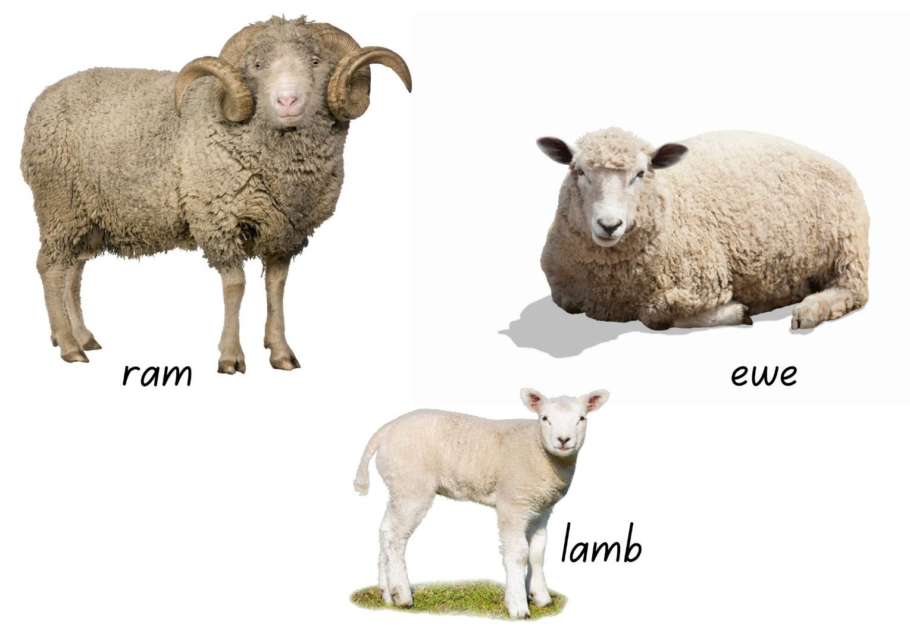
Images sourced from Canva and used in accordance with the Canva Content License Agreement.

Resource 4: Character trait cards
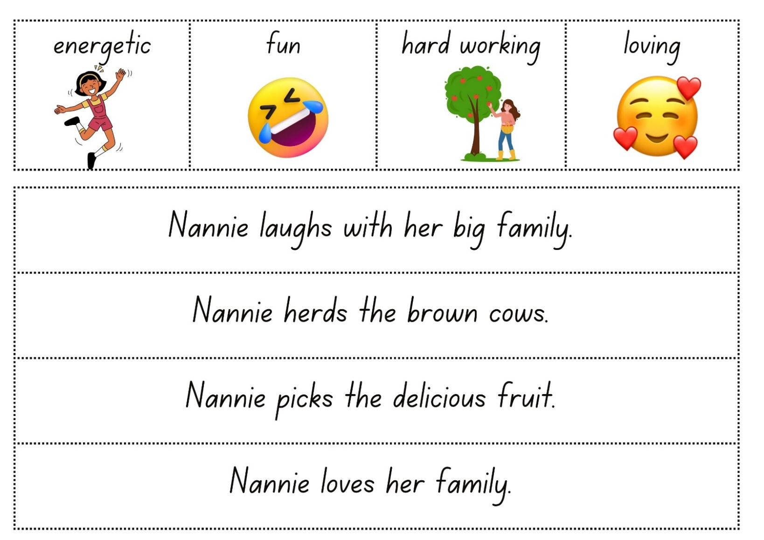
Images sourced from Canva and used in accordance with the Canva Content License Agreement..

Resource 5: Planning template
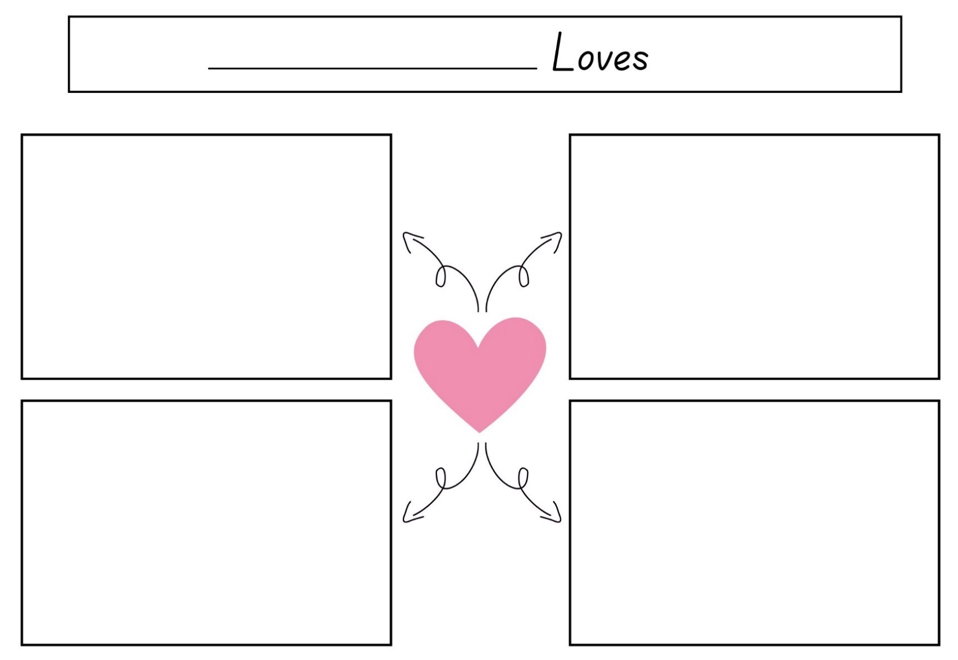
Images sourced from Canva and used in accordance with the Canva Content License Agreement.

References
Links to third-party material and websites
Please note that the provided (reading/viewing material/list/links/texts) are a suggestion only and implies no endorsement, by the New South Wales Department of Education, of any author, publisher, or book title. School principals and teachers are best placed to assess the suitability of resources that would complement the curriculum and reflect the needs and interests of their students.
If you use the links provided in this document to access a third-party's website, you acknowledge that the terms of use, including licence terms set out on the third-party's website apply to the use which may be made of the materials on that third-party website or where permitted by the Copyright Act 1968 (Cth). The department accepts no responsibility for content on third-party websites.
Except as otherwise noted, all material is © State of New South Wales (Department of Education), 2023 and licensed under the Creative Commons Attribution 4.0 International License. All other material (third-party material) is used with permission or under licence. Where the copyright owner of third-party material has not licensed their material under a Creative Commons or similar licence, you should contact them directly for permission to reuse their material.
English K–10 Syllabus © 2022 NSW Education Standards Authority (NESA) for and on behalf of the Crown in right of the State of New South Wales.
© 2022 NSW Education Standards Authority. This document contains NSW Curriculum and syllabus content. The NSW Curriculum is developed by the NSW Education Standards Authority. This content is prepared by NESA for and on behalf of the Crown in right of the State of New South Wales. The material is protected by Crown copyright.
Please refer to the NESA Copyright Disclaimer for more information.
NESA holds the only official and up-to-date versions of the NSW Curriculum and syllabus documents. Please visit the NSW Education Standards Authority (NESA) website and the NSW Curriculum website.
National Literacy Learning Progression © Australian Curriculum, Assessment and Reporting Authority (ACARA) 2010 to present, unless otherwise indicated. This material was downloaded from the Australian Curriculum website (National Literacy Learning Progression) (accessed 14 February 2023) and was not modified. The material is licensed under CC BY 4.0. Version updates are tracked in the ‘Curriculum version history’ section on the 'About the Australian Curriculum' page of the Australian Curriculum website.
ACARA does not endorse any product that uses the Australian Curriculum or make any representations as to the quality of such products. Any product that uses material published on this website should not be taken to be affiliated with ACARA or have the sponsorship or approval of ACARA. It is up to each person to make their own assessment of the product, taking into account matters including, but not limited to, the version number and the degree to which the materials align with the content descriptions and achievement standards (where relevant). Where there is a claim of alignment, it is important to check that the materials align with the content descriptions and achievement standards (endorsed by all education Ministers), not the elaborations (examples provided by ACARA).
Dunstan K (2018) Nannie Loves, Working Title Press, Australia.
ETA (English Teachers Association) and NSW Department of Education (2016) The Textual Concepts and Processes resource, English Textual Concepts website, accessed 14 February 2023.
Fox M (1991) Koala Lou (Lofts P, illus.), Puffin, Australia (original work published 1988).

