English – Early Stage 1 – Unit 17

Contents
Unit overview and instructions for use 3
Teacher notes 4
Outcomes and content – Component A 5
Outcomes and content – Component B 7
Week 1 10
Component A teaching and learning 10
Component B teaching and learning 11
Lesson 1: Building vocabulary knowledge to understand a narrative 12
Lesson 2: Retelling events and ideas from a narrative 14
Lesson 3: Identifying and using nouns, verbs, adjectives 15
Lesson 4: Comparing written and spoken texts 17
Lesson 5: Retelling events and ideas in an audio text 19
Week 2 21
Component A teaching and learning 21
Component B teaching and learning 22
Lesson 6: Creating visual elements to a narrative 23
Lesson 7: Planning a narrative 23
Lesson 8: Composing a narrative 24
Lesson 9: Feedback, editing and publishing 26
Lesson 10: Presenting and reflecting 27
Resource 1: Different word meanings 28
Resource 2: Narrative cards 29
Resource 3: Sequencing template 30
Resource 4: Images 31
Resource 5: Narrative planning 32
References 33

Unit overview and instructions for use
This two-week unit is comprised of Component A and Component B. Connecting learning across both components is encouraged.
Teaching and learning | Component A | Component B
Suggested duration | 60 minutes | 45 minutes
Explicit teaching focus areas | - Phonological awareness  - Print conventions  - Phonic knowledge  - Reading fluency  - Reading comprehension  - Spelling  - Handwriting | - Oral language and communication  - Vocabulary  - Reading comprehension  - Creating written texts  - Understanding and responding to literature
To prepare for teaching and learning: | - Refer to Outcomes and content – Component A, K-2 – Instructional sequence – grapheme–phoneme correspondences [PDF 825 KB], and the teaching advice documents (hyperlinked in Component A teaching and learning table).  - Based on student needs identified through ongoing assessment data, plan and document how you will sequence teaching and learning in whole class and targeted teaching groups across the two-week cycle. | - Familiarise yourself with Outcomes and content – Component B, Textual concepts information and videos, English Textual Concepts and Learning Processes (2016), and the teaching and learning sequence.  - Based on student needs identified through ongoing assessment data, determine how you will support students in whole class and targeted teaching groups across the two-week cycle as required.
English K–10 Syllabus © 2022 NSW Education Standards Authority (NESA) for and on behalf of the Crown in right of the State of New South Wales.

Teacher notes
- ‘Narrative is used to engage students in learning and support them to interpret their own lives. Through narrative students enter and create other worlds. Narrative is an enticing pathway for representing, understanding and engaging with human experience and with ideas.’ – English Textual Concepts and Learning Processes (2016).
- Understanding of narrative can be supported through watching the department’s video: Understanding narrative video (3:51)
- For information on written and spoken texts refer to the NESA Glossary.
- This unit could enhance student learning towards achievement of creative arts outcomes.
- Consider prior student knowledge of nouns, verbs and adjectives.
- Reflect on student learning and engagement in activities and record differentiation and adjustments within the unit to inform future teaching and learning. One way of doing this could be to add comments to the digital file.
- Content points are linked to the National Literacy Learning Progression version (3).
Levels and indicators sourced from National Literacy Learning Progression © Australian Curriculum, Assessment and Reporting Authority (ACARA), (accessed 28 February 2023) and was not modified. See references for more information.

Outcomes and content – Component A
The table below outlines the focus outcomes and content. Content is linked to the National Literacy Learning Progression version (3).
Focus area and outcome | Content points and National Literacy Learning Progression
Phonological awareness  ENE-PHOAW-01 – identifies, blends, segments and manipulates phonological units in spoken words as a strategy for reading and creating texts | - blend aloud all phonemes when asked to delete, add or substitute a final phoneme (PhA5)
Print conventions  ENE-PRINT-01 – tracks written text from left to right and from top to bottom of the page and identifies visual and spatial features of print | N/A
Phonic knowledge  ENE-PHOKW-01 – uses single-letter grapheme–phoneme correspondences and common digraphs to decode and encode words when reading and creating texts | - decode words containing split digraphs and vowel digraphs (PKW5)  - experiment with encoding high-frequency words containing split digraphs and vowel digraphs
Reading fluency  ENE-REFLU-01 – reads decodable texts aloud with automaticity | - know that fluent reading involves recognising and reading words accurately and automatically  - regulate their voice to respond to punctuation such as question marks and exclamation marks (FlY4)
Reading comprehension  ENE-RECOM-01 – comprehends independently read texts using background knowledge, word knowledge and understanding of how sentences connect | - use known vocabulary to work out or refine the meaning of unknown words  - recognise how the position of words in a sentence changes its meaning  - clarify own purpose for reading a text  - use information or events from different parts of the text to form an opinion
Spelling  ENE-SPELL-01 – applies phonological, orthographic and morphological generalisations and strategies to spell taught familiar and high-frequency words when creating texts | - segment multisyllabic words into syllables and phonemes as a strategy for spelling (SpG4)  - experiment with some vowel digraphs and split digraphs to spell taught high-frequency words and/or personally significant words
Handwriting  ENE-HANDW-01 – produces all lower-case and upper-case letters to create texts | - apply taught handwriting skills when creating texts

Outcomes and content – Component B
The table below outlines the focus outcomes and content. Content is linked to the National Literacy Learning Progression version (3).
Focus area and outcome | Content points and National Literacy Learning Progression
Oral language and communication  ENE-OLC-01 – communicates effectively by using interpersonal conventions and language with familiar peers and adults | - listen for a purpose by agreeing or disagreeing, adding to the comment of others, or sharing thoughts and feelings  - recall details of events or stories using who, what, when, where, why and how (SpK2)
Vocabulary  ENE-VOCAB-01 – understands and effectively uses Tier 1 words and Tier 2 words in familiar contexts | - understand words that have different meanings in different contexts  - use specific word choice to clarify meaning
Reading comprehension  ENE-RECOM-01 – comprehends independently read texts using background knowledge, word knowledge and understanding of how sentences connect | - use known vocabulary to work out or refine the meaning of unknown words  - recognise how the position of words in a sentence changes its meaning  - recount the relevant ideas from the text (UnT5)  - use information or events from different parts of the text to form an opinion
Creating written texts  ENE-CWT-01 – creates written texts that include at least 2 related ideas and correct simple sentences | - include recognisable structural features for text purpose (CrT5)  - use prepositional phrases to indicate time or place (GrA2)  - identify and use time connectives to sequence information and events (GrA4)  - experiment with writing compound sentences and recognise that each clause makes meaning by itself (GrA4)  - use capital letters when writing proper nouns (PuN3, CrT5)  - use question marks and exclamation marks (PuN3)  - explain the purpose of a verb, a noun and an adjective in own writing (GrA2, GrA3)  - intentionally select nouns, verbs, adjectives and articles in own writing  - identify differences between spoken and written language  - edit their texts after receiving feedback
Understanding and responding to literature  ENE-UARL-01 – understands and responds to literature read to them | - identify narratives told through a range of modes and media  - understand that narrative can be real or imagined  - experiment with using parts and/or features of a narrative, innovating from a mentor text

Week 1

Component A teaching and learning
The table below can be used to plan and document lessons that address Component A outcomes and content. Both the detailed example [DOC 529KB] of a two-week teaching and learning cycle and brief example [DOC 66KB] may support you in your planning.
Focus Areas | Lesson 1 | Lesson 2 | Lesson 3 | Lesson 4 | Lesson 5
Phonological awareness and
Phonic knowledge
15 minutes
Spelling and Handwriting
15 minutes
Print conventions,
Reading comprehension and Reading fluency
30 minutes

Component B teaching and learning
The following teaching and learning sequence has been designed to address Component B outcomes and content. Adapt the sequence as required to best meet the needs of your students.

Learning intention and success criteria
Learning intentions and success criteria are best co-constructed with students.

Learning intention
Students are learning to explore how narratives can be told through different modes and media.

Success criteria
Students can:
- understand words have different meanings in different contexts
- recall details or events from a text
- recognise how the position of words in a sentence changes its meaning
- identify differences between spoken and written language
- use nouns, verbs and adjectives and explain their purpose
- understand that narratives can be real or imagined.

Resources
- Harris C (2012) It’s a Miroocool! (A James, illus) Hardie Grant Children's Publishing, Australia. ISBN: 9781921541018
- Audio: Phone, Lightning, Turtle (5:00)
- Resource 1: Different word meanings
- Resource 2: Narrative cards – one copy per group
- Resource 3: Sequencing template
- Resource 4: Images – one enlarged copy
- Different coloured markers
- Mini whiteboards
- One enlarged Venn diagram
- Sticky notes

Lesson 1: Building vocabulary knowledge to understand a narrative
- Cover the front cover of the text, It’s a Miroocool! by Christine Harris with sticky notes. Uncover one sticky note at a time to slowly reveal the front cover. As a sticky note is taken off, pause to discuss any clues that could tell students what the story is about. Continue pulling sticky notes off until the front cover is revealed.
- Discuss what type of text It's a Miroocool! is and revise the concept of narrative. Discuss how narratives can be real or imagined texts that have a beginning, middle and end. Explain that It's a Miroocool! is an imaginative text set in a real location called Boulia in Queensland. Locate Boulia and the schools’ local area on an interactive map such as Google Earth or Google Maps. Discuss similarities and differences between the 2 locations. Draw attention to Boulia being set in the outback.
- Read the blurb at the back of the book. In pairs, students predict what the tooth fairy will leave Audrey and how the tooth fairy will find her. Share student responses and record predictions. Encourage students to make connections between Audrey’s remote location and why she feels worried.
- Read the text and stop at the page where Audrey is lying in bed, worried the Tooth Fairy will not find her. Ask students to predict whether they think the tooth fairy will find Audrey or not. Encourage students to use information and events from the text to support their opinion. For example, ‘I don’t think the Tooth Fairy will find Audrey because the fierce wind blew her footprints and map away’. Share student responses.
- Clarify the meaning of new or unknown words from the text and discuss why the author intentionally chose those words. For example, red dust, sketched, fierce.
- Identify words from the text that have different meanings when used in different contexts. For example, billy, Price, trip. Re-read the sentences they are in and discuss the meaning of the word in the context of the book. For example, ‘Audrey worried the Tooth Fairy might not do trips in dust storms’. Ask students what they know about the word trip. Write the word and use drawings to co-construct what the word could mean, emphasising that the meaning can change depending on context. For example, draw people going on a trip (noun) and people tripping over (verb). Repeat with other selected words from the text.
- Display Resource 1: Different word meanings and use the example on the resource to model how words can have different meanings when used in different contexts. Discuss the use of capital letters for the beginning of a sentence and when writing proper nouns. Students choose words from activity 6 and complete Resource 1: Different word meanings.
Too hard? Students draw and orally share their sentences.
Too easy? Students think of other words that have different meanings when used in different contexts and write sentences to show how their meaning can change. For example, jam (referring to food or traffic) and tap (referring to dance or a faucet).
- In pairs, students share their sentences and identify words that have different meanings in different contexts.
Early Stage 1 Assessment task 1 – Observations and work samples from this lesson allow students to demonstrate achievement towards the following syllabus outcomes and content points:
ENE-VOCAB-01 – understands and effectively uses Tier 1 words and Tier 2 words in familiar contexts
- understand words that have different meanings in different contexts
- use specific word choice to clarify meaning.
ENE-RECOM-01 – comprehends independently read texts using background knowledge, word knowledge and understanding of how sentences connect
- use known vocabulary to work out or refine the meaning of unknown words
- use information or events from different parts of the text to form an opinion.

Lesson 2: Retelling events and ideas from a narrative
- Revise the concept of narrative and discuss narrative features. For example, narratives can be real or imagined, include characters, setting, beginning, middle and end. Re-read the text It’s a Miroocool! and discuss the key features.
- Sit students in a large circle. Place Resource 2: Narrative cards upside down in the middle of the circle. Choose a card and model retelling the details or an event from that element of the story. For example, if the card ‘where’ was chosen, the setting of the story would be described. Continue by choosing students to turn cards over and, as a class, discuss the key ideas from the text.
Too easy? In small groups, students select a card and take turns to orally retell or describe that element of the story.
- Revise and discuss time connectives, recording some on an anchor chart. For example, first, then, after. Display in the classroom to use in Lesson 5. Discuss the purpose of time connectives, to sequence information and events. Display Resource 3: Sequencing template. Model drawing 3 key events from the story and use Think-alouds to explain what happened. Model writing a sentence next to the illustration for each part of the story. For example, ‘First, Audrey sketched a map to help the Tooth Fairy. Then she made a track and left a trail of breadcrumbs. After that, the wind blew it away and Audrey felt worried’. Underline the time connectives and discuss how they are used to sequence events.
- Students use Resource 3: Sequencing template to draw and write about 3 events from the story, in order of occurrence. Encourage students to use time connectives to sequence their chosen events.

Lesson 3: Identifying and using nouns, verbs, adjectives
- Explain that students will listen to 2 sentences read aloud. Ask them to think about the position of the words in each sentence to make meaning. Say an example sentence, for example, ‘The Tooth Fairy sketched Audrey’. On mini whiteboards, students draw a picture to match the sentence. Then say another example sentence, for example, ‘Audrey sketched the Tooth Fairy’. On mini whiteboards, students draw a picture to match the sentence. Students compare their drawings and discuss how the position of words (nouns) in the sentences changes its meaning.
- Revise the terms subject, verb and prepositional phrase. Display the sentence, ‘A white tooth sat in Audrey’s hand.’ Model identifying the subject (A white tooth), verb (sat) and prepositional phrase (in Audrey’s hand). Explain that within the subject of the sentence there is an article, an adjective and a noun. Re-read the sentence and model identifying the article (a), adjective (white) and noun (tooth).
Note: Articles refer to a, an and the. They come before the noun.
- Revise nouns and display some from the text on an anchor chart. For example, ants, dingo, emu, Tooth Fairy. Revise the purpose of an adjective. As a class, brainstorm adjectives that describe each of the nouns. For example, hungry, sneaky, angry, magical. Share responses and record adjectives on the anchor chart using a different coloured marker. Revise the purpose of a verb. Students Think-Pair-Share verbs that describe the actions of the nouns. For example, crawled, ran, kicked, flew. Record ideas using a different coloured marker.
- Model writing a sentence using an adjective, noun and verb from activity 3. For example, ‘The sneaky dingo drank’. Identify the article, adjective, noun and verb. Model adding a prepositional phrase to indicate time or place. For example, ‘The sneaky dog drank from the bowl’.
- Students draw a scene from the text. Using ideas from activity 3, students intentionally select nouns, verbs, adjectives and articles to write sentences about their drawing. Encourage students to include prepositional phrases.
- In pairs, students share their writing. Using different coloured pencils, students circle the nouns, adjectives and verbs in their sentence and discuss the purpose of each.
Too hard? Students write their sentence using a sentence frame. The sentence frame could include an article, adjective, noun and verb.
Too easy? Students write compound sentences by adding a second clause to their sentence.
Early Stage 1 Assessment task 2 – Observations and work samples from this lesson allow students to demonstrate achievement towards the following syllabus outcomes and content points:
ENE-RECOM-01 – comprehends independently read texts using background knowledge, word knowledge and understanding of how sentences connect
- recognise how the position of words in a sentence changes its meaning.
ENE-CWT-01 – creates written texts that include at least 2 related ideas and correct simple sentences
- explain the purpose of a verb, a noun and an adjective in own writing
- intentionally select nouns, verbs, adjectives and articles in own writing
- use prepositional phrases to indicate time or place.

Lesson 4: Comparing written and spoken texts
- Discuss how narratives can be presented in different ways. For example, books, videos, oral stories.
- Explain that students will listen to an audio text called Phone, Lightning, Turtle (5:00). Display Resource 4: Images to support students to make predictions about the text. Encourage students to consider whether the text might be real or imagined.
- Listen to the text and discuss the accuracy of student predictions.
- Remind students that narratives can be told using written or spoken language. Display the text, It’s a Miroocool! and flick through the text to identify features of written language. For example, letters, words, spaces between words, punctuation. Explain that the audio text, Phone, Lightning, Turtle uses different features to engage the audience and help the listener understand the text. For example, the use of intonation and pausing between sentences.
- Display an enlarged Venn diagram with the headings ‘It’s a Miroocool! (written text)’ and ‘Phone, Lightning, Turtle (spoken text)’. Explain that there are similarities and differences between the 2 texts. Discuss the similarities between the texts and record ideas on the Venn diagram. For example, both texts are narratives and both texts include real or imagined elements. Discuss the differences between the 2 texts. For example, one text is written text and has illustrations while the other is spoken and uses sound effects. Record ideas on the Venn diagram.
- Ask students to consider which text they preferred and why. In small groups, students take turns sharing their opinion. Students show if they agree or disagree with an opinion using ‘thumbs up’ or ‘thumbs down’. Encourage students to make comments and share their thoughts and feelings about the opinion shared.
- Model writing an opinion about the text using a ‘because’ statement. For example, I liked It’s a Miroocool! because it is set in a real place.
- Students write about which text they preferred and why using a ‘because’ statement. Encourage students to use ideas discussed in activity 5.
Too hard? Students draw a scene from their favourite text and orally share their opinion.
Too easy? Students write about the features they preferred in contrast to the other text.
Early Stage 1 Assessment task 3 – Observations from this lesson allow students to demonstrate achievement towards the following syllabus outcomes and content points:
ENE-OLC-01 – communicates effectively by using interpersonal conventions and language with familiar peers and adults
- listen for a purpose by agreeing or disagreeing, adding to the comment of others, or sharing thoughts and feelings.
ENE-UARL-01 – understands and responds to literature read to them
- identify narratives told through a range of modes and media
- understand that narrative can be real or imagined.

Lesson 5: Retelling events and ideas in an audio text
- Re-listen to the audio text, Phone, Lightning, Turtle (5:00). In groups of 3 or 4, students use Resource 2: Narrative cards to retell details and events from the story. Students select a card and take turns to orally retell or describe that element of the story. For example, if the student selects the card ‘middle’ they will recount the events that occurred.
- Revise time connectives from Lesson 2. Model drawing 3 events from the story to explain what happened in the audio text. Model writing a sentence next to the illustration for each part of the story. For example, ‘First, Turt and Sally had an ocean race and the other animals cheered along. Then Sally sped off and Turt had a pep talk with his coach. After that, Turt won the race and was the fastest turtle in the world’. Underline the time connectives and discuss how they are used to sequence events.
- Students use Resource 3: Sequencing template to draw and write about 3 events from the story. Encourage students to use time connectives to sequence the chosen events.
Early Stage 1 Assessment task 4 – Observations and work samples from this lesson allow students to demonstrate achievement towards the following syllabus outcomes and content points:
ENE-OLC-01 – communicates effectively by using interpersonal conventions and language with familiar peers and adults
- recall details of events or stories using who, what, when, where, why and how.
ENE-RECOM-01 – comprehends independently read texts using background knowledge, word knowledge and understanding of how sentences connect
- recount the relevant ideas from the text
- identify and use time connectives to sequence information and events.

Week 2

Component A teaching and learning
The table below can be used to plan and document lessons that address Component A outcomes and content. Both the detailed example [DOC 529KB] of a two-week teaching and learning cycle and brief example [DOC 66KB] may support you in your planning.
Focus Areas | Lesson 6 | Lesson 7 | Lesson 8 | Lesson 9 | Lesson 10
Phonological awareness and
Phonic knowledge
15 minutes
Spelling and Handwriting
15 minutes
Print conventions,
Reading comprehension and Reading fluency
30 minutes

Component B teaching and learning
The following teaching and learning sequence has been designed to address Component B outcomes and content. Adapt the sequence as required to best meet the needs of your students.

Learning intention and success criteria
Learning intentions and success criteria are best co-constructed with students.

Learning intention
Students are learning to experiment with narrative features to compose a narrative.

Success criteria
Students can:
- sequence events in a narrative text
- use compound sentences and prepositional phrases
- use time connectives
- use feedback to edit and improve writing
- understand that narratives can be presented in different ways.

Resources
- Audio: Phone, Lightning, Turtle (5:00)
- Resource 3: Sequencing template
- Resource 5: Narrative planning – one enlarged copy
- Variety of craft materials, such as craft sticks, felt, paper plates, and pipe cleaners

Lesson 6: Creating visual elements to a narrative
- In small groups, students create puppets or models of the characters and setting from the text, Phone, Lightning, Turtle (5:00) using craft materials. For example, craft sticks, felt, paper plates, and pipe cleaners.
- Students use the props from activity 1 to give an oral retell of the audio text.
- Students present their oral retells, using the props to support them in giving details and describing events from the story.
- Discuss the similarities and differences between presentations.

Lesson 7: Planning a narrative
- Discuss how the narrators from the text, Phone, Lightning, Turtle (5:00) created a story based on 3 words (nouns). Explain that students will use the suggested words (nouns) mentioned at the end of the audio text to create their own narrative called Letter, Thunder, Bird.
- In groups of 3, students brainstorm ideas for a story called Letter, Thunder, Bird.
- Optional: provide students with images, like Resource 4: Images, to support their brainstorming.
- Display an enlarged copy of Resource 5: Narrative planning. As a class, discuss and record possible ideas and events for the story. Explain that, as a class, students will co-construct the beginning of the story. Then, in pairs or groups, they will compose a unique story by creating a middle and end.
- Using the ideas from activity 3, co-construct the beginning of the story. Using Resource 3: Sequencing template, model drawing and labelling the beginning of the story. Explain that students will write the text for their narrative in Lesson 8.
- In pairs or small groups, students use Resource 3: Sequencing template to draw the beginning of the story co-constructed from activity 5. Then students discuss, plan and draw the middle and end of their story.
Too easy? Students plan their own beginning for the story Letter, Thunder, Bird.

Lesson 8: Composing a narrative
- Revise the purpose of writing a narrative and display Resource 3: Sequencing template from Lesson 7. Review the beginning of the story and jointly construct a text to accompany the illustrations. Encourage the use of sentence level grammar previously taught; refer to activity 2 to check that these are included in the jointly constructed text. For example, ‘Today was Dasher the dragonfly’s birthday! Bruno the bird wrote a special letter and then he packed his bag. The friendly bird flew from his tree’.
- Deconstruct the sentences from activity 1. Highlight the nouns, adjectives, verbs and prepositional phrase. Identify the compound sentence, circle the conjunction and discuss how each clause makes sense by itself. Discuss the use of exclamation marks, time connectives and capitals for proper nouns.
- Using the example from activity 1, co-construct a success criteria for writing. For example:
- include a narrative structure (beginning, middle and end)
- use articles, adjectives, nouns and verbs
- use compound sentences
- use prepositional phrases to indicate time or place
- use time connectives
- use question or exclamation marks
- use capital letters for proper nouns.
- In pairs or small groups, students use their drawings in Resource 3: Sequencing template from Lesson 7 to write sentences for each part of their narrative. Encourage students to use the success criteria to guide what they include in their writing.
Too hard? Co-construct the middle and end of the story.
Early Stage 1 Assessment task 5 – Work samples from this lesson allow students to demonstrate achievement towards the following syllabus outcomes and content points:
ENE-CWT-01 – creates written texts that include at least 2 related ideas and correct simple sentences
- include recognisable structural features for text purpose
- identify and use time connectives to sequence information and events
- use capital letters when writing proper nouns
- experiment with writing compound sentences and recognise that each clause makes meaning by itself
- use question marks and exclamation marks
- intentionally select nouns, verbs, adjectives and articles in own writing.
ENE-UARL-01 – understands and responds to literature read to them
- experiment with using parts and/or features of a narrative, innovating from a mentor text.

Lesson 9: Feedback, editing and publishing
- Using the success criteria from Lesson 8, students provide peer feedback on their writing. Provide time for students to apply feedback and edit their work.
- Explain that students will have the opportunity to choose how they publish their narrative. Brainstorm a variety of ways students could publish their work and discuss whether it will involve written or spoken language, such as:
- recording a slideshow with narration using PowerPoint
- creating a text with illustrations
- creating scenes using craft or building materials, such as modelling clay or construction blocks
- creating a short video using stop motion animation
- performing a live show.
- In pairs or small groups, students work together to publish their narratives.
Early Stage 1 Assessment task 6 – Observations and work samples from this lesson allow students to demonstrate achievement towards the following syllabus outcome and content points:
ENE-CWT-01 – creates written texts that include at least 2 related ideas and correct simple sentences
- edit their texts after receiving feedback
- identify differences between spoken and written language.

Lesson 10: Presenting and reflecting
- Provide time for students to complete and present their narratives.
- Discuss the variety of ways that students presented their narratives. For example, written or spoken language.
- Use exit slips to reflect on the textual concepts explored in the unit. For example:
- How can readers identify a narrative? What are the features of a narrative?
- How can narratives be presented or told? Why are narratives presented or told in different ways? Why is this important?
- Explain how narratives can have real and/or imagined elements. Can you give examples of real and/or imagined elements in texts you have read?

Resource 1: Different word meanings
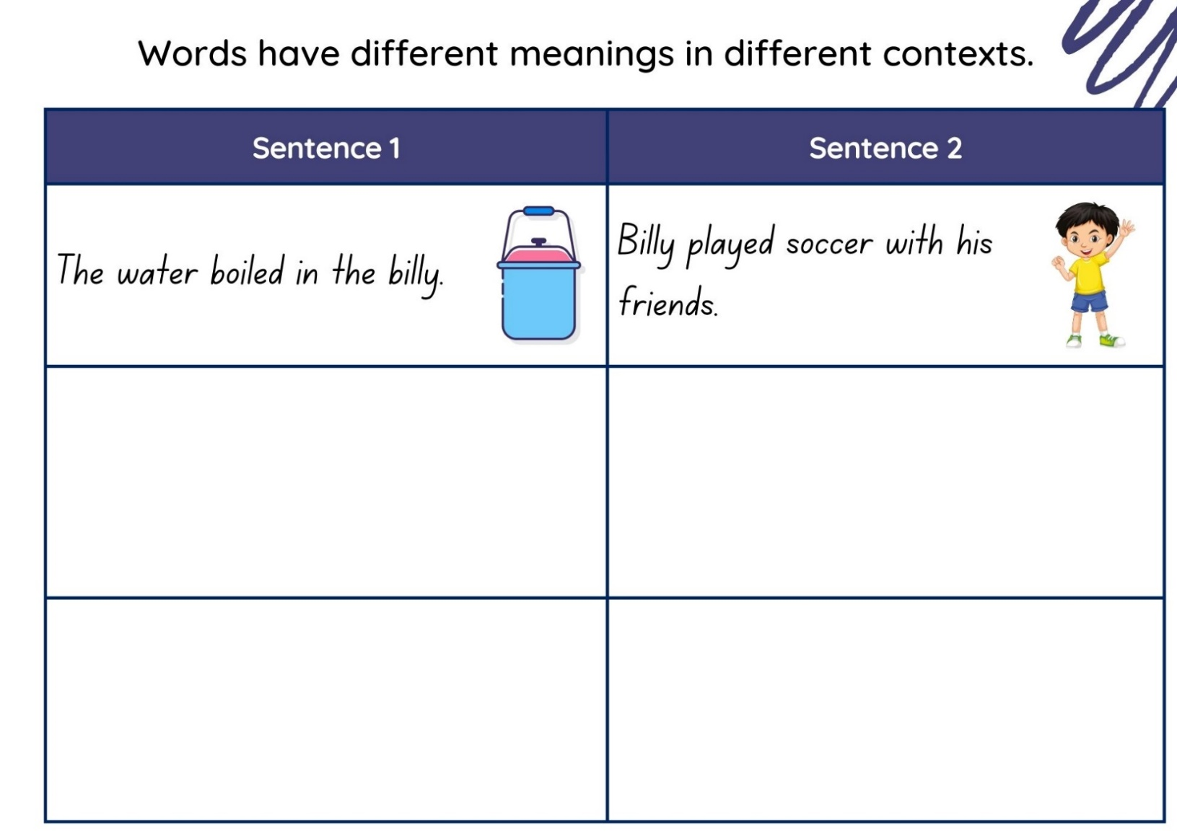
Images sourced from Canva and used in accordance with the Canva Content License Agreement.

Resource 2: Narrative cards
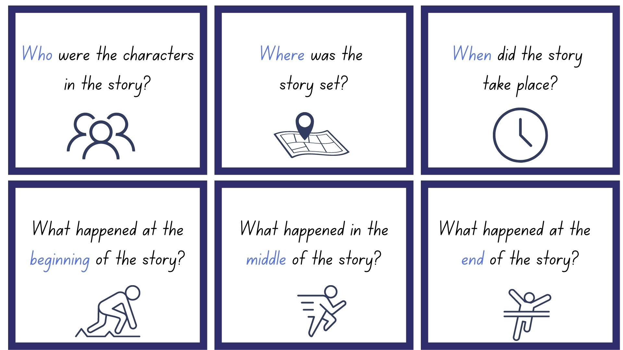
Images sourced from Canva and used in accordance with the Canva Content License Agreement.

Resource 3: Sequencing template
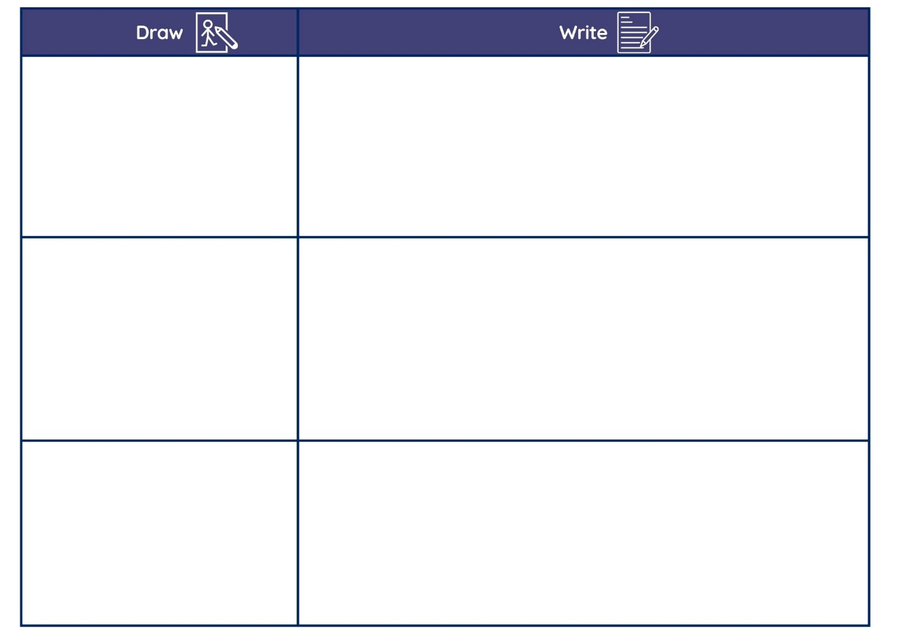
Images sourced from Canva and used in accordance with the Canva Content License Agreement.

Resource 4: Images
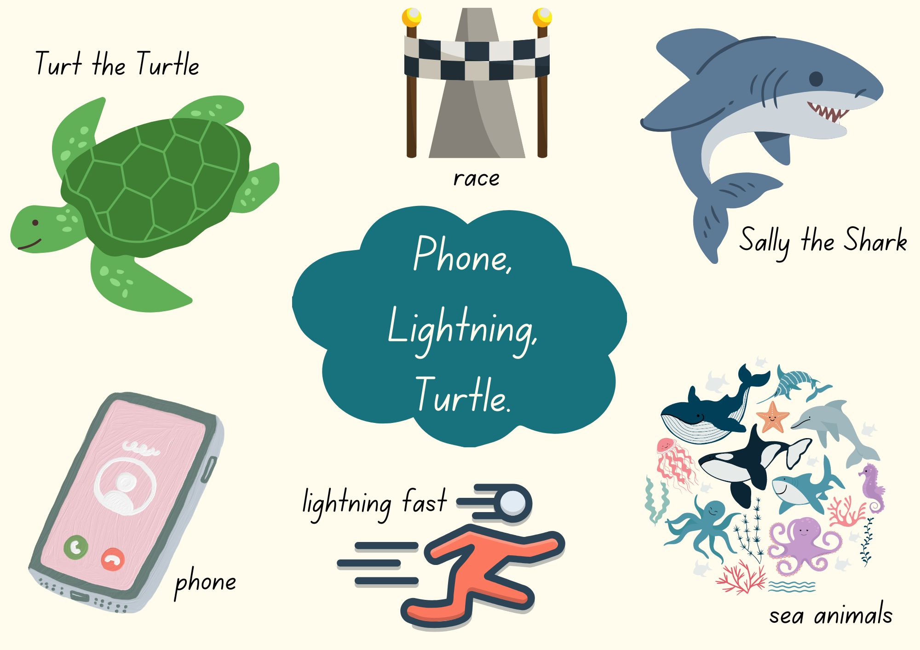
Images sourced from Canva and used in accordance with the Canva Content License Agreement.

Resource 5: Narrative planning
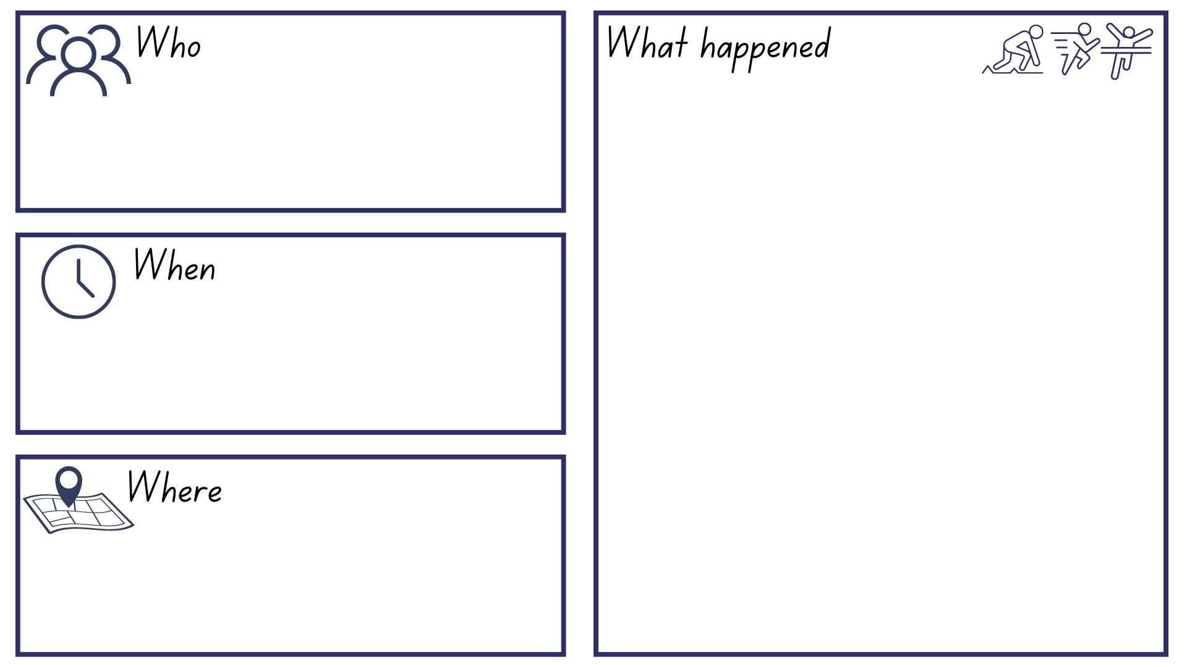
Images sourced from Canva and used in accordance with the Canva Content License Agreement.

References
Links to third-party material and websites
Please note that the provided (reading/viewing material/list/links/texts) are a suggestion only and implies no endorsement, by the New South Wales Department of Education, of any author, publisher, or book title. School principals and teachers are best placed to assess the suitability of resources that would complement the curriculum and reflect the needs and interests of their students.
If you use the links provided in this document to access a third-party's website, you acknowledge that the terms of use, including licence terms set out on the third-party's website apply to the use which may be made of the materials on that third-party website or where permitted by the Copyright Act 1968 (Cth). The department accepts no responsibility for content on third-party websites.
Except as otherwise noted, all material is © State of New South Wales (Department of Education), 2023 and licensed under the Creative Commons Attribution 4.0 International License. All other material (third-party material) is used with permission or under licence. Where the copyright owner of third-party material has not licensed their material under a Creative Commons or similar licence, you should contact them directly for permission to reuse their material.
English K–10 Syllabus © 2022 NSW Education Standards Authority (NESA) for and on behalf of the Crown in right of the State of New South Wales.
© 2022 NSW Education Standards Authority. This document contains NSW Curriculum and syllabus content. The NSW Curriculum is developed by the NSW Education Standards Authority. This content is prepared by NESA for and on behalf of the Crown in right of the State of New South Wales. The material is protected by Crown copyright.
Please refer to the NESA Copyright Disclaimer for more information.
NESA holds the only official and up-to-date versions of the NSW Curriculum and syllabus documents. Please visit the NSW Education Standards Authority (NESA) website and the NSW Curriculum website.
National Literacy Learning Progression © Australian Curriculum, Assessment and Reporting Authority (ACARA) 2010 to present, unless otherwise indicated. This material was downloaded from the Australian Curriculum website (National Literacy Learning Progression) (accessed 28 February 2023) and was not modified. The material is licensed under CC BY 4.0. Version updates are tracked in the ‘Curriculum version history’ section on the 'About the Australian Curriculum' page of the Australian Curriculum website.
ACARA does not endorse any product that uses the Australian Curriculum or make any representations as to the quality of such products. Any product that uses material published on this website should not be taken to be affiliated with ACARA or have the sponsorship or approval of ACARA. It is up to each person to make their own assessment of the product, taking into account matters including, but not limited to, the version number and the degree to which the materials align with the content descriptions and achievement standards (where relevant). Where there is a claim of alignment, it is important to check that the materials align with the content descriptions and achievement standards (endorsed by all education Ministers), not the elaborations (examples provided by ACARA).
Backer M (presenter) (29 November 2022) ‘Phone, Lightning, Turtle’ [radio program], Story Salad, ABC Kidslisten, Australia, accessed 28 February 2023.
ETA (English Teachers Association) and NSW Department of Education (2016) The Textual Concepts and Processes resource, English Textual Concepts website, accessed 28 February 2023.
Harris C (2012) It’s a Miroocool! (A James, illus) Hardie Grant Children's Publishing, Australia.

