English – Early Stage 1 – Unit 15
Contents
Unit overview and instructions for use 3
Teacher notes 4
Outcomes and content – Component A 5
Outcomes and content – Component B 7
Week 1 9
Component A teaching and learning 9
Component B teaching and learning 10
Lesson 1: Sharing opinions about The Terrible Suitcase 11
Lesson 2: Building on personal vocabulary 13
Lesson 3: Writing compound sentences 14
Lesson 4: Comparing texts to form an opinion 16
Lesson 5: Using exclamation and question marks 18
Week 2 21
Component A teaching and learning 21
Component B teaching and learning 22
Lesson 6: Extending sentences with prepositional phrases 23
Lesson 7: Personal pronouns 24
Lesson 8: Writing an opinion 25
Lesson 9: Using feedback to edit writing 27
Lesson 10: Publishing writing 28
Resource 1: Venn diagram 29
Resource 2: Prepositional phrases sort 30
Resource 3: Writing checklist 31
References 32

Unit overview and instructions for use
This two-week unit is comprised of Component A and Component B. Connecting learning across both components is encouraged.
Teaching and learning | Component A | Component B
Suggested duration | 60 minutes | 45 minutes
Explicit teaching focus areas | - Phonological awareness  - Print conventions  - Phonic knowledge  - Reading fluency  - Reading comprehension  - Spelling  - Handwriting | - Oral language and communication  - Vocabulary  - Reading comprehension  - Creating written texts  - Understanding and responding to literature
To prepare for teaching and learning: | - Refer to Outcomes and content – Component A, K-2 – Instructional sequence – grapheme–phoneme correspondences [PDF 825 KB], and the teaching advice documents (hyperlinked in Component A teaching and learning table).  - Based on student needs identified through ongoing assessment data, plan and document how you will sequence teaching and learning in whole class and targeted teaching groups across the two-week cycle. | - Familiarise yourself with Outcomes and content – Component B, Textual concepts information and videos, English Textual Concepts and Learning Processes (2016), and the teaching and learning sequence.  - Based on student needs identified through ongoing assessment data, determine how you will support students in whole class and targeted teaching groups across the two-week cycle as required.
English K–10 Syllabus © 2022 NSW Education Standards Authority (NESA) for and on behalf of the Crown in right of the State of New South Wales.

Teacher notes
- ‘Perspective is a lens through which we learn to see the world; it shapes what we see and the way we see it. Students understand that opinions can be articulated in and through texts.’ – English Textual Concepts and Learning Processes (2016).
- Understanding of perspective can be supported through watching the department’s video: Perspective (3:37).
- While ‘perspective’ is the mentor concept for the conceptual component of this unit, the supporting concept of ‘character’ can be explored using the mentor text The Terrible Suitcase by Emma Allen.
- Reflect on student learning and engagement in activities and record differentiation and adjustments within the unit to inform future teaching and learning. One way of doing this could be to add comments to the digital file.
- Content points are linked to the National Literacy Learning Progression version (3).
Levels and indicators sourced from National Literacy Learning Progression © Australian Curriculum, Assessment and Reporting Authority (ACARA), (accessed 28 November 2022) and was not modified. See references for more information.

Outcomes and content – Component A
The table below outlines the focus outcomes and content. Content is linked to the National Literacy Learning Progression version (3).
Focus area and outcome | Content points and National Literacy Learning Progression
Phonological awareness  ENE-PHOAW-01 – identifies, blends, segments and manipulates phonological units in spoken words as a strategy for reading and creating texts | - blend aloud all phonemes when asked to substitute a medial vowel phoneme
Print conventions  ENE-PRINT-01 – tracks written text from left to right and from top to bottom of the page and identifies visual and spatial features of print | N/A
Phonic knowledge  ENE-PHOKW-01 – uses single-letter grapheme–phoneme correspondences and common digraphs to decode and encode words when reading and creating texts | - decode words containing split digraphs and vowel digraphs (PKW5)  - experiment with encoding high-frequency words containing split digraphs and vowel digraphs
Reading fluency  ENE-REFLU-01 – reads decodable texts aloud with automaticity | - know that fluent reading involves recognising and reading words accurately and automatically  - regulate their voice to respond to punctuation such as question marks and exclamation marks (FlY4)
Reading comprehension  ENE-RECOM-01 – comprehends independently read texts using background knowledge, word knowledge and understanding of how sentences connect | - stop reading when a break in comprehension is registered (UnT4)  - self-correct error using phonic knowledge (UnT5)
Spelling  ENE-SPELL-01 – applies phonological, orthographic and morphological generalisations and strategies to spell taught familiar and high-frequency words when creating texts | - experiment with some vowel digraphs and split digraphs to spell taught high-frequency words and/or personally significant words  - spell high-frequency compound words and homophones comprising taught graphemes
Handwriting  ENE-HANDW-01 – produces all lower-case and upper-case letters to create texts | - use a stable posture when handwriting or drawing by sitting comfortably with feet flat on the floor, the writing arm resting on a table, with the opposite hand resting on the paper, and shoulders relaxed

Outcomes and content – Component B
The table below outlines the focus outcomes and content. Content is linked to the National Literacy Learning Progression version (3).
Focus area and outcome | Content points and National Literacy Learning Progression
Oral language and communication  ENE-OLC-01 – communicates effectively by using interpersonal conventions and language with familiar peers and adults | - use oral language to reason when speaking  - use oral language to persuade, negotiate, give opinions or discuss ideas (InT4)  - use connectives such as and, but and because when speaking (SpK2)  - use a combination of sentences to elaborate and connect ideas (SpK3)
Vocabulary  ENE-VOCAB-01 – understands and effectively uses Tier 1 words and Tier 2 words in familiar contexts | - use vocabulary that is personal
Reading comprehension  ENE-RECOM-01 – comprehends independently read texts using background knowledge, word knowledge and understanding of how sentences connect | - identify conjunctions (and, because, but, for, so) in a compound sentence, their meaning and purpose  - recount the relevant ideas from the text (UnT5)
Creating written texts  ENE-CWT-01 – creates written texts that include at least 2 related ideas and correct simple sentences | - create written texts that describe, give an opinion, recount an event, convey a story  - create a text including at least 2 related ideas (CrT5)  - use personal pronouns in own writing (CrT7)  - use prepositional phrases to indicate time or place (GrA2)  - experiment with writing compound sentences and recognise that each clause makes meaning by itself (GrA4)  - use question marks and exclamation marks (PuN3)  - understand they can improve their writing based on feedback from teachers  - edit their texts after receiving feedback
Understanding and responding to literature  ENE-UARL-01 – understands and responds to literature read to them | - express likes and dislikes about a text (UnT5)  - compare opinions of a text or characters with peers (InT2)  - reason using background knowledge as to why a character has acted in a certain way (UnT4)

Week 1

Component A teaching and learning
The table below can be used to plan and document lessons that address Component A outcomes and content. Both the detailed example [DOC 529KB] of a two-week teaching and learning cycle and brief example [DOC 66KB] may support you in your planning.
Focus Areas | Lesson 1 | Lesson 2 | Lesson 3 | Lesson 4 | Lesson 5
Phonological awareness and
Phonic knowledge
15 minutes
Spelling and Handwriting
15 minutes
Print conventions,
Reading comprehension and Reading fluency
30 minutes

Component B teaching and learning
The following teaching and learning sequence has been designed to address Component B outcomes and content. Adapt the sequence as required to best meet the needs of your students.

Learning intention and success criteria
Learning intentions and success criteria are best co-constructed with students.

Learning intention
Students are learning to explore opinions and convey their perspective through written and oral forms.

Success criteria
Students can:
- give an opinion about a book
- use personal vocabulary to discuss and share ideas
- identify conjunctions and use them when writing compound sentences
- compare similarities and differences between texts to help form an opinion
- identify an exclamation and question mark
- write questions with correct punctuation.

Resources
- Allen E (2014) The Terrible Suitcase (Blackwood F, illus.), Omnibus Books, Australia. ISBN: 9781862919624
- Wild M (2009) Puffling (Vivas J, illus.), Omnibus Books, Australia. ISBN: 9781862915992
- Resource 1: Venn Diagram

Lesson 1: Sharing opinions about The Terrible Suitcase
- Display the front and back cover of The Terrible Suitcase and allow time for the students to observe and analyse details. Ask students what they have noticed.
- Read the blurb and discuss how blurbs often give clues about what will happen in the text rather than tell the reader exactly what will happen.
- Model how to make a justified prediction about the text, using details from the cover. For example, I predict the book is about a girl who does not like her suitcase because she looks sad.
- Ask students to share a prediction using ‘because’ to justify their thinking. Allow thinking time (up to 10 seconds), for students to provide an extended response or a response of greater quality.
- Read The Terrible Suitcase. As the text is being read, use ‘I wonder’ statements to prompt students’ understanding of the text. For example:
- I wonder why the suitcase is so terrible (end of page 1).
- I think the girl looks angry and disappointed. I wonder if there was a time that you felt angry or disappointed when you did not get what you wanted (end of page 1).
- I wonder why the little girl wanted to go home (page 15, after text ‘I want to go home’).
- I wonder what made Millie feel better (after reading page 15, refer to the images on the double page spread).
- I wonder why the girl is sleeping with her suitcase (end of page 28).
- Ask students to show a thumbs up if they liked the text or a thumbs down if they did not like the text. Discuss that readers may have different opinions about a text.
- Model writing a sentence to give an opinion about the text using ‘because’. For example, I liked the book because the suitcase glowed.
- Students write a sentence using ‘because’ to explain their opinion about the text. In Lesson 8 students will extend their writing by elaborating on their opinions.
Too hard? Provide students with a sentence starter. For example, I liked/did not like this book because…
Early Stage 1 Assessment task 1 – Observations and work samples from this lesson allow students to demonstrate achievement towards the following syllabus outcome and content points:
ENE-OLC-01 – communicates effectively by using interpersonal conventions and language with familiar peers and adults
- use oral language to reason when speaking
- use oral language to persuade, negotiate, give opinions or discuss ideas
- use connectives such as and, but and because when speaking.

Lesson 2: Building on personal vocabulary
- Re-read the text The Terrible Suitcase. Before reading, ask students to listen carefully for new or unfamiliar words.
- Flick through each page of the text and ask students if they heard any new or unfamiliar words. Students may need to refer to the text to recall or locate the word. Write the words on a list.
- Select a Tier 2 word (for example, launched, compartment, drifted), clap the syllables or count the phonemes. Re-read the sentence from the text with the Tier 2 word. Model using context cues and illustrations to help work out the meaning of the word. Provide a child-friendly definition of the word.
- Write the selected Tier 2 word on a piece of paper and model using it in another sentence. For example, I launched the tennis ball across the court (activity 6 will require multiple copies of the Tier 2 word for group work).
Incidental learning and word consciousness can be taught through frequent and deliberate modelling of Tier 2 vocabulary throughout the day. Build on everyday known Tier 1 words over time by using more sophisticated synonyms for everyday classroom words, such as ‘exemplary’ instead of ‘great’ when describing work, or ‘distribute’ to replace ‘handing out’ lunch orders or worksheets.
- Place students into small groups. Display pages from the text for students to use their personal vocabulary or topic knowledge to discuss what they see in the picture.
- Hand each group a copy of the Tier 2 word from activity 4. Ask students if they can use the word in a sentence to describe or explain something they see on the page from the text. Students could also describe something that might happen. For example, ‘The rocket launched into space’ (a variation of the activity could be that each group has a different Tier 2 word).
- Model writing a sentence to record what students saw in the pages displayed in activity 5. Co-construct a second sentence that includes the Tier 2 word from activity 4. For example, ‘The girl used the toolkit the fix the rocket. The rocket launched into space.’
- Students write a sentence about what they saw in the displayed pages from the text.
Too easy? Students use the new Tier 2 word in their sentences.
Early Stage 1 Assessment task 2 – Observations and work samples from this lesson allow students to demonstrate achievement towards the following syllabus outcomes and content points:
ENE-OLC-01 – communicates effectively by using interpersonal conventions and language with familiar peers and adults
- use a combination of sentences to elaborate and connect ideas.
ENE-VOCAB-01 – understands and effectively uses Tier 1 words and Tier 2 words in familiar contexts
- use vocabulary that is personal.

Lesson 3: Writing compound sentences
- Revise Lesson 1 to remind students how they used the conjunction ‘because’ to explain their reasoning. Explain that other coordinating conjunctions can be used to join sentences together, for example and, but, for, so, yet, or, for.
- Display a page from the text and ask students to identify where a conjunction has been used. Write the sentence onto a strip of paper. For example, ‘I gave him my suitcase and we all fastened our seatbelts.’
- Explain that compound sentences have 2 independent clauses that make sense by themselves and are joined by a conjunction.
- Using the sentence strip from activity 2, cut out the clauses and conjunction. Read the first clause and explain that is makes sense by itself. Read the second clause and explain that it makes sense by itself. Join the 2 clauses with the conjunction and explain that using conjunctions allows a writer to extend sentences.
- Ask students to list some of the things that the main character in the text did when she was mad. Discuss why the character may have acted that way. For example, she threw her playdough planet because she was feeling jealous.
- Model writing a compound sentence using a character’s actions. For example, ‘The girl was feeling jealous, so she threw her playdough planet.’
- Ask the students if they have been mad, upset, or jealous when they did not get something they really wanted. Model writing a compound sentence to explain. For example, ‘I did not get a new soccer ball so I hid in my room. I wanted a new puppy but I was not allowed to get another dog.’
- Students write a compound sentence about a time when they have been mad, upset, or jealous about not getting something they really wanted. Display a list of conjunctions to support student writing.
Too hard? Provide students with the first clause and a conjunction to complete a compound sentence.
- Students share sentences with the class.
Early Stage 1 Assessment task 3 – Observations and work samples from this lesson allow students to demonstrate achievement towards the following syllabus outcomes and content points:
ENE-RECOM-01 – comprehends independently read texts using background knowledge, word knowledge and understanding of how sentences connect
- identify conjunctions (and, because, but, for, so) in a compound sentence, their meaning and purpose.
ENE-CWT-01 – creates written texts that include at least 2 related ideas and correct simple sentences
- experiment with writing compound sentences and recognise that each clause makes meaning by itself.
ENE-UARL-01 – understands and responds to literature read to them
- reason using background knowledge as to why a character has acted in a certain way.

Lesson 4: Comparing texts to form an opinion
- Display and discuss the front cover of Puffling by Margaret Wild. Ask:
- What animals can you identify?
- What do you notice about them?
- Do you know anything about this animal?
- Explain that a puffin is a small adult seabird and a puffling is a baby puffin. Puffins do not live in Australia.
- Read the blurb on the back cover and encourage text predictions. Students Think-Pair-Share to discuss their responses.
- Read Puffling. Revisit the Think-Pair-Share answers and confirm predictions.
- Display the cover of The Terrible Suitcase. Briefly revisit the text and retell the key ideas.
- Explain that students will be looking for similarities and differences between both texts.
- Ask:
- What did the main character at the beginning of The Terrible Suitcase feel about her suitcase? (angry and upset over her suitcase)
- How did she feel about her suitcase at the end of the book? (happy and thought her suitcase was magnificent)
- Why do you think she changed how she felt?
- Explain that her perspective changed as she appreciated her suitcase and understood why it was magnificent.
- Explain that the text Puffling has characters that have different perspectives. The puffling has one opinion (thinks he is ready) and his parents have another (he is not ready yet).
- Display the first double page of both texts. Note some similarities and differences between texts. Ask:
- What is something both pages show us? For example, the main characters, both in their home.
- What is the difference between how the puffin’s emotions look and how the emotions of the main character of The Terrible Suitcase look? For example, the puffins are happy and pleased, while the main character in The Terrible Suitcase is angry.
- What is one thing you like about one of the texts?
- What is one thing you dislike about one of the texts?
- In small groups, students discuss and share their opinions about the similarities and differences, ensuring that all group members take turns to share their thoughts.
- Discuss whether all students allowed their peers to share their opinions and agreed or disagreed with their thoughts. Explain that personal opinions should be respected and that not all people need to agree.
- As a class, complete Resource 1: Venn diagram about the similarities and differences between both texts.
- Model writing a compound sentence to express an opinion about a preferred text. For example, ‘I liked the book Puffling because I thought the little puffin was brave. The Terrible Suitcase had a rocket and I like to read about rockets.’
- Students write a sentence to express their opinion. Remind students to use a conjunction to add another clause so that they extend their sentences.
Too easy? Students write if they liked or disliked both texts. For example, ‘I did not like the books because Puffling and The Terrible Suitcase were imaginative stories. I like to read factual stories.’

Lesson 5: Using exclamation and question marks
- Read page one of The Terrible Suitcase and ask students to identify what punctuation has been used to end a sentence. Draw attention to the use of the full stop and the use of an exclamation mark.
- Model reading the text without emphasis, as if an exclamation mark was not used. For example, ‘I was mad. M A D, mad.’ Ask if this makes the story sound interesting and whether it shows how the character would be feeling.
- Model reading the text showing emphasis where the exclamation mark was used. For example, ‘I was mad! M A D, mad!’ Ask if this makes the story sound interesting and whether it shows how the character would be feeling. Explain that authors use exclamation marks to show emotion and emphasis.
- Students act out how the character was feeling when the exclamation mark was used. For example, stomping their foot to show the character is mad or making angry faces like the character in the book.
- Explain that students will be using Puffling to find other ways to end a sentence.
- Scan the opening double page spread looking for sentence ending punctuation. Ask what sentence endings are used on those pages.
- Look at the page where Big Stripy Beak and Long Black Feather say ‘Hello Puffling!’ Ask:
- Are they angry like the girl in The Terrible Suitcase?
- Could the characters be feeling a different emotion?
- What emotion might that be?
- Scan Puffling, locating the different types of sentence punctuation. Point out the sentences that end with a question mark. Read the questions. Highlight that all sentences end with a question mark.
- Explain that the class will be conducting a hot seat activity where you will pretend to be Puffling. Model asking questions. For example, ‘How did you feel when you plunged in the water?’
- Students turn and talk to a partner and verbally compose their own questions.
- Select one of the students’ questions to model writing on the board. Write it without the question mark and ask what is missing.
- Model adding the question mark. Explicitly teach the correct formation of a question mark.
- Students write the question they want to ask the Puffling. Remind students about the correct formation of a question mark.
Too hard? Co-construct questions with students.
- Students ask you or Puffling their question during the hot seat activity.
Early Stage 1 Assessment task 4 – Observations and work samples from this lesson allow students to demonstrate achievement towards the following syllabus outcome and content point:
ENE-CWT-01 – creates written texts that include at least 2 related ideas and correct simple sentences
- use question marks and exclamation marks.

Week 2

Component A teaching and learning
The table below can be used to plan and document lessons that address Component A outcomes and content. Both the detailed example [DOC 529KB] of a two-week teaching and learning cycle and brief example [DOC 66KB] may support you in your planning.
Focus Areas | Lesson 6 | Lesson 7 | Lesson 8 | Lesson 9 | Lesson 10
Phonological awareness and
Phonic knowledge
15 minutes
Spelling and Handwriting
15 minutes
Print conventions,
Reading comprehension and Reading fluency
30 minutes

Component B teaching and learning
The following teaching and learning sequence have been designed to address Component B outcomes and content. Adapt the sequence as required to best meet the needs of your students.

Learning intention and success criteria
Learning intentions and success criteria are best co-constructed with students.

Learning intention
Students are learning to explore opinions and convey their perspective through written and oral forms.

Success criteria
Students can:
- extend a sentence to include a prepositional phrase
- compose a text that includes the use of personal pronouns
- express likes or dislikes about a text
- use simple and compound sentences to express an opinion
- respond to and apply feedback when editing writing.

Resources
- Allen E (2014) The Terrible Suitcase (Blackwood F, illus.), Omnibus Books, Australia. ISBN: 9781862919624
- Wild M (2009) Puffling (Vivas J, illus.), Omnibus Books, Australia. ISBN: 9781862915992
- Resource 2: Prepositional phrases sort (enlarged copy)
- Resource 3: Writing checklist (copies for each student and copies for each writing sample)
- collection of student work samples from Lesson 8 for Lesson 9

Lesson 6: Extending sentences with prepositional phrases
- Revisit The Terrible Suitcase and Puffling.
- Introduce prepositional phrases as groups of words used to indicate time or place.
- Provide examples from The Terrible Suitcase. For example:
- The girl sat on the lounge when she was angry. (place)
- At lunch, the girl chewed a sticker. (time)
- Provide students with an instruction that includes a prepositional phrase. Students complete the instruction. For example, stand next to the desk, sit behind the chair, turn around on the count of 3. After each instruction identify the prepositional phrase. Ask students to contribute instructions that include a prepositional phrase.
- Co-construct a list of prepositional phrases.
- Use an enlarged copy of Resource 2: Prepositional phrases sort to sort sentences with prepositional phrases from The Terrible Suitcase and Puffling.
Too easy? Students independently complete Resource 2: Prepositional phrases sort.
- Display the simple sentence ‘Puffling jumped.’ Model extending the sentence by adding a prepositional phrase. For example, Puffling jumped into the water. Circle the prepositional phrase in the sentence.
- Provide students with some simple sentences from the text. Ask students to extend the sentences by adding a prepositional phrase. Consider using:
- The girl threw playdough.
- Puffling ate fish.
- The suitcase glowed.
Too hard? Provide prepositional phrases for students to match the given simple sentences.
- In small groups, students share their sentences while their peers identify the prepositional phrase.

Lesson 7: Personal pronouns
- Revisit and discuss the characters from the supporting text Puffling.
- Display and read pages where personal pronouns are used in the text. Students identify the pronoun and who it refers to. For example:
- ‘Long Black Feather watched him paddle his feet.’ (‘him’ refers to Puffling)
- ‘“Nearly” she said.’ (‘she’ refers Long Black Feather)
- ‘“Almost” they said.’ (‘they’ refers to Puffling’s parents)
- Model writing a short text about Puffling without using a pronoun. For example: Puffling was a small puffin. Puffling’s parents fed Puffling so Puffling would grow bigger. Puffling was brave and Puffling wanted to fly away by himself.
- Explain that pronouns are often used to replace names. Ask students to identify where pronouns could be used. Model how to edit the sentences to include the use of pronouns.
- Read the edited short text and ask students to decide if the first version or the edited version reads better and explain why.
- Students write sentences about what Puffling wants to do using pronouns.

Lesson 8: Writing an opinion
- Revisit and discuss the key events in The Terrible Suitcase and Puffling. Ask students to express if they liked or disliked each text by using thumbs up or thumbs down.
- Remind students how they wrote their opinion about The Terrible Suitcase in Lesson 1 and will now apply their learning to extend their writing. Explain that students are going to write their opinion about which book, scene, and character was their favourite.
- Brainstorm reasons why students liked each text and list on an anchor chart under the headings ‘The Terrible Suitcase’ and ‘Puffling’. Ensure to include ideas about text, scene, and character.
- Display Resource 3: Writing checklist and revise simple and compound sentences, prepositional phrases, and pronouns. Explain that students need to refer to the writing checklist to write their opinions.
- Model writing sentences to give opinions and justifications about the favoured text, scene and character using an example from the anchor chart and Resource 3: Writing checklist. For example: ‘I liked Puffling because it was about a cute baby puffin living in a burrow. I liked the baby puffin. He wanted to leave his burrow but he was not ready to come out. My favourite part was when he was swimming with his friends in the sea.’
- Explain that the modelled sentences have ideas that are related to the text Puffling. This helps to expand on each reason and justify opinions.
- Refer to Resource 3: Writing checklist and identify each point within the modelled writing. For example:
- personal pronouns – I, he
- prepositional phrases – in a burrow, in the sea
- simple sentence – I liked the baby puffin.
- compound sentence with a conjunction – He wanted to leave his burrow but he was not ready to come out.
- Provide students with thinking time to decide which text, scene and character was their favourite and why. In small groups, students share their opinions.
- Students write sentences to give opinions and justifications about the favoured text, scene, and character. Remind students to refer to the anchor chart and the checklist as they write their opinion.
- Ask students to volunteer their work to be assessed against the writing checklist that will be used in Lesson 9. Make a copy of the work samples in readiness for Lesson 9.
Too hard? Students write their opinion about their favourite text or character. Modify the checklist to suit student needs.
Early Stage 1 Assessment task 5 – Observations and work samples from this lesson allow students to demonstrate achievement towards the following syllabus outcomes and content points:
ENE-RECOM-01 – comprehends independently read texts using background knowledge, word knowledge and understanding of how sentences connect
- recount the relevant ideas from the text.
ENE-CWT-01 – creates written texts that include at least 2 related ideas and correct simple sentences
- create written texts that describe, give an opinion, recount an event, convey a story
- create a text including at least 2 related ideas
- use personal pronouns in own writing
- use prepositional phrases to indicate time or place
- experiment with writing compound sentences and recognise that each clause makes meaning by itself.
ENE-UARL-01 – understands and responds to literature read to them
- compare opinions of a text or characters with peers
- expresses likes and dislikes about a text.

Lesson 9: Using feedback to edit writing
- Display and read the student work samples from Lesson 8.
- Explain that students will use the writing checklist to determine if they have met the criteria. Display Resource 3: Writing checklist.
- Discuss the first criteria ‘give an opinion’ and model assessing each of the work samples and circle the appropriate face on the checklist.
- Students evaluate their own writing and complete the first criteria on their checklist.
- Repeat activity 3 and 4 for each criterion on the checklist.
- Model editing a work sample by referring to the criteria.
- Students edit their own writing. Remind students to consistently refer to their checklist to ensure they meet all criteria.
Too hard? Reduce the criteria in the checklist, keeping ‘give an opinion’ as a focus area.
Too easy? Students extend their writing by including information about why they dislike the other text.
Early Stage 1 Assessment task 6 – Observations and work samples from this lesson allow students to demonstrate achievement towards the following syllabus outcome and content points:
ENE-CWT-01 – creates written texts that include at least 2 related ideas and correct simple sentences
- understand they can improve their writing based on feedback from teacher
- edit their texts after receiving feedback.

Lesson 10: Publishing writing
- Students re-read their writing from the previous lesson.
- Use one of the edited work samples to model expectations for published work.
- Students publish their edited writing and add an illustration based on the chosen text.
- Students share their published work with the class.

Resource 1: Venn diagram
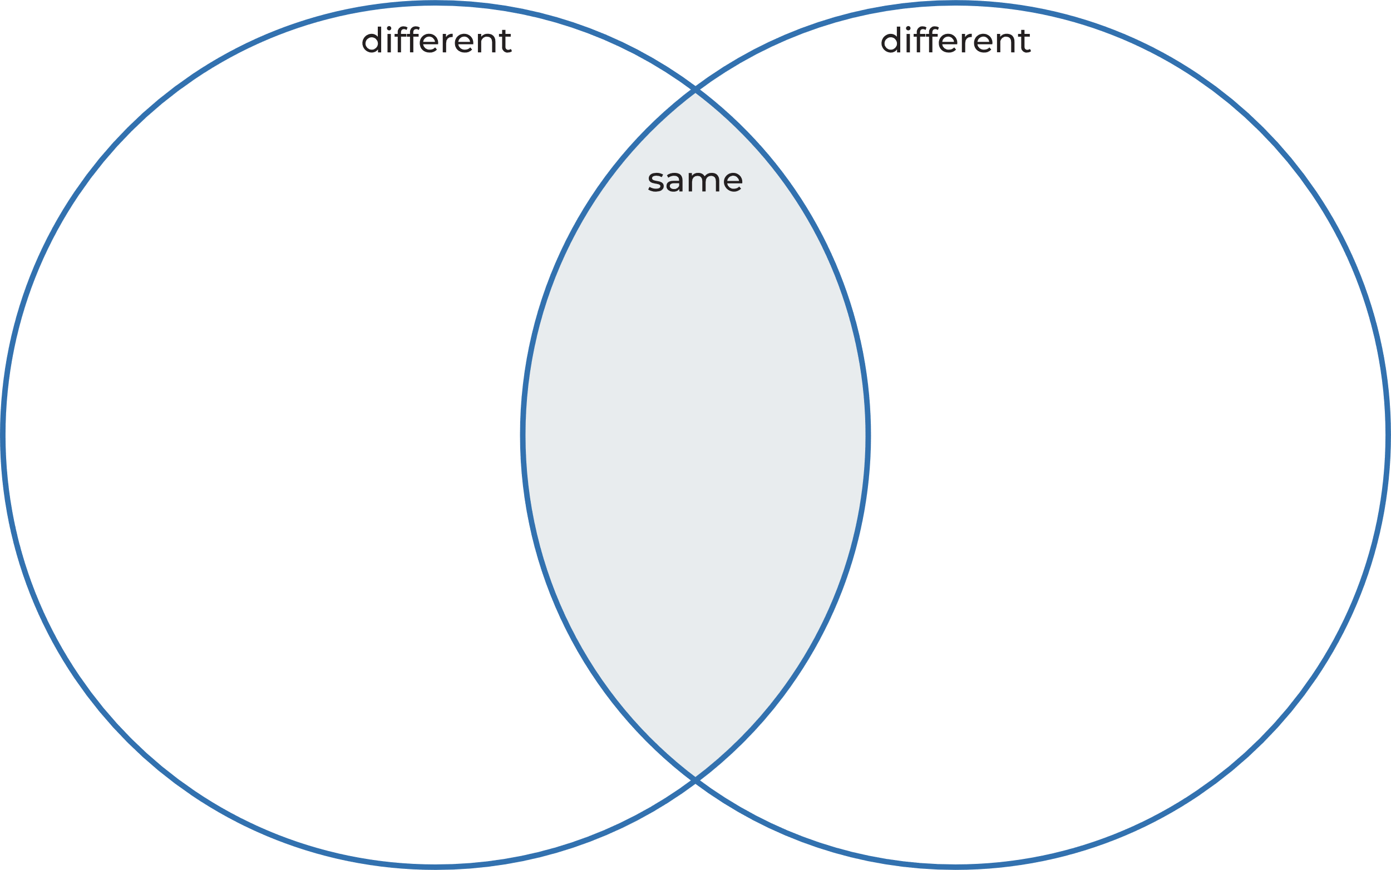

Resource 2: Prepositional phrases sort
Time | Place
Cut out the sentences below and place them in the correct column.
Sentences | Sentences
At school, I saw that Max had a shiny red backpack. | The next morning, Puffling asked.
As the weeks went past, Puffling grew bigger and bolder. | In imagination corner, I was so mad.
He stuck one leg out of the burrow. | He plunged into the ocean.

Resource 3: Writing checklist
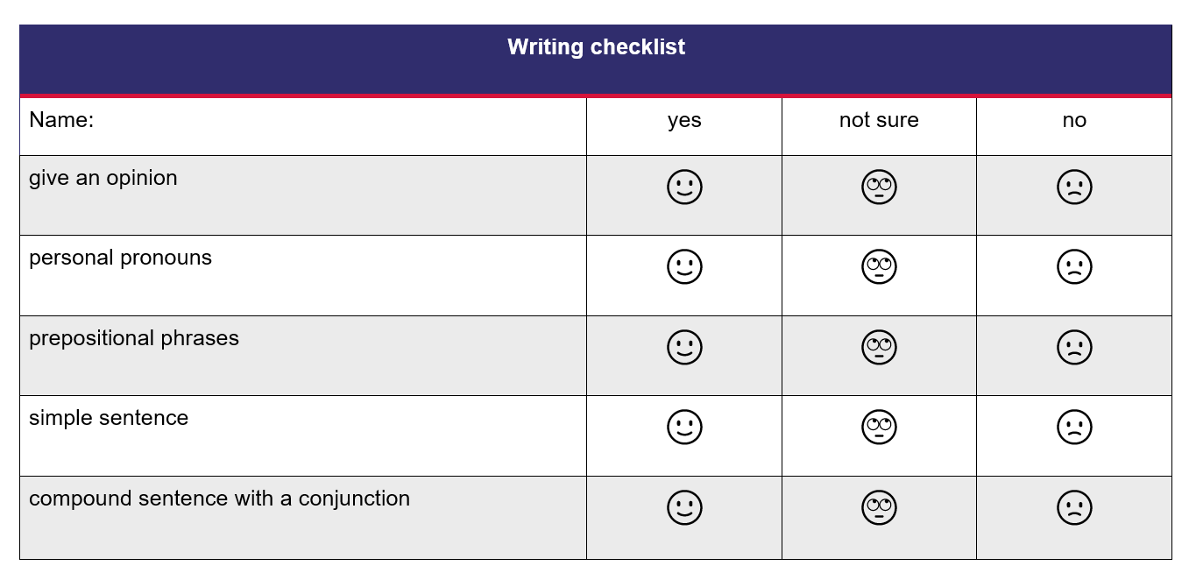

References
Links to third-party material and websites
Please note that the provided (reading/viewing material/list/links/texts) are a suggestion only and implies no endorsement, by the New South Wales Department of Education, of any author, publisher, or book title. School principals and teachers are best placed to assess the suitability of resources that would complement the curriculum and reflect the needs and interests of their students.
If you use the links provided in this document to access a third-party's website, you acknowledge that the terms of use, including licence terms set out on the third-party's website apply to the use which may be made of the materials on that third-party website or where permitted by the Copyright Act 1968 (Cth). The department accepts no responsibility for content on third-party websites.
Except as otherwise noted, all material is © State of New South Wales (Department of Education), 2023 and licensed under the Creative Commons Attribution 4.0 International License. All other material (third-party material) is used with permission or under licence. Where the copyright owner of third-party material has not licensed their material under a Creative Commons or similar licence, you should contact them directly for permission to reuse their material.
English K–10 Syllabus © 2022 NSW Education Standards Authority (NESA) for and on behalf of the Crown in right of the State of New South Wales.
© 2022 NSW Education Standards Authority. This document contains NSW Curriculum and syllabus content. The NSW Curriculum is developed by the NSW Education Standards Authority. This content is prepared by NESA for and on behalf of the Crown in right of the State of New South Wales. The material is protected by Crown copyright.
Please refer to the NESA Copyright Disclaimer for more information.
NESA holds the only official and up-to-date versions of the NSW Curriculum and syllabus documents. Please visit the NSW Education Standards Authority (NESA) website and the NSW Curriculum website.
National Literacy Learning Progression © Australian Curriculum, Assessment and Reporting Authority (ACARA) 2010 to present, unless otherwise indicated. This material was downloaded from the Australian Curriculum website (National Literacy Learning Progression) (accessed 28 November 2022) and was not modified. The material is licensed under CC BY 4.0. Version updates are tracked in the ‘Curriculum version history’ section on the 'About the Australian Curriculum' page of the Australian Curriculum website.
ACARA does not endorse any product that uses the Australian Curriculum or make any representations as to the quality of such products. Any product that uses material published on this website should not be taken to be affiliated with ACARA or have the sponsorship or approval of ACARA. It is up to each person to make their own assessment of the product, taking into account matters including, but not limited to, the version number and the degree to which the materials align with the content descriptions and achievement standards (where relevant). Where there is a claim of alignment, it is important to check that the materials align with the content descriptions and achievement standards (endorsed by all education Ministers), not the elaborations (examples provided by ACARA).
Allen E (2014) The Terrible Suitcase (Blackwood F, illus.), Omnibus Books, Australia.
ETA (English Teachers Association) and NSW Department of Education (2016) The Textual Concepts and Processes resource, English Textual Concepts website, accessed 28 November 2022.
Wild M (2009) Puffling (Vivas J, illus.), Omnibus Books, Australia.

