English – Early Stage 1 – Unit 12
Contents
Unit overview and instructions for use 3
Teacher notes 4
Outcomes and content – Component A 5
Outcomes and content – Component B 7
Week 1 10
Component A teaching and learning 10
Component B teaching and learning 11
Lesson 1: Using time connectives to retell the beginning, middle and end of a text 12
Lesson 2: Vocabulary 14
Lesson 3: Compound sentences and conjunctions 15
Lesson 4: Using prepositional phrases to indicate place 17
Lesson 5: Using different modes and media to recount ideas from a text 18
Week 2 20
Component A teaching and learning 20
Component B teaching and learning 21
Lesson 6: Using compound sentences to describe the events in a text 22
Lesson 7: Conjunctions, connectives and compound sentences 23
Lesson 8: Innovating from a text 26
Lesson 9: Drafting a rebus for a play 26
Lesson 10: Using drama to retell an innovated text 27
Resource 1: Narrative retell 29
Resource 2: Prepositional phrase modelling resource 30
Resource 3: Three Little Pigs rebus 31
References 32

Unit overview and instructions for use
This two-week unit is comprised of Component A and Component B. Connecting learning across both components is encouraged.
Teaching and learning | Component A | Component B
Suggested duration | 60 minutes | 45 minutes
Explicit teaching focus areas | - Phonological awareness  - Print conventions  - Phonic knowledge  - Reading fluency  - Reading comprehension  - Spelling  - Handwriting | - Oral language and communication  - Vocabulary  - Reading comprehension  - Creating written texts  - Understanding and responding to literature
To prepare for teaching and learning: | - Refer to Outcomes and content – Component A, K-2 – Instructional sequence – grapheme–phoneme correspondences [PDF 825 KB], and the teaching advice documents (hyperlinked in Component A teaching and learning table).  - Based on student needs identified through ongoing assessment data, plan and document how you will sequence teaching and learning in whole class and targeted teaching groups across the two-week cycle. | - Familiarise yourself with Outcomes and content – Component B, Textual concepts information and videos, English Textual Concepts and Learning Processes (2016), and the teaching and learning sequence.  - Based on student needs identified through ongoing assessment data, determine how you will support students in whole class and targeted teaching groups across the two-week cycle as required.
English K–10 Syllabus © 2022 NSW Education Standards Authority (NESA) for and on behalf of the Crown in right of the State of New South Wales.

Teacher notes
- Narrative is the mentor textual concept for this unit. It is explored using the mentor text Clancy & Millie and the Very Fine House by Libby Gleeson and Freya Blackwood.
- Narrative refers to the communication of a sequence of related events into a story. A narrative is usually structured in such a way as to invite responder involvement. Narrative can help us make sense of our lives. Understanding of narrative can be supported through watching the department’s video: Narrative (3:51).
- For information on compound sentences, independent clause and prepositions refer to the NESA Glossary.
- This unit could enhance student learning towards achievement of outcomes from the Creative Arts K-6 Syllabus regarding visual art and drama.
- Consider prior student knowledge regarding writing a simple sentence with a subject-verb structure, prepositions and compound sentences with the conjunction ‘and’.
- Reflect on student learning and engagement in activities and record differentiation and adjustments within the unit to inform future teaching and learning. One way of doing this could be to add comments to the digital file.
- Content points are linked to the National Literacy Learning Progression version (3).
Levels and indicators sourced from National Literacy Learning Progression © Australian Curriculum, Assessment and Reporting Authority (ACARA), (accessed 18 January 2022) and was not modified. See references for more information.

Outcomes and content – Component A
The table below outlines the focus outcomes and content. Content is linked to the National Literacy Learning Progression version (3).
Focus area and outcome | Content points and National Literacy Learning Progression
Phonological awareness  ENE-PHOAW-01 – identifies, blends, segments and manipulates phonological units in spoken words as a strategy for reading and creating texts | - identify the first, middle and final phonemes in a one-syllable word (PhA4)  - blend aloud all phonemes when asked to delete, add or substitute an initial phoneme (PhA5)
Print conventions  ENE-PRINT-01 – tracks written text from left to right and from top to bottom of the page and identifies visual and spatial features of print | N/A
Phonic knowledge  ENE-PHOKW-01 – uses single-letter grapheme–phoneme correspondences and common digraphs to decode and encode words when reading and creating texts | - decode and blend words containing consonant digraphs and apply this when reading texts, including decodable texts (PKW5)  - segment and encode CVC words containing consonant digraphs (PKW4) (PKW5)
Reading fluency  ENE-REFLU-01 – reads decodable texts aloud with automaticity | - read words automatically then apply to texts  - know that pace and expression vary when reading, according to the audience and purpose  - regulate their voice to respond to punctuation such as question marks and exclamation marks (FlY4)
Reading comprehension  ENE-RECOM-01 – comprehends independently read texts using background knowledge, word knowledge and understanding of how sentences connect | - identify conjunctions in a compound sentence, their meaning and purpose  - stop reading when a break in comprehension is registered (UnT4)  - re-read to check if an error was made  - self-correct error using phonic knowledge (UnT5)
Spelling  ENE-SPELL-01 – applies phonological, orthographic and morphological generalisations and strategies to spell taught familiar and high-frequency words when creating texts | - segment single-syllable words into phonemes as a strategy for spelling (SpG4)  - add the plural-marking suffix (s) to base nouns that require no change when suffixed (SpG5)
Handwriting  ENE-HANDW-01 – produces all lower-case and upper-case letters to create texts | - form all handwritten letters in NSW Foundation Style when given a verbal prompt from the correct starting point and continue in the correct direction (HwK4)

Outcomes and content – Component B
The table below outlines the focus outcomes and content. Content is linked to the National Literacy Learning Progression version (3).
Focus area and outcome | Content points and National Literacy Learning Progression
Oral language and communication  ENE-OLC-01 – communicates effectively by using interpersonal conventions and language with familiar peers and adults | - use a combination of sentences to elaborate and connect ideas (SpK3)  - use connectives such as and, but and because when speaking (SpK2)  - tell a story or information to peers or adults using oral language (SpK3)
Vocabulary  ENE-VOCAB-01 – understands and effectively uses Tier 1 words and Tier 2 words in familiar contexts | - use vocabulary to select, match and provide categories for groups of images or words  - use specific word choice to clarify meaning
Reading comprehension  ENE-RECOM-01 – comprehends independently read texts using background knowledge, word knowledge and understanding of how sentences connect | - identify conjunctions in a compound sentence, their meaning and purpose  - use background knowledge when identifying connections between a text, own life, other texts and/or the world (UnT4)  - recount the relevant ideas from the text (UnT5)
Creating written texts  ENE-CWT-01 – creates written texts that include at least 2 related ideas and correct simple sentences | - create a text including at least 2 related ideas (CrT5)  - sequence ideas in a text (GrA4)  - use prepositional phrases to indicate time or place  - identify and use time connectives to sequence information and events (GrA2)  - experiment with writing compound sentences and recognise that each clause makes meaning by itself (GrA4)  - understand they can improve their writing based on feedback from teachers  - edit their texts after receiving feedback
Understanding and responding to literature  ENE-UARL-01 – understands and responds to literature read to them | - identify narratives told through a range of modes and media  - identify, discuss and compare the beginning, middle and end in a range of narratives  - experiment with using parts and/or features of a narrative, innovating from a mentor text

Week 1

Component A teaching and learning
The table below can be used to plan and document lessons that address Component A outcomes and content. Both the detailed example [DOC 529KB] of a two-week teaching and learning cycle and brief example [DOC 66KB] may support you in your planning.
Focus Areas | Lesson 1 | Lesson 2 | Lesson 3 | Lesson 4 | Lesson 5
Phonological awareness and
Phonic knowledge
15 minutes
Spelling and Handwriting
15 minutes
Print conventions,
Reading comprehension and Reading fluency
30 minutes

Component B teaching and learning
The following teaching and learning sequence has been designed to address Component B outcomes and content. Adapt the sequence as required to meet the needs of your students.

Learning intention and success criteria
Learning intentions and success criteria are best co-constructed with students.

Learning intention
Students are learning to understand narrative structures and that they can be told through a range of modes and media.

Success criteria
Students can:
- identify the beginning, middle and end in a narrative
- sequence ideas in a text
- use time connectives to sequence events in a text
- group and use vocabulary to clarify meaning
- use prepositional phrases to indicate place
- write compound sentences with the conjunction ‘and’
- understand that narratives can be told using different modes and media
- recount events in a narrative using symbols, pictures, words and numerals.

Resources
- Gleeson L (2009) Clancy & Millie and the Very Fine House (Blackwood F, illus) Little Hare Books, Australia. ISBN: 9781760126681
- Resource 1: Narrative retell – student copies
- Resource 2: Writing strip – enlarged
- Resource 3: Three Little Pigs rebus – enlarged and student copies
- Video: The Three Little Pigs (11:47) from (0:00 to 7:00)
- Play resources, such as blocks and figurines.

Lesson 1: Using time connectives to retell the beginning, middle and end of a text
- Introduce the text Clancy & Millie and the Very Fine House. Explain that the text is a narrative and that narratives can be real or imagined stories that have a beginning, middle and end.
- Display the front and back cover of the text. Read the title and ask students to make predictions about the characters and what might happen in the beginning, middle and end. Read the text.
- Discuss how the text reflects aspects of students’ own experiences. For example, making connections to their own house, moving house, meeting new friends, playing with other children in the neighbourhood and imaginative play. In pairs, students turn and talk to elaborate on and compare their own experiences with the ideas presented in the text.
- Flick through the text using prompting questions for students to identify what happened at the beginning, middle and end of the text. Model the use of time connectives (first, then, after) to summarise student responses. Questions might include:
- Where was Clancy at the start of the story? Who was he with? What happened? How did Clancy feel?
- Where was Clancy in the middle of the story? What did he do? How did he feel?
- Who did Clancy meet at the end of the story? Where did Millie come from? What did Clancy and Millie do together?
- In small groups, students use resources such as boxes or blocks as props to role-play the beginning, middle and end of the story. As students are role-playing, encourage them to use time connectives to explain when events occurred. Move between groups during the session to assess and support oral language skills.
- On poster paper, model writing simple sentences with a subject-verb-object structure to record key events from the beginning, middle and end of the text. For example:
- Clancy (subject) moved (verb) house (object).
- Clancy (subject) met (verb) Millie (object).
- They (subject) built (verbs) houses (object).
- Discuss how the modelled sentences tell the reader what happened, but not when. Re-write the sentences using time connectives. For example, ‘First, Clancy moved house.’
- Using a student copy of Resource 1: Narrative retell, students draw the beginning, middle and end of Clancy & Millie and the Very Fine House and label each drawing using an appropriate time connective.
Too easy? Students write sentences using time connectives to sequence the beginning, middle and end of the narrative.
Early Stage 1 Assessment task 1 – Observations and work samples from this lesson allow students to demonstrate achievement towards the following syllabus outcome and content points:
ENE-RECOM-01 – comprehends independently read texts using background knowledge, word knowledge and understanding of how sentences connect
- use background knowledge when identifying connections between a text, own life, other texts and/or the world
- recount the relevant ideas from the text.

Lesson 2: Vocabulary
- Read the first 2 double pages of Clancy & Millie and the Very Fine House. Draw attention to the word ‘dwelling’ in the sentence ‘It’s a very fine dwelling’. Ask students to say and clap the syllables for ‘dwelling’. Unpack its meaning and how this Tier 2 word compares to the Tier 1 word ‘house’.
- Discuss how there is often more than one word that means the same thing. Ask students to think of words that have the same meaning. For example, small, tiny, little and microscopic.
- Go to the pages where Clancy explores the kitchen, the lounge room and the bedroom. Identify the words that Clancy’s mother uses to describe each of these rooms (shiny, lovely and big). Draw attention to the illustrations and text in the right-hand section of the pages that show what Clancy is feeling about the new house. Ask students:
- Does Clancy agree with his mother?
- Is he happy with the new house? Why or why not?
- Brainstorm, record and group words that Clancy might use to describe the 3 rooms. For example, kitchen – shiny (bright, glossy, gleaming, sparkly); lounge room – cold (chilly, freezing, frosty, icy, crisp); bedroom – big (huge, vast, large, enormous).
- Remind students that Clancy was not happy with the new house. Refer to the text where Clancy says the bedroom is ‘too big’.
- Model writing a sentence using one of the words from activity 4 to describe how Clancy really felt about the new kitchen. For example, ‘The new kitchen is too bright.’
- Students draw a picture of Clancy’s new lounge room or bedroom and write a sentence using the sentence stem ‘The new _ _ is too __’. For example, ‘The lounge room is too chilly.’ ‘The bedroom is too large.’
- Students add a sentence to their drawing of Clancy’s new house to describe the lounge room or bedroom.
Too hard? Jointly construct sentences.
Too easy? Students write without the sentence stem.
- In pairs, students use their drawing and sentences to role-play exploring Clancy’s new house. Discuss how the vocabulary used helps to role-play how Clancy felt about the new house.
Early Stage 1 Assessment task 2 – Observations and work samples from this lesson allow students to demonstrate achievement towards the following syllabus outcome and content points:
ENE-VOCAB-01 – understands and effectively uses Tier 1 words and Tier 2 words in familiar contexts
- use vocabulary to select, match and provide categories for groups of images or words
- use specific word choice to clarify meaning.

Lesson 3: Compound sentences and conjunctions
- Re-read Clancy & Millie and the Very Fine House and revise the sequence of ideas using time connectives.
- Display the page where Clancy goes outside. Unpack the sentence ‘Clancy goes outside’, highlighting that it is a simple sentence with one idea.
- Look at the next page and write the sentence ‘He flops down and watches a fat snail.’ Explain that this is a compound sentence because it has 2 ideas joined by the conjunction ‘and’.
- Without showing the illustrations, read the sentence, ‘He pushes them and pokes them’. Ensure students know what the inferred subject is (boxes). Ask students to identify the 2 ideas in the compound sentence by drawing 2 pictures to show the 2 ideas. In between the 2 drawings, ask students write the conjunction ‘and’. Students use their drawings to support them to verbalise the compound sentence.
- Repeat activity 4 using the next compound sentence on the same page, ‘Clancy crawls under one and sits inside another.’
- Look at the illustrations on the next 2 double pages and ask students to explain some of the things that are happening. Record students’ responses on poster paper as simple sentences. For example, ‘Millie is looking at Clancy.’ ‘Clancy is looking at Millie.’ ‘Clancy is sitting in a box.’ ‘The toy dog is in the box.’ ‘Millie is talking to Clancy.’ ‘Clancy is talking to Millie.’
- Co-construct a compound sentence with the conjunction ‘and’, using 2 of the sentences from activity 6. For example, ‘Millie is looking at Clancy and Clancy is looking at Millie.’
- Using simple sentences recorded in activity 6, students write a compound sentence using the conjunction ‘and’. Students draw a picture for each of the ideas in the compound sentence.
Too hard? Give students 2 sentences from activity 6 and have them draw a picture for each of the ideas with ‘and’ in between. Students verbalise the compound sentence they have drawn.
Too easy? Use time connectives with compound sentence to sequence events.
- In pairs, students share their compound sentences, checking for capital letters and full stops.

Lesson 4: Using prepositional phrases to indicate place
- Revise prepositions as words that indicate time or place. Explain that this lesson will focus on prepositions that indicate place.
- Flick through the illustrations in Clancy & Millie and the Very Fine House to brainstorm and record a work bank of prepositions. For example, inside, on, under, beside, above, behind. As students respond, model using the illustrations to verbalise a sentence using a subject, verb and prepositional phrase. For example, ‘Clancy (subject) sits (verb) under the table (prepositional phrase).’
- Go to the double page of Clancy & Millie and the Very Fine House with illustrations showing Clancy kicking, opening, crawling under and sitting inside a box. Using Resource 2: Prepositional phrases modelling resource, model writing a sentence using think-alouds to show the subject, verb and prepositional phrase that describes the action and position of a character.
- Display the next double page and discuss the actions and positions of Clancy and Millie.
- In pairs, students turn and talk to practise using a subject, verb and prepositional phrase to describe the action and position.
- Using Resource 2 again, co-construct sentences with prepositional phrases that describe the actions of Clancy and Millie in the text. For example, ‘Clancy sits inside the box. Millie climbed over the fence.’
- In pairs or small groups, students use resources such as boxes or blocks as props to make create models of parts of the text that show the action and position of characters. Students make paper cut outs of the characters or use other objects to represent them. Encourage students to use the subject, verb, preposition structure as demonstrated in Resource 2. Move between groups during the session to assess and support oral language skills.
- Using sentence strips, each student writes at least one sentence using a subject, verb and prepositional phrase to describe one of their models.
Too hard? Co-construct writing a simple sentence with a subject and prepositional phrase using ‘is’ as the verb. For example, ‘He is on the box.’
- Invite students to share their models and matching sentences using a prepositional phrase.
Early Stage 1 Assessment task 3: – Observations and work samples from this lesson allow students to demonstrate achievement towards the following syllabus outcome and content points:
ENE-CWT-01 – creates written texts that include at least 2 related ideas and correct simple sentences
- use prepositional phrases to indicate time or place.

Lesson 5: Using different modes and media to recount ideas from a text
- Remind students the text Clancy & Millie and the Very Fine House is a narrative with a beginning, middle and end structure.
- Introduce the concept of a fairy tale as being a narrative with a beginning, middle and end structure that conveys an imagined story and characters. Ask students to share fairy tales that they are familiar with.
- Go to the section of the text where Clancy and Millie play out the events from The Three Little Pigs. Re-read this section and ask students if they can recall the name of the story that Clancy and Millie are re-enacting.
- Remind students that narratives can be told through different modes and media. Compare the book Clancy & Millie and the Very Fine House with other ways stories can be told, such as orally, picture books, video, animation, plays, puppet shows.
- View the video The Three Little Pigs (11:47) (from 0:00 to 7:00). Compare the video to the picture book Clancy & Millie and the Very Fine House.
- Create an anchor chart by drawing and labelling the characters and objects in The Three Little Pigs (pigs, wolf, straw, sticks, bricks, chimney) as a scaffold for students during the independent task.
- Revisit the idea that stories can be told through different modes and media. Introduce a rebus as a multimodal text that uses a combination of pictures, symbols, letters and words. Explain that students will use a rebus to recount the ideas from The Three Little Pigs. Model creating a title using the rebus style for the text. For example, ‘The (numeral 3) Little (image of 3 pigs)’. Explain the elements of a simple rebus to demonstrate how meaning can be made from the combination of images, symbols and words.
- Using enlarged copy of Resource 3: Three Little Pigs rebus, co-construct completing the rebus for the first pig. For example, ‘The (first) Pig made a house of (straw). The (wolf) huffed and puffed. The (house) blew down. Invite students to chorally read the text.’
- Refer to the chart from activity 6 and discuss the pictures, symbols or words that could be used to recount the ideas related to the second and third pig.
- Students use Resource 4: Three Little Pigs rebus to recount the ideas related to second or third pig.
Too easy? Students create a rebus for the text without the resource.
- Remind students that narratives can be told through different modes, such as an oral retell or with words and images.

Week 2

Component A teaching and learning
The table below can be used to plan and document lessons that address Component A outcomes and content. Both the detailed example [DOC 529KB] of a two-week teaching and learning cycle and brief example [DOC 66KB] may support you in your planning.
Focus Areas | Lesson 6 | Lesson 7 | Lesson 8 | Lesson 9 | Lesson 10
Phonological awareness and
Phonic knowledge
15 minutes
Spelling and Handwriting
15 minutes
Print conventions,
Reading comprehension and Reading fluency
30 minutes

Component B teaching and learning
The following teaching and learning sequence has been designed to address Component B outcomes and content. Adapt the sequence as required to best meet the needs of your students.

Learning intention and success criteria
Learning intentions and success criteria are best co-constructed with students.

Learning intention
Students are learning use a range of modes and media to innovate on a text.

Success criteria
Students can:
- understand that narratives can be told using different modes and media
- write compound sentences with the conjunction ‘but’
- experiment with parts of a text and innovate on it
- retell a narrative using different modes and media, including drama.

Resources
- Gleeson L (2009) Clancy and Millie and the Very Fine House (Blackwood F, illus) Little Hare Books, Australia. ISBN: 9781921541902
- Resource 1: Narrative retell – enlarged copy and student copies
- Video: Goldilocks and the Three Bears (10:09)
- Video: The Three Little Pigs (11:47) from (0:00 to 7:00)
- Exit ticket
- Art paper and materials and cotton wool
- Boxes or construction blocks
- Device to record video

Lesson 6: Using compound sentences to describe the events in a text
- Remind students that narratives can be told through different modes, such as role-play.
- In small groups or pairs, invite students to recreate The Three Little Pigs with puppets, blocks or other resources. Remind students that the story has a beginning, middle and end.
- Revisit the learning from Lesson 3 about compound sentences using a conjunction to join 2 ideas. Discuss how the conjunction ‘and’ can be used to form a compound sentence. Ask students to share 2 ideas from the role-play activity and to verbalise as a compound sentence using the conjunction ‘and’.
- Explain how different coordinating conjunctions can be used to create compound sentences.
- Co-construct writing a compound sentence using the conjunction ‘but’ to describe different events in the text. For example:
- The first little pig built a house of straw, but the wolf blew it down.
- The second little pig built a house of sticks, but the wolf blew it down.
- Compare how the conjunctions ‘and’ and ‘but’ effect the meaning in a compound sentence. For example:
- The third little pig built a house of bricks and the wolf could not blow it down.
- Students draw a picture of an event at the end of The Three Little Pigs. These might include the wolf climbing down the chimney or the wolf running away.
- Students write a compound sentence using the conjunction ‘but’ to describe an event at the end of the story. For example, ‘The wolf ran away, but the pigs lived happily ever after.’
Too hard? Jointly construct a compound sentence using ‘and’ or ‘but’.

Lesson 7: Conjunctions, connectives and compound sentences
- Revisit the text Clancy & Millie and the Very Fine House. Re-read the beginning of the text where Clancy moves to the new house, and how he explores the new rooms.
- Discuss how Clancy feels about his new house. Prompt with questions. For example:
- What does Clancy think about his new kitchen?
- How does Clancy describe his new bedroom?
- Introduce the fairy tale Goldilocks and the Three Bears by asking students to make connections with Clancy & Millie and the Very Fine House. For example, in both texts the characters explore a new or unfamiliar home.
- Activate background knowledge of the fairy tale Goldilocks and the Three Bears by asking students to share their knowledge of characters, setting and the sequence of events.
- Remind students that stories can be told through different modes and media. Explain that they will listen to a version of the story. Play the audio file Goldilocks the Three Bears (10:09). As students listen to the story, allow them to draw pictures to help them retain information.
- Create an anchor chart by drawing and labelling the characters and objects in Goldilocks and the Three Bears (Goldilocks, Father Bear, Mother Bear, Baby Bear, chair, bowl, bed) as a scaffold for students during independent tasks.
- Discuss what happens at the beginning, middle and end of the story.
- Discuss how the beginning, middle and end events can be retold in detail. Model saying and writing compound sentences beginning with a time connective and using a conjunction (‘and’ or ‘but’). For example:
- First, Goldilocks ate Father Bear’s porridge, but it was too hot.
- Then, Goldilocks tried Mother Bear’s porridge, but it was too cold.
- After, Goldilocks tried Baby Bear’s porridge and it was just right.
- Using a copy of Resource 1: Narrative retell, students draw 3 events from Goldilocks and the Three Bears and label each drawing using an appropriate time connective. Students write a compound sentence using ‘and’ or ‘but’ to match one of their drawings.
Too Hard? Students write simple sentences to describe an event from the text. For example, Goldilocks sat on the chair.
Too easy? Students start their sentences with an appropriate time connective.
- In small conference groups, review and edit students’ writing. Explain how students can improve their writing using teacher feedback.
- Provide students with additional time to edit and publish their work for display in the classroom. Students might like to take before and after photos of their work.
Early Stage 1 Assessment task 4 – Observations and work samples from this lesson allow students to demonstrate achievement towards the following syllabus outcomes and content points:
ENE-RECOM-01 – comprehends independently read texts using background knowledge, word knowledge and understanding of how sentences connect
- identify conjunctions (and, because, but, for, so) in a compound sentence, their meaning and purpose.
ENE-CWT-01 – creates written texts that include at least 2 related ideas and correct simple sentences
- create a text including at least 2 related ideas
- sequence ideas in a text
- identify and use time connectives to sequence information and events
- experiment with writing compound sentences and recognise that each clause makes meaning by itself
- understand they can improve their writing based on feedback from teachers
- edit their texts after receiving feedback.

Lesson 8: Innovating from a text
- Turn to the first page in Clancy & Millie and the Very Fine House where the clouds are shaped like 3 pigs and highlight the reason the illustrator chose the image of the 3 pigs in the sky. Explain that the illustration gives the audience a connection to the narrative The Three Little Pigs.
- Explain to students that they will re-create Clancy & Millie and the Very Fine House so that the characters play out Goldilocks and the Three Bears instead of The Three Little Pigs. The re-created story will be told through a rebus and acted out by students in small groups in Lesson 10. The rebus text will support students.
- Co-construct a simple rebus for the beginning of Clancy & Millie and the Very Fine House up until when Clancy meets Millie. For example, ‘Clancy moved to a new house. He did not like the new house. It was too big. It was too cold. It was too lonely.’
- Briefly re-cap the characters and objects in Goldilocks and the Three Bears using the chart from Lesson 7.
- Revisit the first double page of the text showing the pigs illustrated in the clouds. Ask students what characters or objects might be illustrated in the clouds if Clancy & Millie and the Very Fine House was connected to Goldilocks and the Three Bears.
- Provide students with art paper and materials to re-create the illustrated page in Clancy & Millie and the Very Fine House as if it was connected to Goldilocks and the Three Bears.
- Students write a description of their artwork.

Lesson 9: Drafting a rebus for a play
- Re-visit the artworks from Lesson 8. Discuss how the events in Clancy & Millie and the Very Fine House might be different if the text was connected to Goldilocks and the Three Bears.
- In pairs, students will innovate on the middle events from Clancy & Millie and the Very Fine House so that the characters play out Goldilocks and the Three Bears instead of The Three Little Pigs. Students will create a rebus to retell the events from their play.
- Provide pairs of students with a good selection of boxes or construction blocks and allow them to imagine being Clancy and Millie playing out the events of Goldilocks and the Three Bears. This can be differentiated so that students role-play several events or only one event, for example, Goldilocks trying the porridge.
- Co-construct an exemplar rebus based on an event from Goldilocks and the Three Bears. Refer to the chart from Lesson 7 for ideas on how use a range of pictures, symbols, words and numerals to make an effective rebus. Keep a copy of this for students to refer to in Lesson 10.
- Students return to their partner from activity 3 and complete a rebus for one or more of the events they acted out.
- Students share their rebus texts and reflect on the effectiveness of the pictures, symbols, words and numerals in retelling the events from a story. Keep student rebuses for students to refer to in Lesson 10.
- Co-construct a rebus for the ending of Clancy & Millie and the Very Fine House (similar to activity 3 in Lesson 8). Ask students to use the word ‘dwelling’ instead of house. Keep a copy of this for students to refer to in Lesson 10.

Lesson 10: Using drama to retell an innovated text
- As a class, reflect on the different ways students have engaged with stories. For example, picture books, videos, audio recordings and multimodal texts, such as a rebus. Ask students to share how they prefer to engage with stories and why.
- Explain that in this lesson, students will experiment with a different mode of telling a story, through drama. They will act out their innovated stories based on Clancy & Millie and the Very Fine House and Goldilocks and the Three Bears. Students will use the co-constructed rebuses for the beginning and end of Clancy & Millie and the Very Fine House (from Lesson 8 and Lesson 9) and their individual rebuses from Lesson 9 to support them acting out the events in their innovated stories.
- Provide students time to rehearse their plays before performing to the class.
- Optional: Record performances to share with families.
- Using exit tickets, reflect on the learning that has occurred. Ask:
- What have I learnt about narratives?
- What have I learnt about how stories can be told or shared?
- How have I retold stories?
- How have I used parts of a narrative and changed it? What effect has this had?
Early Stage 1 Assessment task 5 – Observations and work samples from this lesson allow students to demonstrate achievement towards the following syllabus outcomes and content points:
ENE-OLC-01 – communicates effectively by using interpersonal conventions and language with familiar peers and adults
- use a combination of sentences to elaborate and connect ideas
- use connectives such as and, but and because when speaking
- tell a story or information to peers or adults using oral language.
ENE-UARL-01 – understands and responds to literature read to them
- identify narratives told through a range of modes and media
- identify, discuss and compare the beginning, middle and end in a range of narratives
- experiment with using parts and/or features of a narrative, innovating from a mentor text.

Resource 1: Narrative retell
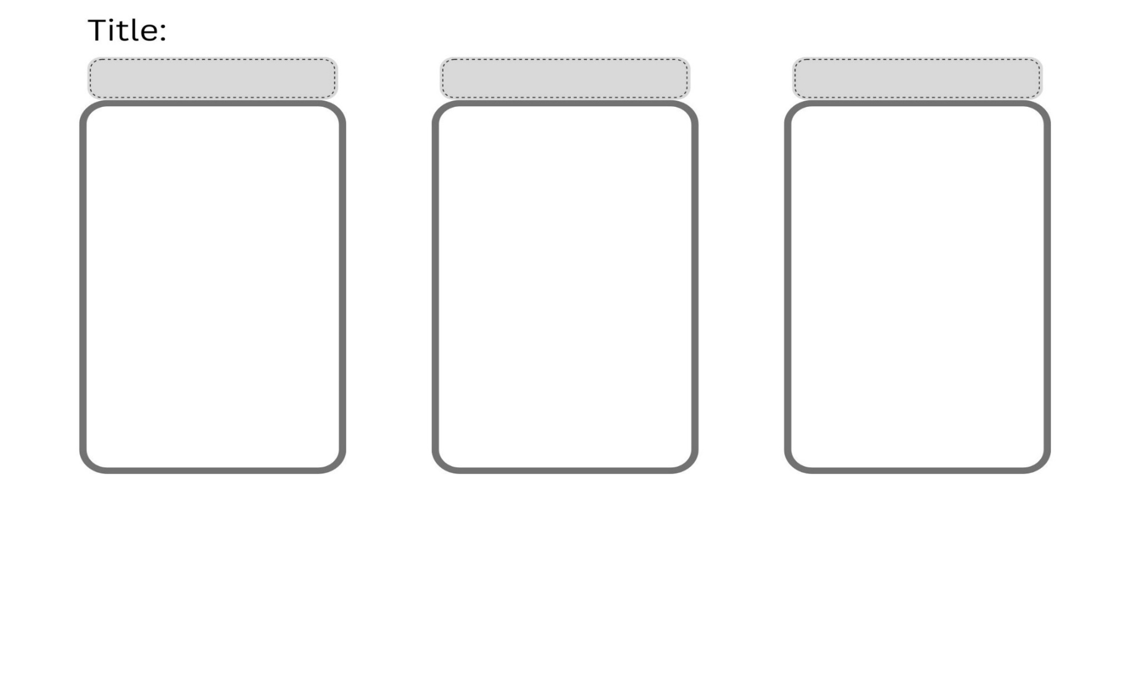

Resource 2: Prepositional phrase modelling resource
Subject (noun) | Verb | Prepositional phrase
Clancy | crawled | under the box
Clancy | sat | inside the box

Resource 3: Three Little Pigs rebus
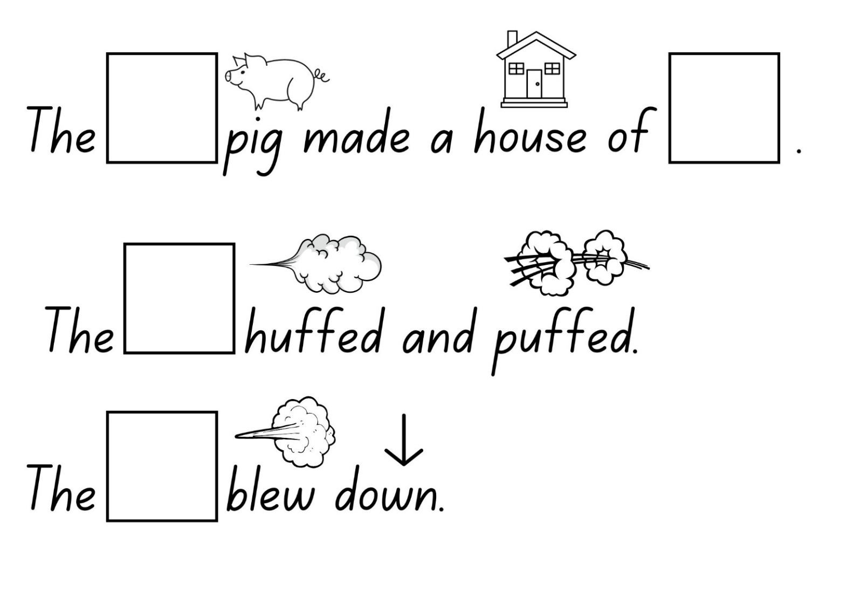
Images sourced from Canva and used in accordance with the Canva Content License Agreement.

References
Links to third-party material and websites
Please note that the provided (reading/viewing material/list/links/texts) are a suggestion only and implies no endorsement, by the New South Wales Department of Education, of any author, publisher, or book title. School principals and teachers are best placed to assess the suitability of resources that would complement the curriculum and reflect the needs and interests of their students.
If you use the links provided in this document to access a third-party's website, you acknowledge that the terms of use, including licence terms set out on the third-party's website apply to the use which may be made of the materials on that third-party website or where permitted by the Copyright Act 1968 (Cth). The department accepts no responsibility for content on third-party websites.
Except as otherwise noted, all material is © State of New South Wales (Department of Education), 2023 and licensed under the Creative Commons Attribution 4.0 International License. All other material (third-party material) is used with permission or under licence. Where the copyright owner of third-party material has not licensed their material under a Creative Commons or similar licence, you should contact them directly for permission to reuse their material.
English K–10 Syllabus © 2022 NSW Education Standards Authority (NESA) for and on behalf of the Crown in right of the State of New South Wales.
Creative Arts K-6 Syllabus © 2006 NSW Education Standards Authority (NESA) for and on behalf of the Crown in right of the State of New South Wales.
© 2022 NSW Education Standards Authority. This document contains NSW Curriculum and syllabus content. The NSW Curriculum is developed by the NSW Education Standards Authority. This content is prepared by NESA for and on behalf of the Crown in right of the State of New South Wales. The material is protected by Crown copyright.
Please refer to the NESA Copyright Disclaimer for more information.
NESA holds the only official and up-to-date versions of the NSW Curriculum and syllabus documents. Please visit the NSW Education Standards Authority (NESA) website and the NSW Curriculum website.
National Literacy Learning Progression © Australian Curriculum, Assessment and Reporting Authority (ACARA) 2010 to present, unless otherwise indicated. This material was downloaded from the Australian Curriculum website (National Literacy Learning Progression) (accessed 18 January 2023) and was not modified. The material is licensed under CC BY 4.0. Version updates are tracked in the ‘Curriculum version history’ section on the 'About the Australian Curriculum' page of the Australian Curriculum website.
ACARA does not endorse any product that uses the Australian Curriculum or make any representations as to the quality of such products. Any product that uses material published on this website should not be taken to be affiliated with ACARA or have the sponsorship or approval of ACARA. It is up to each person to make their own assessment of the product, taking into account matters including, but not limited to, the version number and the degree to which the materials align with the content descriptions and achievement standards (where relevant). Where there is a claim of alignment, it is important to check that the materials align with the content descriptions and achievement standards (endorsed by all education Ministers), not the elaborations (examples provided by ACARA).
English Fairy Tales and Stories (26 December 2019) ‘Goldilocks and the Three Bears Story | English Fairy Tales And Stories | storytime’, English Fairy Tales and Stories, YouTube, accessed 18 January 2023.
English Fairy Tales and Stories (16 November 2020) ‘Three Little Pigs | Stories For Kids’, English Fairy Tales and Stories, YouTube, accessed 18 January 2023.
ETA (English Teachers Association) and NSW Department of Education (2016) The Textual Concepts and Processes resource, English Textual Concepts website, accessed 18 January 2023.
Gleeson L (2009) Clancy & Millie and the Very Fine House (Blackwood F, illus) Little Hare Books, Australia.

