English – Early Stage 1 – Unit 11
Contents
Unit overview and instructions for use 3
Teacher notes 4
Outcomes and content – Component A 6
Outcomes and content – Component B 8
Week 1 11
Component A teaching and learning 11
Component B teaching and learning 12
Lesson 1: Exploring the features of a text that entertains – Wombat Stew 13
Lesson 2: Sequencing events and writing sentences with subject-verb-object 15
Lesson 3: Compound sentences with prepositional phrases 17
Lesson 4: Re-creating an entertaining text through role-play 19
Lesson 5: Writing an entertaining text 20
Week 2 22
Component A teaching and learning 22
Component B teaching and learning 23
Lesson 6: Identifying and comparing the features of texts that inform 24
Lesson 7: Innovating on texts 26
Lesson 8: Following a recipe 28
Lesson 9: Drafting a recipe 30
Lesson 10: Publishing a recipe 31
Resource 1: Vocabulary cards 33
Resource 2: Teacher resource 34
Resource 3: Text examples of compound sentences 35
Resource 4: Recipe scaffold 36
References 37

Unit overview and instructions for use
This two-week unit is comprised of Component A and Component B. Connecting learning across both components is encouraged.
Teaching and learning | Component A | Component B
Suggested duration | 60 minutes | 45 minutes
Explicit teaching focus areas | - Phonological awareness  - Print conventions  - Phonic knowledge  - Reading fluency  - Reading comprehension  - Spelling  - Handwriting | - Oral language and communication  - Vocabulary  - Reading comprehension  - Creating written texts  - Understanding and responding to literature
To prepare for teaching and learning: | - Refer to Outcomes and content – Component A, K-2 – Instructional sequence – grapheme–phoneme correspondences [PDF 825 KB], and the teaching advice documents (hyperlinked in Component A teaching and learning table).  - Based on student needs identified through ongoing assessment data, plan and document how you will sequence teaching and learning in whole class and targeted teaching groups across the two-week cycle. | - Familiarise yourself with Outcomes and content – Component B, Textual concepts information and videos, English Textual Concepts and Learning Processes (2016), and the teaching and learning sequence.  - Based on student needs identified through ongoing assessment data, determine how you will support students in whole class and targeted teaching groups across the two-week cycle as required.
English K–10 Syllabus © 2022 NSW Education Standards Authority (NESA) for and on behalf of the Crown in right of the State of New South Wales.

Teacher notes
- Context refers to factors acting upon composers and responders that affect meaning. To understand context, we look beyond the text to consider the world in which it was produced and the worlds of its reception. Different contexts can affect the meanings and values of similar content. – English Textual Concepts and Learning Processes (2016).
- Understanding of context can be supported through watching the department’s video: Context (5:24).
- While context is the mentor concept for the conceptual component of this unit, the supporting concept of perspective could be explored using the mentor text Wombat Stew by Marcia Vaughan.
- For information on conjunctions, prepositions and compound sentences refer to the NESA Glossary.
- This unit could enhance student learning towards achievement of outcomes from the Science syllabus and Creative Arts syllabus.
- Lesson 8 follows a recipe to make Frozen fruit cups. This requires fruit cut into pieces, plastic cups, spoons and fruit juice for each student. It is recommended that parents and caregivers be informed that children will be eating fruit and frozen juice and students with allergies will need to be catered for.
- In Lesson 9, students will write a draft recipe which they will then publish in Lesson 10. Teachers will need to review students’ draft recipes prior to Lesson 10 and give appropriate feedback for students to improve their writing when publishing.
- Consider prior student knowledge and learning about prepositions and verbs, and the language and structural features of texts that inform and entertain.
- Reflect on student learning and engagement in activities and record differentiation and adjustments within the unit to inform future teaching and learning. One way of doing this could be to add comments to the digital file.
- Content points are linked to the National Literacy Learning Progression version (3).
Levels and indicators sourced from National Literacy Learning Progression © Australian Curriculum, Assessment and Reporting Authority (ACARA), (accessed 11 January 2023) and was not modified. See references for more information.

Outcomes and content – Component A
The table below outlines the focus outcomes and content. Content is linked to the National Literacy Learning Progression version (3).
Focus area and outcome | Content points and National Literacy Learning Progression
Phonological awareness  ENE-PHOAW-01 – identifies, blends, segments and manipulates phonological units in spoken words as a strategy for reading and creating texts | - identify the difference between a voiced phoneme and an unvoiced phoneme  - blend aloud all phonemes when asked to delete, add or substitute an initial phoneme (PhA5)
Print conventions  ENE-PRINT-01 – tracks written text from left to right and from top to bottom of the page and identifies visual and spatial features of print | N/A
Phonic knowledge  ENE-PHOKW-01 – uses single-letter grapheme–phoneme correspondences and common digraphs to decode and encode words when reading and creating texts | - blend common single-letter grapheme–phoneme correspondences to read CCVC and CVCC words, and apply this when reading texts, including decodable texts (PKW3, PKW4)  - segment common, single-letter grapheme–phoneme correspondences to encode CCVC and CVCC words (PKW5)  - decode and blend words containing consonant digraphs and apply this when reading texts, including decodable texts (PKW5)  - segment and encode CVC words containing consonant digraphs (PKW4) (PKW5)
Reading fluency  ENE-REFLU-01 – reads decodable texts aloud with automaticity | - read texts with taught grapheme–phoneme correspondences and taught high-frequency words with automaticity  - know that pace and expression vary when reading, according to the audience and purpose
Reading comprehension  ENE-RECOM-01 – comprehends independently read texts using background knowledge, word knowledge and understanding of how sentences connect | - ask or pause to clarify meaning of unknown words (UnT3)  - stop reading when a break in comprehension is registered (UnT4)  - ask a question or make a statement to clarify meaning (UnT3) (UnT4)  - recall the sequence of events/information in texts (UnT5)
Spelling  ENE-SPELL-01 – applies phonological, orthographic and morphological generalisations and strategies to spell taught familiar and high-frequency words when creating texts | - know that words do not usually end with the letter v, and that ve is commonly used  - spell high-frequency compound words and homophones comprising taught graphemes
Handwriting  ENE-HANDW-01 – produces all lower-case and upper-case letters to create texts | - correctly produce a clockwise ellipse, anticlockwise ellipse and downward diagonal stroke when forming letter shapes

Outcomes and content – Component B
The table below outlines the focus outcomes and content. Content is linked to the National Literacy Learning Progression version (3).
Focus area and outcome | Content points and National Literacy Learning Progression
Oral language and communication  ENE-OLC-01 – communicates effectively by using interpersonal conventions and language with familiar peers and adults | - recognise how nonverbal language can contribute to meaning in spoken communication (LiS3)  - use connectives such as and, but and because when speaking (SpK2)
Vocabulary  ENE-VOCAB-01 – understands and effectively uses Tier 1 words and Tier 2 words in familiar contexts | - use vocabulary to select, match and provide categories for groups of images or words
Reading comprehension  ENE-RECOM-01 – comprehends independently read texts using background knowledge, word knowledge and understanding of how sentences connect | - identify conjunctions in a compound sentence, their meaning and purpose  - recall the sequence of events/information in texts (UnT5)
Creating written texts  ENE-CWT-01 – creates written texts that include at least 2 related ideas and correct simple sentences | - sequence ideas in a text (GrA4)  - identify and use verbs in simple sentences, including in own writing (GrA2)  - write a simple sentence with correct subject–verb–object structure to convey an idea (GrA2) (GrA3) (CrT4)  - use prepositional phrases to indicate time or place (GrA2)  - experiment with writing compound sentences and recognise that each clause makes meaning by itself (GrA4)  - understand that punctuation is a feature of written language and how it impacts meaning  - identify different purposes for writing (CrT4)  - understand they can improve their writing based on feedback from teachers
Understanding and responding to literature  ENE-UARL-01 – understands and responds to literature read to them | - identify and contrast features of texts that inform, persuade and/or entertain (UnT5)  - identify texts that are composed for specific audiences and purposes  - create imaginative and/or informative texts relating to their own experience, the world and/or other texts (CrT3)

Week 1

Component A teaching and learning
The table below can be used to plan and document lessons that address Component A outcomes and content. Both the detailed example [DOC 529KB] of a two-week teaching and learning cycle and brief example [DOC 66KB] may support you in your planning.
Focus Areas | Lesson 1 | Lesson 2 | Lesson 3 | Lesson 4 | Lesson 5
Phonological awareness and
Phonic knowledge
15 minutes
Spelling and Handwriting
15 minutes
Print conventions,
Reading comprehension and Reading fluency
30 minutes

Component B teaching and learning
The following teaching and learning sequence has been designed to address Component B outcomes and content. Adapt the sequence as required to best meet the needs of your students.

Learning intention and success criteria
Learning intentions and success criteria are best co-constructed with students.

Learning intention
Students are learning to identify features of texts that entertain and re-create an imaginative text.

Success criteria
Students can:
- identify the text purpose and audience of a text that entertains
- recognise how non-verbal language is used to communicate
- sort words and images into categories
- sequence events in a text
- use verbs in own writing
- use prepositional phrases
- experiment with writing a compound sentence.

Resources
- Vaughn M (2014) Wombat Stew (Lofts P, ilIus.) Scholastic Australia Pty Ltd. ISBN: 9781743621837
- Resource 1: Vocabulary cards (enlarged copy and student copies)
- Resource 2: Teacher resource (teacher copy)
- Resource 3: Text examples of compound sentences (enlarged copy)
- Art paper and art materials
- Billycan prop (pot, bucket, container)
- Large sheets of paper
- Sentence strips
- Optional: Natural items from the playground environment (leaves, gumnuts, twigs, grass, small rocks)

Lesson 1: Exploring the features of a text that entertains – Wombat Stew
- Introduce the text Wombat Stew. Look at the illustrations on the front cover and read the title.
- Explore the context of the text by introducing the main character, Dingo, and the other Australian animals featured. Start an anchor chart by drawing and labelling the animals from the text; this can be used throughout the unit to support student writing. Use the chart to prompt a discussion with students sharing their knowledge about dingoes, for example, they are strong, predators, meat eaters. Discuss how the author has used what is known about Australian animals and their environment to create an imaginative text that entertains children.
- After discussing the animals in the text, students tell a partner what they think the title Wombat Stew means and make predictions about what ‘ingredients’ the main character, Dingo, intends on using to make a stew.
- Read the text Wombat Stew. Review students’ predictions from activity 3. Discuss some of the features in the text that students found entertaining. For example, the illustrations, rhyme and repetition. Ask students who might enjoy reading this text and why.
- Display the page of Dingo tasting the stew. Unpack the features on the page, including Dingo’s expression; the tears or sweat falling off his face; the noise he makes, as shown in the speech bubble; the text, for example, “I am poisoned!” he howled. Identify the punctuation used in the text and discuss the purpose of the exclamation.
- In pairs, students discuss Dingo’s reaction. Support discussion with questions. For example:
- Why didn’t Dingo like the stew?
- Would you like to eat the wombat stew?
- Show how you would react if you tasted the wombat stew. What would you do or say?
- Revisit the text and identify other parts of the story that show the reactions of different characters through the illustrations and text. Name how the characters are feeling in the scenes.
- Discuss how facial expression and body language contribute to meaning. In small groups, students role-play scenes from the text by creating freeze frames to show the characters’ reactions and feelings. Allocate scenes to groups. For example:
- when Dingo catches Wombat (happy, proud)
- when Wombat realises he is going to be put in the stew (worried, scared)
- when Platypus (smirks, looks confident) first tricks Dingo (shocked, surprised) by suggesting adding mud to the stew
- animals showing that they do not like Dingo singing (annoyed, hands over ears, bothered)
- the animals’ reaction when the stew is ready for the wombat to be added (shocked, worried, angry)
- Dingo boasting (toothy grin, puffed out chest, dancing)
- the animals’ reaction when Dingo tries the stew and runs away (laughing, celebrating).
- Students take turns sharing their freeze frames while the rest of the class guesses the scene they are depicting from the text. As students are describing the characters’ reactions/feelings, write these for students to refer to during independent writing.
- Using one of the group’s freeze frames, model writing a sentence to describe it. For example, Dingo is proud. Wombat is scared.
- Students draw a picture of the scene they acted out in activity 8 and write a sentence to describe it. They can use the chart and teacher modelling to write independently.
Too hard? Students draw and label their freeze frame scene.
Too easy? Students use the conjunction ‘because’ to write a compound sentence. For example, Dingo is proud because he caught Wombat.

Lesson 2: Sequencing events and writing sentences with subject-verb-object
- Re-read Wombat Stew. Encourage shared reading of the rhyming and repetitive language.
- Using a pre-cut, enlarged copy of Resource 1: Vocabulary cards, display and categorise the words as ‘characters’ and ‘stew ingredients’. Then, as a class, match the characters to the ingredients they added to the stew, in order of how this occurred in the text. Model orally recalling the sequence of events using the cards as prompts. For example, first Dingo caught Wombat, then Platypus put mud into the stew.
- Create a large sentence frame with 3 columns under the headings ‘Character (subject)’, ‘Action (verb)’ and ‘Ingredient (object)’. Place the matched cards from activity 2 on the frame, with characters under ‘subject’ and ingredient under ‘object’. The middle column, ‘verb’, will be blank.
- Discuss the characters’ actions when collecting the different ingredients for the stew. Refer to the text by identifying the verb (action word) that describes how each character collected the ingredients. Write verbs for the sentences that match the cards. For example, caught, scooped up, picked, snapped, dug, thought.
- Revise that a simple sentence contains a subject, verb and an object to convey an idea. Using the sentence frame, model writing 3 simple sentences using subject-verb-object to retell the sequence of the first 3 events of characters collecting ingredients. For example:
- Dingo caught a wombat.
- Platypus scooped up mud.
- Emu picked feathers.
Identify the subject, verb and object in each sentence.
- Using personal vocabulary and words on display, students write 3 sentences using the subject-verb-object structure to complete sequencing the events. For example:
- Lizard snapped flies.
- Echidna dug up creepy crawlies.
- Koala thought of gumnuts.
Too hard? Students draw 3 events in sequence. Jointly construct sentences using subject-verb-object structure to describe drawings.
Too easy? Students add details to describe the ingredients. For example, big blobs of mud, finest feathers, one hundred flies.
- In pairs, students role-play the sentences they wrote. For example, ‘Echidna digging up creepy crawlies.’ Encourage students to make their role-play entertaining through facial expressions and movement.
Early Stage 1 Assessment task 1 – Collecting work samples from this lesson allows students to demonstrate achievement towards the following syllabus outcomes and content points:
ENE-VOCAB-01 – understands and effectively uses Tier 1 words and Tier 2 words in familiar contexts
  - use vocabulary to select, match and provide categories for groups of images or words.
ENE-RECOM-01 – comprehends independently read texts using background knowledge, word knowledge and understanding of how sentences connect
- recall the sequence of events/information in texts.
ENE-CWT-01 – creates written texts that include at least 2 related ideas and correct simple sentences
- sequence ideas in a text
- identify and use verbs in simple sentences, including in own writing
- write a simple sentence with correct subject-verb-object structure to convey an idea.

Lesson 3: Compound sentences with prepositional phrases
- Revisit the sequence of events and simple sentences recorded in Lesson 2. Remind students that each sentence contains a subject, verb and an object to convey a complete idea. For example, Dingo (subject) caught (verb) a wombat (object).
- Introduce the concept of compound sentences with prepositional phrases. Refer to Resource 2: Teacher resource to understand how the text demonstrates compound sentences with prepositional phrases and an inferred subject in the second clause. This can be explored and differentiated as appropriate or used for teacher reference.
- Revisit the text to show how the author has used compound sentences with prepositional phrases to present 2 ideas in one sentence. For example, ‘Platypus scooped up big blobs of mud with his tail and tipped them into the stew.’ Highlight that a compound sentence joins 2 ideas using a connective such as ‘and’.
- Using an enlarged copy of Resource 3: Compound sentences, deconstruct some of the compound sentences from the text, drawing attention to the 2 ideas and the conjunction that connects them. If appropriate, remind students that the subject in the second clause can sometimes be inferred.
- Refer to the bank of verbs recorded on the sentence frame in Lesson 2 that describes how the characters added ingredients to the stew. Revise prepositional phrases and highlight those in the text. For example, into the stew, into the billycan.
- Provide an opportunity for students to experiment with compound sentences and conjunctions in speech. Students sit in a circle with a billycan prop placed in the centre. Through role-play, they practise saying compound sentences with a prepositional phrase. For example, ‘Lizard snapped flies and flipped them into the stew.’ This activity could be completed in small groups so that each student has a turn.
Too hard? Use Resource 1: Vocabulary cards to support students with saying a compound sentence.
- Using a student’s example from activity 6, co-construct writing a compound sentence with a prepositional phrase. Identify the 2 clauses, the conjunction, verbs and prepositional phrase.
- Students turn the simple sentences they wrote in Lesson 2 into a compound sentence with a prepositional phrase. For example:
- Echidna dug up creepy crawlies and (he) dropped them into the stew.
- Koala thought of gumnuts and (he) shook them into the stew.
Encourage students to use words on display and the sentence frame to support independent writing.
Too hard? Jointly construct compound sentences using conjunctions and prepositional phrases.
Early Stage 1 Assessment task 2 – Observations from this lesson allow students to demonstrate achievement towards the following syllabus outcomes and content points:
ENE-OLC-01 – communicates effectively by using interpersonal conventions and language with familiar peers and adults
- use connectives such as and, but and because when speaking.
ENE-RECOM-01 – comprehends independently read texts using background knowledge, word knowledge and understanding of how sentences connect
- identify conjunctions in compound sentences, their meaning and purpose.

Lesson 4: Re-creating an entertaining text through role-play
- Revise the characters, setting and sequence of events from Wombat Stew. Explain to students that they will create a similar story using different Australian animals. Remind students that the purpose of the text is to entertain so will have the same structure and features as Wombat Stew. Revisit these from Lesson 1. Students will role-play their story in this lesson and write about it in Lesson 5.
- Brainstorm and record several Australian animals by drawing and labelling them for students to refer to during independent writing. Use the brainstorm activity for students to share what they know about the animals, including the purpose of physical features and what the animals eat. Ensure to include some animals that are ‘predators’, like Dingo.
- In small groups, students re-create Wombat Stew using different animals recorded in activity 2. Each student is allocated an animal role, with one being the ‘predator’ like Dingo and one being the ‘intended meal’ like Wombat. They will each decide on their actions, based on their animal character, and what ingredients they will add to the stew. For example, ‘Kangaroo digs up clumps of grass with her paws and puts it into the stew.’ Provide students with a range of resources for students to use as costumes or props, such as billycans, pots and items for stew ingredients. Students act out their role and verbalise their actions using verbs, compound sentences and prepositions to revise the learning from Lesson 3. Students think of a title for their story that matches their animals, such as ‘Wallaby Stew’.
- Students take turns performing their stories to the class.
- Optional: Students perform their plays at a school assembly or for other classes/family or school community.

Lesson 5: Writing an entertaining text
- In this lesson, students will work in their role-play groups from Lesson 4 to write out their story as an entertaining text for children.
- Using one of the group’s re-created stories, model how to sequence the events by drawing each animal and their stew ingredient. Under each illustration, co-construct a compound sentence with a prepositional phrase, as taught in Lesson 3. For example, ‘Crow snapped up a bug with his beak and dropped it into the stew.’
- The groups work together to draw the sequence of events in their story (order of animal and ingredients put into the stew). Each student uses a sentence strip to write a compound sentence with a prepositional phrase to match their animal character/illustration. Students use the co-constructed sentences from activity 2 and words on display in the classroom and from the text as a support. Students will need this piece of work for Lesson 6.
Too hard? Jointly construct compound sentences using conjunctions and prepositional phrases.
Too easy? Add describing words to the prepositional phrases. For example, ‘into the gooey stew’.
- Optional: Provide students with additional time to publish their work into mini books with illustrations.

Week 2

Component A teaching and learning
The table below can be used to plan and document lessons that address Component A outcomes and content. Both the detailed example [DOC 529KB] of a two-week teaching and learning cycle and brief example [DOC 66KB] may support you in your planning.
Focus Areas | Lesson 6 | Lesson 7 | Lesson 8 | Lesson 9 | Lesson 10
Phonological awareness and
Phonic knowledge
15 minutes
Spelling and Handwriting
15 minutes
Print conventions,
Reading comprehension and Reading fluency
30 minutes

Component B teaching and learning
The following teaching and learning sequence has been designed to address Component B outcomes and content. Adapt the sequence as required to best meet the needs of your students.

Learning intention and success criteria
Learning intentions and success criteria are best co-constructed with students.

Learning intention
Students are learning to identify and contrast the features of texts that entertain and inform and write a recipe.

Success criteria
Students can:
- identify the text purpose and audience of a text that informs
- sequence information in a text
- use verbs in own writing
- use prepositional phrases
- experiment with writing a compound sentence
- write a recipe
- use feedback to improve writing.

Resources
- Vaughn M (2014) Wombat Stew (Lofts P, ilIus.) Scholastic Australia Pty Ltd. ISBN: 9781743621837
- ABC Kids Recipe Book
- Resource 4: Recipe scaffold
- Natural items from the playground environment (leaves, gumnuts, twigs, grass, small rocks)
- Diced fruit, fruit juice, plastic cups and spoons (class supply)

Lesson 6: Identifying and comparing the features of texts that inform
- Revisit the purpose of the text Wombat Stew as a narrative to entertain. Explain that students will be exploring different informative texts this week. Briefly discuss different texts that inform, such as books that have information or real facts about things, and texts that tell us how to do or make things, like instructions or recipes.
- Ask students what they know about recipes and their purpose. Display a smoothie recipe from page 10 or 11 in the ABC Kids Recipe Book. Walk through the features of the recipe and explain that these are common features of most recipes. For example, the title informs the reader what the end product will be, there is a list of required ingredients and items under the heading ‘What you need’, and the steps or instructions under the heading ‘What to do’. Discuss how these recipe features inform the reader of what they need and how to follow a recipe.
- Highlight how the recipe’s instruction is sequenced in order of what to do. Discuss why this is an important feature in a recipe. Ask students what would happen if the steps in a recipe were not in order. Compare how the events in an imaginative text, like Wombat Stew, are also sequenced.
- Using the recipe, identify the verbs (combine, mix), the compound sentence using the conjunction ‘and’ (Combine all ingredients in a blender and mix until smooth) and preposition (in a blender). Compare with the verbs, compound sentences and prepositions in Wombat Stew. Note that, in the recipe, the verbs are in present tense and the punctuation is different as there are no speech marks or exclamation marks.
- Explain that students will experiment with writing a recipe, using the text Wombat Stew. Discuss how the title ‘Wombat Stew’ sounds like a recipe.
- Model how to identify and group features of a recipe using Wombat Stew as a stimulus and Resource 4: Recipe scaffold.
- Draw and list the ingredients and items required, and model writing the instructions or steps. Differentiate the written instructions or method according to student needs. These could be broken down into a series of steps using different verbs used in Week 1 or a simple step as shown in the smoothie recipe. For example, Put all the ingredients into a pot and mix.
- Students experiment with identifying and grouping features of a recipe using their re-created text from Lesson 5. They draw or write the required ingredients, items and steps from their re-created text on Resource 4: Recipe scaffold.
Too hard? Display the chart from Lesson 2 to support students to draw the ingredients and items required to make wombat stew.
Too easy? Students write the ingredients and utensils.
Early Stage 1 Assessment task 3 – Collecting work samples from this lesson allows students to demonstrate achievement towards the following syllabus outcomes and content points:
ENE-CWT-01 – creates written texts that include at least 2 related ideas and correct simple sentences
- use prepositional phrases to indicate time or place
- experiment with writing compound sentences and recognise that each clause makes meaning by itself
- identify different purposes for writing.
ENE-UARL-01 – understands and responds to literature read to them
- identify and contrast features of texts that inform, persuade and/or entertain.

Lesson 7: Innovating on texts
- Explain that students are going to create their own stew from ingredients found in the playground and write a recipe for it.
- Take students outside to collect ‘ingredients’ for their ‘playground stew’. In small groups, students collect 4-5 natural materials from the playground environment to take back to the classroom for their stew.
- Review ingredients collected by students. Create a word bank of ingredients and add images to support meaning.
- Using Resource 4: Recipe scaffold, students write the heading ‘Playground Stew’ and record the ingredients and utensils needed for their recipe as drawings or words.
- Remind students how the characters from the text collected the ingredients for the stew, as described in Lesson 2. Brainstorm interesting verbs to describe how students collected ingredients for their recipe. For example, pick, scoop, dig up, grab, pull, gather, collect. Add verbs to the word bank.
- Ask students to imagine how they will add their ingredients to a pot to make their playground stew. Brainstorm verbs to describe these actions and add them to the word bank.
- In small groups, students use the collected ingredients to orally compose a set of steps for the recipe. Encourage each student to use a different verb. For example:
- Flip the gumnuts into the stew.
- Sprinkle the sand into the stew.
- Stir the leaves into the stew.
- Select students to share their steps with the class. Using students’ examples and vocabulary from the word banks, model writing 2 simple sentences with prepositional phrases as a procedure to make playground stew. For example:
- Gather (verb) sticks and mud (noun) from the playground (prepositional phrase).
- Stir (verb) the sticks and mud (noun) into the stew (prepositional phrase).
- Model writing a compound sentence using the simple sentences from activity 8. For example, Gather ingredients from the playground and stir into the stew. Identify each clause and the conjunction ‘and’.
- Students use vocabulary on display to complete Resource 4: Recipe scaffold, writing a compound sentence as an instruction for their recipe.
Too hard? Students write simple sentences or draw the steps for their recipe.
- Students role-play making the stew, using their sentences from activity 10 to match their actions. At the end of the role-play, encourage students to express their like/dislike using nonverbal language and facial expressions to show how they would react to tasting the playground stew.
Early Stage 1 Assessment task 4 – Observations and work samples from this lesson allow students to demonstrate achievement towards the following syllabus outcomes and content points:
ENE-OLC-01 – communicates effectively by using interpersonal conventions and language with familiar peers and adults
- recognise how nonverbal language can contribute to meaning in spoken communication.
ENE-CWT-01 – creates written texts that include at least 2 related ideas and correct simple sentences
- use prepositional phrases to indicate time or place
- experiment with writing compound sentences and recognise that each clause makes meaning by itself.

Lesson 8: Following a recipe
- Display the front page and read the title of the ABC Kids Recipe Book. Ask students what the purpose of the text is. Support students’ responses by walking through the text and displaying features of the text that inform.
- Display the Frozen Fruit Cups recipe on page 23 of the ABC Kids Recipe Book (or alternative recipe). Explain that the purpose of the recipe is to inform readers how to make a frozen fruit cup. In this lesson, the class will read and follow the steps of the recipe together to make frozen fruit cups.
- Prepare the ingredients and set up the class so that students can access the ingredients and items required to make a frozen fruit cup.
- As a class, read the list of ingredients and items in the recipe. Provide students with time to collect these, then ask students to sort items into 2 categories: ingredients and items. Students label their plastic cups with their name.
- Read through the rest of the recipe, step-by-step, until all students have made a frozen fruit cup using the fruit they like. Set fruit cups away to be frozen.
- Discuss how, by following the steps in the recipe, the class have made frozen fruit cups to eat. Compare this to the purpose of reading a text that entertains, like Wombat Stew.
- Model writing a sentence describing how the frozen fruit cup was made. For example, ‘I put kiwi fruit and orange juice in the cup and mixed it.’
Too hard? Students draw and label the steps taken to follow the recipe.
Early Stage 1 Assessment task 5 – Collecting work samples from this lesson allows students to demonstrate achievement towards the following syllabus outcomes and content points:
ENE-VOCAB-01 – understands and effectively uses Tier 1 words and Tier 2 words in familiar contexts
- use vocabulary to select, match and provide categories for groups of images or words.
ENE-RECOM-01 – comprehends independently read texts using background knowledge, word knowledge and understanding of how sentences connect
- recall the sequence of events/information in texts.
ENE-UARL-01 – understands and responds to literature read to them
- identify and contrast features of texts that inform, persuade and/or entertain
- identify texts that are composed for specific audiences and purposes.

Lesson 9: Drafting a recipe
- In this lesson, each student will write a sandwich recipe. All the sandwich recipes will be compiled into a class recipe book.
- Brainstorm ingredients that could be used on a sandwich. For example, cheese, tomato, lettuce. Create an illustrated word bank to support student writing.
- Discuss the items required to make a sandwich. For example, plate, knife, chopping board. Add to the illustrated word bank.
- Co-construct simple sentences using verbs, nouns and prepositional phrases for a procedure to make a sandwich. For example:
- Put (verb) the bread (noun group) on a board (prepositional phrase).
- Spread (verb) butter (noun) on the bread (prepositional phrase).
- Put (verb) cheese (noun) on the bread (prepositional phrase).
- Cut (verb) the sandwich (noun) in the middle (prepositional phrase).
- Students draft simple sentences using verbs, nouns and prepositional phrases to make a sandwich with ingredients of their choice.
Too hard? Students draw images to represent the steps. Jointly construct or scribe sentences.
Too easy? Students write compound sentences with prepositional phrases for 2 or more ingredients.
- Students review and self-assess their writing, checking that sentences begin with a capital letter and end with a full stop. Students can use a coloured pencil to mark edits.
Teachers to give feedback on student writing samples from this lesson. Feedback will be required for students to publish their recipes in Lesson 10.

Lesson 10: Publishing a recipe
- In this lesson, students will publish their draft sandwich recipe from Lesson 9, using the teacher feedback provided.
- Using an enlarged copy of Resource 4: Recipe scaffold, model writing the complete sandwich recipe, including a title. Refer to the word bank of ingredients and items and the co-constructed sentence frame from Lesson 9 to support the publishing process.
- Students publish their recipe on a new copy of Resource 4: Recipe scaffold.
- Students create a drawing of their completed sandwich.
- Compile published recipes into a class recipe book. Discuss the audience and purpose of the recipe book.
Early Stage 1 Assessment task 6 – Collecting work samples from this lesson allows students to demonstrate achievement towards the following syllabus outcomes and content points:
ENE-CWT-01 – creates written texts that include at least 2 related ideas and correct simple sentences
- identifying different purposes for writing
- understand they can improve their writing based on feedback from teachers
- understand that punctuation is a feature of written language and how it impacts meaning.
ENE-UARL-01 – understands and responds to literature read to them
- create imaginative and/or informative texts relating to their own experience, the world and/or other texts.

Resource 1: Vocabulary cards
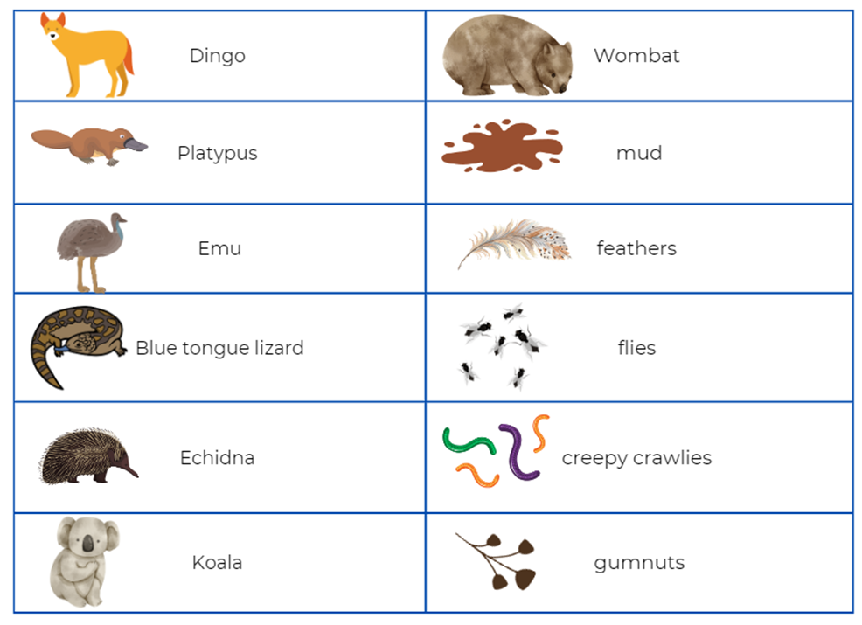
Images sourced from Canva and used in accordance with the Canva Content License Agreement.

Resource 2: Teacher resource
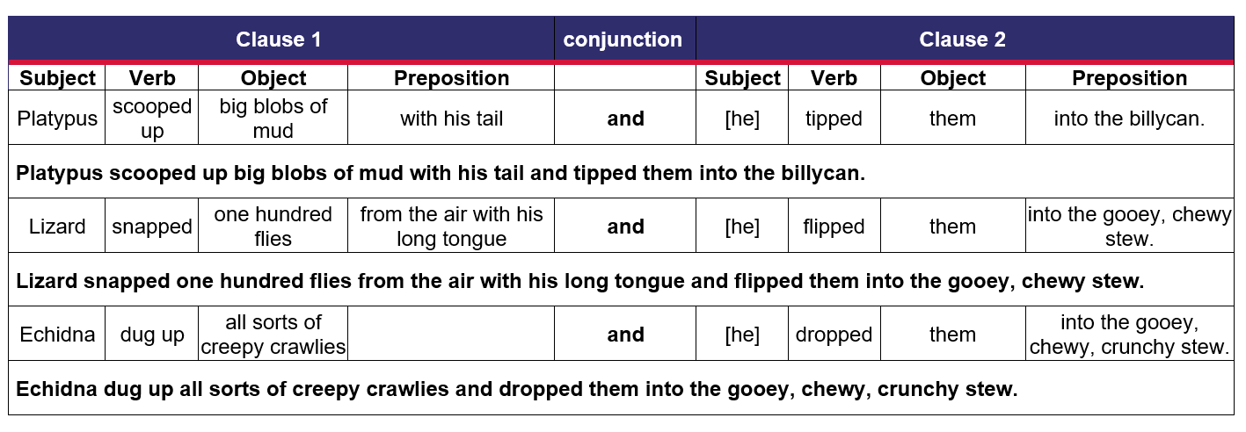

Resource 3: Text examples of compound sentences
Compound sentences
Platypus scooped up blobs of mud and tipped them into the stew.
Emu picked her feathers and dropped them into the stew.
Lizard snapped one hundred flies and flipped them into the stew.
Echidna dug up creepy crawlies and dropped them into the stew.
Koala thought of gumnuts and shook them into the stew.

Resource 4: Recipe scaffold
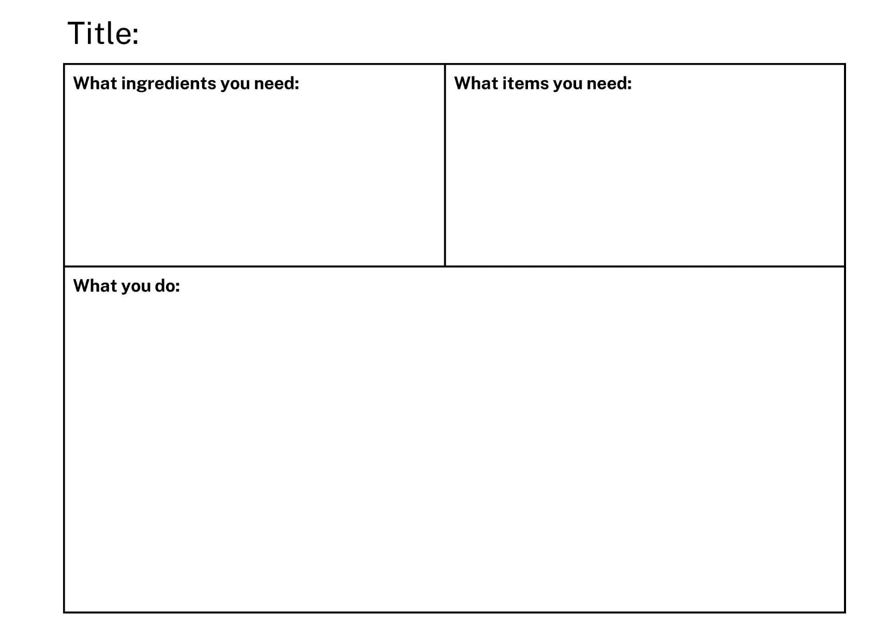

References
Links to third-party material and websites
Please note that the provided (reading/viewing material/list/links/texts) are a suggestion only and implies no endorsement, by the New South Wales Department of Education, of any author, publisher, or book title. School principals and teachers are best placed to assess the suitability of resources that would complement the curriculum and reflect the needs and interests of their students.
If you use the links provided in this document to access a third-party's website, you acknowledge that the terms of use, including licence terms set out on the third-party's website apply to the use which may be made of the materials on that third-party website or where permitted by the Copyright Act 1968 (Cth). The department accepts no responsibility for content on third-party websites.
Except as otherwise noted, all material is © State of New South Wales (Department of Education), 2023 and licensed under the Creative Commons Attribution 4.0 International License. All other material (third-party material) is used with permission or under licence. Where the copyright owner of third-party material has not licensed their material under a Creative Commons or similar licence, you should contact them directly for permission to reuse their material.
English K–10 Syllabus © 2022 NSW Education Standards Authority (NESA) for and on behalf of the Crown in right of the State of New South Wales.
Creative Arts K-6 Syllabus © 2006 NSW Education Standards Authority (NESA) for and on behalf of the Crown in right of the State of New South Wales.
Science and Technology K-6 Syllabus © 2017 NSW Education Standards Authority (NESA) for and on behalf of the Crown in right of the State of New South Wales.
© 2022 NSW Education Standards Authority. This document contains NSW Curriculum and syllabus content. The NSW Curriculum is developed by the NSW Education Standards Authority. This content is prepared by NESA for and on behalf of the Crown in right of the State of New South Wales. The material is protected by Crown copyright.
Please refer to the NESA Copyright Disclaimer for more information.
NESA holds the only official and up-to-date versions of the NSW Curriculum and syllabus documents. Please visit the NSW Education Standards Authority (NESA) website and the NSW Curriculum website.
National Literacy Learning Progression © Australian Curriculum, Assessment and Reporting Authority (ACARA) 2010 to present, unless otherwise indicated. This material was downloaded from the Australian Curriculum website (National Literacy Learning Progression) (accessed 11 January 2023) and was not modified. The material is licensed under CC BY 4.0. Version updates are tracked in the ‘Curriculum version history’ section on the 'About the Australian Curriculum' page of the Australian Curriculum website.
ACARA does not endorse any product that uses the Australian Curriculum or make any representations as to the quality of such products. Any product that uses material published on this website should not be taken to be affiliated with ACARA or have the sponsorship or approval of ACARA. It is up to each person to make their own assessment of the product, taking into account matters including, but not limited to, the version number and the degree to which the materials align with the content descriptions and achievement standards (where relevant). Where there is a claim of alignment, it is important to check that the materials align with the content descriptions and achievement standards (endorsed by all education Ministers), not the elaborations (examples provided by ACARA).
ETA (English Teachers Association) and NSW Department of Education (2016) The Textual Concepts and Processes resource, English Textual Concepts website, accessed 11 January 2023.
ABC Kids (2021) 'Recipe Book', Play School, accessed 11 January 2023.
Vaughn M (1984) Wombat Stew (Lofts P, ilIus.), Scholastic Australia Pty Ltd.

