English – Early Stage 1 – Unit 10
Contents
Unit overview and instructions for use 3
Teacher notes 4
Outcomes and content – Component A 5
Outcomes and content – Component B 7
Week 1 10
Component A teaching and learning 10
Component B teaching and learning 11
Lesson 1: Revisiting familiar texts 12
Lesson 2: Identifying and comparing text purpose 13
Lesson 3: Identifying favourite characters in imaginative texts 15
Lesson 4: Identifying and comparing illustrations in texts 18
Lesson 5: Identifying and comparing language features in texts 21
Week 2 23
Component A teaching and learning 23
Component B teaching and learning 24
Lesson 6: Sharing favourite texts 25
Lesson 7: Exhibition of text illustrations 27
Lesson 8: Exploring favourite characters in imaginative texts 28
Lesson 9: Identifying favourite text features 30
Lesson 10: Book celebration 31
Resource 1: Question wheel 33
Resource 2: Conversation bears 34
Resource 3: Text review 35
References 36

Unit overview and instructions for use
This two-week unit is comprised of Component A and Component B. Connecting learning across both components is encouraged.
Teaching and learning | Component A | Component B
Suggested duration | 60 minutes | 45 minutes
Explicit teaching focus areas | - Phonological awareness  - Print conventions  - Phonic knowledge  - Reading fluency  - Reading comprehension  - Spelling  - Handwriting | - Oral language and communication  - Vocabulary  - Reading comprehension  - Creating written texts  - Understanding and responding to literature
To prepare for teaching and learning: | - Refer to Outcomes and content – Component A, K-2 – Instructional sequence – grapheme–phoneme correspondences [PDF 825 KB], and the teaching advice documents (hyperlinked in Component A teaching and learning table).  - Based on student needs identified through ongoing assessment data, plan and document how you will sequence teaching and learning in whole class and targeted teaching groups across the two-week cycle. | - Familiarise yourself with Outcomes and content – Component B, Textual concepts information and videos, English Textual Concepts and Learning Processes (2016), and the teaching and learning sequence.  - Based on student needs identified through ongoing assessment data, determine how you will support students in whole class and targeted teaching groups across the two-week cycle as required.
English K–10 Syllabus © 2022 NSW Education Standards Authority (NESA) for and on behalf of the Crown in right of the State of New South Wales.

Teacher notes
- ‘Perspective is a lens through which we learn to see the world. It can clarify, magnify, distort or blur what we see. By adopting different perspectives, a responder can bring to light the underlying values in the text and construct meanings that may challenge, confirm or modify the original reading of a text.’ – English Textual Concepts and Learning Processes (2016).
- Understanding of perspective can be supported through watching the department’s video: Understanding perspective video (3:37).
- For information on Perspective refer to the NESA Glossary.
- This unit could enhance student learning towards achievement of outcomes from the Creative Arts and Mathematics syllabuses in regard to visual art and data.
- In Lesson 7, teachers will need to prepare a range of illustrated texts created with different mediums.
- In Lesson 8, both students and the teacher can dress up as their favourite character from a text. Teachers may wish to plan for this by communicating details to parents and caregivers prior to the lesson. Alternatively, provide a range of dress up and craft resources for students to create their own character costumes in class.
- Students will need access to a favourite book or books from home, the classroom or school library for lessons in Week 2.
- In Lesson 10, a staff member or special guest may be invited to the class for students to interview about their favourite text. Both students and staff will need to bring a favourite book for this lesson to celebrate and discuss the text.
- An optional activity to complete Week 2 is included. Parents, carers, and other school staff can be invited to attend an ‘open classroom’ book celebration with students. Teachers will need to plan for this event and communicate details to invited guests.
- Reflect on student learning and engagement in activities and record differentiation and adjustments within the unit to inform future teaching and learning. One way of doing this could be to add comments to the digital file.
- Content points are linked to the National Literacy Learning Progression version (3).
Levels and indicators sourced from National Literacy Learning Progression © Australian Curriculum, Assessment and Reporting Authority (ACARA), (accessed 2 December 2022) and was not modified. See references for more information.

Outcomes and content – Component A
The table below outlines the focus outcomes and content. Content is linked to the National Literacy Learning Progression version (3).
Focus area and outcome | Content points and National Literacy Learning Progression
Phonological awareness  ENE-PHOAW-01 – identifies, blends, segments and manipulates phonological units in spoken words as a strategy for reading and creating texts | - blend onset and rime to say a one-syllable word (PhA2)  - identify the first, middle and final phonemes in a one-syllable word (PhA4)  - identify the difference between a voiced phoneme and an unvoiced phoneme.
Print conventions  ENE-PRINT-01 – tracks written text from left to right and from top to bottom of the page and identifies visual and spatial features of print | N/A
Phonic knowledge  ENE-PHOKW-01 – uses single-letter grapheme–phoneme correspondences and common digraphs to decode and encode words when reading and creating texts | - decode and blend words containing consonant digraphs and apply this when reading texts, including decodable texts (PKW5)  - segment and encode CVC words containing consonant digraphs (PKW4, PKW5).
Reading fluency  ENE-REFLU-01 – reads decodable texts aloud with automaticity | - read words automatically then apply to texts  - read phrases comprising 2 or 3 words aloud, in a rhythmic manner (FIY2, FIY3).
Reading comprehension  ENE-RECOM-01 – comprehends independently read texts using background knowledge, word knowledge and understanding of how sentences connect | - recall key characters, events and/or information in text (UnT5).
Spelling  ENE-SPELL-01 – applies phonological, orthographic and morphological generalisations and strategies to spell taught familiar and high-frequency words when creating texts | - combine phonological, phonic, orthographic and morphemic knowledge to spell taught high-frequency irregular words comprising up to 3 phonemes (SpG5)  - experiment with the tense-marking suffixes to spell familiar base verbs (SpG5).
Handwriting  ENE-HANDW-01 – produces all lower-case and upper-case letters to create texts | - form all handwritten letters in NSW Foundation Style when given a verbal prompt from the correct starting point and continue in the correct direction (HwK4).

Outcomes and content – Component B
The table below outlines the focus outcomes and content. Content is linked to the National Literacy Learning Progression version (3).
Focus area and outcome | Content points and National Literacy Learning Progression
Oral language and communication  ENE-OLC-01 – communicates effectively by using interpersonal conventions and language with familiar peers and adults | - understand how pronouns can be linked to nouns to support meaning  - start a conversation with a peer and/or adult, staying on topic (InT3)  - ask questions using who, what, when, where, why or how  - recall details of events or stories using who, what, when, where, why and how (SpK2).
Vocabulary  ENE-VOCAB-01 – understands and effectively uses Tier 1 words and Tier 2 words in familiar contexts | - use vocabulary that is personal.
Reading comprehension  ENE-RECOM-01 – comprehends independently read texts using background knowledge, word knowledge and understanding of how sentences connect | - understand that informative and imaginative texts have different structures, features and forms (UnT5)  - use background knowledge when identifying connections between a text, own life, other texts and/or the world (UnT4)  - recall key characters, events and/or information in text. (UnT5).
Creating written texts  ENE-CWT-01 – creates written texts that include at least 2 related ideas and correct simple sentences | - create written texts that describe, give an opinion, recount an event, convey a story  - identify and use nouns in simple sentences, including in own writing (GrA2)  - write a simple sentence with correct subject–verb–object structure to convey an idea (GrA2, GrA3, CrT4)  - recognise a simple sentence in own writing (GrA3)  - use personal pronouns in own writing (CrT7)  - use personal vocabulary, words on display and in mentor texts when constructing sentences  - use capital letters when writing proper nouns (PuN3, CrT5)  - use question marks and exclamation marks (PuN3)  - identify different purposes for writing (CrT4).
Understanding and responding to literature  ENE-UARL-01 – understands and responds to literature read to them | - express likes and dislikes about a text (UnT5)  - identify favourite stories and/or characters in texts using verbal and/or nonverbal modes.

Week 1

Component A teaching and learning
The table below can be used to plan and document lessons that address Component A outcomes and content. Both the detailed example [DOC 529KB] of a two-week teaching and learning cycle and brief example [DOC 66KB] may support you in your planning.
Focus Areas | Lesson 1 | Lesson 2 | Lesson 3 | Lesson 4 | Lesson 5
Phonological awareness and
Phonic knowledge
15 minutes
Spelling and Handwriting
15 minutes
Print conventions,
Reading comprehension and Reading fluency
30 minutes

Component B teaching and learning
The following teaching and learning sequence has been designed to address Component B outcomes and content. Adapt the sequence as required to best meet the needs of your students.

Learning intention and success criteria
Learning intentions and success criteria are best co-constructed with students.

Learning intention
Students are learning to express likes and dislikes about texts and identify favourite stories and characters of in familiar texts.

Success criteria
Students can:
- share an opinion about texts with peers and adults
- express likes and dislikes about illustrations, characters, and language features from a range of texts
- have a conversation with a peer by asking questions and staying on topic
- use personal pronouns (I, my, our, we) in own writing to give an opinion
- use capital letters for proper nouns in own writing opinions about texts and characters in texts.

Resources
- Fox M (1989) Shoes from Grandpa (Mullins P, illus.), 25th Anniversary edn, Scholastic, Australia. ISBN: 9781760151133
- Howarth K (2018) Chip, Hardie Grant Children’s Publishing, Australia. ISBN: 9781760409623
- Lee S (2008) Wave, Chronicle Books, United States. ISBN: 9780811859240
- Zommer Y (2016) The Big Book of Bugs, Thames and Hudson Ltd, Great Britain. ISBN: 9780500650677
- Resource 1: Question wheel (enlarged copy)
- Resource 2: Conversation bears (plus individual copy and counters for each student)
- Poster paper
- Sticky notes
- T-chart

Lesson 1: Revisiting familiar texts
- Explain that over the next few lessons, students will be completing a critical review of 4 familiar texts that have been explored in previous units. Re-introduce the texts, The Big Book of Bugs, Chip, Shoes from Grandpa and Wave.
- In small groups, students visit a ‘book station’ displaying each text. Using Resource 1: Question wheel as a prompt, students discuss and recall the events (what, where and when), key characters (who) and/or information (what) for each of the texts.
- As a class, walk through each text, revisiting the details of events, characters, and text features.
- Create a concept map for each text. Recall and record details of each text into the categories of who, what, where and when.
- Remind students that readers view texts from their own perspectives. Explain that readers can express what they like and dislike about a text as a whole, but also by its features, such as the illustrations, language, characters or topic.
- Using 2 sticky notes, students draw a smiley face and a sad face on each. Students revisit the book stations from activity 2 and place a smiley face on the text they liked the most and a sad face on the text they liked the least.
- Define proper nouns as the specific name of a person, place or thing. Explain that, when writing, a person or character's name must begin with a capital letter. Jointly construct a class definition for proper nouns to display in the classroom.
- Explain that book titles are proper nouns. Model writing the 4 text titles to show how capital letters are used in book titles. For example, Shoes from Grandpa and The Big Book of Bugs.
- Provide students with paper folded into 4 quadrants and have students number each quadrant 1-4. Students order their preferences of most liked (1) to least liked text (4) by writing the title and drawing an image to represent each text.
- In pairs, students share their preferences and give reasons for their preferences.
- Create a class column graph to make visual representations of the most and least liked texts. Use the smiley face sticky notes from activity 6 to create one column that represents the most liked text and the sad face sticky notes to show the least liked text. Discuss the graph and how it shows the class’s text preferences.

Lesson 2: Identifying and comparing text purpose
- Remind students of the 4 texts re-visited in Lesson 1. Explain that these texts can be sorted into 2 groups based on their purpose, inform or entertain, and these are known as informative or imaginative texts.
- As a class, discuss the purpose of each text (to inform or entertain) and categorise them as informative or imaginative.
- Revisit the column graph from Lesson 1 and count the smiley face sticky notes to identify the most popular text in the class. Discuss the text’s intended purpose (to inform or entertain) and whether it is informative or imaginative. Ask students how they know. In pairs, students discuss why they think it is the most popular text and what features make it popular. For example, it has an entertaining story, a funny character, and colourful illustrations.
- Model writing short sentences to summarise the most popular class preference. Highlight the use of pronouns when writing. For example, ‘Our class likes imaginative texts. Our favourite text has a funny character. We like books that entertain.’
- Divide the class into small groups. Provide each group with different sections from The Big Book of Bugs and either Chip, Shoes from Grandpa or Wave. Students discuss the similarities and differences between the informative and imaginative texts. For example, text purpose, audience, characters, topic, illustrations, and language features. Note that these aspects will be unpacked in later lessons.
- Student groups share the similarities and differences with the whole class. Record student responses on a T-chart to compare the features of imaginative and informative texts.
- Using the completed T-chart, unpack the purpose and main features of informative and imaginative texts. For example, informative texts provide facts and inform readers about a topic, structures the information using an index, glossary, page numbers and headings, uses illustrations or images to support the information presented. Imaginative texts tell a story with events occurring at the beginning, middle and end, use illustrations to give more information about the events or characters, evoke feelings and aim to entertain.
- Model writing sentences that express likes and dislikes about informative and imaginative texts and provide reasons. Use sentence starters (in bold) to support writing. For example:
- I like informative texts because they have interesting facts.
- I dislike informative texts because they are not funny.
- I like imaginative texts because they have interesting characters.
- I dislike imaginative texts because they are not true.
- In pairs, students use the sentence starters to give an oral response expressing their likes and dislikes about imaginative or informative texts and why.
- Students use the modelled writing and sentences starters from activity 8, personal vocabulary and the words on display to write a sentence expressing their likes and or dislikes about imaginative texts or informative texts.
Too hard? Jointly construct sentences expressing likes about imaginative or informative texts.
Too easy? Write a sentence expressing likes and dislikes about both imaginative and informative texts.
- Students share their responses with peers and form groups with similar opinions. Determine if students’ opinions match the graph from Lesson 1.

Lesson 3: Identifying favourite characters in imaginative texts
- Read the text Chip. Discuss the text’s purpose and features; that it is imaginative, a narrative with events that occur at the beginning, middle and end and has a main character, a seagull named Chip.
- Explain that characters can be a fictional identity in the form of a person, animal, or inanimate object. Authors and illustrators use language and illustrations or images in texts to show what a character does, says, and thinks.
- Explain that authors create characters with features and traits that allow the reader to develop an opinion about the character. Authors create characters that have likable or unlikable traits which might include being brave, clever, funny or dishonest, mean, or scary.
- Recall the character, Chip, discuss and record his features and traits. Repeat for the key characters from Shoes from Grandpa and Wave. Highlight how the authors and illustrators have used language and images in the texts to represent what the characters are like, what they do and say, and how this influences people’s opinions of them.
- Refer to Resource 1: Question wheel and use questioning to prompt students to express their likes and dislikes about the characters from the 3 imaginative texts. For example:
- Who is your favourite or least favourite character?
- Why do you like or dislike them?
- What trait do you like or dislike most?
- Does the character remind you of someone you know?
- Write the questions from activity 5 to model using and forming question marks. Invite students to add question marks to questions as they are written on the board.
- In pairs, students take turns asking and answering questions from activity 5 and 6, expressing their likes and dislikes about the characters. Students draw their partner’s favourite character.
- Share students’ opinions and drawings. Select several examples to model writing a simple sentence using the subject-verb-object structure and proper nouns to record student opinions about characters. For example, Ms Green likes Jessie. Revisit the definition of proper nouns from Lesson 1 and remind students to use capital letters when writing proper nouns (names).
- Students write a simple sentence using subject–verb–object agreement and correct punctuation, including capital letters for proper nouns, to describe a peer’s opinion about a character from one of the imaginative texts.
Too hard? Provide students with a sentence frame, student name (subject) likes (verb) character’s name (object).
- Take photos of students’ work. Present work samples as a slide show for students to identify the proper nouns in work samples. Students record capital letters used on individual whiteboards.
Early Stage 1 Assessment task 1 – Observations and work samples from this lesson allow students to demonstrate achievement towards the following syllabus outcomes and content points:
ENE-OLC-01 – communicates effectively by using interpersonal conventions and language with familiar peers and adults
- start a conversation with a peer and/or adult, staying on topic
- ask questions using who, what, when, where, why or how
- recall details of events or stories using who, what, where, why and how.
ENE-CWT-01 – creates written texts that include at least 2 related ideas and correct simple sentences
- identify and use nouns in simple sentences, including in own writing
- write a simple sentence with correct subject–verb–object structure to convey an idea
- use personal vocabulary, words on display and in mentor texts when constructing sentences
- use capital letters when writing proper nouns.
ENE-UARL-01 – understands and responds to literature read to them
- identify favourite stories and/or characters in texts using verbal and/or nonverbal modes
- express likes and dislikes about a text.

Lesson 4: Identifying and comparing illustrations in texts
- Explain that authors use illustrations to provide deeper meaning, evoke emotion, enhance enjoyment, or provide information about a topic.
- Flick through The Big Book of Bugs, Chip, Shoes from Grandpa and Wave to revisit the illustrations in each text. Highlight how the illustrations help to tell a story or give information through use of colour, shape, size, and composition.
- Use the See, Think, Wonder routine to identify the features of the illustrations in each of the texts. Record key features on a poster. For example:
- Wave – sepia tones and blue, simple line drawings, expressions on the girl’s face, setting remains the same, blue becomes more prominent toward the end of the story line, realistic.
- The Big Book of Bugs – multiple images, vibrant and colourful, real bugs and creatures represented with animated detail.
- Chip – colourful, cartoon style, signs and words part of illustrations, close-up and far away perspectives.
- Shoes from Grandpa – colourful, uses mixed media, line drawn details.
- Explore the similarities and differences between the 4 texts.
- Provide all students with a copy of Resource 2: Conversation bears. Explain that initiating and responding in conversations is an important skill. By placing a counter on the bear each time a contribution is made so the class/small group can ensure that everyone is participating equally. Explain that some people may feel more confident than others. Remind students that allowing time for each person to think and speak is important.
- In small groups, students use Resource 2: Conversation bears to discuss the illustrations from all the texts. Encourage students to ask what, why and how questions and explain their opinions, likes and dislikes. For example:
- What do the illustrations make you think/wonder about?
- How do the illustrations make you feel?
- Why are the illustrations important to the text?
- What is your favourite illustration?
- What do you like/dislike about the text illustrations?
- Each group decides which illustrations they liked the most. Share and record group responses.
- Explain that personal pronouns can be used instead of using names when describing an opinion (for example, I like). Draw stick figures of one person (singular) and 3 or 4 people (multiple) and brainstorm singular and multiple pronouns. Record pronouns under the stick figures. For example, ‘I’ and ‘my’ for the singular stick figure; ‘we’ and ‘our’ for multiple stick figures.
- Refer to the illustration features recorded in activity 3 and the opinions in activity 7, model writing short sentences with a personal pronoun to express a group’s opinion. For example, ‘Our group likes the illustrations in Shoes from Grandpa. We like the bright colours.’ Ask students to identify personal pronouns, proper nouns and capital letters. Repeat this using a student’s favourite illustration to model the use of the pronouns ‘I’ and ‘my’.
- In pairs, students use the singular pronouns, ‘I’ and ‘my’, to orally express their opinions about their favourite illustrations from one of the texts.
- Students write 2 short sentences to express their opinions about their favourite illustration from one of the texts using ‘I’ and ‘my’. For example, ‘I like the illustrations in Wave. My favourite illustrations are blue.’
Too hard? Jointly construct sentences using personal pronouns to express their own opinion.
Too easy? Students write sentences expressing their dislikes.
Early Stage 1 Assessment task 2 – Observations and work samples from this lesson allow students to demonstrate achievement towards the following syllabus outcomes and content points:
ENE-OLC-01 – communicates effectively by using interpersonal conventions and language with familiar peers and adults
- understand how pronouns can be linked to nouns to support meaning.
ENE-VOCAB-01 – understands and effectively uses Tier 1 words and Tier 2 words in familiar contexts
use vocabulary that is personal.
ENE-RECOM-01 – comprehends independently read texts using background knowledge, word knowledge and understanding of how sentences connect
- understand that informative and imaginative texts have different structures, features and forms
- use background knowledge when identifying connections between a text, own life, other texts and/or the world
- recall key characters, events and/or information in text.
ENE-CWT-01 – creates written texts that include at least 2 related ideas and correct simple sentences
- create written texts that describe, give an opinion, recount an event, convey a story
- use personal pronouns in own writing
- use personal vocabulary, words on display and in mentor texts when constructing sentences
- identify different purposes for writing
- recognise a simple sentence in own writing.
ENE-UARL-01 – understands and responds to literature read to them
- express likes and dislikes about a text.

Lesson 5: Identifying and comparing language features in texts
- Read the text Shoes from Grandpa. Encourage students to join in shared reading to highlight the rhyme, alliteration, assonance, and repetitive language used in the text.
- After reading the text, play ‘word ping pong’ by stating an item of clothing Jessie was given. Students then orally recall words that rhyme. For example, sweater and wetter, skirt, and dirt, coat and boat, scarf and laugh, hat and that.
- Discuss the use of rhyme and repetition. In a talking circle, students share their responses to the following questions:
- What do you like about rhyming texts?
- Why do authors use rhyme, alliteration, assonance and repetition?
- Remind students about the purpose of texts, to inform or entertain. Explain that a text’s purpose influences the language features used by the author. For example, in Shoes from Grandpa the author uses rhyme and repetition to entertain readers.
- Review and compare the language features in the texts. For example, Chip uses humorous language to tell an imagined story. For example, ‘Chip and the amazing aerobatic gulls’. The Big Book of Bugs uses factual language, for example, ‘Insects have a body in three parts, six legs…’. Revise that Wave is a wordless text and highlight that, although it does not use language, it still tells a story and conveys meaning through illustrations.
- Explain that students will make groups to indicate the text with the language features that they prefer. Place the 4 texts around the room and ask students to sit in a circle around the text they have chosen. Count the number of students at each group and record results on a simple pictograph with stick figures.
- Model writing a simple sentence to describe the graph. For example:
- Our class liked texts that rhyme the most.
- We liked the wordless text the least.
- Students record a sentence using personal vocabulary and words on display to describe the text with the language features they preferred, using the personal pronouns ‘I’ and ‘my’. In pairs, students share their responses.
Too hard? Students give an oral description about the class pictograph.

Week 2

Component A teaching and learning
The table below can be used to plan and document lessons that address Component A outcomes and content. Both the detailed example [DOC 529KB] of a two-week teaching and learning cycle and brief example [DOC 66KB] may support you in your planning.
Focus Areas | Lesson 6 | Lesson 7 | Lesson 8 | Lesson 9 | Lesson 10
Phonological awareness and
Phonic knowledge
15 minutes
Spelling and Handwriting
15 minutes
Print conventions,
Reading comprehension and Reading fluency
30 minutes

Component B teaching and learning
The following teaching and learning sequence has been designed to address Component B outcomes and content. Adapt the sequence as required to best meet the needs of your students.

Learning intention and success criteria
Learning intentions and success criteria are best co-constructed with students.

Learning intention
Students are learning to deepen their understanding and perspectives through a critical review of familiar texts.

Success criteria
Students can:
- ask who, what, where and why questions to peers and adults to gather information
- express preferences about illustrations, characters and language features from a range of text
- use question marks in own writing
- use and identify nouns and pronouns in own simple sentences.

Resources
- Fox M (1989) Shoes from Grandpa (Mullins P, illus.), 25th Anniversary edn, Scholastic, Australia. ISBN: 9781760151133
- Howarth K (2018) Chip, Hardie Grant Children’s Publishing, Australia. ISBN: 9781760409623
- Lee S (2008) Wave, Chronicle Books, United States. ISBN: 9780811859240
- Zommer Y (2016) The Big Book of Bugs, Thames and Hudson Ltd, Great Britain. ISBN: 9780500650677
- Resource 1: Question wheel (enlarged copy)
- Resource 3: Text review (copies for students)
- T-chart
- A wide selection of familiar texts including students’ favourite text from home or school
- Art paper and a range art material
- Cardboard strips
- Large paper or A3 envelopes (one per student)
- Individual whiteboards
- Sticky notes

Lesson 6: Sharing favourite texts
- Revise the diversity in text purpose, illustrations, characters and language features of The Big Book of Bugs, Chip, Shoes from Grandpa and Wave explored in Week 1. Revisit students’ likes and dislikes.
- Explain that this week, the class (including you) will share a favourite text brought from home, the library, or the classroom.
- Share a favourite text with the class. As you share your book, prompt students to ask questions using Resource 1: Question wheel.
- Co-construct a list of key questions. For example:
- What is your favourite book? Why?
- Who is your favourite character? Why?
- What do you like about the illustrations/images?
- When did you get the book?
- Where did you get it from?
- How often do you read the book?
- Record sentences on cardboard sentence strips. Highlight the use of capital letters and question marks. Keep questions for possible use in Lesson 10.
- In pairs or small groups, students take turns sharing their favourite text brought from home, the library, or the classroom. Students not presenting use Resource 1: Question wheel and co-constructed questions from activity 4 to ask questions and gather information about why the text is their peer’s favourite.
- Ask several students to share questions asked and responses given. Ask students to identify the most interesting questions to ask about someone else’s favourite book.
- Model writing short sentences using proper nouns and pronouns to record what someone else’s favourite book was and why. For example, Student Name’s (proper noun) favourite book is Chip (proper noun). He (pronoun) likes the funny seagull (noun).
- Using the Draw, Talk, Write (and Share) strategy, students record a sentence and a drawing of someone else’s favourite text and gives reasons for their opinion.
Too hard? Jointly construct sentences using personal pronouns, capital letters and full stop.
- Take photos of students’ work. Present to the class as a slide show. Students identify the proper nouns, pronouns and capital letters in work samples.

Lesson 7: Exhibition of text illustrations
- Use a familiar text from Week 1 or the text shared in Lesson 6 to revisit the purpose of illustrations in texts. Discuss that they add or convey meaning, help create a mental model and give information or entertain the reader.
- As a class, explore a selection of pre-prepared texts that have a range of illustrations created with different features/mediums. For example, water colours, line drawing, bright colours, black and white, cartoon illustrations and mixed media.
- Explain that students will act as ‘judges’ to award the text with the best illustrations. Students engage in a gallery walk of the illustrated texts set up on display across the classroom. Students vote for their favourite illustrated text by placing a sticky note with their name on the text with the illustrations they liked the most. Identify the most liked and least liked illustrated texts.
- In a talking circle, invite students to explain their preferences. Ask students prompting questions, such as:
- What features of the illustrations did they like best?
- Why do they believe it is the ‘best’ illustration?
- Do the illustrations help to make connections with other texts, own life or the world?
- Provide students with a range of art material to recreate an illustration from their favourite text (this could be from their chosen text in Lesson 6 or one of the texts from the gallery walk activity in this lesson. Students label their artwork with the text’s title, using capital letters as appropriate.
Too easy? Students write a short description of their illustration.
- Collect and display the recreated illustrations as an exhibition. Invite the principal and/or librarian to visit the class exhibition.

Lesson 8: Exploring favourite characters in imaginative texts
- Refer to the teacher notes in preparation for this lesson, which requires students to dress up as their favourite book character from an imaginative text they have brought in from home, the library or classroom.
- Ask students to stand in a circle and introduce themselves, naming the character they are dressed up as.
- Model giving an explanation to describe who you are dressed as, what book you are from, why you chose this character and a brief description of the book. Encourage students to ask questions to gather information.
- In small groups, students take turns interviewing each other about the character they are dressed up as. Remind students to use Resource 1: Question wheel to ask who, what, when, where, why and how to remain on topic.
- Explain the concept of ‘villain’ and ‘hero’ characters in imaginative texts. For example, a villain deliberately does things that are mean or unkind. A hero helps people, is brave and courageous. Use familiar texts to highlight this, such as Pig the pug is a villain because he is mean and a fibber. Chip is a hero because he creates a plan to get more chips for his seagull friends.
- Using a T-chart with the headings ‘villains’ and ‘heroes’, discuss and record character features and traits of known villains and heroes in familiar imaginative texts. Ask students which type of character they prefer and why.
- Students identify their dress up character as a villain or hero. Designate a side of the room for ‘hero’ characters and the other ‘villain’ for characters. Students move to a side of the classroom that best describes their character and give reasons for their choices referring to their character’s traits or features.
- Model writing the question and simple sentences describing the character you or a student are dressed up as. For example, Who is my favourite character? My (personal pronoun) favourite character (noun) is Pug (proper noun). He is cheeky.
- Students write a question (Who is my favourite character?) and answer it using simple sentences with personal pronouns, nouns and proper nouns. Remind students to use capital letters to start their sentence and when writing proper nouns, and a full stop. Ask students to identify simple sentences in their own writing by underlining one sentence.
Too hard? Students draw a picture of their favourite character and write a simple sentence. For example, I like Pug. I like Chip.
Too easy? Students write multiple reasons to support their opinion.
- In pairs, students share their illustrations and sentences and identify nouns in each other’s sentences.
Early Stage 1 Assessment task 3 – Observations from this lesson allow students to demonstrate achievement towards the following syllabus outcomes and content points:
ENE-RECOM-01 – comprehends independently read texts using background knowledge, word knowledge and understanding of how sentences connect
- recall key characters, events and/or information in text.
ENE-CWT-01 – creates written texts that include at least 2 related ideas and correct simple sentences
- use personal vocabulary, words on display and in mentor texts when constructing sentences
- use a capital letter to start a sentence and a full stop to end a sentence
- recognise a simple sentence in own writing
- use question marks and exclamation marks.
ENE-UARL-01– understands and responds to literature read to them
- express likes and dislikes about a text
- identify favourite stories and/or characters in texts using verbal and/or nonverbal modes.

Lesson 9: Identifying favourite text features
- Revisit the text language features as discussed in Lesson 5. For example, rhyming language, humorous and playful language, wordless texts, and informative texts with facts.
- Display the texts The Big Book of Bugs, Chip, Shoes from Grandpa and Wave. Briefly describe the language features of each text with statements that are true or false. Students show a thumbs up if the statement is true and a thumbs down if the statement is false. For example, The Big Book of Bugs is a rhyming text (thumbs down) or Wave is a wordless text (thumbs up).
- Display a wide range of familiar texts with similar language features as the mentor texts featured in Week 1. For example, Pug the Pig (rhyme), Go Home Cheeky Animals (humorous and playful), Spencers New Pet (wordless), A is for Australian Animals (informative text with facts).
- Read 2-3 pages from each text to highlight the language features. Guide students to identify language features.
- In small groups, students explore the language features in their favourite text from home or school.
- Explain that students will create a book wrap for their favourite text. On the book wrap, students will write and draw clues about the book to entice others to want to read it.
- Model writing sentences to describe language features. For example:
- This book has rhyming words.
- This book has facts.
- This book is funny.
- This book is wordless.
- Provide students with white wrapping paper or A3 envelopes to create a book wrap for their favourite text. On the book wrap, students write a sentence about the language features using the modelled writing from activity 7. Students may wish to write a draft sentence before writing it on to the book wrap.
- Students draw other features of the text that they like, such as favourite characters and scenes or a fact or topic. Once students have written and drawn several clues on the book wraps (without writing the text tile), wrap the books or place them inside the A3 envelopes. Students write their name on the back of the wraps so that they can be returned at the end of the lesson.
- Place the wrapped/covered books around the classroom for students to access easily. Allow students time to explore the book wraps and select different books to unwrap or open based on the clues draw and written on the wrap. When students have finished looking at a book, they re-wrap it or put in back in the envelope for another student to explore.
- Students discuss why they chose to explore the books based on the written and drawn clues on the book wraps. For example, ‘I chose the book _ because I like rhyming books, I like wordless texts, I like black and white illustrations, I like scary characters or I like reading about real facts and topics.’
- Return texts and book wraps to their owners.

Lesson 10: Book celebration
- At the end of this unit, hold a ‘Book Celebration’ event. Suggested activities for the event might include:
- Students decorating and setting the classroom up for the event with welcome signs, a ‘Book Celebration’ banner, artworks from Lesson 4, stations for students to share their favourite texts with invited guests.
- Invite parents/carers, librarian, support staff, principal and/or another class to visit the event. Guests can explore students’ favourite texts and ask questions.
- Invited guests bring their favourite texts to the event. Students ask guests questions about their favourite text using the questions developed in Lesson 6.
- Students use their book wraps from Lesson 9 to share their favourite texts with guests.
- Students share their text preferences, reviews and opinions about familiar texts explored in this unit. Provide students and invited guests with Resource 3: Text review to complete a rating for texts. Alternatively, use sticky notes to draw or write what they liked about the texts that others share at the Book Celebration.

Resource 1: Question wheel
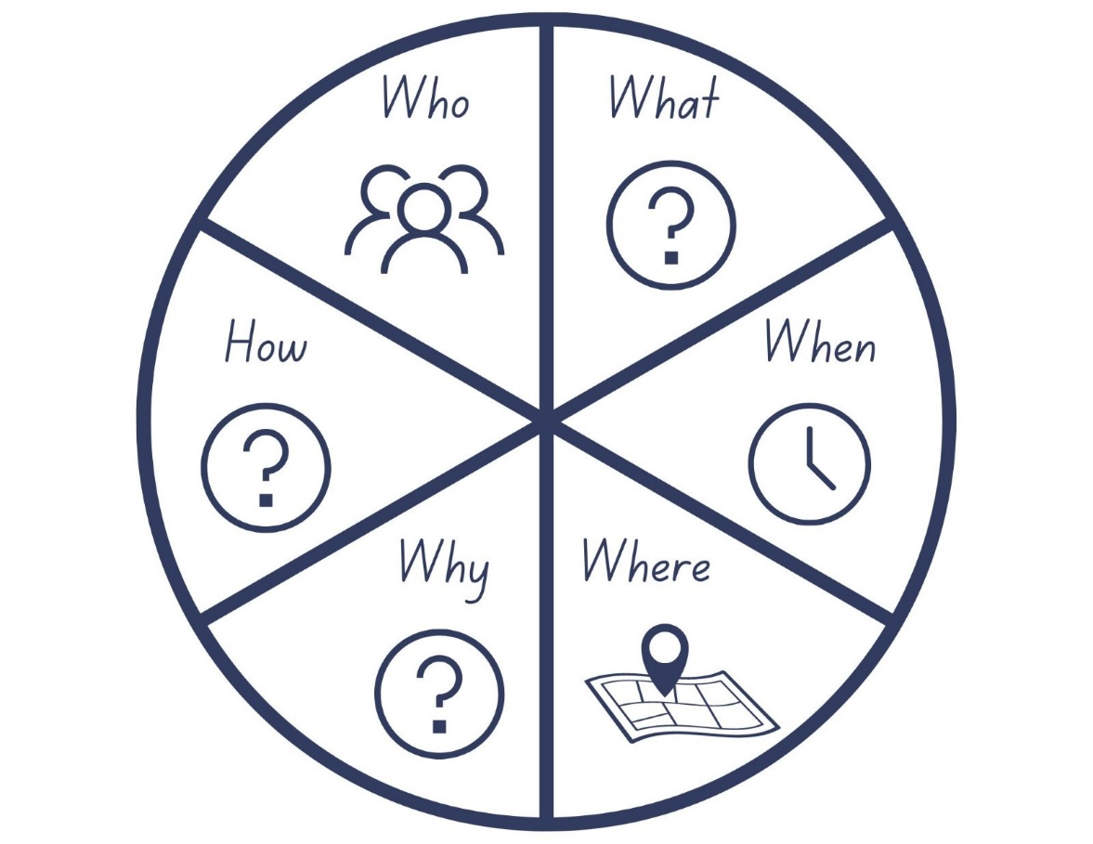
Images sourced from Canva and used in accordance with the Canva Content License Agreement.

Resource 2: Conversation bears
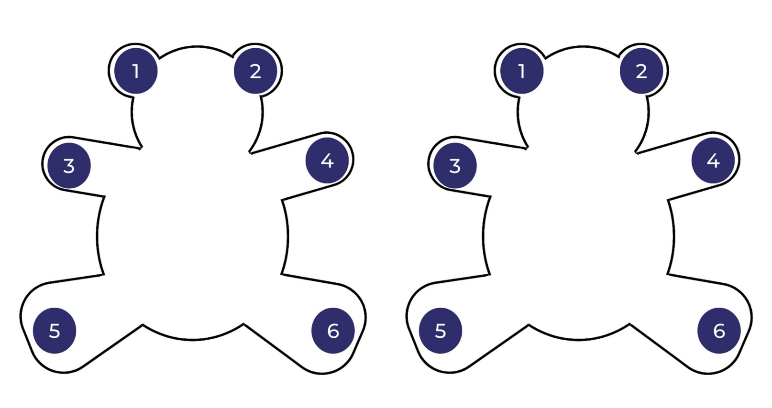
Images sourced from Canva and used in accordance with the Canva Content License Agreement.

Resource 3: Text review
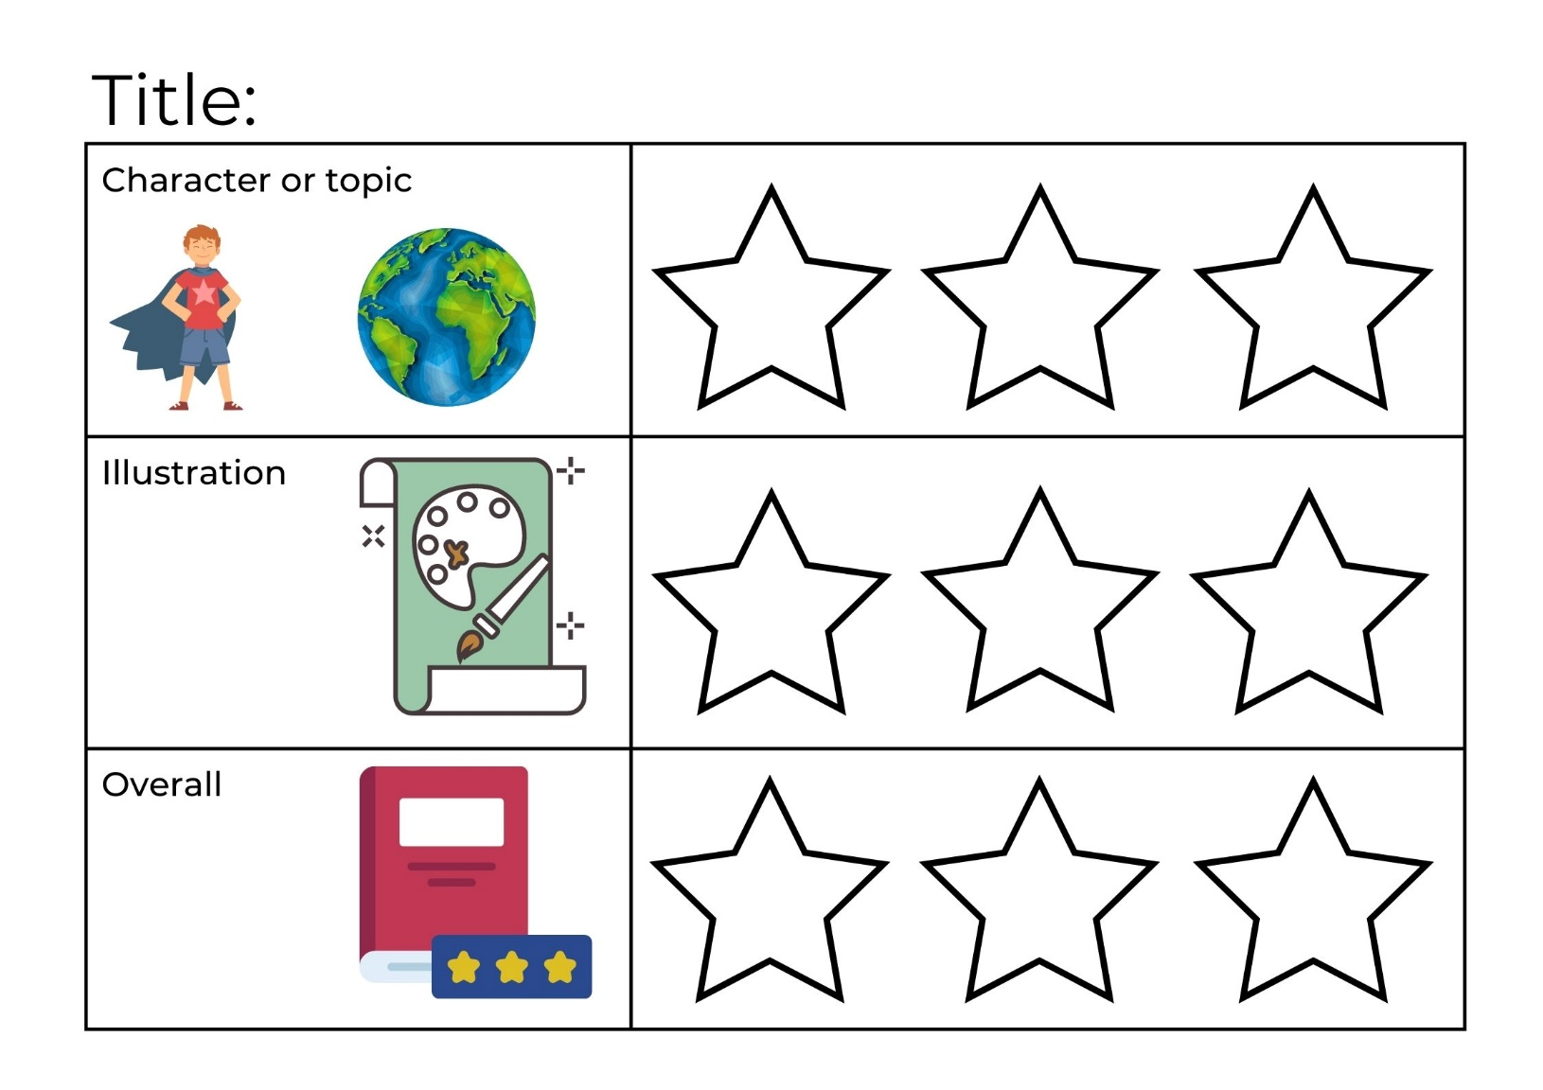
Images sourced from Canva and used in accordance with the Canva Content License Agreement.

References
Links to third-party material and websites
Please note that the provided (reading/viewing material/list/links/texts) are a suggestion only and implies no endorsement, by the New South Wales Department of Education, of any author, publisher, or book title. School principals and teachers are best placed to assess the suitability of resources that would complement the curriculum and reflect the needs and interests of their students.
If you use the links provided in this document to access a third-party's website, you acknowledge that the terms of use, including licence terms set out on the third-party's website apply to the use which may be made of the materials on that third-party website or where permitted by the Copyright Act 1968 (Cth). The department accepts no responsibility for content on third-party websites.
Except as otherwise noted, all material is © State of New South Wales (Department of Education), 2021 and licensed under the Creative Commons Attribution 4.0 International License. All other material (third-party material) is used with permission or under licence. Where the copyright owner of third-party material has not licensed their material under a Creative Commons or similar licence, you should contact them directly for permission to reuse their material.
English K–10 Syllabus © 2022 NSW Education Standards Authority (NESA) for and on behalf of the Crown in right of the State of New South Wales.
Creative Arts K-6 Syllabus © 2006 NSW Education Standards Authority (NESA) for and on behalf of the Crown in right of the State of New South Wales.
Mathematics K–10 Syllabus © 2022 NSW Education Standards Authority (NESA) for and on behalf of the Crown in right of the State of New South Wales.
© 2021 NSW Education Standards Authority. This document contains NSW Curriculum and syllabus content. The NSW Curriculum is developed by the NSW Education Standards Authority. This content is prepared by NESA for and on behalf of the Crown in right of the State of New South Wales. The material is protected by Crown copyright.
Please refer to the NESA Copyright Disclaimer for more information.
NESA holds the only official and up-to-date versions of the NSW Curriculum and syllabus documents. Please visit the NSW Education Standards Authority (NESA) website and the NSW Curriculum website.
National Literacy Learning Progression © Australian Curriculum, Assessment and Reporting Authority (ACARA) 2010 to present, unless otherwise indicated. This material was downloaded from the Australian Curriculum website (National Literacy Learning Progression) (accessed 2 December 2022) and was not modified. The material is licensed under CC BY 4.0. Version updates are tracked in the ‘Curriculum version history’ section on the 'About the Australian Curriculum' page of the Australian Curriculum website.
ACARA does not endorse any product that uses the Australian Curriculum or make any representations as to the quality of such products. Any product that uses material published on this website should not be taken to be affiliated with ACARA or have the sponsorship or approval of ACARA. It is up to each person to make their own assessment of the product, taking into account matters including, but not limited to, the version number and the degree to which the materials align with the content descriptions and achievement standards (where relevant). Where there is a claim of alignment, it is important to check that the materials align with the content descriptions and achievement standards (endorsed by all education Ministers), not the elaborations (examples provided by ACARA).
ETA (English Teachers Association) and NSW Department of Education (2016) The Textual Concepts and Processes resource, English Textual Concepts website, accessed 2 December 2022.
ETA (English Teachers Association) and NSW Department of Education (2016) Perspective, English Textual Concepts website, accessed 2 December 2022.
Fox M (1989) Shoes from Grandpa (Mullins P, illus.), 25th Anniversary edn, Scholastic, Australia.
Howarth K (2018) Chip, Hardie Grant Children’s Publishing, Australia.
Lee S (2008) Wave, Chronicle Books, United States.
Mackenzie N (22 October 2019) ‘Draw, Talk, Write (and Share)’, Noella’s Blog, accessed 2 December 2022.
President and Fellows of Harvard College (2022) ‘See, Think, Wonder’, Resources, Project Zero website, accessed 2 December 2022.
Zommer Y (2016) The Big Book of Bugs, Thames and Hudson Ltd, Great Britain.

