English – Early Stage 1 – Unit 9
Contents
Unit overview and instructions for use 3
Teacher notes 4
Outcomes and content – Component A 5
Outcomes and content – Component B 7
Week 1 10
Component A teaching and learning 10
Component B teaching and learning 11
Lesson 1: Understanding images in a wordless text 12
Lesson 2: Describing images and identifying mood at the beginning of the text 14
Lesson 3: Describing images and identifying mood in the middle of a text 16
Lesson 4: Describing the wave – beginning, middle and end 19
Lesson 5: Making text-to-self connections 20
Week 2 22
Component A teaching and learning 22
Component B teaching and learning 23
Lesson 6: Using visual cues to make meaning 24
Lesson 7: Using visual cues to ask and respond to questions 26
Lesson 8: Using visual cues to support predictions 27
Lesson 9: Retelling a sequence of events using prepositional phrases 29
Lesson 10: Using images, symbols and creative language to enhance events 31
Resource 1: Question wheel 33
Resource 2: Subject–verb–object sentence frame 34
Resource 3: Mood cards 35
Resource 4: Subject-verb-prepositional phrase sentence frame 36
Resource 5: Story map example 37
Resource 6: Spotlight template 38
References 39

Unit overview and instructions for use
This two-week unit is comprised of Component A and Component B. Connecting learning across both components is encouraged.
Teaching and learning | Component A | Component B
Suggested duration | 60 minutes | 45 minutes
Explicit teaching focus areas | - Phonological awareness  - Print conventions  - Phonic knowledge  - Reading fluency  - Reading comprehension  - Spelling  - Handwriting | - Oral language and communication  - Vocabulary  - Reading comprehension  - Creating written texts  - Understanding and responding to literature
To prepare for teaching and learning: | - Refer to Outcomes and content – Component A, K-2 – Instructional sequence – grapheme–phoneme correspondences [PDF 825 KB], and the teaching advice documents (hyperlinked in Component A teaching and learning table).  - Based on student needs identified through ongoing assessment data, plan and document how you will sequence teaching and learning in whole class and targeted teaching groups across the two-week cycle. | - Familiarise yourself with Outcomes and content – Component B, Textual concepts information and videos, English Textual Concepts and Learning Processes (2016), and the teaching and learning sequence.  - Based on student needs identified through ongoing assessment data, determine how you will support students in whole class and targeted teaching groups across the two-week cycle as required.
English K–10 Syllabus © 2022 NSW Education Standards Authority (NESA) for and on behalf of the Crown in right of the State of New South Wales.

Teacher notes
- Imagery, symbol and connotation extend words and symbols beyond their literal meaning. They are used to provide deeper meaning, evoke emotion and enhance enjoyment in texts. – English Textual Concepts and Learning Processes (2016).
- Understanding of imagery, symbol and connotation can be supported through watching the department’s video: Understanding connotation, imagery and symbol video (6:07).
- While imagery, symbol and connotation is the mentor concept for the conceptual component of this unit, the supporting concept of narrative can be explored using the mentor text Wave by Suzy Lee and supporting text Spencer’s New Pet by Jessie Sima.
- For information on verbs, prepositions, imagery and symbol refer to the NESA Glossary.
- The draw, talk, write (and share) strategy for emergent writers includes drawing as part of a meaning making process, while talking and sharing allows children to make sense of their ideas and to develop their vocabulary and oral language skills. Writing provides an opportunity to apply phonic and word knowledge into another context. Best practice in this strategy is modelled by Australian researcher Noella Mackenzie. For further information, refer to the website Draw, Talk, Write (and Share).
- Reflect on student learning and engagement in activities and record differentiation and adjustments within the unit to inform future teaching and learning. One way of doing this could be to add comments to the digital file.
- Content points are linked to the National Literacy Learning Progression version (3).
Levels and indicators sourced from National Literacy Learning Progression © Australian Curriculum, Assessment and Reporting Authority (ACARA), (accessed 15 November 2022) and was not modified. See references for more information.

Outcomes and content – Component A
The table below outlines the focus outcomes and content. Content is linked to the National Literacy Learning Progression version (3).
Focus area and outcome | Content points and National Literacy Learning Progression
Phonological awareness  ENE-PHOAW-01 – identifies, blends, segments and manipulates phonological units in spoken words as a strategy for reading and creating texts | - provide a word when given a starting phoneme (PhA2)  - identify the number of phonemes that make up a spoken one-syllable word comprising fewer than 4 phonemes (PhA4)
Print conventions  ENE-PRINT-01 – tracks written text from left to right and from top to bottom of the page and identifies visual and spatial features of print | N/A
Phonic knowledge  ENE-PHOKW-01 – uses single-letter grapheme–phoneme correspondences and common digraphs to decode and encode words when reading and creating texts | - blend common single-letter grapheme–phoneme correspondences to read CCVC and CVCC words, and apply this when reading texts, including decodable texts (PKW5)  - segment common, single-letter grapheme–phoneme correspondences to encode CCVC and CVCC words (PKW5)  - decode and blend words containing consonant digraphs and apply this when reading texts, including decodable texts (PKW5)  - segment and encode CVC words containing consonant digraphs (PKW4, PKW5)
Reading fluency  ENE-REFLU-01 – reads decodable texts aloud with automaticity | - know that fluent reading involves recognising and reading words accurately and automatically
Reading comprehension  ENE-RECOM-01 – comprehends independently read texts using background knowledge, word knowledge and understanding of how sentences connect | - use visual cues in multimodal texts to interpret meaning (UnT5)  - recall the sequence of events/information in texts (UnT5)
Spelling  ENE-SPELL-01 – applies phonological, orthographic and morphological generalisations and strategies to spell taught familiar and high-frequency words when creating texts | - combine phonological, phonic, orthographic and morphemic knowledge to spell taught high-frequency irregular words comprising up to 3 phonemes (SpG5)  - know that the digraphs zz, ss, ll, ff and ck do not usually start a word in Standard Australian English  - experiment with the tense-marking suffixes to spell familiar base verbs (SpG5)
Handwriting  ENE-HANDW-01 – produces all lower-case and upper-case letters to create texts | - apply taught handwriting skills when creating texts

Outcomes and content – Component B
The table below outlines the focus outcomes and content. Content is linked to the National Literacy Learning Progression version (3).
Focus area and outcome | Content points and National Literacy Learning Progression
Oral language and communication  ENE-OLC-01 – communicates effectively by using interpersonal conventions and language with familiar peers and adults | - understand how the most common inflected word forms affect the meanings of words  - ask questions using who, what, when, where, why or how  - use regular past tense verbs when speaking  - use irregular past tense verbs when speaking  - tell a story or information to peers or adults using oral language (SpK3)
Vocabulary  ENE-VOCAB-01 – understands and effectively uses Tier 1 words and Tier 2 words in familiar contexts | - understand and use words to describe shape, size, texture, position, numerical order, time and seasons (SpK3, CrT3)  - identify, name and describe a range of objects, characters, animals, people and places when given visual and/or auditory prompts (GrA1)
Reading comprehension  ENE-RECOM-01 – comprehends independently read texts using background knowledge, word knowledge and understanding of how sentences connect | - use visual cues in multimodal texts to interpret meaning  - recall the sequence of events/information in texts
Creating written texts  ENE-CWT-01 – creates written texts that include at least 2 related ideas and correct simple sentences | - include recognisable structural features for text purpose (CrT5)  - create written texts that describe, give an opinion, recount an event, convey a story  - write a simple sentence with correct subject-verb-object structure to convey an idea (GrA2, GrA3, CrT4)  - use prepositional phrases to indicate time or place (GrA4)  - use personal vocabulary, words on display and in mentor texts when constructing sentences  - use drawing, images or mind maps to support planning and writing (CrT4)
Understanding and responding to literature  ENE-UARL-01 – understands and responds to literature read to them | - identify how visual cues contribute to the meaning of a text  - identify and discuss how creative language and/or symbols enhance enjoyment in texts  - experiment with using parts and/or features of a narrative, innovating from a mentor text

Week 1

Component A teaching and learning
The table below can be used to plan and document lessons that address Component A outcomes and content. Both the detailed example [DOC 529KB] of a two-week teaching and learning cycle and brief example [DOC 66KB] may support you in your planning.
Focus Areas | Lesson 1 | Lesson 2 | Lesson 3 | Lesson 4 | Lesson 5
Phonological awareness and
Phonic knowledge
15 minutes
Spelling and Handwriting
15 minutes
Print conventions,
Reading comprehension and Reading fluency
30 minutes

Component B teaching and learning
The following teaching and learning sequence has been designed to address Component B outcomes and content. Adapt the sequence as required to best meet the needs of your students.

Learning intention and success criteria
Learning intentions and success criteria are best co-constructed with students.

Learning intention
Students are learning how authors use illustrations to enhance meaning in texts.

Success criteria
Students can:
- use visual cues to interpret meaning in a text
- use regular and irregular past tense verbs when speaking
- use visual prompts to describe objects, characters and places
- write a simple sentence using subject-verb-object structure
- use prepositional phrases.

Resources
- Lee S (2008) Wave, Chronicle Books, United States. ISBN: 9780811859240
- Resource 1: Question wheel
- Resource 2: Subject-verb-object sentence frame
- Resource 3: Mood cards
- Resource 4: Subject-verb-prepositional phrase sentence frame
- Sticky notes
- Blue paper or cellophane and craft sticks
- Art and craft materials, such as art paper, blue paint, black markers

Lesson 1: Understanding images in a wordless text
- Revise the textual concepts of imagery, symbol and connotation and explain that they can enrich a text by making words and images mean more than one thing.
- Display the text Wave by Suzy Lee. Look at the title and images on the front cover and make predictions about what type of text it is, the characters, setting and what it could be about. In pairs, students orally share predictions and draw a picture of what they think the character may do in the book. Prompt students to use visual cues, their own background knowledge and prior experiences to make predictions. Share responses as a class.
- Flick through several pages of the text and ask students if they notice anything different compared to other books they have read. For example, Wave has no written text, and blue and white are the only colours added to the illustrations.
- Silently walkthrough the text from beginning to end. Provide time for students to look at each image and think about what is happening throughout the story.
- Highlight how the author has told the story using visuals. In pairs, students discuss what the text is about. Explain that this wordless text is a narrative. Provide the opportunity for students to make comparisons with other narratives read as a class. Highlight that narratives give information including who the text is about, what is happening and what the circumstances are (when, where, how and/or why).
- Display Resource 1: Question wheel. Explain how question words and sentences help readers to understand details about characters, events and information in a text. Prompt students with guiding questions. For example:
- Who was/were the characters in the story?
- Where did the story take place?
- What was the problem in the story?
- How did the main character feel?
Encourage students to refer to visual cues from the text to support their thinking. For example, the story is set at the beach because there is sand, waves and seagulls.
- Return to students’ predictions from activity 2. Discuss the similarities and differences between what students thought may happen, and what occurred in the story.
- Provide time for students to draw something that occurred in the text Wave.
- Model using Resource 2: Subject-verb-object sentence frame to write simple sentences about the text with a focus on the role of the subject, verb and object. For example, The little girl (subject) loved (verb) the beach (object). She ran. She jumped. She played.
- Model rephrasing or recasting statements to ensure correct inflections when speaking in past tense. Give present tense verbs for students to say as past tense. Begin with regular and move to irregular as appropriate, for example, walk-walked, play-played, run-ran, fly-flew, sit-sat. Put words into contextually relevant sentences for students to hear and repeat. Provide non-examples and examples for irregular past tense. For example, the girl sitted on the beach / the girl sat on the beach.
- In pairs, students share sentences about their drawing. Encourage students to use past tense. Students write a sentence about their own drawing.
- Share student learning with a focus on the ‘who’ and 'what’ elements they have represented in their drawings and writing.

Lesson 2: Describing images and identifying mood at the beginning of the text
- Review the text Wave. Explain that, over the next 3 lessons, students will focus on the beginning, middle and end of the text. This lesson will focus on the beginning. Look at pages from the beginning of the text that show the girl when she gets to the beach and plays on the sand (before entering the waves). Explain that in the beginning of a narrative we often learn about the character and the setting.
- Using Resource 1: Question wheel, students turn and talk to a partner to discuss what happened in the beginning of the text. Review and expand on strategies for making meaning from a wordless text. For example, using background knowledge and prior experiences about beaches; using visual cues such as body language, facial expressions, positioning of the characters, size of images and colour. Provide opportunities for students to focus on and describe the seagulls, the ocean and the central character.
- Display Resource 3: Mood cards. Explain that the author has conveyed the emotions of the character using colour and images. Look closely at pages from the beginning of the text and ask students:
- What did the girl do in the pictures?
- Where is the girl?
- How did she feel? How do you know?
- Where are the seagulls? Are the seagulls doing something that is the same or different to the little girl?
- What are the waves doing?
- Discuss student responses. Ask students to select mood cards to match the pages showing how the girl felt.
- Revise the term ‘verbs’ and explain that they are words that tell the reader what is happening, or what has happened. Explicitly teach that verbs can describe actions and feelings. Using events from the beginning of the story, create an anchor chart of verbs that provide information about actions and feelings, for example:
- actions – ran, looked, sat, played
- feelings – scared, worried, brave.
- Call out different action and feeling verbs from the anchor chart for students to act out.
- Revise the term ‘prepositional phrase’ as a group of words that describe where (place) or when (time) something is in relation to something else. Provide examples of prepositions that describe place. For example, on, in, above. Contextualise examples to the text (The girl played on the sand. The seagulls flew above the little girl). Review the beginning pages of the text and have students think of prepositions that describe place. Add examples to the anchor chart.
- Select a double page from the beginning of the text. Model writing simple sentences that describe the character’s actions and emotions. Explicitly teach how a sentence can be expanded with contextually precise prepositional phrases to describe ‘where’. For example:
- The girl sat on the sand. She was scared of the waves.
- The seagulls stood behind the little girl. She felt worried.
- Lilly roared at the waves. I am brave.
Note: To add variety to text construction, the central character may be given a name.
- Students draw a scene from the beginning of the text. In pairs, students use Resource 1: Question wheel to ask and answer questions about their drawings. Students use the models provided from activity 8 to write a sentence containing a prepositional phrase to describe their illustration.
Too hard? Students write a sentence using the subject-verb structure. For example, The girl ran.
Too easy? Students include details about how the girl felt. For example, The girl ran away from the wave because she felt scared.

Lesson 3: Describing images and identifying mood in the middle of a text
- Review the text Wave. Revise how the girl felt at the beginning of the story. Encourage students to explain how the author has conveyed meaning using different visual cues. Explain that this lesson will focus on what happened in the middle of the text. Highlight that in the middle of a narrative we often get to see what the character is doing through a series of events. Sometimes there can be a problem in the middle of a narrative.
- Look at the 2 double pages that show the character entering the water. Discuss the images, including the positioning of the seagulls and the ocean. Ask students:
- What did the girl do in the picture?
- Where is the girl?
- Where are the seagulls? Are the seagulls doing something that is the same or different to the little girl?
- What are the waves doing?
- Display Resource 3: Mood cards. Explain that the author has used visual cues, such as the use of colour, size and layout, to convey meaning and how the mood of the character changes throughout the text. Look at one page from the middle of the text, for example, the girl running away from the wave. Consider how the character's mood has changed from the beginning of the text where she was playing on the sand. Ask students:
- How did she feel? How did you know?
- What might she be thinking in this part of the text?
- Discuss student responses. Place the mood cards on the pages to reflect how the girl was feeling during this ‘event’ in the middle of the story. Discuss the visual techniques used to indicate the change in the girl’s mood/feelings from the beginning of the text. For example, the girl became more confident and was not afraid of the water; she moved from the left-hand side of the page to the right.
- Revise the anchor chart of verbs from Lesson 2. Add verbs to describe the girl’s actions and feelings in the middle of the text. For example:
- actions – splashed, kicked, played
- feelings – excited, happy, delighted.
- Provide the opportunity for students to act out verbs recorded on the anchor chart.
- Look at the following 5 double pages in the text which show the character interacting with the wave and then being swept over by the wave. Discuss images and use mood cards again, similar to activities 2 to 6. Highlight the change in events and character mood.
- In small groups, students use the list of action and feeling verbs to orally construct sentences about what the character was doing in the middle of the story. Encourage students to use past tense verbs to retell the story. Share student sentences.
- Select a double page from the middle of the text. Display Resource 4: Subject-verb-prepositional phrase sentence frame. Model writing simple sentences into the sentence frame that describe the character’s actions. Include contextually precise prepositional phrases. Additional words can be added to reflect the character’s emotions. For example:
- The little girl splashed in the waves. The seagulls played above her.
- Oh no! A big wave rolled towards Lilly and the seagulls.
- Lilly ran away from the giant wave. The seagulls flew away from the giant wave.
- Students draw a picture about the girl in the middle of the story. Students orally share their sentence with a partner. Students write a sentence about the girl using a subject (who), verb (what) and prepositional phrase (where). Encourage students to use personal vocabulary and words on display to support sentence construction.
Too hard? Students write a sentence using the subject-verb structure. For example, The girl played.
Too easy? Students write a sentence about how the girl felt in the middle of the story. For example, The girl was scared of the big wave.
Early Stage 1 Assessment task 1 – Observations from this lesson allow students to demonstrate achievement towards the following syllabus outcome and content points:
ENE-OLC-01 – communicates effectively by using interpersonal conventions and language with familiar peers and adults
- understand how the most common inflected word forms affect the meanings of words
- use regular past tense verbs when speaking
- use irregular past tense verbs when speaking.

Lesson 4: Describing the wave – beginning, middle and end
- Review learning from the previous lessons. Explain that at the end of a narrative, the problem that occurred in the middle of the story is usually resolved. Walkthrough the text Wave and discuss how the character felt at the end of the story. Using Resource 1: Question wheel, provide the opportunity for students to ask each other questions about events from the end of the story.
- Consider if the story ‘problem’ was resolved. Highlight how the author has used colour to convey meaning. For example, on the page as the wave reached the girl, the author spread the colour blue into the sky and on the girl’s dress. This shows that the girl now has a positive relationship with the beach and the waves.
- Look at the images of the waves from the beginning, middle and end of the text. Discuss how the size and colour of the waves change.
- Using sticky notes, write words to describe the shape, size and position of the waves and label them throughout the text. For example, big, strong, calm, flat, choppy, scary, giant. Explain that the author has used colour, shape, size, and the position of the waves to reflect the relationship between the girl and the waves.
- Provide students with blue paper or cellophane and an object to represent the girl from the text. In pairs, students retell parts of the story using the paper or cellophane as the wave. Encourage students to use the position of the wave and the girl to show how their relationship changed throughout the text. For example, at the beginning of the story the girl is positioned away from the waves, in the middle the waves crashes over her, and at the end of the story the girl plays in a shallow wave before going home. Students can reshape the paper or cellophane to match the changing wave.
- Draw an illustration of the wave from the text. Model writing a sentence about the wave. For example, The giant wave scared the girl. Highlight how the visual features of the artwork reflect the sentence. For example, the wave is taking up most of the paper and the girl is much smaller than the wave. The girl is positioned far away from the wave to show she is afraid.
- Students write a sentence about their artwork. Encourage students to use personal vocabulary and words on display.
Too hard? Students label colour, size and shape on their artwork using words on display from activity 4.
Too easy? Students include a prepositional phrase in their sentence. For example, The scary wave chased the girl up the beach.
Early Stage 1 Assessment task 2 – Observations and work samples from this lesson allow students to demonstrate achievement towards the following syllabus outcomes and content points:
ENE-VOCAB-01 – understands and effectively uses Tier 1 words and Tier 2 words in familiar contexts
- understand and use words to describe shape, size, texture, position, numerical order, time and seasons
- identify, name and describe a range of objects, characters, animals, people and places when given visual and/or auditory prompts.
ENE-CWT-01 – creates written texts that include at least 2 related ideas and correct simple sentences
- write a simple sentence with correct subject-verb-object structure to convey an idea.

Lesson 5: Making text-to-self connections
- Revise the narrative structure of Wave as a sequence of events about a girl at the beach, playing with the waves. Recall events from the beginning, middle and end of the narrative. Identify events that reflect a problem or surprise.
- Explain that students will create an artwork of how they think they would feel if they were at this beach with the seagulls and waves.
- Ask students to close their eyes and visualise themselves on the beach. Prompt students to imagine what it would look like, feel like and sound like.
- In pairs, students describe the shape, size and position of the wave that they will create and to think about how they will place themselves in the artwork. For example, what they will be doing and how they are feeling.
- Provide students with art and craft materials, such as art paper, blue paint and black markers. Students create an artwork of their wave and themselves. Explain that, like the author Suzy Lee, students will use colour, size, shape and position to show the relationship between the wave, the seagulls and themselves, and add detail to the image to show how they are feeling.
- Display completed artworks. Using Resource 1: Question wheel, guide students to ask and answer questions about the artworks.
- Select an artwork to model writing a simple sentence using subject (who), verb (what) and prepositional phrase (where) to describe the image.
- Students write a sentence describing their own artwork using personal and displayed vocabulary to support construction.
Too hard? Students use their artwork to give an oral sentence describing who, what and where. Scribe sentences for students.

Week 2

Component A teaching and learning
The table below can be used to plan and document lessons that address Component A outcomes and content. Both the detailed example [DOC 529KB] of a two-week teaching and learning cycle and brief example [DOC 66KB] may support you in your planning.
Focus Areas | Lesson 6 | Lesson 7 | Lesson 8 | Lesson 9 | Lesson 10
Phonological awareness and
Phonic knowledge
15 minutes
Spelling and Handwriting
15 minutes
Print conventions,
Reading comprehension and Reading fluency
30 minutes

Component B teaching and learning
The following teaching and learning sequence has been designed to address Component B outcomes and content. Adapt the sequence as required to best meet the needs of your students.

Learning intention and success criteria
Learning intentions and success criteria are best co-constructed with students.

Learning intention
Students are learning how authors use illustrations to enhance meaning in texts.

Success criteria
Students can:
- use visual cues to interpret meaning in a text
- ask questions using who, what, when, where, why or how
- use prepositional phrases
- use drawings to support planning and writing
- use personal vocabulary and words on display to construct sentences.

Resources
- Sima J (2019) Spencer’s New Pet, Simon & Schuster Books. ISBN: 9781534418776
- Resource 1: Question wheel
- Resource 4: Subject-verb-prepositional phrase sentence frame
- Resource 5: Story map example
- Resource 6: Spotlight template
- Sticky notes

Lesson 6: Using visual cues to make meaning
- Introduce the text Spencer’s New Pet and explain that the text was inspired by silent films. Outline that this text is also a wordless narrative like Wave. The author uses images to give information including who it is about, what is happening and what the circumstances are (when, where, how and/or why).
- Flick through the beginning of the text and identify film aspects, such as the black and white colours, the 3 countdown circles and the use of title cards for each part of the text. Explain that the text is broken into 3 parts and this lesson will focus on the beginning of the text, Part 1: The Pet. Silently walkthrough Part 1, stopping at each page to provide time for students to notice details and think about the story that is being told.
- Using Think-Pair-Share, students give their opinion about the text, describe what they noticed in the images and discuss what they wonder about. As a class, identify the main characters and events in Part 1. Ask students what visual cues they used to make meaning. For example, one of the main characters is a clown, and readers know this because he was inside a circus tent and wore a hat and a coat.
- Display Resource 1: Question wheel. Model asking questions about the text and record these on a class display. For example:
- Who is Spencer?
- What is Spencer’s new pet?
- When did Spencer get his new pet?
- Where did Spencer take his new pet?
- Why would Spencer take him to the vet?
- How did Spencer feel when he ran out of the vet?
- Choose a question from the class display in activity 4. Model answering the question using visual cues from the text. For example, Spencer ran out of the vet feeling worried because the animal spike could pop his balloon pet.
- In small groups, students use Resource 1: Question wheel to generate questions about the beginning of the text or choose questions from the class display to ask each other. Students take turns to answer each other’s questions about the beginning, referring to images in Part 1 if needed.
- Revise the main events in Part 1 of the text. Co-construct 2 or 3 simple sentences to retell an event that occurred at the beginning of the text. Include details about who, what and where, using the sentence structures of subject-verb-object and subject-verb-prepositional phrase. Display sentences in the classroom. For example, Spencer’s new pet (subject) was (verb) a balloon dog (object). He (subject) sat it (verb) on his lap (prepositional phrase).
- Using the draw, talk, write (and share) strategy, students retell an event from Part 1 of the text and write a sentence to match their drawing.

Lesson 7: Using visual cues to ask and respond to questions
- Revise Part 1 of Spencer’s New Pet.
- Read the title, Part 2: The Park and explain that this is the middle of the text. Ask students to predict what problem there might be in the middle of Spencer’s New Pet. Prompt students to think about what other dangers Spencer and his pet could face at the park. Students draw their predictions. Share drawings and display in the classroom.
- Silently walkthrough Part 2 of the text. Discuss the character’s actions and the main events. Ask students if their predictions from activity 2 are similar to the text or different.
- Revisit Resource 1: Question wheel. Model asking questions about the text. For example:
- Who gave Spencer the skateboard?
- What was Spencer’s pet in danger of?
- When did Spencer feel worried?
- Where did Spencer go in the park?
- Why did Spencer jump between his pet and the dog?
- How did Spencer’s feelings change at the park?
- Model answering one of the questions using visual cues from the text.
- In small groups, students generate more questions about the text. Share questions as a class and add questions to the class display. In pairs, students choose questions from the class display and use visual cues from the text to answer the questions. For example, when Spencer arrived at the park, he was smiling and feeling happy. He became scared when his pet was in danger of getting bitten by a dog. Spencer chased his pet through the park.
- Re-read the co-constructed sentences about the beginning of the text from Lesson 6. Using Resource 4: Subject-verb-prepositional phrase sentence frame, co-construct 2 or 3 sentences describing events that happened at the park with details about who, what and where. For example:
- Spencer (who/subject) walked (what/verb) through the park (where/prepositional phrase).
- His pet (who/subject) blew (what/verb) up into the sky (where/prepositional phrase).
- Spencer (who/subject) ran (what/verb) after his pet (where/prepositional phrase).
Display in the classroom.
- Using the draw, talk, write (and share) strategy, students retell an event from Part 2 of the text and write a sentence to match their drawing.
Too hard? Students label their drawing using words or phrases on display.

Lesson 8: Using visual cues to support predictions
- Revise Part 1: The Pet and Part 2: The Park of Spencer’s New Pet.
- Introduce Part 3: The Party and discuss the dangers Spencer and his pet could face at the party.
- In pairs, students predict what the problem might be in Part 3: The Party, and how it may be resolved in the end. Students share their predictions.
- Silently walkthrough Part 3, stopping at the page with the word ‘POP’. Explain that the story is ending. Ask students to predict what might happen and how the story might end, recording ideas on sticky notes. Share and display predictions in the classroom.
- Display the page in the text showing the balloon dog and Spencer’s glasses on the ground. Ask students if their predictions were correct. Identify which character popped and provide reasons using clues in the text. For example, Spencer popped because there is a pair of glasses on the ground and they belonged to him.
- Revisit Resource 1: Question wheel. In small groups, students generate questions about Part 3 of the text. Share with the class and create a display of questions. In pairs, students choose questions from the class display and use visual cues from the text to answer the questions.
- Re-read the text as a whole and look for clues to support the idea that Spencer was a balloon. Pause throughout the text and discuss students’ ideas. Ask students to give their opinion about the end of the text. Explain how the author has used visual elements to create suspense, surprise the reader and enhance enjoyment. For example, the page of text with the word ‘POP’. Discuss other ways the author has used visual cues or symbols to enhance suspense and enjoyment.
- Re-read the co-constructed sentences about Part 1 and Part 2 of the text. Co-construct 2 or 3 simple sentences to retell events that happened in the middle and end of the narrative, at the party. Use subject-verb object and subject-verb-prepositional phrase sentence structure to describe who, what and where/when. For example:
- Spencer (who/subject) popped (what/verb) at the party (where/prepositional phrase).
- The clown (who/subject) made (what/verb) a new balloon boy (what/object).
- Using the draw, talk, write (and share) strategy, students represent an event from Part 3 of the text and record a sentence to match their drawing.
Too hard? Students label their drawing using words on display.
Early Stage 1 Assessment task 3 – Observations from this lesson allow students to demonstrate achievement towards the following syllabus outcomes and content points:
ENE-OLC-01 – communicates effectively by using interpersonal conventions and language with familiar peers and adults
- ask questions using who, what, when, where, why or how.
ENE-RECOM-01 – comprehends independently read texts using background knowledge, word knowledge and understanding of how sentences connect
- use visual cues in multimodal texts to interpret meaning.
ENE-UARL-01 – understands and responds to literature read to them
- identify how visual cues contribute to the meaning of a text
- identify and discuss how creative language and/or symbols enhance enjoyment in texts.

Lesson 9: Retelling a sequence of events using prepositional phrases
- Explain that the text, Spencer’s New Pet took the reader on a journey. Create a list of places Spencer visited to display in the classroom. Review the anchor chart of prepositions from Lesson 2 and prepositional phrases displayed on sentence frames. Remind students that prepositional phrases describe where (place) or when (time) something is in relation to something else.
- Display Resource 5: Story map example. Model retelling the journey Spencer took through the park, using prepositional phrases. Highlight the use of visual cues, such as images and dotted lines, to retell events in sequence. In pairs, students use the story map to orally retell the sequence of events in the park. Support students to include prepositional phrases.
- Revisit Part 3: The Party, in the text. Explain that students will create a story map of Spencer’s journey through the party. Brainstorm events that occurred at the party. Create an anchor chart of key vocabulary with matching images. Students create a story map using images and lines to sequence events in order.
- In pairs, students share their story map to retell the events in the middle of the narrative (at the party), using prepositional phrases. For example, Spencer went under the sign, beside the pinata, across the table, above the party hat, over the candles and through the animals.
- Students write prepositional phrases on their story map. Encourage students to use personal vocabulary and words on display.
Too hard? Students label their story map using prepositions.
Too easy? Students write sentences that match the sequence of events on their story map.
Early Stage 1 Assessment task 4 – Observations and work samples from this lesson allow students to demonstrate achievement towards the following syllabus outcomes and content points:
ENE-OLC-01 – communicates effectively by using interpersonal conventions and language with familiar peers and adults
- tell a story or information to peers or adults using oral language
ENE-CWT-01 – creates written texts that include at least 2 related ideas and correct simple sentences
- include recognisable structural features for text purpose
- create written texts that describe, give an opinion, recount an event, convey a story
- use prepositional phrases to indicate time or place
- use personal vocabulary, words on display and in mentor texts when constructing sentences
- use drawing, images or mind maps to support planning and writing.

Lesson 10: Using images, symbols and creative language to enhance events
- Review the text, Spencer’s New Pet and draw attention to the spotlight on some of the pages. Discuss the purpose of the spotlight. For example, the author is using the spotlight to highlight an important part of the story.
- Ask students what worried Spencer throughout the text. Flick through the text and identify the dangers posed to the balloon dog. Ask students what visual elements the author used to highlight these dangers, such as the use of stars at the point of an object. Create a list of dangers that Spencer encountered.
- Ask students what happened when Spencer hit the pin from the donkey’s tail. Explain that words that sound like their actions are called onomatopoeia. Draw a balloon on an anchor chart, and list different sounds it could make if it bursts. For example, pop, crack, bang, boom, pow.
- Select other images from the text and ask students to describe the image using onomatopoeia. For example:
- when the dog is going to bite Spencer’s pet – woof, yelp, growl
- on the page when Spencer goes through the park gate and lines represent the wind – whoosh, swish
- on the page where the eagle is chasing Spencer’s pet through the air – squawk, screech, shriek.
Add vocabulary to the anchor chart.
- Using Resource 6: Spotlight template, model drawing some of the dangerous items that Spencer’s pet encountered in the text. For example, the sharp edge of the kite, the bees in the garden and the burning candles. Model using the anchor chart to write an onomatopoeia that matches the image.
- Using Resource 6: Spotlight template, students draw 3 dangerous events Spencer encountered in the text. Encourage students to sequence their ideas in order and use visual techniques, such as the use of stars to highlight the dangerous objects. Students use the anchor chart to write an onomatopoeia that matches the images in their 3 events.
- In pairs, students share their drawings and describe the features and words used to enhance their retell of events.
Too hard? Students draw 3 spotlight pictures and record their sound using voice-to-text technology.
Too easy? Students draw 3 spotlight pictures and write sentences retelling the story.
Early Stage 1 Assessment task 5 – Observations and work samples from this lesson allow students to demonstrate achievement towards the following syllabus outcomes and content points:
ENE-RECOM-01 – comprehends independently read texts using background knowledge, word knowledge and understanding of how sentences connect
- recall the sequence of events/information in texts.
ENE-UARL-01 – understands and responds to literature read to them
- experiment with using parts and/or features of a narrative, innovating from a mentor text.

Resource 1: Question wheel
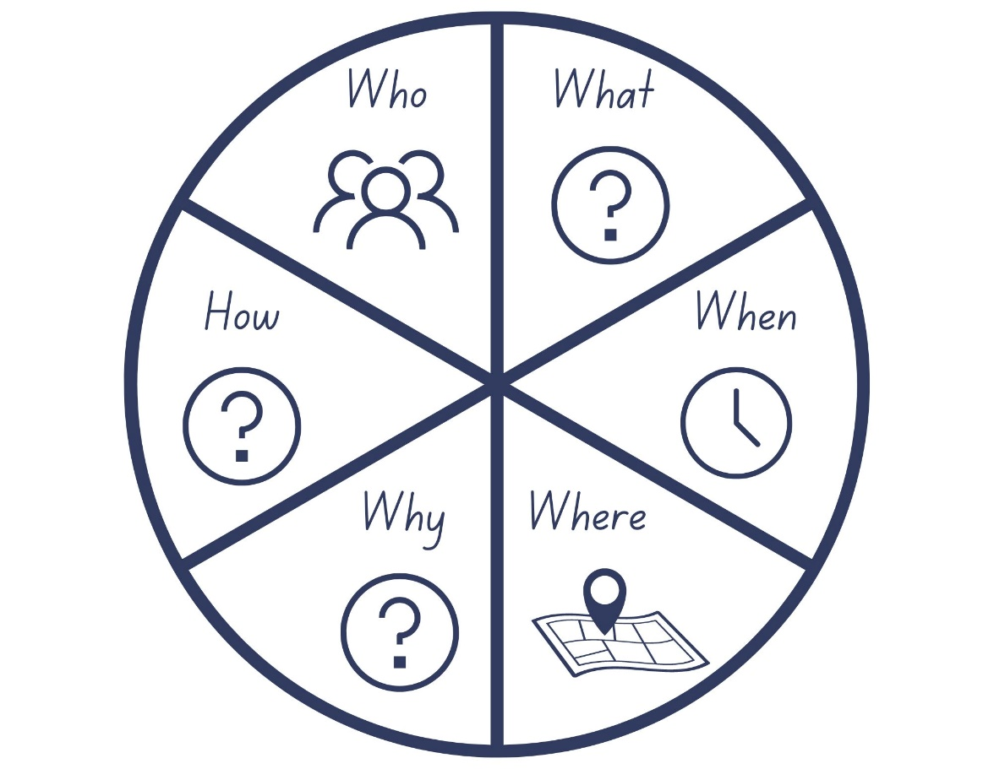
Images sourced from Canva and used in accordance with the Canva Content License Agreement.

Resource 2: Subject–verb–object sentence frame
Example:
Subject | Verb  (doings/happenings/states) | Object
The girl | kicked | the waves.
Use the sentence frame to create your own sentences.
Subject | Verb  (doings/happenings/states) | Object

Resource 3: Mood cards
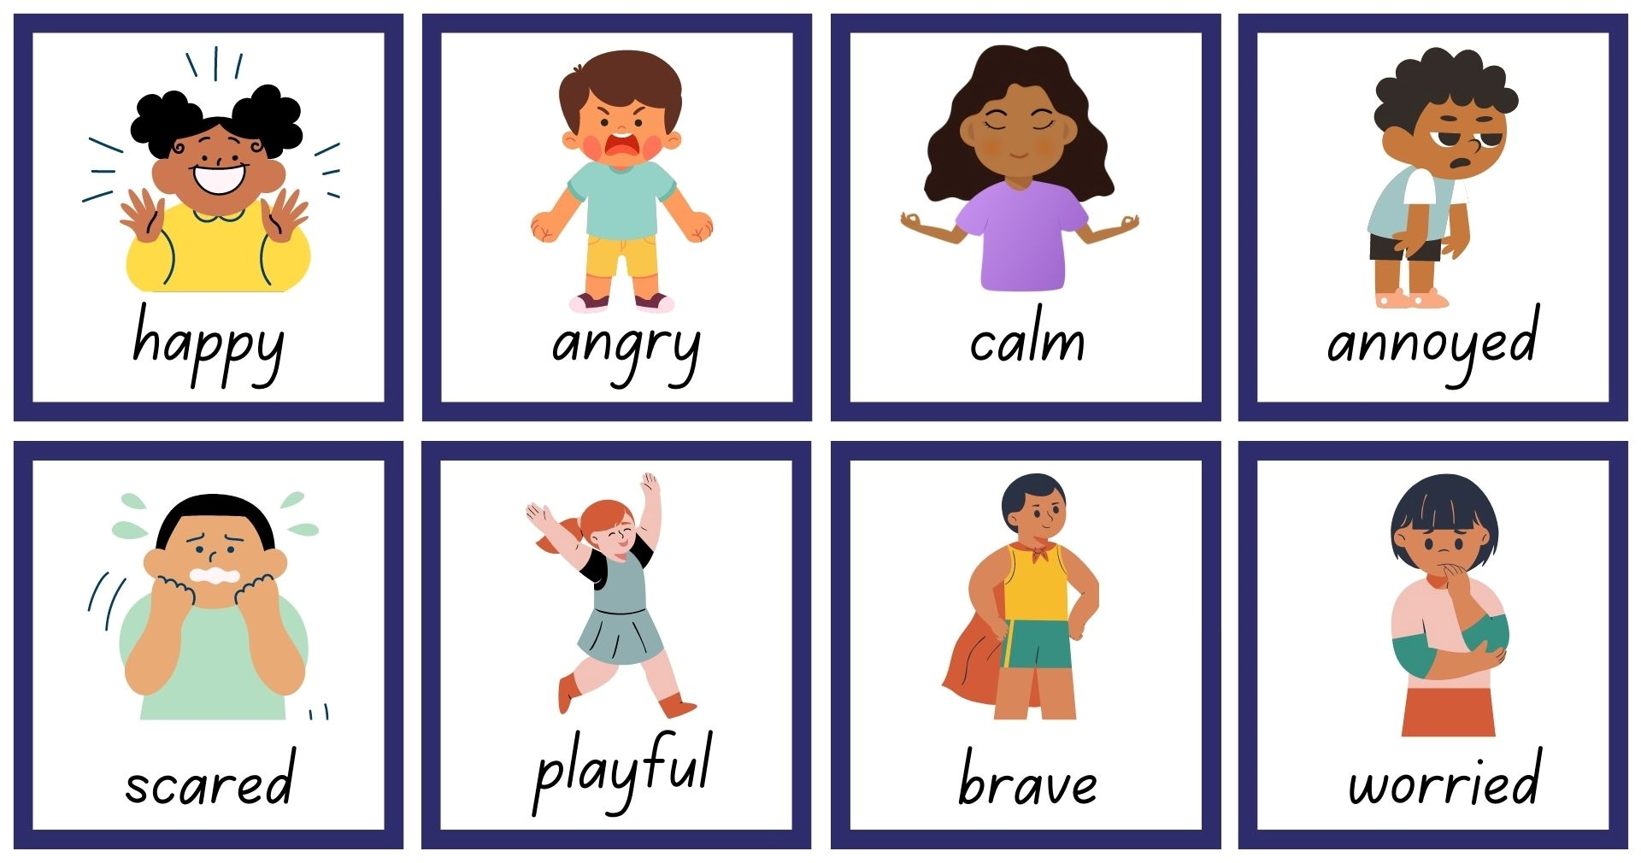
Images sourced from Canva and used in accordance with the Canva Content License Agreement.

Resource 4: Subject-verb-prepositional phrase sentence frame
Use the sentence frame to create your own sentences.
Subject | Verb  (doings/happenings/states) | Prepositional phrase

Resource 5: Story map example
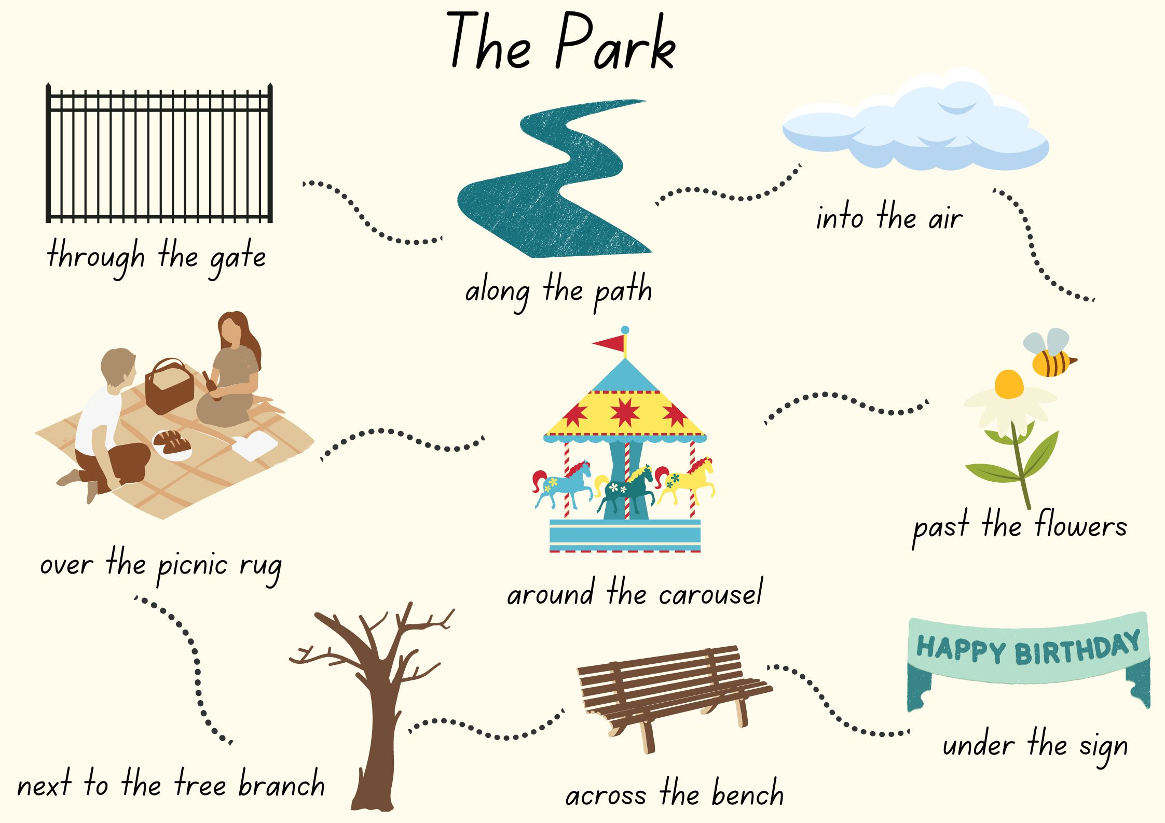
Images sourced from Canva and used in accordance with the Canva Content License Agreement.

Resource 6: Spotlight template
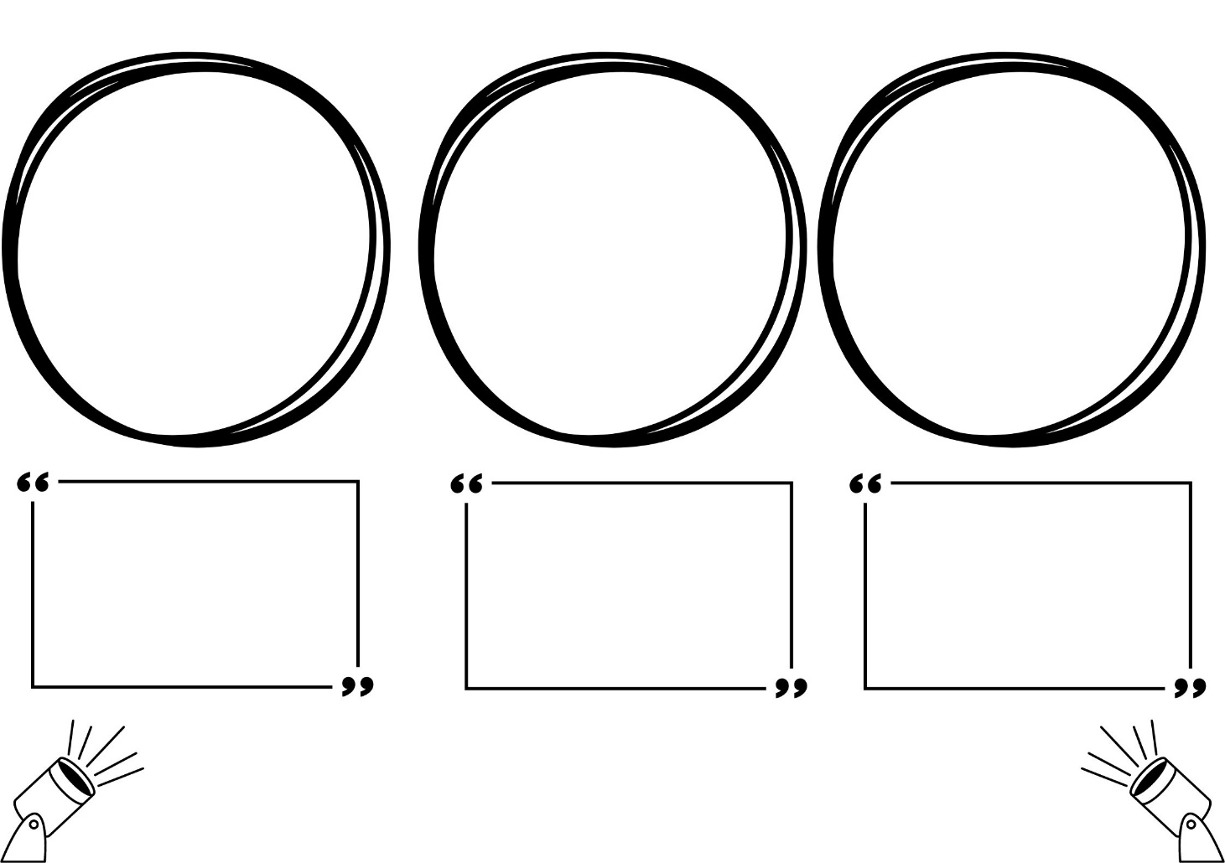
Images sourced from Canva and used in accordance with the Canva Content License Agreement.

References
Links to third-party material and websites
Please note that the provided (reading/viewing material/list/links/texts) are a suggestion only and implies no endorsement, by the New South Wales Department of Education, of any author, publisher, or book title. School principals and teachers are best placed to assess the suitability of resources that would complement the curriculum and reflect the needs and interests of their students.
If you use the links provided in this document to access a third-party's website, you acknowledge that the terms of use, including licence terms set out on the third-party's website apply to the use which may be made of the materials on that third-party website or where permitted by the Copyright Act 1968 (Cth). The department accepts no responsibility for content on third-party websites.
Except as otherwise noted, all material is © State of New South Wales (Department of Education), 2021 and licensed under the Creative Commons Attribution 4.0 International License. All other material (third-party material) is used with permission or under licence. Where the copyright owner of third-party material has not licensed their material under a Creative Commons or similar licence, you should contact them directly for permission to reuse their material.
English K–10 Syllabus © 2022 NSW Education Standards Authority (NESA) for and on behalf of the Crown in right of the State of New South Wales.
© 2021 NSW Education Standards Authority. This document contains NSW Curriculum and syllabus content. The NSW Curriculum is developed by the NSW Education Standards Authority. This content is prepared by NESA for and on behalf of the Crown in right of the State of New South Wales. The material is protected by Crown copyright.
Please refer to the NESA Copyright Disclaimer for more information.
NESA holds the only official and up-to-date versions of the NSW Curriculum and syllabus documents. Please visit the NSW Education Standards Authority (NESA) website and the NSW Curriculum website.
National Literacy Learning Progression © Australian Curriculum, Assessment and Reporting Authority (ACARA) 2010 to present, unless otherwise indicated. This material was downloaded from the Australian Curriculum website (National Literacy Learning Progression) (accessed 15 November 2022) and was not modified. The material is licensed under CC BY 4.0. Version updates are tracked in the ‘Curriculum version history’ section on the 'About the Australian Curriculum' page of the Australian Curriculum website.
ACARA does not endorse any product that uses the Australian Curriculum or make any representations as to the quality of such products. Any product that uses material published on this website should not be taken to be affiliated with ACARA or have the sponsorship or approval of ACARA. It is up to each person to make their own assessment of the product, taking into account matters including, but not limited to, the version number and the degree to which the materials align with the content descriptions and achievement standards (where relevant). Where there is a claim of alignment, it is important to check that the materials align with the content descriptions and achievement standards (endorsed by all education Ministers), not the elaborations (examples provided by ACARA).
ETA (English Teachers Association) and NSW Department of Education (2016) The Textual Concepts and Processes resource, English Textual Concepts website, accessed 15 November 2022.
Lee S (2008) Wave, Chronicle Books, United States.
Mackenzie N (22 October 2019) ‘Draw, Talk, Write (and Share)’, Noella’s Blog, accessed 15 November 2022.
Sima J (2019) Spencer’s New Pet, Simon & Schuster Books, New York.

