English – Early Stage 1 – Unit 8
Contents
Unit overview and instructions for use 3
Teacher notes 4
Outcomes and content – Component A 5
Outcomes and content – Component B 7
Week 1 10
Component A teaching and learning 10
Component B teaching and learning 11
Lesson 1: Floof 12
Lesson 2: Understanding character 13
Lesson 3: Simple sentences 15
Lesson 4: Predicting a character’s behaviour 17
Lesson 5: Creating a floofy character 19
Week 2 21
Component A teaching and learning 21
Component B teaching and learning 22
Lesson 6: When Billy Was a Dog 23
Lesson 7: Comparing characters 25
Lesson 8: Writing a short text 26
Lesson 9: Planning and drafting 28
Lesson 10: Publish writing 30
Resource 1: Day and night 31
Resource 2: Thought bubble 32
Resource 3: Types of floof 33
Resource 4: Dog actions 34
Resource 5: Missing poster 35
References 36

Unit overview and instructions for use
This two-week unit is comprised of Component A and Component B. Connecting learning across both components is encouraged.
Teaching and learning | Component A | Component B
Suggested duration | 60 minutes | 45 minutes
Explicit teaching focus areas | - Phonological awareness  - Print conventions  - Phonic knowledge  - Reading fluency  - Reading comprehension  - Spelling  - Handwriting | - Oral language and communication  - Vocabulary  - Reading comprehension  - Creating written texts  - Understanding and responding to literature
To prepare for teaching and learning: | - Refer to Outcomes and content – Component A, K-2 – Instructional sequence – grapheme–phoneme correspondences [PDF 825 KB], and the teaching advice documents (hyperlinked in Component A teaching and learning table).  - Based on student needs identified through ongoing assessment data, plan and document how you will sequence teaching and learning in whole class and targeted teaching groups across the two-week cycle. | - Familiarise yourself with Outcomes and content – Component B, Textual concepts information and videos, English Textual Concepts and Learning Processes (2016), and the teaching and learning sequence.  - Based on student needs identified through ongoing assessment data, determine how you will support students in whole class and targeted teaching groups across the two-week cycle as required.
English K–10 Syllabus © 2022 NSW Education Standards Authority (NESA) for and on behalf of the Crown in right of the State of New South Wales.

Teacher notes
- ‘Character is defined as a construct of verbal or visual statements about a fictional identity. Analysis of characters contribute to our own personal judgements about self, morals and values.’ – English Textual Concepts and Learning Processes (2016).
- Understanding of character can be supported through watching the department’s video: Character (2:31).
- For information on simple sentences, subject, verb, object, comparative and superlative adjectives, and visualising, refer to the NESA Glossary.
- This unit could enhance student learning towards achievement of outcomes from the Creative Arts K-6 Syllabus regarding visual art and drama.
- Consider prior student knowledge regarding simple sentences with a subject-verb-object structure.
- Reflect on student learning and engagement in activities and record differentiation and adjustments within the unit to inform future teaching and learning. One way of doing this could be to add comments to the digital file.
- Content points are linked to the National Literacy Learning Progression version (3).
Levels and indicators sourced from National Literacy Learning Progression © Australian Curriculum, Assessment and Reporting Authority (ACARA), (accessed 28 November 2022) and was not modified. See references for more information.

Outcomes and content – Component A
The table below outlines the focus outcomes and content. Content is linked to the National Literacy Learning Progression version (3).
Focus area and outcome | Content points and National Literacy Learning Progression
Phonological awareness  ENE-PHOAW-01 – identifies, blends, segments and manipulates phonological units in spoken words as a strategy for reading and creating texts | - blend onset and rime to say a one-syllable word (PhA2)  - provide a word when given a starting phoneme (PhA2)  - listen to up to 4 words, indicate those that start with the same phoneme and say other words that start with that phoneme (PhA2)  - identify the first, middle and final phonemes in a one-syllable word (PhA4)
Print conventions  ENE-PRINT-01 – tracks written text from left to right and from top to bottom of the page and identifies visual and spatial features of print | N/A
Phonic knowledge  ENE-PHOKW-01 – uses single-letter grapheme–phoneme correspondences and common digraphs to decode and encode words when reading and creating texts | - blend common single-letter grapheme–phoneme correspondences to read CCVC and CVCC words, and apply this when reading texts, including decodable texts (PKW5)  - segment common, single-letter grapheme–phoneme correspondences to encode CCVC and CVCC words (PKW5)  - decode and blend words containing consonant digraphs and apply this when reading texts, including decodable texts (PKW5)  - segment and encode CVC words containing consonant digraphs (PKW4, PKW5)
Reading fluency  ENE-REFLU-01 – reads decodable texts aloud with automaticity | - know that fluent reading involves recognising and reading words accurately and automatically  - read phrases comprising 2 or 3 words aloud, in a rhythmic manner (FlY2, FlY3)
Reading comprehension  ENE-RECOM-01 – comprehends independently read texts using background knowledge, word knowledge and understanding of how sentences connect | - use known vocabulary to build a mental model of the content of a text  - predict purpose, type of text or topic from title, illustration, image and/or form (UnT4)
Spelling  ENE-SPELL-01 – applies phonological, orthographic and morphological generalisations and strategies to spell taught familiar and high-frequency words when creating texts | - combine phonological, phonic, orthographic and morphemic knowledge to spell taught high-frequency irregular words comprising up to 3 phonemes (SpG5)  - know that the digraphs zz, ss, ll, ff and ck do not usually start a word in Standard Australian English
Handwriting  ENE-HANDW-01 – produces all lower-case and upper-case letters to create texts | - apply appropriate pressure when handwriting to produce legible writing (HwK2)

Outcomes and content – Component B
The table below outlines the focus outcomes and content. Content is linked to the National Literacy Learning Progression version (3).
Focus area and outcome | Content points and National Literacy Learning Progression
Oral language and communication  ENE-OLC-01 – communicates effectively by using interpersonal conventions and language with familiar peers and adults | - start a conversation with a peer and/or adult, staying on topic (InT3)
Vocabulary  ENE-VOCAB-01 – understands and effectively uses Tier 1 words and Tier 2 words in familiar contexts | - identify, name and describe a range of objects, characters, animals, people and places when given visual and/or auditory prompts (GrA1)
Reading comprehension  ENE-RECOM-01 – comprehends independently read texts using background knowledge, word knowledge and understanding of how sentences connect | - use known vocabulary to build a mental model of the content of a text  - predict purpose, type of text or topic from title, illustration, image and/or form (UnT4)  - use background knowledge when identifying connections between a text, own life, other texts and/or the world (UnT4)
Creating written texts  ENE-CWT-01 – creates written texts that include at least 2 related ideas and correct simple sentences | - create written texts that describe, give an opinion, recount an event, convey a story  - identify and use verbs in simple sentences, including in own writing (GrA2)  - write a simple sentence with correct subject-verb-object structure to convey an idea (GrA2, GrA3, CrT4)  - recognise a simple sentence in own writing (GrA3)  - identify and use nouns in simple sentences, including in own writing (GrA1)  - use personal pronouns in own writing (CrT7)  - use capital letters when writing proper nouns (PuN3, CrT5)  - use drawing, images or mind maps to support planning and writing (CrT4)
Understanding and responding to literature  ENE-UARL-01 – understands and responds to literature read to them | - use background knowledge to support understanding of characters’ actions in a text  - identify and discuss language used to describe characters in narratives  - understand that characters in texts are represented by how they look, what they say and do, and their thoughts

Week 1

Component A teaching and learning
The table below can be used to plan and document lessons that address Component A outcomes and content. Both the detailed example [DOC 529KB] of a two-week teaching and learning cycle and brief example [DOC 66KB] may support you in your planning.
Focus Areas | Lesson 1 | Lesson 2 | Lesson 3 | Lesson 4 | Lesson 5
Phonological awareness and
Phonic knowledge
15 minutes
Spelling and Handwriting
15 minutes
Print conventions,
Reading comprehension and Reading fluency
30 minutes

Component B teaching and learning
The following teaching and learning sequence has been designed to address Component B outcomes and content. Adapt the sequence as required to best meet the needs of your students.

Learning intention and success criteria
Learning intentions and success criteria are best co-constructed with students.

Learning intention
Students are learning to understand, describe, and write about character traits and actions.

Success criteria
Students can:
- describe the actions of a character
- understand a character’s personality
- write a simple sentence with a subject-verb-object structure
- use background knowledge to understand a character’s behaviour
- use knowledge of a text to create and write about a new character.

Resources
- McKinnon H (2022) Floof, Allen & Unwin Book Publishers, Sydney. ISBN: 9781761180088
- Resource 1: Day and night (Enlarged copy and individual copies for each student)
- Resource 2: Thought bubble (Enlarged copy and individual copies for each student)
- Resource 3: Types of floof (Enlarge and cut out the labels prior to lesson)
- Video: ABC Education – Pet Superstars: Will Meeko grow up to be like his dad? (3:15)
- Venn diagram
- A3 paper
- Coloured markers
- Craft materials, sticky tape, coloured markers, paint or coloured pencils
- Mini whiteboards

Lesson 1: Floof
- Introduce the text Floof. Ask students what they think the word ‘floof’ means and why they think that. Explain that the word ‘floof’ means extra fluffy and provide examples in a sentence, such as, ‘Floof is extra fluffy like a cloud’, ‘Floof is extra fluffy like a marshmallow’.
- Remind students that authors use a character’s name in the title to draw attention to the main character to build interest in the story. Focusing on the title and cover, ask students to make predictions about the text, drawing their visualisations on mini whiteboards.
- Read Floof and confirm student predictions. Explain that authors engage the reader by creating characters by how they look, what they say and do, and their thoughts. Explain that Floof has animal and human traits. Ask students what human traits Floof has. For example, Floof eats pancakes, Floof reads, Floof gardens, and Floof has many hobbies.
- Use a Venn diagram to compare Floof’s character traits with other cats and what they have in common. For example, cats chase and eat mice and Floof is friends with mice, cats eat cat biscuits and Floof eats pizza, all cats sleep and play.
- Discuss how the author builds the character of Floof using verbs to explain what they do. Revisit images in the text that illustrate verbs. Ask students to recall verbs from the text and add these to a word wall. For example, reads, eats, sleeps, gardens.
- Model writing the sentence, ‘Floof sleeps’ to show the subject-verb sentence structure and correct punctuation. For example, a capital letter to start a sentence and a full stop to end the sentence.
- Using mini whiteboards, students write the subject (Floof) and select another verb from the word wall to complete the sentence. For example, Floof eats, Floof reads, Floof plays. Students read their sentences in small groups.
- Students draw an image of an activity Floof likes to do and write their own sentence using a subject-verb structure.
Too hard? Students orally describe their picture to a peer.
Too easy? Students write a sentence with a subject-verb-object structure.

Lesson 2: Understanding character
- Re-read Floof, focusing on Floof’s character traits. Use the think aloud strategy when reading the text, positioning students to think more about Floof’s character and personality. For example, I wonder if Floof is a pet, I wonder if the dog likes Floof, I wonder if the family thinks Floof is well behaved.
- Flick through the text and discuss how the author uses imagery to show Floof’s character traits by what activities Floof does. For example, Floof reads, Floof is gardening, Floof eats. Discuss how the images show Floof sleeping and what this tells readers about Floof’s character. Turn to the page with the text ‘Floof is gardening.’ Ask students to explain what gardening looks like and whether Floof is gardening in this way.
- Ask students to locate pictures in the text that support and represent Floof’s character traits. For example, Floof likes to sleep, Floof is lazy, Floof is sneaky, Floof is cheeky, Floof breaks things, Floof does not care.
- To check student comprehension regarding Floof’s behaviour, explain that students will respond to spoken statements about Floof’s character traits. Students will use cat ears on their head to respond, ‘yes’ and a tail on their waist to respond ‘no’. Statements could include:
- Floof has friends.
- Floof sleeps at night.
- Floof is busy.
- Floof likes dogs.
- Floof eats pizza.
- Draw students' attention to the page with Floof’s big eyes and the text ‘lights out’. Ask students what Floof is doing on this page. Discuss what Floof does during the day and at night. For example, Floof sleeps during the day. At night, Floof steals a ball to play with. Ask students why Floof might do certain activities at night instead of during the day.
- Discuss what Floof does during the day and at night. Record student responses to create a word bank to support writing.
- Using an enlarged copy of Resource 1: Day and night, model drawing a picture of something that Floof does during the day and something Floof does at night. Model writing a simple sentence with a subject-verb-object structure to accompany each picture. For example, Day: Floof eats pancakes; Night: Floof plays with a ball.
- Using their own copy of Resource 1: Day and night, students draw a picture of an activity Floof does during the day and at night and write a subject-verb-object sentence to accompany each illustration.
Too hard? Students select one side, day or night, to draw a picture to represent an activity Floof does writing a subject-verb-object sentence.
Too easy? Students write a subject-verb-object sentence using an adjective to describe the object. For example, ‘Floof eats big pancakes.’

Lesson 3: Simple sentences
- Open Floof to the page where Floof steals the ball from the sleeping dog. As there is no text on the page, ask students to describe what is occurring in their own words.
- Focus on how Floof takes the ball from the dog and what this reveals about their character. For example, Floof is sneaky, funny, and enjoys playing games. Ask students what types of things Floof could do with the ball, for example, toss, throw, catch, roll, spin, lick. Add the verbs to the word wall.
- Brainstorm other toys that the dog might play with and Floof might like to take. List student responses on the board and draw simple pictures to match.
- Using mini whiteboards, students draw a new toy that Floof might take from the dog then create it using craft materials such as paper and sticky tape. Students may create a real or imagined toy.
- In small groups, students share and describe their toy design explaining how the toy could be used. For example, rolled, chewed,
- Discuss the character traits of the dog, for example, it is cranky and mean as the illustrations show sharp teeth and angry eyebrows. Ask students why the author has not given the dog a name.
- As a class, select a name for the dog in the story. Remind students of the importance of using a capital letter when writing a proper noun. Ask students what pronoun might be used for the dog, for example, she, he, it.
- Model writing a sentence about the dog and a new toy using a subject-verb-object structure. For example, Bruce (subject) chased (verb) his rocket toy (object); Bruce (subject) chewed (verb) his rocket toy (object). Explain to students that the names of the objects are nouns.
- Students write their own simple sentence about the dog playing with the toy from activity 4 using a subject-verb-object structure.
- Select students to read their sentences and identify the verb, nouns, and pronoun.
Too hard? Students write a simple sentence in the same style as the text using a subject and a verb only. For example, Bruce (subject) chews (verb).
Too easy? Students write a sentence containing 2 ideas and a personal pronoun describing the dog playing with their toy design. For example, Bruce chased his rocket toy and he chewed it.
- Students Think-Pair-Share to identify the subject-verb-object in their sentence.
Early Stage 1 Assessment task 1 – Observations and work samples from this lesson allow students to demonstrate achievement towards the following syllabus outcome and content points:
ENE-CWT-01 – creates written texts that include at least 2 related ideas and correct simple sentences
- create written texts that describe, give an opinion, recount an event, convey a story
- identify and use verbs in simple sentences, including in own writing
- write a simple sentence with correct subject–verb–object structure to convey an idea
- identify and use nouns in simple sentences, including in own writing
- use capital letters when writing proper nouns.

Lesson 4: Predicting a character’s behaviour
- Re-read Floof. Discuss all the activities Floof does throughout the text and list these on an anchor chart.
- Turn to the final page of the text and ask students what things Floof might do the next day.
- Open Pet Superstars: Will Meeko grow up to be like his dad? (3:15) and watch the video. Pause to discuss the different activities Meeko the cat does in the video and add these to the anchor chart. Allow students to make connections between the video and Floof by discussing which activities were similar and the character traits they might have in common. Ask students to share their own experiences with cats, for example, a family or friend’s pet cat and the things it likes to do. Prompt students to stay focused on what they saw a cat doing.
- Students turn and talk to discuss what they think Floof will do the next day after the story has ended. Remind students to consider what they know about Floof’s character and personality when discussing potential activities.
- Students share their thoughts with the class.
- Display an enlarged copy of Resource 2: Thought bubble. Explain that students will draw a picture of what the fluffy cat is imagining it will do the next day, just like Floof in the story. Model drawing a picture to represent a chosen activity from the anchor chart and write a simple sentence to describe the activity. The sentence may be written from the perspective of the cat, for example, ‘I will chase mice.’ Highlight the use of a personal pronoun when writing from the point of view of the cat.
- Students complete their own copy of Resource 2: Thought bubble, drawing a picture to represent their chosen activity for the cat before writing a simple sentence to describe it. Students may like to name their cat and use it in their sentence (with a capital letter), or they can write their sentence from the point of view of the cat, using the personal pronoun of ‘I’.
Too hard? Students draw a picture to represent their chosen activity and write verbs to match the activity.
Too easy? Students write a compound sentence to describe 2 activities the cat might do. For example, ‘I will chase mice and eat lots of fish.’
Early Stage 1 Assessment task 2 – Observations from this lesson allow students to demonstrate achievement towards the following syllabus outcomes and content points:
ENE-OLC-01 – communicates effectively by using interpersonal conventions and language with familiar peers and adults
- start a conversation with a peer and/or adult, staying on topic.
ENE-VOCAB-01 – understands and effectively uses Tier 1 words and Tier 2 words in familiar contexts
- identify, name and describe a range of objects, characters, animals, people and places when given visual and/or auditory prompts.
ENE-RECOM-01 – comprehends independently read texts using background knowledge, word knowledge and understanding of how sentences connect
- use background knowledge when identifying connections between a text, own life, other texts and/or the world.
ENE-UARL-01 – understands and responds to literature read to them
- use background knowledge to support understanding of characters’ actions in a text.

Lesson 5: Creating a floofy character
- Read the first few pages of Floof where it says ‘Floof is floofy. Floof is very floofy. Floof is the floofiest!’ Revisit what the word ‘floof’ means from Lesson 1 and brainstorm ideas as to what is meant by the term ‘floofiest’. Ask:
- What do you notice about the order of the words: floofy, very floofy, and floofiest? For example, it makes a comparison between the fluffiness of Floof’s coat with other cats.
- Why has the author used bold text and an exclamation mark? To emphasise that Floof is a very fluffy cat and is the fluffiest of all cats.
Note: While this is not a specific teaching point, comparative and superlative adjectives quantify a noun or a pronoun. They may include more, delicate, best, bigger, biggest.
- Brainstorm other words that have a similar meaning to ‘floof’. For example, hairy, fluffy, woolly, shaggy, fleecy, fuzzy, furry, velvety.
- Display Resource 3: Types of floof and discuss what the students can see in the images. Read the labels of the types of floof and then chorally read the labels with the students. Ask:
- Which of these animals looks hairy? Why? For example, the tarantula. It has lots of tiny hairs on its legs.
- Which of these animals looks fluffy? Why? For example, the rabbit. It has soft delicate fur.
- Which of these animals looks woolly? Why? For example, the sheep. It has a woollen coat.
- Which of these animals looks shaggy? Why? For example, the dog. It has long fur.
- Select students to place the label beside the appropriate animal. Students share their reasons with the class.
- Explain that students are going to design their own floofy character. Revise with students what they know about Floof’s character traits and what things it can do to support them to create their own floof. Students turn and talk to discuss what their floof character would look like and what it can do.
- Students use craft materials, coloured markers, paint or coloured pencils to draw their own floofy character on A3 paper. Encourage students to refer to Resource 3: Types of floof and the anchor chart from Lesson 4 to assist with their drawing.
- Students label their floofy character identifying its simple body parts and features. Students will use these labels to support writing sentences with a subject-verb-object structure.
- Model writing a simple sentence using a student’s labelled floof creation. For example, ‘The floof can__ (verb: jump, climb, run, swim)’; ‘The floof has hairy/woolly/shaggy/fluffy __ (object: legs, arms, ears)’.
- Students independently write a simple sentence to describe their floof creation.
Too hard? Provide students with the following sentence starter to complete with a verb, ‘The floof can __.’
Too easy? Students extend their writing by including a pronoun in a second sentence, for example, ‘The floof can jump. He stretches his fluffy legs.’
- Attach student sentences to their illustrations to be displayed in the classroom.

Week 2

Component A teaching and learning
The table below can be used to plan and document lessons that address Component A outcomes and content. Both the detailed example [DOC 529KB] of a two-week teaching and learning cycle and brief example [DOC 66KB] may support you in your planning.
Focus Areas | Lesson 6 | Lesson 7 | Lesson 8 | Lesson 9 | Lesson 10
Phonological awareness and
Phonic knowledge
15 minutes
Spelling and Handwriting
15 minutes
Print conventions,
Reading comprehension and Reading fluency
30 minutes

Component B teaching and learning
The following teaching and learning sequence has been designed to address Component B outcomes and content. Adapt the sequence as required to best meet the needs of your students.

Learning intention and success criteria
Learning intentions and success criteria are best co-constructed with students.

Learning intention
Students are learning to understand, describe, and write about character traits and actions.

Success criteria
Students can:
- identify and understand text purpose
- compare characters from different texts
- use verbs to describe the actions of a character
- use personal pronouns in own writing
- use drawing to support writing
- write texts that describe a character’s behaviour.

Resources
- Murray K (2019) When Billy Was a Dog (Blair K, illus.), Allen & Unwin Book Publishers, Sydney. ISBN: 9781760631826
- McKinnon H (2022) Floof, Allen & Unwin Book Publishers, Sydney. ISBN: 9781761180088
- Resource 4: Dog actions
- Resource 5: Missing poster (Enlarged copy and A3 copies for each student)
- Mini whiteboards
- A4 paper

Lesson 6: When Billy Was a Dog
- Introduce the text When Billy Was a Dog, only reading the title. Without showing students the cover, ask students what type of text it might be and what it is about.
- Explain that students are going to be character detectives, visualising what the character Billy looks like without seeing a picture. Read the first 5 pages of When Billy was a Dog. Ask students to visualise what Billy might look like and draw a picture of him on mini whiteboards. Select students to describe their drawings of Billy.
- Show students the images of Billy and discuss his features and how he is similar or different to their illustrations. Ask:
- What does Billy look like?
- What do we know about Billy?
- What does Billy say and do?
- Explicitly teach that written words and illustrations within books helps the reader to understand more about the character.
- Ask students to predict what might happen next, after Billy said ‘Woof’. Record student responses.
- Continue to read the text, pausing to discuss the images on each page. Explain that the character, Billy, pretends to be a dog and takes on dog character traits within the text.
- Explain that adjectives are words used to describe a noun or object. Display 2 sentences on the board ‘Billy loves dogs’, ‘Billy loves fluffy dogs.’ Ask students which sentence gives them more information. Underline the adjective ‘fluffy’ and discuss its meaning and what things students see in their mind when they visualise this sentence.
- Students Think-Pair-Share different adjectives that could be used to describe dogs. For example, fluffy, shaggy, brown, spotty, stinky. Record student responses to create a word wall.
- Model selecting an adjective from the word wall and write it in a sentence using the frame ‘Billy loves __ dogs.’ For example, ‘Billy loves big dogs’, ‘Billy loves small dogs’, ‘Billy loves shaggy dogs’, ‘Billy loves stinky dogs’.
- Students select an adjective from the word wall to describe a type of dog Billy likes. Students draw a picture and write a simple sentence using the frame from activity 9.
- Check student comprehension regarding Billy’s behaviour. Explain that students will respond to spoken statements about Billy's character traits by wagging their tail/hips respond, ‘yes’ and barking to respond ‘no’. Statements could include:
- Billy likes cats.
- Billy wants a pet dog.
- Billy chased his tail.
- Billy played fetch with a ball.
- Billy will take care of Boots.
Early Stage 1 Assessment task 3 – Observations from this lesson allow students to demonstrate achievement towards the following syllabus outcomes and content points:
ENE-RECOM-01 – comprehends independently read texts using background knowledge, word knowledge and understanding of how sentences connect
- use known vocabulary to build a mental model of the content of a text
- predict purpose, type of text or topic from title, illustration, image and/or form.
ENE-UARL-01 – understands and responds to literature read to them
- identify and discuss language used to describe characters in narratives
- understand that characters in texts are represented by how they look, what they say and do, and their thoughts.

Lesson 7: Comparing characters
- Display the texts Floof and When Billy Was a Dog. Ask students who the main character in each text is and how they know. Revise the author’s purpose of using a main character’s name in the title of a text to build the reader’s interest in the story.
- Explain that characters of different texts often have traits that are similar and different. Ask students to consider what character traits Floof and Billy have that are similar and what makes them different.
- Use the texts to compare the 2 characters, writing student responses on a Venn diagram. This will be used again in Lesson 9.
- Revisit the text Floof, pausing to discuss the character traits of Floof. For example, Floof eats pizza, Floof is lazy, Floof is sneaky, Floof is cheeky.
- Flick through the text When Billy Was a Dog, focusing on the character traits of Billy and the different ways he pretends to be a dog. For example, Billy loves dogs, Billy is cheeky, Billy is caring as he looks after Fluffy, Billy plays fetch.
- Discuss and list things Floof and Billy have in common, for example, they both have friends, they both like playing games, they both like to sleep, they both like eating.
- Select one trait for each character from the Venn diagram. Model writing a simple sentence with a subject-verb-object structure to describe an activity or character trait of Floof and Billy. For example, Floof likes to play games; Billy likes to play games.
- Students write a simple sentence with a subject-verb-object structure to describe one thing Floof and Billy like.
Too hard? Students select one character to write a simple sentence about.
Too easy? Students write sentences to describe something the 2 characters do not have in common. For example, Billy loves dogs. Floof does not like dogs.

Lesson 8: Writing a short text
- Revisit When Billy Was a Dog, focusing on the illustrations and text that show the actions Billy did when pretending to be a dog. For example: eat, panted, chased, sniffed, barked, dug. Record verbs on an anchor chart.
- Students participate in a mime activity to act out different verbs. Explain that students will respond by performing the action pretending they are the character, Billy. For example, Billy jumps, Billy eats, Billy runs, Billy growls, Billy digs.
- Discuss additional actions dogs can do, adding these to the anchor chart. For example: jump, growl, drink, beg, roll over, shake, swim, wag its tail.
- Ask students to close their eyes and imagine that they are a dog. Ask questions to assist in their visualisation. For example:
- What colour is your fur?
- Are you a big or small dog?
- What breed of dog are you?
- What tricks can you do?
- What food do you like to eat?
- What games do you play?
- Allow students to share what they would look like and things they would do as a dog with the class.
- Explain that students will be drawing 4 pictures to represent different things they would do if they were a new dog character in the text.
- Model using an enlarged copy Resource 4: Dog actions to draw a dog character doing 4 different actions (verbs) selected from the anchor chart. Write the chosen verbs in each box on the line provided to match the illustration.
- Students select 4 verbs from the anchor chart and draw themselves as a dog completing each action on their own copy of Resource 4: Dog actions. Remind students to think about the character traits of dogs and encourage them to be creative with the actions they select for their dog character.
- Students share and describe their drawings in pairs or small groups.
- Model using a student’s work sample to write sentences. For example, ‘My name is Blake; I can run; I can jump; I can bark; I can swim.’ Remind students about using a personal pronoun and a capital letter for names and at the start of a sentence.
- Explain that students will write simple sentences stating their name and 4 ‘I can’ statements to match their illustrations.
Too hard? Students write the sentence using their name and 2 ‘I can’ sentences to describe their chosen drawings.
Too easy? Students include an adjective to describe their verb. For example, ‘I can run fast’; ‘I can jump high.’
Early Stage 1 Assessment task 4 – Observations from this lesson allow students to demonstrate achievement towards the following syllabus outcome and content points:
ENE-CWT-01 – creates written texts that include at least 2 related ideas and correct simple sentences
- recognise a simple sentence in own writing
- use personal pronouns in own writing
- use capital letters when writing proper nouns
- use drawing, images or mind maps to support planning and writing.

Lesson 9: Planning and drafting
- Re-read When Billy Was a Dog.
- Explain that the class will imagine that Billy has gone missing and his parents have made a poster to try and find him. Ask students what it means to go missing and if they have ever had a pet escape or run away. Discuss that the information on a missing poster describes what a pet or person looks like. Explain that information included on a missing poster could include a name, photo, description of appearance, and things they like to do.
- Display an enlarged copy of Resource 5: Missing poster, explaining that students will draft their work before publishing in Lesson 10. Model writing Billy’s name and drawing a picture of him.
- Revisit the class Venn diagram from Lesson 7, reviewing the character traits and activities Billy likes to do. Explain that the information on the Venn diagram will help plan what to write.
- Select a character trait from the Venn diagram and model writing the first sentence on the poster. For example, Billy loves dogs. Use think alouds to demonstrate the use of a capital letter, nouns, and verbs.
- Select another character trait and co-construct another sentence on the poster. For example, Billy plays fetch.
- Explain that students will use the modelled sentences on their own poster and will write the final sentence independently. For example, ‘Billy digs holes’, ‘Billy sniffs dirt’, ‘Billy loves tickles’, ‘Billy rolls on the floor’.
- Using A4 paper students draft their sentences about Billy. Students will publish their writing in Lesson 10.
Too hard? Students write simple sentences using a subject and a verb to describe the things Billy does.
Too easy? Students include adjectives to describe Billy and alternate between the proper noun ‘Billy’ and the personal pronoun ‘he’ to begin each sentence.
Early Stage 1 Assessment task 5 – Collecting work samples from this lesson allows students to demonstrate achievement towards the following syllabus outcome and content points:
ENE-CWT-01 – creates written texts that include at least 2 related ideas and correct simple sentences
- create written texts that describe, give an opinion, recount an event, convey a story
- identify and use verbs in simple sentences, including in own writing
- write a simple sentence with correct subject–verb–object structure to convey an idea
- identify and use nouns in simple sentences, including in own writing.

Lesson 10: Publish writing
- Students use teacher feedback to edit their writing from Lesson 9.
- Model how to publish writing using a student’s work sample. Highlight the importance of using capital letters and full stops.
- Students publish their sentences onto an A3 copy of Resource 5: Missing poster, drawing a picture of Billy based on the illustrations in the text, and writing his name on the line provided.
- Students read their poster in pairs or small groups.
- Optional: Select students to participate in a hot seat activity. Students act out character traits from Floof or When Billy Was a Dog and answer questions from their peers about who they are.

Resource 1: Day and night
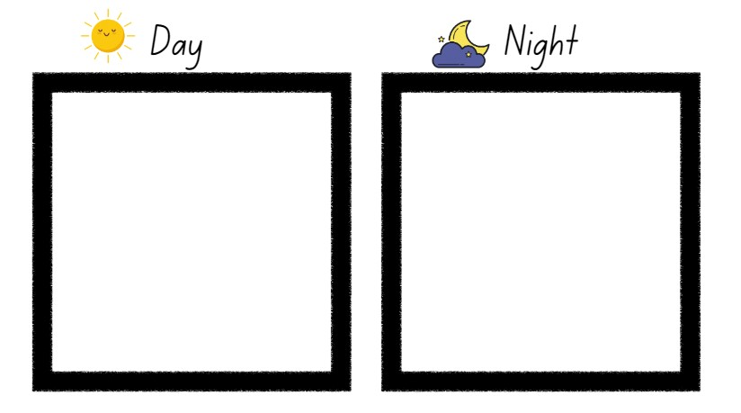
Images sourced from Canva and used in accordance with the Canva Content License Agreement.

Resource 2: Thought bubble
Images sourced from Canva and used in accordance with the Canva Content License Agreement.

Resource 3: Types of floof
hairy | woolly
shaggy | fluffy
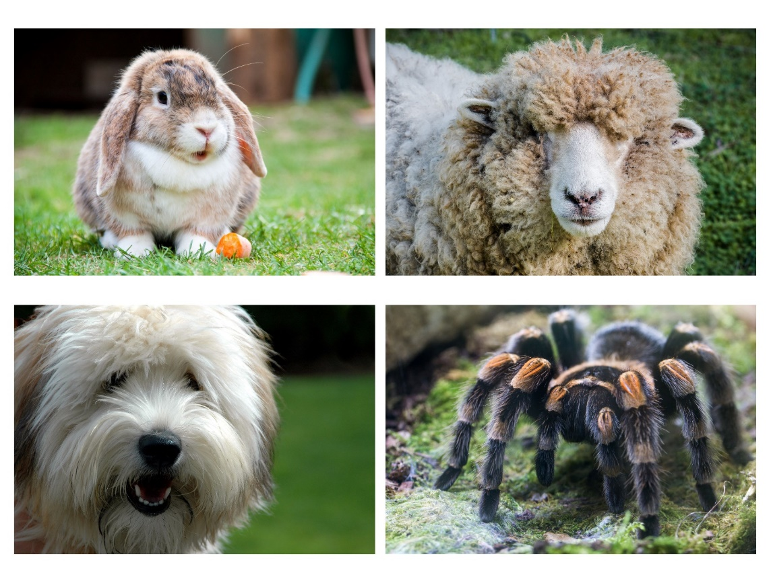
Images sourced from Canva and used in accordance with the Canva Content License Agreement.

Resource 4: Dog actions
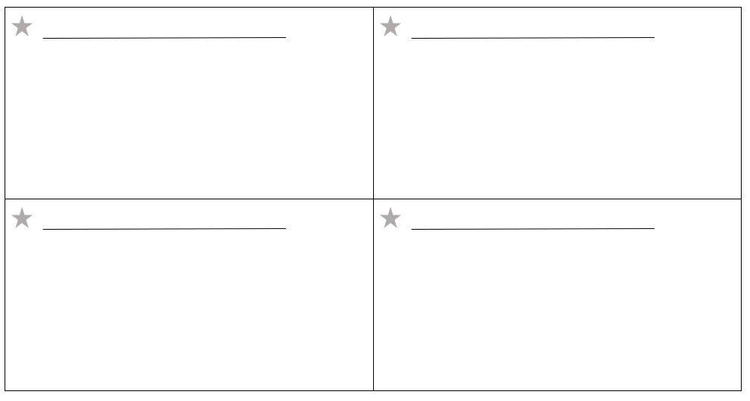

Resource 5: Missing poster

References
Links to third-party material and websites
Please note that the provided (reading/viewing material/list/links/texts) are a suggestion only and implies no endorsement, by the New South Wales Department of Education, of any author, publisher, or book title. School principals and teachers are best placed to assess the suitability of resources that would complement the curriculum and reflect the needs and interests of their students.
If you use the links provided in this document to access a third-party's website, you acknowledge that the terms of use, including licence terms set out on the third-party's website apply to the use which may be made of the materials on that third-party website or where permitted by the Copyright Act 1968 (Cth). The department accepts no responsibility for content on third-party websites.
Except as otherwise noted, all material is © State of New South Wales (Department of Education), 2021 and licensed under the Creative Commons Attribution 4.0 International License. All other material (third-party material) is used with permission or under licence. Where the copyright owner of third-party material has not licensed their material under a Creative Commons or similar licence, you should contact them directly for permission to reuse their material.
English K–10 Syllabus © 2022 NSW Education Standards Authority (NESA) for and on behalf of the Crown in right of the State of New South Wales.
Creative Arts K-6 Syllabus © 2006 NSW Education Standards Authority (NESA) for and on behalf of the Crown in right of the State of New South Wales.
© 2021 NSW Education Standards Authority. This document contains NSW Curriculum and syllabus content. The NSW Curriculum is developed by the NSW Education Standards Authority. This content is prepared by NESA for and on behalf of the Crown in right of the State of New South Wales. The material is protected by Crown copyright.
Please refer to the NESA Copyright Disclaimer for more information.
NESA holds the only official and up-to-date versions of the NSW Curriculum and syllabus documents. Please visit the NSW Education Standards Authority (NESA) website and the NSW Curriculum website.
National Literacy Learning Progression © Australian Curriculum, Assessment and Reporting Authority (ACARA) 2010 to present, unless otherwise indicated. This material was downloaded from the Australian Curriculum website (National Literacy Learning Progression) (accessed 28 November 2022) and was not modified. The material is licensed under CC BY 4.0. Version updates are tracked in the ‘Curriculum version history’ section on the 'About the Australian Curriculum' page of the Australian Curriculum website.
ACARA does not endorse any product that uses the Australian Curriculum or make any representations as to the quality of such products. Any product that uses material published on this website should not be taken to be affiliated with ACARA or have the sponsorship or approval of ACARA. It is up to each person to make their own assessment of the product, taking into account matters including, but not limited to, the version number and the degree to which the materials align with the content descriptions and achievement standards (where relevant). Where there is a claim of alignment, it is important to check that the materials align with the content descriptions and achievement standards (endorsed by all education Ministers), not the elaborations (examples provided by ACARA).
ABC (Australian Broadcasting Corporation) (30 March 2022) 'Pet Superstars: Will Meeko grow up to be like his dad?' [video], ABC Education, ABC website, accessed 28 November 2022.
ETA (English Teachers Association) and NSW Department of Education (2016) The Textual Concepts and Processes resource, English Textual Concepts website, accessed 28 November 2022.
McKinnon H (2022) Floof, Allen & Unwin Book Publishers, Sydney.
Murray K (2019) When Billy Was a Dog (Blair K, illus.), Allen & Unwin Book Publishers, Sydney.

