English – Early Stage 1 – Unit 7
Contents
Unit overview and instructions for use 3
Teacher notes 4
Outcomes and content – Component A 5
Outcomes and content – Component B 7
Week 1 10
Component A teaching and learning 10
Component B teaching and learning 11
Lesson 1: Shoes from Grandpa 12
Lesson 2: Using illustrations and language to describe – Part 1 14
Lesson 3: Proper nouns and pronouns 16
Lesson 4: Using illustrations and language to describe – Part 2 18
Lesson 5: Class narrative 19
Week 2 22
Component A teaching and learning 22
Component B teaching and learning 23
Lesson 6: Feathers for Phoebe 24
Lesson 7: Describing characters with adjectives 26
Lesson 8: Proper nouns and pronouns 27
Lesson 9: Writing simple sentences 28
Lesson 10: Comparing texts 30
Resource 1: Beginning, middle and end chart 32
Resource 2: Shoe identification chart 33
Resource 3: Word mat 34
Resource 4: Bird identification chart 35
Resource 5: Sentence examples 36
References 37

Unit overview and instructions for use
This two-week unit is comprised of Component A and Component B. Connecting learning across both components is encouraged.
Teaching and learning | Component A | Component B
Suggested duration | 60 minutes | 45 minutes
Explicit teaching focus areas | - Phonological awareness  - Print conventions  - Phonic knowledge  - Reading fluency  - Reading comprehension  - Spelling  - Handwriting | - Oral language and communication  - Vocabulary  - Reading comprehension  - Creating written texts  - Understanding and responding to literature
To prepare for teaching and learning: | - Refer to Outcomes and content – Component A, K-2 – Instructional sequence – grapheme–phoneme correspondences [PDF 825 KB], and the teaching advice documents (hyperlinked in Component A teaching and learning table).  - Based on student needs identified through ongoing assessment data, plan and document how you will sequence teaching and learning in whole class and targeted teaching groups across the two-week cycle. | - Familiarise yourself with Outcomes and content – Component B, Textual concepts information and videos, English Textual Concepts and Learning Processes (2016), and the teaching and learning sequence.  - Based on student needs identified through ongoing assessment data, determine how you will support students in whole class and targeted teaching groups across the two-week cycle as required.
English K–10 Syllabus © 2022 NSW Education Standards Authority (NESA) for and on behalf of the Crown in right of the State of New South Wales.

Teacher notes
- Narrative refers to the communication of a sequence of related events into a story. ‘A narrative is usually structured in such a way as to invite responder involvement.’ Narrative helps us make sense of our lives. – English Textual Concepts and Learning Processes (2016). A narrative is an account of events or related experiences which may be fictional or non-fictional.
- Understanding narrative can be supported through watching the department’s video: Narrative (3:51).
- While narrative is the mentor concept for the conceptual component of this unit, the supporting concept of context can be explored using the mentor text Shoes from Grandpa by Mem Fox.
- For information on adjectives, nouns, verbs, simple sentence, independent clauses, dependent clauses, pronouns, recasting, and syllables, refer to the NESA Glossary.
- This unit could enhance student learning towards achievement of outcomes from the Creative Arts K-6 Syllabus regarding visual art and drama, and the PDHPE K-6 Syllabus regarding exploring personal identity.
- Consider prior student knowledge regarding writing a simple sentence with a subject-verb structure.
- Reflect on student learning and engagement in activities and record differentiation and adjustments within the unit to inform future teaching and learning. One way of doing this could be to add comments to the digital file.
- Content points are linked to the National Literacy Learning Progression version (3).
Levels and indicators sourced from National Literacy Learning Progression © Australian Curriculum, Assessment and Reporting Authority (ACARA), (accessed 9 November 2022) and was not modified. See references for more information.

Outcomes and content – Component A
The table below outlines the focus outcomes and content. Content is linked to the National Literacy Learning Progression version (3).
Focus area and outcome | Content points and National Literacy Learning Progression
Phonological awareness  ENE-PHOAW-01 – identifies, blends, segments and manipulates phonological units in spoken words as a strategy for reading and creating texts | - blend onset and rime to say a one-syllable word (PhA2)  - provide a word when given a starting phoneme (PhA2)  - listen to up to 4 words, indicate those that start with the same phoneme and say other words that start with that phoneme (PhA2)  - identify the difference between a voiced phoneme and an unvoiced phoneme
Print conventions  ENE-PRINT-01 – tracks written text from left to right and from top to bottom of the page and identifies visual and spatial features of print | N/A
Phonic knowledge  ENE-PHOKW-01 – uses single-letter grapheme–phoneme correspondences and common digraphs to decode and encode words when reading and creating texts | - blend common single-letter grapheme–phoneme correspondences to read CCVC and CVCC words, and apply this when reading texts, including decodable texts (PKW5)  - segment common, single-letter grapheme–phoneme correspondences to encode CCVC and CVCC words (PKW5)
Reading fluency  ENE-REFLU-01 – reads decodable texts aloud with automaticity | - know that fluent reading involves recognising and reading words accurately and automatically  - read phrases comprising 2 or 3 words aloud, in a rhythmic manner (FlY2, FlY3)
Reading comprehension  ENE-RECOM-01 – comprehends independently read texts using background knowledge, word knowledge and understanding of how sentences connect | - recall the sequence of events/information in texts (UnT5)
Spelling  ENE-SPELL-01 – applies phonological, orthographic and morphological generalisations and strategies to spell taught familiar and high-frequency words when creating texts | - combine phonological, phonic, orthographic and morphemic knowledge to spell taught high-frequency irregular words comprising up to 3 phonemes (SpG5)  - segment single-syllable words into phonemes as a strategy for spelling (SpG4)
Handwriting  ENE-HANDW-01 – produces all lower-case and upper-case letters to create texts | - apply appropriate pressure when handwriting to produce legible writing (HwK2)

Outcomes and content – Component B
The table below outlines the focus outcomes and content. Content is linked to the National Literacy Learning Progression version (3).
Focus area and outcome | Content points and National Literacy Learning Progression
Oral language and communication  ENE-OLC-01 – communicates effectively by using interpersonal conventions and language with familiar peers and adults | - understand how pronouns can be linked to nouns to support meaning  - recall details of events or stories using who, what, when, where, why and how (SpK2)
Vocabulary  ENE-VOCAB-01 – understands and effectively uses Tier 1 words and Tier 2 words in familiar contexts | - understand and use words to describe shape, size, texture, position, numerical order, time and seasons (SpK2, CrT5)
Reading comprehension  ENE-RECOM-01 – comprehends independently read texts using background knowledge, word knowledge and understanding of how sentences connect | - use known vocabulary to build a mental model of the content of a text  - understand how adjectives describe a noun and verbs identify actions in a sentence  - understand that informative and imaginative texts have different structures, features and forms (UnT5)  - use background knowledge when identifying connections between a text, own life, other texts and/or the world (UnT4)  - recall the sequence of events/information in texts (UnT5)
Creating written texts  ENE-CWT-01 – creates written texts that include at least 2 related ideas and correct simple sentences | - include recognisable structural features for text purpose (CrT5)  - create written texts that describe, give an opinion, recount an event, convey a story  - write a simple sentence with correct subject–verb–object structure to convey an idea (GrA2, GrA3, CrT4)  - use personal pronouns in own writing (CrT7)  - use capital letters when writing proper nouns (PuN3, CrT5)  - use personal vocabulary, words on display and in mentor texts when constructing sentences  - identify different purposes for writing (CrT4)
Understanding and responding to literature  ENE-UARL-01 – understands and responds to literature read to them | - identify aspects of their own world represented in texts (UnT4)  - understand that narrative can be real or imagined  - identify, discuss and compare the beginning, middle and end in a range of narratives  - experiment with using parts and/or features of a narrative, innovating from a mentor text

Week 1

Component A teaching and learning
The table below can be used to plan and document lessons that address Component A outcomes and content. Both the detailed example [DOC 529KB] of a two-week teaching and learning cycle and brief example [DOC 66KB] may support you in your planning.
Focus Areas | Lesson 1 | Lesson 2 | Lesson 3 | Lesson 4 | Lesson 5
Phonological awareness and
Phonic knowledge
15 minutes
Spelling and Handwriting
15 minutes
Print conventions,
Reading comprehension and Reading fluency
30 minutes

Component B teaching and learning
The following teaching and learning sequence has been designed to address Component B outcomes and content. Adapt the sequence as required to best meet the needs of your students.

Learning intention and success criteria
Learning intentions and success criteria are best co-constructed with students.

Learning intention
Students are learning to identify the sequence of events in a narrative and use descriptive language in their writing.

Success criteria
Students can:
- identify events from the beginning, middle, and end of a text
- give responses to who, what, when, where, why in a familiar text
- use adjectives to describe a noun
- use pronouns when referencing a person
- experiment writing sentences with a subject-verb-object structure.

Resources
- Fox M (2015) Shoes from Grandpa (Mullins P, illus.), 25th anniversary edn, Scholastic Australia Pty Ltd. ISBN: 9781760151133
- Resource 1: Beginning, middle and end chart (enlarged copies and copies for each student)
- Resource 2: Shoe identification chart
- T-chart
- A4 paper
- Coloured markers
- Dress up items that are the same or similar those in the text (for Lesson 2)

Lesson 1: Shoes from Grandpa
- Introduce the text Shoes from Grandpa. Display the front and back cover. Ask students to predict what the text might be about and who the characters on the cover might be. Explicitly teach that the text is a narrative and explain that narratives can be real or imagined stories that follow a beginning, middle, and end structure.
- Read Shoes from Grandpa. Reflect on student predictions. Discuss how the text reflects aspects of students’ own experiences, for example, making connections to their own family, a barbeque they attended, going shopping, and receiving gifts.
- Display an enlarged copy of Resource 1: Beginning, middle and end chart. Explain that within each part of the text, the reader can identify who is in the story, what is happening, where the scene is taking place, and when it is happening. Flick through the text and discuss the key events that took place. Prompt students through questioning.
- Ask students:
- Beginning: Where was Jessie at the start of the story? Who was at the barbeque? What did Grandpa say?
- Middle: Who gave something to Jessie? What did they give her?
- End: How did Jessie feel? What did Jessie want?
- Model writing simple sentences with a subject-verb-object structure, for example, Jessie (subject) wanted (verb) a pair of jeans (object). Using Resource 1: Beginning, middle and end chart, students draw pictures to show one event that occurred in each section of the text. For example, the beginning is a picture of the family barbeque, the middle shows Jessie with many types of clothing, and the end is Jessie on her skateboard. Using the model, students write a sentence to describe one event.
Too hard? Students write words directly from the text or modelled writing.
Too easy? Students write sentences to match each of their drawings.
- Students share their drawings and writing in pairs or small groups.
Early Stage 1 Assessment task 1 – Observations from this lesson allow students to demonstrate achievement towards the following syllabus outcomes and content points:
ENE-OLC-01 – communicates effectively by using interpersonal conventions and language with familiar peers and adults
- recall details of events or stories using who, what, when, where, why and how.
ENE-RECOM-01 – comprehends independently read texts using background knowledge, word knowledge and understanding of how sentences connect
- use background knowledge when identifying connections between a text, own life, other texts and/or the world
- recall the sequence of events/information in texts.
ENE-UARL-01 – understands and responds to literature read to them
- identify aspects of their own world represented in texts
- understand that narrative can be real or imagined.

Lesson 2: Using illustrations and language to describe – Part 1
- Re-read Shoes from Grandpa. Encourage students to chorally read so that they recognise the use of repetition in the story.
- Look at the illustrations which show the pieces of clothing given to Jessie. Consider how the author has used rhythm, rhyme, and alliteration to make the descriptions sound funny to the reader. For example, ‘I’ll get you a skirt that won’t show the dirt’ (rhyme), ‘I’ll get you a sweater when the weather gets wetter’ (alliteration).
- Highlight how the text continues to build each time something new is given to Jessie. Look at the illustration that has Jessie wearing the clothes at the same time. Consider how this relates to the author’s purpose, to entertain, in this narrative. Explain that authors can use both words and pictures to describe characters, objects, and settings in texts.
- Create a T-chart with the headings ‘nouns’ (object) and ‘adjectives’. Explicitly teach that nouns are objects and adjectives are words that are used to describe the noun or object. Explain that adjectives can describe an object’s colour, size, shape, texture, or pattern.
- Open the book to each page where Jessie received an item of clothing. Model drawing and labelling the different items of clothing (objects) Jessie received on the T-chart. Define any unknown words students may be unfamiliar with, for example, blouse, sweater, coat, scarf, mittens.
- Discuss words that could be used to describe each item of clothing. For example, stripy, red, warm, spotty, frilly, striped. Write 2 or 3 adjectives for each item of clothing in the column labelled ‘adjectives’. Orally construct sentences that use the adjectives and nouns from the chart. In pairs, students create their own examples.
- Using dress up items, students select one piece of clothing and describe it to a peer using adjectives. For example, my shirt has red buttons, I have a fluffy scarf, my hat is woolly and warm.
- Model writing a simple sentence on the board using a subject-verb-object structure. Explicitly teach that a simple sentence makes sense by itself and is a complete idea. Using 3 different coloured markers, underline the subject, verb, and object in your sentence. For example, I (subject) am wearing (verb) a blue scarf (object).
Note: The subject is the word(s) in a clause that convey who or what the clause is about, for example, ‘The girl threw the ball.'
The verb is the word that defines the action taking place, for example, 'The girl threw the ball.'
The object is the noun, noun group, or pronoun in a sentence that is affected by an action, for example, ‘The girl threw the ball.’
- Provide students with the sentence starter ‘I am wearing a __ __.’ Using the class T-chart as a guide, students write the name of their chosen clothing item (noun) and a simple adjective to describe it. Encourage students to illustrate their writing to show the specific details that are part of their dress up item.
Too hard? Students draw a picture of themselves wearing the item of clothing. Students orally share their description with a peer.
Too easy? Students write and complete the sentence independently using variations in the subject/verb structure. For example, ‘Mum bought me a __ __.’
- Optional: Students sit in a circle. Select one student to stand in the centre and wear all the items of clothing. Each student places an item of clothing on the student in the centre, saying the phrase ‘I will buy you a __ (clothing name).’ Students in the circle repeat each line aloud in a cumulative style, for example, I will buy you a hat, scarf, shirt, tie.

Lesson 3: Proper nouns and pronouns
- Open Shoes from Grandpa to the page where the whole family is at the barbeque and Grandpa states that he will buy Jessie new shoes. Write the following sentence from the page on the board: ‘When Grandpa saw Jessie he stood back and said, “My, how you’ve grown!”’
- Ask students to identify any names in the sentence (Grandpa, Jessie) and how they know these are names. Explain that names are proper nouns that begin with a capital letter.
- Using 2 different coloured markers, underline ‘Grandpa’ and ‘Jessie’. Circle the pronoun ‘he’ and draw an arrow to ‘Grandpa’, explaining that ‘he’ refers to Grandpa. Circle the pronoun ‘you’ and ask the students who this pronoun is referring to (Jessie). Explicitly teach that pronouns are used in place of a noun and help a narrative to flow. List common examples of personal pronouns on the board, for example, she, he, I, they, you, my, me.
- Using dress up items from Lesson 2, select students to wear an item of clothing. Explicitly model using pronouns when asking and answering questions. For example, explain that Molly is wearing a red shirt, and then ask what Molly is wearing. Elicit student responses that include a pronoun, such as, she is wearing a red shirt. Use recasting to correct misuse of pronouns. For example, if a student says, her is wearing a red shirt, recast with yes, she is wearing a red shirt. Repeat the question (Who is wearing a red shirt?).
Note: Recasting is a teaching strategy to support students in their oral language. A recast occurs when the teacher modifies a learner’s utterance by adding new or different grammar (syntax) or by using precise words. Recasts serve to add or correct information without obstructing the natural flow of communication.
- Explain that the class will be writing about each item Jessie was given using pronouns and descriptive language.
- Open Shoes from Grandpa to the page where Jessie receives a coat from her grandmother. Model saying and then writing sentences about the grandmother’s gift and Jessie’s feelings about it. For example, the grandmother gave Jessie a warm coat. She did not want a warm coat.
- Highlight the use of a capital for the proper noun and the pronoun. Use the same repetitive structure with the other items Jessie was given.
- Sit students in a circle. One at a time, students suggest what they would give Jessie if they were in her family. Students share their idea in a complete sentence. For example, I gave Jessie a pink tutu. Have the rest of the class respond (using the correct pronoun) with the refrain, ‘She did not want ___ (a pink tutu).’
- Use the Draw, Talk, Write, Share strategy to support students in creating an illustration and sentence about their gift to Jessie.
Too hard? Students draw a picture of their gift to Jessie and write their name and Jessie’s name next to it. Reinforce the use of a capital letter at the start of a person’s name.
Too easy? Students include adjectives to describe their gift to Jessie.
Early Stage 1 Assessment task 2 – Observations from this lesson allow students to demonstrate achievement towards the following syllabus outcomes and content points:
ENE-OLC-01 – communicates effectively by using interpersonal conventions and language with familiar peers and adults
- understand how pronouns can be linked to nouns to support meaning.
ENE-CWT-01 – creates written texts that include at least 2 related ideas and correct simple sentences
- use personal pronouns in own writing
- use capital letters when writing proper nouns.

Lesson 4: Using illustrations and language to describe – Part 2
- Write the word ‘shoes’ on the board and ask students to think of other words that could be used in place of ‘shoes’. For example, runners, sandals, boots. Remind students that authors use details about people and objects in narratives through both words and illustrations. Revise the term ‘adjectives’ and their role in describing a noun/object.
- Display Resource 2: Shoe identification chart. Explain to students that they will work together to describe each of the shoes.
- Select one shoe at a time and ask:
- Who might wear this shoe?
- What are its features?
- When might someone wear them?
- Where might someone wear these?
- Why would someone wear them?
- How do they look?
- Using the images to support idea generation, students design a new pair of shoes they would like to wear. Encourage students to provide as much detail as possible in their illustration. Explain that the shoes can be real or imagined.
- Model drawing a pair of shoes on the board and write a simple sentence with a subject-verb-object structure to match it. For example, my boots have big buckles. Discuss the use of the pronoun ‘my’ at the beginning of the sentence.
- Students write a simple sentence to describe their shoe design.
Too hard? Students label their illustration.
Too easy? Students describe a range of detailed features from their shoe design. Encourage the use of a range of adjectives to describe elements, such as size, colour, texture, materials.

Lesson 5: Class narrative
- Re-read Shoes from Grandpa, referring to the class beginning, middle and end chart from Lesson 1.
- Revise that real and imagined narratives follow the structure of beginning, middle, and end to convey a series of events.
- Explain that students will create a class story about food to take on a picnic in a similar style to Shoes from Grandpa.
- Ask students what food they would like to take on a picnic and list these on the board, for example, sandwiches, cheese, salad, popcorn. Draw illustrations to match each item to support reading and writing. Allow students to write or draw different food options on the board.
- Write the title of the class narrative on the board, for example, ‘Food for a Picnic’.
- Using an interactive writing strategy, co-construct a simple sentence to set the scene and context for the story. For example, one day our class decided to have a picnic.
- Select 3 students whose names will be used in the story and write these on the board, highlighting the importance of using a capital letter for proper nouns.
- Select 3 food items from the class list and co-construct sentences using creative language features such as rhyme and alliteration to make the descriptions sound funny to the reader. For example, Charlie brought ice-cream that will make us all scream, Olivia brought cheese to eat in the breeze, Abdul brought chicken wings that will make us sing. Match the person to the food when constructing the sentences.
- Write the following sentence starter on the board, ‘Please may I bring __.’
- Explain that students will be ending the class narrative by writing a food item they would prefer to take on a picnic, like Jessie wanting jeans at the end of Shoes from Grandpa. Students may select a food item from the class list or write their own food of choice.
- Students write and complete the sentence and illustrate a picture to match their chosen food item.
Too hard? Support students to use speech-to-text technology to complete their sentence.
Too easy? Students write their own simple sentence describing the food item they would prefer to take on a picnic.
- Chorally read the class text together. Students share their own writing with their peers as part of a gallery walk.
Early Stage 1 Assessment task 3 – Observations and work samples from this lesson allow students to demonstrate achievement towards the following syllabus outcomes and content points:
ENE-CWT-01 – creates written texts that include at least 2 related ideas and correct simple sentences
- include recognisable structural features for text purpose
- create written texts that describe, give an opinion, recount an event, convey a story
- use personal vocabulary, words on display and in mentor texts when constructing sentences
- identify different purposes for writing.
ENE-UARL-01 – understands and responds to literature read to them
- experiment with using parts and/or features of a narrative, innovating from a mentor text.

Week 2

Component A teaching and learning
The table below can be used to plan and document lessons that address Component A outcomes and content. Both the detailed example [DOC 529KB] of a two-week teaching and learning cycle and brief example [DOC 66KB] may support you in your planning.
Focus Areas | Lesson 6 | Lesson 7 | Lesson 8 | Lesson 9 | Lesson 10
Phonological awareness and
Phonic knowledge
15 minutes
Spelling and Handwriting
15 minutes
Print conventions,
Reading comprehension and Reading fluency
30 minutes

Component B teaching and learning
The following teaching and learning sequence has been designed to address Component B outcomes and content. Adapt the sequence as required to best meet the needs of your students.

Learning intention and success criteria
Learning intentions and success criteria are best co-constructed with students.

Learning intention
Students are learning to identify the sequence of events in a narrative and use descriptive language in their writing.

Success criteria
Students can:
- identify events from the beginning, middle, and end of a text
- use real images to describe a noun
- use a capital letter when writing a proper noun
- identify the subject, verb, and object in simple sentences
- compare real and imagined narratives
- write simple sentences using adjectives and personal pronouns.

Resources
- Clement R (2010) Feathers for Phoebe, HarperCollins Publishers, Sydney. ISBN: 9780732289201
- Fox M (2015) Shoes from Grandpa (Mullins P, illus.), 25th anniversary edn, Scholastic Australia Pty Ltd. ISBN: 9781760151133
- Resource 1: Beginning, middle and end chart (enlarged copy and copies for each student)
- Resource 3: Word mat (enlarged copy)
- Resource 4: Bird Identification chart
- Resource 5: Sentence examples
- T-chart
- A3 paper
- Coloured pencils, craft materials, paint, or markers
- Mini whiteboards

Lesson 6: Feathers for Phoebe
- Introduce the text Feathers for Phoebe. Display the front and back cover. Ask students to predict what the text might be about and who the character on the front cover might be. Explain that this text is a narrative and that narratives can be real or imagined stories. Ask students if this text is real or imagined and why.
- Read Feathers for Phoebe. Reflect on student predictions. Encourage students to chorally read the right-hand pages when Phoebe is given different feather options.
- Flicking through the text, stop to highlight the detail in the illustrations. Promote discussion about the use of describing words (adjectives) to describe the feather accessories in Zelda’s beauty salon. For example, purple, curly, large, fluffy, pretty.
- Display an enlarged copy of Resource 1: Beginning, middle and end chart. Explain that in each part of the text, the reader can identify who is in the story, what is occurring, where the scene is taking place, and when it is happening. Flick through the text discussing the key events. Prompt students through questioning.
- Ask students:
- Beginning: Where does the story begin? How is Phoebe feeling? Who does she go to visit? What did Zelda say?
- Middle: What did Phoebe get? What happened each time she tried a new look?
- End: What happened to Phoebe in the end? What did Phoebe learn?
Note: Narratives may contain a moral at the end to personalise the reading experience for the audience or to teach the reader a lesson.
- Explain that narratives may have a message or a lesson at the end. In pairs, ask students to think about what Phoebe learned and what the message (moral) from the narrative is. For example, be happy with who you are, always be yourself.
- Model writing simple sentences with a subject-verb-object structure within each section of the chart. For example, Phoebe (subject) wanted (verb) a new crest (object).
- Using Resource 1: Beginning, middle and end chart, students draw pictures to show one event that occurred in each section of the text. For example, the beginning is a picture of Phoebe visiting Zelda’s beauty salon, the middle shows Phoebe wearing different types of feathers for her new look, and the end is Phoebe falling and landing beside the other bird that looks like her.

Too hard? Students focus on only one section of the narrative.
Too easy? Students write sentences to describe the key events in each part of the text.

Lesson 7: Describing characters with adjectives
- Explain that adjectives are used to provide more information about the characteristics of nouns and pronouns.
- Explicitly teach that authors use adjectives to help the reader create a clearer picture in their mind of an object (noun). Display an enlarged copy of Resource 3: Word mat. As a class, select an adjective from the text and complete each section.
Too easy? Students select an adjective from the text and complete Resource 3: Word mat in pairs or independently.
- Select more examples of adjectives from Feathers for Phoebe to write on the board and discuss with students. For example, Phoebe got a new crest (new), Phoebe chose a long tail (long), Phoebe got shiny wings (shiny), Phoebe made a loud sound (loud), Phoebe climbed a low-hanging vine (low-hanging). Ask students what each adjective is describing. For example, the crest, tail, wings, vine, sound (objects/nouns).
- Look at the illustrations of the crests and discuss what each crest looks like. For example, straight, curly, long, big, pink. Record student responses, allowing students to illustrate the different types of crests.
- Display Resource 4: Bird identification chart and discuss what students see. Create a T-chart, with the headings ‘adjectives’ and ‘nouns’. Using the images, complete the chart based on the appearance of each bird. For example, large (adjective) wings (noun), red (adjective) chest (noun), sharp (adjective) claws (noun), pointy (adjective) beak (noun).
- Ask students to pretend they are a bird. Using coloured pencils, craft materials, paint or markers, students draw themselves as a bird on A3 paper. Students refer to the class T-chart to assist with their drawing. Keep the drawing for Lesson 8.
- Students write their first name underneath the bird drawing. Highlight the importance of using a capital letter at the start of a name (proper noun).
- Optional: Ask students to pretend they are different types of birds from the local area. For example, kookaburra, emu, seagull, cockatoo. Call out the name of a bird and ask students to act out the sound and moves of each bird. Ask students to make up sounds and moves for their bird illustration.
Early Stage 1 Assessment task 4 – Observations from this lesson allow students to demonstrate achievement towards the following syllabus outcomes and content points:
ENE-VOCAB-01 – understands and effectively uses Tier 1 words and Tier 2 words in familiar contexts
- understand and use words to describe shape, size, texture, position, numerical order, time and seasons.
ENE-RECOM-01 – comprehends independently read texts using background knowledge, word knowledge and understanding of how sentences connect
- use known vocabulary to build a mental model of the content of a text
- understand how adjectives describe a noun and verbs identify actions in a sentence.

Lesson 8: Proper nouns and pronouns
- Revisit proper nouns by opening Feathers for Phoebe to the page where Phoebe goes to visit Zelda’s beauty salon. Write the following sentence from the page on the board, ‘“I want to look like you,” Phoebe told Zelda.’
- Ask students to identify any names in the sentence (Phoebe, Zelda) and how they know these are names. Explain that names are proper nouns and must begin with a capital letter.
- Using 2 different coloured markers, underline ‘Phoebe’ and ‘Zelda’. Circle the pronoun ‘I’ and draw an arrow to ‘Phoebe’, explaining that ‘I’ refers to Phoebe as she is the one speaking. Circle the pronoun ‘you’ and ask the students who the pronoun refers to (Zelda). Explicitly teach that pronouns are used in place of a noun and help a narrative to flow. List common examples of personal pronouns on the board, for example, she, he, I, they, you, my, me.
- Select some students to discuss their imaginary bird drawings from Lesson 7 and ask the students to give the bird a name. Explicitly model the use of pronouns in spoken questions and statements about each bird’s appearance. For example, Kristy is a large bird. She has sharp claws. What colour are her wings? Recast student answers if needed.
- Open Feathers for Phoebe to the page where Phoebe receives new wings. Explain that students will be finishing sentences orally using correct pronoun referencing and interpreting what the result was. For example, Phoebe got new wings but __(she) could not __(fly). ‘“From now on __(you) will __(walk),” said Zelda.’
- Model writing sentences that include correct noun-pronoun referencing. For example, Phoebe got new wings. She could not fly.
- In pairs, students write a sentence about the other feathers Phoebe received, using correct noun-pronoun referencing.

Lesson 9: Writing simple sentences
- Reread Feathers for Phoebe, pausing to discuss the main idea throughout the text.
- Revise that a simple sentence makes sense by itself and can use a subject-verb-object structure to convey an idea.
- Write a simple sentence on the board from the text about an event in the story using a subject-verb-object structure. For example, Phoebe chose a new crest. Phoebe climbed a low-hanging vine. Use 3 different coloured markers to underline or circle the subject (Phoebe), the verb (chose), and the object (a new crest).
- In pairs, students to complete Resource 5: Sentence examples to underline or circle the subject, verb, and object in different colours.
Too hard? In small groups, students use an enlarged copy of Resource 5: Sentence examples to underline or circle the subject, verb and object in each sentence.
Too easy? Students write their own sentence and identify the subject, verb, and object.
- Explain that students will be writing sentences about their bird illustration from Lesson 7. Model writing the first sentence using the subject-verb-object structure. Begin the second sentence with a pronoun and include an adjective. For example:
- __ (bird’s name) chose new __ (wings, claws, eyes).
- Her/His __ (wings, crest, beak, claws, eyes) was/were __ (adjective).
Too hard? Students use speech-to-text technology to complete the sentences.
Too easy? Students include a sentence using one of their senses. For example, She/he looks like __, She/he sounds like __, She/he smells like __, She/he feels like __.
- Students read their sentences in pairs before sharing with the class through a gallery walk.
- Attach student sentences to their bird illustrations to be displayed in the classroom.

Early Stage 1 Assessment task 5 – Observations from this lesson allow students to demonstrate achievement towards the following syllabus outcome and content points:
ENE-CWT-01 – creates written texts that include at least 2 related ideas and correct simple sentences
- include recognisable structural features for text purpose
- create written texts that describe, give an opinion, recount an event, convey a story
- write a simple sentence with correct subject–verb–object structure to convey an idea
- use personal pronouns in own writing
- use capital letters when writing proper nouns
- use personal vocabulary, words on display and in mentor texts when constructing sentences.

Lesson 10: Comparing texts
- Display the completed beginning, middle and end chart from Lesson 1 about Shoes from Grandpa. Compare it to the chart about Feathers for Phoebe from Lesson 6. Discuss any similarities or differences between the 2 texts regarding their structure, characters, and events.
- Ask students:
- What did the main characters want? Jessie wanted a pair of jeans; Phoebe wanted a new look.
- What did they do? Jessie got gifts from her family; Phoebe visited Zelda’s beauty salon.
- What did they find out? Jessie realised the gifts were not what she wanted; Phoebe realised she was fine the way she was.
- How did Jessie and Phoebe feel throughout the story? Jessie felt overwhelmed by all her gifts; Phoebe felt she looked silly with her new feathers.
- Could Feathers for Phoebe be a real narrative? No, it is imaginary because birds cannot talk.
- Could Shoes from Grandpa be a real narrative? Yes, it could be real because the characters and events might happen.
- Who were each of these stories written for? School-aged children.
- Using mini whiteboards, students write to state which character or text is their favourite.
Too hard? Students draw a picture of their favourite character.
Too easy? Students write a sentence describing which character or text is their favourite and why.
- Students share their sentence with a peer and explain their preferences.
Early Stage 1 Assessment task 6 – Observations and work samples from this lesson allow students to demonstrate achievement towards the following syllabus outcomes and content points:
ENE-RECOM-01 – comprehends independently read texts using background knowledge, word knowledge and understanding of how sentences connect
- understand that informative and imaginative texts have different structures, features and forms.
ENE-UARL-01 – understands and responds to literature read to them
- identify, discuss and compare the beginning, middle and end in a range of narratives
- experiment with using parts and/or features of a narrative, innovating from a mentor text.

Resource 1: Beginning, middle and end chart
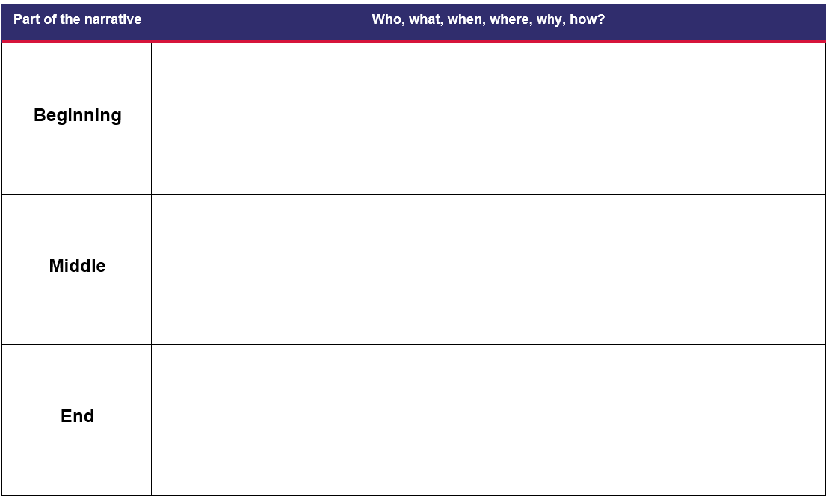

Resource 2: Shoe identification chart
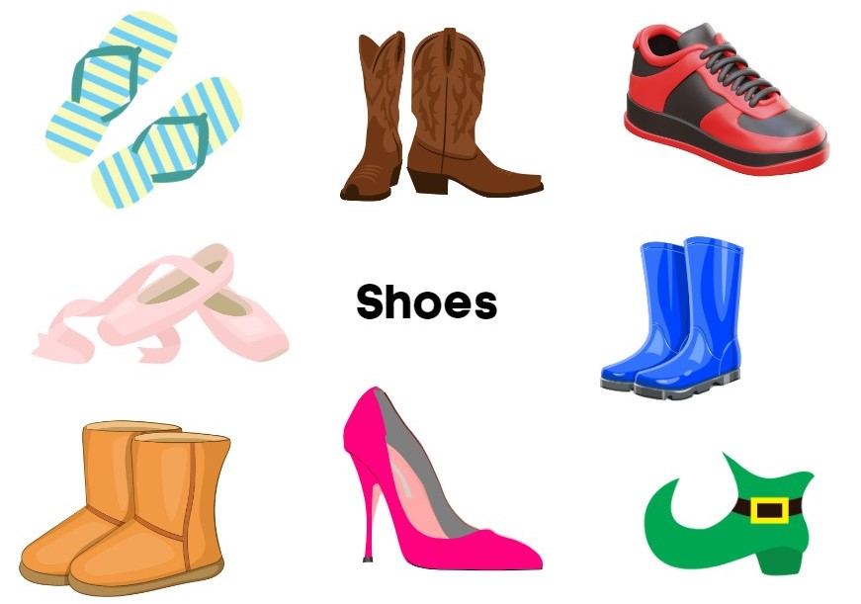
Images sourced from Canva and used in accordance with the Canva Content License Agreement.

Resource 3: Word mat
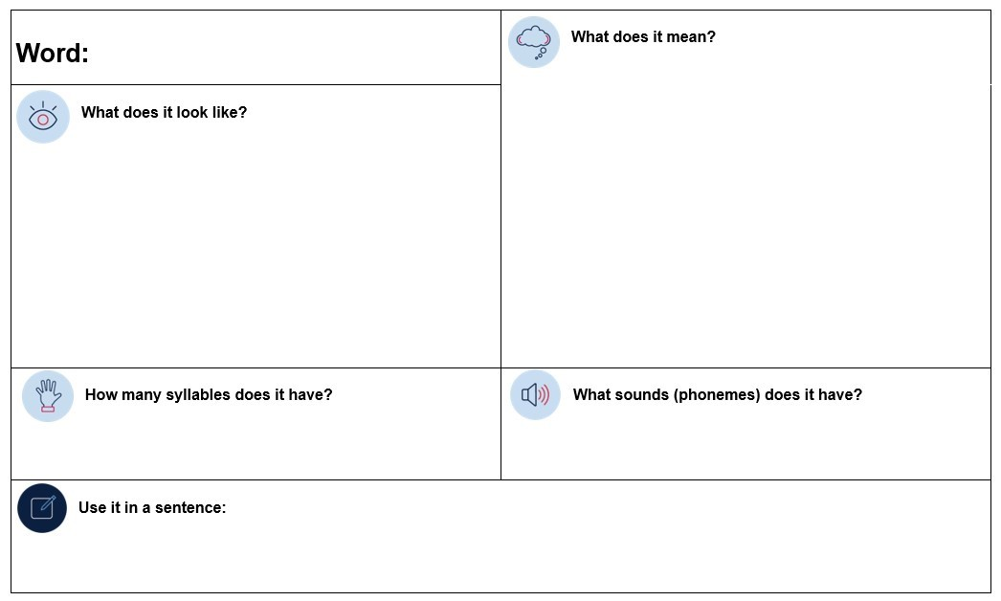

Resource 4: Bird identification chart
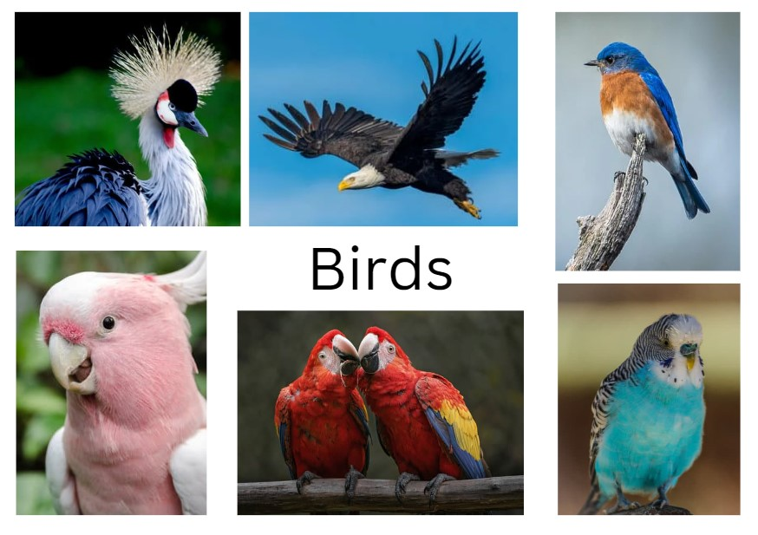
Images sourced from Canva and used in accordance with the Canva Content License Agreement.

Resource 5: Sentence examples
Phoebe chose a new crest.
Phoebe chose a long tail.
Phoebe chose a blue chest.
Phoebe chose shiny wings.
Phoebe made a new song.

References
Links to third-party material and websites
Please note that the provided (reading/viewing material/list/links/texts) are a suggestion only and implies no endorsement, by the New South Wales Department of Education, of any author, publisher, or book title. School principals and teachers are best placed to assess the suitability of resources that would complement the curriculum and reflect the needs and interests of their students.
If you use the links provided in this document to access a third-party's website, you acknowledge that the terms of use, including licence terms set out on the third-party's website apply to the use which may be made of the materials on that third-party website or where permitted by the Copyright Act 1968 (Cth). The department accepts no responsibility for content on third-party websites.
Except as otherwise noted, all material is © State of New South Wales (Department of Education), 2021 and licensed under the Creative Commons Attribution 4.0 International License. All other material (third-party material) is used with permission or under licence. Where the copyright owner of third-party material has not licensed their material under a Creative Commons or similar licence, you should contact them directly for permission to reuse their material.
English K–10 Syllabus © 2022 NSW Education Standards Authority (NESA) for and on behalf of the Crown in right of the State of New South Wales.
Creative Arts K–6 Syllabus © 2006 NSW Education Standards Authority (NESA) for and on behalf of the Crown in right of the State of New South Wales.
PDHPE K–10 Syllabus © 2018 NSW Education Standards Authority (NESA) for and on behalf of the Crown in right of the State of New South Wales.
© 2021 NSW Education Standards Authority. This document contains NSW Curriculum and syllabus content. The NSW Curriculum is developed by the NSW Education Standards Authority. This content is prepared by NESA for and on behalf of the Crown in right of the State of New South Wales. The material is protected by Crown copyright.
Please refer to the NESA Copyright Disclaimer for more information.
NESA holds the only official and up-to-date versions of the NSW Curriculum and syllabus documents. Please visit the NSW Education Standards Authority (NESA) website and the NSW Curriculum website.
National Literacy Learning Progression © Australian Curriculum, Assessment and Reporting Authority (ACARA) 2010 to present, unless otherwise indicated. This material was downloaded from the Australian Curriculum website (National Literacy Learning Progression) (accessed 10 November 2022) and was not modified. The material is licensed under CC BY 4.0. Version updates are tracked in the ‘Curriculum version history’ section on the 'About the Australian Curriculum' page of the Australian Curriculum website.
ACARA does not endorse any product that uses the Australian Curriculum or make any representations as to the quality of such products. Any product that uses material published on this website should not be taken to be affiliated with ACARA or have the sponsorship or approval of ACARA. It is up to each person to make their own assessment of the product, taking into account matters including, but not limited to, the version number and the degree to which the materials align with the content descriptions and achievement standards (where relevant). Where there is a claim of alignment, it is important to check that the materials align with the content descriptions and achievement standards (endorsed by all education Ministers), not the elaborations (examples provided by ACARA).
Clement R (2010) Feathers for Phoebe, HarperCollins Publishers, Sydney.
ETA (English Teachers Association) and NSW Department of Education (2016) The Textual Concepts and Processes resource, English Textual Concepts website, accessed 9 November 2022.
Fox M (2015) Shoes from Grandpa (Mullins P, illus.), 25th anniversary edn, Scholastic Australia Pty Ltd (original work published 1989).
Mackenzie N (22 October 2019) ‘Draw, Talk, Write (and Share)’, Noella’s Blog, accessed 9 November 2022.

