English – Early Stage 1 – Unit 5
Contents
Unit overview and instructions for use 3
Teacher notes 4
Outcomes and content – Component A 6
Outcomes and content – Component B 9
Week 1 12
Component A teaching and learning 12
Component B teaching and learning 13
Lesson 1: Chip as a character 14
Lesson 2: Chip’s perspective 15
Lesson 3: Understanding how images and words work together 17
Lesson 4: Verbs to describe Chip’s actions 18
Lesson 5: Gull News 20
Week 2 22
Component A teaching and learning 22
Component B teaching and learning 23
Lesson 6: Elmer 24
Lesson 7: I’m special – Simple sentence traits 25
Lesson 8: Wordplay and fun with elephants 27
Lesson 9: Describing your true colours 28
Lesson 10: Comparing and expressing opinions on characters and texts 29
Resource 1: Seagull glasses 32
Resource 2: T-chart character traits 33
Resource 3: Elephant poems 34
Resource 4: Elephant outline 35
Resource 5: Elephant stimulus 36
Resource 6: T-chart – Elmer and Chip character traits 37
References 38

Unit overview and instructions for use
This two-week unit is comprised of Component A and Component B. Connecting learning across both components is encouraged.
Teaching and learning | Component A | Component B
Suggested duration | 60 minutes | 45 minutes
Explicit teaching focus areas | - Phonological awareness  - Print conventions  - Phonic knowledge  - Reading fluency  - Reading comprehension  - Spelling  - Handwriting | - Oral language and communication  - Vocabulary  - Reading comprehension  - Creating written texts  - Understanding and responding to literature
To prepare for teaching and learning: | - Refer to Outcomes and content – Component A, K-2 – Instructional sequence – grapheme–phoneme correspondences [PDF 825 KB], and the teaching advice documents (hyperlinked in Component A teaching and learning table).  - Based on student needs identified through ongoing assessment data, plan and document how you will sequence teaching and learning in whole class and targeted teaching groups across the two-week cycle. | - Familiarise yourself with Outcomes and content – Component B, Textual concepts information and videos, English Textual Concepts and Learning Processes (2016), and the teaching and learning sequence.  - Based on student needs identified through ongoing assessment data, determine how you will support students in whole class and targeted teaching groups across the two-week cycle as required.
English K–10 Syllabus © 2022 NSW Education Standards Authority (NESA) for and on behalf of the Crown in right of the State of New South Wales.

Teacher notes
- ‘Perspective is a lens through which we learn to see the world. It can clarify, magnify, distort, or blur what we see. By adopting different perspectives, a responder can bring to light the underlying values in the text and construct meanings that may challenge, confirm, or modify the original reading of a text’. – English Textual Concepts and Learning Processes (2016).
- Understanding of perspective can be supported through watching the department’s video: Perspective (3:37).
- While ‘perspective’ is the mentor concept for the conceptual component of this unit, the supporting concept of ‘character’ can be explored using the mentor texts Chip by Kylie Howarth and the supporting text Elmer by David McKee.
- For information on multimodal texts refer to the NESA Glossary.
- A variety of instructional strategies have been included to support students’ understanding and responding to literature:
- Thinking aloud involves verbally modelling the thinking processes before, during and after reading or writing. It is important that you verbalise what is going on in your mind as you read or write. Having a focus for a think aloud makes sure that this strategy is used effectively and efficiently.
- Thinking partners are used to engage students in accountable conversations about texts and personal experiences. The strategy helps students to share their experiences and thinking in a non-threatening way. Similar strategies include ‘talking partners’, Think-Pair-Share, and turn and talk.
- A variety of instructional strategies have been included to support students’ creating written texts:
- The Draw, Talk, Share, Write strategy for emergent writers includes drawing as part of a meaning making process, while talking and sharing allows children to make sense of their ideas and to develop their vocabulary and oral language skills. Writing provides an opportunity to apply phonic and word knowledge into another context. Best practice in this strategy is modelled by Australian researcher Noella Mackenzie. For further information, refer to the public domain website Draw, Talk, Write (and Share).
- Interactive writing is a shared writing strategy where the teacher and students write together to compose and record a co-constructed text. The teacher models how successful writers generate and organise their ideas, and guides students to record the text. Interactive writing can also provide an opportunity to teach concepts about print, sentence structure and grammar, spelling strategies, punctuation, and handwriting.
- Modelled writing provides opportunities for teachers to demonstrate the thoughts and actions of a proficient writer when creating texts. The teacher takes full responsibility for scribing during this process and students observe what and how the writing is created, learning from what is being explained by the teacher.
- Text-to-self is when students connect what they read to their own personal experiences and knowledge.
- This unit could enhance student learning towards achievement of outcomes from the Creative Arts syllabus.
- Reflect on student learning and engagement in activities and record differentiation and adjustments within the unit to inform future teaching and learning. One way of doing this could be to add comments to the digital file.
- Content points are linked to the National Literacy Learning Progression version (3).
Levels and indicators sourced from National Literacy Learning Progression © Australian Curriculum, Assessment and Reporting Authority (ACARA), (accessed 16 September 2022) and was not modified. See references for more information.

Outcomes and content – Component A
The table below outlines the focus outcomes and content. Content is linked to the National Literacy Learning Progression version (3).
Focus area and outcome | Content points and National Literacy Learning Progression
Phonological awareness  ENE-PHOAW-01 – identifies, blends, segments and manipulates phonological units in spoken words as a strategy for reading and creating texts | - orally blend up to 4 phonemes together to make a one-syllable spoken word (PhA4)  - orally segment one syllable words comprised of up to 4 phonemes into separate phonemes (PhA4)  - identify the first, middle and final phonemes in a one-syllable word (PhA4)
Print conventions  ENE-PRINT-01 – tracks written text from left to right and from top to bottom of the page and identifies visual and spatial features of print | - identify words in a variety of situations in school, the classroom and the environment (PKW1) (UnT1)  - identify spaces between words (PKW2)  - identify numerals in texts (PKW2)  - identify and name lower- and upper-case letters (PKW4)  - recognise symbols, icons and personally significant words in everyday situations and in texts (UnT2)  - begin reading at the top of the page and conclude reading at the bottom of the page (UnT3)  - track left to right and use return sweep (UnT4)
Phonic knowledge  ENE-PHOKW-01 – uses single-letter grapheme–phoneme correspondences and common digraphs to decode and encode words when reading and creating texts | - match single letter grapheme with a phoneme  - say the most common phoneme for single-letter graphemes (graphs) (PKW3)  - blend single-letter grapheme correspondences to decode VC and CVC words, and apply this knowledge when reading, including decodable texts (PKW3) (PKW4)  - segment and encode single-letter VC and CVC words, and apply this knowledge when writing words and creating texts (PKW4)
Reading fluency  ENE-REFLU-01 – reads decodable texts aloud with automaticity | - read words automatically then apply to texts  - read texts with taught grapheme–phoneme correspondences and taught high-frequency words with automaticity  - stop at the end of a sentence in response to a full stop (FIY3)
Reading comprehension  ENE-RECOM-01 – comprehends independently read texts using background knowledge, word knowledge and understanding of how sentences connect | - recognise familiar vocabulary in a text (UnT4)  - recall key characters, events and/or information in text (UnT5)
Spelling  ENE-SPELL-01 – applies phonological, orthographic and morphological generalisations and strategies to spell taught familiar and high-frequency words when creating texts | - segment single-syllable words into phonemes as a strategy for spelling (SpG4)  - experiment with the tense-marking suffixes to spell familiar base verbs (SpG5)  - add the plural-marking suffix (s) to base nouns that require no change when suffixed (SpG5)
Handwriting  ENE-HANDW-01 – produces all lower-case and upper-case letters to create texts | - apply taught handwriting skills when creating texts  - form all handwritten letters in NSW Foundation Style when given a verbal prompt from the correct starting point and continue in the correct direction (HwK4)

Outcomes and content – Component B
The table below outlines the focus outcomes and content. Content is linked to the National Literacy Learning Progression version (3).
Focus area and outcome | Content points and National Literacy Learning Progression
Oral language and communication  ENE-OLC-01 – communicates effectively by using interpersonal conventions and language with familiar peers and adults | - respond to spoken questions  - use oral language to make requests and express needs  - use short phrases and simple sentences when speaking (SpK1)
Vocabulary  ENE-VOCAB-01 – understands and effectively uses Tier 1 and Tier 2 words in familiar contexts | - identify, name and describe a range of objects, characters, animals, people and places when given visual and/or auditory prompts (GrA1)  - experiment with and create wordplay and poems
Reading comprehension  ENE-RECOM-01 – comprehends independently read texts using background knowledge, word knowledge and understanding of how sentences connect | - identify words that represent who, what, when, where and why in texts  - understand how adjectives describe a noun and verbs identify actions in a sentence  - use visual cues in multimodal texts to interpret meaning (UnT5)
Creating written texts  ENE-CWT-01 – creates written texts that include at least 2 related ideas and correct simple sentences | - create written texts that describe, give an opinion, recount an event, convey a story  - use personal vocabulary, words on display and in mentor texts when constructing sentences  - know that a simple sentence makes sense by itself and is a complete thought represented by a subject and verb (GrA3)  - understand that punctuation is a feature of written language and how it impacts meaning  - use a capital letter to start a sentence and a full stop to end a sentence (PuN2) (CrT5)  - use drawing, images or mind maps to support planning and writing (CrT4)
Understanding and responding to literature  ENE-UARL-01 – understands and responds to literature read to them | - express likes and dislikes about a text (UnT5)  - identify favourite stories and/or characters in texts using verbal and/or nonverbal modes

Week 1

Component A teaching and learning
The table below can be used to plan and document lessons that address Component A outcomes and content. Both the detailed example [DOC 529KB] of a two-week teaching and learning cycle and brief example [DOC 66KB] may support you in your planning.
Focus Areas | Lesson 1 | Lesson 2 | Lesson 3 | Lesson 4 | Lesson 5
Phonological awareness and
Phonic knowledge
15 minutes
Spelling and Handwriting
15 minutes
Print conventions,
Reading comprehension and Reading fluency
30 minutes

Component B teaching and learning
The following teaching and learning sequence has been designed to address Component B outcomes and content. Adapt the sequence as required to best meet the needs of your students.

Learning intention and success criteria
Learning intentions and success criteria are best co-constructed with students.

Learning intention
Students are learning to form opinions about characters and understand that authors/others have different perspectives.

Success criteria
Students can:
- view the world from a character's perspective
- identify words (adjectives) that describe character features
- describe character traits and features
- make connections to personal experiences and knowledge.

Resources
- Howarth K (2018) Chip, Hardie Grant Children’s Publishing. ISBN13: 9781760409623
- Resource 1: Seagull glasses
- Video: Seagulls (2:10)
- Video: Aboriginal Performance Seagulls Dance: Minica Seagull, Yuin Nation (1:10)
- Video: Sneaky seagull shoplifts a snack (0:46)
- Soft ball

Lesson 1: Chip as a character
- Introduce the text Chip. Revise that people and animals in stories are called characters. Explain that the author uses the main character’s name in the title to draw attention to Chip and to build their interest in the story. Focusing on the cover and title page, ask students what the images tell them about the character, Chip. Students share thinking and make predictions.
- Read Chip and confirm student predictions. Discuss how the character’s name is also the name of the object that he wants so much, and this is an example of wordplay.
- Introduce perspective by making a text-to-self connection to show students how personal experiences and feelings shape how readers see and understand a text. For example, this reminds me of… the same thing happened to me when… I felt the same way when…
- Using Think-Pair-Share, students connect their own experiences and feelings to the text. For example, this reminds me of when the magpie swooped me at the river, the same thing happened to me when a pigeon tried to steal my sandwich at the park, I felt the same way when my brother said there was no more ice-cream.
- Revisit images of Chip and focus on how the author uses illustrations to show character features. For example, yellow beak, a red scarf. Explain that authors write about a character’s features using words called adjectives or describing words.
- Watch the video Seagulls (2:10). Ask students to recall the features of seagulls. Explain how adjectives describe the noun. For example, white body, grey wing, yellow beak, black eye. Add these to a class word wall.
- Model drawing the character Chip, adding detail and labels with simple adjectives and nouns. Explain how authors use adjectives that describe character features to create a visual image for the reader.
- Students draw a seagull and label their image with one or more adjectives and nouns from the word wall. Students may use a variety of art mediums such as crayons, crepe paper, tissue paper, pencils, markers, or watercolour paints to illustrate.

Lesson 2: Chip’s perspective
- Explicitly teach how Aboriginal and Torres Strait Islander peoples are connected to Country and have a relationship with the animals on the land, sea, sky, and waterways. Students view Aboriginal Performance Seagulls Dance: Minica Seagull, Yuin Nation (1:10). Explain that authors come from different cultural backgrounds, and this can shape how they see the world. Discuss how the dancers use movement, music, and song to become the seagull. Explore being a seagull through dance.
- Explain that authors create characters so readers can put themselves in the character’s position to imagine what they would feel, think, or do if they were in that situation. Demonstrate that the students can look through imaginary ‘gull glasses’ to see the story from Chip’s perspective to better understand how he is feeling. Model putting on imaginary ‘gull glasses’ and use the think aloud strategy to show students how you are now seeing things from Chip’s perspective. For example, ‘I want hot chips, I need hot chips’.
- Ask students to put on their own imaginary ‘gull glasses’ to view the world from Chip’s perspective. View the first page of the text where Chip is flying over the beach. Discuss what Chip sees from his aerial view as he flies over this scene.
- Re-read the text Chip focusing on his perspective and how it shapes what the reader sees, and the way readers respond.
- Use images from the text that show the story is from Chip’s perspective. Ask students to pretend they are Chip and answer questions based on his perspective, such as ‘Do you like soggy and sandy chips?’ ‘Do you like eating apples?’ Students respond to questions using ‘wings up’ or ‘wings down’ to show if they respond yes or no. Connect student responses to the text.
- Explain students will remove their imaginary ‘gull glasses’ and look at the images from their own perspective. Repeat the questions. Students respond with thumbs up or thumbs down. Draw students’ attention to similarities and differences between the things they each like or dislike – and the similarities between them and the character Chip.
- Ask students to look through their imaginary ‘gull glasses’ again to understand how Chip is feeling. For example, he is sad because he can’t have chips.
- Discuss the things Chip likes and dislikes. Model drawing images to represent this and write simple sentences to support. For example, ‘I like fat chips; I do not like apples’. Explicitly review that a simple sentence makes sense by itself and is a complete thought represented by a subject and verb. Highlight the use of sentence boundary punctuation and spaces between words.
- Using Resource 1: Seagull glasses, students draw something that Chip likes and something he dislikes inside the lenses. Remind students they are drawing from Chip’s perspective. Students label their drawings using print from models or the class word wall.
Too easy? Students write a sentence stating one thing Chip liked and disliked to support their illustration.
Early Stage 1 Assessment task 1 – Observations from this lesson allow students to demonstrate achievement towards the following syllabus outcome and content points:
ENE-OLC-01 – communicates effectively by using interpersonal conventions and language with familiar peers and adults.

Lesson 3: Understanding how images and words work together
- Watch the video, Sneaky seagull shoplifts a snack (0:46). Students retell what happened with the seagull and share their likes and dislikes about the text using short spoken sentences.
- Re-read the text Chip.
- Co-construct an oral retell of the story.
- Draw students’ attention to the images of Chip trying to grab chips. Explain that students can look closely at the images to learn more about what is happening in the story, and to see what is happening from Chip’s perspective. Explain that authors and illustrators work together to create meaning for the reader. Identify parts of the story where information is provided in the illustrations, but not in the written text.
- Sit with students in a circle. Roll a soft ball to different students and ask a question that involves a choice. For example, ask students if they are feeling happy or sad, cranky, or excited, if they like apples or chips, fish, or noodles. Explain that the answers we give are our perspective.
- Explain that authors use illustrations like Chip’s disguise to entertain the reader. Discuss the meaning of ‘disguise’ and check for understanding. With the image as a prompt, students can identify, name, and describe parts of Chip’s disguise.
- Model drawing Chip in disguise. Create a simple sentence describing Chip. Explicitly review that a simple sentence makes sense by itself and is a complete thought represented by a subject and verb. Highlight the use of sentence boundary punctuation and spaces between words.
- Students draw Chip in a creative new disguise. Support students to write about the character Chip with words and/or a simple sentence. Share in small groups.
Early Stage 1 Assessment task 2 – Observations from this lesson allow students to demonstrate achievement towards the following syllabus outcomes and content points:
ENE-OLC-01 – communicates effectively by using interpersonal conventions and language with familiar peers and adults
- respond to spoken questions
- use short phrases and simple sentences when speaking.
ENE-RECOM-01 – comprehends independently read texts using background knowledge, word knowledge and understanding of how sentences connect
- use visual cues in multimodal texts to interpret meaning.

Lesson 4: Verbs to describe Chip’s actions
- Revisit the text Chip focusing on the text and images of Joe telling Chip he is being rude. Highlight the author’s use of punctuation, such as exclamation marks and capital letters, to tell the reader that Joe is yelling at Chip. Draw students’ attention to Joe’s warning signs, for example, ‘Do not feed the gulls’, including the symbol signs. Ask students if they agree or disagree with Joe’s signs and discuss responses. Have students describe where and when they have seen similar signs that express what can and cannot occur in spaces. For example, a stop sign, don’t litter signs.
- Draw students’ attention to the airshow poster and Chip’s idea. Consider the layout and features of the poster.
- Remind students to look at things from Chip’s perspective. Using the turn and talk strategy, ask students to role-play what Chip says to the other seagulls to get them to train and fly with him. Ask students to recall what is happening in these scenes, who the characters are, where and when it is taking place, and why the characters are behaving in this way.
- Revisit text images that represent verbs and explain that verbs are words that describe an action. Students identify verbs, such as loop the loop, stall, dive, roll and fall. Model spoken sentences, such as ‘the seagulls can dive’, ‘the seagulls can spin’, ‘the seagulls can fly’. Students chorally chant each sentence and perform their own airshow using hand movements to represent actions.
- Highlight the phrase, ‘the crowd went wild’ at the airshow. Explain the use of the word ‘wild’ and its meaning in this sentence. Make text-to-self connections and discuss examples when students have seen a crowd go wild. For example, at a football match, rodeo, concert, or live show.
- Model drawing the seagulls in action in an airshow poster and write a simple sentence with a subject and a verb, for example, The seagulls can dive. Explain that the simple sentence makes sense by itself and is a complete thought. Draw students’ attention to the capital letter to start a sentence and the full stop to end a sentence. Highlight the use of spaces between words.
- Using the Draw, Talk, Share, Write strategy, students draw a poster that has the seagulls flying and write a sentence using verbs from the model or the word wall. Provide a sentence starter to support students, for example, ‘The seagulls can…’
Too hard? Students label their drawing with a verb from the word wall.
Too easy? Students write a sentence with 2 verbs from the word wall. For example, ‘The seagulls can roll and dive.’
Early Stage 1 Assessment task 3 – Observations from this lesson allow students to demonstrate achievement towards the following syllabus outcomes and content points:
ENE-OLC-01 – communicates effectively by using interpersonal conventions and language with familiar peers and adults
- use short phrases and simple sentences when speaking.
ENE-RECOM-01 – comprehends independently read texts using background knowledge, word knowledge and understanding of how sentences connect
- identify words that represent who, what, when, where and why in texts.
ENE-CWT-01 – creates written texts that include at least 2 related ideas and correct simple sentences
- create written texts that describe, give an opinion, recount an event, convey a story
- know that a simple sentence makes sense by itself and is a complete thought represented by a subject and verb
- understand that punctuation is a feature of written language and how it impacts meaning
- use a capital letter to start a sentence and a full stop to end a sentence.

Lesson 5: Gull News
- Re-read the text Chip to explore the use of the newspaper. Highlight the visual elements of the newspaper and its similarities and differences with other types of texts students have read. Explain that stories in newspapers and on the television provide readers with a perspective about something that has happened. Model being a reporter and ask students questions about the seagulls and the airshow. For example, you could ask what they liked about the airshow, and why did they come to the airshow.
- Make or find small microphones and provide students with an extended opportunity to role-play being a reporter for Gull News. Remind students that characters can be people or animals. Encourage students to conduct interviews with different characters, such as Chip, Joe, people in the crowd, or the other seagulls.
- Co-construct a newspaper article about the airshow. Use the verbs from the word wall to model writing a simple sentence, for example, The seagulls flew through the air. The crowd watched in amazement. Continue to reinforce that a simple sentence makes sense by itself and is a complete thought. Draw students’ attention to the ‘subject’ (seagulls/the crowd) and ‘verb’ (flew/watched) of each sentence, and the sentence boundary punctuation.
- Students draw an image for the newspaper article and label with verbs from the model or word wall. Students may choose to write a sentence of their own or copy a sentence from the model.

Week 2

Component A teaching and learning
The table below can be used to plan and document lessons that address Component A outcomes and content. Both the detailed example [DOC 529KB] of a two-week teaching and learning cycle and brief example [DOC 66KB] may support you in your planning.
Focus Areas | Lesson 6 | Lesson 7 | Lesson 8 | Lesson 9 | Lesson 10
Phonological awareness and
Phonic knowledge
15 minutes
Spelling and Handwriting
15 minutes
Print conventions,
Reading comprehension and Reading fluency
30 minutes

Component B teaching and learning
The following teaching and learning sequence has been designed to address Component B outcomes and content. Adapt the sequence as required to best meet the needs of your students.

Learning intention and success criteria
Learning intentions and success criteria are best co-constructed with students.

Learning intention
Students are learning to form opinions about characters and understand that authors/others have different perspectives.

Success criteria
Students can:
- identify character traits and features
- make connections to personal experiences and knowledge
- sequence events from a text
- express likes and dislikes about characters within the text.

Resources
- McKee, D (2019) Elmer 30th Anniversary Collector's Edition, Andersen Press. ISBN13: 9781783447534
- Resource 2: T-chart character traits
- Resource 3: Elephant poems
- Resource 4: Elephant outline
- Resource 5: Elephant stimulus
- Resource 6: T-chart Elmer and Chip character traits (enlarged copy)
- Video: David McKee reads Elmer (6:51)

Lesson 6: Elmer
- Introduce the text Elmer, focusing on the front and back cover. Remind students that authors might include the main character’s name in the title to create interest in stories and to prompt them to pay attention to this character. Ask students what they notice about Elmer. Explain the vocabulary ‘patchwork’, check for understanding and make connections to background knowledge. For example, my Nonna made a patchwork quilt. Ask students to make predictions.
- Read Elmer, with minimal interruptions. Confirm students’ predictions about the text.
- Draw students’ attention to the words describing the characters. Explain that adjectives can be about a personality trait, or about how a character looks. For example, different, patchwork, young, same old, old, tall, fat, thin, serious, silent, still, ordinary.
- Revisit the first 4 pages of the text. Discuss how the author uses adjectives to tell the reader that some of the grey elephants have features that are the same and some are different, so it’s not just Elmer that is different.
- Look at the herd of elephants and have students match adjectives with individual elephants. For example, find an elephant that is old and label it with the adjective. Consider other adjectives that are not in the book that could be used to describe the elephants, for example, wrinkly, blue, small.
- Create a word wall that includes adjectives that describe personality traits and appearance for students to refer to when reading and writing.
- Model drawing Elmer and one of the grey elephants. Include detailed features and labels with simple adjectives.
- Students draw Elmer and one of the other elephants. Students can label their illustrations using print from the teacher model or the adjective word wall.
- Provide the opportunity for students to describe their illustration orally and read any writing they have produced.
Early Stage 1 Assessment task 4 – Observations from this lesson allow students to demonstrate achievement towards the following syllabus outcomes and content points:
ENE-VOCAB-01 – understands and effectively uses Tier 1 and Tier 2 words in familiar contexts
- identify, name and describe a range of objects, characters, animals, people and places when given visual and/or auditory prompts.
ENE-RECOM-01 – comprehends independently read texts using background knowledge, word knowledge and understanding of how sentences connect
- understand how adjectives describe a noun and verbs identify actions in a sentence.

Lesson 7: I’m special – Simple sentence traits
- Re-read Elmer, pausing at the pages that explicitly show Elmer’s character traits. Remind students that traits are words that describe a character’s personality and make them who they are. Discuss how the author has given Elmer traits that make him special such as colourful, funny, and friendly. Traits related to appearance may also be included.
- List Elmer’s traits on Resource 2: T-chart character traits. Highlight text features that are part of a list, including that single words can be used (not complete sentences) and the downwards reading path which is different to the reading path we use when writing a sentence.
- Revisit the text, focusing on the phrase ‘It didn’t take you long to show your true colours’. Discuss how the elephants could see Elmer’s true character traits of being funny and cheeky. Explain that the author is showing us that it is important to be ourselves and that the main idea of the text is that we are happiest when we are ourselves.
- Remind students about the structure of a simple sentence, highlighting the importance of it being a complete thought that makes sense by itself. Say simple statements about what makes different students special. Sentences could include, (Name) is kind, funny, helpful, friendly, tall; (Name) has brown hair, has a red bow. Also make incomplete statements (sentence fragments). Students listen to examples and raise their arms like elephant trunks if they think a complete sentence has been used.
- Students share, in complete sentences, traits that make them special. List personality and appearance traits on the T-chart.
- Model writing the sentence, I am kind. Focus on how the sentence is a complete idea. Count the number of words in the sentence and show how there are spaces between each word. Highlight the capital letter that starts the sentence and the full stop that ends the sentence.
- Students draw themselves and complete the sentence, ‘I am…’ or ‘I have…’ using words from the T-chart.
- In small groups, students share their special traits, drawings, and any writing they have produced.
Too hard? Scribe oral sentences for students. Students point to sentence features.
Too easy? Students write several simple sentences to describe a range of ways they are special.

Lesson 8: Wordplay and fun with elephants
- Explain that students will watch Elmer being read by the author, David McKee reads Elmer (6:51). Focus on the use of alliteration, for example, ‘serious, silent, still, standing elephants’ or ‘golly gosh’.
- Ask students why the elephants are so serious. Connect the vocabulary ‘serious’ to background knowledge and other texts they have read. For example, The Book with No Pictures. Revise how authors can use both words and images to entertain the reader.
- Remind students that Elmer’s special trait is being funny and making jokes. Ask students to recall what Elmer did to make the elephants laugh. Model wordplay through jokes, for example:
- Why won’t the elephant use a computer? Because it is afraid of the mouse.
- What is yellow on the outside and grey on the inside? An elephant dressed in banana skin.
- Why are elephants so wrinkly? Because ironing them would take too long.
- Provide opportunities for students to share their own jokes.
- Introduce some fun poems Resource 3: Elephant poems that also include wordplay through rhyme, repetition, and actions.
- Create a short poem with students that uses wordplay including alliteration, repetition, rhyme, and onomatopoeia, such as:
Bang, crash
Stomp, stomp, stomp -
Can you hear the elephants as they
Romp, romp, romp?
- Write the poem on a large sheet of paper and have students create illustrations that can be presented around it.
Early Stage 1 Assessment task 5 – Observations from this lesson allow students to demonstrate achievement towards the following syllabus outcome and content point:
ENE-VOCAB-01 – understands and effectively uses Tier 1 and Tier 2 words in familiar contexts
- experiment with and create wordplay and poems.

Lesson 9: Describing your true colours
- Look at the final double-page spread in Elmer where all the elephants decorate themselves and parade. Provide students with elephant images from the text to describe using adjectives. Students can consider both appearance and character traits. Share responses as a class.
- Ask students to express who their favourite character is in the herd. This may be completed through verbal and/or nonverbal modes. If time permits, you may select 3 to 4 elephants and create a simple column graph which represents each student’s favourite elephant.
- Use Resource 4: Elephant outline, to model designing an elephant that reflects your ‘true colours’ and celebrates who you really are. Include your favourite colours, shapes, patterns, objects. Refer to Resource 5: Elephant stimulus to show how elephants can be embellished in vibrant colours and celebrated across cultures to support drawing.
- As a model for students, orally describe your elephant’s features and write simple labels using descriptive words. For example, red stripes, spotted toenails.
- Students use Resource 4: Elephant outline to create their own designs celebrating how they are special, using their favourite colours, shapes, patterns, and images.
- Place a variety of art equipment at tables around the room, making sure each table has something different. Explain that students will need to request the use of materials. Model language to support students when asking and answering requests.
- Once artworks are complete, provide the opportunity for students to parade (like the elephants in the story) with their artwork.
- In small groups, students orally describe their ‘true colour’ elephant designs using vocabulary that has been explored during previous lessons. Students can also read any writing that they have produced with a partner.
Too hard? Ask students questions that can be answered using non-verbal modes such as thumbs up/thumbs down.
Too easy? Students write several simple sentences to describe a range of ways they are special.
Early Stage 1 Assessment task 6 – Observations from this lesson allow students to demonstrate achievement towards the following syllabus outcome and content point:
ENE-OLC-01 – communicates effectively by using interpersonal conventions and language with familiar peers and adults
- use oral language to make requests and express needs.

Lesson 10: Comparing and expressing opinions on characters and texts
- Sit with students in a circle. Roll a soft ball to different students and ask a question that allows them to express a like or dislike about the text Elmer. Explain that we can all have a perspective, or view, of texts and characters.
- Re-visit the texts Chip and Elmer and compare the main characters. Ask students to recall some of their character traits, and model recording responses as drawings or words on an enlarged copy of Resource 6: T-chart Elmer and Chip character traits.
- Explain that authors use character traits to entertain the reader and to make them feel emotions that inform opinions such as like and dislike. The author gave Elmer likeable traits, for example, he is funny, friendly, helpful, and kind. The author gave Chip some traits at the beginning of the story that are not very likeable such as being scary, greedy, and rude.
- To transfer an understanding of perspective, ask students additional questions about favourite characters from other stories they have read. Students respond using short phrases and simple sentences. Students may use the sentence frame, ‘My favourite character is… because…’ as a guide.
- Model drawing your favourite character from a text. Discuss the traits that make the character your favourite. Label the illustration with traits and write a simple sentence using descriptive language. Focus on the sentence being a complete idea. Highlight sentence boundary punctuation and spaces between words.
- Students draw their favourite character from Chip or Elmer and label their image with their character traits from the class T-chart, or from words used around the classroom or in books. When sharing their response, students can be supported by sentence frames such as, ‘I like… because…’
Too hard? Students draw a picture of their favourite character and write the sentence ‘I like Elmer’ or ‘I like Chip.’
Too easy? Students write 2 reasons to support their opinion.
Early Stage 1 Assessment task 7 – Observations from this lesson allow students to demonstrate achievement towards the following syllabus outcomes and content points:
ENE-UARL-01– understands and responds to literature read to them
- express likes and dislikes about a text
- identify favourite stories and/or characters in texts using verbal and/or nonverbal modes.
ENE-CWT-01 – creates written texts that include at least 2 related ideas and correct simple sentences
- use personal vocabulary, words on display and in mentor texts when constructing sentences
- use a capital letter to start a sentence and a full stop to end a sentence
- use drawing, images or mind maps to support planning and writing.

Resource 1: Seagull glasses
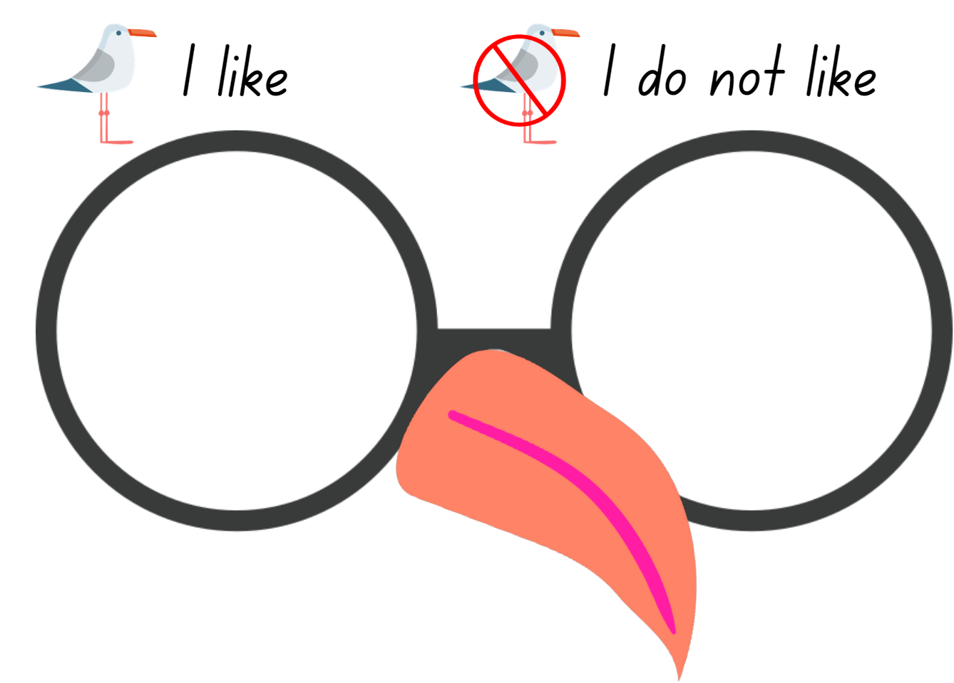
Images sourced from Canva and used in accordance with the Canva Content License Agreement.

Resource 2: T-chart character traits
Elmer | Students

Resource 3: Elephant poems
Five Little Elephants | The African Elephant
Five little elephants standing in a row.  Five little trunks waving to and fro.  ‘Good day,’ said an elephant, ‘I must go.’  Four little elephants standing in a row.  [Continue with – 4 little elephants; 3 little elephants etc]  One little elephant standing in a row,  One little elephant waving to and fro,  ‘Good day,’ said an elephant, ‘I must go.’  No little elephants standing in a row.  Choose actions that can be used when reading the poem.  Source: Mighty Book | The elephant has enormous ears,  And a trunk so very long.  His eyes are very tiny, though,  And his tusks are sharp and strong.  Choose actions that can be used when reading the poem.  Source: Early Learning HQ

Resource 4: Elephant outline
This image is adapted from “Elephant outline” by grmarc and is used in accordance with the Canva Content License Agreement.

Resource 5: Elephant stimulus
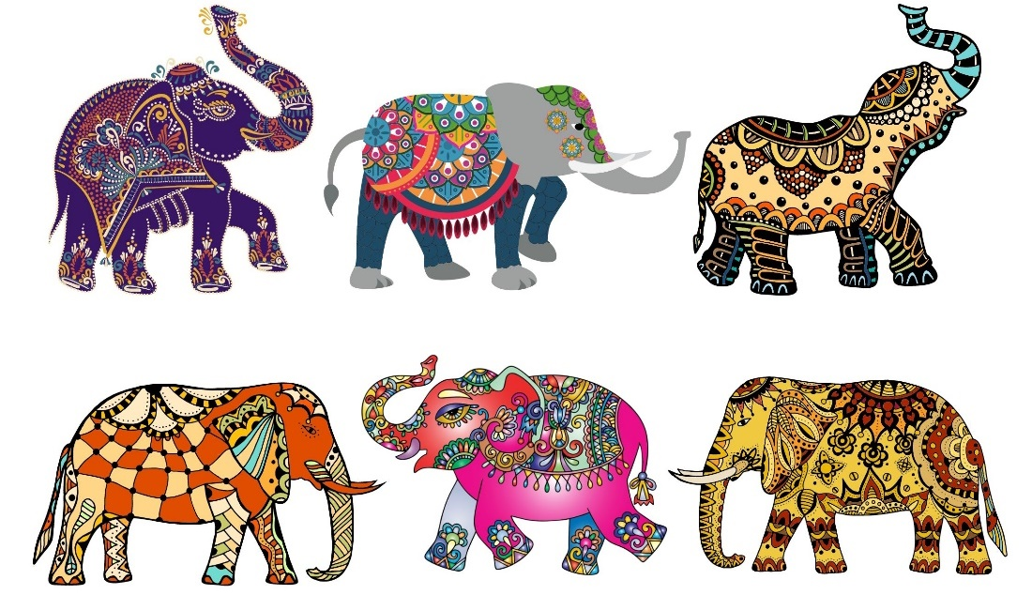
Images sourced from Canva and used in accordance with the Canva Content License Agreement.
Resource 6: T-chart – Elmer and Chip character traits
Elmer | Chip

References
Links to third-party material and websites
Please note that the provided (reading/viewing material/list/links/texts) are a suggestion only and implies no endorsement, by the New South Wales Department of Education, of any author, publisher, or book title. School principals and teachers are best placed to assess the suitability of resources that would complement the curriculum and reflect the needs and interests of their students.
If you use the links provided in this document to access a third-party's website, you acknowledge that the terms of use, including licence terms set out on the third-party's website apply to the use which may be made of the materials on that third-party website or where permitted by the Copyright Act 1968 (Cth). The department accepts no responsibility for content on third-party websites.
Except as otherwise noted, all material is © State of New South Wales (Department of Education), 2021 and licensed under the Creative Commons Attribution 4.0 International License. All other material (third-party material) is used with permission or under licence. Where the copyright owner of third-party material has not licensed their material under a Creative Commons or similar licence, you should contact them directly for permission to reuse their material.
English K–10 Syllabus © 2022 NSW Education Standards Authority (NESA) for and on behalf of the Crown in right of the State of New South Wales.
Creative Arts K–6 Syllabus © 2006 NSW Education Standards Authority (NESA) for and on behalf of the Crown in right of the State of New South Wales.
© 2021 NSW Education Standards Authority. This document contains NSW Curriculum and syllabus content. The NSW Curriculum is developed by the NSW Education Standards Authority. This content is prepared by NESA for and on behalf of the Crown in right of the State of New South Wales. The material is protected by Crown copyright.
Please refer to the NESA Copyright Disclaimer for more information.
NESA holds the only official and up-to-date versions of the NSW Curriculum and syllabus documents. Please visit the NSW Education Standards Authority (NESA) website and the NSW Curriculum website.
National Literacy Learning Progression © Australian Curriculum, Assessment and Reporting Authority (ACARA) 2010 to present, unless otherwise indicated. This material was downloaded from the Australian Curriculum website (National Literacy Learning Progression) (accessed 16 September 2022) and was not modified. The material is licensed under CC BY 4.0. Version updates are tracked in the ‘Curriculum version history’ section on the 'About the Australian Curriculum' page of the Australian Curriculum website.
ACARA does not endorse any product that uses the Australian Curriculum or make any representations as to the quality of such products. Any product that uses material published on this website should not be taken to be affiliated with ACARA or have the sponsorship or approval of ACARA. It is up to each person to make their own assessment of the product, taking into account matters including, but not limited to, the version number and the degree to which the materials align with the content descriptions and achievement standards (where relevant). Where there is a claim of alignment, it is important to check that the materials align with the content descriptions and achievement standards (endorsed by all education Ministers), not the elaborations (examples provided by ACARA).
All Things Animals TV (17 March 2015) ‘Seagulls’ [video], YouTube, accessed 24 August 2022.
AndersenPress (9 May 2019) ‘David McKee reads Elmer’ [video], YouTube, accessed 30 August 2022.
Early Learning HQ (2016) ‘The African Elephant Poem’, Jungle, Early Learning HQ website, access 16 September 2022.
ETA (English Teachers Association) and NSW Department of Education (2016) The Textual Concepts and Processes resource, English Textual Concepts website, accessed 23 August 2022.
Howarth, K (2018) Chip, Hardie Grant Children’s Publishing.
Mackenzie, N (2019) ‘Draw, Talk, Write (and Share)’, Noella’s Blog, Noella Mackenzie website, accessed 16 September 2022.
McKee, D (2019) Elmer 30th Anniversary Collector's Edition, Andersen Press, UK (original work published 1968).
Mighty Book (2021) Five Little Elephants, Mighty Book website, accessed 16 September 2022.
South Eastern Sydney Local Health District (5 November 2020) ‘Aboriginal Performance Seagulls Dance [video], YouTube, accessed 24 August 2022.
State Government of Victoria (2018) ‘Interactive writing’, Literacy Teaching Toolkit, Victoria Department of Education and Training website, accessed 16 September 2022.
ViralHog (13 August 2021) ‘Sneaky Seagull Shoplifts a Snack’ [video], YouTube, accessed 24 August 2022.

