English – Early Stage 1 – Unit 4
Contents
Unit overview and instructions for use 3
Teacher notes 4
Outcomes and content – Component A 6
Outcomes and content – Component B 9
Week 1 11
Component A teaching and learning 11
Component B teaching and learning 12
Lesson 1: BLORK and BLuuRF – Nonsense words and alliteration as connotation 13
Lesson 2: Robot Monkey – Font choice and imagery as connotation 15
Lesson 3: Glug, glug, glug – Symbols and rhyme as word play 17
Lesson 4: Ziggy Zaggy Zog – imagery and alliteration 18
Lesson 5: Blueberry pizza – connotation and alliteration 20
Week 2 23
Component A teaching and learning 23
Component B teaching and learning 24
Lesson 6: This is a ball – imagery 25
Lesson 7: Is it really a dog? – symbol 27
Lesson 8: Monsters – symbols 28
Lesson 9: Crash, bang – imagery 30
Lesson 10: Splish Splash – connotation 31
Resource 1: Rhyme cards 33
Resource 2: Alliteration wordplay – discussion card 34
Resource 3: Ziggy Zaggy Zog 35
Resource 4: Anchor chart 37
Resource 5: Monster puppets 38
Resource 6: Onomatopoeia poem 39
Resource 7: Splish Splash poem 41
Resource 8: Segment and reconstruct a sentence 43
References 45

Unit overview and instructions for use
This two-week unit is comprised of Component A and Component B. Connecting learning across both components is encouraged.
Teaching and learning | Component A | Component B
Suggested duration | 60 minutes | 45 minutes
Explicit teaching focus areas | - Phonological awareness  - Print conventions  - Phonic knowledge  - Reading fluency  - Reading comprehension  - Spelling  - Handwriting | - Oral language and communication  - Vocabulary  - Reading comprehension  - Creating written texts  - Understanding and responding to literature
To prepare for teaching and learning: | - Refer to Outcomes and content – Component A, K-2 – Instructional sequence – grapheme–phoneme correspondences [PDF 825 KB], and the teaching advice documents (hyperlinked in Component A teaching and learning table).  - Based on student needs identified through ongoing assessment data, plan and document how you will sequence teaching and learning in whole class and targeted teaching groups across the two-week cycle. | - Familiarise yourself with Outcomes and content – Component B, Textual concepts information and videos, English Textual Concepts and Learning Processes (2016), and the teaching and learning sequence.  - Based on student needs identified through ongoing assessment data, determine how you will support students in whole class and targeted teaching groups across the two-week cycle as required.
English K–10 Syllabus © 2022 NSW Education Standards Authority (NESA) for and on behalf of the Crown in right of the State of New South Wales.

Teacher notes
- Imagery, symbol, and connotation enrich a text by making words and images mean more than one thing. Connotation is an idea or feeling that we sometimes connect to a word. It suggests more than the word’s basic meaning. These can be different, depending on personal and cultural experiences. Symbols are pictures, colours, or objects that represent something else, usually something abstract like an idea. Imagery invites an interpretation of an idea by engaging our senses which often evokes an emotional reaction – English Textual Concepts and Learning Processes (2016).
- Understanding of imagery, symbol and connotation can be supported through watching the department’s video, Connotation, imagery and symbol (6:06).
- Refer to the NESA Glossary for information on ‘imagery’ and ‘symbol’.
- A variety of instructional strategies have been included to support students’ understanding and responding to literature:
- Thinking aloud involves verbally modelling the thinking processes before, during and after reading or writing. It is important that you verbalise what is going on in your mind as you read or write. Having a focus for a think aloud makes sure that this strategy is used effectively and efficiently.
- Thinking partners are used to engage students in accountable conversations about texts and personal experiences. The strategy helps students to share their experiences and thinking in a non-threatening way. Similar strategies include ‘talk partners’, Think-Pair-Share, and turn and talk.
- A variety of instructional strategies have been included to support students engaged in creating written texts:
- The Draw, Talk, Share, Write strategy for emergent writers includes drawing as part of a meaning making process, while talking and sharing allows children to make sense of their ideas and to develop their vocabulary and oral language skills. Writing provides an opportunity to apply phonic and word knowledge into another context. Best practice in this strategy is modelled by Australian researcher Noella Mackenzie. For further information, refer to the public domain website Draw, Talk, Write (and Share).
- Interactive writing is a shared writing strategy where the teacher and students write together to compose and record a co-constructed text. The teacher models how successful writers generate and organise their ideas, and guides students to record the text. Interactive writing can also provide an opportunity to teach concepts about print, sentence structure and grammar, spelling strategies, punctuation, and handwriting.
- Modelled writing provides opportunities for teachers to demonstrate the thoughts and actions of a proficient writer when creating texts. The teacher takes full responsibility for scribing during this process and students observe what and how the writing is created, learning from what is being explained by the teacher.
- Soundscapes use a variety of sounds and sound sources (including, but not only, voices and instruments) to create a scene, express an idea, create a mood or feeling.
- This unit could enhance student learning towards achievement of outcomes from the Creative Arts syllabus.
- Reflect on student learning and engagement in activities and record differentiation and adjustments within the unit to inform future teaching and learning. One way of doing this could be to add comments to the digital file.
- Content points are linked to the National Literacy Learning Progression version (3).
Levels and indicators sourced from National Literacy Learning Progression © Australian Curriculum, Assessment and Reporting Authority (ACARA), accessed 2 September 2022 and was not modified. See references for more information.

Outcomes and content – Component A
The table below outlines the focus outcomes and content. Content is linked to the National Literacy Learning Progression version (3).
Focus area and outcome | Content points and National Literacy Learning Progression
Phonological awareness  ENE-PHOAW-01 – identifies, blends, segments and manipulates phonological units in spoken words as a strategy for reading and creating texts | - complete familiar spoken phrases in texts, including chants, rhymes, songs, and poems (PhA1)  - consistently say the first phoneme of spoken one syllable word (PhA2)  - orally blend up to 4 phonemes together to make a one-syllable spoken word (PhA4)  - orally segment one-syllable words comprised of up to 4 phonemes into separate phonemes (PhA4)
Print conventions  ENE-PRINT-01 – tracks written text from left to right and from top to bottom of the page and identifies visual and spatial features of print | - identify pictures in texts (PKW2)  - know the difference between a letter and a word (PKW1)  - distinguish between punctuation, letters, words and numerals in texts (PKW2)  - identify spaces between words (PKW2)  - identify and name lower-and upper-case letters (PKW4)  - turn pages one at a time (UnT2)  - consistently read left page before right page (UnT4)
Phonic knowledge  ENE-PHOKW-01 – uses single-letter grapheme–phoneme correspondences and common digraphs to decode and encode words when reading and creating texts | - match single letter grapheme with a phoneme  - say the most common phoneme for a single-letter graphemes (graphs) (PKW3)  - blend single-letter grapheme-phoneme correspondences to decode VC and CVC words, and apply this knowledge when reading, including decodable texts (PKW3) (PKW4)  - segment and encode single-letter VC and CVC words, and apply this knowledge when writing words and creating texts (PKW4)
Reading fluency  ENE-REFLU-01 – reads decodable texts aloud with automaticity | - read texts with taught grapheme-phoneme correspondences and taught high-frequency words with automaticity
Reading comprehension  ENE-RECOM-01 – comprehends independently read texts using background knowledge, word knowledge and understanding of how sentences connect | - recall key characters, events, and/or information in text (UnT5)
Spelling  ENE-SPELL-01 – applies phonological, orthographic and morphological generalisations and strategies to spell taught familiar and high-frequency words when creating texts | - segment single-syllable words into phonemes as a strategy for spelling (SpG1)  - add the plural-marking suffix (s) to base nouns that require no change when suffixed (SpG5)
Handwriting  ENE-HANDW-01 – produces all lower-case and upper-case letters to create texts | - correctly produce a clockwise ellipse, anticlockwise ellipse and downward diagonal stroke when forming letter shapes  - apply appropriate pressure when handwriting to produce legible writing (HwK2)

Outcomes and content – Component B
The table below outlines the focus outcomes and content. Content is linked to the National Literacy Learning Progression version (3).
Focus area and outcome | Content points and National Literacy Learning Progression
Oral language and communication  ENE-OLC-01 – communicates effectively by using interpersonal conventions and language with familiar peers and adults | - respond to spoken questions  - follow-up to 3-part spoken instructions (LiS3)  - take turns when speaking during structured and unstructured play (InT3)  - retell favourite stories, poems, songs and rhymes with some parts as exact repetition and some in their own words (SpK2)
Vocabulary  ENE-VOCAB-01 – understands and effectively uses Tier 1 and Tier 2 words in familiar contexts | - experiment with and create wordplay and poems  - identify, name and describe a range of objects, characters, animals, people and places when given visual and/or auditory prompts (GrA1)
Reading comprehension  ENE-RECOM-01 – comprehends independently read texts using background knowledge, word knowledge and understanding of how sentences connect | - identify words that represent who, what, where and why in texts  - understand how adjectives describe a noun and verbs identify actions in a sentence  - use visual cues in multimodal texts to interpret meaning (UnT5)
Creating written texts  ENE-CWT-01 – creates written texts that include at least 2 related ideas and correct simple sentences | - use personal vocabulary, words on display and in mentor texts when constructing sentences  - identify and use verbs in simple sentences, including in own writing (GrA2)  - know that a simple sentence makes sense by itself and is a complete thought represented by a subject and verb (GrA3)  - identify differences between spoken and written language  - use drawing, images or mind maps to support planning and writing (CrT4)
Understanding and responding to literature  ENE-UARL-01 – understands and responds to literature read to them | - identify and discuss how creative language and/or symbols enhance enjoyment in texts  - experiment with creative play with language in own texts

Week 1

Component A teaching and learning
The table below can be used to plan and document lessons that address Component A outcomes and content. Both the detailed example [DOC 529KB] of a two-week teaching and learning cycle and brief example [DOC 66KB] may support you in your planning.
Focus Areas | Lesson 1 | Lesson 2 | Lesson 3 | Lesson 4 | Lesson 5
Phonological awareness and
Phonic knowledge
15 minutes
Spelling and Handwriting
15 minutes
Print conventions,
Reading comprehension and Reading fluency
30 minutes

Component B teaching and learning
The following teaching and learning sequence has been designed to address Component B outcomes and content. Adapt the sequence as required to best meet the needs of your students.

Learning intention and success criteria
Learning intentions and success criteria are best co-constructed with students.

Learning intention
Students are learning to explore how creative language, imagery and symbol enhance enjoyment in texts.

Success criteria
Students can:
- use wordplay such as rhyme and alliteration to evoke enjoyment
- create a simple sentence, that includes imagery
- follow three-part instructions to create an image
- respond to spoken questions.

Resources
- Resource 1: Rhyme cards
- Resource 2: Alliteration wordplay – discussion card
- Resource 3: Ziggy Zaggy Zog
- Resource 4: Anchor chart
- Novak BJ (2016) The Book With No Pictures, Puffin. ISBN: 9780141361796
- Novak BJ (2019) My Book With No Pictures, Puffin. IBSN: 9780241444177
- Modelling clay

Lesson 1: BLORK and BLuuRF – Nonsense words and alliteration as connotation
- Introduce the text The Book With No Pictures by asking students if they think that a book without pictures will be exciting or interesting, or if they think it will be boring. Explain when reading books with no pictures, readers need to listen carefully to the author’s words. The way the words are written and spoken help readers to see or imagine pictures in their heads. Explain that this is also called visualising.
- Read the text The Book With No Pictures and encourage students to join in and interact with the text in response to the fun questions that are asked. Briefly unpack any new vocabulary as the text is being read, for example ‘preposterous’.
- Have students consider how they felt when listening to the story. Ask students to describe what made them feel that way. Explain that authors use different techniques or strategies when creating texts to make readers feel a particular way.
- Re-read sections of the text that contain nonsense words. Highlight how silly ideas and nonsense words, like ‘BLORK’, ‘BluuRF’ and ‘ma GRUMPH-a-doo’ were used. Discuss the difference between real words and nonsense words. Explain that the author has used nonsense words because they sound funny and make the reader feel a certain way. The words ‘BLORK’ and ‘BluuRF’ are fun and have happy connotations.
- Using known grapheme-phoneme correspondences, create additional nonsense words with students. For example, ‘nop’, ‘neeeeeeeep’ and ‘naap’ and record in a nonsense word bank for student reference. Students experiment with funny ways to say the words, ‘nop’, ‘neeeeeeeeep’ and ‘naap’.
- Highlight the wordplay technique of alliteration, explaining that it is another device used by authors to create feelings of fun. Say the words ‘BLORK’ and ‘BluuRF’, accentuating the beginning sounds. Say other words beginning with /b/. Find and discuss other examples of alliteration in the book such as ‘boo butt’. Using the Think-Pair-Share strategy, students create a spoken sentence that uses nonsense words and alliteration, for example, ‘beeb butt bites biscuits’.
- Ask students what they think a ‘BLORK’ and a ‘BluuRF’ might be. Using modelling clay, students create a ‘BLORK’ or ‘BluuRF’. Students write alliterative nonsense words around their creation from the nonsense word bank. These could be the words that a ‘BLORK’ or ‘BluuRF’ would say. Encourage students’ sense of fun with wordplay through choral reading of their word creations.
- Take photos of the ‘BLORK’ and ‘BluuRF’ modelling clay creations and the words they say, and share with families via Class Dojo or the Seesaw app.
Early Stage 1 Assessment task 1 – Observations from this lesson allow students to demonstrate achievement towards the following syllabus outcome and content point:
ENE-VOCAB-01 – understands and effectively uses Tier 1 and Tier 2 words in familiar contexts
- experiment with and create wordplay and poems.

Lesson 2: Robot Monkey – Font choice and imagery as connotation
- Re-read text The Book With No Pictures. Explain that written language is different to spoken language, and is represented by letters that form words. Each word has spaces between them that tells the reader to pause. Written language has punctuation, such as full stops and exclamation marks. These help the reader to know what expression to use when reading.
- Focus on print conventions such as font types, colour, and size and how this connects with the author’s intention for readers to find this book funny (even though it doesn’t have any pictures). With students, practice reading sections with attention to how the text style impacts on changes in volume and expression.
- Draw students’ attention to the page ‘Also, I am a ROBOT MONKEY’. Explain that the author uses the pixelation of the font to create an image of machine writing. We can imagine the robot monkey moving like a machine, expressing no emotion, and doing things in an automatic way. Students explore movement using volume and pitch that reflects the style of the font and the image of the robot monkey.
- Explain that the author wants the reader to imagine what a robot monkey would look like because this too would create enjoyment and fun. Students can turn to a partner to describe what a robot monkey looks like. Highlight that student’s robot monkeys will have some things that are the same and some things that are different because readers visualise things in different ways.
- Use descriptive language to create an image of a robot monkey. Explain that the words we use to ‘describe’ are called adjectives. Use the 'share the pen’ strategy with students to draw features of a robot monkey using adjectives, for example, zig zag arms, round buttons, pointy nose, curly hair, brown body, long legs, short tail. Write labels next to the features of the robot monkey.
- Model writing a simple sentence to describe the robot monkey. For example, ‘I have a long tail’. Highlight print features such as words, spaces, capital letter and full stop. Read the sentence aloud to demonstrate that a sentence needs to be a complete idea that makes sense by itself. Compare the sentence/s to the labels that were written and how the labels do not make sense on their own, for example, long tail.
- Using the Draw, Talk, Share, Write strategy, students create their own robot monkey that they think would make someone laugh. Encourage students to add details to the different parts of their robot monkey, and then compare with others to describe the humorous features. Explore how individuals create their own unique image in their mind based on their personal background knowledge (imagery).
- Revisit the use of nonsense words and alliteration as techniques used by the author in The Book With No Pictures, as well as the use of colour and font size. With a partner, students come up with words that could be spoken by the robot monkey, including nonsense words that begin with the same letter. For example, SIT, sot, SEEEEEP. Students can draw on the nonsense word bank from Lesson 1. Using a speech bubble, students experiment with writing words in different colours and sizes.
Too hard? Write simple nonsense words on sticky notes for students to copy into their speech bubble.
Too easy? Students write a sentence using a noun and an adjective.
Early Stage 1 Assessment task 2 – Observations from this lesson allow students to demonstrate achievement towards the following syllabus outcomes and content points:
ENE-RECOM-01 – comprehends independently read texts using background knowledge, word knowledge and understanding of how sentences connect
- understand how adjectives describe a noun and verbs identify actions in a sentence.
ENE-CWT-01 – creates written texts that include at least 2 related ideas and correct simple sentences
- use personal vocabulary, words on display and in mentor texts when constructing sentences
- use drawing, images or mind maps to support planning and writing.

Lesson 3: Glug, glug, glug – Symbols and rhyme as word play
- Re-read the text The Book With No Pictures. Draw students’ attention to the page with ‘glug my face is a bug...’ and ask why it was read in a sing-song style. Highlight the use of music note symbols and how the word ‘ruuuuuuuug’ is in a curved line to add to the textual elements.
- Revisit the song, ‘Glug, glug, glug’ to further students’ understanding of the concept that rhyming words support imagery, helping the reader to see what the author is describing. Ask students when they listen to ‘Glug, glug, glug’ can they see a bug face eating ants off the rug.
- Focus on the rhyming words ‘bug’ and ‘rug’. Explain rhyming word families make the same sound at the end of the word. Model rhyming by leading students in a rhyming chant, bug/bug/bug/rug/rug/rug/bug/rug/bug/rug/bug/rug/bug. Show students the cards, bug/rug/ant from Resource 1: Rhyme cards. Students choral read the images, bug/rug/ant/bug/rug/ant. Ask students which word does not rhyme.
- Explain that authors select rhyming words when writing a song to convey meaning and entertain the audience. Co-construct a rhyming song using the text scaffold, for example, splat, splat, splat, my face is a cat, or I like to eat a hat for breakfast right off the maaaaat. Ask students what symbols we can add to show this is a song.
- Students choral sing the co-constructed song with emphasis on rhyming words. In pairs, ask students to think about what they see when they hear splat/cat/hat and to create body percussion or movements to visually represent the rhyming words. Repeat the choral chant with students adding their body percussion.
Early Stage 1 Assessment task 3 – Observations from this lesson allow students to demonstrate achievement towards the following syllabus outcomes and content points:
ENE-UARL-01 – understands and responds to literature read to them
- experiment with creative play with language in own texts
- identify and discuss how creative language and/or symbols enhance enjoyment in texts.
ENE-VOCAB-01 – understands and effectively uses Tier 1 and Tier 2 words in familiar contexts
- experiment with and create wordplay and poems.
ENE-OLC-01 – communicates effectively by using interpersonal conventions and language with familiar peers and adults
- retell favourite stories, poems, songs and rhymes with some parts as exact repetition and some in their own words.

Lesson 4: Ziggy Zaggy Zog – imagery and alliteration
- Read text My Book With No Pictures. Revisit how the intention of word play is to be funny. Focus on Robot Monkey’s friend, Boo Butt and how authors use alliterative devices to create imagery and humour. Model how to expand the alliteration in the sentence ‘Boo Butt bounces bugs’ to add to the imagery.
- Use Resource 2: Alliteration wordplay – discussion card. Ask students to label parts of the picture such as pink, pig, pineapple and model how to group 2 words together to make a simple alliteration, for example, purple pig, pointy pineapple. Lead students in an alliterative tongue twister, ‘the purple pig paints pictures of pink pineapples’.
- Discuss how authors use adjectives such as purple and pointy to describe the subject/noun, purple pig, pointy pineapple. Adjectives add to the imagery so readers can get a clearer picture of who is in our text. Explain that students will listen to instructions (Resource 3: Ziggy Zaggy Zog), drawing on the imagery they see in their minds to create a new character, Ziggy Zaggy Zog.
- Students share images and compare how they are alike and different. Discuss how we can hear the same instructions, but we see the descriptions in different ways because we have had different experiences.
- Collect images to create a class text for Ziggy Zaggy Zog.
Too hard? Students follow one step instruction.
Too easy? Students follow three-part instructions and add more details.
- Explain we know the who, our character is Ziggy Zaggy Zog, and we want to know what Zog can do (actions and verbs). Students brainstorm verbs and record responses for the word wall.
- Use Resource 4: Anchor chart to model writing a sentence, for example, Zog likes to jump. Explain how a simple sentence makes sense by itself and is a complete thought represented by a subject and verb.
- Model how to change the ‘who’ to another character or person, such as Bing Bang Boo or Mrs Smith likes to jump. Emphasise that the sentence is still a complete idea.
- Model how to change the ‘what’ to a different verb phrase, likes to sing, likes to eat, likes to bounce. Emphasise that the sentence is still a complete idea.
Early Stage 1 Assessment task 4 – Observations and work samples from this lesson allow students to demonstrate achievement towards the following syllabus outcomes and content points:
ENE-OLC-01 – communicates effectively by using interpersonal conventions and language with familiar peers and adults
- follow-up to 3-part spoken instructions.
ENE-RECOM-01 – comprehends independently read texts using background knowledge, word knowledge and understanding of how sentences connect
- identify words that represent who, what, when, where and why in texts
- understand how adjectives describe a noun and verbs identify actions in a sentence.
ENE-CWT-01 – creates written texts that include at least 2 related ideas and correct simple sentences
- identify and use verbs in simple sentences, including in own writing
- know that a simple sentence makes sense by itself and is a complete thought represented by a subject and verb.

Lesson 5: Blueberry pizza – connotation and alliteration
- Re-read the text My Book With No Pictures. Revisit the wordplay technique of alliteration and model how alliteration repeats the sound at the beginning of words, for example, glibbity globbity glibbity and beep bop. Explain that alliteration is a device used by authors to create positive connotations or feelings, for example, sunshine Sam and lovable Lucy.
- Authors use alliteration to position the reader in a particular way, sometimes the connotation may be negative depending on the experiences of the reader. For example, if a reader has a fear of bugs the alliteration ‘big bad bugs bite butts’ may encourage negative feelings. Words have connotations that may differ between individuals.
- Explain to students that they are going to see how it makes them feel when they hear some alliterative phrases, and what connotations are created. Students use a ‘thumbs up’ for a positive response, and a ‘thumbs down’ for a negative response to the following questions:
- Do you like slimy smelly socks?
- Do you like stinky sticky sneakers?
- Do you like crunchy caramel cake?
- Do you like luscious lollypops?
- Do you like muddy marshmallows?
- Discuss using think aloud strategies that words and imagery invite the reader to make connections to ideas by engaging their senses, ask can you smell and almost feel the slimy smelly socks. Encourage students to think of their own simple alliterations to create positive or negative feelings.
- Revisit the page, ‘And my head is made of blueberry pizza’. Think aloud that the author is describing a pizza head, and ask what students think a pizza head looks, feels, smells, and tastes like.
- Using ‘thinking partners’, students think of a pizza or sandwich head and share what they see, hear, taste, and feel.
- Using the Draw, Talk, Share, Write strategy, model drawing a pizza or sandwich head with labels next to the features of the image. Model spoken alliterative phrases such as muddy mouth, enormous ears, egg eyes, nutty nose.
- Students draw and label their image of a pizza or sandwich head.
- As a class, students compare their images. Discuss how everyone visualises things differently.
Early Stage 1 Assessment task 5 – Observations from this lesson allow students to demonstrate achievement towards the following syllabus outcomes and content points:
ENE-OLC-01 – communicates effectively by using interpersonal conventions and language with familiar peers and adults
- responds to spoken questions
- take turns when speaking during structured and unstructured play.
ENE-UARL-01 – understands and responds to literature read to them
- experiment with creative play with language in own texts
- identify and discuss how creative language and/or symbols enhance enjoyment in texts.
ENE-RECOM-01 – comprehends independently read texts using background knowledge, word knowledge and understanding of how sentences connect
- understand how adjectives describe a noun and verbs identify actions in a sentence.

Week 2

Component A teaching and learning
The table below can be used to plan and document lessons that address Component A outcomes and content. Both the detailed example [DOC 529KB] of a two-week teaching and learning cycle and brief example [DOC 66KB] may support you in your planning.
Focus Areas | Lesson 6 | Lesson 7 | Lesson 8 | Lesson 9 | Lesson 10
Phonological awareness and
Phonic knowledge
15 minutes
Spelling and Handwriting
15 minutes
Print conventions,
Reading comprehension and Reading fluency
30 minutes

Component B teaching and learning
The following teaching and learning sequence has been designed to address Component B outcomes and content. Adapt the sequence as required to best meet the needs of your students.

Learning intention and success criteria
Learning intentions and success criteria are best co-constructed with students.

Learning intention
Students are learning that a sentence is a complete thought with a subject and verb.

Success criteria
Students can:
- identify nouns and verbs in simple sentences
- segment sentences into words
- identify adjectives that describe the noun.

Resources
- Resource 5: Monster puppets
- Resource 6: Onomatopoeia poem
- Resource 7: Splish Splash poem
- Resource 8: Segment and reconstruct a sentence
- Venn diagram
- Stanton B and Stanton M (2015) This is a ball, ABC Books. ISBN: 9780733334351
- 4 Hoops
- Sticky notes

Lesson 6: This is a ball – imagery
- Introduce the text This is a ball. Before reading the title, ask students to predict what the text might be about. Read the title and ask if students have changed their predictions.
- Ask students to think of a ball, it may be a ball they have at home or one they have played with at school, or it could be a ball from their imagination. Explain that when people imagine something they see a picture of it; this is called visualising.
- Explain that students will explore a feely bag filled with familiar objects, including a ball and curved blocks. Students feel the items using their sense of touch. Each student explores the bag and describes what they are feeling. Record student descriptions of objects to build an adjective word bank, including a drawn image. If a student immediately names an object, ask how they know. Ask students to describe the object they are touching by modelling spoken questions, for example, ‘Is it pointy, big, small, hard, or smooth?’ Observe if students have used the same words to describe a ball and a block such as big, small, smooth, curved. Explain how each object is different but have similar characteristics. Read through the adjectives from the word bank.
- Read the text This is a ball, emphasising the questioning. Explain how the author uses questioning to imply that the reader is confused or feeling sick, such as ‘Are you feeling okay? Are you confused?’
- Model how the authors use symbols and words, drawing attention to examples where they do not match the imagery students can see. Discuss how the author uses symbols to represent something else creating a sense of fun. Show students a spikey ball and model a spoken sentence using an adjective from the word wall, ‘Look at my spikey ball’. Students repeat the sentence. Model drawing an echidna and label it with spikey ball. Ask students if they are sure, and prompt students to look closer.
- With students, map ideas of what their ball could represent. For example, a wavy ball could be a snake, a spikey ball could be an echidna.
- Explain that students will draw a ‘ball’ and label it with adjectives from the word wall, using the Draw, Talk, Share, Write strategy. Encourage students to see the silliness and fun in drawing objects that do not match the spoken sentence, for example, ‘Look at my wavy ball’.
Too hard? Students draw an image.
Too easy? Students write a simple sentence.
- Use a text creator app or similar to create a multimodal text by taking photos of each student’s drawings and share with families.
Early Stage 1 Assessment task 6 – Observations from this lesson allow students to demonstrate achievement towards the following syllabus outcomes and content points:
ENE-CWT-01 – creates written texts that include at least 2 related ideas and correct simple sentences
- use personal vocabulary, words on display and in mentor texts when constructing sentences
- use drawing, images or mind maps to support planning and writing.
ENE-RECOM-01 – comprehends independently read texts using background knowledge, word knowledge and understanding of how sentences connect
- understands how adjectives describe a noun and verbs identify actions in a sentence.

Lesson 7: Is it really a dog? – symbol
- Re-read the text This is a ball, focusing on how the symbols and words do not represent the same thing.
- Revisit the page, ‘This is a dog’. Ask students to look at the image and share what they see. Explain how the author has selected an image of an elephant, but the author says ‘This is a dog, I can see its eyes. Its legs. It must be a dog’. Think aloud that an elephant and a dog have eyes, legs, ears, and tails. Ask students how they know that a dog is really a dog, if it might also be an elephant.
- Using Think-Pair-Share, students describe the characteristics of either a dog or an elephant. Record student thinking in a Venn diagram. Draw students’ attention to similarities between the animals, such as eyes and a tail, and compare the differences. Explain that students now know the image really is an elephant because only the elephant has a trunk and giant ears. Ask students if the monster is really a monster, and how they know.
- Explain how authors use verbs to tell the reader what is happening. Use the opposites game ‘don’t do this, do that’ to model verbs such as hop, jump, dance, fly, drive, sing, run. Explain that when students hear, ‘don’t do this’ they copy the action, and when they hear ‘do that’ they freeze.
- Explain to students that a sentence is a group of words that expresses a complete thought, and verbs are an important part of a sentence. Use an anchor chart to model writing subject-verb sentences, for example, ‘This dog can...’. Students brainstorm different action verbs such as dance, read, skip, skate, cook, sing, drive, and fly. Record verbs in word banks or on word walls.
- Using the Draw, Talk, Share, Write strategy, explain that students will draw an animal that is not a dog to go with the sentence starter, ‘This dog can....’. Students add a verb from the verb word wall.
Too hard? Support students in a small group.
- Invite students to share with the class.
Early Stage 1 Assessment task 7 – Observations from this lesson allow students to demonstrate achievement towards the following syllabus outcomes and content points:
ENE-RECOM-01 – comprehends independently read texts using background knowledge, word knowledge and understanding of how sentences connect
- use visual cues in multimodal texts to interpret meaning.
ENE-RECOM-01 – comprehends independently read texts using background knowledge, word knowledge and understanding of how sentences connect
- understand how adjectives describe a noun and verbs identify actions in a sentence.

Lesson 8: Monsters – symbols
- Re-read the text This is a ball, encourage student interaction and responses to the questions, and model how students can ask their own questions to imply something is not real to confuse the reader.
- Revisit the page, ‘This is a princess flying a kite at the beach’. Students Think-Pair-Share to discuss the imagery and symbols in the text. Ask students how the images differ to the imagery in their heads, including connotations or feelings.
- Use the sentence, ‘This is a princess flying a kite at the beach’ to show the sentence structure, who and what. Discuss how the author builds the story by adding on and repeating previous information. Write the sentence onto sticky notes or similar. As a whole class, students innovate on the sentence generating ideas for the subject. Record responses onto sticky notes and change the sentence, for example, ‘This is a cow flying a kite at the beach’, ‘This is a giraffe flying a kite at the beach’. Students choral read sentences.
Too easy? Students create who, what, where sentences, The monster chased the cow in the city.
- Students create and draw monster puppets that can be attached to an ice-cream stick or similar. Provide opportunities for students to take photos of their monster puppets at different places around the school or home. Share images on the smartboard such as an image of a monster kicking the ball. Model spoken sentences, who and what, ‘My princess is dancing on the slide’.
Too hard? Students use Resource 5: Monster puppets and attach to a craft stick or similar.
Early Stage 1 Assessment task 8 – Observations from this lesson allow students to demonstrate achievement towards the following syllabus outcomes and content points:
ENE-VOCAB-01 – understands and effectively uses Tier 1 and Tier 2 words in familiar contexts
- identify, name and describe a range of objects, characters, animals, people and places when given visual and/or auditory prompts.
ENE-RECOM-01 – comprehends independently read texts using background knowledge, word knowledge and understanding of how sentences connect
- identify words that represent who, what, where and why in texts.

Lesson 9: Crash, bang – imagery
- Re-read the text This is a ball and encourage students to choral read the text. Revisit the page with the monster who says ‘Boo!’ Introduce onomatopoeia wordplay using objects from the text, for example, triangle, car, dog, balloon. Ask students to listen for sounds, encouraging them to say the sound they hear and name the object. Explain that onomatopoeia words describe actions and make a story more exciting. They build imagery by engaging our senses, helping readers connect with a story through hearing and vision.
- Revisit the page, ‘This is a monster telling a story about a princess flying her kite at the beach with her pet dog, while standing on a block’. Think aloud that the monster is standing on a ball and is wobbling. Ask students to predict what will happen next. Add examples of onomatopoeia to students’ responses. Encourage students to add their own imagery through onomatopoeia words. Model spoken sentences, ‘The monster went crash’, ‘The princess went boo hoo’, ‘The dog went ker-plunk, ouch’. Students repeat the sentences using word play.
- Using Resource 6: Onomatopoeia poem, sing the poem to the tune of Little Peter Rabbit, emphasising the onomatopoeia words. Record some simple words such as boo, ouch, zing, bang, buzz, and moo.
- Use the Draw, Talk, Share, Write strategy to explain that students will be experimenting with drawing the imagery for boo, buzz, bang, and moo.
Early Stage 1 Assessment task 9 – Observations from this lesson allow students to demonstrate achievement towards the following syllabus outcomes and content points:
ENE-VOCAB-01 – understands and effectively uses Tier 1 and Tier 2 words in familiar contexts
- experiment with and create wordplay and poems.
ENE-CWT-01 – creates written texts that include at least 2 related ideas and correct simple sentences
- use drawing, images or mind maps to support planning and writing.

Lesson 10: Splish Splash – connotation
- Re-read the text This is a ball and encourage students to choral read the text.
- Explain how a spoken sentence can be broken into words. Place 4 hoops on the floor and model jumping into hoops as each word in a sentence is spoken. Provide students with a sentence to segment, for example, ‘The rocket went zoom’, ‘The rocket went swoosh’. Students identify the number of words in the sentence.
- Using Resource 7: Splish Splash poem, ask students to think about the images and listen carefully to the poem. Discuss the imagery in the poem and ask students which image they think the poem describes. Prompt students to share how they know the poem is about the playing in the rain. Provide opportunities for responses and support students to identify the onomatopoeia drip-drop, splish-splash, woosh and splosh. Model spoken phrases. Re-read the words ‘giggles’ and ‘squeal’ and explain how the onomatopoeia word ‘giggles’ helps readers to visualise or see someone who is happy, while ‘squeal’ tells readers that the child playing in the rain is excited and filled with joy.
- Model segmenting and reconstructing a sentence, ‘She can jump’.
- Students draw an image of playing in the rain and segment and reconstruct the sentence using Resource 8: Segment and reconstruct a sentence: Segment and reconstruct a sentence.
Too hard? Students cut and paste, and match ‘I can jump’ to the baseboard.
Too easy? Students reconstruct a sentence and write a sentence, just as, I can jump and splash.
- Using Resource 6: Onomatopoeia poem, sing the poem to the tune of Little Peter Rabbit, emphasising the rhythm and prosody of the onomatopoeia words.

Resource 1: Rhyme cards
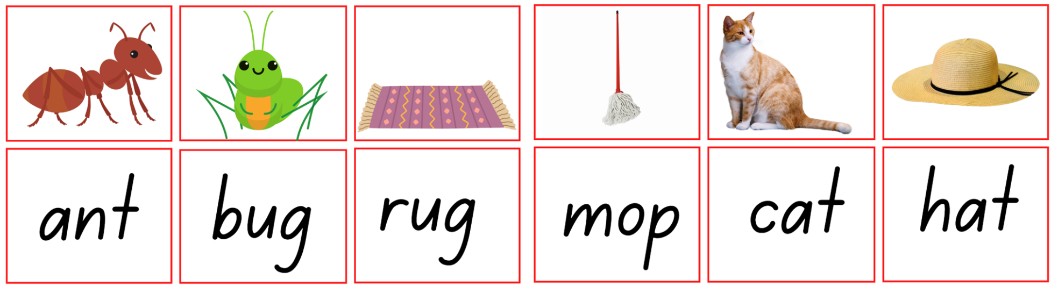
Images sourced from Canva and used in accordance with the Canva Content License Agreement.

Resource 2: Alliteration wordplay – discussion card
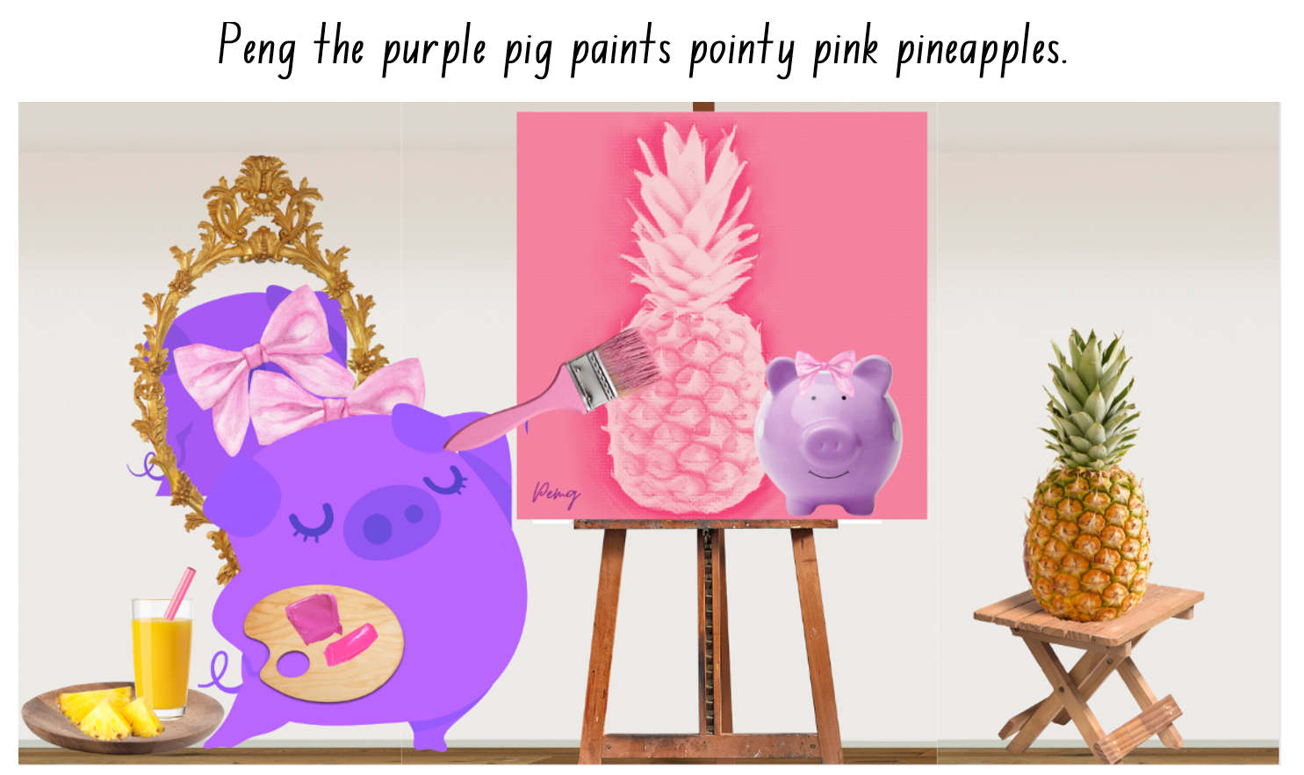
Images sourced from Canva and used in accordance with the Canva Content License Agreement.

Resource 3: Ziggy Zaggy Zog
Students follow up to 3 part-spoken instructions to draw Ziggy Zaggy Zog.
- round body with spots
- fluffy tail with zig zags
- curly arms with stripes
- skinny legs with toes
- long neck with stars
- head with big eyes and eyelashes
- mouth with a long tongue and sharp teeth
- pointy nose with boogers and flies
- spikey hair with a hat and a flower
Students follow one to two part spoken instructions to draw Ziggy Zaggy Zog.
- round body
- fluffy tail
- curly arms
- skinny legs
- long neck
- head with big eyes
- mouth with sharp teeth
- pointy nose
- spikey hair

Resource 4: Anchor chart
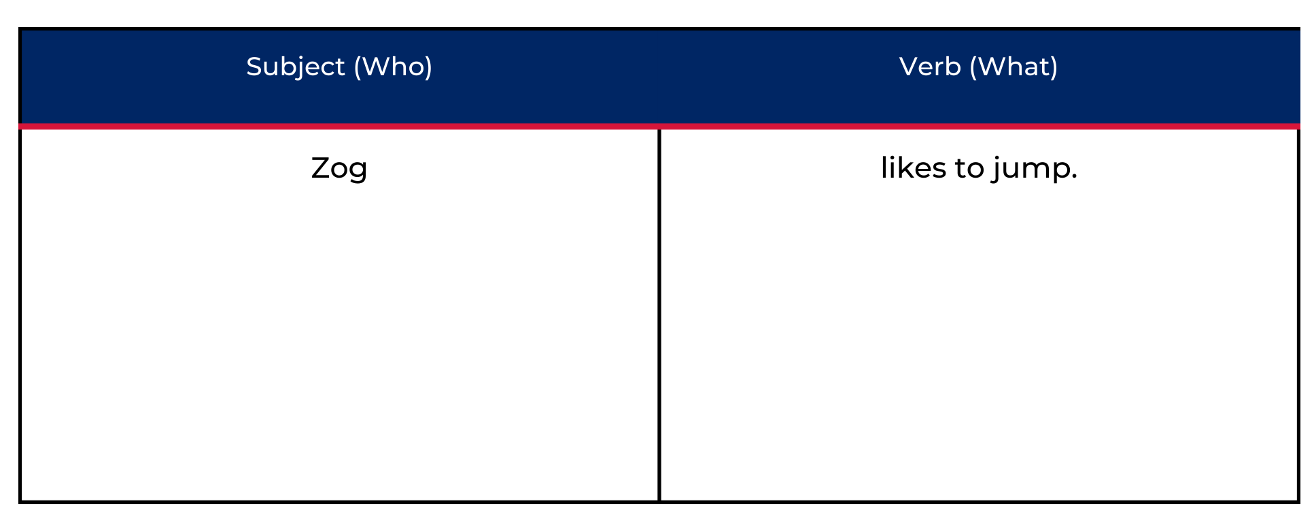

Resource 5: Monster puppets
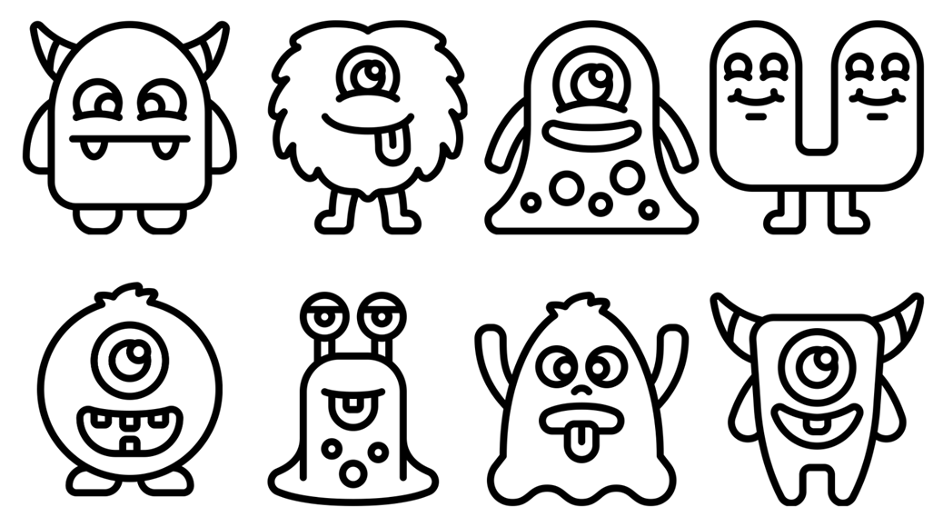
Image sourced from Canva and used in accordance with the Canva Content License Agreement.

Resource 6: Onomatopoeia poem
By Lill Pluta
An onomatopoeia
is a very special thing.
It's a word like quack or flutter,
or oink or boom or zing.
It sounds just like its meaning,
for example snort and hum.
It's the crash and clang of cymbals,
and the rat-a-tat of drums.
It's the clatter and the plip-plops,
and the beeps and bonks and chirps.
It's the mumbles and the rumbles,
the rattles and the burps.
It's the hissing and the buzzing,
and the giggles and the moos.
And on a spooky moonlit night,
it is a scary BOO!
Onomatopoeia poem by Lill Pluta

Resource 7: Splish Splash poem
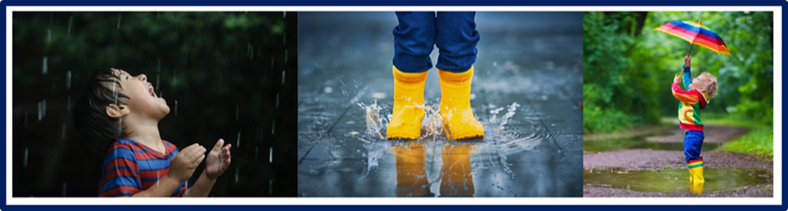
Images sourced from Canva and used in accordance with the Canva Content License Agreement.

Splish Splash
By Jennifer Betts
The drip, drop of the rain.
It’s time to run.
A big jump.
Splish splash goes the puddle.
SQUEAL!
And the child giggles happily.
Splish Splash by Jennifer Betts

Resource 8: Segment and reconstruct a sentence
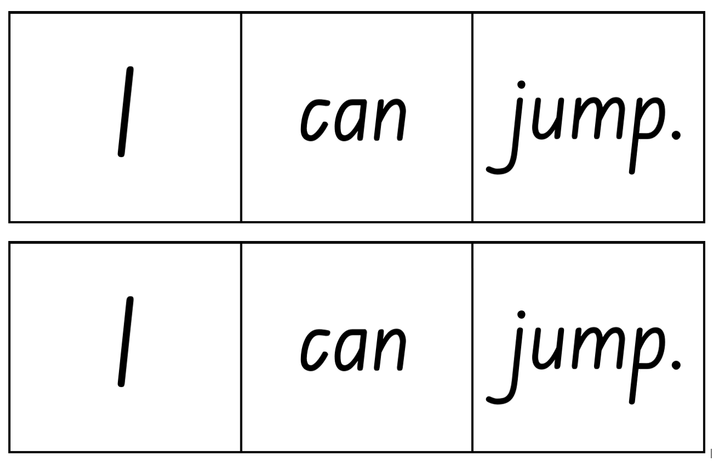
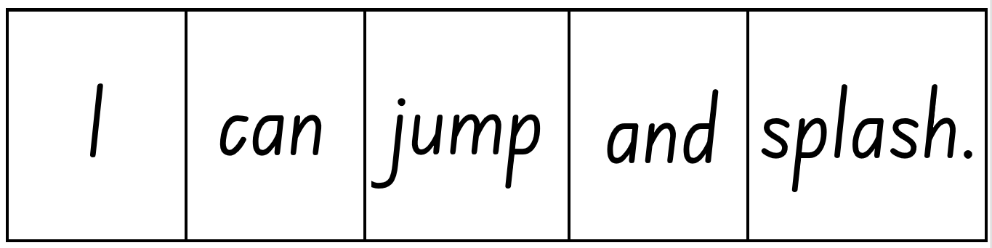

References
Links to third-party material and websites
Please note that the provided (reading/viewing material/list/links/texts) are a suggestion only and implies no endorsement, by the New South Wales Department of Education, of any author, publisher, or book title. School principals and teachers are best placed to assess the suitability of resources that would complement the curriculum and reflect the needs and interests of their students.
If you use the links provided in this document to access a third-party's website, you acknowledge that the terms of use, including licence terms set out on the third-party's website apply to the use which may be made of the materials on that third-party website or where permitted by the Copyright Act 1968 (Cth). The department accepts no responsibility for content on third-party websites.
Except as otherwise noted, all material is © State of New South Wales (Department of Education), 2021 and licensed under the Creative Commons Attribution 4.0 International License. All other material (third-party material) is used with permission or under licence. Where the copyright owner of third-party material has not licensed their material under a Creative Commons or similar licence, you should contact them directly for permission to reuse their material.
English K–10 Syllabus © 2022 NSW Education Standards Authority (NESA) for and on behalf of the Crown in right of the State of New South Wales.
Creative Arts Syllabus © 2006 NSW Education Standards Authority (NESA) for and on behalf of the Crown in right of the State of New South Wales.
© 2021 NSW Education Standards Authority. This document contains NSW Curriculum and syllabus content. The NSW Curriculum is developed by the NSW Education Standards Authority. This content is prepared by NESA for and on behalf of the Crown in right of the State of New South Wales. The material is protected by Crown copyright.
Please refer to the NESA Copyright Disclaimer for more information.
NESA holds the only official and up-to-date versions of the NSW Curriculum and syllabus documents. Please visit the NSW Education Standards Authority (NESA) website and the NSW Curriculum website.
National Literacy Learning Progression © Australian Curriculum, Assessment and Reporting Authority (ACARA) 2010 to present, unless otherwise indicated. This material was downloaded from the Australian Curriculum website (National Literacy Learning Progression) (accessed 2 September 2022) and was not modified. The material is licensed under CC BY 4.0. Version updates are tracked in the ‘Curriculum version history’ section on the About the Australian Curriculum page of the Australian Curriculum website.
ACARA does not endorse any product that uses the Australian Curriculum or make any representations as to the quality of such products. Any product that uses material published on this website should not be taken to be affiliated with ACARA or have the sponsorship or approval of ACARA. It is up to each person to make their own assessment of the product, taking into account matters including, but not limited to, the version number and the degree to which the materials align with the content descriptions and achievement standards (where relevant). Where there is a claim of alignment, it is important to check that the materials align with the content descriptions and achievement standards (endorsed by all education Ministers), not the elaborations (examples provided by ACARA).
Betts J (n.d.) ‘Examples of Onomatopoeia Poems’, Literature, YourDictionary: Examples website, accessed 2 September 2022.
ETA (English Teachers Association) and NSW Department of Education (2016) The Textual Concepts and Processes resource, English Textual Concepts website, accessed 2 September 2022.
Mackenzie N (22 October 2019) ‘Draw, Talk, Write (and Share)’, Noella’s Blog, accessed 2 September 2022.
Novak BJ (2016) The Book With No Pictures, Puffin, London.
Novak BJ (2019) My Book With No Pictures, Puffin, London.
Pluta L (2022) ‘Onomatopoeia’, Poems for Kids, Super Teacher Worksheets, accessed 2 September 2022.
Stanton B and Stanton M (2015) This is a ball, ABC Books, Sydney.
State of Victoria (Department of Education and Training) (2018) ‘Interactive Writing’, Literacy Teaching Toolkit, State of Victoria Department of Education and Training website, accessed 2 September, 2022.

