English – Early Stage 1 – Unit 3
Contents
Unit overview and instructions for use 3
Teacher notes 4
Outcomes and content – Component A 6
Outcomes and content – Component B 9
Week 1 11
Component A teaching and learning 11
Component B teaching and learning 12
Lesson 1: What is a character? 13
Lesson 2: Character’s actions 15
Lesson 3: Character’s feelings 17
Lesson 4: Comparing character’s feelings 19
Lesson 5: Sentence writing 21
Week 2 24
Component A teaching and learning 24
Component B teaching and learning 25
Lesson 6: Describing dogs 27
Lesson 7: Identifying Pig and Trevor verbs 29
Lesson 8: Writing a dog description 31
Lesson 9: Rich text talk about character traits 35
Lesson 10: Writing a new beginning, middle, and end 37
Resource 1: Emu facts bubble map 42
Resource 2: Retell scaffold 43
Resource 3: Sentence anchor chart 44
Resource 4: Frayer Model for vocabulary 45
Resource 5: Pig and Trevor anchor chart 46
Resource 6: All kinds of dogs 47
Resource 7: Dogs by Marchette Chute 49
Resource 8: Dog descriptions 50
Resource 9: Venn diagram 51
Resource 10: Storyboard 52
References 53
Further reading 56

Unit overview and instructions for use
This two-week unit is comprised of Component A and Component B. Connecting learning across both components is encouraged.
Teaching and learning | Component A | Component B
Suggested duration | 60 minutes | 45 minutes
Explicit teaching focus areas | - Phonological awareness  - Print conventions  - Phonic knowledge  - Reading fluency  - Reading comprehension  - Spelling  - Handwriting | - Oral language and communication  - Vocabulary  - Reading comprehension  - Creating written texts  - Understanding and responding to literature
To prepare for teaching and learning: | - Refer to Outcomes and content – Component A, K-2 – Instructional sequence – grapheme–phoneme correspondences [PDF 825 KB], and the teaching advice documents (hyperlinked in Component A teaching and learning table).  - Based on student needs identified through ongoing assessment data, plan and document how you will sequence teaching and learning in whole class and targeted teaching groups across the two-week cycle. | - Familiarise yourself with Outcomes and content – Component B, Textual concepts information and videos, English Textual Concepts and Learning Processes (2016), and the teaching and learning sequence.  - Based on student needs identified through ongoing assessment data, determine how you will support students in whole class and targeted teaching groups across the two-week cycle as required.
English K–10 Syllabus © 2022 NSW Education Standards Authority (NESA) for and on behalf of the Crown in right of the State of New South Wales.

Teacher notes
- Character is the key concept of this unit, explored using the mentor texts Edward the Emu by Sheena Knowles and Pig the Pug by Aaron Blabey. The supporting concept is perspective. Students are provided opportunities to see that opinions can be articulated in and through texts. Students understand that characters in imaginative texts are visual, verbal and aural representations of people who participate in the narrative (English Textual Concepts 2016). Understanding of character can be supported through watching the department’s video: Character (2:31).
- Refer to the NESA Glossary for information on mentor text, Tier 1 and Tier 2 words, grapheme-phoneme correspondence and multimodal texts.
- This unit could enhance student learning towards achievement of outcomes from the PDHPE and Creative Arts syllabuses.
- For vocabulary support, resources and professional learning, visit Effective reading in the early years of school – vocabulary.
- Loose parts are a collection of objects that children can use to create. They can be natural or synthetic. Some examples include stones, pinecones, seeds, shells, feathers, leaves, lids, material scraps, foam, ribbon, buttons, and beads. Any open-ended reusable material which will inspire imagination and creativity can be used.
- Reflect on student learning and engagement in activities and record differentiation and adjustments within the unit to inform future teaching and learning. One way of doing this could be to add comments to the digital file.
- In addition to teaching advice in the syllabus, the following instructional strategies are included to enhance students’ understanding and responding to literature and creating written texts.
Strategies for understanding and responding to literature
- Thinking aloud involves verbally modelling the thinking processes before, during and after reading or writing. It is important that you verbalise what is going on in your mind as you read or write. Having a focus for a think aloud makes sure that this strategy is used effectively and efficiently.
- See, Think, Wonder encourages students to make careful observations and thoughtful interpretations. Teachers can model by using the sentence starters ‘I see…, I think…, I wonder…'
- Thinking partners are used to engage students in accountable conversations about texts and personal experiences. This strategy helps students share their experiences and thinking in a non-threatening way. Similar strategies include ‘talk partners’, ‘think, pair, share’, and ‘turn and talk’.
- ‘Dialogic reading involves rich dialogue with students while reading aloud. Teacher-led, targeted prompts evaluate and expand students’ understanding of text’ (Watkins 2018).
Strategies for creating written texts
- ‘Draw, Talk, Write, Share’ for emergent writers includes drawing as part of a meaning making process, while talking and sharing allows children to make sense of their ideas and to develop their vocabulary and oral language skills. Writing provides an opportunity to apply phonic and word knowledge into another context. For best practice see, Draw, Talk, Write (and Share) (Mackenzie 2019).
- Interactive writing – Teacher and students compose and record a co-constructed text. The teacher models how successful writers generate and organise their ideas, and guides students to record the text. Interactive writing can also provide an opportunity to teach concepts about print, sentence structure and grammar, spelling strategies, punctuation, and handwriting.
- Content points are linked to the National Literacy Learning Progression version (3).
Levels and indicators sourced from National Literacy Learning Progression © Australian Curriculum, Assessment and Reporting Authority (ACARA), (accessed 31 August 2022) and was not modified. See references for more information.

Outcomes and content – Component A
The table below outlines the focus outcomes and content. Content is linked to the National Literacy Learning Progression version (3).
Focus area and outcome | Content points and National Literacy Learning Progression
Phonological awareness  ENE-PHOAW-01 – identifies, blends, segments and manipulates phonological units in spoken words as a strategy for reading and creating texts | - orally blend and segment syllables in words comprising up to 3 syllables (PhA2)  - orally blend up to 4 phonemes together to make a one-syllable spoken word (PhA4)  - orally segment one-syllable words comprised of up to 4 phonemes into separate phonemes (PhA4)
Print conventions  ENE-PRINT-01 – tracks written text from left to right and from top to bottom of the page and identifies visual and spatial features of print | - understand that written Standard Australian English uses letters to represent sounds  - know the difference between a letter and a word (PKW1)  - identify and name lower- and upper-case letters (PKW4)  - turn pages one at a time (UnT3)  - consistently read left page before right page (UnT4)
Phonic knowledge  ENE-PHOKW-01 – uses single-letter grapheme–phoneme correspondences and common digraphs to decode and encode words when reading and creating texts | - match single letter grapheme with a phoneme  - say the most common phoneme for single-letter graphemes (graphs) (PKW3)  - blend single-letter grapheme correspondences to decode VC and CVC words, and apply this knowledge when reading, including decodable texts (PKW3, PKW4)  - segment and encode single-letter VC and CVC words, and apply this knowledge when writing words and creating texts (PKW4)
Reading fluency  ENE-REFLU-01 – reads decodable texts aloud with automaticity | - read texts with taught grapheme–phoneme correspondences and taught high-frequency words with automaticity
Reading comprehension  ENE-RECOM-01 – comprehends independently read texts using background knowledge, word knowledge and understanding of how sentences connect | - read texts with taught grapheme–phoneme correspondences and taught high-frequency words with automaticity
Spelling  ENE-SPELL-01 – applies phonological, orthographic and morphological generalisations and strategies to spell taught familiar and high-frequency words when creating texts | - combine phonological, phonic, orthographic and morphemic knowledge to spell taught high-frequency irregular words comprising up to 3 phonemes (SpG5)  - segment single-syllable words into phonemes as a strategy for spelling (SpG4)  - spell their own name (SpG1)
Handwriting  ENE-HANDW-01 – produces all lower-case and upper-case letters to create texts | - use a stable posture when handwriting or drawing by sitting comfortably with feet flat on the floor, the writing arm resting on a table, with the opposite hand resting on the paper, and shoulders relaxed

Outcomes and content – Component B
The table below outlines the focus outcomes and content. Content is linked to the National Literacy Learning Progression version (3).
Focus area and outcome | Content points and National Literacy Learning Progression
Oral language and communication  ENE-OLC-01 – communicates effectively by using interpersonal conventions and language with familiar peers and adults | - respond to spoken questions  - contribute to group conversations (InT3)  - use imaginative, verbal language in structured and unstructured activities
Vocabulary  ENE-VOCAB-01 – understands and effectively uses Tier 1 words and Tier 2 words in familiar contexts | - use vocabulary that is personal  - recognise and understand taught Tier 1 and Tier 2 words (PKW3, SpK3)
Reading comprehension  ENE-RECOM-01 – comprehends independently read texts using background knowledge, word knowledge and understanding of how sentences connect | - identify words that represent who, what, when, where and why in texts  - understand how adjectives describe a noun and verbs identify actions in a sentence  - use background knowledge when identifying connections between a text, own life, other texts and/or the world (UnT4)  - use visual cues in multimodal texts to interpret meaning (UnT5)  - recall key characters, events and/or information in text (UnT5)
Creating written texts  ENE-CWT-01 – creates written texts that include at least 2 related ideas and correct simple sentences | - know that a simple sentence makes sense by itself and is a complete thought represented by a subject and a verb (GrA3)  - identify and use nouns in simple sentences, including in own writing (GrA1)  - use personal vocabulary, words on display and in mentor texts when constructing sentences  - use drawing, images or mind maps to support planning and writing (CrT4)
Understanding and responding to literature  ENE-UARL-01 – understands and responds to literature read to them | - identify and discuss character features and actions (UnT3)  - share feelings and thoughts in response to characters and actions in texts  - identify and compare characters in a range of texts  - identify favourite stories and/or characters in texts using verbal and/or nonverbal modes

Week 1

Component A teaching and learning
The table below can be used to plan and document lessons that address Component A outcomes and content. Both the detailed example [DOC 529KB] of a two-week teaching and learning cycle and brief example [DOC 66KB] may support you in your planning.
Focus Areas | Lesson 1 | Lesson 2 | Lesson 3 | Lesson 4 | Lesson 5
Phonological awareness and
Phonic knowledge
15 minutes
Spelling and Handwriting
15 minutes
Print conventions,
Reading comprehension and Reading fluency
30 minutes

Component B teaching and learning
The following teaching and learning sequence has been designed to address Component B outcomes and content. Adapt the sequence as required to best meet the needs of your students.

Learning intention and success criteria
Learning intentions and success criteria are best co-constructed with students.

Learning intention
Students are learning to identify and discuss character features and actions at the beginning, middle and end of a narrative text.

Success criteria
Students can:
- contribute to whole and small group conversations
- identify the main character in a familiar text and how character traits or actions change through a narrative from beginning, middle to the end
- share an opinion about a character from text.

Resources
- Knowles S (1988) Edward the Emu (Clement R, illus.), Harper Collins Publishers. ISBN: .9780207170515
- Knowles S (1996) Edwina the Emu (Clement R, illus.), Harper Collins Publishers. ISBN: 9780207189142
- Blabey A (2015) Thelma the Unicorn, Scholastic Australia. ISBN: 9781743625804
- Resource 1: Emu facts bubble map
- Resource 2: Retell scaffold
- Resource 3: Sentence anchor chart
- Resource 4: Frayer Model for vocabulary
- Student copy of Resource 2: Retell scaffold
- Video: Emu Facts with Keeper Ally at Taronga Western Plains Zoo (1:33)
- Video: Australian Aboriginal Crane Dance (1:36)
- Unlined scrapbook/student workbook or blank paper.

Lesson 1: What is a character?
- Discuss a familiar narrative or rhyme such as Humpty Dumpty. Ask students who the story is about. Explain that the people or things in stories are called characters and are an important part of narratives. Characters in imaginative texts are visual, verbal, and aural representations of people who participate in the narrative.
- Recall some familiar characters and ask students to identify the story that they are from. For example, Alexander, Goldilocks, Big Bad Wolf and Hairy Maclary. Explain that one way authors spark readers’ interest in stories and prompt them to pay attention to the main characters is to include their name in the title. For example, in the story Goldilocks and the Three Bears, the main character is Goldilocks.
- Ask students to name characters from familiar texts. Discuss the characters identified by students, acknowledging that some are people, some are animals, and some can be an object. Explain that words used to name things are nouns. For example, characters and their names are nouns. Jointly construct a class definition for nouns. Display in the classroom. A noun is a word or group of words that name things. A noun can be singular – cat, tree, coolamon, school, or plural – cats, trees, coolamons, schools.
- Explain that authors create characters with features or traits that make the reader feel emotions towards the character. Authors create characters that have likable traits such as bravery, cleverness, or who are funny. Authors also create characters that we dislike, who may have traits such as dishonesty, meanness, or who are scary. Authors make characters perform different actions and have a range of feelings. Give an example of characters that are strong, brave, funny, silly, a villain or protagonist. Discuss that sometimes the reader can draw comparisons between the character and themselves.
- Ask students to think about their favourite character. Unpack each character’s traits by asking students why they are a favourite. Use the sentence frame ‘My favourite character is… because…' to guide student responses.
- Model drawing a favourite character. Think aloud to label features and traits of that character. Discuss the traits that make the character a favourite.
- Students Draw, Talk, Share their favourite character from a familiar text. Create a display of ‘Our favourite characters'.
Too hard? Support students by suggesting a character to draw or provide a scaffold to draw a character. Allow students to use a text illustration as a visual aid.
Too easy? Ask students to write labels to describe features of their characters. Students write a sentence about why the character is their favourite.
Early Stage 1 Assessment task 1 – Observations and work samples from this lesson allow students to demonstrate achievement towards the following syllabus outcomes and content points:
ENE-OLC-01 – communicates effectively by using interpersonal conventions and language with familiar peers and adults
- respond to spoken questions
- contribute to group conversations
- use imaginative, verbal language in structured and unstructured activities.
ENE-VOCAB-01 – understands and effectively uses Tier 1 words and Tier 2 words in familiar contexts
- use vocabulary that is personal.
ENE-UARL-01 – understands and responds to literature read to them
- share feelings and thoughts in response to characters and actions in texts
- identify and compare characters in a range of texts
- identify favourite stories and/or characters in texts using verbal and/or nonverbal modes.

Lesson 2: Character’s actions
- Position students so that they are facing you to encourage listening for understanding and attending to visual information. Introduce the book Edward the Emu, paying attention to the front and back cover. Ask who the main character in the text might be. Read the title and check for understanding.
- Activate students’ background knowledge of emus to support their understanding of the character in the text before reading. Students can use whiteboards to draw or write facts about emus. Students share their responses to make a class mind map using Resource 1: Emu facts bubble map. If required, watch video Emu Facts with Keeper Ally at Taronga Western Plains Zoo (1:33).
- Read the text aloud. Explain that students are to pay attention to Edward as the main character. Think about Edward’s actions and traits.
- Co-construct a retell of Edward’s actions at the beginning, middle and end of the narrative using Resource 2: Retell scaffold. For example, Edward was bored. At night he jumped from his enclosure to the seals’ enclosure. Edward tried being a seal by balancing a ball, roaring like a lion, then hissing like a snake. Edward heard a visitor say that they think emus are best and returns to find another emu in his enclosure.
- Highlight the traits of the other characters that Edward copied.
- Brainstorm other animals that Edward may have visited at the zoo.
- Prepare a space for students to explore movement and dance. Watch the video Australian Aboriginal Crane Dance (1:36). Discuss how the dancers mimic the shapes and movements (traits) of Australian animals and birds with their bodies.
- Ask each student to think of an Australian animal and how each animal would move in the bush.
- Students role-play or create an animal dance to explore its traits. For example, a kangaroo hops and uses its front paws to balance and scratch their sides. An emu dance may include using a hand raised for the emu’s head, bending to peck at the ground.
- Explain how Edward tried new actions, mimicking other animal traits. Explain that words used to describe actions are verbs. Jointly construct a class definition for verbs. Display in the classroom. Verbs are words that tell what is happening. Different types of verbs include: action, thinking, feeling, saying and relating.
- Thinking partners discuss a new activity or actions they have tried recently or would like to try. For example, Aboriginal dancing or a new school activity such as sport lessons. Partners then share their responses with the whole class.
- Students create a detailed drawing of themselves doing the activity. Share drawings with the class to identify and discuss words that tell what is happening (verbs).
- Select one example to record words that tell what is happening. Use Resource 3: Sentence anchor chart to model writing and thinking aloud to explain parts of a simple sentence that include the student’s name (noun) and action (verb). Explain that a sentence must have a capital letter and full stop.
Too easy? Students write a simple sentence about their drawing.
Early Stage 1 Assessment task 2 – Observations and work samples from this lesson allow students to demonstrate achievement towards the following syllabus outcomes and content points:
ENE-RECOM-01 – comprehends independently read texts using background knowledge, word knowledge and understanding of how sentences connect
- understand how adjectives describe a noun and verbs identify actions in a sentence
- use background knowledge when identifying connections between a text, own life, other texts and/or the world.
ENE-CWT-01 – creates written texts that include at least 2 related ideas and correct simple sentences
- identify and use nouns in simple sentences, including in own writing
- use drawing, images or mind maps to support planning and writing.

Lesson 3: Character’s feelings
- Display the cover and first page of Edward the Emu. Use ‘See, Think, Wonder’ to discuss what emotions Edward is showing. Ask students what clues the author and illustrator have given readers about how Edward the emu is feeling. Brainstorm students' responses, encouraging students to give evidence. For example, I can see that he is lying down, looking down, he has a bored expression. I think he is bored. I wonder why he is so bored?
- Have students use Resource 2: Retell scaffold to complete the retell by recording Edward’s feelings at the beginning and middle of the narrative. Complete a reading of Edward the Emu using thinking aloud and pauses to highlight illustrations and clues from the text that show how Edward is feeling.
- Refer to the words ‘basked’ and ‘snarled’. Using Resource 4: Frayer Model for vocabulary, write the word bask. Define the word. Record the word in a sentence. Record a synonym (example) and antonym (non-example) for bask. A student-friendly definition for bask is to enjoy sitting or lying in the heat of the sun or a fire. It can also mean to enjoy the approval or attention that you are getting from other people. Ask students to turn to a partner and use the word in a sentence. Students can draw a picture of, or role-play, an animal or person basking.
Too hard? Support students by scaffolding a sentence frame for students to use.
- Repeat for the word ‘snarl’. A student-friendly definition: if an animal snarls, it makes a low, angry sound and shows its teeth. It can also mean to speak or say something in a nasty, angry way.
- Ask students to self-assess their understanding of the words bask and snarl. Students give a thumbs up if they feel confident that they would be able to tell another person what the word means, and that they can use the word in a sentence. Students give a thumb sideways if they are starting to understand the meaning and need help to use the word. Students give a thumbs down if they are not sure what the word means or how to use it in a sentence.
- Re-read the ending of the text from when Edward hears the opinion of a visitor that the emus are the best thing in the zoo. Have students revisit Resource 2: Retell scaffold and add Edward’s feelings at the end of the text.
- Revisit Resource 1: Emu facts bubble map created in Lesson 2 to reactivate background knowledge of emus. Using thinking partners, ask students to predict what might happen after the end of the text. For example, what could happen next for Edward and Edwina?
- Students Draw, Talk, Share a picture of what Edward and Edwina might do or feel.
Too hard? Support students by scaffolding ideas, or join in a Think-Pair-Share.
Too easy? Students write a sentence about their prediction.
- Position students so that they are facing you, to encourage listening for understanding and attending to visual information. Introduce the book Edwina the Emu paying attention to the front and back cover.
- Read the text. Reflect on the students’ predictions using dialogic reading prompts.

Lesson 4: Comparing character’s feelings
- Introduce the book Thelma the Unicorn paying attention to the front and back cover. Read aloud the title and author. Ask students to predict who the main character could be. During the read aloud, draw attention to the pictures of Thelma’s changing appearance and identify the main characters, Thelma and Otis.
- In thinking pairs, students retell what Thelma did at the beginning, middle, and end of the story.
Too hard? Support students by using dialogic reading prompts as you walk through the text.
- Using a student copy of Resource 2: Retell scaffold students draw a picture or write a sentence about Thelma’s actions and features (appearance) at the beginning, middle and end of the text.
- Explain that authors use characters to entertain the reader and to make them feel emotions. Recall key characters, events and/or information in the text that highlight being entertained, and when students have felt emotions such as sadness or concern for a character. For example, when Thelma was being chased by her fans.
- Re-read the text pausing at pages that explicitly show or explain Thelma’s emotions. Use See, Think, Wonder to draw students’ attention to why Thelma feels a particular emotion. During the reading, compile the emotions to form a list.
- Take a deep dive into Tier 2 words that highlight how Thelma is feeling. For example, inspired, shocked, content, proud, stressed, fearful, worried, upset, lonely. Invite students to role-play the emotions recorded on the list. Suggested prompts may include:
- What would your face look like if you were feeling this emotion?
- What would your body look like?
- What is something you might say when you are feeling this emotion?
- When have you felt this emotion?
- Ask students how they felt about/for Thelma at each of the stages of the text. Students can express their emotions by using facial expressions. For example, a sad expression when Thelma is lonely, or happy when she is reunited with Otis.
- Recreate the song ‘If you are happy and you know it’ with an emotion and action. For example, ‘if you are content and you know it give a thumbs up'.
Early Stage 1 Assessment task 3 – Collecting work samples from this lesson allows students to demonstrate achievement towards the following syllabus outcomes and content points:
ENE-RECOM-01 – comprehends independently read texts using background knowledge, word knowledge and understanding of how sentences connect
- use visual cues in multimodal texts to interpret meaning
- recall key characters, events and/or information in text.
ENE-UARL-01 – understands and responds to literature read to them
- identify and discuss character features and actions.

Lesson 5: Sentence writing
- Read Thelma the Unicorn using dialogic reading and questioning. For example, you could ask students ‘What is Thelma feeling? How do you know?’ Highlight the multimodal clues used by the author to share the meaning and make the characters engaging.
- Highlight the words ‘shrieked’ and ‘lonely’. Using Resource 4: Frayer Model for vocabulary, write the word ‘shriek’. Define the word. Record the word in a sentence. Record the synonym and antonym for ‘shriek’. Ask students to turn to a partner and use the word in a sentence. A student-friendly definition for shrieked is to make a very high, loud sound, especially because you are afraid, angry, excited, or in pain. Repeat for the word ‘lonely’. A student-friendly definition for lonely is feeling unhappy because you are alone or do not have anyone to talk to.
- Ask students to self-assess their understanding of the words shriek and lonely using non-verbal cues as outlined in Lesson 3.
- Explicitly explain the concept of a sentence as a subject (noun-who) and verb (action or feelings) to make a complete message.
- From the students who self-assessed as confident, choose a student to share their sentence using the word ‘shriek’ or ‘lonely’, and scribe their sentence. Highlight the parts of the sentence that make it a complete thought, for example, the subject (noun) and verb (action or feeling).
- Using Resource 3: Sentence anchor chart, add the subject and verb for a sentence about the book characters Edward, Edwina and Thelma. For example, Thelma can smile, Edward can hiss, or Edwina can dance.
- Brainstorm different verbs (actions) that apply to thinking positively about oneself. For example, draw, run, sing, build, dance, kick and so on. Think aloud the grapheme-phoneme correspondences (letters and sounds) for words as they are recorded. Create and display a word bank.
- Compare the characters Thelma the Unicorn and Edward the Emu. Explain that both characters had similar behaviours and actions in that they both wanted to be someone else. Unpack how the authors created main characters who were happiest when they were themselves. Explain that the main idea (theme) of the texts is that we are happiest when we are ourselves.
- Students will use interactive writing to create a sentence about themselves, responding to the statement ‘Happy to be me'. Think aloud the talking process of creating a sentence using the sentence stem ‘I can’. Use thinking aloud dialogue such as, I can think it, I can say it, I can write it. Model writing a response to the statement using the Resource 3: Sentence anchor chart. For example, I can dance.
- Ask students to think of a sentence, say the sentence to a thinking partner, and rehearse the sentence.
- Students write a sentence in response to ‘Happy to be me’ Using the sentence frame ‘I can…’ verb from the work bank. Encourage students to use the word bank by identifying the word by grapheme-phoneme correspondences (letters and sounds) Explain that their sentence must have a capital letter and full stop.
- Review and monitor student writing. Explain that, as authors, we can add a picture. Pictures add meaning to messages. Students draw a self-portrait that reflects the verb (action).
Too hard? Encourage students to attempt writing using approximations. You can scribe students’ sentences.
Too easy? Students write a sentence independently with additional verbs using a connective such as ‘and’.
- Lead a talking circle to discuss what traits make students happy to be themselves.
Early Stage 1 Assessment task 4 – Observations and work samples from this lesson allow students to demonstrate achievement towards the following syllabus outcomes and content points:
ENE-VOCAB- 01 – understands and effectively uses Tier 1 words and Tier 2 words in familiar contexts
- use vocabulary that is personal
- recognise and understand taught Tier 1 and Tier 2 words.
ENE-RECOM-01 – comprehends independently read texts using background knowledge, word knowledge and understanding of how sentences connect
- use background knowledge when identifying connections between a text, own life, other texts and/or the world.
ENE-CWT-01 – creates written texts that include at least 2 related ideas and correct simple sentences
- know that a simple sentence makes sense by itself and is a complete thought represented by a subject and a verb
- use personal vocabulary, words on display and in mentor texts when constructing sentences.

Week 2

Component A teaching and learning
The table below can be used to plan and document lessons that address Component A outcomes and content. Both the detailed example [DOC 529KB] of a two-week teaching and learning cycle and brief example [DOC 66KB] may support you in your planning.
Focus Areas | Lesson 6 | Lesson 7 | Lesson 8 | Lesson 9 | Lesson 10
Phonological awareness and
Phonic knowledge
15 minutes
Spelling and Handwriting
15 minutes
Print conventions,
Reading comprehension and Reading fluency
30 minutes

Component B teaching and learning
The following teaching and learning sequence has been designed to address Component B outcomes and content. Adapt the sequence as required to best meet the needs of your students.

Learning intention and success criteria
Learning intentions and success criteria are best co-constructed with students.

Learning intention
Students are learning to identify, describe and compare character features and actions in a narrative text.

Success criteria
Students can:
- name characters in a familiar text
- describe what a character looks like
- describe characters’ actions
- describe similarities and differences between characters
- talk about how characters can change in a story
- make a connection between the actions or feelings of characters and those of their own.

Resources
- Blabey A (2014) Pig the Pug, Scholastic Australia. ISBN: 9781743624777
- Blabey A (2015) Pig the Fibber, Scholastic Australia. ISBN: 9781743629062
- Blabey A (2016) Pig the Winner, Scholastic Australia. ISBN: 9781760154288
- Resource 5: Pig and Trevor anchor chart
- Resource 6: All kinds of dogs
- Resource 7: Dogs by Marchette Chute
- Resource 8: Dog descriptions
- Resource 9: Venn diagram
- Resource 10: Storyboard
- Video: Tell me a tale: The importance of honesty (1:05)
- Video: Feeling Brave | Moodies (1:10)
- Unlined scrapbook/student workbook or blank paper
- Loose parts (see definition in Teacher notes), dramatic play resources, figurines, and toys
- 2 hoops (optional)

Lesson 6: Describing dogs
- Position students so that they are facing you to encourage listening for understanding and attending to visual information. Recall key characters in past texts including Edward, Edwina and Thelma or similar. Discuss character features and actions. Ask students to share their feelings and thoughts about these characters.
- Introduce the book Pig the Pug paying attention to the front and back cover. Read aloud the title and author. Check if any students are familiar with the story. Ask who the main character of the text might be. Ask students to describe the features of Pig.
- Explain the author also wrote Thelma the Unicorn. Display the cover of both Pig the Pug and Thelma the Unicorn. Ask students to compare the 2 characters and identify similarities and differences in their features.
Similarities (student-friendly definition): Ways in which things are almost the same.
Differences (student-friendly definition): Ways in which things are not like each other.
- Give a brief orientation to the narrative, explaining that it is an imaginary story about a pug dog who lives with another dog called Trevor, and that Pig does not like to share. Discuss what the dogs could share and ask students to make predictions about things that Pig might not want to share with Trevor.
- Briefly discuss print conventions before reading. Complete an uninterrupted reading of Pig the Pug. Conclude reading with a comment about Pig being greedy and selfish.
- Explain that when talking or writing about characters, we need to describe their features using words called adjectives. Revisit the definition of verbs from Lesson 2 about words used to name a character's actions. Explain that words that describe nouns (people, places and things) are called adjectives. Jointly construct a class definition for adjectives. Display in the classroom.
- Discuss how Aaron Blabey uses images to show the reader the features of each character. Display the first images of Pig and Trevor together in the flat and the images on the following double page when ‘Pig flipped his wig'. Ask children to describe Pig and Trevor, focusing attention on features such as ear shape, eyes, body shape, paws and colour. Record vocabulary on Resource 5: Pig and Trevor anchor chart or similar and add the heading Adjectives.
- Take a deeper dive into Tier 2 words describing dogs. Use Resource 6: All kinds of dogs or a selection of dog images, to create an anchor chart or class display. Ask students to describe the dogs in the images. Write vocabulary on labels or similar and attach to the matching dog images.
- With a thinking partner, students describe a dog they know. This could be a pet, a relative’s or friend’s dog, a toy, a dog they know from a movie or similar. Encourage students to discuss the features that make their dog different to other dogs. Explore student responses sharing several with the whole class.
- Model drawing a dog using thinking aloud to build details into the image of the character.
- Students use the Draw, Talk, Write, Share process to create a detailed drawing of their favourite dog.
Too easy? Ask students to label features of their dog using adjectives and write the dog’s name.
Early Stage 1 Assessment task 5 – Observations and work samples from this lesson allow students to demonstrate achievement towards the following syllabus outcomes and content points:
ENE-VOCAB-01 – understands and effectively uses Tier 1 words and Tier 2 words in familiar contexts
- use vocabulary that is personal.
ENE-UARL-01 – understands and responds to literature read to them
- identify and discuss character features and actions
- identify and compare characters in a range of texts.

Lesson 7: Identifying Pig and Trevor verbs
- Recall the previous lesson, focusing on features of dogs. Revisit vocabulary describing Pig, Trevor, and other dogs, making connections to the nouns and adjectives.
- Introduce and read the poem about dogs, Resource 7: Dogs by Marchette Chute. Discuss how the author uses words in the poem to tell us about dogs. Explain that dogs are the noun and the words that describe them are the adjectives. Re-read the poem and ask students to identify the adjectives describing dogs. Add additional vocabulary from the poem to the class display of dog images.
- Discuss that, in addition to describing characters by their features, we can also identify character actions and feelings using verbs. Revisit the definition of verbs if needed. Display a second copy of Resource 5: Pig and Trevor anchor chart or similar and add the heading Verbs.
- Read Pig the Pug to students using thinking aloud or the See, Think, Wonder strategy to make connections between Pig’s actions and Trevor’s responses. Include the page with the image showing ‘This book belongs to Pig’, as it is relevant for following lessons.
- Display the images of Pig and Trevor when Pig calls Trevor a ‘sausage-shaped swine' as well as the images on the next 2 double-page spreads where Pig gathers his stuff into a pile. Ask students to describe Pig’s actions. Record vocabulary on the verbs anchor chart under the heading Pig.
- Read through the text again drawing students’ attention to the images of Trevor. Students describe Trevor’s actions and feelings in response to Pig’s actions. Add vocabulary to the verbs anchor chart under the heading Trevor.
- Using a variety of props as toys, select students to role-play the story from when Trevor suggests that it might be more fun if they play together, then continue until Pig tells Trevor to ‘scoot'. Engage remaining students in the dialogue between the 2 dogs using ‘I say, We say, You say’. Form 2 groups, one to repeat the dialogue for Trevor, the other for Pig. Students selected for role-play complete the ‘You say’ part in their individual roles as Trevor and Pig. Model expression, tone, and volume, and encourage students to use these for each character.
- Take a deeper dive into Tier 2 words for actions and feelings. Revisit images of the dogs in Pig the Pug that are connected to the anchor chart vocabulary. Discuss how the author has used the images to show the characters’ actions and feelings about sharing. Use the recorded vocabulary to have students create a ‘freeze frame’ pose and facial expression to match the words on the anchor chart. Repeat and have students create a pose or expression that shows their reaction to an action word.
- Discuss the concept of sharing. Make a connection between the dogs’ experiences in the text and real-life experiences. Ask students how they feel about sharing. Discuss feelings about self and the actions of others. Add additional vocabulary to the verbs anchor chart. With a thinking partner, students talk about their experiences with sharing. Ask several students to share their experiences.
- Model drawing a sharing experience using thinking aloud to add detailed facial expressions that convey the characters’ feelings. Using vocabulary from the verbs anchor chart, use interactive writing to co-construct sentences describing feelings when sharing.
Early Stage 1 Assessment task 6 – Observations and work samples from this lesson allow students to demonstrate achievement towards the following syllabus outcomes and content points:
ENE-OLC-01 – communicates effectively by using interpersonal conventions and language with familiar peers and adults
- contribute to group conversations
- use imaginative, verbal language in structured and unstructured activities.
ENE-VOCAB-01 – understands and effectively uses Tier 1 words and Tier 2 words in familiar contexts
- use vocabulary that is personal
- recognise and understand taught Tier 1 and Tier 2 words.
ENE-RECOM-01 – comprehends independently read texts using background knowledge, word knowledge and understanding of how sentences connect
- use background knowledge when identifying connections between a text, own life, other texts and/or the world
- use visual cues in multimodal texts to interpret meaning.
ENE-UARL-01 – understands and responds to literature read to them
- identify and discuss character features and actions.

Lesson 8: Writing a dog description
- Revisit and read the poem, Resource 7: Dogs by Marchette Chute. Encourage students to repeat the lines and/or join in.
- Ask students to recall the actions and feelings of the characters in Pig the Pug. Explain that we now know that Pig is a greedy and selfish character who does not like to share. Explain that we can learn more about Pig’s character, and Trevor’s, because Aaron Blabey has created more books about them.
- Introduce the book Pig the Fibber, paying attention to the front and back cover. Read aloud the title and discuss the word ‘fibber’. Check if any students are familiar with the story. Ask students to predict what Pig might lie about and why.
- Display the page showing the image ‘This book belongs to Trevor’ with red writing in capital letters stating ‘No. It’s Pig’s’. Ask:
- Who crossed out Trevor’s name and how do you know?
- How would Trevor feel?
- How would you feel if someone did that to your things?
- Read Pig the Fibber using thinking aloud or See, Think, Wonder. Ask students to recall the beginning, middle, and end of the story. Discuss the characters’ actions, identifying positive and negative traits. With a thinking partner, students give their opinions about the characters and their actions. Encourage discussion about what students like or do not like about Pig and Trevor, and why. Share several responses with the whole class.
- Discuss what else Pig the Fibber reveals about Pig and Trevor’s character traits and ask students what other adjectives or verbs could be used to describe them. Add vocabulary to the anchor charts from lessons 6 and 7.
- Explore students’ understanding of vocabulary describing Pig and Trevor. Explain that characters can be recognised not only by their name, but also by the words that represent what they look like or do. Introduce and explain how a Venn diagram can be used to show differences and similarities between characters and things. Use hoops and loose items to model.
- Read aloud each description sentence in Resource 8: Dog Descriptions in no set order. Working in pairs or individually, ask students to write a ‘P’ for Pig or ‘T’ for Trevor in the correct position on Resource 9: Venn diagram.
Too hard? Students place a loose item instead of writing a grapheme on the Venn diagram.
- Use a large Venn diagram or similar to create a class display of sentences, organised under the headings of Pig, Trevor and Same. Invite students to place sentences under the correct heading. Ask students what other headings could be used to describe the character traits, if they did not use the headings Pig, Trevor, and Same. Discuss in terms of differences and similarities, good and bad, and villain and hero character traits.
- Refer to the sentences on a displayed Resource 8: Dog descriptions. Discuss the words that represent ‘who’ and ‘what’ about each character. Circle the noun, adjective, and verb in distinct colours to highlight the differences.
- Explain that the word ‘he’ in a sentence by itself does not tell the reader who the dog is. The word ‘he’ only tells the reader that the dog is male, and readers need more information to know who the sentence is about. Ask students to think of words that could be used instead of ‘he’ to tell readers more about the character. Model rewriting several sentences replacing ‘he’ with the dog’s name, including a sentence starting with ‘Pig and Trevor…’ Model writing 2 to 3 sentences, explaining that ‘he’ can be used to start the next sentence once we let the reader know who we are writing about. Discuss print conventions while recording sentences.
- Select a dog description from Resource 8: Dog descriptions to model oral construction of sentences describing a dog using sentence stems. For example:
- [Dog’s name] is a … Bingo is a small, fluffy dog.
- He/She likes to … He likes to play.
- [Dog’s name] can … Bingo can do tricks.
- He/She likes to … He likes to eat ice-cream.
- Ask students to reflect on the dog they talked about and drew in Lesson 6; if needed, have students look at their images. With a thinking partner, students describe their dog, including the dog’s name, what it looks like and what it does. Ask several students to share their dog descriptions with the class. Select one to record using the interactive writing strategy. Write 2 sentences and highlight the words that represent ‘who’ and ‘what’. Model drawing to illustrate the sentence. Explain that the words and image need to match.
- Students use the Draw, Talk, Write, Share process to describe their chosen dog and actions. Encourage students to give an oral description and/or write a sentence using words representing ‘who’ and ‘what’, and to use the vocabulary anchor charts if needed.
- Optional activity: Collect images and writing to create a class book about students’ dogs.
Too hard? Students give an oral description for the teacher to scribe. Students can attempt to record initial sounds of words using an alphabet/sound chart or similar for support.
Too easy? Students record several sentences describing their dog.
Early Stage 1 Assessment task 7 – Observations and work samples from this lesson allow students to demonstrate achievement towards the following syllabus outcomes and content points:
ENE-RECOM-01 – comprehends independently read texts using background knowledge, word knowledge and understanding of how sentences connect
- identify words that represent who, what, when, where and why in texts
- understand how adjectives describe a noun and verbs identify actions in a sentence
- recall key characters, events and/or information in text.
ENE-CWT-01 – creates written texts that include at least 2 related ideas and correct simple sentences
- know that a simple sentence makes sense by itself and is a complete thought represented by a subject and a verb
- use personal vocabulary, words on display and in mentor texts when constructing sentences
- use drawing, images or mind maps to support planning and writing.

Lesson 9: Rich text talk about character traits
- Read Pig the Fibber to students using thinking aloud or See, Think, Wonder. Focus on making connections for students between the text characters, their feelings and actions, and honesty and friendship in the real world.
- Position students in a literature or yarning circle to talk about the text. Revisit expectations of these circles and expectations of speakers and listeners. Speakers look at the audience, speak loud and clear, and stay on the topic. Listeners look at the speaker, stay quiet and still, and think about the topic.
- Ask questions to check for understanding about the main character. Some questions might include:
- Does Pig tell fibs and lies?
- What does he say or do?
- Is Pig doing the right thing? Why/Why not?
- Why would Pig lie about what he has done?
- Display the images when Pig messes up the mat, shatters the vase, and rips up the dress. Ask students to predict why he might have done these things. Discuss how Pig blames Trevor for the mess and damage. Ask students to identify what Pig does and says about Trevor. Discuss Trevor’s reactions to Pig blaming him for the mess.
- Display the images of Trevor’s distraught face and Pig walking away. Re-read the text on these 2 pages, stopping at ‘Whatever’. Ask students if it is acceptable to treat friends this way and to give a reason for their answer.
- Ask students to recall Pig’s plan to steal the treats. Discuss the words ‘sneakiest plan’ and ask students what these words tell us about Pig’s character. Draw student’s attention to Pig’s greedy, sneaky, and smart character traits by making connections from Pig’s actions to each trait. Ask what happens in the story that shows us Pig is greedy. Prompt students to focus on what Pig does that is sneaky and what he does to make readers think that he is a smart dog.
- Discuss what happened at the end of the story. Explain that Pig made one big mistake in his plan. Ask students what mistake Pig made and if he blamed Trevor for it. Ask students to predict if Pig will continue to tell lies and blame Trevor after he got hurt. Encourage students to give reasons for their predictions.
- Ask students about honesty to determine their knowledge of the character trait. Some questions could include:
- What does it mean to be honest?
- What are lies and fibs?
- How do people feel when they are told lies or fibs?
- Watch The Importance Of Honesty | Tell Me A Tale (1:05). Ask students why it is important to be honest.
- Ask students what Pig could have done instead of telling fibs or blaming Trevor for messing up the house, breaking the vase, ripping up the dress or climbing on the chair to get treats. Use thinking partners for students to discuss their ideas. Ask several students to share responses with the class.
- Discuss what good character traits would be used to describe Pig if he did not fib. Some words to use could be honest, truthful, trustworthy, patient, kind, playful, and friendly. Record vocabulary on an anchor chart or similar. Ask students if they know a character or person that displays these traits. With a thinking partner, students discuss who they know and what that person does. Ask several students to share responses with the class.
- Select one example of Pig demonstrating a good character trait and use it to design a new book cover. Model drawing and writing a book title using Pig’s name and previously recorded vocabulary.
- Use the Draw, Talk, Write, Share process for students to design a new book cover for a story about Pig as a good character.
Too hard? Students design a new book cover for a story about Trevor. For example, Trevor the friend.
Early Stage 1 Assessment task 8 – Observations and work samples from this lesson allow students to demonstrate achievement towards the following syllabus outcomes and content points:
ENE-OLC-01 – communicates effectively by using interpersonal conventions and language with familiar peers and adults
- respond to spoken questions
- contribute to group conversations.
ENE-RECOM-01 – comprehends independently read texts using background knowledge, word knowledge and understanding of how sentences connect
- use background knowledge when identifying connections between a text, own life, other texts and/or the world
- use visual cues in multimodal texts to interpret meaning.
ENE-UARL-01 – understands and responds to literature read to them
- share feelings and thoughts in response to characters and actions in texts.

Lesson 10: Writing a new beginning, middle, and end
- Recall the endings in Pig the Pug and Pig the Fibber. Ask students to identify what caused Pig to get hurt at the end of each story. Discuss the effects of Pig’s actions and character traits of greed, selfishness and fibbing about himself and Trevor.
- Ask students if they think Pig has learned a lesson about being greedy and selfish. Ask students to predict if he has changed his bad character traits because of what has happened. Explain that you are going to read another story about Pig and see if their predictions are correct.
- Introduce the book Pig the Winner paying attention to the front and back cover. Check if any students are familiar with the story. Read aloud the title and discuss the word ‘winner’. Ask students to say the word winner and clap the syllables. Students can play rock, paper, scissors, or a similar game to experience winning or losing. Ask students to describe their feelings about being a winner or how they felt when they did not win.
- Explain that in Pig the Winner, Pig will do anything to win and that when he does not, he acts very badly. Display the page showing the image ‘Award for third place, Trevor’ and the red writing in capital letters stating, ‘Pig came first’. Ask why Pig would do this if he came first.
- Read Pig the Winner using thinking aloud or See, Think, Wonder. Highlight the characters’ actions displayed through the images, identifying actions that were good and those that were bad. With a thinking partner, students give their opinions about the characters and their actions. Encourage discussion about what students like or do not like about Pig and Trevor in this book, and why. Share several responses with the whole class.
- Ask students to recall the beginning, middle and end of the story and discuss if their predictions about Pig changing his actions are correct or not.
- Reflect on Pig and Trevor’s character traits across all 3 stories. Discuss how Pig was selfish and greedy and did not treat Trevor kindly or with respect. Ask students:
- Would they like to be friends with Pig? Why or why not?
- Why did Trevor remain Pig’s friend even when Pig was unkind to him?
- How might Trevor act if Pig continues being greedy, selfish and unkind?
- What could Trevor say to Pig, or do, when Pig does something that he does not like?
- Discuss choices Trevor could make in response to Pig’s actions. These might include taking no action and continuing to be his friend, ignoring him, telling him you do not like what he is doing, fighting with him or being unkind back to him. Ask students what actions a good choice or bad choice would be, and why. Explain that the best choice Trevor could make would be to tell Pig that he does not like what he is doing and why. Explain that for Trevor to do this, he might need to be brave.
- Watch Feeling Brave | Moodies (1:09). Ask students ‘What suggestions did Rachel make in the video for you to try when you want to feel brave or help someone else to feel brave? What could Trevor do to be brave and stand up for himself when he does not like what Pig is doing?’
- Ask students, ‘Could you give Trevor some good advice to teach Pig how to be a better dog? What would you say or show him?’ With a thinking partner, students discuss and give reasons for their answers. Ask several students to share their responses with the class.
- In pairs, students role-play as a person or another dog giving Trevor advice to be brave.
- Explain that the class is going to plan a new book called Trevor the Brave. Discuss how, as authors, students could build Trevor’s character from a dog who was not brave, into one that is. Use interactive writing to co-construct a retell of Trevor’s actions at the beginning, middle and end of the narrative using Resource 10: Storyboard. To support this:
- For the beginning, revisit and read aloud the first page of writing in Pig the Pug, Pig the Fibber and Pig the Winner. Model writing the beginning of Trevor the Brave based on the structure used by Aaron Blabey. For example, Trevor was a sausage dog and I’m sorry to say, he wasn’t very brave. Pig would ruin his day.
- In the middle, ask students to recall an event from the texts, or to imagine a new event, where Pig is being unkind to Trevor. Co-construct 2 to 3 sentences with students, using vocabulary from anchor charts where possible. For example, Pig was greedy and selfish. He wolfed down all Trevor’s biscuits and doggie treats.
- In the end, use thinking partners for students to decide what brave action Trevor could take to stop Pig repeating what happened in the middle of the story. Ask students to share their ideas with the class. Select one idea to model writing for the ending.
- Use the Draw, Talk, Write, Share process for students to retell their own beginning, middle or end to the story Trevor the Brave. Encourage students to give an oral description and write words or a sentence about their images.
- Students share their Trevor the Brave stories. Ask students to reflect on the ways other students have represented Trevor as a brave dog through their illustrations and writing. Discuss why they built Trevor’s character this way.
Too easy? Students plan the beginning, middle and end of the story. Students write a sentence to accompany each part of the story.
Early Stage 1 Assessment task 9 – Observations and work samples from this lesson allow students to demonstrate achievement towards the following syllabus outcomes and content points:
ENE-OLC-01 – communicates effectively by using interpersonal conventions and language with familiar peers and adults
- use imaginative, verbal language in structured and unstructured activities.
ENE-RECOM-01 – comprehends independently read texts using background knowledge, word knowledge and understanding of how sentences connect
- use background knowledge when identifying connections between a text, own life, other texts and/or the world
- use visual cues in multimodal texts to interpret meaning
- recall key characters, events and/or information in text.
ENE-CWT-01 – creates written texts that include at least 2 related ideas and correct simple sentences
- use personal vocabulary, words on display and in mentor texts when constructing sentences
- use drawing, images or mind maps to support planning and writing.

Resource 1: Emu facts bubble map
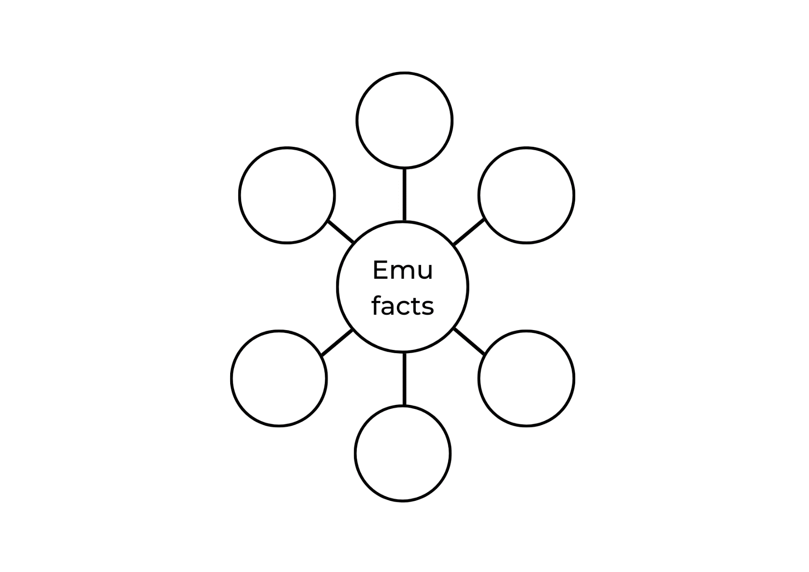

Resource 2: Retell scaffold
Beginning | Middle | End

Resource 3: Sentence anchor chart
The naming part (who or what)  Noun | The happening part (action)  Verb

Resource 4: Frayer Model for vocabulary
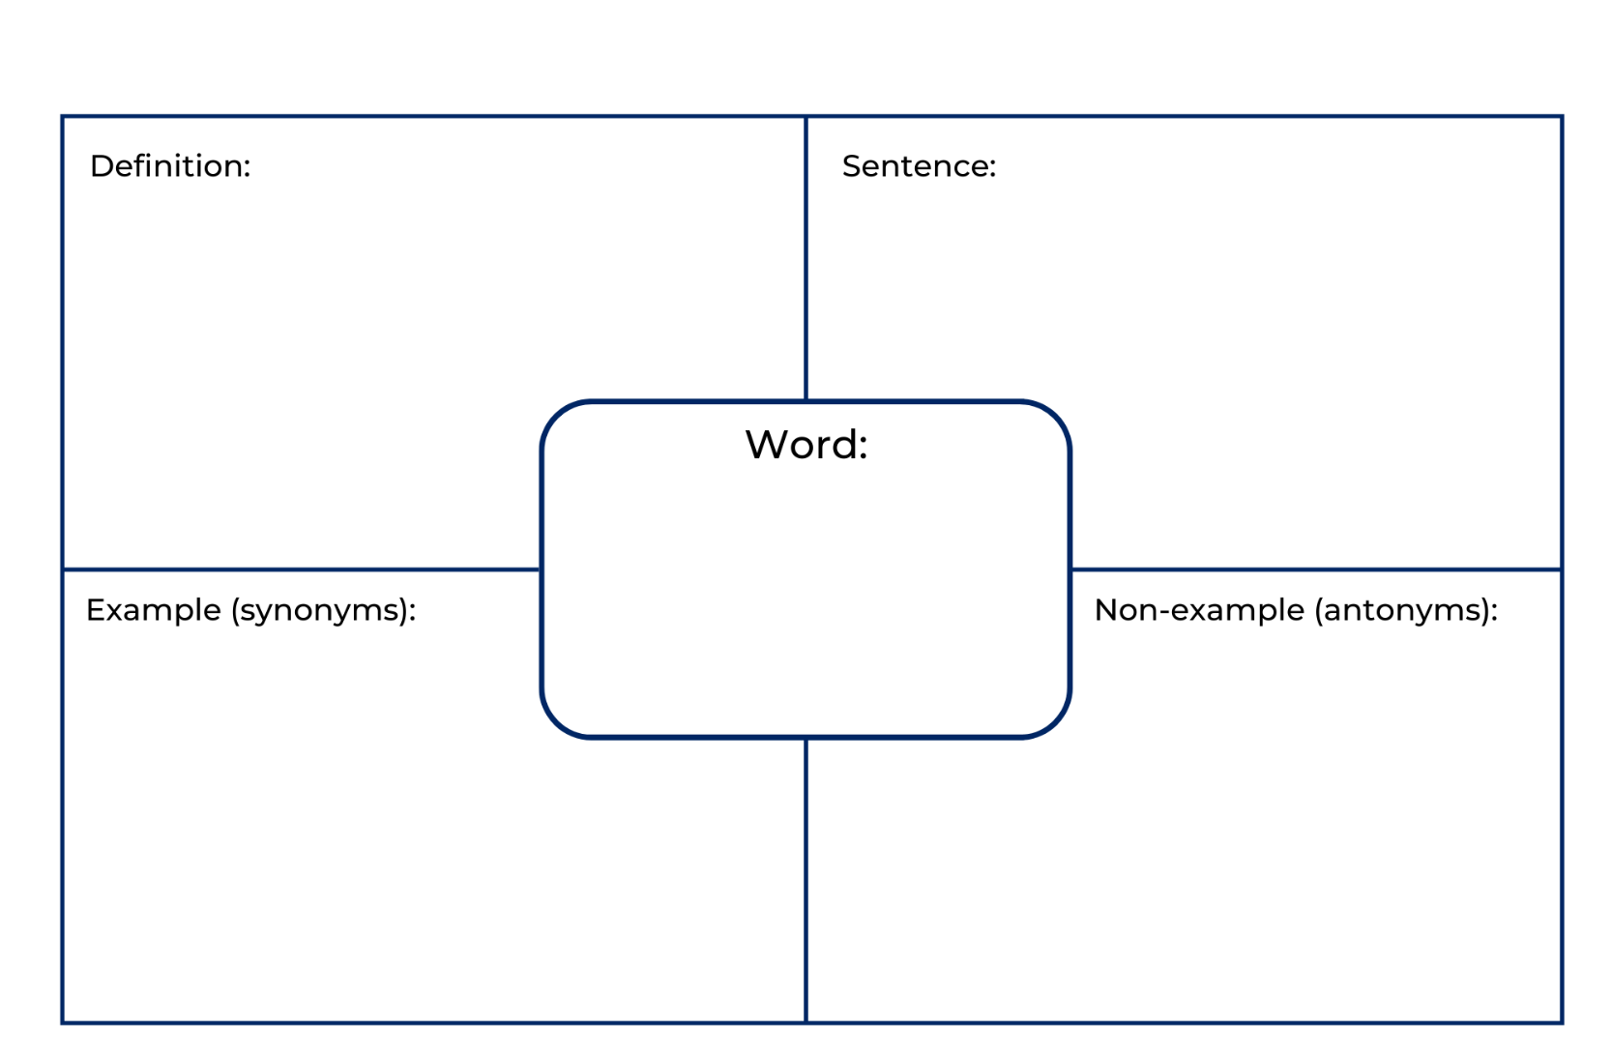

Resource 5: Pig and Trevor anchor chart
Pig | Trevor

Resource 6: All kinds of dogs
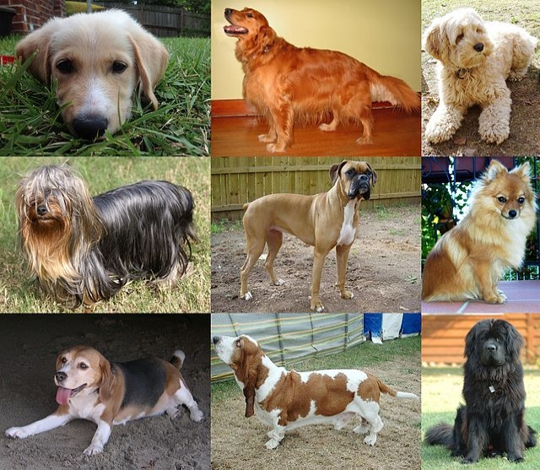
“Collage of Nine Dogs” by December21st2012Freak is licensed under CC-BY-SA-3.0.
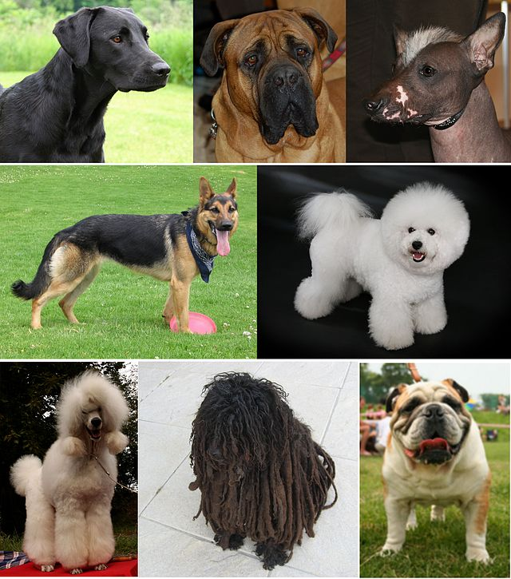
“Montage of Dogs” by Bodlina~commonswiki is licensed under CC BY 2.5.

Resource 7: Dogs by Marchette Chute
The dogs I know
Have many shapes.
For some are big and tall,
And some are long,
And some are thin,
And some are fat and small.
And some are little bits of fluff
And have no shape at all.

Resource 8: Dog descriptions
Pig | Both | Trevor
He is greedy. | He is a dog. | He is friendly.
He is selfish. | He lives in a flat. | He likes to share.
He is a fibber. | He plays with toys. | He is a sausage dog.
He is a pug dog. | He has a black nose. | He has a long nose.
He is messy. | He has a tail. | He is kind.
He does not like to share. | He likes dog treats. | He is forgiving.
He has a curly tail. | He cannot fly. | He is caring.
He is fat and has wrinkles. | He likes to play. | He has brown fur.

Resource 9: Venn diagram
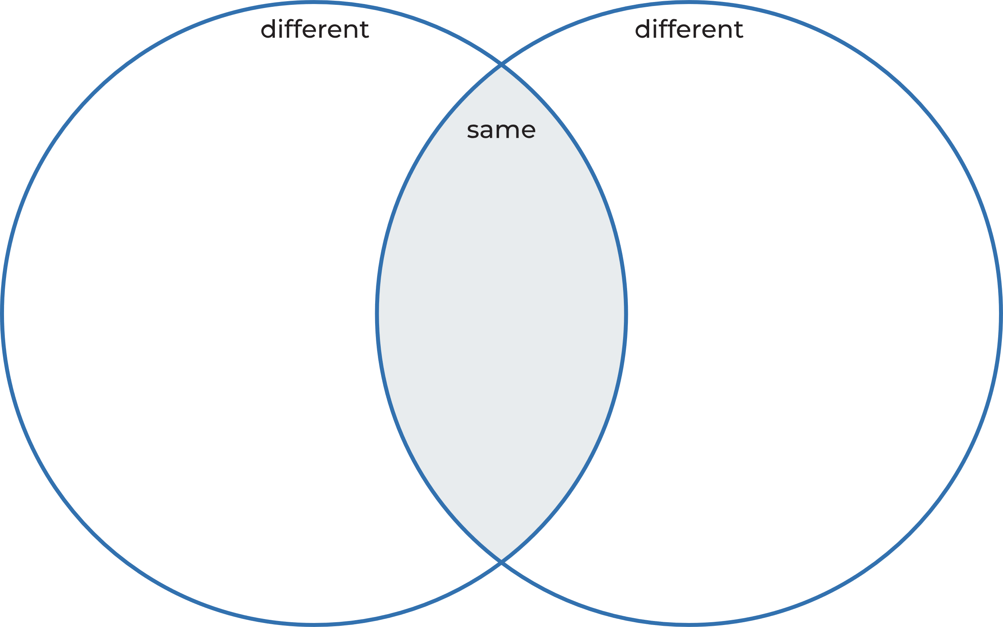

Resource 10: Storyboard
 | Beginning | Middle | End
Writing
Visual

References
Links to third-party material and websites
Please note that the provided (reading/viewing material/list/links/texts) are a suggestion only and implies no endorsement, by the New South Wales Department of Education, of any author, publisher, or book title. School principals and teachers are best placed to assess the suitability of resources that would complement the curriculum and reflect the needs and interests of their students.
If you use the links provided in this document to access a third-party's website, you acknowledge that the terms of use, including licence terms set out on the third-party's website apply to the use which may be made of the materials on that third-party website or where permitted by the Copyright Act 1968 (Cth). The department accepts no responsibility for content on third-party websites.
Except as otherwise noted, all material is © State of New South Wales (Department of Education), 2021 and licensed under the Creative Commons Attribution 4.0 International License. All other material (third-party material) is used with permission or under licence. Where the copyright owner of third-party material has not licensed their material under a Creative Commons or similar licence, you should contact them directly for permission to reuse their material.
English K–10 Syllabus © 2022 NSW Education Standards Authority (NESA) for and on behalf of the Crown in right of the State of New South Wales.
Creative Arts K–6 Syllabus © 2006 NSW Education Standards Authority (NESA) for and on behalf of the Crown in right of the State of New South Wales.
PDHPE K–10 Syllabus © 2018 NSW Education Standards Authority (NESA) for and on behalf of the Crown in right of the State of New South Wales.
© 2021 NSW Education Standards Authority. This document contains NSW Curriculum and syllabus content. The NSW Curriculum is developed by the NSW Education Standards Authority. This content is prepared by NESA for and on behalf of the Crown in right of the State of New South Wales. The material is protected by Crown copyright.
Please refer to the NESA Copyright Disclaimer for more information.
NESA holds the only official and up-to-date versions of the NSW Curriculum and syllabus documents. Please visit the NSW Education Standards Authority (NESA) website and the NSW Curriculum website.
National Literacy Learning Progression © Australian Curriculum, Assessment and Reporting Authority (ACARA) 2010 to present, unless otherwise indicated. This material was downloaded from the Australian Curriculum website (National Literacy Learning Progression) (accessed 31 August 2022) and was not modified. The material is licensed under CC BY 4.0. Version updates are tracked in the ‘Curriculum version history’ section on the 'About the Australian Curriculum' page of the Australian Curriculum website.
ACARA does not endorse any product that uses the Australian Curriculum or make any representations as to the quality of such products. Any product that uses material published on this website should not be taken to be affiliated with ACARA or have the sponsorship or approval of ACARA. It is up to each person to make their own assessment of the product, taking into account matters including, but not limited to, the version number and the degree to which the materials align with the content descriptions and achievement standards (where relevant). Where there is a claim of alignment, it is important to check that the materials align with the content descriptions and achievement standards (endorsed by all education Ministers), not the elaborations (examples provided by ACARA).
ABC Kids (24 December 2021) 'Feeling Brave | Moodies | ABC Kids' [video], ABC Kids, YouTube, accessed 31 August 2022.
ABC Kids (25 February 2022) 'The importance of honesty: Tell me a tale' [video], ABC Kids, YouTube, accessed 31 August 2022.
Blabey A (2014) Pig the Pug, Scholastic Australia.
Blabey A (2015) Pig the Fibber, Scholastic Australia.
Blabey A (2015) Thelma the Unicorn, Scholastic Australia.
Blabey A (2016) Pig the Winner, Scholastic Australia.
Chute M (n.d.) ‘Dogs’, Rainy Day Poems website, accessed 31 August 2022.
ETA (English Teachers Association) and NSW Department of Education (2017) The Textual Concepts and Processes resource, English Textual Concepts website, accessed 31 August 2022.
Harvard Graduate School of Education (2015) ‘See, Think, Wonder’, Core Thinking Routines, Project Zero website, accessed 31 August 2022.
Knowles S and Clements R (2018) Edward the Emu, HarperCollins Publishers, Australia.
Knowles S and Clements R (2019) Edwina the Emu, HarperCollins Publishers, Australia.
Mackenzie N (22 October 2019), ‘Draw, Talk, Write (and Share)’, Noella Mackenzie, accessed 31 August 2022.
Roco43 (23 October 2008) 'Australian Aboriginal Crane Dance' [video], Roco43, YouTube, accessed 31 August 2022.
State of Victoria (Department of Education and Training) (2019) ‘Interactive Writing’, Literacy Teaching Toolkit, State of Victoria Department of Education and Training website, accessed 30 August 2022.
Taronga Zoo Sydney (1 November 2020) ‘Emu Facts with Keeper Ally at Taronga Western Plains Zoo’ [video], Taronga Zoo Sydney, YouTube, accessed 31 August 2022.
Watkins P (2018) ‘Extensive reading for primary in ELT’ [PDF 380 KB], Part of the Cambridge Papers in ELT series, Cambridge University Press, accessed 31 August 2022.

Further reading
Listed in K-2 English Research Tool Kit English professional reading library: Mackenzie N and Scull J (eds) (2017) Understanding and Supporting Young Writers from Birth to 8, 1st edn, Routledge, London.
Mackenzie NM (2015) ‘Interactive writing: A powerful teaching strategy’, Practical Literacy: the early and primary years, 20(3):36–38, accessed 31 August 2022.
McCarrier A, Fountas IC and Pinnell GS (2018) Interactive writing: How Language & Literacy Come Together, K-2, 3rd edn, Heinemann Educational Books, Portsmouth.

