English – Early Stage 1 – Unit 2
Contents
Unit overview and instructions for use 3
Teacher notes 4
Outcomes and content – Component A 6
Outcomes and content – Component B 8
Week 1 11
Component A teaching and learning 11
Component B teaching and learning 12
Lesson 1: We’re Going on a Bear Hunt – first encounter 13
Lesson 2: We’re Going on a Bear Hunt – fluency 14
Lesson 3: We’re going on a principal hunt 15
Lesson 4: We’re Going on a Bear Hunt – exploring alternatives 16
Lesson 5: We’re Going on a Bear Hunt – predictions 17
Week 2 19
Component A teaching and learning 19
Component B teaching and learning 20
Lesson 6: Introducing Alexander’s Outing 21
Lesson 7: Alexander’s Outing – beginning, middle, and end 23
Lesson 8: Rich text talk for writing 25
Lesson 9: Going on an outing – prepositions 27
Lesson 10: Adventure News – talking and listening 29
Resource 1: Teddy bear poem 32
Resource 2: Simon says 33
Resource 3: Nursery rhymes 34
Resource 4: Labels for beginning, middle, and end display 35
Resource 5: Alexander’s Outing beginning, middle, and end sentences 36
Resource 6: Rich text talk 37
Resource 7: Five Little Ducks poem 40
Resource 8: Duck outing anchor chart 42
Resource 9: Student story map 43
References 44
Further reading 46

Unit overview and instructions for use
This two-week unit is comprised of Component A and Component B. Connecting learning across both components is encouraged.
Teaching and learning | Component A | Component B
Suggested duration | 60 minutes | 45 minutes
Explicit teaching focus areas | - Phonological awareness  - Print conventions  - Phonic knowledge  - Reading fluency  - Reading comprehension  - Spelling  - Handwriting | - Oral language and communication  - Vocabulary  - Reading comprehension  - Creating written texts  - Understanding and responding to literature
To prepare for teaching and learning: | - Refer to Outcomes and content – Component A, K-2 – Instructional sequence – grapheme–phoneme correspondences [PDF 825 KB], and the teaching advice documents (hyperlinked in Component A teaching and learning table).  - Based on student needs identified through ongoing assessment data, plan and document how you will sequence teaching and learning in whole class and targeted teaching groups across the two-week cycle. | - Familiarise yourself with Outcomes and content – Component B, Textual concepts information and videos, English Textual Concepts and Learning Processes (2016), and the teaching and learning sequence.  - Based on student needs identified through ongoing assessment data, determine how you will support students in whole class and targeted teaching groups across the two-week cycle as required.
English K–10 Syllabus © 2022 NSW Education Standards Authority (NESA) for and on behalf of the Crown in right of the State of New South Wales.

Teacher notes
- The unit of learning explores narrative as a way of sharing and learning about life experiences and to explicitly teach students how to identify the beginning, middle, and end of a text. For further information, refer to NESA teaching advice (additional): Early Stage 1 – Understanding and responding to literature.
- Refer to the NESA Glossary for information on preposition, prosody, mentor text, Tier 1 and Tier 2 words, and multi-modal texts.
- This unit could enhance student learning towards achievement of outcomes from the Creative Arts, Science and Technology, and PDHPE syllabuses.
- A variety of instructional strategies have been included to support students’ understanding and responses to literature:
- ‘Thinking aloud’ involves verbally modelling the thinking processes before, during and after reading or writing. It is important that you verbalise what is going on in your mind as you read or write. Having a focus for a think aloud makes sure that this strategy is used effectively and efficiently.
- To engage students in accountable conversations about texts and personal experiences, you can introduce ‘thinking partners’. This strategy helps students to share their experiences and thinking in a non-threatening way. Similar strategies include ‘talk partners’ and turn and talk.
- For further information, refer to NESA teaching advice (additional): Early Stage 1 – Understanding and responding to literature.
- The Draw, Talk, Share, Write strategy for emergent writers includes drawing as part of a meaning making process, while talking and sharing allows children to make sense of their ideas and to develop their vocabulary and oral language skills. Writing provides an opportunity to apply phonic and word knowledge into another context. Best practice in this strategy is modelled by Australian researcher Noella Mackenzie. For further information, refer to the public domain website Draw, Talk, Write (and Share).
- Interactive writing is a shared writing strategy where the teacher and students write together to compose and record a co-constructed text. The teacher models how successful writers generate and organise their ideas, and guides students to record the text. Interactive writing can also provide an opportunity to teach concepts about print, sentence structure and grammar, spelling strategies, punctuation, and handwriting.
- For further information, refer to NESA teaching advice (additional): Early Stage 1 – Creating written texts.
- Loose parts are a collection of objects that children can use to create. They can be natural or synthetic. Some examples include stones, pinecones, seeds, shells, feathers, leaves, lids, material scraps, foam, ribbon, buttons, and beads, but any open ended re-usable material which will inspire imagination and creativity can be used.
- The pages in the mentor text for Week 2, Alexander’s Outing, are not numbered. For the purposes of lesson notes, page one starts with ‘Alexander lived with his mother and his four brothers and sisters …’
- Reflect on student learning and engagement in activities and record differentiation and adjustments within the unit to inform future teaching and learning. One way of doing this could be to add comments to the digital file.
- Content are points are linked to the National Literacy Learning Progression version (3).
Levels and indicators sourced from National Literacy Learning Progression © Australian Curriculum, Assessment and Reporting Authority (ACARA), (accessed 13 July 2022) and was not modified. See references for more information.

Outcomes and content – Component A
The table below outlines the focus outcomes and content. Content is linked to the National Literacy Learning Progression version (3).
Focus area and outcome | Content points and National Literacy Learning Progression
Phonological awareness  ENE-PHOAW-01 – identifies, blends, segments and manipulates phonological units in spoken words as a strategy for reading and creating texts | - complete familiar spoken phrases in texts, including chants, rhymes, songs and poems (PhA1)  - segment a spoken sentence of 3 to 5 words into separate spoken words (PhA2)  - orally blend and segment syllables in words comprising up to 3 syllables (PhA2)
Print conventions  ENE-PRINT-01 – tracks written text from left to right and from top to bottom of the page and identifies visual and spatial features of print | - understand that written Standard Australian English uses letters to represent sounds  - show awareness of appropriate orientation of the text being read (UnT2)  - locate the front and back of a book and top and bottom of page (UnT2)
Phonic knowledge  ENE-PHOKW-01 – uses single-letter grapheme–phoneme correspondences and common digraphs to decode and encode words when reading and creating texts | - match single letter grapheme with a phoneme  - say the most common phoneme for single-letter graphemes (graphs) (PKW3)  - blend single-letter grapheme correspondences to decode VC and CVC words, and apply this knowledge when reading, including decodable texts (PKW5)
Reading fluency  ENE-REFLU-01 – reads decodable texts aloud with automaticity | - read texts with taught grapheme–phoneme correspondences and taught high-frequency words with automaticity
Reading comprehension  ENE-RECOM-01 – comprehends independently read texts using background knowledge, word knowledge and understanding of how sentences connect | - recall key characters, events and/or information in text (UnT5)
Spelling  ENE-SPELL-01 – applies phonological, orthographic and morphological generalisations and strategies to spell taught familiar and high-frequency words when creating texts | - spell their own name (SpG1)
Handwriting  ENE-HANDW-01 – produces all lower-case and upper-case letters to create texts | - use writing implements with a stable and relaxed pencil grip (HwK2)  - use a stable posture when handwriting or drawing by sitting comfortably with feet flat on the floor, the writing arm resting on a table, with the opposite hand resting on the paper, and shoulders relaxed

Outcomes and content – Component B
The table below outlines the focus outcomes and content. Content is linked to the National Literacy Learning Progression versions [2] and (3).
Focus area and outcome | Content points and National Literacy Learning Progression
Oral language and communication  ENE-OLC-01 – communicates effectively by using interpersonal conventions and language with familiar peers and adults | - orientate self to the speaker (LiS1)  - follow up to 3-part spoken instructions (LiS3)  - contribute to group conversations (InT3)  - use imaginative, verbal language in structured and unstructured activities  - retell favourite stories, poems, songs, and rhymes with some parts as exact repetition and some in their own words
Vocabulary  ENE-VOCAB-01 – understands and effectively uses Tier 1 and Tier 2 words in familiar contexts | - understand that texts in Standard Australian English are made up of words and groups of words that convey meaning  - recognise and understand taught Tier 1 and Tier 2 words (PKW3, SpK3)  - use vocabulary that is personal
Reading comprehension  ENE-RECOM-01 – comprehends independently read texts using background knowledge, word knowledge and understanding of how sentences connect | - use background knowledge when identifying connections between a text, own life, other texts and/or the world (UnT4)  - recall key characters, events and/or information in text (UnT5)
Creating written texts  ENE-CWT-01 – creates written texts that include at least 2 related ideas and correct simple sentences | - use personal vocabulary, words on display and in mentor texts when constructing sentences  - use drawing, images or mind maps to support planning and writing (CrT4)
Understanding and responding to literature  ENE-UARL-01 – understands and responds to literature read to them | - identify, discuss and compare the beginning, middle and end in a range of narratives  - experiment with using parts and/or features of a narrative, innovating from a mentor text

Week 1

Component A teaching and learning
The table below can be used to plan and document lessons that address Component A outcomes and content. Both the detailed example [DOC 529KB] of a two-week teaching and learning cycle and brief example [DOC 66KB] may support you in your planning.
Focus Areas | Lesson 1 | Lesson 2 | Lesson 3 | Lesson 4 | Lesson 5
Phonological awareness and
Phonic knowledge
15 minutes
Spelling and Handwriting
15 minutes
Print conventions,
Reading comprehension and Reading fluency
30 minutes

Component B teaching and learning
The following teaching and learning sequence has been designed to address Component B outcomes and content. Adapt the sequence as required to best meet the needs of your students.

Learning intention and success criteria
Learning intentions and success criteria are best co-constructed with students.

Learning intention
Students are learning to interact with stories through drama and actions, and to retell stories with the use of simple story maps and visuals.

Success criteria
Students can:
- face the speaker and attend to visual information in a book
- retell stories, poems, songs, and rhymes with some parts as exact repetition and some in their own words
- follow up to two-part spoken instructions
- recall key events in text
- use drawing to support writing.

Resources
- Rosen M (1989) We’re Going on a Bear Hunt (Oxenbury H, illus.), Walker Books Australia. ISBN: 9780744523232
- Resource 1: Teddy bear poem
- Video: Michael Rosen performs We’re Going on a Bear Hunt (5:02)
- Art and craft supplies (Lesson 2)
- Loose parts (see definition in Teacher notes), small dramatic play resources, figurines, and construction equipment
- Unlined scrap book/student workbook or blank paper
- Suggested text to read for enjoyment: Alborough, J (1992) Where’s My Teddy?, Walker Books Australia. ISBN: 9781406373660

Lesson 1: We’re Going on a Bear Hunt – first encounter
- Position students so that they are facing you, to encourage listening for understanding and attending to visual information. Introduce the book We’re Going on a Bear Hunt, paying attention to the front and back cover. Ask who the people in the text are, where they are going, and how they are feeling. Read the title. Discuss the meaning of the word ‘hunt’. Emphasise that this is the beginning of the story.
- Read the story. The first read is just for enjoyment with minimal interruption to the flow. You may occasionally stop at a key point to predict what may happen next. After reading, invite the children to tell you what happened. Recall the places the family travelled on their journey. You might also ask why they will not go on a bear hunt again.
- Introduce the prepositions over, under, and through. Use props from the classroom to set up a simple obstacle course. Direct small groups of students to move around the classroom demonstrating over, under and through using either one or two step instructions.
- Reread the story, stopping at each new setting to encourage students to think of hand/arm/body movements for each environment. For example, ask students how they could make their arms move like long wavy grass.
- Watch Michael Rosen performs We’re Going on a Bear Hunt (5:02).
Early Stage 1 Assessment task 1– Observations from this lesson allow students to demonstrate achievement towards the following syllabus outcome and content points.
ENE-OLC-01 – communicates effectively by using interpersonal conventions and language with familiar peers and adults
- orientate self to the speaker
- follow up to 3-part spoken instructions

Lesson 2: We’re Going on a Bear Hunt – fluency
- Re-read the story We’re Going on a Bear Hunt with a focus on prosody.
Note: Prosody is the rhythm of language related to patterns of stress and intonation.
- Read a short section of the text at a time and have the students echo back.
- Begin a story map by recalling the places the family moved through on their journey. Record each place on the board or large piece of paper with a word and a pictorial representation. Ask students to close their eyes and imagine what each location might look like, sound like, smell like, and feel like. Model ‘thinking aloud’.
- Use the created list to play ‘Would you rather?’ For example: Would you rather go through thick, oozy mud, or a swirling, whirling snowstorm? Why?
- Set up 6 tables with a variety of art and craft materials for children to create each environment. For example, one table could include various materials for representing long grass such as paint, pens, scissors, glue, and various shades of green paper. Students either make an individual piece or contribute to a small group piece. Encourage students to listen and contribute to group conversations as they create.
- Artworks can be displayed to create a story map with arrows to symbolise the family's journey through each environment. Selected students to use the created list to label each environment. Use the display to orally tell the story.
- Introduce Resource 1: Teddy bear poem. Model the actions for each line. Encourage individual students to make up new lines for the poem for the class to copy.

Lesson 3: We’re going on a principal hunt
- Write the sentence, ‘We’re going on a principal hunt’ on the board. Discuss each word and encourage students to predict what it may say. Compare words with those on the cover of We're Going on a Bear Hunt. Encourage students to predict what the second last word may say.
- Co-construct a list of the different areas around the school that the class can move through whilst searching for the principal. Class moves around the school with the chant of, ‘We're going on a principal hunt...’
- Stop at each area from your list and recall the lines of the book, ‘We can't go over it, we can't go under. Oh no!’ When close to the principal’s office, tip toe quietly before discovery and then move back through the areas of the school to the classroom.
- Students use the Draw, Talk, Share, Write process to record their hunt for the principal. Explain that students will draw where they travelled. Encourage students to tell you about their drawing, then tell someone else about their drawing. Students then add words/letters.
Early Stage 1 Assessment task 2 – Observations and work samples from this lesson allow students to demonstrate achievement towards the following syllabus outcomes and content points:
ENE-RECOM-01 – comprehends independently read texts using background knowledge, word knowledge and understanding of how sentences connect
- recall key characters, events and/or information in text.
ENE-CWT-01 – creates written texts that include at least 2 related ideas and correct simple sentences
- use personal vocabulary, words on display and in mentor texts when constructing sentences
- use drawing, images or mind maps to support planning and writing.

Lesson 4: We’re Going on a Bear Hunt – exploring alternatives
- Gather the students by singing Resource 1: Teddy bear poem.
- Open the book We’re Going on a Bear Hunt to the page where the dog first encounters the bear. Explain that this is the middle of the story. Ask how both characters might be feeling. Use ‘thinking aloud’ to model the thinking practice when analysing the picture.
- Discuss what may have happened if the family did not run away. Ask how this may have changed the ending. Draw a line down the middle of a large piece of paper. On one side write ‘Good things’. On the other side write ‘Bad things’. Write students’ ideas on the side of the paper where they belong. Add a simple drawing to represent each idea.
- Students use the Draw, Talk, Share, Write process to record their favourite alternate ending. Students draw their favourite ending and tell a partner about their drawing. Students then add words/ letters/ more detail.
- Discuss how the middle and the end of the story has changed. Reinforce the concept of beginning, middle and end by organising the students into groups of 3, arranging themselves into a line, and identifying who is at the beginning, middle and end. Have the students rearrange themselves and repeat the process.
- Read the story Where’s My Teddy? by Jez Alborough for enjoyment, or another journey-related text with a beginning, middle and end.

Lesson 5: We’re Going on a Bear Hunt – predictions
- Re-read the book We're Going on a Bear Hunt. Leave out key words for students to read aloud. Use the hand and arm movements previously formulated for each page.
- In the middle of a large piece of paper write the word ‘Bear’. Generate a list of rhyming words, for example, pear, square, air, dare, fair, rare. Try each of these words in the title.
- Write the title on a large piece of paper leaving out the word ‘Bear’. Ask the students to think of some other words that would make a good story. For example, mouse, chocolate, lolly, friend.
- Students use loose parts, small dramatic play resources, figurines, and construction equipment to make a model of their story. Students describe their model to a thinking partner.
Early Stage 1 Assessment task 3 – Observations from this lesson allow students to demonstrate achievement towards the following syllabus outcomes and content points:
ENE-OLC-01 – communicates effectively by using interpersonal conventions and language with familiar peers and adults- contribute to group conversations
- retell favourite stories, poems, songs and rhymes with some parts as exact repetition and some in their own words.
ENE-VOCAB-01 – understands and effectively uses Tier 1 and Tier 2 words in familiar contexts
- uses vocabulary that is personal.
ENE-UARL-01 – understands and responds to literature read to them
- experiments with using parts and/or features of a narrative, innovating from a mentor text.

Week 2

Component A teaching and learning
The table below can be used to plan and document lessons that address Component A outcomes and content. Both the detailed example [DOC 529KB] of a two-week teaching and learning cycle and brief example [DOC 66KB] may support you in your planning.
Focus Areas | Lesson 6 | Lesson 7 | Lesson 8 | Lesson 9 | Lesson 10
Phonological awareness and
Phonic knowledge
15 minutes
Spelling and Handwriting
15 minutes
Print conventions,
Reading comprehension and Reading fluency
30 minutes

Component B teaching and learning
The following teaching and learning sequence has been designed to address Component B outcomes and content. Adapt the sequence as required to best meet the needs of your students.

Learning intention and success criteria
Learning intentions and success criteria are best co-constructed with students.

Learning intention
Students are learning to identify a narrative as a real or imagined story with characters and events, that can be told through words, images, and actions.

Success criteria
Students can:
- name characters, places, and events in a story or personal experience
- retell a story or personal experience with a beginning, middle, and end
- use drawings to tell a story
- take turns when speaking in partner and group conversations
- copy the actions of characters in a story.

Resources
- Allen P (1994) Alexander’s Outing, Penguin Australia Pty Ltd. ISBN: 9780140554786
- Resource 2: Simon says
- Resource 3: Nursery rhymes
- Resource 4: Labels for beginning, middle, and end display
- Resource 5: Alexander’s Outing beginning, middle, and end sentences
- Resource 6: Rich text talk
- Resource 7: Five Little Ducks poem
- Resource 8: Duck outing anchor chart
- Resource 9: Student story map
- Microphone props (optional)
- Unlined scrapbook/student workbook or blank paper
- 3 hoops

Lesson 6: Introducing Alexander’s Outing
- Position students so they are facing you, to encourage listening for understanding and looking at visual information presented. Introduce text Alexander’s Outing. Display front and back of cover. Read aloud the title and author. Explain that the author’s purpose in telling a story with pictures and words is for the reader to enjoy. Give a brief orientation to the narrative, explaining that it is an imaginary story about a family of ducks going for an outing. Check if any students are familiar with the story.
- Discuss the word ‘outing’, check for understanding and give examples. Ask students to recall an outing with their family, encourage thinking about where they went and who was with them. Listen to responses from several students. Use thinking partners for all students to share responses.
- Check student knowledge about ducks. Ask students what they are, what they look like, where they live, and how they behave.
- Have students predict where the ducks could be going in the text. Think aloud, ‘I wonder if the ducks are going out or coming back from their outing?’ Ask ‘Who is Alexander?’
- Display the first image of the ducks in the park with the Sydney Opera House and Harbour Bridge in the background. Ask where the ducks live and whether they are wild ducks or pet ducks. Prompt students to consider how they know this and whether they know which city the ducks live in. Point out the Opera House and Harbour Bridge to prompt answers.
- Before reading, briefly discuss print conventions – starting at a capital letter, left to right, return sweep, pause at full stop, making meaning from words and images. Complete an uninterrupted read of Alexander’s Outing. Highlight directionality across double pages and breaks in text, pointing out where the text ends and where it continues. Conclude reading with a brief comment about the outing.
- Ask students if they enjoyed the narrative. Select 2 to 3 students to share their responses.
- Discuss how Pamela Allen created the story with characters, places, and events, including a problem. Explain ‘characters’ are who is in the story, ‘places’ are where it happens, and ‘events’ are what happens. Talk about how authors use interesting words to describe characters and what happens.
- Reread the text focusing on characters and their actions. Define Tier 2 words and unfamiliar phrases. For example, straggled, commotion, peer, pranced and snaky line.
- Play Resource 2: Simon says to support students to learn Tier 2 words from the text and make connections between characters and their actions.
- Explore characters and events from the text through role-play and re-enactment of the story.
Early Stage 1 Assessment task 4 – Observations from this lesson allow students to demonstrate achievement towards the following syllabus outcomes and content points:
ENE-OLC-01 – communicates effectively by using interpersonal conventions and language with familiar peers and adults
- use imaginative, verbal language in structured and unstructured activities
- retell favourite stories, poems, songs, and rhymes with some parts as exact repetition and some in their own words.
ENE-VOCAB-01 – understands and effectively uses Tier 1 and Tier 2 words in familiar contexts
- understand that texts in Standard Australian English are made up of words and groups of words that convey meaning
- recognise and understand taught Tier 1 and Tier 2 words.

Lesson 7: Alexander’s Outing – beginning, middle, and end
- Direct students to recall story characters and events in Alexander’s Outing.
- Discuss that, when retelling, a summary of events can make it quicker to tell someone what happened. Define ‘summary’. Explain a story can be summarised into 3 parts: a beginning, middle and end.
- Teach the concept of beginning, middle and end through one of these options:
- describing events throughout the day
- Resource 3: Nursery rhymes
- sorting objects into 3 hoops labelled beginning, middle, and end
- lining students up and identifying who is at the beginning, middle and end of the line, rearrange and repeat.
- Explain a beginning, middle or end can be made up of different events. Show the first 6 pages as an example, noting that together they make the beginning. Flash pages from the text out of order and have students identify if the page belongs to the beginning, middle or end.
- Use thinking partners for students to retell Alexander’s Outing with a beginning, middle and end. Ask students to think about what happened in the beginning of Alexander’s Outing. Guide students to retell using the sentence starter ‘In the beginning of the story...’ Repeat using ‘In the middle of the story...,’ and ‘At the end of the story...’. Select 2 to 3 students to share their retelling.
- Explain the beginning, middle and end of the story can also be told using images. Students use the Draw, Talk, Share, Write process to retell an event from the beginning, middle or end of the story.
- Place 3 hoops on the floor with labels from Resource 4: Labels for beginning, middle, and end display. Students place their image into the matching hoop. Ask students to check sequencing. Create a class display.
- Model writing a sentence to summarise the beginning, middle and end. Use ‘thinking aloud’ for composing and print conventions. Alternatively, add prepared written summaries from Resource 5: Alexander’s Outing beginning, middle, and end sentences to the display. Read the text to students, asking them to match text to images.
Early Stage 1 Assessment task 5 – Observations from this lesson allow students to demonstrate achievement towards the following syllabus outcomes and content points:
ENE-RECOM-01 – comprehends independently read texts using background knowledge, word knowledge and understanding of how sentences connect
- recall key characters, events and/or information in text.
ENE-UARL-01 – understands and responds to literature read to them
- identify, discuss and compare the beginning, middle and end in a range of narratives.

Lesson 8: Rich text talk for writing
- Read Alexander’s Outing to students, using ‘thinking aloud’ questions and statements. Focus on making connections for students between the text characters, their feelings and actions, and going out on an adventure in the real world where things go wrong. Refer to Resource 6: Rich text talk for additional support.
- Position students in a literature or yarning circle to talk about the text. Introduce ‘orient self to speaker’ and the expectations of speakers and listeners: speakers look at the audience, speak loud and clear, and stay on the topic; listeners look at the speaker, stay quiet and still, and think about the topic.
- Display the first page and discuss the beginning ‘they all set out in search of adventure’. Ask:
- What does this mean?
- Why did they go? Why was mother duck bored?
- Do you think they have been on an adventure before?
- How might they be feeling?
- Explore the first 5 pages, focusing on images of ducks. Have students identify Alexander and the mother duck, giving reasons. Discuss what Alexander was doing. Ask students why he was straggling and why his mother said, ‘Stay close, take care!’
- Discuss how searching for an adventure could be dangerous. Ask students to identify dangers in the city and their local area if they were going on an outing.
- Review what happened to Alexander in the middle of the story and why. Ask:
- How did Alexander’s accident affect the family’s outing?
- How did Alexander’s brothers, sisters, and mother feel?
- Did Alexander learn his lesson? How do you know?
- How is Alexander’s mother feeling about the outing?
- Would she take the ducks on another outing? Why/Why not?
- Introduce and teach Resource 7: Five Little Ducks poem making connections with Alexander’s Outing about ducks going on an adventure. Students can re-enact the poem or recite the poem using hand/finger actions.
- Explain the poem has a beginning, they ‘went over the hill and far away’, and an end, when ‘all of the little ducks came back’. We know all the ducks went missing over the hill in the middle, but we don’t know what each duck was doing in that time. Use thinking partners for students to orally tell the missing part of the ducks’ stories. Ask students to imagine an adventure the ducks might have when they went over the hill. Prompt thinking by asking:
- Where did they go?
- Who were they with?
- What did they see and do?
- Was there danger? What happened?
- Explore student responses sharing several with the whole class. Select one to model drawing, using ‘thinking aloud’ about character and event details.
- Students use the Draw, Talk, Share, Write process to retell a duck’s adventure.
Too easy? Students can retell the ducks’ adventure from beginning to end or write another animal’s adventure.
Early Stage 1 Assessment task 6 – Observations from this lesson allow students to demonstrate achievement towards the following syllabus outcomes and content points:
ENE-OLC-01 – communicates effectively by using interpersonal conventions and language with familiar peers and adults
- contribute to group conversations
- retell favourite stories, poems, songs and rhymes with some parts as exact repetition and some in their own words.
ENE-RECOM-01 – comprehends independently read texts using background knowledge, word knowledge and understanding of how sentences connect
- uses background knowledge when identifying connections between a text, own life, other texts and/or the world.

Lesson 9: Going on an outing – prepositions
- Recite Resource 7: Five Little Ducks poem.
- Discuss prepositions in the poem, noting the preposition ‘over’. Use loose parts to model over. Revisit prepositions from We’re Going on a Bear Hunt including ‘over’, ‘under’, ‘around’, and ‘through’, checking for understanding. Connect this text to Alexander’s Outing explaining how prepositions are also used to tell us where the ducks go.
- Revisit Alexander’s Outing. Identify prepositions and places describing where the ducks went the beginning of the story.
- Record 3 sentences, modelling writing:
- The ducks went past the bottle tree. The ducks went through the iron gates. The ducks went along Art Gallery Road.
- Add a drawing of a bottle tree, gate and art gallery to the end of the corresponding sentence to prompt meaning.
- Have students identify prepositions using initial letter/sound. Circle the preposition.
- Add vocabulary to Resource 8: Duck outing anchor chart or a similar anchor chart.
- Connect text prepositions to real life examples for students to learn vocabulary: Give an example of a path travelled from the classroom, in the home, or going to school, using prepositions. For example, I went through the front door, along the hall and past the kitchen. Ask students to give a simple oral sentence using a preposition to describe somewhere they went. Have students repeat the outing told by the previous student before telling their own outing.
Too hard? Support with sentence starters; for example, On the way to school I went past ..., At the park I went through ..., At the supermarket I went along ...
Too easy? Students give a more complex oral sentence using more than one preposition.
- Use thinking partners to describe a duck outing with prepositions. Ask students to imagine other places where ducks might go ‘past’, ‘through’ or ‘along’ in their local area, the city, in a park or on a farm. ‘Over’, ‘around’ and ‘under’ may also be used if students make a connection to prepositions in We’re going on a Bear Hunt, used in Week 1. Encourage students to orally create a story with a beginning, middle and end.
- Students use the Draw, Talk, Share, Write process to retell their duck’s outing. Use Resource 8: Duck outing anchor chart or similar to record vocabulary used by students in the ‘Share’ step. Ask students to name the preposition and place. Add an image to ‘place’ words to enhance meaning. Select one student’s drawing and matching group of words from the anchor chart to co-construct a sentence using one of the interactive writing strategies described in the teacher notes. Students write their own text to match their drawing using vocabulary on the anchor chart to assist. Select work from several students to share to the class.
Early Stage 1 Assessment task 7 – Observations and work samples from this lesson allow students to demonstrate achievement towards the following syllabus outcomes and content points:
ENE-VOCAB-01 – understands and effectively uses Tier 1 and Tier 2 words in familiar contexts
- recognise and understand taught Tier 1 and Tier 2 words.
ENE-CWT-01 – creates written texts that include at least 2 related ideas and correct simple sentences
- use personal vocabulary, words on display and in mentor texts when constructing sentences.
ENE-UARL-01 – understands and responds to literature read to them
- experiments with using parts and/or features of a narrative, innovating from a mentor text.

Lesson 10: Adventure News – talking and listening
- Recite Resource 7: Five Little Ducks poem. Explain to students that they have been learning about imaginative stories involving journeys. Add that stories can also be a retelling of real adventures. Check for understanding of imagined and real experiences.
- Revisit ‘orient self to speaker’ and expectations of speakers and listeners (Lesson 8, activity 2). Explain that students will ask each other questions and listen to replies to learn about each other’s real adventures.
- Select one student to interview. Model asking questions and allow thinking time between questions. After the interview, model retelling the student’s adventure as a story with a beginning, middle and end. Questions to ask may include:
- Where did you go?
- Who went with you?
- How did you get there?
- What did you do?
- How did it make you feel?
- Would you like to do it again? Why?
- Use thinking partners for students to ask questions and talk about their own adventure or personal outing. Students take turns to be the interviewer and responder. Guide students through questions, giving the question and have students repeat. Make the experience more authentic using ‘microphone’ props.
Too hard? Work with students needing oral language support in a small group, asking questions and prompting answers.
- Students use the Draw, Talk, Share, Write process to retell their story with a beginning, middle and end. Model drawing a beginning, middle and end of an outing using Resource 9: Student story map. Use ‘thinking aloud’ to describe details about characters and events.
Too hard? Students retell one part of their story only.
Early Stage 1 Assessment task 8 – Observations and work samples from this lesson allow students to demonstrate achievement towards the following syllabus outcomes and content points:
ENE-OLC-01 – communicates effectively by using interpersonal conventions and language with familiar peers and adults
- orientate self to speaker.
ENE-VOCAB-01 – understands and effectively uses Tier 1 and Tier 2 words in familiar contexts
- uses vocabulary that is personal.
ENE-CWT-01 – creates written texts that include at least 2 related ideas and correct simple sentences
- use personal vocabulary, words on display and in mentor texts when constructing sentences
- use drawing, images or mind maps to support planning and writing.

Resource 1: Teddy bear poem
Teddy bear, teddy bear, turn around.
Teddy bear, teddy bear, touch the ground.
Teddy bear, teddy bear, jump up high.
Teddy bear, teddy bear, touch the sky.
Teddy bear teddy bear, bend down low.
Teddy bear, teddy bear, touch your toes.
Teddy bear, teddy bear, switch out the light.
Teddy bear, teddy bear say goodnight.
Teddy bear poem adapted from A Story a Day: 365 Fairy Tales, Rhymes and Other Stories, Paragon Books (2011)

Resource 2: Simon says
Instructions:
The teacher acts as ‘Simon’. The children gather around Simon, who gives instructions by saying, ‘Simon says …’ telling the students to perform a physical action. For example, ‘Simon says touch your nose’, ‘Simon says shake like a leaf’. Each child must perform the action. If Simon leaves out ‘Simon says’ before giving instruction, anyone who performed the activity is out!
This game may be played choosing one child as ‘Simon’.
These verbs from Alexander’s Outing can be used to play the game: quack, flap, straggle, waddle, prance, look down a hole, reach into a hole, stop traffic, picnic, be a commotion, pour out a drink, search in a bag, dip, drip, floating up, pop out, celebrate.
Simon says is from the Genius at Play website on the public domain (accessed 13 July 2022).

Resource 3: Nursery rhymes
These nursery rhymes can be used to model the concept of a story with a beginning, middle, and end.
Humpty Dumpty | Little Miss Muffet | Incy Wincy Spider
Humpty Dumpty sat on a wall,  Humpty Dumpty had a great fall;  All the king's horses and all the king's men  Couldn't put Humpty together again. | Little Miss Muffet  Sat on a tuffet,  Eating her curds and whey;  Along came a spider,  Who sat down beside her,  And frightened Miss Muffet away. | Incy Wincy spider  Climbed up the waterspout  Down came the rain  And washed the spider out  Out came the sun  and dried up all the rain  Incy Wincy spider  Climbed up the spout again.
Humpty Dumpty, Little Miss Muffet and Incy Wincy Spider are from A Story a Day: 365 Fairy Tales, Rhymes and Other Stories, Paragon Books (2011).

Resource 4: Labels for beginning, middle, and end display
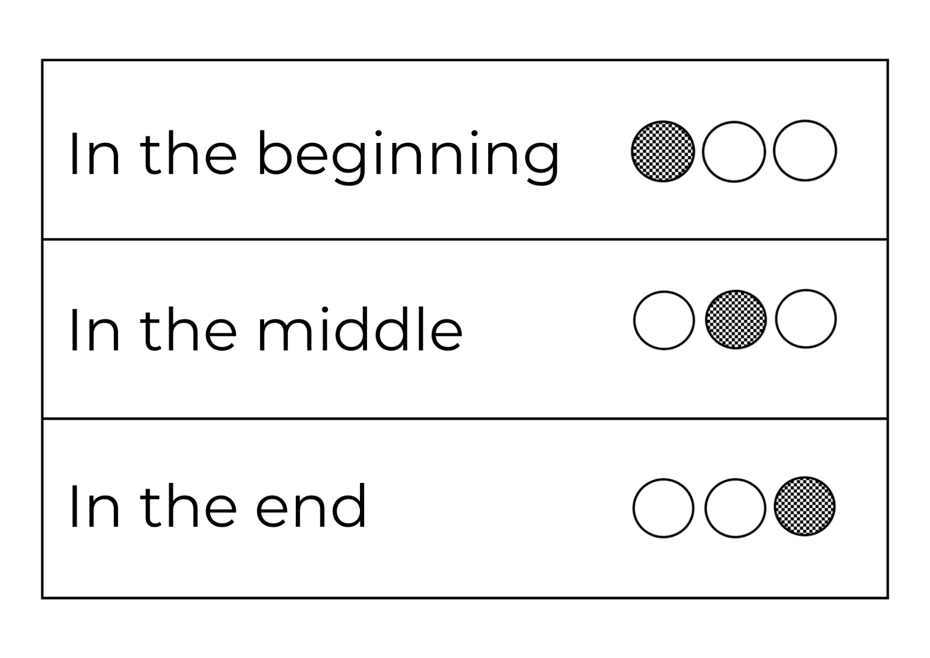

Resource 5: Alexander’s Outing beginning, middle, and end sentences
In the beginning, Mother Duck took Alexander and his brothers and sisters out for an adventure. She told them to stay close and take care, but Alexander did not.
In the middle, Alexander fell down a deep hole and no one could get him out.
In the end, everyone got water from the fountain and tipped it into the hole to make Alexander float up. When he got out of the hole everyone celebrated and the ducks went back home.

Resource 6: Rich text talk
Page | Alexander’s Outing Thinking Aloud
1 | - I wonder if Alexander and his brothers and sisters were bored too?  - Why would anyone want to leave such a beautiful park?
2 to 3 | - Does Alexander’s mother know where she is going?  - None of the other ducks have looked back at Alexander. I wonder if she knows what Alexander is doing? That’s a bit worrying. Maybe she’s given up telling him what to do. It is annoying trying to help someone and they keep ignoring you.
4 | - The people in the cars look surprised to see the ducks crossing the road. Ducks do not know road rules like people. That is dangerous! I wonder if Alexander will pay attention because there is danger?
5 | - The ducks have noticed something wrong, and they are upset and calling for Alexander. I can imagine them all quacking loudly.
6 | - I wonder if Alexander would have fallen in the hole if he was watching where he was walking and looking at the ground.
7 to 9 | - I notice Alexander’s mother is not leaving him. His family keep talking to him to let him know they are not leaving him.  - The middle-aged lady can see how upset the ducks are. I think she is worried for them.
10 to 11 | - I wonder why the woman dropped some sandwich down the hole? Can ducks eat cheese and bread?  - What would the ducks think about the humans trying to help?
12 | - I wonder how Alexander is feeling down in the deep hole?  - Does he know there are people trying to help him?
13 to 15 | - Everyone looks concerned. They look like they really do not know what to do next. It is a big problem!  - Alexander’s mother must be worried.
16 to 17 | - Everyone is shocked when the boy pours his drink down the hole. I wonder what it did to Alexander?
18 to 21 | - I think the people have a plan to solve the problem. I wonder whose idea it was?  - Some people are bending over the fountain. I wonder what they are doing?  - These ducks must know that the people have found a way to rescue Alexander. They are not quacking and flapping as much.
22 to 23 | - Now we can see how the problem is being solved. The ducks are waiting by the hole. I wonder how they are all feeling?  - I think all those people must be very kind to spend so much time trying to save Alexander.
24 to 25 | - Alexander must have been down in the hole for a very, very long time. I wonder how long he would have been down there if there were not all those people working together to save him.  - It was a special moment when he got out because everyone celebrated. His mother must be so happy!
26 to 28 | - All the people look happy. I wonder how they are feeling after rescuing Alexander? Can you imagine them telling their friends and family a story about helping some ducks in trouble?  - I am concerned about Alexander. As the ducks walk home, he is starting to straggle again. I am wondering if he has learnt anything at all from his experience.  - I wonder if his mother has thought about moving him closer to her so that she can keep an eye on him.  - They must be tired from their day out. I am sure they will all be glad to get home safely.  - I wonder if mother duck will go in search of another adventure again.

Resource 7: Five Little Ducks poem
Five Little Ducks
Five little ducks went swimming one day
Over the hills and far away.
Mother duck said, "Quack, quack, quack, quack"
But only four little ducks came back.
Four little ducks went swimming one day
Over the hills and far away.
Mother duck said, "Quack, quack, quack, quack"
But only three little ducks came back.
Three little ducks went swimming one day
Over the hills and far away.
Mother duck said, "Quack, quack, quack, quack"
But only two little ducks came back.

Two little ducks went swimming one day
Over the hills and far away.
Mother duck said, "Quack, quack, quack, quack"
But only one little duck came back.
One little duck went swimming one day
Over the hills and far away.
Mother duck said, "Quack, quack, quack, quack"
But none of the five little ducks came back.
Mother duck went swimming one day
Over the hills and far away.
Mother duck said, "Quack, quack, quack, quack"
And five little ducks came swimming back.
This text of ‘Five Little Ducks’ is taken from A Story a Day: 365 Fairy Tales, Rhymes and Other Stories, Paragon Books (2011).

Resource 8: Duck outing anchor chart
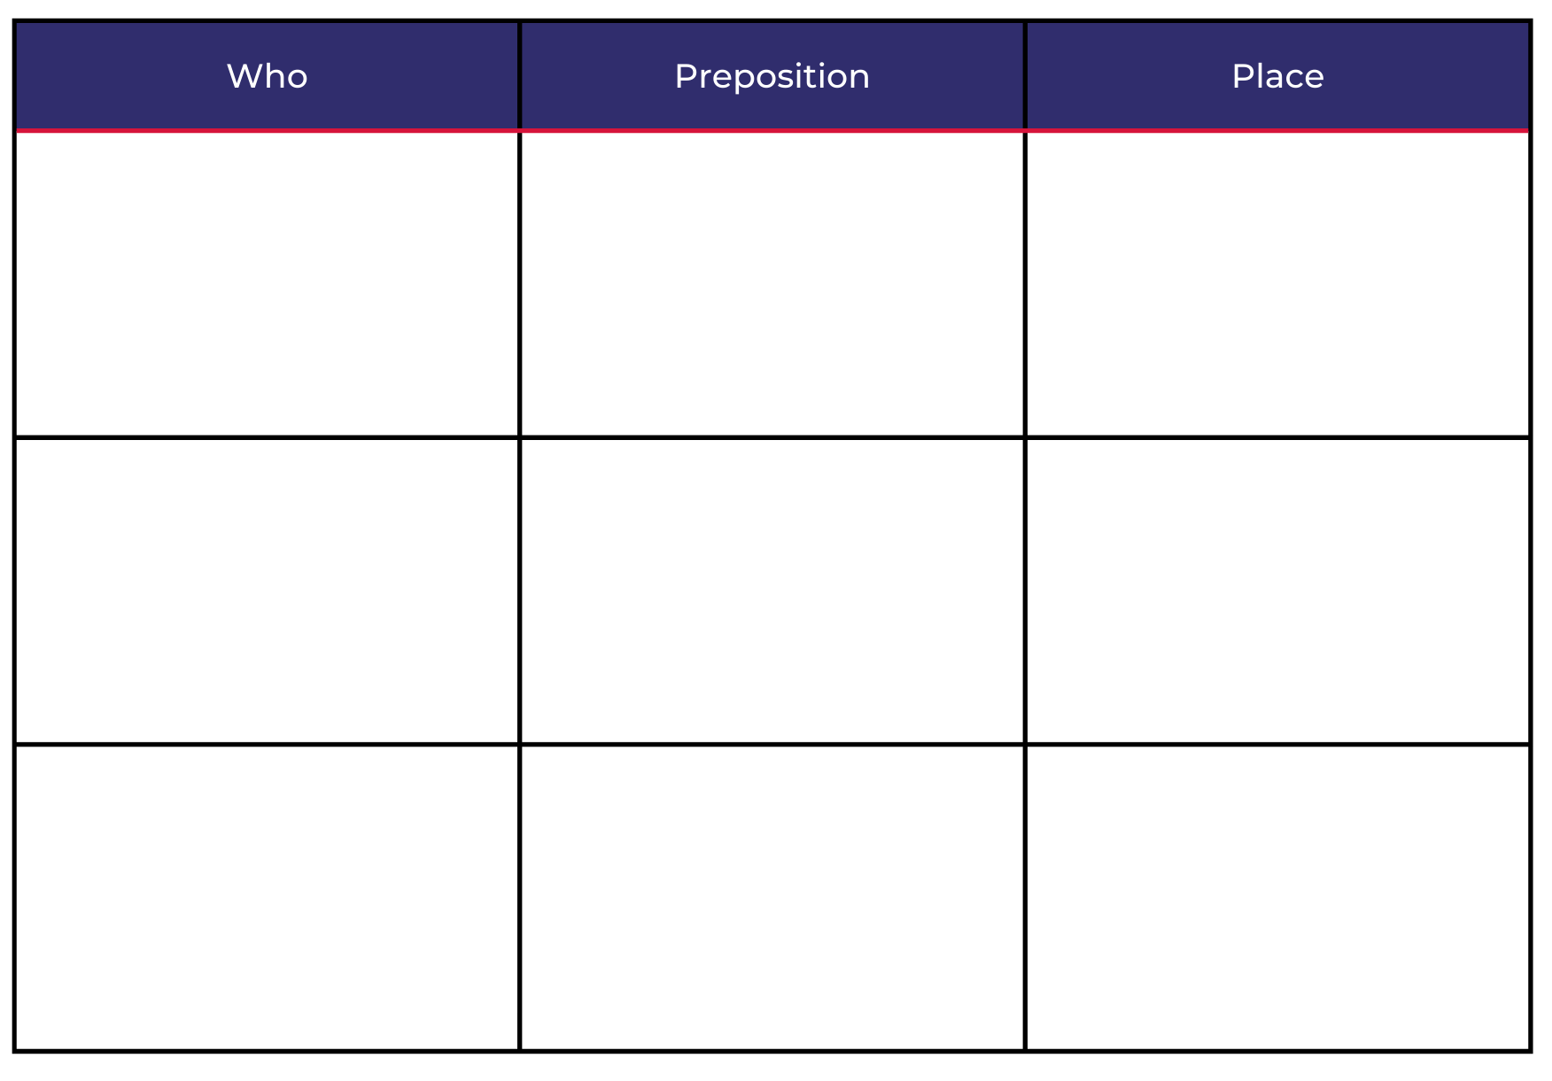

Resource 9: Student story map
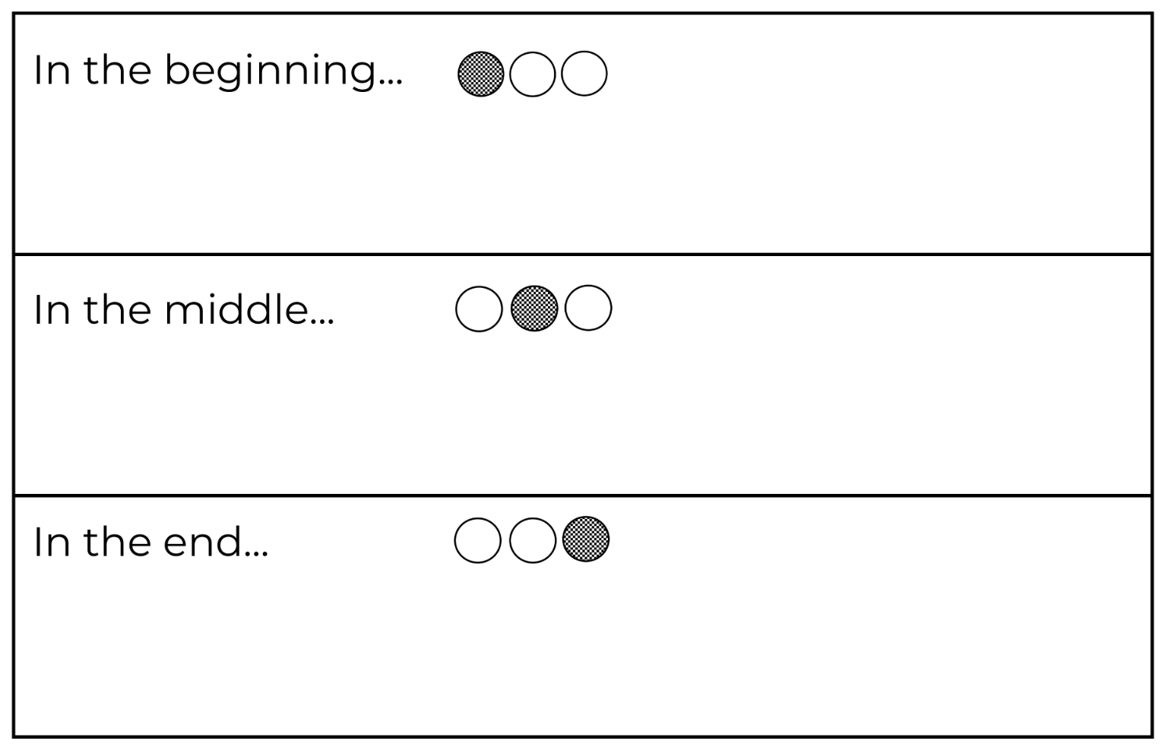

References
Links to third-party material and websites
Please note that the provided (reading/viewing material/list/links/texts) are a suggestion only and implies no endorsement, by the New South Wales Department of Education, of any author, publisher, or book title. School principals and teachers are best placed to assess the suitability of resources that would complement the curriculum and reflect the needs and interests of their students.
If you use the links provided in this document to access a third-party's website, you acknowledge that the terms of use, including licence terms set out on the third-party's website apply to the use which may be made of the materials on that third-party website or where permitted by the Copyright Act 1968 (Cth). The department accepts no responsibility for content on third-party websites.
Except as otherwise noted, all material is © State of New South Wales (Department of Education), 2021 and licensed under the Creative Commons Attribution 4.0 International License. All other material (third-party material) is used with permission or under licence. Where the copyright owner of third-party material has not licensed their material under a Creative Commons or similar licence, you should contact them directly for permission to reuse their material.
English K–10 Syllabus © 2022 NSW Education Standards Authority (NESA) for and on behalf of the Crown in right of the State of New South Wales.
Creative Arts K–6 Syllabus © 2006 NSW Education Standards Authority (NESA) for and on behalf of the Crown in right of the State of New South Wales.
PDHPE K–10 Syllabus © 2018 NSW Education Standards Authority (NESA) for and on behalf of the Crown in right of the State of New South Wales.
Science and Technology K–6 Syllabus © 2017 NSW Education Standards Authority (NESA) for and on behalf of the Crown in right of the State of New South Wales.
© 2021 NSW Education Standards Authority. This document contains NSW Curriculum and syllabus content. The NSW Curriculum is developed by the NSW Education Standards Authority. This content is prepared by NESA for and on behalf of the Crown in right of the State of New South Wales. The material is protected by Crown copyright.
Please refer to the NESA Copyright Disclaimer for more information.
NESA holds the only official and up-to-date versions of the NSW Curriculum and syllabus documents. Please visit the NSW Education Standards Authority (NESA) website and the NSW Curriculum website.
National Literacy Learning Progression © Australian Curriculum, Assessment and Reporting Authority (ACARA) 2010 to present, unless otherwise indicated. This material was downloaded from the Australian Curriculum website (National Literacy Learning Progression) (accessed 13 July 2022) and was not modified. The material is licensed under CC BY 4.0. Version updates are tracked in the ‘Curriculum version history’ section on the 'About the Australian Curriculum' page of the Australian Curriculum website.
ACARA does not endorse any product that uses the Australian Curriculum or make any representations as to the quality of such products. Any product that uses material published on this website should not be taken to be affiliated with ACARA or have the sponsorship or approval of ACARA. It is up to each person to make their own assessment of the product, taking into account matters including, but not limited to, the version number and the degree to which the materials align with the content descriptions and achievement standards (where relevant). Where there is a claim of alignment, it is important to check that the materials align with the content descriptions and achievement standards (endorsed by all education Ministers), not the elaborations (examples provided by ACARA).
Alborough J (2017) Where’s My Teddy, 25th Anniversary edn, Walker Books Australia (original work published 1992).
Allen P (1994) Alexander’s Outing, Penguin Australia Pty Ltd, Australia.
Bingham H, Martin L, Goldsack G, Astly J, Harker J, Jewitt K, Butterfield M, Bently P, Elliot R, Elliott R, Randall R, Delmege S, Hughes M, Swain-Smith J and Graves S (2015) A Story a Day: 365 Fairy Tales, Rhymes and Other Stories (Kolanovic D, East J and Dunn R, illus.), Paragon Books Limited, New York.
ETA (English Teachers Association) and NSW Department of Education (2016) The Textual Concepts and Processes resource, English Textual Concepts website, accessed 13 July 2022.
Mackenzie N (22 October 2019) ‘Draw, Talk, Write (and Share)’, Noella’s Blog, accessed 13 July 2022.
Rosen M (2022) We’re Going on a Bear Hunt (Oxenbury H, illus.), Walker Books Australia, (original work published 1989).
The Genius of Play (n.d.) ‘Simon Says’, Play Ideas & Games, The Genius of Play website, accessed 13 July 2022.
Walker Books (15 February 2014) ‘Michael Rosen performs We're Going on a Bear Hunt’ [video], Walker Books, YouTube, accessed 13 July 2022.

Further reading
Listed in the K-2 English Research Tool Kit English professional reading library: Mackenzie N and Scull J (eds) (2017) Understanding and Supporting Young Writers from Birth to 8, 1st edn, Routledge, London.
Mackenzie NM (2015) ‘Interactive writing: A powerful teaching strategy’, Practical Literacy: the early and primary years, 20(3):36–38, accessed 13 July 2022.
McCarrier A, Fountas IC and Pinnell GS (2018) Interactive writing: How Language & Literacy Come Together, K-2, 3rd edn, Heinemann Educational Books, Portsmouth.

