English – Early Stage 1 – Unit 1
Contents
Unit overview and instructions for use 3
Teacher notes 4
Outcomes and content – Component A 6
Outcomes and content – Component B 8
Week 1 10
Component A teaching and learning 10
Component B teaching and learning 11
Lesson 1: My first day 12
Lesson 2: Around the school 14
Lesson 3: Making friends 15
Lesson 4: New things 17
Lesson 5: The best things about school 19
Week 2 21
Component A teaching and learning 21
Component B teaching and learning 22
Lesson 6: Who lives at your place? 23
Lesson 7: Family pets 25
Lesson 8: Our home 27
Lesson 9: Things we do with our family 28
Lesson 10: Family foods 29
Resource 1: Backpack cards 32
Resource 2: Backpack 36
References 37

Unit overview and instructions for use
This two-week unit is comprised of Component A and Component B. Connecting learning across both components is encouraged.
Teaching and learning | Component A | Component B
Suggested duration | 60 minutes | 45 minutes
Explicit teaching focus areas | - Phonological awareness  - Print conventions  - Phonic knowledge  - Reading fluency  - Reading comprehension  - Spelling  - Handwriting | - Oral language and communication  - Vocabulary  - Reading comprehension  - Creating written texts  - Understanding and responding to literature
To prepare for teaching and learning: | - Refer to Outcomes and content – Component A, K-2 – Instructional sequence – grapheme–phoneme correspondences [PDF 825 KB], and the teaching advice documents (hyperlinked in Component A teaching and learning table).  - Based on student needs identified through ongoing assessment data, plan and document how you will sequence teaching and learning in whole class and targeted teaching groups across the two-week cycle. | - Familiarise yourself with Outcomes and content – Component B, Textual concepts information and videos, English Textual Concepts and Learning Processes (2016), and the teaching and learning sequence.  - Based on student needs identified through ongoing assessment data, determine how you will support students in whole class and targeted teaching groups across the two-week cycle as required.
English K–10 Syllabus © 2022 NSW Education Standards Authority (NESA) for and on behalf of the Crown in right of the State of New South Wales.

Teacher notes
- Context refers to the factors outside the text that shape its meaning. Texts are composed for specific audiences and purposes and reflect aspects of our own world. Different situations require different language and behaviour. Our own experiences and knowledge influence how we create texts and how we respond to them – English Textual Concepts and Learning Processes (2016).
- Understanding of context can be supported through watching the department’s video: Context (5:24).
- While context is the mentor concept for Component B of this unit, the supporting concept of ‘character’ can be explored using the mentor text Starting School by Jane Godwin and Anna Walker.
- A variety of instructional strategies have been included to support students’ understanding and responses to literature.
- ‘Thinking aloud’ involves verbally modelling the thinking processes before, during, and after reading or writing. It is important that you verbalise what is going on in your mind as you read or write. Having a focus for a think aloud makes sure that this strategy is used effectively and efficiently.
- To engage students in accountable conversations about texts and personal experiences, you can introduce ‘thinking partners’. This strategy helps students to share their experiences and thinking in a non-threatening way. Similar strategies include ‘talk partners’ and ‘turn and talk’.
- For further information, refer to NESA teaching advice (additional): Early Stage 1 – Understanding and responding to literature.
- The Draw, Talk, Share, Write strategy for emergent writers includes drawing as part of a meaning making process. Talking and sharing allows children to make sense of their ideas and to develop their vocabulary and oral language skills. Writing provides an opportunity to apply phonic and word knowledge into another context. Best practice in this strategy is modelled by Australian researcher Noella Mackenzie. For further information, refer to the public domain website Draw, Talk, Write (and Share).
- Refer to the NESA Glossary for information on Tier 1 and Tier 2 vocabulary.
- Component B of this unit could enhance student learning towards achievement of outcomes from the Creative Arts, HSIE and PDHPE syllabuses. Online texts could be substituted to enhance student learning across key learning areas.
- Reflect on student learning and engagement in activities and record differentiation and adjustments within the unit to inform future teaching and learning. One way of doing this could be to add comments to the digital file.
- Content points are linked to the National Literacy Learning Progressions version (3).
Levels and indicators sourced from National Literacy Learning Progression © Australian Curriculum, Assessment and Reporting Authority (ACARA), (accessed 19 July 2022) and was not modified. See references for more information.

Outcomes and content – Component A
The table below outlines the focus outcomes and content. Content linked to the National Literacy Learning Progression version (3).
Focus area and outcome | Content points and National Literacy Learning Progression
Phonological awareness  ENE-PHOAW-01 – identifies, blends, segments and manipulates phonological units in spoken words as a strategy for reading and creating texts | - repeat words and phrases  - complete familiar spoken phrases in texts, including chants, rhymes, songs and poems (PhA1)  - segment a spoken sentence of 3 to 5 words into separate spoken words (PhA2)
Print conventions  ENE-PRINT-01 – tracks written text from left to right and from top to bottom of the page and identifies visual and spatial features of print | - understand that print contains a message  - identify pictures in texts (PKW2)  - identify words in a variety of situations in school, the classroom and the environment (PKW1) (UnT1)  - recognise symbols, icons and personally significant words in everyday situations and in texts (UnT2)  - show awareness of appropriate orientation of the text being read (UnT2)  - locate the front and back of a book and top and bottom of page (UnT2)
Phonic knowledge  ENE-PHOKW-01 – uses single-letter grapheme–phoneme correspondences and common digraphs to decode and encode words when reading and creating texts | - focus on phonological awareness
Reading fluency  ENE-REFLU-01 – reads decodable texts aloud with automaticity | - focus on phonological awareness
Reading comprehension  ENE-RECOM-01 – comprehends independently read texts using background knowledge, word knowledge and understanding of how sentences connect | - use background knowledge when identifying connections between a text, own life, other texts and/or the world (UnT4)  - recall key characters, events and/or information in text (UnT5)
Spelling  ENE-SPELL-01 – applies phonological, orthographic and morphological generalisations and strategies to spell taught familiar and high-frequency words when creating texts | - spell their own name (SpG1)
Handwriting  ENE-HANDW-01 – produces all lower-case and upper-case letters to create texts | - use writing implements with a stable and relaxed pencil grip (HwK2)

Outcomes and content – Component B
The table below outlines the focus outcomes and content. Content is linked to the National Literacy Learning Progression versions (3).
Focus area and outcome | Content points and National Literacy Learning Progression
Oral language and communication  ENE-OLC-01 – communicates effectively by using interpersonal conventions and language with familiar peers and adults | - orientate self to the speaker (LiS1)  - contribute to group conversations (InT3)  - use oral language to make requests and express needs  - understand there are many languages that are used by family, peers and community (InT1)
Vocabulary  ENE-VOCAB-01 – understands and effectively uses Tier 1 and Tier 2 words in familiar contexts | - use vocabulary that is personal (SpK1)
Reading comprehension  ENE-RECOM-01 – comprehends independently read texts using background knowledge, word knowledge and understanding of how sentences connect | - use background knowledge when identifying connections between a text, own life, other texts and/or the world (UnT4)  - recall key characters, events and/or information in text (UnT5)
Creating written texts  ENE-CWT-01 – creates written texts that include at least 2 related ideas and correct simple sentences | - use personal vocabulary, words on display and in mentor texts when constructing sentences  - use drawing, images or mind maps to support planning and writing (CrT4)
Understanding and responding to literature  ENE-UARL-01 – understands and responds to literature read to them | - identify aspects of their own world represented in texts (UnT4)  - create imaginative and/or informative texts relating to their own experience, the world and/or other texts (CrT3)

Week 1

Component A teaching and learning
The table below can be used to plan and document lessons that address Component A outcomes and content. Both the detailed example [DOC 529KB] of a two-week teaching and learning cycle and brief example [DOC 66KB] may support you in your planning.
Focus Areas | Lesson 1 | Lesson 2 | Lesson 3 | Lesson 4 | Lesson 5
Phonological awareness and
Phonic knowledge
15 minutes
Spelling and Handwriting
15 minutes
Print conventions,
Reading comprehension and Reading fluency
30 minutes

Component B teaching and learning
The following teaching and learning sequence has been designed to address Component B outcomes and content. Adapt the sequence as required to best meet the needs of your students.

Learning intention and success criteria
Learning intentions and success criteria are best co-constructed with students.

Learning intention
Students are learning to use background knowledge to make connections between their own life and a text.

Success criteria
Students can:
- make connections between texts and personal experiences
- draw to convey meaning
- join in partner and whole-class discussions
- use oral language to make requests and express needs
- use personal vocabulary to construct sentences.

Resources
- Godwin J (2013) Starting School (Walker A, illus.), Penguin Australia Pty Ltd, Australia. ISBN: 9780670076765
- Naitanui N (2019) Little Nic’s Big Day (Anaya F, illus.), A & U Children’s, Australia. ISBN: 9781760876876
- Resource 1: Backpack cards
- Resource 2: Backpack (enlarged class copy and 1 per student)
- Video: Play School: Who’s in Jeongwoon’s family? (1:39)

Lesson 1: My first day
- Introduce Starting School by Jane Godwin and illustrated by Anna Walker. Model the think aloud strategy, ‘Tim, Hannah, Sunita, Jane, and Polly are all going to school for the first time. Let’s meet them and look at the things they do on their first day! I wonder what exciting things they will discover?’.
- Read Starting School and discuss how the text reflects aspects of students' own experiences.
- Revisit the pages ‘Getting ready’ and ‘The first day’. Support students to make text-to-self connections using the think aloud strategy to discuss each character and the things they need for school. Draw students' attention to the line drawings across the bottom of the page to prompt discussion about the items needed for school.
- Introduce students to Draw, Talk, Share, Write.
- Revisit the children’s portraits in the back of the text, Starting School. Explain that students will draw a picture of themselves on the first day of school. Model drawing using a relaxed pencil grip on a large piece of paper. Use think alouds to describe details such as shorts, shoes, ribbons, a dress, a bag, and a hat and label parts of the picture to show that these words carry meaning. Display Tier 1 words on a word wall to build personal vocabulary and to support guided writing.
- Introduce thinking partners. Model what you expect to hear and see: Students sit in a circle on the floor, turn to a partner to show that they are looking and listening, and take turns to speak. Students describe what they will draw.
- Students draw themselves on their first day of school. Promote student talk about their drawings by discussing the details of their illustrations while drawing.
Too hard? Students draw a face with features.
Too easy? Students write a sentence to match their drawing, using the sentence starter ‘This is my...’
- Invite 2 students to share their drawings with the class.
- Students come back as a class group with the same thinking partner. Students turn to thinking partners and take turns to explain their drawings.
- Throughout the coming week, read the text, Little Nic’s Big Day by Nic Naitanui and illustrated by Fatima Anaya or another similar text. Students discuss the differences between Hannah, Polly, Tim, Sunita and Joe’s first day at school and little Nic’s first day at school. Use a mind map to show the similarities and differences. Continue to build on the mind map throughout the week.
Early Stage 1 Assessment task 1 – Observations from this lesson allow students to demonstrate achievement towards the following syllabus outcomes and content points:
ENE-RECOM-01 – comprehends independently reads texts using background knowledge, word knowledge and understanding of how sentences connect
- use background knowledge when identifying connections between a text, own life, other texts and/or the world.
ENE-OLC-01 – communicates effectively by using interpersonal conventions and language with familiar peers and adults
- orientate self to the speaker
- contribute to group conversations.

Lesson 2: Around the school
- Lead students on a walk around school to specific locations. Model and encourage students to use short phrases and sentences to describe the locations.
- Re-read the text, Starting School. Ask students to recall where Miss Quick visited during their walk around the school. Mention the playground, the hall, the toilets, and the music room. To promote text-to-self connection, ask students what they saw when they walked around the school. Students recall what they saw. Model spoken sentences, for example, ‘We saw the …toilets, playground, and office’.
- Revisit the page ‘Learning at school’. Draw students’ attention to the ribbon of line drawings at the bottom of the page.
- Gather objects from the classroom for each student, such as a glue stick, small whiteboard, pencil, crayon, and paintbrush. Orientate students to the new learning space by playing the ‘Let’s find the...’ game to locate objects within the classroom. Students’ select an object and see how quickly they can find where the items are kept in the classroom.
- Revisit Draw, Talk, Share, Write.
- Explain that students will draw a picture of themselves playing in the classroom. Model drawing using a relaxed pencil grip. Use the think aloud strategy to describe details in the drawing such as blocks, books, games, and dress-ups. Label parts of the picture to show that words carry meaning. Build students’ personal vocabulary by labelling items in the classroom.
- Students sit in a circle on the floor. Revise the roles of thinking partners. Model what you expect to hear and see: students should turn to a partner to show that they are looking, listening, and taking turns to speak. With a thinking partner, students describe what they will draw.
- Students draw themselves playing in the classroom. Discuss details about their drawings to promote student talk.
Too hard? Support students in a small group to complete their drawings.
Too easy? Students draw a map of the classroom, with them playing in one section.
- Students come back as a class with the same thinking partner. Invite 2 students to share their drawings with the class.
- Students turn to their thinking partners and take turns explaining their drawings.
Early Stage 1 Assessment task 2 – Observations from this lesson allow students to demonstrate achievement towards the following syllabus outcomes and content points:
ENE-RECOM-01 – comprehends independently reads texts using background knowledge, word knowledge and understanding of how sentences connect
- use background knowledge when identifying connections between a text, own life, other texts and/or the world.
ENE-OLC-01 – communicates effectively by using interpersonal conventions and language with familiar peers and adults
- orientate self to the speaker
- contribute to group conversations.

Lesson 3: Making friends
- Explain that friends are people who like to spend time together. Sometimes friends like the same things and sometimes friends like different things. Explain that when things are different, it means they are not alike. For example, Tim and Joe like ladybugs, but Polly likes drawing. Tim and Joe like different things to Polly. Explain that friends are kind and say nice things to each other, for example, Sunita said to Polly ‘I love your drawing’.
- Re-read the text Starting School, focusing on the characters Sunita and Polly in the context of developing friendships. Discuss how Sunita uses her words to express her needs and wants. Sunita says, ‘I love school’, ‘Can l play too?’ and tells the boy to ‘Stop doing that, Polly doesn’t like it’. Talk about how Polly wants to draw with someone. Ask students what Polly could say to invite someone to draw with her.
- Model role play using small objects to represent 2 friends. Highlight the use of simple spoken sentences to make a request or to express a need to a friend, for example, ‘I need a..., I want the...’
- Provide students with a short play opportunity to practise requesting and expressing needs and wants with friends when playing. Play could include blocks, drawing, games, puppets, dress-ups, and play dough.
- Revisit Draw, Talk, Share, Write.
- Explain that students will draw a picture of them playing with friends at school. Model drawing and use the think aloud strategy to describe details in the drawing. Label parts of the picture and add words to the word wall.
- Use the thinking partners strategy. Students sit in a circle on the floor and turn to a partner. Taking turns to speak, students describe what they will draw.
- Students draw what they described to their partner. Promote student talk about their drawings and encourage students to write their own labels. Some students may write letters or words.
Too hard? Support students in a small group.
Too easy? Students write a sentence to match their drawing, using the sentence starter ‘I need a ...’
- Invite 2 students to share their drawings with the class.
- Students turn to thinking partners and take turns to explain their drawings.
Early Stage 1 Assessment task 3 – Observations from this lesson allow students to demonstrate achievement towards the following syllabus outcomes and content points:
ENE-OLC-01 – communicates effectively by using interpersonal conventions and language with familiar peers and adults
- use oral language to make requests and express needs.
ENE-RECOM-01 – comprehends independently read texts using background knowledge, word knowledge and understanding of how sentences connect
- recall key characters, events and/or information in text.

Lesson 4: New things
- Re-read the text Starting School.
- Revisit the page ‘New things to get used to’. Explain that there are lots of things students need to remember to bring to school and take home each day. Revise that Sunita keeps a list to help her remember everything she needs for school.
- Distribute one picture from Resource 1: Backpack cards to each student. Place Resource 2: Backpack in the middle of the circle. Students chant, ‘1, 2, 3, clap, clap, clap, what goes in our backpack?’ Students take turns to show their card, name the item and, as a class, students decide if the item belongs in the backpack by standing up for ‘yes’ and sitting for ‘no’. Place picture cards that belong in the middle of the backpack. Model spoken sentences such as, ‘In my bag is a drink bottle. In my bag is a hat. There is a jumper in my bag. In my bag is a lunchbox. This is a dinosaur in my bag.’
- Revisit Draw, Talk, Share, Write.
- Explain that students will decorate a backpack and draw the things they bring to school each day. Model decorating Resource 2: Backpack, adding special elements such as patterns of stars, cars, or dinosaurs. When drawing the items around the backpack, use think alouds to describe what you bring to school each day in your backpack. Students sit in a circle on the floor and turn to a partner to show that they are looking and listening and taking turns to speak. Students briefly describe what they will draw.
- Students decorate Resource 2: Backpack and draw items they bring to school each day. While drawing, promote student talk about their drawings by discussing details. Students may write letters and personal vocabulary such as their name, bag, or hat.
Too hard? Support students in small groups with drawing patterns.
Too easy? Students write a sentence to match their drawing, using the sentence starter ‘In my bag is a …’
- Encourage students to explore adjectives through silly oral language sentences, ‘In my backpack is a ... hairy black spider; spotty purple dinosaur.
- Students come back as a class group with the same thinking partner. Invite 2 students to share their drawings with the class.
- Students turn to thinking partners and take turns to explain their drawings.
- Provide students with play-based opportunities to explore nouns through simple, silly oral language sentences. For example, in my backpack is a ... pencil, dinosaur, drink bottle, spider, library bag, unicorn, hat, snake, jumper, tiger, and car.
Early Stage 1 Assessment task 4 – Observations and work samples from this lesson allow students to demonstrate achievement towards the following syllabus outcomes and content points:
ENE-CWT-01 – creates written texts that include at least 2 related ideas and correct simple sentences
- use drawing, images or mind maps to support planning and writing.
ENE-VOCAB-01 – understands and effectively uses Tier 1 and Tier 2 words in familiar contexts
- use vocabulary that is personal.

Lesson 5: The best things about school
- Re-read the text Starting School.
- Revisit the page, ‘Home time’ and discuss the things Hannah, Sunita, Joe, Polly, and Tim shared with their families about school. For example, Hannah played in the playground, Tim met someone who knew facts about dinosaurs, Joe got lost in the playground finding a ladybug, Sunita loves school, and Polly likes school now.
- Revisit the page, ‘The best things about school’. Focusing on the pictures, ask students if they like music, drawing, playing, and sport. Students use thumbs up or thumbs down to show if they like or dislike the activity. If students really like something they can put 2 thumbs up in the air or 2 thumbs down if they really dislike it. Throughout the activity, model spoken sentences using students' names. For example, ‘Sam and Lucy like drawing; Ahmed, Charlotte and Miles like sport. Everyone likes playing!’
- Revise that Joe likes insects and Tim likes dinosaurs. Ask students about their interests and things they like to do. Model writing a list and creating a simple written sentence using the list words, for example, swim, play and run. ‘I like to swim in the ocean, I like to play in the park, I like to run on the beach’.
- Revisit Draw, Talk, Share, Write.
- Explain that students will draw things they like to do at school. Model drawing using the think aloud strategy to describe details in the drawing. For example, ‘At school l like to draw, at school I like to play, at school l like to dance’.
- With a thinking partner, students briefly describe what they want to draw.
- Students draw what they like to do at school. Promote student talk about their drawings and encourage students to write a sentence. Students may write letters and personal vocabulary such as name, run or hop.
Too hard? Support students in a small group to draw one or two things that they like at school.
Too easy? Provide simple written sentence starter, for example, ‘At school l like...’
- Students come back as a class group with the same thinking partner. Invite 2 students to share their drawings with the class.
- Students turn to thinking partners and take turns to explain their drawings.
- Students explore the best things about school through play-based learning opportunities such as writing, games, music, art, reading books, and building.
- Students watch Who’s in Jeongwoon’s family (1:39). Discuss how Jeongwoon likes to go for bushwalks with his family and build towers out of blocks. His family also like to look at photos of their time together in Korea, when Jeongwoon’s family adopted him.
Early Stage 1 Assessment task 5 – Observations and work samples from this lesson allow students to demonstrate achievement towards the following syllabus outcomes and content points:
ENE-CWT-01 – creates written texts that include at least two related ideas and correct simple sentences
- use drawing, images or mind maps to support planning and writing.
ENE-VOCAB-01 – understands and effectively uses Tier 1 and Tier 2 words in familiar contexts
- use vocabulary that is personal.

Week 2

Component A teaching and learning
The table below can be used to plan and document lessons that address Component A outcomes and content. Both the detailed example [DOC 529KB] of a two-week teaching and learning cycle and brief example [DOC 66KB] may support you in your planning.
Focus Areas | Lesson 6 | Lesson 7 | Lesson 8 | Lesson 9 | Lesson 10
Phonological awareness and
Phonic knowledge
15 minutes
Spelling and Handwriting
15 minutes
Print conventions,
Reading comprehension and Reading fluency
30 minutes

Component B teaching and learning
The following teaching and learning sequence has been designed to address Component B outcomes and content. Adapt the sequence as required to best meet the needs of your students.

Learning intention and success criteria
Learning intentions and success criteria are best co-constructed with students.

Learning intention
Students are learning to identify and makes connections to aspects of their own world represented in texts.

Success criteria
Students can:
- contribute to partner and whole-class discussions
- recognise that different languages are used by families
- discuss connections between texts and their world
- draw an image that represents their connection to a text.

Resources
- Godwin J (2022) Families (Frankel Y, illus.), Hardie Grant Children’s Publishing, Australia. ISBN: 9781760508678
- Recycled materials for collage
- Video: Play School: Introducing Emily’s family (1:47)
- Video: Play School: Azra and Wednesday’s Family (1:58)
- Video: Pets | Play School: Through The Windows | ABC Kids (2:57) Play School: Through The Windows
- Video: Play School: Meet Molly’s Family (2:11)
- Video: Play School: Meet Jonas and his family (2:30)

Lesson 6: Who lives at your place?
- Introduce the text Families by Jane Godwin and illustrated by Yael Frankel. Discuss the word, ‘family’. Read whilst emphasising the text, ‘So many families, some big and some small. Each one is different, let’s look at them all!’. Look at the front cover and guide students to make predictions about the text.
- Read Families. Revisit the text predictions and provide opportunities for students to make text-to-self connections.
- Explain that all families are different and ask students who lives at their place. Encourage students to contribute to the conversation. Model writing a list of Tier 1 words on the word wall: mum, dad, brother, sister, baby, aunt, uncle, nan, pop. Discuss how some families speak different languages. Think aloud, ‘I wonder if we have different names for our grandparents? Encourage the students to share names from other languages and cultures such as, oma, opa (German), yaya, papou (Greek), nonna, nonno (Italian), nenek, datuk (Malay), grand-mere, grand-pere (French), situ, jidu (Lebanese), maadar-e bozorg, pedar-e bozorg (Farsi).
- Revisit Draw, Talk, Share, Write. Model drawing the people who live at your place using the think aloud strategy to describe details.
- Model spoken sentences such as ‘This is my mum, this is my dad, this is my brother, this is my nonna’. Model writing the sentence ‘This is my family’. Students count the number of words in the sentence to develop word awareness.
- Students sit in a circle on the floor and turn to a thinking partner to describe who lives at their place and what they will be drawing.
Too hard? Support students in a small group using directed drawing.
Too easy? Students write a sentence to match their drawing, using the sentence starter ‘My family is …’
- Students draw who lives at their place. Promote student talk about their drawings and encourage students to write a sentence. Students may write letters; use personal vocabulary such as names or mum, dad, and words from the word wall.
- Students return to the floor, sitting next to their thinking partners. Invite 2 students to share their drawings with the class.
- Students turn to their thinking partners and take turns explaining their drawings.
- Students watch Azra and Wednesday’s family (1:58).
- Draw students' attention back to the text. Read the passage ‘Families are a place where we should feel loved and a place we belong. For all our families, the same thing is true – there's someone to love and someone loves you.’ Emily’s favourite thing about her family is she always has someone to play with her. Azra and Wednesday love reading with their dads.
Early Stage 1 Assessment task 6 – Observations from this lesson allow students to demonstrate achievement towards the following syllabus outcomes and content points:
ENE-OLC-01 – communicates effectively by using interpersonal conventions and language with familiar peers and adults
- understand there are many languages that are used by family, peers and community.
ENE-VOCAB-01 – understands and effectively uses Tier 1 and Tier 2 words in familiar contexts
- use vocabulary that is personal.

Lesson 7: Family pets
- Explain that people, pets, and even bugs have families. Re-read the text, Families, drawing attention to the sentence: ‘There are families of bugs and families of bees, families of birds and families of trees.’ Explain that you can hear rhyming words, for example, bee and tree sound the same, therefore bee and tree are rhyming words. Engage students in a simple singing or rhyming chant: ‘bee, bee, bee, bee, tree, tree, tree, tree, bee, tree, bee, tree, bee, tree, bee!’ Repeat the rhyming chant, with students singing the chant whilst tapping their knees for bee and clapping their hands for tree.
- Revisit the passage: ‘Some families have pets that are part of their crew. Some families’ houses look more like a zoo!’ Explain that some families call themselves a crew, a mob, the fam, or relatives. There are many ways of saying we are a family. Ask students what they think the author means by ‘looks more like a zoo’. Explain that sometimes families have lots of pets and they are loud and noisy, just like a zoo. Recall the pets from the text. Model writing a list as students recall the animals, for example, bird, dog, goats, cat. Model describing the different pets. For example, little grey bird, fluffy orange cat, big spotty dog, and white furry goats.
- Revisit Draw, Talk, Share, Write. Explain that students will use their imagination to draw their family's special pet. The special pet may be real, like a guinea pig or rabbit, or imaginary, like a rainbow unicorn, a dog with wings, or a rock. Model drawing using the think aloud strategy to describe details in the drawing. Model writing the sentence ‘This is my pet’. Students count the number of words in the sentence to develop word awareness.
- With a thinking partner, students briefly describe the special pet they are going to draw.
- Students draw their special pet. Promote student talk about their drawings and encourage students to write a sentence. Students may write letters or use personal vocabulary and words from word walls.
Too hard? Support students in a small group using directed drawing.
Too easy? Students write a sentence to match their drawing, using the sentence starter ‘My special pet has...’
- Students come back as a class group with the same thinking partner. Invite 2 students to share their drawings with the class.
- Students turn to their thinking partners and take turns explaining their drawings.
- Revisit the simple singing rhyming chant ‘bee, bee, bee, bee, tree, tree, tree, tree, bee, tree, bee, tree, bee, tree, bee.’ Explore simple rhyming chants using words from mentor text, crew/zoo, round/ground, small/all, mountain/fountain. Students move around the room stamping to the rhythm of the rhyming chant ‘crew, crew, crew, crew, zoo, zoo, zoo, zoo, crew, zoo, crew, zoo, crew, zoo, crew, zoo, crew.’
- Students watch Pets | Play School: Through The Windows | ABC Kids (2:57). Discuss the pets in the video and support students to make connections to their own lives.
Early Stage 1 Assessment task 7 – Observations from this lesson allow students to demonstrate achievement towards the following syllabus outcomes and content points:
ENE- RECOM-01 – comprehends independently read texts using background knowledge, word knowledge and understanding of how sentences connect
- recall key characters, events and/or information in text.
ENE-CWT-01 – creates written texts that include at least 2 related ideas and correct simple sentences
- use drawing, images and mind maps to support planning and writing.

Lesson 8: Our home
- Re-read the text Families. Explain that some families live in different homes, houses, units, and apartments; some families live in a teepee, motel or shed; and some families live in homes that move around, like a bus, caravan, houseboat, tent, or van. Ask students if they would like a home that moves on land or water. Discuss why it would be so special to have a home that moves from one town to another.
- Explain that students will design a house or home. Model drawing using the think aloud strategy to describe details in the drawing, including imaginary elements such as a cinema or a shark shaped pool. Model describing your house, for example, ‘My house has big wheels.’
- Model writing ‘My house has a roof’. Students clap the number of words in the sentence to develop word awareness.
- With a thinking partner, students briefly describe the house they will draw.
- Students draw their house. Promote student talk about their drawings and encourage students to write a sentence. Students may write letters; use personal vocabulary, and words from word walls.
Too hard? Support students in a small group using directed drawing.
Too easy? Students draw and label a map of their home.
- Students come back as a class group with the same thinking partner. Invite 2 students to share their drawings with the class.
- Students turn to their thinking partners and take turns explaining their drawings.
- Provide students with opportunities to construct a home using recycled materials and collage.
Early Stage 1 Assessment task 8 – Observations and work samples from this lesson allow students to demonstrate achievement towards the following syllabus outcomes and content points:
ENE-RECOM-01 – comprehends independently read texts using background knowledge, word knowledge and understanding how sentences connect
- use background knowledge when identifying connections between a text, own life and other texts and/or the world.
ENE-UARL-01 – understands and responds to literature read to them
- create imaginative and/or informative texts relating to their own experience, the world and/or other texts.

Lesson 9: Things we do with our family
- Re-read Families, drawing attention to the passage: ‘Some families are crafty, always making new things. Some can play music on keyboard or strings. Some families play sport and go and see matches.’ Explain that families do lots of different things together. Students recall the activities the families do together in the text. For example, feeding birds in the park, driving in the car, walking, watching tv, reading, drawing, cuddling, and picnics.
- Use a mind map to record the different things the students do with their families. Model oral language sentences, for example, ‘My family likes to sing. My family likes to swim. My family likes to cuddle. My family likes to play.’
- Explain that students will draw something they like to do with their families. Model drawing using the think aloud strategy to describe details in the drawing. Model writing simple sentences such as ‘My family likes to camp.’ Students clap the number of words in the sentences to develop word awareness.
- With a thinking partner, students briefly describe something they like to do with their families and what they will draw.
- Students draw what their family likes to do. Promote student talk about their drawings and encourage students to write the modelled sentence or their own sentence. Students may write letters, use personal vocabulary such as names, or CVC words such as mum, dad, and words from word walls.
Too hard? Support students in a small group.
Too easy? Students write a simple sentence using a starter such as ‘My family likes to...’
- Students come back as a class group with the same thinking partner. Invite 2 students to share their drawings with the class.
- Students turn to their thinking partners and take turns explaining their drawing.
- Students watch Meet Molly’s family (2:11). Discuss what Molly’s family likes to do together.
Early Stage 1 Assessment task 9 – Observations from this lesson allow students to demonstrate achievement towards the following syllabus outcomes and content points:
ENE-OLC-01 – communicates effectively with familiar peers and adults
- contributes to group conversations.
ENE-CWT-01 – creates written texts that include at least 2 related ideas and correct simple sentences
- use drawing, images or mind maps to support planning and writing.

Lesson 10: Family foods
- Re-read Families.
- Draw attention to the passage: ‘Some families like cooking a cake or a curry. Some like to get takeaway when in a hurry.’ Explain that all families are different and different families cook and eat different foods. Encourage students to share the foods they love and draw a list of their favourite foods. Model oral language sentences using the list, for example, ‘I love to eat and munch apples, sausages, noodles, rice, pasta, jelly snakes, and fruit’. Students join in a chorus, ‘I love to eat and munch...’, working through the list. During the chorus, experiment with the oral sentences by emphasising different words, ‘I LOVE to eat and munch..., I love to EAT and munch..., I love to eat and MUNCH...’
- Explain that students will draw their favourite food. Model drawing using think alouds to describe details in the drawing. Model writing a sentence such as ‘My favourite food is cake’. Students clap the number of words in the sentence to develop word awareness.
- With a thinking partner, students briefly describe their favourite food.
- Students draw their favourite food. Promote student talk about their drawings and encourage students to write a sentence. Students may write letters, use personal vocabulary, and words from word walls.
Too hard? Support students in a small group to draw details.
Too easy? Students write a simple sentence using a starter such as ‘My favourite foods are...’
- Students come back as a class group with the same thinking partner. Invite 2 students to share their drawings with the class.
- Students turn to their thinking partners and take turns explaining their drawings.
- Students watch Meet Jonas and his family (2:30). Provide an opportunity for students to identify similarities and differences between Jonas’ family and their own.
Early Stage 1 Assessment task 10 – Observations from this lesson allow students to demonstrate achievement towards the following syllabus outcomes and content points:
ENE-RECOM-01– comprehends independently read texts using background knowledge, word knowledge and understanding how sentences connect
- use background knowledge when identifying connections between a text, own life, other texts and/or the world.
ENE-UARL-01 – understands and responds to literature read to them
- create imaginative and/or informative texts relating to their own experience, the world and/or other text.

Resource 1: Backpack cards
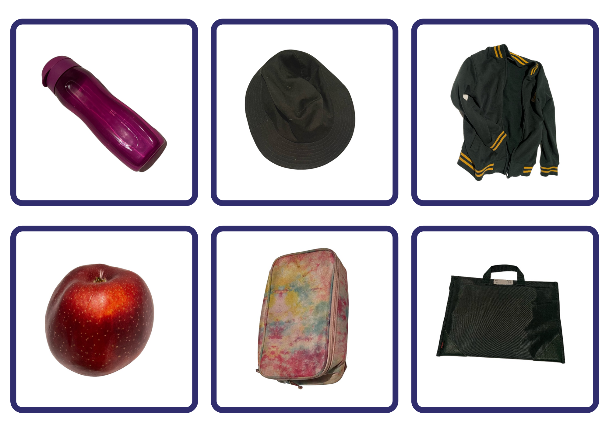
Images from Pixabay and are licensed under the Pixabay Licence.
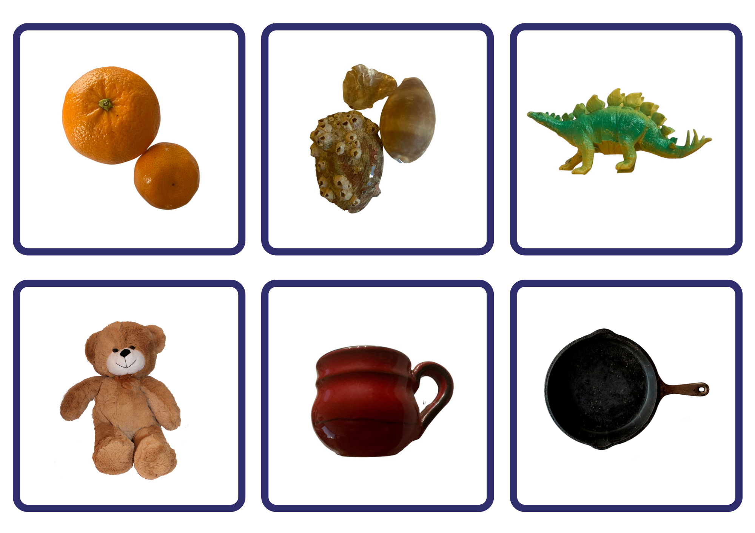
Images from Pixabay and are licensed under the Pixabay Licence.
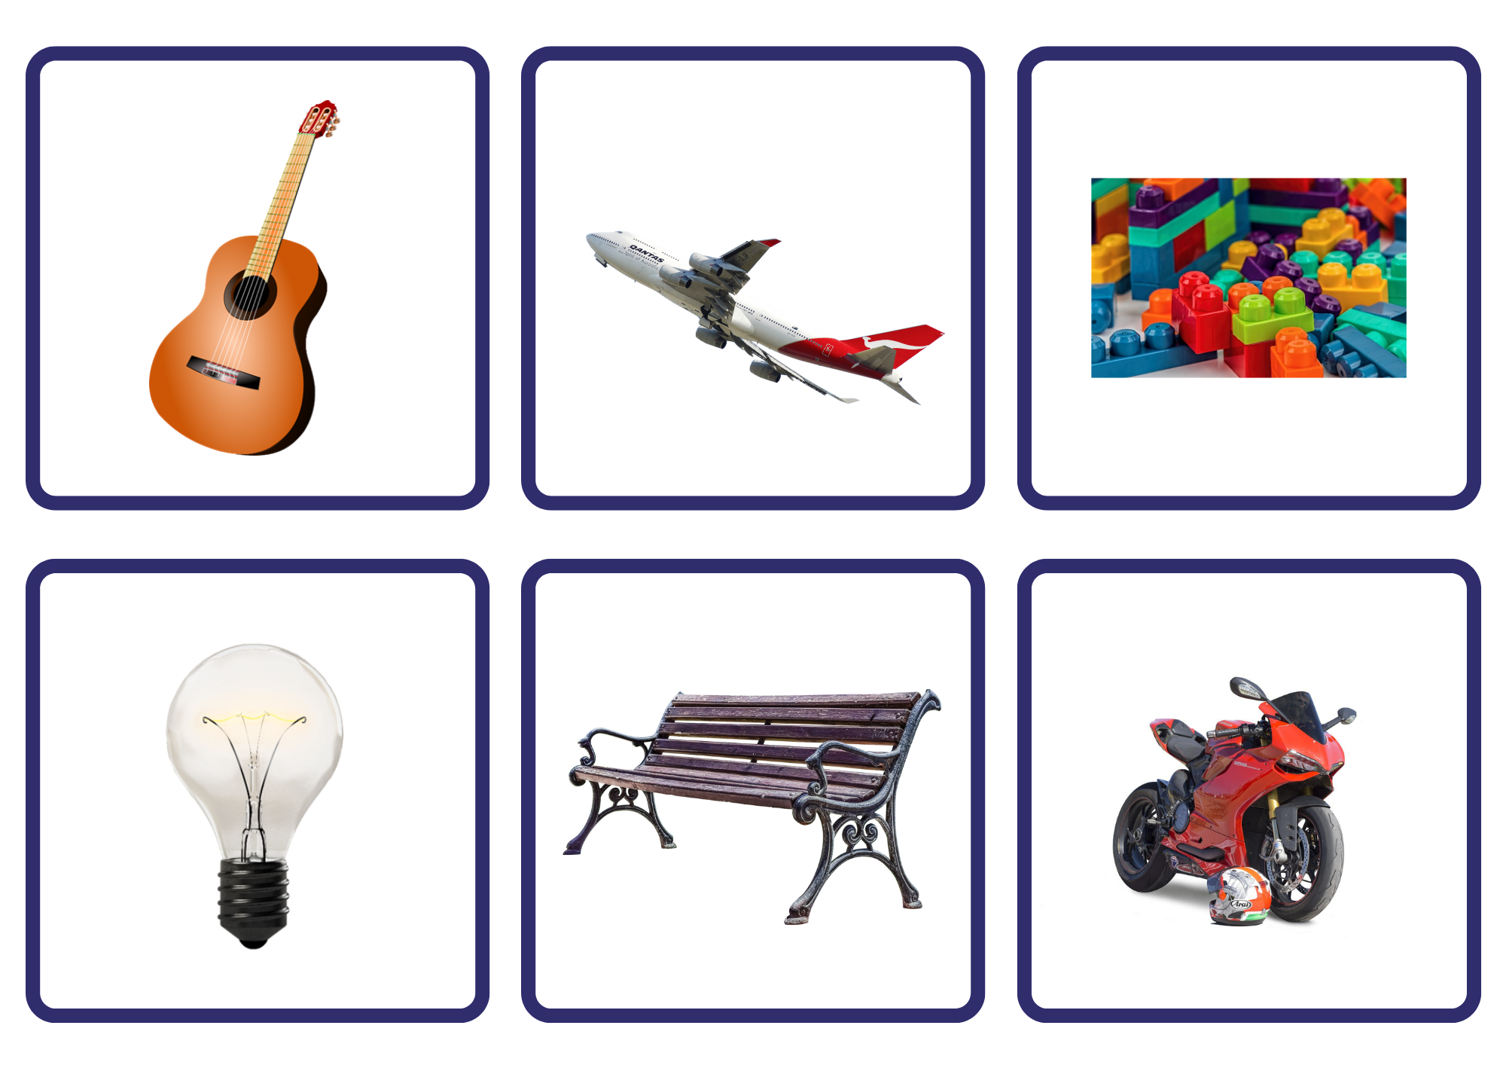
Images from Pixabay and are licensed under the Pixabay Licence.
Images from Pixabay and are licensed under the Pixabay Licence.

Resource 2: Backpack
“Backpack” by OpenClipart-Vectors/27383 is used in accordance with the Pixabay License.

References
Links to third-party material and websites
Please note that the provided (reading/viewing material/list/links/texts) are a suggestion only and implies no endorsement, by the New South Wales Department of Education, of any author, publisher, or book title. School principals and teachers are best placed to assess the suitability of resources that would complement the curriculum and reflect the needs and interests of their students.
If you use the links provided in this document to access a third-party's website, you acknowledge that the terms of use, including licence terms set out on the third-party's website apply to the use which may be made of the materials on that third-party website or where permitted by the Copyright Act 1968 (Cth). The department accepts no responsibility for content on third-party websites.
Except as otherwise noted, all material is © State of New South Wales (Department of Education), 2021 and licensed under the Creative Commons Attribution 4.0 International License. All other material (third-party material) is used with permission or under licence. Where the copyright owner of third-party material has not licensed their material under a Creative Commons or similar licence, you should contact them directly for permission to reuse their material.
English K–10 Syllabus © 2022 NSW Education Standards Authority (NESA) for and on behalf of the Crown in right of the State of New South Wales.
Creative Arts K–6 Syllabus © 2006 NSW Education Standards Authority (NESA) for and on behalf of the Crown in right of the State of New South Wales.
History K–10 Syllabus © 2012 NSW Education Standards Authority (NESA) for and on behalf of the Crown in right of the State of New South Wales.
PDHPE K–10 Syllabus © 2018 NSW Education Standards Authority (NESA) for and on behalf of the Crown in right of the State of New South Wales.
© 2021 NSW Education Standards Authority. This document contains NSW Curriculum and syllabus content. The NSW Curriculum is developed by the NSW Education Standards Authority. This content is prepared by NESA for and on behalf of the Crown in right of the State of New South Wales. The material is protected by Crown copyright.
Please refer to the NESA Copyright Disclaimer for more information.
NESA holds the only official and up-to-date versions of the NSW Curriculum and syllabus documents. Please visit the NSW Education Standards Authority (NESA) website and the NSW Curriculum website.
National Literacy Learning Progression © Australian Curriculum, Assessment and Reporting Authority (ACARA) 2010 to present, unless otherwise indicated. This material was downloaded from the Australian Curriculum website (National Literacy Learning Progression) (accessed 19 July 2022) and was not modified. The material is licensed under CC BY 4.0. Version updates are tracked in the ‘Curriculum version history’ section on the 'About the Australian Curriculum' page of the Australian Curriculum website.
ACARA does not endorse any product that uses the Australian Curriculum or make any representations as to the quality of such products. Any product that uses material published on this website should not be taken to be affiliated with ACARA or have the sponsorship or approval of ACARA. It is up to each person to make their own assessment of the product, taking into account matters including, but not limited to, the version number and the degree to which the materials align with the content descriptions and achievement standards (where relevant). Where there is a claim of alignment, it is important to check that the materials align with the content descriptions and achievement standards (endorsed by all education Ministers), not the elaborations (examples provided by ACARA).
ABC (25 May 2022) ‘Azra and Wednesday’s Family’ [video], ABC Education, ABC website, accessed 20 July 2022.
ABC (25 May 2022) ‘Introducing Emily’s Family’ [video], ABC Education, ABC website, accessed 20 July 2022.
ABC (25 May 2022) ‘Meet Jonas and his family’ [video], ABC Education, ABC website, accessed 20 July 2022.
ABC (25 May 2022) ‘Meet Molly's family’ [video], ABC Education, ABC website, accessed 20 July 2022.
ABC Kids (12 April 2021) ‘Pets’ [video], ABC Kids, YouTube, accessed 20 July 2022.
ABC (25 May 2022) ‘Who's in Jeongwoon's family?’ [video], ABC Education, ABC website, accessed 20 July 2022.
ETA (English Teachers Association) and NSW Department of Education (2016) The Textual Concepts and Processes resource, English Textual Concepts website, accessed 20 July 2022.
Godwin J (2013) Starting School (Walker A, illus.), Penguin Australia Pty Ltd, Australia.
Godwin J (2022) Families (Frankel Y, illus.), Hardie Grant Children’s Publishing, Australia.
Naitanui N (2019) Little Nic’s Big Day (Anaya F, illus.), A&U Children’s, Australia.

