iSTEM – Writing Scientific Reports: Teacher Guide
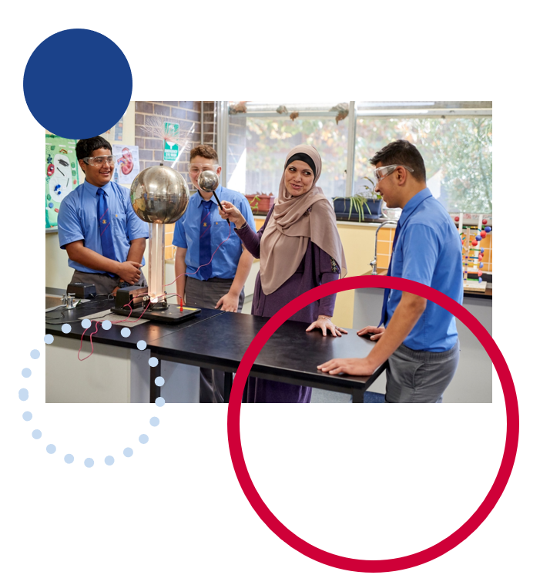

Contents
General information 2
Purpose 2
Structure 2
Writing style 3
Components 5
1. Title page 5
2. Abstract/Summary 6
3. Background research 7
4. Aim 7
5. Hypothesis 7
6. Materials and equipment 8
7. Method 9
8. Results 10
9. Discussion 12
10. Conclusion 12
11. References 12
References 13

General information
An essential part of science is communicating the findings from a scientific investigation. Thus, preparing a scientific report is an important part of student learning. A scientific report is a document that describes the process, progress and/or results of technical or scientific research, or the state of a technical or scientific research problem. This guide to writing a scientific report for iSTEM is not prescriptive but explains some generally accepted methods of presenting the most significant components that make up a report. The intention is to guide classroom conversations around developing scientific reports and not for developing marking criteria.

Purpose
Important considerations when preparing scientific reports are the audience and purpose. A scientific report will always recount a scientific investigation's method, results, and conclusions. The level of scientific language used and the depth of conceptual explanation required will depend on the audience. All scientific reports are based on a similar structure, but may not include all sections of the report, such as background research or risk assessment. Again, this will depend on the audience of the report.
In iSTEM, the writing of scientific reports is frequently used as a significant component of assessment tasks. Scientific reports can be written when investigating scientific hypotheses where you need to report findings. The report allows students to demonstrate scientific literacy and to use data to draw conclusions about STEM-based processes and principles.
It is recommended that teachers select and emphasise components of scientific reports that are similar in structure to those used in science courses undertaken at school. The process should allow students to demonstrate critical thinking applied to solving STEM based problems.

Structure
Scientific reports vary in their purpose and the information presented. The following sections should be used to scaffold and guide students through a methodical process in addressing all relevant aspects of a scientific investigation as they create a record of their learning through experimentation:
- Title page
- Abstract/Summary
- Background research
- Aim
- Hypothesis
- Materials and equipment
- Method
- Results
- Discussion
- Conclusion
- References
Not all the sections listed above will be necessary for every report. There may be a focus on specific sections of a report, or students may produce a scientific brief or utilise different scientific communication methods such as a poster. Alternative methods to demonstrate student understanding of the process and findings could also be considered, such as text-to-speech, audio recordings, or video.

Writing style
Scientific reports use a formal style of writing, referred to as ‘third person, passive voice’. Students may not be familiar with this style of writing. Students may find it useful to compare types of texts where they are commonly used. Engineering reports will share some common features.

Subjective language
Personal language is avoided in scientific reports, with preference given to impersonal language that emphasises scientific objectivity. This means restructuring sentences to avoid personal pronouns (Winckel and Hart 2002).

Passive voice
The passive voice is usually used in scientific reports where the writing is intended to be impersonal and objective. Passive voice is used to highlight the object that experiences an action, rather than the thing that performs the action. In other words, the most important thing becomes the subject of the sentence.

Verb tense
Verb tense changes according to the section in the report, the purpose of the section or sentence, and the type of information included. The following suggestions are a general guide only:
- use present tense to explain or discuss
- use past tense to state or describe.
For example, ‘The equipment (subject) is being repaired (verb). (We are interested in the equipment, not in the people who are doing the repairs).

Components

1. Title page
The title page of a scientific report should contain:
- the title of the report
- the topic
- the name(s) of the student(s)
- the date submitted.
The report's title should be clear, concise, and indicate the subject of the report. The title should be self-explanatory and should indicate what the study is addressing. The table below outlines some examples of poor titles for scientific reports and how they could be improved.
Table 1 – Examples of poor and improved report titles
Poor title | Improved title
Scientific report | Scientific report: The effects of pH on the growth of beans
Scientific analysis | Analysis of materials used in bio medical device
Aeronautical report | Analysis of wing length in balsa planes
Design for space scientific report | Seedling growth rates show a positive correlation with photo period’

2. Abstract/Summary
An abstract provides a summary of the key points of the scientific report. It is a snapshot of the entire report used by scientists to quickly determine whether the report is relevant to their current research. As such, its main purpose is to summarise the key results and conclusions of the report.
Depending on the type of experiment/report, the abstract could:
- include the aim of the experiment
- highlight the variable changed and measured
- describe main results
- outline conclusions
- make recommendations.
The abstract should include enough information for the reader to understand what is being discussed in the full report without reading it. Although the abstract is the first section after the title page, it is usually the last one written.
Note: Not all scientific reports need an abstract, especially short reports.

3. Background research
The background research section should outline key findings from primary and secondary sources related to the chosen experiment. These may be related to relevant scientific processes or principles, or could be a summary of findings outlined in published scientific investigations. The background research will provide reference material for the conclusion.

4. Aim
The aim of the experiment should succinctly state the problem that is being investigated. It should refer to the relationship between the dependent and independent variables.
It should begin with the words ‘To determine…’
For example: To determine if increasing the temperature of water affects the time taken for sugar to dissolve.

5. Hypothesis
The hypothesis is a statement that is tested by the experiment. A hypothesis can be supported or not supported based on the data collected in an investigation. This statement can be seen as a reasoned prediction that can be supported or refuted through experimentation or observation. It should outline the expected relationship between the dependent and independent variables.
It should be written in the form of ‘If …, then…” OR “As…, then…’
For example: If the temperature of a cup of water is raised, then the amount of sugar that can be dissolved will increase.

6. Materials and equipment
A detailed list of all equipment and resources necessary used in the experiment. Exact measurements of materials and type of equipment used are expected when recording the experiment.

Variables
In some reports, it is advisable to identify and describe the variables involved in the experiment. Most investigations will have a single independent and a single dependent variable. These would include:
Independent variable: This is the factor that is changed. It is the factor being tested. Typically, there is only one independent variable being manipulated.
Dependent variable: This is what you will be measuring during the experiment. Typically, there is only one dependent variable.
Controlled variables: These are factors which must be kept constant during the experiment to ensure that it is a fair test. There can be many controlled variables.
For an experiment to be valid:
- all variables (other than the independent and dependant variables) must be controlled
- the measurements obtained are accurate and/or precise
- the experimental design enables the investigator to measure what is intended (that is, the dependant variable is correctly measured)
- the experiment uses the correct (and best available) equipment
- the method should ensure measurement reliability (that is, the results are reproducible).

7. Method
The method is a set of repeatable instructions that clearly outline the procedure to be undertaken when conducting the experiment. They must assume that the person undertaking the experiment has no prior knowledge but does have experience with the relevant equipment.
A quality method includes diagrams and must fulfil the following criteria:
- instructions written in numbered steps
- each instruction starts with a scientific verb
- there are no personal pronouns (I, we, us)
- it is written in present tense
- it uses scientific language and exact measurements.
For example, an incorrect step may read ‘We added some sugar to the water.’ This could be improved to ‘1. Add 1 teaspoon of sugar to the water.’
Note: Scientific methods written at a tertiary level follow a different format. These are written as a descriptive recount of the procedure. They often use past tense and third person language rather than numbered steps. Schools may choose to use this format if it is appropriate to the individual setting.

Risk assessment
A risk assessment is often added to the method particularly if it requires the use of materials or procedures that pose a risk.
This is an assessment of the level of risk and actions that can be taken to prevent or minimise risk when conducting the experiment. Identified risks should be realistic. They should consider the environment in which the experiment is being conducted and the age/skill of the people conducting it.

8. Results
The results section is where data collected from the experiment is recorded. Where appropriate it should include a description of the main findings, for example patterns and trends in the data, errors, and uncertainties. Note it should not be an explanation of the results but what was observed.
The results section may include tables, graphs, or other visual representations of the results obtained from the experiment. The results outline the changes in the independent variable and the effect on the dependent variable being measured. It should correspond to the process outlined in the method.
A results table must fulfil the following criteria:
- a descriptive title is present
- the changes in the independent variable are listed in the left most column
- appropriate headings are given to all columns
- units of measurement appear in the column headings only.
For example:
Table 2 – Time taken for sugar to dissolve at various temperatures
Temperature of water (°C) | Trial 1 time (sec) | Trial 2 time (sec) | Trial 3 time (sec) | Average time (sec)
10 | 50 | 52 | 48 | 50
30 | 35 | 36 | 37 | 36
50 | 26 | 28 | 27 | 27
The graph can be presented in various forms, but must directly compare the dependent and independent variable on the X and Y axes. This may simply refer to the averages obtained from the results table.
For a line, column, or bar graph the following criteria must be fulfilled:
- a descriptive title is present
- the independent variable is on the X axis and the dependent variable is on the Y axis
- axes are labelled including units
- an appropriate scale is used on the axes
- a line of best fit where appropriate.
For example:
Figure 1 – Average time taken for sugar to dissolve at various temperatures
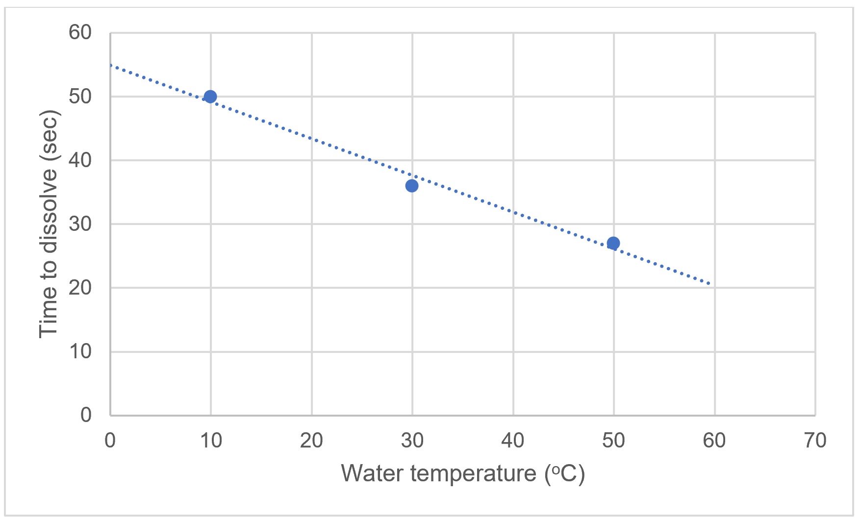

9. Discussion
The purpose of the discussion is to interpret the results, identify trends in the data, and to assess the results for accuracy, reliability, and validity. If background research was conducted, the discussion should relate the results to the main findings of the research.
The discussion should also reflect on how well the experiment was conducted and any modifications that could be made to the experiment to improve the results. It may also include a proposal for extending the research to examine another variable or other factors relating to the experiment.

10. Conclusion
The conclusion includes a brief statement that clearly states the key results and trends obtained from the data. It should also compare the results to the aim and hypothesis of the experiment, stating whether they were achieved and if not, why.

11. References
All references to other authors or text cited in the report need to be acknowledged. One of the main types of referencing should be used:
- numbered reference list
- alphabetical reference list.
Microsoft have published a detailed guide on how to add citations in a Word document.

References
Links to third-party material and websites
Please note that the provided (reading/viewing material/list/links/texts) are a suggestion only and implies no endorsement, by the New South Wales Department of Education, of any author, publisher, or book title. School principals and teachers are best placed to assess the suitability of resources that would complement the curriculum and reflect the needs and interests of their students.
If you use the links provided in this document to access a third-party's website, you acknowledge that the terms of use, including licence terms set out on the third-party's website apply to the use which may be made of the materials on that third-party website or where permitted by the Copyright Act 1968 (Cth). The department accepts no responsibility for content on third-party websites.
All material © State of New South Wales (Department of Education), 2021 unless otherwise indicated. All other material used by permission or under licence.
Microsoft (2022) ‘Add citations in a Word document’, Microsoft Office Support website, accessed 26 August 2022.
Winckel A and Hart B (2002) Report Writing Style Guide for Engineering Students [PDF 193KB], 4th edn, University of South Australia website, accessed 26 August 2022.

