Big History – Core 8: Agriculture and civilisations

Contents
Focus 3
Outcomes 3
Rationale 4
Aim 4
Purpose and audience 5
When and how to use this document 5
Teacher note 5
Learning sequence 1: Agriculture 6
Importance of agriculture 6
Learning sequence 2: Agrarian civilisations 8
Early cities and states 8
Burial practices 9
Record keeping and collective learning 9
Learning sequence 3: News 13
Using news sources 13
Learning sequence 4: Zones of the agrarian world 15
Features 15
Silk Road 15
Song dynasty China 16
Learning sequence 5: Exploration and trade 17
Explorers 17
Exchanging culture, traditions and goods 18
Learning sequence 6: Development of agriculture and civilisation 19
Assessment task 20
Outcomes 20
Content 20
Task 20
Sources 23
Marking criteria 27
Additional information 28
Assessment for learning 28
Differentiation 29
About this resource 30
References 33

Focus
This unit will investigate how humans harnessed the power of the sun with agriculture 12,000 years ago. By domesticating and cultivating our crops, collective learning and increasing complexity accelerated. Students will explore the development of the earliest agrarian civilisations, which signal the start of conventional history approximately 5000 years ago. From powerful emperors to brave warriors, to intrepid explorers, to rapacious adventurers, they will discover how these new hubs of collective learning spread across the earth and gradually united the globe into a single complex system.

Outcomes
A student:
- BH5-2 evaluates a range of differing claims of knowledge and perspectives
- BH5-3 identifies types of evidence and interdisciplinary claims of knowledge of the universe used in addressing essential questions
- BH5-4 explains and assesses the role of evidence and interdisciplinary claims of knowledge of the universe used in addressing essential questions
- BH5-5 describes appropriate concepts to address relevant questions, cases, problems and claims of knowledge
- BH5-7 locates and uses relevant sources of information and evidence from across a range of disciplines
- BH5-8 evaluates the usefulness of sources and evidence across a range of disciplines to respond to essential questions
- BH5-9 assesses claims of knowledge across a range of disciplines
Outcomes referred to in this document are from the Big History Course Document © NSW Department of Education for and on behalf of the crown in the State of New South Wales (2021).

Rationale
This course is designed for students curious about seeking answers to big questions regarding the history and development of our universe, including the origin of our species. It promotes reasoned predictions of future events. Collaboration amongst students, teachers, scholars and scientists is the foundation of Big History. It places human history in the broader context of the universe’s history.
Throughout history, humans have collaborated in creative endeavours leading to a dynamic body of knowledge which is continually refined and contested as evidence evolves. This knowledge provides explanations for various phenomena and enables sense to be made of the development of human society.
In Big History, students will develop deep knowledge, understanding and skills that will allow them to create new ideas and translate their ideas into practical applications. Through engaging with varying sources and perspectives, students will develop problem-solving, research and critical thinking skills, and demonstrate respect for differing viewpoints. Through the integrated study of the cosmos, life and humanity, students will use empirical evidence to develop a deeper appreciation of the evolution of knowledge systems and the complex relationship between evidence and ideas.
Big History addresses the need for students to use interdisciplinary understanding to solve problems and develop critical thinking skills to assess the validity of claims of knowledge. The course will build upon the learning across the curriculum content, including the general capabilities priorities from the NSW syllabus documents, that encompass the knowledge, skills, attitudes and behaviours to assist students to live and work successfully in the 21st century.

Aim
This course aims to develop students’ understanding of the history of the universe from the ‘Big Bang’ to the modern day and beyond, through an exploration of the themes and patterns that can help us better understand the world we live in. Big History will develop students’ ability to synthesise complex information, hypothesise and develop arguments, develop key critical thinking skills and enhance their reading, writing, and research skills in a multidisciplinary way.

Purpose and audience
This teaching resource is for teachers delivering or planning to deliver the course. The learning sequence demonstrates how a combination of outcomes can be used to develop teaching and learning activities. It also suggests a range of resources to support teachers when planning and/or teaching the course.

When and how to use this document
Use this resource when designing learning activities that align with the course outcomes and content. The activities and resources can be used directly or may be adapted based on teacher judgment and knowledge of their students. Core modules must precede options in the delivery of the course. Consult the course document for further details on timing of core and options.

Teacher note
This resource provides some suggested teaching strategies that could be used in your classroom.
The course supports the opportunity to explore a range of areas within the scope of Big History. It is recommended that teachers should refer to the Controversial Issues in Schools policy.
Note: The following learning sequences are designed to supplement the materials and activities available through the Big History School and OER Project websites. There is no requirement to use all (or any) of the following activities, as they are suggestions only. These sequences are not intended to be used as a complete teaching and learning program.
It is strongly recommended that science trained teachers support the delivery of this unit.

Learning sequence 1: Agriculture
Students:
- explain the appearance of agriculture and civilisation as the seventh threshold of increasing complexity, including
- agriculture as an important turning point in human history
- the impact of domestication of crops over time
- factors that affect the quality of life of both farmers and foragers.

Importance of agriculture
Big History uses specific vocabulary, with some words and phrases being used differently to everyday speech or in other subjects. As you work through each learning sequence, complete a vocabulary tracker with the key words and phrases you encounter.
Table 1 – Vocabulary tracker
Word/phrase | Definition | Synonyms | Antonyms | Use in a sentence
Agriculture | The practice of cultivating land or raising livestock | Farming, agrarian, pastoral | Industry, Non-agricultural | Ever since we've had agriculture, people have been employing technology to make it better.
Use the Agriculture Timeline, The Development of Agriculture, and a world map to show the spread of agriculture over time.
Read Was agriculture the greatest blunder in human history?, Why is farming better than foraging? and Farmers have less leisure time than hunter-gatherers and make a summary of the positive and negative impacts of agriculture on quality of life. Create 2 persuasive posters:
- one from the perspective of farmers urging hunter-gatherers to turn to agriculture
- one from the perspective of foragers urging farmers to return to the ‘old ways’.
As a class, discuss the usefulness of attempting to define groups of people in history as either hunter-gatherers or farmers. What values and judgements does it require us to make, and are these valid?
Divide the class into 2 groups and research and debate whether farming is superior to foraging.

Learning sequence 2: Agrarian civilisations
Students:
- investigate the establishment of cities in areas that have agriculture, including
- where and when the first cities and states appeared
- the conditions that allowed cities and states to appear in some places and not others
- common features of agrarian civilisations
- different sources about burial practices in agrarian civilisations
- burial practices and social status, and power in agrarian civilisations
- the relationship between record-keeping and collective learning
- the similarities and differences of civilisations.

Early cities and states
Watch Çatalhöyük (Catal Huyuk) and the Dawn of Civilization (6:28) and complete Table 2 below.
Table 2 – Video analysis
Fact or opinion from video | Evidence that supports it | Questions it raises
There was no leader | All the houses were roughly the same size | How did they resolve conflict in the community?
Use The History of Cities and your own research to write 2-3 paragraphs explaining the link between the establishment of cities and agricultural practices.
Source 1: Captain James Cook describing Aboriginal society, Cook’s Descriptions of Places, New Holland, p.92.
…they (Aboriginals) may appear to some to be the most wretched people upon Earth, but in reality, they are far more happier than we Europeans; being wholy unacquainted not only with the superfluous (unnecessary) but the necessary conveniences so much sought after in Europe, they are happy in not knowing the use of them. They live in a Tranquillity which is not disturb’d by the Inequality of Condition: The Earth and sea … furnishes them with all things necessary for life; they covet not Magnificent Houses, Household-stuff, etc. they live in a warm and fine Climate and enjoy a very wholsome Air, so that they have very little need of Clothing … this, in my opinion argues that they think themselves provided with all the necessarys of Life …
Using the source above and Aboriginal inventions, discuss as a class the possible reasons Australian First Nations civilisations do not appear to have established cities.
In groups, discuss the key features of agrarian societies. List the various roles an agrarian society would require and what rules would be needed to ensure the society was successful.
How useful is the concept of ‘civilisation’ when assessing the success of a society? What are the potential problems relating to bias and perspective when investigating foreign or ancient societies?

Burial practices
Watch The fascinating history of cemeteries (5:18) and complete the following:
- Other than burying the dead, what other ways have humans dealt with human remains?
- What were some of the original reasons for burying the dead?
- Outline some of the theories about why burial became more widespread.
- Explain why burial traditions can be useful for historians to study.

Record keeping and collective learning
Use 8 Oldest Recorded History in the World to complete Table 3 below.
Table 3 – Source analysis
Source | Purpose | What we can infer about the society | Questions it raises
Chinese oracle bones | Predicting the future | Religious, made long term plans | Did you pay to have your fortune told? What happened if the prediction didn’t come true?
Reforms of Urukagina
Kesh temple hymn
Seal of Seth-Peribsen
Beer payslip
Narmer palette
Hieroglyphic billboard
Scorpion I’s tomb hieroglyphs
Read The biggest estate on earth and How to Revive a Lost Language. As a class, discuss the difficulties faced when investigating civilisations that did not keep written records or whose languages have been lost. To what extent can the loss of a language equate with the loss of collective knowledge?
Note: This activity is designed to give students an idea of how collective learning and record keeping are linked, and how they allow civilisations to grow, and human knowledge to develop faster. You will need one pack of playing cards for each group.
In groups of 3, students (labelled A, B and C) complete the following practical activities

Task 1
- Student A shuffles a deck of cards and places it face down.
- Student B turns over the first 5 cards in order, without showing them to the other students, and places them face down on a separate pile. They then verbally tell Student C the order of the 5 cards.
- Student C announces what each card is, then turns it face up to check the result. Student A keeps a tally of how many are correct.
Task 2
- Student A shuffles a deck of cards and places it face down.
- Student B turns over the first 5 cards in order, without showing them to the other students. As they turn the cards, they record R (red) or B (black) for the colour of each card in Table 4 below and place them face down in a separate pile. They then verbally tell Student C what each card is.
- Student C announces what each card is, then turns it face up to check the result. Student A keeps a tally of how many are correct.
Table 4 – Student table (Task 2)
Card | Colour
1
2
3
4
5
Task 3
- Student A shuffles a deck of cards and places it face down. Student C leaves the room.
- Student B turns over the first 5 cards in order, without showing them to the other students, and places them face down in a separate pile. They then complete Table 5 below, recording S, D, C, H for the suit of each card and 1-10, J, Q, K, A indicating the value of the card. They then leave the room.
- Student C enters the room and reads the table. They announce what each card is, then turns it face up to check the result. Student A keeps a tally of how many are correct.
Table 5 – Student table (Task 3)
Card | Notes
1
2
3
4
5
At the end of the 3 tasks, discuss as a group how record-keeping and collective learning impacted the process of remembering the sequence of cards. Write 2-3 paragraphs explaining how this can be applied to the increasing complexity of written records and advances in civilisations.
Note: This activity could also be spread across multiple days to show the ability for written records and collective learning to transmit information across generations.
Complete a SWOT analysis of agrarian and hunter-gatherer civilisations.

Learning sequence 3: News
Students investigate the role of current news as source of information about agricultural civilisations.

Using news sources
Note: Unpack the concept of ‘interdisciplinary study’ with students prior to completing the following task.
Conduct a Google news search for ‘prehistoric agriculture’ and complete Table 6 for 3 of the news articles you find.
Table 6 – Using news sources
Title of article and link | Date of publication | Key facts | How it adds to or changes our understanding of the development and spread of agriculture
How ancient people fell in love with bread, beer and other carbs | 22 June 2021 | New research has discovered early evidence of grinding grains for food and drinks in prehistoric Turkey. | People relied on grains in their diet even before these crops were domesticated.  Bread may have been first made 5000 years before wheat was farmed.  Electron microscopes are being used to re-examine samples of cooking utensils and pots.
Use one of the articles and write 2-3 paragraphs discussing how interdisciplinary approaches and collaborations are increasingly important and valuable when investigating the past.

Learning sequence 4: Zones of the agrarian world
Students:
- explore the 4 zones of the agrarian world, including
- the key features of a society within one of the world zones
- the challenges of governing growing agrarian civilisations
- the importance of collective learning in the development of agrarian civilisations
- the importance of the Silk Road and the network of exchanges it created
- collective learning and the process of innovation in Song dynasty China.

Features
Note: This content is covered within the Big History School website.

Silk Road
Read the following extract from Peter Frankopan’s, The Silk Roads: A New History of the World and write a response explaining what it tells us about trade and contact between different societies via the Silk Road.
Source 2: Peter Frankopan, ‘The Silk Roads: A New History of the World’ (Copyright Peter Frankopan, 2015, Bloomsbury Publishing p.25)
We can imagine the life of a gold coin two millennia ago, struck perhaps in a provincial mint and used by a young soldier as part of his pay to buy goods on the northern frontier in England and finding its way back to Rome in the coffers of an imperial official sent to collect taxes, before passing into the hands of a trader heading east, and then being used to pay for produce bought from traders who had come to sell their provisions at Barygaza. There it was admired and presented to leaders in the Hindu Kush, who marvelled at its design, shape and size and then gave it over to be copied by an engraver – himself perhaps from Rome, perhaps from Persia, or from India or China, or perhaps even someone local who had been taught the skills of striking. This was a world that was connected, complex and hungry for exchange.
Use A Fascinating Map of Medieval Trade Routes and the source above to create a cartoon strip telling the story of the journey from England to the Far East, from the coin’s perspective.

Song dynasty China
Read China’s Age of Invention, watch Discovering China – The Song Dynasty (6:20) and in small groups complete Table 7 below.
Table 7 – Song China inventions
Invention or discovery | Connection or influence from prior discoveries | Influence on Chinese society | Impact on world today

Learning sequence 5: Exploration and trade
Students:
- draw comparisons between the similarities and differences of explorers
- investigate the exchange of culture, traditions and goods through trade and conquest.

Explorers
Watch The Age of Exploration: Crash Course European History (15:39) and then divide the class into 3 groups: positives, minus, interesting. Students in each group use sticky notes to complete a collaborative PMI chart. At the end of the video students place their sticky notes on a large PMI chart on the board. This is then used to lead a class discussion on the age of exploration.
Using 15 Famous Explorers Who Changed the World, complete Table 8, identifying the main motivations of different explorers.
Table 8 – Explorers
Explorer | Trade | Fame | Religion | Money | Adventure
Marco Polo | Yes | Yes | No | No | Yes
(Add explorer) | Yes/No | Yes/No | Yes/No | Yes/No | Yes/No
(Add explorer) | Yes/No | Yes/No | Yes/No | Yes/No | Yes/No
Write a response to the following statement: ‘The age of exploration was shaped more by accident than skill’. Discuss.

Exchanging culture, traditions and goods
Note: Project a blank world map for the class to view. Provide students with sticky notes with the names of the following foodstuffs: coffee, chocolate, corn, mango, rice, pasta, pepper, and potato. Get students to place the sticky notes on the countries where they think the food originated. Then give other students the chance to discuss and move the sticky notes to other locations. Finally, have students research where each item actually comes from and discuss as a class.
Read 12 Important Columbian Exchange Pros and Cons. In pairs, summarise the unintended consequences of the trade between Europe, Africa and the Americas.
Note: During this part of the learning sequence students will use a visible thinking routine, Ways Things Can Be Complex, designed to encourage deep thinking of the complexity of the exchange of culture, traditions, and goods. Facilitate a class discussion for each of the steps in the thinking routine and encourage students to disagree and defend their ideas.
Use the Ways Things Can Be Complex to investigate the exchange of culture, traditions, and goods through trade and conquest.

Learning sequence 6: Development of agriculture and civilisation
Students:
- explain the development of agriculture and civilisation, for example
- claims testing the concept of agriculture and civilisation as the seventh threshold of increasing complexity
- the role of a data scientists in the study of history
- the role of an ancient historian
- the importance of different disciplinary thinking, for example, a data scientist and an ancient historian, to understand why agriculture was so important.
Note: This content is covered within the Big History School website.

Assessment task
Note: When using this task, ensure it is placed on the school template and follows all assessment requirements.
This task has been adapted from Worksheet 7.4.4 from the Big History School website.
The ‘sources’ for the assessment task are made-up artefacts from a fake ancient civilisation. When providing the sources to students, remove the hyperlink so that students are not confused by the actual origin of the source.

Outcomes
- BH5-7 locates and uses relevant sources of information and evidence from across a range of disciplines
- BH5-9 assesses claims of knowledge across a range of disciplines.

Content
Students explain the development of agriculture and civilisation, such as the importance of different disciplinary thinking, for example, a data scientist and an ancient historian, to understand why agriculture was so important.

Task
Scenario
You are the head of a team working in Northern Africa that have located human remains and other material that have been dated to approximately 7500 years old. This predates existing knowledge of societies in this area by about 3000 years.
It is your job to assemble a team of specialists to help investigate the site and analyse the artefacts that are found to determine who lived there and what their society and way of life was like. Use the sources provided at the end of the assessment task to help determine what disciplinary experts will be most useful.

Part 1
Table 9 – Disciplinary experts
Discipline | What specialist knowledge and skills do they have? | Based on the specialist knowledge what questions would they ask about the discovery to better understand it?
Archaeobotanist | Ancient plants and interactions with humans through the analysis of plant remains | Where is the site located? Where are the plants natively found? Is there evidence the plants were farmed? What season were the plants collected in?
Metallurgist | Study of past use and production of metals from humans | What metals is it made of? Where did the ore for the metal come from? How was it made? How old is it? How was it used?
Pottery specialist | Manufacture and dating of pottery | How was it made? What design elements are similar to other civilisations? What was it used for? What residues are inside the pots? Are there signs of decoration?
Bioarchaeologist | Study of human remains | Gender? Height? Age? Clues about health or diseases? Evidence of lifestyle, for instance wear on particular bones?
Ethnographer | Study of ancient artworks and the culture of a civilisation | How was the artwork made? What paints or materials were used and where did they come from? What symbolism is present? What can be inferred about beliefs and culture? What is the purpose of the artwork?
Archaeologist | Study of the past by looking at material remains, including buildings and tools | How was the item made? What was it used for? What does it tell us about the society?
Using the information above and individual research, complete Table 10 below.
Table 10 – Experts source analysis
Source | Discipline | What they would tell us about the source | How useful is this information in judging the importance of agriculture to the development of civilisations?
Grains
Pottery urns
Human remains
Copper axe
Human palaeofaeces
Rock art
Rock wall and steps
Stone grinding tool
Identify which 3 experts’ comments from Table 10 above are most useful in assessing why agriculture was so important in the development of this civilisation. Write 3 paragraphs justifying your choices.

Part 2
Create a podcast episode of 3-5 minutes, assessing the importance of using information from a variety of disciplines to give a more complete picture of the past.

Sources
Source 1 – Aztec Pumpkin Seeds
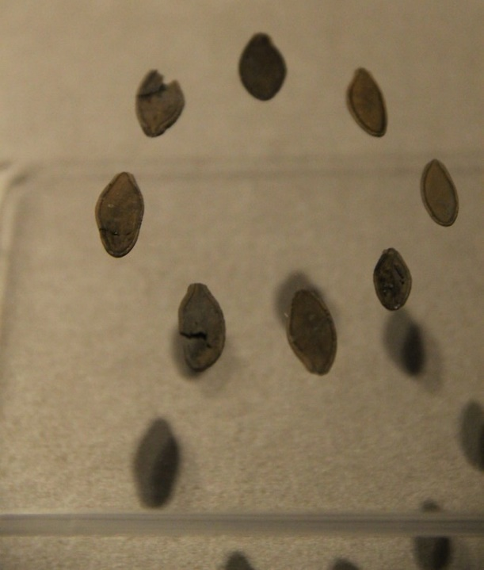
"Aztec Pumpkin Seeds" by Gary Todd is in the Public Domain, CC0
Source 2 – Late Roman pots, Boscombe Down, Amesbury
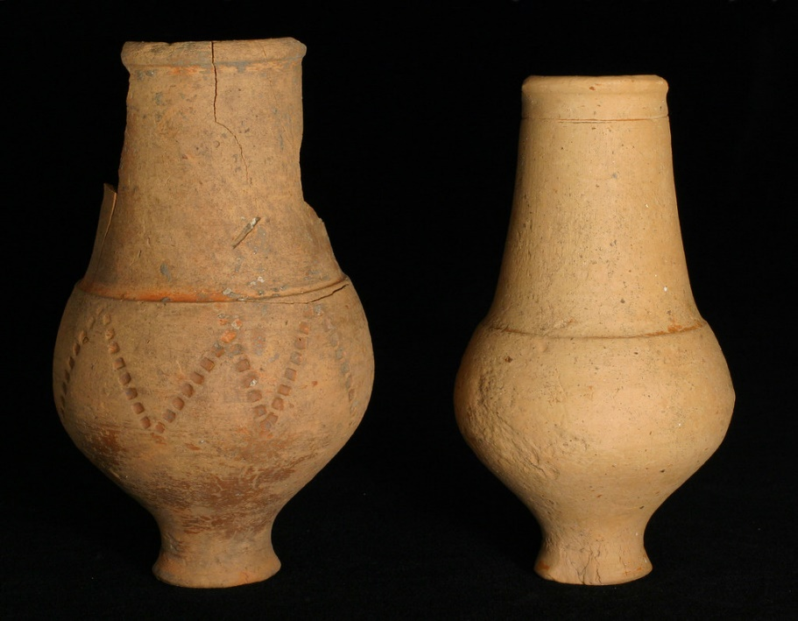
"Late Roman pots, Boscombe Down, Amesbury" by Wessex Archaeology is licensed under CC BY-NC-SA 2.0
Source 3 – Recovering Soldier Conducting Archaeological Dig with Operation Nightingale
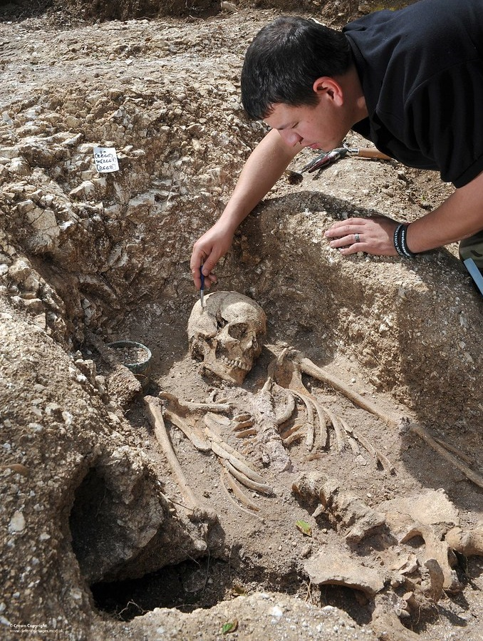
"Recovering Soldier Conducting Archaeological Dig with Operation Nightingale" by Defence Imagery is licensed under CC BY-NC-ND 2.0
Source 4 – Small Late Bronze Age hoard, Axe 3
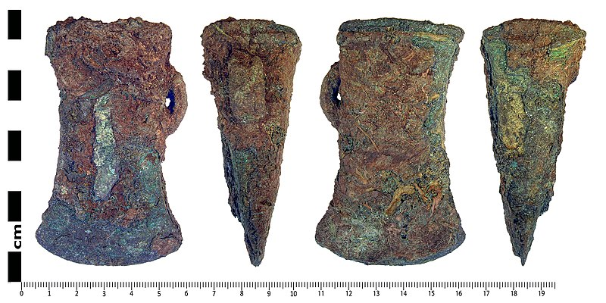
"Small Late Bronze Age hoard, Axe 3" by The Portable Antiquities Scheme is licensed under CC BY 2.0
Source 5 – Human paleofeces from the Neolithic site Çatalhöyük
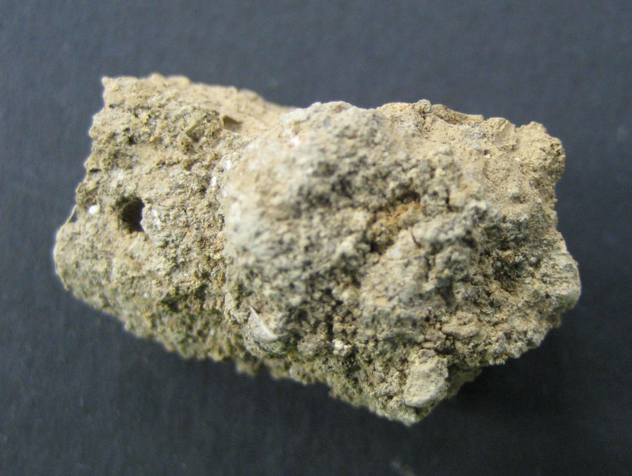
"Human paleofeces from the Neolithic site Çatalhöyük" by Drlmshillito is licensed under CC BY-SA 4.0
Source 6 – Sierra de Guadalupe cave paintings
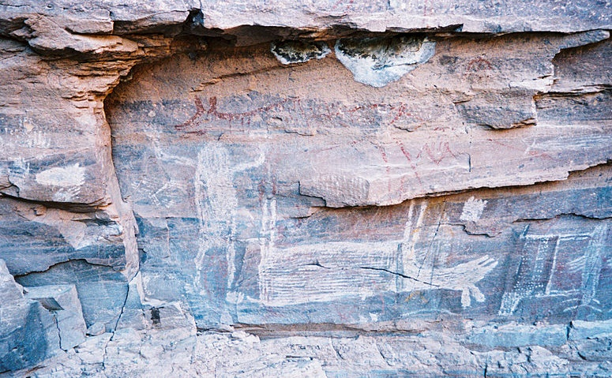
"Sierra de Guadalupe cave paintings" by Moomintrollmania is licensed under CC BY-SA 3.0
Source 7 – Dholavira (6)
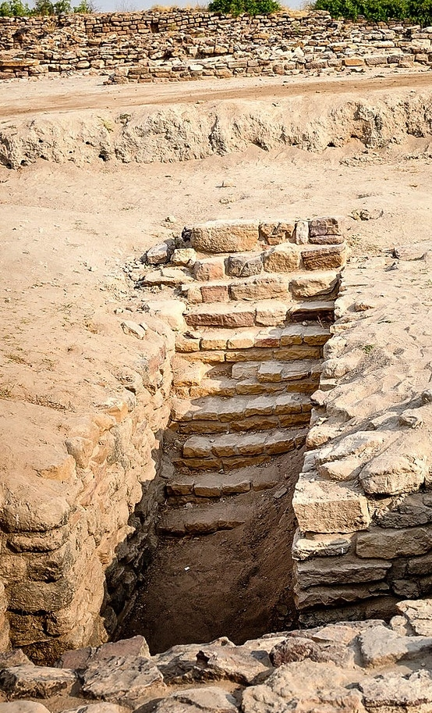
"Dholavira (6)" by Travelling Slacker is licensed under CC BY 2.0
Source 8 – Two items commonly used by indigenous Mexicans. The mortar is called a Metate and the stone lying across it a Mano.
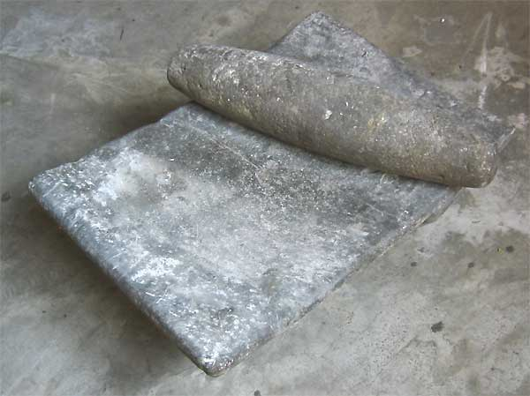
"Metate and Mano" By Jim Conrad is in the Public Domain

Marking criteria
Table 11 – Assessment marking criteria
Criteria | Grade
Demonstrates outstanding knowledge of the course content and concepts by effectively selecting relevant evidence from across a range of disciplines.  Provides a clear judgement with a sophisticated and sustained argument, demonstrating a comprehensive understanding of the importance of interdisciplinary knowledge. | A
Demonstrates thorough knowledge of the course content and concepts by effectively selecting relevant evidence from across a range of disciplines.  Provides a judgement with a coherent argument, demonstrating a sound understanding of the importance of interdisciplinary knowledge. | B
Demonstrates sound knowledge of the course content and concepts by selecting relevant evidence from across a range of disciplines.  Provides a relevant, but largely narrative or descriptive response which may contain an implied judgement or understanding of the importance of interdisciplinary knowledge. | C
Demonstrates some knowledge of the course content and concepts by selecting evidence from across some disciplines.  Presents a generalised, mostly relevant or descriptive response. | D
Limited knowledge of the course content and concepts. May refer to some disciplines.  Makes general statements in relation to the question. | E

Additional information
Please complete the following feedback form to help us improve our resources and support.
The information below can be used to support teachers when using this teaching resource for Big History.

Assessment for learning
Possible formative assessment strategies that could be included:
- Learning intentions and success criteria assist educators to articulate the purpose of a learning task to make judgements about the quality of student learning. These help students focus on the task or activity taking place and what they are learning and provide a framework for reflection and feedback. Online tools can assist implementation of this formative assessment strategy.
- Eliciting evidence strategies allow teachers to determine the next steps in learning and assist teachers in evaluating the impact of teaching and learning activities. Strategies that may be added to a learning sequence to elicit evidence include all student response systems, exit tickets, mini whiteboards (actual or digital), hinge questions, Kahoot, Socrative, or quick quizzes to ensure that individual student progress can be monitored and the lesson sequence adjusted based on formative data collected.
- Feedback is designed to close the gap between current and desired performance by informing teacher and student behaviour (AITSL 2017). AITSL provides a factsheet to support evidence-based feedback.
- Peer feedback is a structured process where students evaluate the work of their peers by providing valuable feedback in relation to learning intentions and success criteria. It can be supported by online tools.
- Self-regulated learning opportunities assist students in taking ownership of their own learning. A variety of strategies can be employed and some examples include reflection tasks, Think-Pair-Share, KWLH charts, learning portfolios and learning logs.
The primary role of assessment is to establish where individuals are in their learning so that teaching can be differentiated and further learning progress can be monitored over time.
Feedback that focuses on improving tasks, processes and student self-regulation is the most effective. Students engaging with feedback can take many forms including formal, informal, formative, summative, interactive, demonstrable, visual, written, verbal and non-verbal.
What works best update 2020 (CESE 2020a)

Differentiation
Differentiated learning can be enabled by differentiating the teaching approach to content, process, product and the learning environment. For more information on differentiation go to Differentiating learning and Differentiation.
When using these resources in the classroom, it is important for teachers to consider the needs of all students in their class, including:
- Aboriginal and Torres Strait Islander students. Targeted strategies can be used to achieve outcomes for Aboriginal students in K-12 and increase knowledge and understanding of Aboriginal histories and cultures. Teachers should utilise students’ Personalised Learning Pathways to support individual student needs and goals.
- EAL/D learners. EAL/D learners will require explicit English language support and scaffolding, informed by the EAL/D enhanced teaching and learning cycle and the student’s phase on the EAL/D Learning Progression. In addition, teachers can access information about supporting EAL/D learners and literacy and numeracy support specific to EAL/D learners.
- Students with additional learning needs. Learning adjustments enable students with disability and additional learning and support needs to access syllabus outcomes and content on the same basis as their peers. Teachers can use a range of adjustments to ensure a personalised approach to student learning. In addition, the Universal Design for Learning planning tool can be used to support the diverse learning needs of students using inclusive teaching and learning strategies. Subject specific curriculum considerations can be found on the Inclusive Practice hub.
- High potential and gifted learners. Assessing and identifying high potential and gifted learners will help teachers decide which students may benefit from extension and additional challenge. Effective strategies and contributors to achievement for high potential and gifted learners help teachers to identify and target areas for growth and improvement. In addition, the Differentiation Adjustment Tool can be used to support the specific learning needs of high potential and gifted students. The High Potential and Gifted Education Professional Learning and Resource Hub supports school leaders and teachers to effectively implement the High Potential and Gifted Education Policy in their unique contexts.
All students need to be challenged and engaged to develop their potential fully. A culture of high expectations needs to be supported by strategies that both challenge and support student learning needs, such as through appropriate curriculum differentiation. (CESE 2020a:6).

About this resource
All curriculum resources are prepared through a rigorous process. Resources are periodically reviewed as part of our ongoing evaluation plan to ensure currency, relevance and effectiveness. For additional support or advice contact the Teaching and Learning Curriculum team by emailing secondaryteachingandlearning@det.nsw.edu.au.
Alignment to system priorities and/or needs:
This resource aligns to the School Excellence Framework elements of curriculum (curriculum provision) and effective classroom practice (lesson planning, explicit teaching).
This resource supports teachers to address Australian Professional Teaching Standards 2.1.2, 2.3.2, 3.2.2, 7.2.2
This resource has been designed to support schools with successful implementation of new curriculum, specifically the NSW Department of Education approved elective course, Big History © 2021 NSW Department of Education for and on behalf of the Crown in right of the State of New South Wales.
The resource is produced to assist schools with promoting and implementing the course for the first time. As the course may be taught by teachers from a range of key learning areas, the resource is designed to support teachers from a variety of KLA expertise.
Department approved elective course: Big History
Course outcomes:, BH5-2, BH5-3, BH5-4, BH5-5, BH5-7, BH5-8, BH5-9
Author: Curriculum Secondary Learners
Publisher: State of NSW, Department of Education
Resource: Teaching resource
Related resources: Further resources to support Big History can be found on the Department approved elective courses webpage including course document, sample scope and sequences, assessment materials and other learning sequences.
Professional Learning: Join the Teaching and Learning 7-12 statewide staffroom for information regarding professional learning opportunities.
Universal Design for Learning Tool: Universal Design for Learning planning tool. Support the diverse learning needs of students using inclusive teaching and learning strategies.
Consulted with: Aboriginal Outcomes and Partnerships, Inclusion and Wellbeing, EAL/D, Macquarie University.
Reviewed by: This resource was reviewed by Curriculum Secondary Learners and by subject matter experts in schools to ensure accuracy of content.
Creation date: 1st November 2022
Rights: © State of New South Wales, Department of Education
Evidence Base:
‘The long-term vision is for a curriculum that supports teachers to nurture wonder, ignite passion and provide every young person with knowledge, skills and attributes that will help prepare them for a lifetime of learning, meaningful adult employment and effective future citizenship’ (NESA 2020:xi).
The development of the course and the course document as part of department approved electives aims to respond to the goals articulated in NESA’s curriculum review. Consistent messages from the review include:
- ‘flexibility’ was the word most used by teachers to describe the systemic change they want
- teachers need more time to teach important knowledge and skills
- students want authentic learning with real-world application.
This teaching resource provides teachers with some examples of explicit and authentic learning experiences. The option to adjust these learning sequences leads to ‘increased local decision making in relation to the curriculum’ as this ‘is associated with higher levels of student performance’ (NESA 2020:52).
The suggested strategies for teaching and learning align with the principles of explicit teaching. ‘The evidence shows that students who experience explicit teaching practices perform better than students who do not. Explicit teaching reduces the cognitive burden of learning new and complex concepts and skills, and helps students develop deep understanding’ (CESE 2020a:11).

References
Links to third-party material and websites
Please note that the provided (reading/viewing material/list/links/texts) are a suggestion only and implies no endorsement, by the New South Wales Department of Education, of any author, publisher, or book title. School principals and teachers are best placed to assess the suitability of resources that would complement the curriculum and reflect the needs and interests of their students.
If you use the links provided in this document to access a third party's website, you acknowledge that the terms of use, including licence terms set out on the third party's website apply to the use which may be made of the materials on that third-party website or where permitted by the Copyright Act 1968 (Cth). The department accepts no responsibility for content on third-party websites.
All material © State of New South Wales (Department of Education), 2021 unless otherwise indicated. All other material used by permission or under licence.
Chao-Fong L (27 September 2021) ‘15 Famous Explorers Who Changed the World’, HistoryHit, accessed 24 November 2022.
CrashCourse (4 May 2019) ‘The Age of Exploration: Crash Course European History #4’ [video], CrashCourse, Youtube, accessed 24 November 2022.
Curnoe D (18 October 2017) ‘Was agriculture the greatest blunder in human history?’, The Conversation, accessed 24 November 2022.
Curry A (22 June 2021) ‘How ancient people fell in love with bread, beer and other carbs’, nature, accessed 24 November 2022.
Delacey L (12 March 2015) ‘Aboriginal inventions: 10 enduring innovations’, Australian Geographic, accessed 24 November 2022.
d-maps.com (2022) Map: Planisphere World (Pacific Ocean), d-maps.com, accessed 24 November 2022.
Eveleth R (8 February 2013) ‘How to Revive a Lost Language’, Smithsonian Magazine, accessed 24 November 2022.
Farming Base (2022) Why Is Farming Better Than Foraging?, Farming Base website, accessed 24 November 2022.
Frankopan P (2016) The Silk Roads: A New History of the World, Bloomsbury, Great Britain.
Frankopan P (n.d.) peterfrankopan.com [website], accessed 24 November 2022.
Gammage B (8 December 2011) ‘The biggest estate on earth: how Aborigines made Australia’, The Conversation, accessed 24 November 2022.
Google (n.d.) Google News, Google website, accessed 24 November 2022.
Harvard Graduate School of Education (2020) ‘Ways Things Can Be Complex’, Project Zero, Harvard Graduate School of Education, accessed 24 November 2022.
History with Cy (16 February 2019) ‘Çatalhöyük (Catal Huyuk) and the Dawn of Civilization’ [video], History with Cy, Youtube, accessed 24 November 2022.
Layne J (18 September 2020) ‘12 Important Columbian Exchange Pros and Cons’, Ablison Energy, accessed 24 November 2022.
Macquarie University (2022) ‘Big History School’, Big History Institute, Macquarie University website, accessed 24 November 2022.
Macquarie University (2022) ‘Agriculture and Civilisations’, Big History Institute, Macquarie University website, accessed 24 November 2022.
Map Pictures (2022) World Maps Archive, Niche Gallery website, accessed 24 November 2022.
National Geographic Society (2 June 2022) ‘The History of Cities’, National Geographic, accessed 24 November 2022.
National Geographic Society (2022) National Geographic Education Resource Library, National Geographic website, accessed 23 November 2022.
National Geographic Society (8 July 2022) ‘The Development of Agriculture’, National Geographic, accessed 24 November 2022.
NESA (NSW Education Standards Authority) (2020) Nurturing Wonder and Igniting Passion, designs for a new school curriculum: NSW Curriculum Review [PDF 1.12MB], NESA, accessed 24 November 2022.
NTDonChina (12 January 2013) ‘Discovering China – The Song Dynasty’ [video], NTDonChina, Youtube, accessed 24 November 2022.
OER Project (2022) Big History Project: 13.8 Billion Years of History, OER Project website, accessed 24 November 2022.
Oldest.org (2021) ‘8 Oldest Recorded History in the World’, Culture, oldest.org, accessed 24 November 2022.
Routley N (24 May 2018) ‘A Fascinating Map of Medieval Trade Routes’, Visual Capitalist, accessed 24 November 2022.
South Seas (2014) Cook’s Descriptions of Places, New Holland, page 92, Trove website, accessed 24 November 2022.
State of New South Wales (Department of Education) and CESE (Centre for Education Statistics and Evaluation) (2020a) ‘What works best: 2020 update’, CESE, NSW Department of Education, accessed 24 November 2022.
State of New South Wales (Department of Education) and CESE (Centre for Education Statistics and Evaluation) (2020b) ‘What works best in practice’, CESE, NSW Department of Education, accessed 24 November 2022.
TED-Ed (31 October 2018) ‘The fascinating history of cemeteries - Keith Eggener’ [video], TED-Ed, Youtube, accessed 24 November 2022.
University of Cambridge (21 May 2019) ‘Farmers have less leisure time than hunter-gatherers’, ScienceDaily, accessed 24 November 2022.
WGBH Educational Foundation (29 February 2000) ‘China’s Age of Invention’, NOVA, accessed 23 November 2022.
World History Encyclopedia (2022) ‘Agriculture Timeline’, Timeline, World History Encyclopedia website, accessed 24 November 2022.

