Horse suitability assessment tool
Note: the activities listed are the minimum requirement for a horse to be deemed suitable for use in a school environment. It may be appropriate for a horse to be introduced to a school if one or more of the activities are unsatisfactory, however, this is at the school principal’s discretion after seeking advice from the equine manager or coach. This should only be considered after the rider’s ability is assessed.
This horse suitability assessment tool is used to determine the suitability of horses used at school. The tool can be applied to horses owned by students or the school.
The assessment is made up of 2 processes:
- The owner or vendor completes background and health information, and the behaviour and handling assessment before the horse is delivered to the school.
- A staff member with relevant coaching accreditation and experience or a freelance professional coach, completes the behaviour and handling assessment based on observation of the horse and rider completing activities using the school facilities.

Activities
- The assessment must be completed each time the horse is removed from the school for more than 7 days, including over a school holiday break.
- A horse biosecurity declaration and relevant travel documents must be completed each and every time a horse is introduced or reintroduced to the school.
- For schools purchasing horses – horse suitability must be assessed prior to purchase.
- For students supplying their own horse, suitability must be assessed as soon as practical after a horse arrives at the school.
- Horse behaviour must be monitored while the horse is at the school. Any behaviour issues must be resolved, or the horse removed from the school site.

Horse background
This section must be completed:
- prior to the horse arriving at the school for the first time or if it has been off site for more than 7 days
- by the student, owner or vendor, and reviewed by a teacher with appropriate qualifications or a freelance professional coach.

Identification
Table 1 – horse background identification
Feature | Detail
Horse name
Owner/vendor
Owner/vendor contact details (address and phone number)
Address where horse previously/currently kept
(include Property Identification Code [PIC])
Proposed arrival date
Proposed departure date
Colour/distinctive markings
Height
Age
Breed
Gender
Registrations
Microchip
Brands Near Side (NS)
Brands Off Side (OS)

Identification diagram
Please fill out the horse identification diagram below:
Figure 1 – Horse diagram
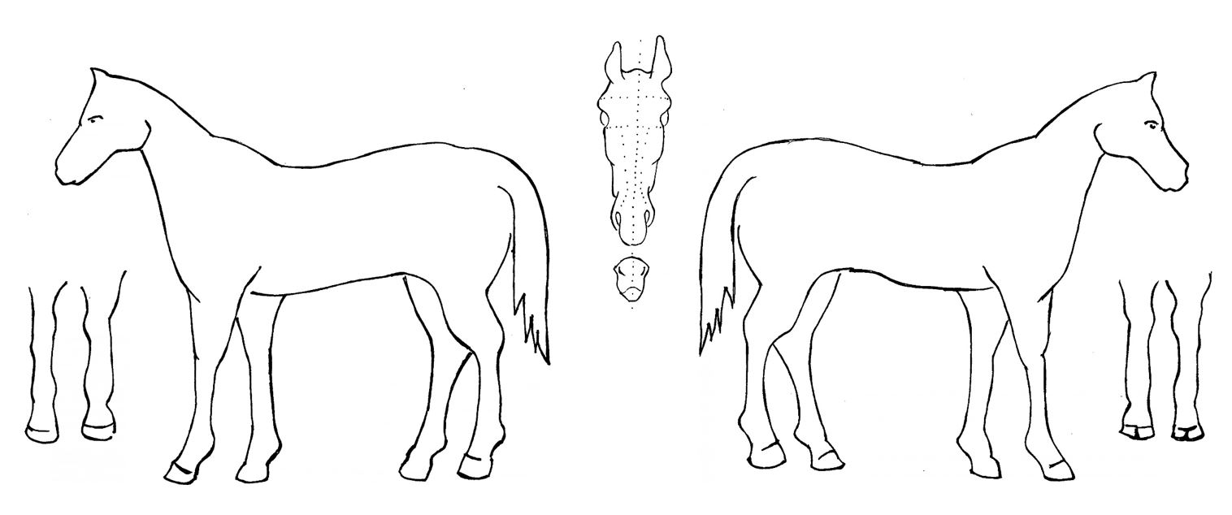

Health history
Table 2 – health history of a horse
Property | Detail
Weight/Body condition score (1–5) on arrival
Regular veterinarian contact details (include address and phone number)
Vaccination/Treatment status (include date administered)
Tetanus
Strangles
Hendra
Drenching (include brand used)
Allergies (describe any preventative measures/medications)
Last dental check by veterinarian or equine dentist
Last farrier date
Is the horse shod or trimmed?
Has the horse had major recent injuries? (provide details, including rehabilitation)
Any results/findings from recent veterinary checks which may affect management and/or exercise regime
Vices (for example, cribbing, weaving, windsucking)

Horse history
Table 3 – horse history
Observed activity | Circle response | Comments
Stabling
Has the horse been mostly paddocked, stabled or yarded? | Paddocked  Stabled  Yarded
Does the horse prefer to be paddocked with other horses or in an individual paddock? | With others  Individually
Is there any reason the horse cannot be kept in either a paddock or a stable? | Yes  No
Husbandry
Is the horse well-behaved for the farrier to trim/shoe it? | Yes  No | If no, please provide comment
Is the horse easily manageable when administering oral medications/drenches? | Yes  No
Is the horse easily manageable when administering injections? | Yes  No
Education
Is the horse of a suitable level of education for its proposed handler’s ability? This includes both ridden and on the ground in a range of situations | Yes  No

Behaviour and handling
The assessment must be completed for horses intended for use in school and must be repeated if the horse has been off the school site for 7 days or more.

Student owned horses
After a satisfactory assessment by the student or owner, the student must be observed using the school facilities to complete the activities below by a teacher with relevant qualifications or a freelance professional coach.

Horses assessed for purchase or lease
A teacher with relevant qualifications or a freelance professional coach should complete the assessment themselves using the school’s facilities.

Behaviour and handling assessment
Table 4 – assessment for behaviour and handling of a horse
Observed activity | Circle response | Comments  (Completed by student, owner or vendor prior to delivery) | Circle response | Comments  (Completed by teacher with relevant qualifications or coach using school facilities)
Load and unload the horse
Does the horse load and unload easily and travel well on a float or truck? | Yes  No |  | Yes  No
Specify preferred method (straight load, angle or truck). | Straight  Angle  Truck |  | Straight  Angle  Truck
Catch the horse
Can the horse be caught quickly and easily in a paddock, yard and stable? | Yes  No |  | Yes  No
Lead the horse
Does the horse lead calmly, safely and obediently? | Yes  No |  | Yes  No
Tie up horse on cross ties and rail
Can the horse be tied up for a 10-minute period or more without pulling back, becoming stressed, moving around excessively, putting the owner or other horses in danger? | Yes  No |  | Yes  No
Grooming
Will the horse stand tied up to be groomed all over, including head, legs, belly and ears? | Yes  No |  | Yes  No
Does the horse easily and safely pick up and hold up each of its 4 feet to be cleaned out? | Yes  No |  | Yes  No
Is the horse used to being rugged? Can rugs be put on safely? | Yes  No |  | Yes  No
Can the horse be hosed and washed in all areas of its body? | Yes  No |  | Yes  No
Husbandry
Can the horse’s temperature be taken safely? | Yes  No |  | Yes  No
Education
Can the horse be lunged in a large area? | Yes  No |  | Yes  No
Can the horse be lunged in a round yard? | Yes  No |  | Yes  No
Is the horse of a suitable level of education for its proposed handler’s ability? This includes both ridden and on the ground in a range of situations | Yes  No |  | Yes  No
Behaviour
Does the horse show signs of aggression towards the handler? | Yes  No |  | Yes  No
Does the horse show signs of aggression towards another horse? | Yes  No |  | Yes  No
Does the horse display unusual behaviours or have behaviour that make it difficult to manage? For example, kicking, biting, pulling back, weaving, anxiety, pawing, separation anxiety | Yes  No |  | Yes  No
Saddling and riding
Does the horse accept the required equipment and saddlery needed to be ridden? For example, boots, saddle, bridle | Yes  No |  | Yes  No
What is the quality of basic flatwork in an enclosed arena as an individual? | High  Satisfactory  Low |  | High  Satisfactory  Low
What is the quality of basic flat work in an open space as an individual? | High  Satisfactory  Low |  | High  Satisfactory  Low
What is the quality of basic flatwork in an enclosed arena with over 3 horses? | High  Satisfactory  Low |  | High  Satisfactory  Low
What is the quality of basic flat work in an open space with over 3 horses? | High  Satisfactory  Low |  | High  Satisfactory  Low
What is the quality of trail riding or farm riding individually? | High  Satisfactory  Low |  | High  Satisfactory  Low
What is the quality of trail riding or farm riding over 3 horses? | High  Satisfactory  Low |  | High  Satisfactory  Low
What is the quality of one-rein emergency stop in an enclosed arena? | High  Satisfactory  Low |  | High  Satisfactory  Low
What is the quality of one-rein emergency stop in an open space? | High  Satisfactory  Low |  | High  Satisfactory  Low
Loud noises (including vehicles, doors and gates slamming)
Does the horse react dangerously while ridden in an enclosed space? | Yes  No |  | Yes  No
Does the horse react dangerously while ridden in an open space? | Yes  No |  | Yes  No
Inclement weather (including rain, wind and thunder)
Does the horse react dangerously while in stables/yards? | Yes  No |  | Yes  No
Does the horse react dangerously while being ridden? | Yes  No |  | Yes  No

Rider assessment
This section must be completed by a staff member with relevant coaching accreditation or a freelance professional coach with relevant qualifications to determine the skill level of the students to complete the intended equine activity.
Principals have duties under the Work Health and Safety (WHS) Act 2011 (NSW) to ensure the health and wellbeing of workers and those affected by the work activities (such as students and visitors). Where a rider or handler is ‘new or inexperienced’ (that is, if they have no or minimal knowledge or skill gained from interacting with horses or, in some circumstances, where there has been a significant change in duties) they should comply with the SafeWork NSW approved Code of Practice: Managing Risks when New or Inexperienced Riders or Handlers Interact with Horses in the Workplace [PDF 341 KB].
Table 5 – assessing a rider’s skill level
Intended disciplines and activities intended for the horse | Suitability of horse for this activity | Rider level required for this activity on this horse
Dressage
Jumping
Campdrafting
Recreational riding
Riding school horse for school use
Other

Declarations

Owner or vendor
I have completed the assessment of the horse described above truthfully and to the best of my knowledge.
Signature:
Print name:
Date:

School assessor
I have completed the assessment of the horse described above truthfully and to the best of my knowledge.
Qualifications:
Signature:
Print name:
Date:

Principal
I am satisfied that the horse suitability has been assessed appropriately and approve the use of the horse at school.
Signature:
Print name:
Date:

References
Equestrian Australia (2023) Equestrian Australia [website], accessed 1 February 2023.
State of New South Wales (Department of Education), Catholic Schools NSW and the Association of Independent Schools of NSW (n.d.) ‘Animals in Schools’, Teaching and learning, NSW Department of Education website, accessed 1 February 2023.
State of New South Wales (NSW Agriculture) (1996) ‘NSW Animal Welfare Code of Practice No 3 – Horses in riding centres and boarding stables’, Dogs, cats, horses and other pets, NSW Department of Primary Industries website, accessed 1 February 2023.
State of New South Wales (SafeWork NSW) (n.d.) Working Safely with Horses [142 KB], SafeWork NSW, accessed 1 February 2023.
State of New South Wales (SafeWork NSW) (2017) Code of Practice: Managing Risks when New or Inexperienced Riders or Handlers Interact with Horses in the Workplace [PDF 341 KB], SafeWork NSW, accessed 1 February 2023.

© State of New South Wales (Department of Education), 2023
The copyright material published in this resource is subject to the Copyright Act 1968 (Cth) and is owned by the NSW Department of Education or, where indicated, by a party other than the NSW Department of Education (third-party material).
Copyright material available in this resource and owned by the NSW Department of Education is licensed under a Creative Commons Attribution 4.0 International (CC BY 4.0) license.
This license allows you to share and adapt the material for any purpose, even commercially.
Attribution should be given to © State of New South Wales (Department of Education), 2023.
Material in this resource not available under a Creative Commons license:
- the NSW Department of Education logo, other logos and trademark-protected material
- material owned by a third party that has been reproduced with permission. You will need to obtain permission from the third party to reuse its material.
Links to third-party material and websites
Please note that the provided (reading/viewing material/list/links/texts) are a suggestion only and implies no endorsement, by the New South Wales Department of Education, of any author, publisher, or book title. School principals and teachers are best placed to assess the suitability of resources that would complement the curriculum and reflect the needs and interests of their students.
If you use the links provided in this document to access a third-party's website, you acknowledge that the terms of use, including licence terms set out on the third-party's website apply to the use which may be made of the materials on that third-party website or where permitted by the Copyright Act 1968 (Cth). The department accepts no responsibility for content on third-party websites.

