Strong and successful start to school

Transition assessment and planning tool
Schools are responsible for planning, implementing and monitoring impact within the school community to support successful children’s outcomes, and strive to meet the first goal in the Department of Education Strategic Plan 2018-2022 “All children make a strong start in life and learning and make a successful transition to school”. The Transition assessment and planning tool is designed to support schools in implementing effective transition practices. Plans should be sustainable and achievable within the resources available to the school.
The Strong and successful start to school: Transition assessment and planning tool supports schools in meeting improvement measures aligned with the School Excellence in Action resource and the School Excellence Policy. It supports planning for effective transition practices, through the School Excellence cycle of continuous improvement.

Using the transition assessment and planning tool
Planning for school improvement is a continuous process which does not begin or end with any one Strategic Improvement Plan (SIP). The development of your school’s four-year SIP is supported by the situational analysis, a rigorous self-assessment process informed by external validation and the School Excellence Framework Self-assessment Survey (SEF S-aS). Each year, your school will reflect on the progress and impact of your plan through the lens of the SEF S-aS.
This transition assessment and planning tool will focus on the self-assessment practices and evaluative thinking embedded within all components of the School Excellence cycle.
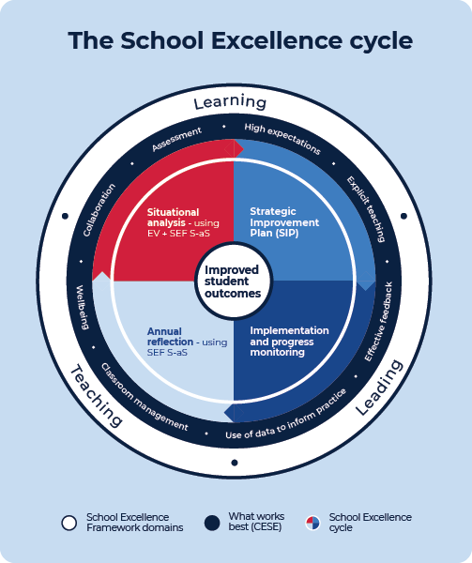
Source: education.nsw.gov.au/teaching-and-learning/school-excellence-and-accountability/2021-school-excellence-in-action/school-improvement-and-excellence/the-school-excellence-cycle

Situational analysis
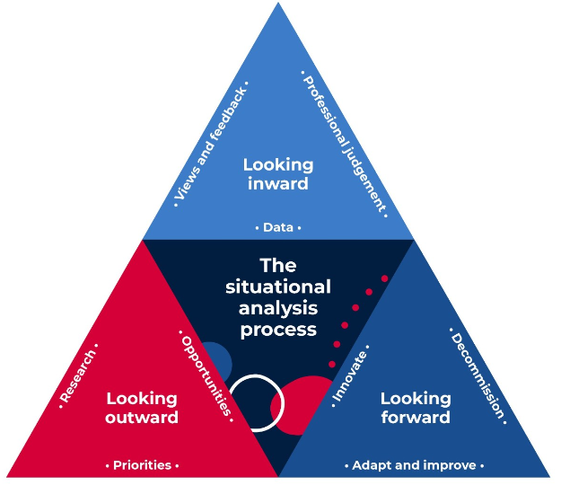
Source: education.nsw.gov.au/teaching-and-learning/school-excellence-and-accountability/2021-school-excellence-in-action/situational-analysis
The situational analysis is a key component of the School Excellence cycle and is an essential step in the development of your school’s four-year Strategic Improvement Plan (SIP) that will effectively prioritise your school's identified areas for growth.
Through the situational analysis process you will develop a rich and highly contextualised understanding of your school’s current situation and undertake a thorough self-assessment of your school’s performance. This assessment and planning tool can help inform your school’s transition planning through reflective questioning, assessment and forward planning to achieve a strong and successful start to school for all children, as part of your whole school improvement planning.

- Assess current practice: looking inward, where are we now?
Use the reflective comments in this document to review existing transition practices. The reflections can be shared and collaborated on with families, early childhood services and community services to determine what is already working well and identify priorities for action. For example, you might reflect on the following existing transition practices:
- What type of relationship do we have with local early childhood services?
- How do our current families and community participate in the school?
- What is our staff’s understanding of the links between the early childhood and school curriculum to support continuity?
- How do our current practices align with the Strong and successful start to school transition guidelines?
- How have our improvement measures within the previous plan related to transition been reached?
- Have we considered the elements and themes from the SEF S-aS in striving to excel in transition practices?

2. Collaborative planning to establish strategies based on data: looking outward, where do we want to be?
Community level data offers schools an idea of the strengths and needs of children in the area. Evidence from data can inform discussions with all stakeholders and help to identify opportunities and barriers to effective transition. For example, you might consider the following data:
- Transition to school statement – captures what children know, can do and understand as they transition from prior to school education to school
- Best Start Kindergarten Assessment (BSKA) - identifies children’s literacy and numeracy skills on entry to Kindergarten
- Whole school data such as attendance, behaviour management, literacy and numeracy and identified areas for improvement
- Australian Early Development Census (AEDC) - provides community and school level data on how children are developing and their needs
- Community mapping to consolidate knowledge of school context and diversity
- Surveys from families and early childhood services
- Attendance and enrolment patterns

3. Improving transitions and continuity of learning: looking forward, how good can we be?
Once the school transition team have looked inward and outward, and school leaders have identified transition to school as a focus for school improvement, schools might consider:
- What existing transition strategies should we adapt, improve or scale up?
- Are there innovative transition practices that we should adopt?
- Should we decommission any transition practices that are not aligned with the Strong and successful start to school transition guidelines or have not been sufficiently effective as evidenced by our improvement measures?
- How will families be involved in transition practices? How are children’s voices valued and how do they inform planning?
- How can we create a dedicated transition team within the school, that is inclusive of the school’s wellbeing and support staff?
- What facility upgrades are required to support transition delivery and orientation programs?
- Are our new transition practices based on current national and international research?
- What strategic direction in our SIP will we link improved transitions to?
By looking inward, outward and forward through the process of the situational analysis, schools may determine that improvement in transitions and continuity of learning should be included in one of the school’s strategic directions.

The Strategic Improvement Plan
The SIP is a working document that details the steps your school will take to improve learning outcomes, and the achievement and growth of all students. To ensure continuous improvement, the SIP reflects where your school is at and how it will further improve learning, teaching and leading.
Effective strategies and improvement measures for transition are documented in the SIP. Details of the plan are documented in Implementation and progress monitoring.
The school’s plan for transition could also be published on the school’s website and social media platform to inform families and community partners.
Ensuring sustainability in transition planning is crucial to impact and ongoing success. Actions need to be embedded into school planning to ensure accountability for delivering strategies. Success should be shared among the school community, Community of Schools, principal networks, transition networks and collaboration where schools draw enrolments from similar catchments. For example, you might reflect on the following:
- Are our transition practices supporting a strong and successful start to school and what evidence do we have to support this on-balance judgement?
- Have we considered ongoing family and child feedback from a variety of sources and can we identify practices that need changing?
- Are we ready to consult with our community regarding these findings - to develop our vision and context statements and to collaborate, leading to strong links between community groups and leaders? How is this evidenced?

Annual reflection
Each year, your school will conduct an annual review of progress and impact through the lens of the SEF S-aS while engaging and consulting with your community. This evaluation of progress and impact will be included in your school’s annual report and may include an evaluation of improvements to transition practices.

The School Excellence Framework identifies quality practice to help schools plan and monitor strategies for ongoing improvement. Transitions and continuity of learning is a theme of the Learning Culture element in the Learning domain.
SEF theme: Transitions and continuity of learning descriptors
DELIVERING | SUSTAINING AND GROWING | EXCELLING
The school actively plans for student transitions (e.g. into Kindergarten; Y6 to Y7; Y10 to Y11). The school clearly communicates its transition activities to the school community. | The school collects and analyses information to inform and support students’ successful transitions.  The school seeks to collaborate with parents of students whose continuity of learning is at risk. | The school engages in strong collaborations between parents, students and the community that inform and support continuity of learning for all students at transition points, including highly mobile students and students with atypical enrolment.
Evidence suggests that schools that excel at transition are collaborative in their practices and actively engage with their community. This tool provides a space for schools to reflect on their current transition practices and create sustained plans for improvement to ensure children experience a strong start to school.

Ready schools: welcoming and inclusive practices
Collaborative transition practices reflecting meaningful community engagement | Actions:  Where are we now?  What are the opportunities for improvement and innovation?
Schools prioritise time to meet and engage with families, early childhood services, early intervention, key professionals and key community members. Strategies are in place to identify and respond to disability and additional needs, high potential and gifted educational needs and equity groups including refugee students, new arrivals and integration support.

Ready schools: continuity of learning
Collaborative and engagement transition practices | Actions  Where are we now?  What are the opportunities for improvement and innovation?
School staff have a deep understanding of the connection between pedagogies and are able to apply a strong continuity of learning which include investigations, real life experiences delivered and assessed using multiple pedagogies.

Ready schools: Procedures
Collaborative and engagement transition practices | Actions  Where are we now?  What are the opportunities for improvement and innovation?
School approaches transition as an integrated process throughout the year, following a strategically thought out plan where all stakeholders are included.

Ready communities: Data
Collaborative and engagement transition practices | Actions  Where are we now?  What are the opportunities for improvement and innovation?
AECD and other data is used to inform discussions with partners and to inform transition practices.
Transition practices incorporate information provided in transition statements.

Ready communities: Teamwork
Collaborative and engagement transition practices | Actions  Where are we now?  What are the opportunities for improvement and innovation?
The transition team actively utilise information about children and families, early childhood settings, the community, students’ voices and SRC/school leaders to enhance transition practices.
Community groups/leaders actively participate in planning transition practices.
School involves relevant agencies in discussion and planning for children.
Advice is sought from relevant agencies about strength-based strategies to transition specific groups of children.

Ready families: Data
Collaborative and engagement transition practices | Actions  Where are we now?  What are the opportunities for improvement and innovation?
School prioritises time to meet with parents to discuss their child.
Information is shared widely via various mediums, including the wider community and in the home language/s of the community.
Evidence of family input is included in planning and implementing transition practices.
Feedback from families actively informs and shapes transition practices.

Ready Children: Prior learning - known, valued and cared for
Collaborative and engagement transition practices | Actions  Where are we now  What are the opportunities for improvement and innovation?
Transition practices are responsive to individual children and planned for collaboratively with all stakeholders including the child.
Transition practices acknowledge the need to promote social and emotional wellbeing through responsive planning.
Children play an active role in expressing their likes, motivations and expectations.

