Participant tech tips

Before the day
- Check you have the session by session guide as it has all the links for sessions on the day.
- Check for Zoom updates

Checking for new versions/Updating Zoom
Step | What it looks like
- In the search bar on the left-hand side of the menu ribbon at the bottom of your laptop, type in Zoom. Click on the Zoom App option as shown. | 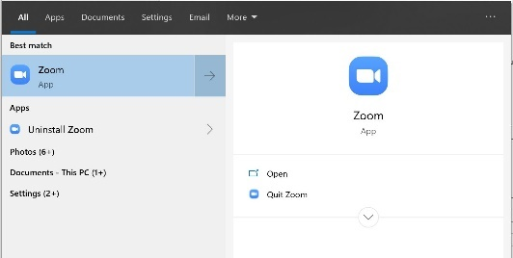
- This will open the Zoom application. Click on the red button in the top right-hand corner of the window and select ‘Check for updates in the menu. | 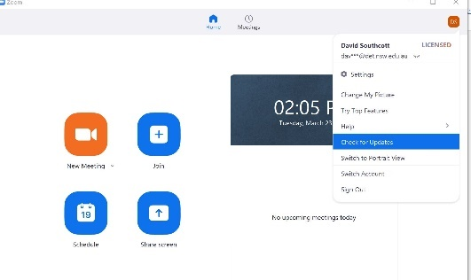
- Wait while the app checks for updates. If any are found, an ‘Update’ button will appear.
Click update and wait while the changes are configured.

If you are prompted to sign in
Step | What it looks like
- When you join a Zoom webinar, you may be prompted for a registration password (this will be sent to you with the webinar invite). ITD Live meetings always use ‘zoom’ (all lowercase). In some instances, you may be prompted to sign in. If so, it is important follow these steps | 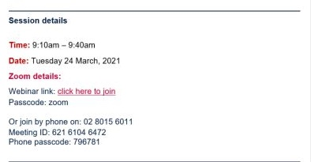
- Sign in | 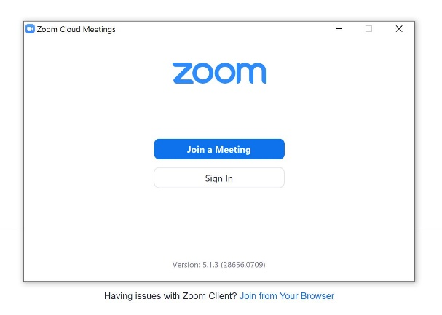
- NSW Department of Education staff sign in with SSO  - Select “Sign in with SSO” | 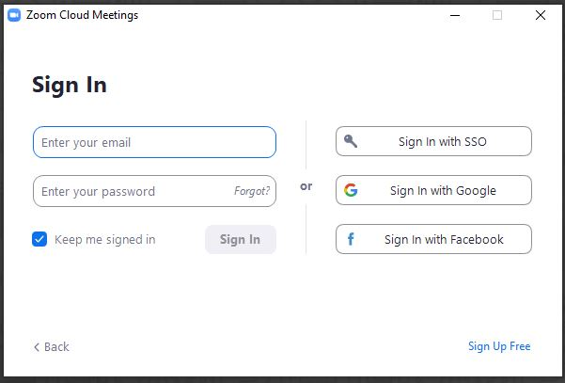
- In the window shown, first click “I know the company domain” which will be underlined beneath the Company Domain window).  - The in the ‘Company domain’ field, type: nsweducation (one word)  - Then hit ‘continue’ | 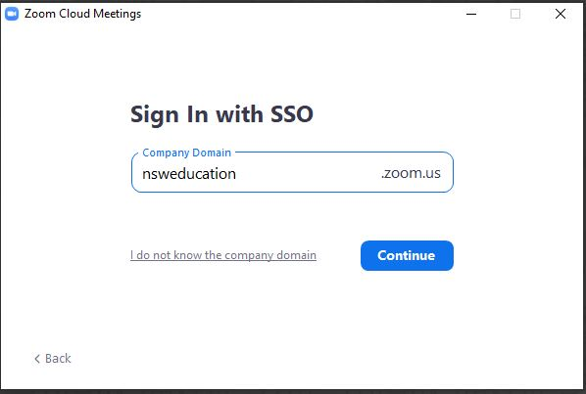  3  2  1

On the day – logging in
- Open the conference “Session by Session” document that contains links to each section
  - Session by session details can also be found on the Early Learning 2021 Inclusion forum webpage
- Using Google Chrome 2010+
Chrome is the recommended browser for the best user experience. Avoid additional internet browsers/windows being open concurrently.
- Use a laptop, notebook or desktop computer
  - Clear cookies and cache: Find out how here
  - Turn off and close out any unused applications
  - Log in early. We recommend logging in at least 15 minutes before the scheduled start time, to become familiar with the portal.
  - Sound on. Make sure your computer's sound is on. For the best audio experience, use external speakers with adjustable volume control.
- Logging in to the Zoom Session

Device | Steps
Computer | - Ensure Zoom app is installed and you are logged into your Zoom account  - Click on the provided link
Tablet | - Ensure Zoom app is installed and you are logged into your Zoom account  - Click on the provided link  - Enter password provided
Phone | - Ring 02 8015 6011  - Enter the Webinar/meeting ID and #  - Enter participant ID and #  - Enter passcode, if prompted, followed by #

Still having technical difficulties?
- REFRESH
- Call the Early Learning team on 1300 083 698

During the meeting

Attendee option view

Transcripts
You will be given the opportunity to turn on live captioning.
If you would like to use this feature
- click ‘Live Transcript’ and then select Show Subtitle.
Note: The provided subtitles can be clicked and dragged to move their position in the meeting window.
To adjust the caption size:
- Click ‘settings’
- Move the slider to adjust the caption size.
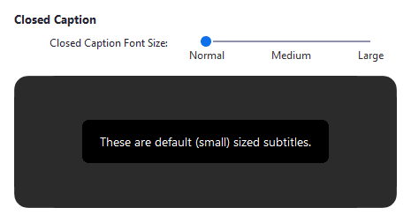

Audio and video
You should enter the session with your video off and on mute. The session host may invite you to enable. If so click to join audio
Unmute/ Mute

Chat
Important links will be placed in the chat for you to access.

Polls and quizzes
During the session the host may launch a poll for you to interact with.
- Click on your response and then ‘submit’.
- If you cannot see the ‘submit’ button, attempt to scroll down to ensure all questions have been answered.

Q&A
Available only in sessions 1, 3 and 5
You can ask questions to the host and panellists. They can either reply back to you via text in the Q&A window or answer your question live
- Open the Q&A window
- Type your question into the Q&A box. Select Send.
- If the host replies via the Q&A, you will see a reply in the Q&A window.
Note: Check Send Anonymously if you do not want your name attached to your question in the Q&A.

Leave meeting
- Click ‘End’ to leave the session at any time.
- If you leave, you can re-join if the session is still in progress

