2021 Inclusion forum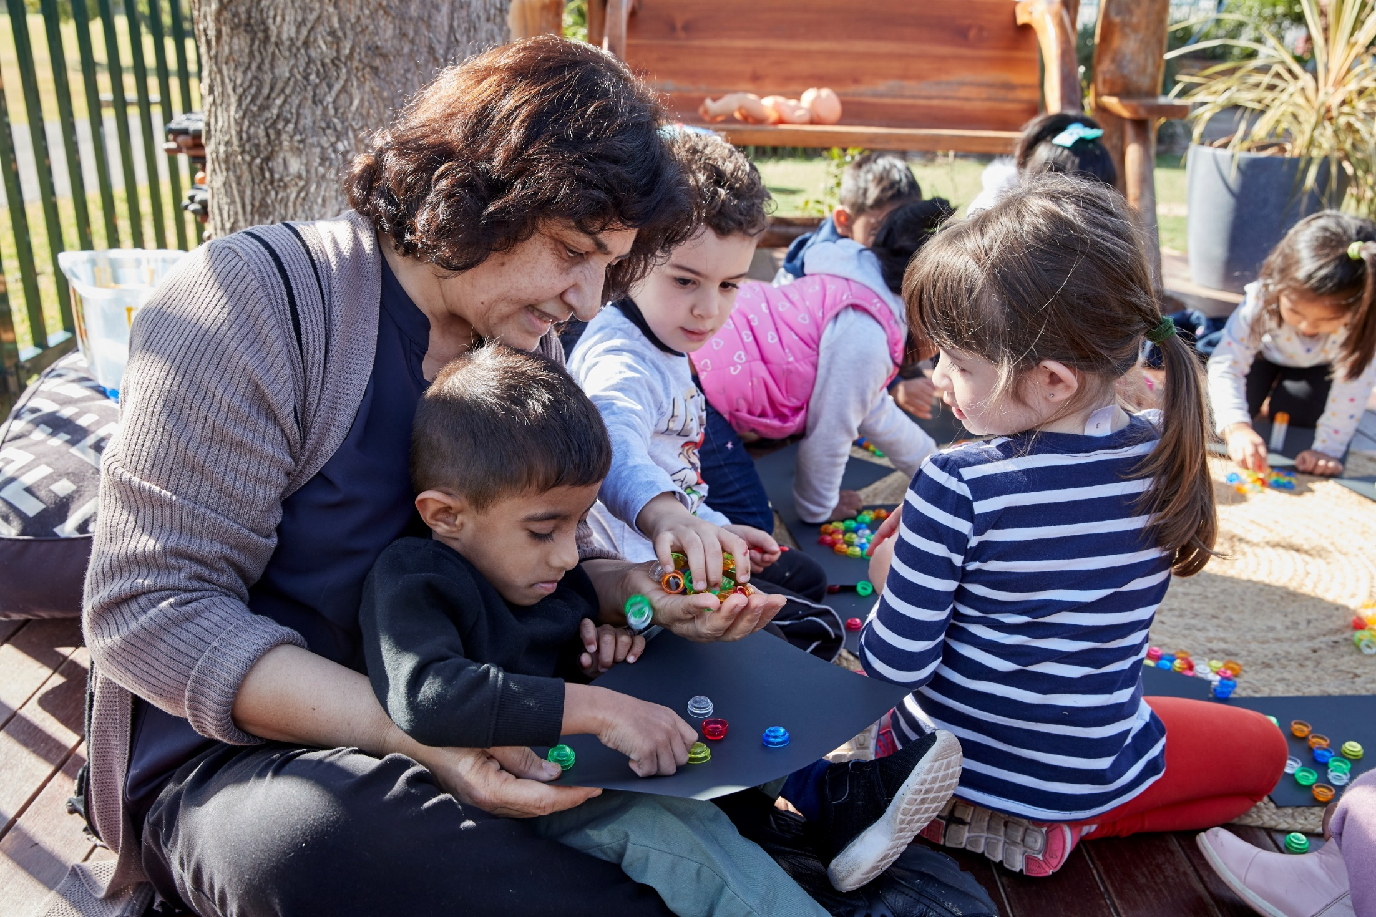

Wednesday 28 April 2021

8:30 am to 3:15 pm

2021 Inclusion Forum

Agenda
Time | Session
8:30-10:15 am | Session 1 – Welcome  Welcoming remarks and keynote addresses.
10:15-11:00 am | Break
11:00-11:45 am | Session 2 – Concurrent options  - Supported playgroup for children with disability and their families  - Capacity building to support inclusion  - OnLine Training Australia: professional learning courses  - Across a year in a department early intervention support class  - Parents and carers Inclusive Support Hub
11:45 am-12:00 pm | Break
12:00-12:40 pm | Session 3 – Amplifying practice  In this session, 6 early learning leaders will be sharing inclusive practices from their settings.
12:40-1:30 pm | Lunch
1:30-2:15 pm | Session 4 – Concurrent options  - Best Start kindergarten assessment–support for children with a disability  - Inclusion, belonging and the disability revolution  - Stories to change our future  - ‘Turning 6’ a 360-degree perspective  - External providers and their engagement with schools
2:15-2:30 pm | Break
2:30-3:15 pm | Session 5 – Panel discussion  Question and answer style panel discussion using questions submitted through registration and throughout the day.

Session 1 – Welcome

8:30-10:15am

Session information
Welcome
Jacqui Ward
Early Learning Coordinator
Acknowledgement of Country and performance
Robert Townson
High School, Hearing Impairment Unit
Opening address
Kay Coombs
A/Executive Director, Educational Standards
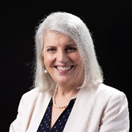
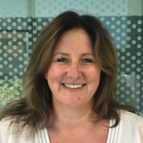
Keynote address
An Inclusive transition to school
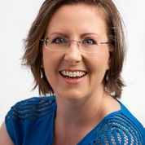
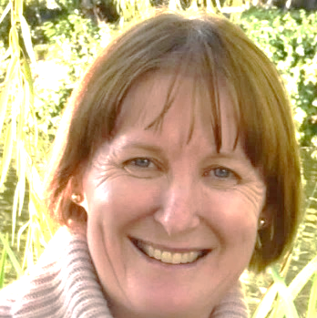
Sarah Hanson
Director, Disability Strategy
Louise Farrell
Director, Inclusive Education
The department is committed to creating a more inclusive education system for all students. Sarah Hanson, Director Disability Strategy and Louise Farrell, Director Inclusive Education, will provide an overview of the work being done to improve the experience of students and families as they transition to school. Sarah and Louise will unpack the Inclusive Education Statement for students with disability and provide an update on reforms and initiatives that help bring the inclusion statement to life so that all students are able to reach their potential in the NSW school system.

Keynote address
Inclusive Education in Early Childhood – what does that really mean?
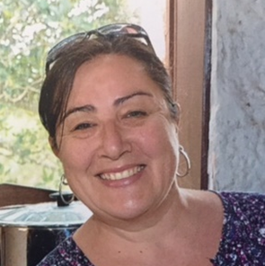
Dr Jane Warren
Lecturer Early Years, University of Wollongong
‘The NSW Department of Education is committed to building a more inclusive education system. An education system where every student is known, valued and cared for and all students are learning to their fullest capability’ – NSW Department of Education, Inclusive Education statement for students with disability.
Irrespective of individual circumstances, all children have the right to an education and a number of principles guide quality inclusive practice. Enrolment does not equal inclusion. This presentation will outline what inclusive education encompasses, and how you can ensure you are building a culture of inclusion in your educational environment. The foundations of inclusion need to start in early childhood settings, where play is a great leveller and provides a foundation for valuing and embracing diversity.

Zoom information
- Session 1
- Meeting ID: 656 7584 1574
- Passcode: 748606

Session 2 – Option 1

11:00-11:45am

Option 1 – Supported playgroup for children with disability and their families

Session information
The sense of isolation experienced by many families of children with disabilities is significant and the importance of support during these early years is crucial.
This session will highlight the role of supported playgroups, and centre on a supported playgroup for children with disabilities in a regional area in Australia. The playgroup focuses on participation, engagement and relationships. This includes providing families with opportunities for social networking, and information about relevant organisations and events. Families can be referred to other agencies if required to assist in maximising engagement and participation in the community.
In addition, the group provides opportunities for children with a range of disabilities to engage in relevant, meaningful and appropriate social situations, where play-based experiences offer developmentally appropriate and engaging learning opportunities. We will explore the key objectives of the playgroup within a socially inclusive model.

Zoom information
- Session 2 Option 1
- Meeting ID: 626 6635 4816
- Passcode: 313767

Speaker
Dr Jane Warren
Lecturer Early Years, University of Wollongong

Session 2 – Option 2

11:00-11:45am

Option 2 – Capacity building to support inclusion

Session information
This session will look at the collaborative practices between early childhood environments and starting school, looking at the importance of relationships, continuity, family input and unpacking the school system.

Zoom information
- Session 2 Option 2
- Meeting ID: 698 9027 8671
- Passcode: 400147

Speaker
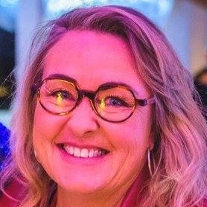
Donna Deehan
Transition Advisor, Early Learning

Session 2 – Option 3

11:00-11:45am

Option 3 – OnLine Training Australia courses

Session information
Online Training Australia offers a suite of professional learning courses, covering specific areas of disability as well as personalised learning and mental health and wellbeing. The courses support teachers and other educational personnel to understand and respond to diverse learning needs. Some courses are freely accessible for teachers and parents on the OLT website and most jurisdictions in NSW hold a licence to access other courses.
In this session, the structure of the courses will be explained and some samples of course content will be shared. The delivery format implemented by NSW Department of Education will also be outlined.

Zoom information
- Session 2 Option 3
- Meeting ID: 646 5893 5917
- Passcode: 552455

Additional links
- Courses for NSW Department of Education – Disability, learning and support

Speaker
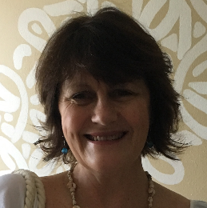
Jenny Harrison
Adjusted Learning Advisor, Inclusive Education

Session 2 – Option 4

11:00-11:45am

Option 4 – Across a year in a department early intervention support class

Session information
Early intervention is specialised support provided for young children who have a disability or learning support need and their families. It promotes each child’s development and meaningful participation in all aspects of their life. The role of an early intervention teacher is both diverse and unique.
Tash will use her lived experience as an early intervention teacher to share an overview of a year in the early intervention space. She will discuss delivery of play-based learning experiences, working in partnership with families and the importance of a collaborative team approach with early childhood services and allied health.

Zoom information
- Session 2 Option 4
- Meeting ID: 622 7823 2590
- Passcode: 813369

Speaker
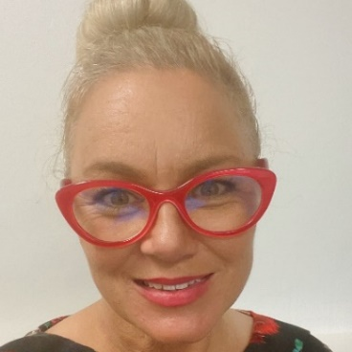
Tash Churchill
R/Transition Advisor, Early Learning

Session 2 – Option 5

11:00-11:45am

Option 4 – Parents and carers inclusive support hub

Session information
Delivering useful information for families through human centred design. A session to demonstrate the Parents and Carers Inclusive Support hub and reflect on the Human Centred Design approach over the last 12 months working as product developers in the Disability Systems team at the Department of Education. From building simple, innovative solutions through to mentoring new innovators in collaboration with schools, school supports and other stakeholders in the department.

Zoom information
- Session 2 Option 5
- Meeting ID: 622 7823 2590
- Passcode: 813369

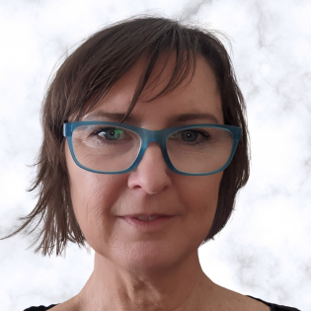
Speakers
Liz Slakey
Program Manager, Disability Systems
Ross Dixon
Product Innovation Lead

Session 3 – Amplifying practice

12:00-12:40pm

Session information and speakers:

1. Setting IEP/ILP goals with Pictability
Bankstown South Infants School – Principal Kimberlee Collas and Early Intervention teacher Judy Chan will share how they have used the Pictability tool to train and support parents with setting IEP/ILP goals and develop positive partnerships with families.

2. Coloured hats, an ongoing journey of inclusion
Punchbowl Public School – Midori Jobling, Deputy Principal Instructional Leader Preschool, shares their journey of inclusion, focusing on improving inclusive practices to benefit all children, especially those with disability.

3. Responsive quality inclusive education
KU Macquarie Fields – Director Cathie Hayes will share how KU Macquarie Fields provides inclusive mainstream preschool to 80 families each week. The service provides a program that is responsive to the needs of the community, giving ‘wrap around supports’ to ensure quality inclusive education for all children.

4. Inclusion for all at Waratah
Waratah Public School – Preschool teacher and AP, Bec Dodds, preschool teacher Suzi Ward and Principal Matt Freeman discuss the process of inclusion for children with additional needs at Waratah PPS and the role that Transition to School Statements play in ensuring smooth transitions for all children. A case study of one child with a physical disability, will detail the transition process at our school.

5. Communication is the key
Mittagong Preschool – Pauline Iacono, Director/ECTA will share how they use email documentation as a means of communication with all stakeholders including invited feedback and program input, doubling as reflection of strategies used towards ILP goals.

6. Connecting to preschools
Cessnock West Public School – Camilla Robertson, Early Stage 1 teacher will share how they establish connections with local preschools to support a positive transition and strong start to school.

Zoom information
- Session 3
- Meeting ID: 687 5922 0803
- Passcode: 838207

Session 4 – Option 1

1:30-2:15pm

Option 1 – Best Start kindergarten assessment – support for children with a disability

Session information
This session will provide an overview of the Best Start Kindergarten Assessment (BSKA) and the guidelines in place to support inclusion of children with a disability, demystifying the BSKA experience for parents. The BSKA supplementary guide provides clear, explicit options to ensure equitable access to the assessment for all children.

Zoom link
- Session 4 Option 1
- Meeting ID: 689 2466 9205
- Passcode: 720098

Speaker information
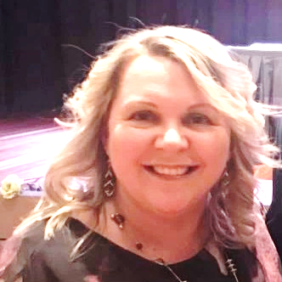
Merryn Watling
R/Professional Learning Coordinator

Session 4 – Option 2

1:30-2:15pm

Option 2 – Inclusion, belonging and the disability revolution

Session information
In this session Donna will showcase Jennie Fenton, a parent, a carer, a disability advocate, an environmental scientist and Ambassador for the NSW government's program, Living Life My Way.
After hearing Jennie share her family’s journey from disability to possibility and all the dark and light places in between, participants will be encouraged to engage in discussions around changes happening in their context for people who live with disability and ways that individuals can do their part.

Zoom information
- Session 4 Option 2
- Meeting ID: 610 1059 8934
- Passcode: 281498

Speaker information
Donna Deehan
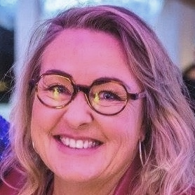
Transition Advisor, Early Learning

Session 4 – Option 3

1:30-2:15pm

Option 3 – Stories to change our future

Session information
In this session Anna will share stories from the families who she met as she travelled 70,000 kms across Australia to shape the first ever National Action Plan for children with developmental delay and/or disability and their families. Anna will share the learnings, vision and hope for a different future where all children and their families can meaningfully belong and what we can all do today to lead the change.

Zoom information
- Session 4 Option 3
- Meeting ID: 617 3234 6367
- Passcode: 576140

Speaker information
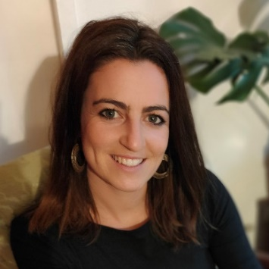
Anna McCracken
Social Strategist, Reimagine

Session 4 – Option 4

1:30-2:15pm

Option 4 – ‘Turning 6’ A 360-degree perspective

Session information
By law in NSW all children must be in compulsory schooling by their 6th birthday.
Join us to unpack the complexities faced by preschools, families and other stakeholders when a request is made for an ‘additional year’ of preschool. What are the issues and how can we support children and families? We will present KU’s experience and then ‘go live’ to a panel of professionals from the field to share their perspectives and insights.

Zoom information
- Session 4 Option 4
- Meeting ID: 624 5654 1824
- Passcode: 077176

Speaker information
Colette Eyers
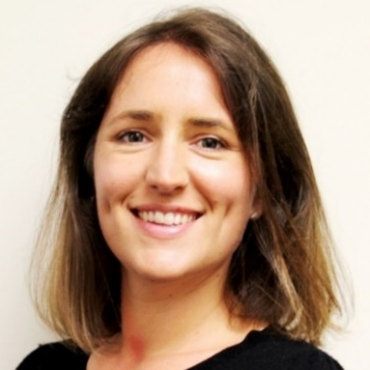
KU Children’s Services. Manager Equity, Education and Support

Session 4 – Option 5

1:30-2:15pm

Option 5 – External providers and their engagement with schools

Session information
The session will focus on the two manners in which schools collaborate with external providers:
- the first part of the session will focus on how schools work with NDIS providers
- the next part of the session will focus on how schools can engage external providers through the pre-qualified Specialist Allied Health and Behaviour Support Providers Scheme.
Participants will discuss the potential opportunities this presents.

Zoom information
- Session 4 Option 5
- Meeting ID: 650 6082 1652
- Passcode: 974744

Speaker information
Maja Patoor
Manager Disability and Diversity Policy
Tracey Winfer
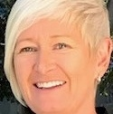
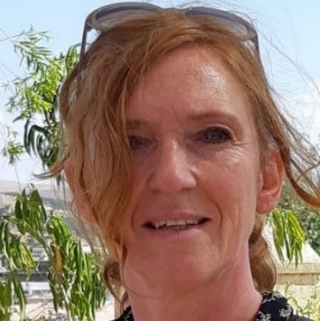
NDIS School planning and Implementation Coordinator

Session 5 – Panel discussion

2:30-3:15pm

Session 5 – Panel discussion

Session information
Question and Answer style using questions submitted during registration and throughout the day. Submit your question here.
Panel:
- Dr Jane Warren – University of Wollongong
- Sarah Hanson – Director, Disability Strategy
- Louise Farrell – Director, Inclusive Education
- Anna McCracken – Social Strategist, Reimagine Australia
Concluding comments:
- Jacqui Ward – Early Learning Coordinator

Zoom link
- Session 5
- Meeting ID: 655 4866 9660
- Passcode: 607432

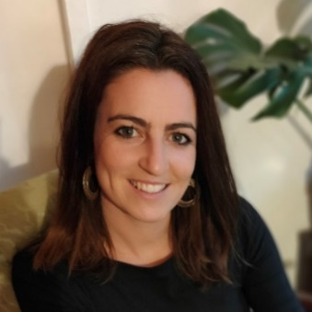
Speakers
Dr Jane Warren
University of Wollongong
Sarah Hanson
Director, Disability Strategy
Louise Farrell
Director, Inclusive Education
Anna McCracken
Social Strategist, Reimagine Australia
Jacqui Ward Early Learning Coordinator

