Our Children
Our Communities
Our Future

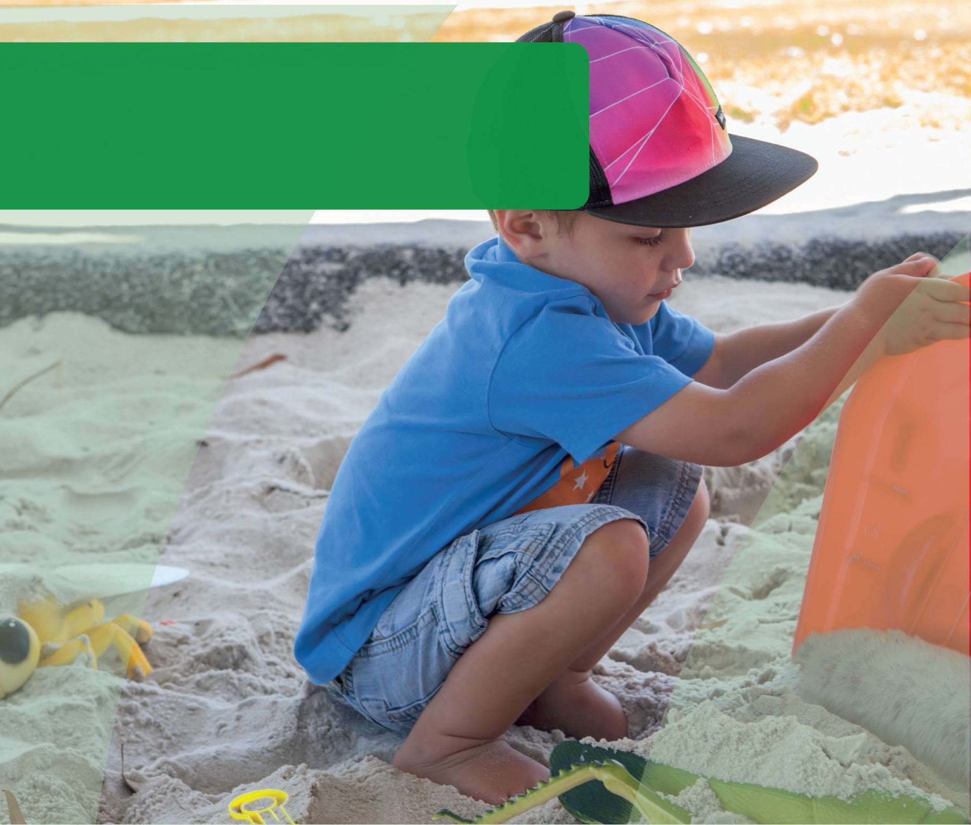
DOMAIN GUIDE:
Social Competence
This guide supports early childhood education and care services and schools to gain a deeper understanding of the AEDC social competence domain. The guide can be used to inform early childhood and curriculum planning, quality improvement and strengthen partnerships with families and the community.
© Western Australian Department of Education 2018

Importance of social competence in educational
settings
Reflecting on the way in which social competence enables children to engage in learning and social environments empowers educators and leaders to shape their approach to planning for children.
In reading the section below about the impact of social competence on educational settings: Consider the challenges children may face in your setting.
How can you promote further development in social competence?
How does your program support children who are not well developed in social competence?
Social competence refers to a set of abilities that enable children to independently navigate their social world, to interact with peers and adults, to form friendships, and to understand the needs of others. Intertwined with the development of these skills is children’s development of their sense of self – what type of person they think they are and how they see themselves fitting into the world of people.
Children learn social skills in the contexts of their early environments. For this reason social competence can look different for children from culturally diverse backgrounds. What is considered polite in one culture may not be in another.
Social competence not only supports children to interact with others, it also supports their learning. Educators know that to learn, children need to feel safe. Unfamiliar environments pose a challenge for young children, heightening their brains’ arousal and stress centres, especially so when they are disconnected from their primary caregiver(s). Children need to feel that they can navigate social environments, understand how they fit, and feel a sense of social connectedness or belonging. When children feel secure in a new environment their brains quickly return from a state of stress to one of exploration and curiosity. Educators who recognise cues that signal that children do not feel safe, connected and secure in their environments are better placed to address the social needs of children and facilitate their readiness to learn.
Emerging independence and a secure sense of self, supports children to adapt to a variety of environments. Educators recognise the independence that children have practiced and developed in one environment supports them to engage with new environments. Independence and self-confidence enable children to explore new environments and adapt quickly to new settings. This supports children in their transition from home to early learning and care, to kindergarten, and to school. Although younger children tend to require more support,
the amount of support children need during these transitions is dependent on their stage of development, irrespective of their age.

The AEDC for considering children’s social competence
The AEDC provides a picture of children’s social development across the community. It provides a snapshot of vulnerability which can trigger educators and communities to look at contributing or underlying factors that may be impacting on children’s development at the community level. This approach also helps educators to plan for transitions in a way that is responsive to the needs of children in the community.
Specifically, the AEDC social competence domain measures:
- Overall social competence (peer social skills)
- Responsibility and respect
- Approaches to learning
- Readiness to explore new things
Consider who makes up your community:
Your community may include
those who live in the area and the surrounding suburbs. In some cases this may differ from the families that actually attend your educational setting.
Reflect on how other data you collect (e.g. home background or attendance) can be used alongside the AEDC data to help understand your community and their needs.

© Western Australian Department of Education 2018
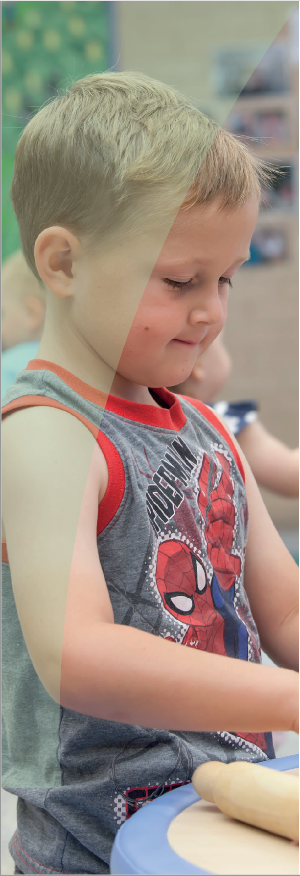
Thinking about how children develop in a domain can help educators and leaders identify what has contributed to the AEDC data in their community. Consider the domain description below and reflect on what is supporting the development of children’s social competence in your community.

About social competence
Learning about the social world is the most complex learning children undertake. In addition to learning
about social rules and expectations that can be taught
or explained, to successfully negotiate the social world, children must learn to interpret a suite of hidden and
subtle cues about people. Children learn to read the facial and behavioural cues of others, they learn that other people have thoughts that are different from their own,
and that others’ behaviours are guided by their internal thoughts and beliefs.
Children learn social competence by actively engaging in the social world, through play and interactions with adults and their peers. Successfully navigating this emerging independence requires consistent and supportive adults who set boundaries and limits while also understanding and celebrating children’s emerging autonomy.
The AEDC measures a series of capabilities that are indicators of children’s social competence. Although children can exhibit differing skills in varying contexts (e.g. able to follow routines at home with familiar adults), the factors measured in the AEDC signal that children have developed social competence and have been able to demonstrate these in the school environment. These should be considered markers of how well children have developed, what might be working well in communities, and where things might be getting in the way of children developing social competence.
Educators who consider factors impacting on children’s ability to engage with the learning environment are better able to tailor their planning. Ask yourself:
- Are children able to engage with other children in play?
- Do children have the opportunity to
contribute to the development of group rules
and expectations?
- Is there support for children who are not
coping with the demands of the learning and social environment?
© Western Australian Department of Education 2018

Supporting the development of social competence
Research has demonstrated the influence of several family and community level protective factors on the
development of social competence. Consider the protective factors that might exist in your community
and the role you play in promoting these through your partnerships with families and the community. When thinking of development in this domain, educators and education leaders should think about factors that contribute to respectful behaviours, confidence and self-control.

Family level factors
Children who face hardship can develop resilience when they are supported by warm responsive adults who promote their confidence, growing independence and respect their culture and differing backgrounds.
Activities that promote development, such as story reading and play provide children with a safe way to practice the skills they need in life. Research has demonstrated that irrespective of the child’s background or home environment, children who are read to regularly have better developed social skills, translating to a lower risk
of conduct problems and hyperactivity (Kalb & van Ours. 2013). Sharing stories and engaging in play allows children to learn about other people, teaches them to see things from another person’s perspective, and helps them learn about the world and their place in it.
Educators who engage families in their children’s learning share insights, listen, and learn from
parents, and plan together for children’s development. Ask yourself:
- What do I learn from parents that supports my work with children?
- How do I work in partnership with families who have a different cultural background from my own?
- How easy is it for parents to access good information on how they can provide rich early experiences and supportive environments for their children?

Community level factors
Research has demonstrated that attending high quality early childhood education and care services or
playgroup supports children’s social development. These experiences give children opportunities to develop
self-control, responsibility, ability to focus, respectful behaviour, readiness to explore and conscientiousness (Gregory et al. 2017). Positive early learning and care experiences enable children to interact regularly with their peers, developing their ability to negotiate in a cooperative way, learn social rules and how to communicate effectively at an early age (Vahedi 2012). Friendship among peers such as that established in preschool or playgroup, can also provide social and emotional support for young children at times of transition (Vahedi 2012).
In communities where there are high quality early education environments (e.g. early childhood education and care services, playgroups, library programs and Child and Parent Centres) and mechanisms that support families to connect with these services children’s development is supported. (Goldfeld et al., 2016; Patel, Corter, Pelletier, & Bertrand, 2016).
Communities that enable access to services for children who could benefit the most consider and respond to the barriers families may face in accessing these services.
Ask yourself:
- What opportunities do children in my community have to regularly engage in free play with other children?
- Why are children missing out on opportunities to play?
- How are parents supported in their parenting?
© Western Australian Department of Education 2018

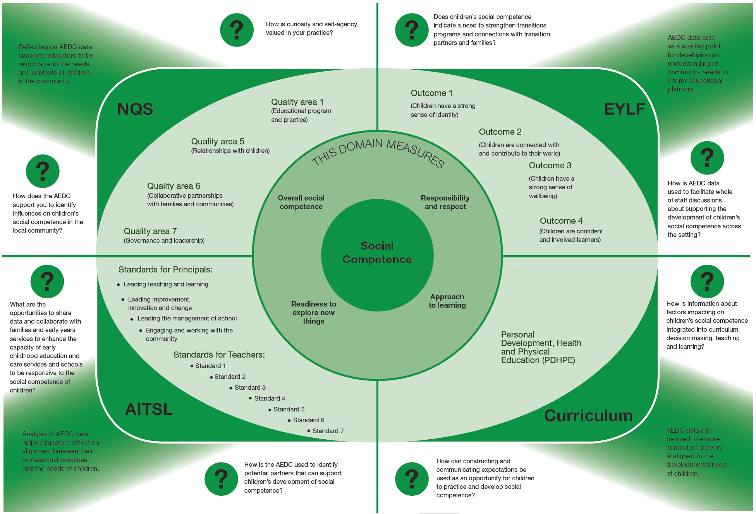

© Western Australian Department of Education 2018

Strategies to support children and families
Educators and leaders can support the development of children’s social skills in their settings, and they should also work in partnership with families and communities to support children. Consider how you can support children’s social development:

In the education environment
- Provide opportunities for free play, imaginary play, and role modelling
- Foster friendships through opportunities for building connections
- Set rules and expectations together
- Provide children with opportunities to discuss right and wrong and empower them to make choices
- Demonstrate respect for diverse cultures
- Read stories that explore social conflict and resolution including acceptance of children from different backgrounds and cultures
- Create caring and supportive environments that model respectful behaviours
- Model self-regulation behaviours
- Support children’s natural curiosity by being responsive, encouraging and support children to be independent and promote self-help skills
- Create activities that involve sharing, taking turns, or working together
- Teach children the words or skills to use when communicating with their peers
- Be aware of the signs of potential difficulties
- Provide opportunities for small and large group experiences
- Share your data with the whole of staff, school boards and parent leaders
- Partner with Aboriginal Education Officers where appropriate

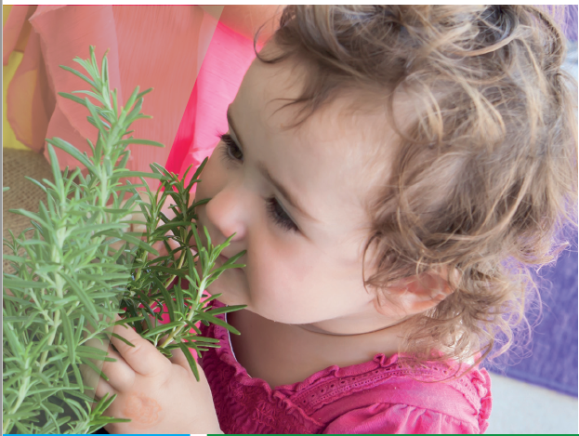
In partnership with families
- Ensure your approach is welcoming and respectful when engaging with families and is considerate of differing families’ experiences and backgrounds.
- Work in partnership to set shared goals for children
- Share knowledge about how children develop social competence
- Learn about local cultures and different approaches to children rearing
- Support families to share information about their children’s social development
- If you are worried about a child, make an appointment to speak with their family to talk about your concerns
- Encourage families to develop a deeper knowledge about children’s social development by attending parenting workshops
- Identify children and families who may be in need of additional support

In the community
- Share your data with the community
- Connect with services and supports to talk about what is happening for families
- Invite people into your setting to learn about what you do and to learn about what they do
- Set shared goals for children
- Advocate for policies and procedures at Early Learning and Care centres or schools that relate to social competence
- Build collaborative partnerships with services and professionals, and other community agencies to actively promote and support children’s social development and mental health
- Link families with support and information services for mental health and wellbeing
- Strengthen transition programs and continuity of learning, e.g. through a collaborative partnership between childcare and schools, and other early services
- Share and use the AEDC results as an evidence base to draw attention to children’s social development and mobilise community action

© Western Australian Department of Education 2018

Key partners in your community
Consider where you can develop partnerships in your community to support children’s social development.
- Playgroups
- Schools
- Early education and care
- Local Aboriginal organisations
- Child health centres / Parent health centres
- Library and local council program for children and families
- Local Aboriginal organisations
- Parenting support services

Links to more information
To learn more about children’s social development and how you can foster this in your setting, visit:

Early Childhood Australia
Fact sheets and information on a range of topics including communication skills and general knowledge. Available from www.earlychildhoodaustralia.org.au

SNAICC
A national non-governmental peak body representing the interests of Aboriginal and Torres Strait Islander children. Resources, news and events, research and policy briefs available from www.snaicc.org.au

What Works for Kids
Australia’s first searchable online database and networking site for researchers, practitioners and policy-makers working to improve the wellbeing of children and youth, aged 0–24 years. Available from www.whatworksforkids.org.au

KidsMatter
Frameworks and resources that can assist staff, parents and carers in supporting children’s social and emotional wellbeing needs. Available from
www.kidsmatter.edu.au

Risk, protection and resilience in children and families
This Research to Practice Note aims to improve understanding of risk, protection and resilience in working
with children and families and provides a brief overview of the relevant literature in this area. Available at: www.
community.nsw.gov.au/ data/assets/pdf_file/0018/321633/ researchnotes_resilience.pdf

Collaborative for Academic, Social and Emotional Learning (CASEL)
The CASEL group provides resources, guidance and tools to support integrated academic, social, and emotional learning for all children in preschool through high school. Available from www.casel.org

Abbotsford Early Years
Resources, information and activities to support development for children aged 0 to 5 years. Available at www.abbyearlyyears.com/child-development

Raising children’s network
The Australian parenting website: comprehensive, practical, expert child health and parenting information and activities covering children aged 0-15 years. Available at: www. raisingchildren.net.au

Relevant research
Farajian, F. (2012). Social Competence and Behavior Problems in Preschool Children. Iranian Journal of Psychiatry, 7(3), 126-134.
Goldfeld, S., O’Connor, E., O’Connor, M., Sayers, M., Moore, T., Kvalsvig, A., & Brinkman, S. (2016). The role of preschool in promoting children’s healthy development: evidence from an Australian population cohort. Early Childhood Research Quarterly, 35, 40-48.
Gregory, T., Herreen, D., & Brinkman, S. (2017). Review of the quality of evidence for preschool and school- based programs to support social and emotional skills,
perseverance and academic self-concept. Fraser Mustard Centre: Adelaide.
Kalb, G., van Ours, J.C. (2013). Reading to Young Children: A Head-Start in Life? The Institute for the Study of Labor (IZA) Discussion Paper, 7416, May. Germany.
Patel, S., Corter, C., Pelletier, J., & Bertrand, J. (2016). ‘Dose-response’ relations between participation in integrated early childhood services and children’s early development. Early Childhood Research Quarterly, 35, 49- 62. doi: http://dx.doi.org/10.1016/j.ecresq.2015.12.006

The Australian Government is working with State and Territory Governments to implement the Australian Early Development Census (AEDC). Since 2002, the Australian Government has worked in partnership with eminent child health research institutes: the Centre for Community Child Health; Royal Children’s Hospital, Melbourne; and the Telethon Kids Institute, Perth, to deliver the AEDC to communities nationwide.
Find out more at www.aedc.gov.au and https://education.nsw.gov.au/student-wellbeing/whole-school-approach/aedc
© Department of Education Western Australia 2017 (see: https://www.education.wa.edu.au/copyright and https://www.education.wa.edu.au/ disclaimer for full details).
Developed in partnership between the Western Australian Department of Education, the Association of Independent Schools Western Australia, Catholic Education of Western Australia, the New South Wales Department of Education and the South Australian Department for Education and Child Development. The partners acknowledge the assistance and expertise of the Telethon Kids Institute in the development of the resources.
© Western Australian Department of Education 2018
TKI882 - AEDC Domain Guide Social Competence

