Career story

Ulladulla High School

Rural and Remote K-12 Career Education Initiative.

Describe your school’s project.
The Ulladulla High School Rural and Remote K-12 Career Education Initiative comprised three distinct elements. Our Year 10 students prepared engaging activities to deliver to the Year 6 students to support with the transition from Primary to Secondary School. We had a group of Year 9 and Year 10 students form a “Trade Team” to work on small construction projects over a three-day time frame. Finally, a group of Year 8 students worked in teams to deliver a fun, careers related activity to Year 5 students from partner Primary Schools.
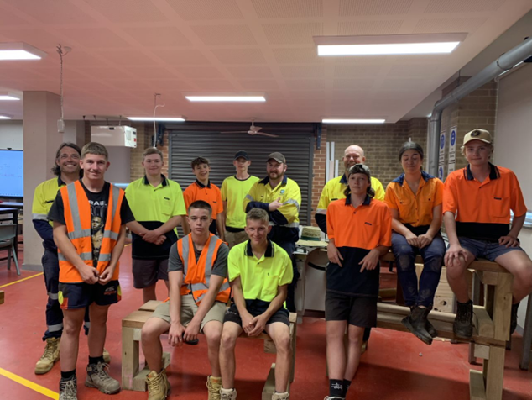
Figure 1 Ulladulla High School Trade Team

What were the key objectives for your school’s project?
Our key objectives were to provide Ulladulla High School students with career learning, mentoring, and volunteering opportunities within a 4C’s framework (Creativity, Collaboration, Communication and Critical reflection). These opportunities varied in style and ranged across several projects.
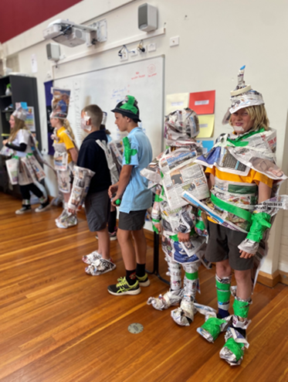
Figure 2 Partner Primary School students participating in fun activities.

How did the team monitor and measure the programs’ key objectives?
Our organising committee sought feedback from staff, students and parents who participated in the projects. The feedback was received via survey, written feedback and conversation. Anecdotal evidence was crucial as we witnessed the students flourish as they engaged in career learning. We held meetings to debrief after events to ensure effective planning and improvement for future events.
Student participation, enthusiasm and engagement was evident in all activities. The immersion in real world, outside of the classroom activities resulted in a wonderful learning experience for all those participating students.
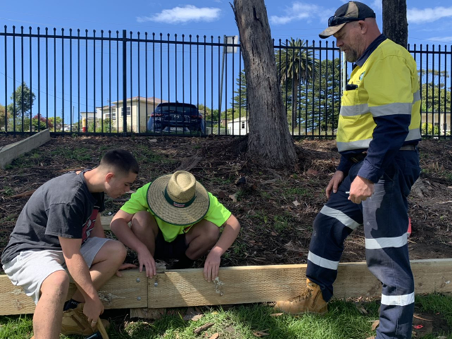
Figure 3 Installing Garden edging

How has the project strengthened links with parents and wider community?

Parents and community were kept informed throughout all stages of the projects via notes and school newsletters. We held an information evening at the conclusion of the transition activities with parents invited to attend. The evening was well supported, with parents reporting positive and enthusiastic feedback from their students regarding their participation in the transition day activities.

Our local Bunnings Warehouse supported our Trade Team by providing hats for our students as well as garden mulch and plants for the garden trade project. This activity has helped strengthen links between the school and local business.

Describe any challenges the project faced and how they were managed.
There were some challenges regarding staffing with a key member of the organising committee relocating. This initially resulted in a loss of momentum, however with a few minor adjustments to the program, we managed to get things back on track to provide some wonderful career learning experiences for our students.

What measures did you use to ensure the project remains sustainable beyond 2022?
Moving forward, we believe the transition project can be further developed and improved based on the feedback and suggestions we received. With the return of our pivotal staff member in the role of Transition Adviser and First Nations Student mentor, this project can be richer in future years.
The Trade Team project is ‘in progress’ with students completing garden edging and seating and looking forward to planting a sustainable garden in 2023. 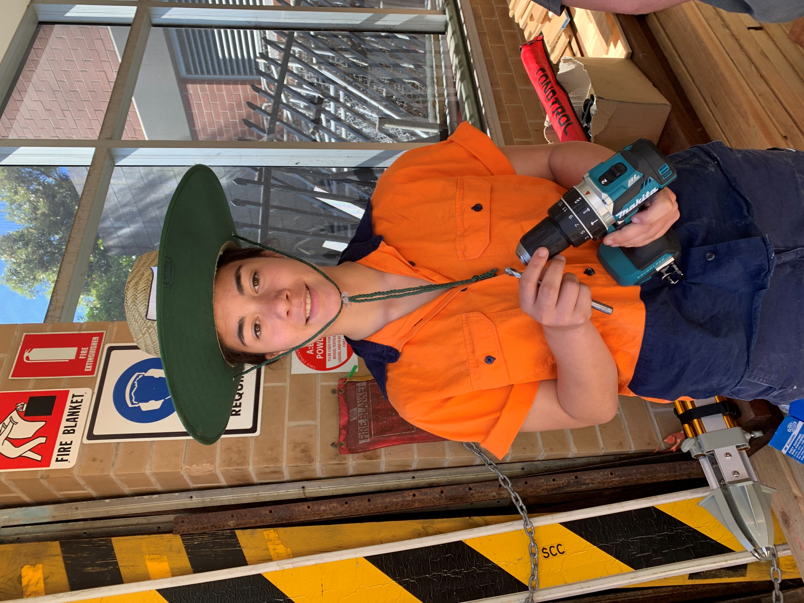
Figure 4 Trade Team member ready for work

Which of the broad project objectives did you achieve successfully, and which objectives require further improvement?
Success: We gained further success in establishing strong relationships within the community.
Further improvement: Our aim is to develop a monitoring, review and evaluation process founded on evidence-based research.

Participating Schools
- Ulladulla High School
- Milton Public School
- Ulladulla Public School
- St Mary’s Start of the Sea

Number of participating students
Primary K–6 = 200.
High School 7–12 = 80.

