Career story

Quirindi High School

Rural and Remote K-12 Career Education Initiative.

Describe your school’s project.
Quirindi High School hosted a careers expo attended by all student’s year 7 to 12 to expose them to universities and various career pathways by connecting students to local businesses and training services. In addition, we organised the “Above and Beyond” excursion where 19 senior students travelled to Sydney to gain valuable networking experience with larger corporate businesses and to gain on campus university exposure. Finally, our Careers Hub was designed to create a purpose-built career learning centre to increase the significance and exposure of the career services at QHS.
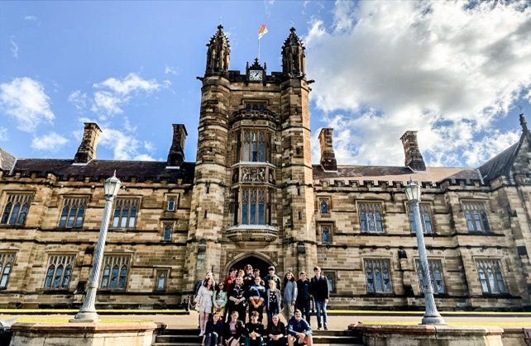
Figure 1 University Excursion

What were the key objectives for your school’s project?
Our key objectives were to design and develop a dedicated Career Learning space within Quirindi High School. The Above and Beyond excursion would then encourage students to think broadly about post school pathways and opportunities outside of the “constraints” of the rural and regional areas, whilst the Careers Expo reinforced the career pathway message. Having gaining insights and exposure, the students then had the Careers Hub as a resource for research and investigation into potential career pathways.
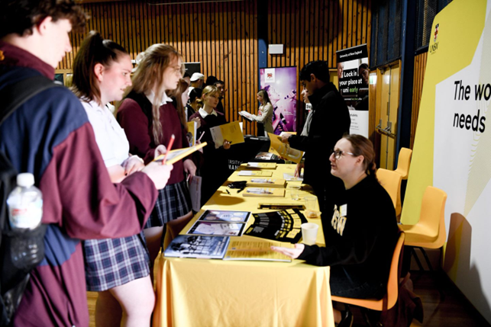
Figure 2 Quirindi High School Students at Careers Expo

How did the team monitor and measure the programs’ key objectives?
Students and community partners were surveyed post the activities and feedback was gained. A key indicator will be the post school destination survey at the end of 2023, identifying any possible impact of the project in relation to University applications and employment related to the Careers Expo. The use of the Careers Hub is a clear indicator of the ongoing popularity and value as a school resource. 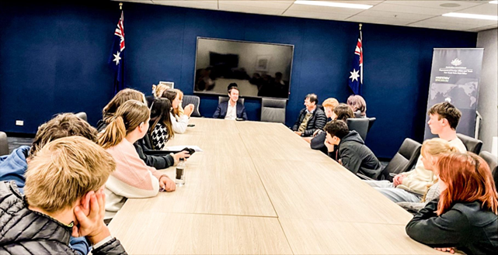
Figure 3 Parliament address

How has the project strengthened links with parents and wider community?
The Careers Expo built solid relationships with local businesses, tertiary providers, and emergency services with the school community, including both students and staff. As a result, some students are currently undertaking work experience with some of those businesses that attended, some have joined volunteer emergency services and some students have followed through with university applications and open days.
The Above and Beyond excursion has encouraged students to apply for universities that we visited. Parents have continued conversations with staff in attendance regarding the opportunities explored and possibilities pertaining to their young person’s future study.
The Careers Hub has provided a dedicated space suitable for community members to come in and complete training with students, such as White Card Training. Presentations have also occurred in the space by the aviation industry.

Describe any challenges the project faced and how they were managed.
Timing of the Careers Expo meant that partner Primary School attendance was minimal. Unfortunately, this couldn’t be avoided. Some of the smaller local business couldn’t attend due to work commitments. This was overcome by inviting industry organisations and training providers.
A last-minute change of accommodation was the major challenged faced with the Above and Beyond excursion and room shortages at QHS has meant that timetabling other cases into the Careers Hub has become a necessity.

What measures did you use to ensure the project remains sustainable beyond 2022?
Surveys for feedback were sent out to our Careers Expo guests so that improvements could be made for future expos, ensuring that participants were happy to return. We have consulted with the principal to discuss school funding arrangements for similar “Above and Beyond” excursions in the future. The Careers Hub has been established with careers resources and the Head Teacher works closely with the timetabling committee to ensure that career education classes are timetabled into the space, along with career focused subjects such as Commerce and Business Studies.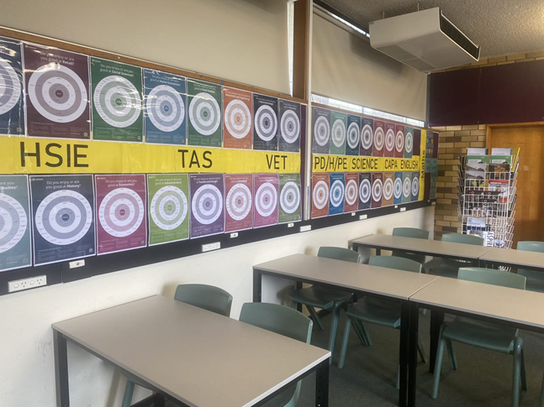
Figure 4 The Careers Hub

Which of the broad project objectives did you achieve successfully, and which objectives require further improvement?
Success: We have successfully raised student expectations and knowledge of pathways into further study and/or training. We have provided teachers with appropriate professional learning and have established strong, lasting relationships with the community.
Further improvement: Our next step will be to establish a monitoring, review and evaluation process founded on evidence-based research. Strengthening the transition from primary to secondary school will also be a focus moving forward.

Participating Schools
- Quirindi High School

Number of participating students
High School 7–12 = 359.

