Career story

Dungog High School

Rural and Remote K-12 Career Education Initiative.

Describe your school’s project.

To develop films of alumni of Dungog High school and to teach/mentor primary students how to create films of alumni of their own school.
These films will be stored on a website which all the participating schools can access to use and embed within their teaching programs. This can be utilised across curriculum to create connection, awareness and conversations about career pathways and progression within subject areas.
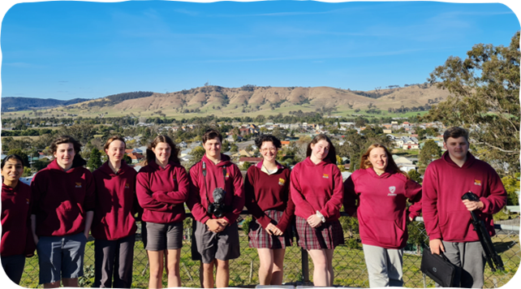
Figure 1 Dungog High School Film Production Team.

What were the key objectives for your school’s project?
Our key objectives were to create a library of films that could be used and shared within/between schools to incorporate in all curricular teaching programs where possible.
We aimed to provide an awareness of possible career pathways for participating high school students whilst developing skills and knowledge in interviewing and film making techniques. Our collaboration and mentorship between the Primary and High School students led to conversations about future options, planting the seeds regarding future career possibilities.
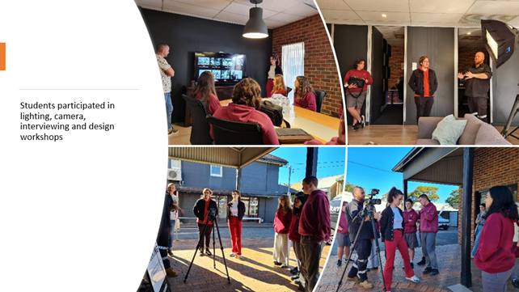
Figure 2 students participating in lighting, camera, design and interview workshops

How did the team monitor and measure the programs’ key objectives?
Our students were interviewed and given the option to withdraw from the program at the beginning of each term. To date, only one student has chosen to leave. The Primary School students and staff were surveyed with very positive feedback received. A connection has been made with the students from the partner Primary Schools. Some have even been creating and producing their own films.
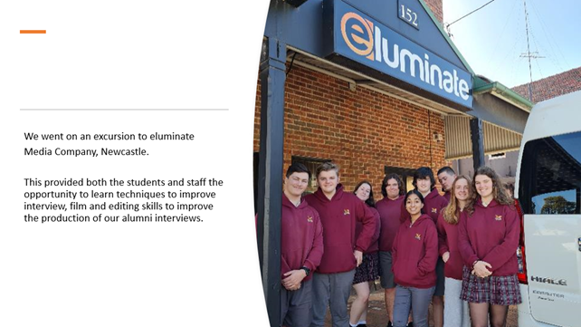
Figure 3 Students standing at the entrance of the production company eluminate

How has the project strengthened links with parents and wider community?
We have re-established links with former Dungog High School students showcasing their career journey and gaining exposure in the community. We have strengthened our links with the partner Primary Schools leading to a more comfortable transition into High School for the Year 6 students.

Describe any challenges the project faced and how they were managed.
We have overcome many challenges to ensure the program was a success. Covid initially provided a challenge with restricted access to Alumni and restrictions around school excursions. With the support of the Senior Executive and school staff, we navigated timetable challenges, staff changes and staff shortages.

What measures did you use to ensure the project remains sustainable beyond 2022?
Replace the following “placeholder text”. This text should be in STYLE Normal
We plan to run the project during sport time which will alleviate many of the timetabling issues. We will also upskill a new group of students in the area of film creation and production during this time. Our focus will be on one or two Partner Primary Schools per term and the film equipment that we have purchased can be shared among the participating schools making the process cost effective.
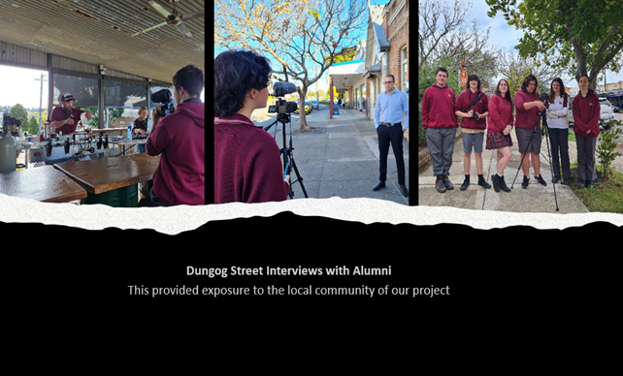
Figure 4 Interviewing Alumni

Which of the broad project objectives did you achieve successfully, and which objectives require further improvement?

Success Creating small films of conversations with alumni of our school about their different career journeys. These film clips can be shown and may the ‘plant the seeds’ for career possibilities and initiate conversations about career pathways. This was offered as an option for interested students during sport.
The project also involved high school students working with a pilot primary school to encourage/ mentor primary students in developing skills so that they could also develop films of alumni of their school about different career journeys.
Career showcase tour – Tour to visit five feeder primary schools over a week (8 schools participating). All primary students participated in dressing up in possible future career costumes. Films are presented and career-based workshop activities delivered by high school students to Years 5 and 6 primary students, introducing interview and film making skills to primary students to enable the students to produce their own alumni interviews and ‘planting seeds’ to think about and have conversations about their individual career aspirations and providing knowledge of educational pathways.

Participating Schools
- Dungog High School
- Vacy Public School
- Paterson Public School
- Gresford Public School
- Clarence Town Public School
- Glen William Public School
- Stroud Public School
- Stroud Road Public School
- Booral Public School

Number of participating students
Primary K–6 = 179.
High School 7–12 = 10.

