Career story

Alstonville High School

Rural and Remote K-12 Career Education Initiative

Describe your school’s project.
We liaised with our 3 main Feeder Primary Schools to try and arrange a suitable date for our Alstonville High School (AHS) Careers Team to visit Term 4 and deliver an introductory Careers Presentation and Activity.
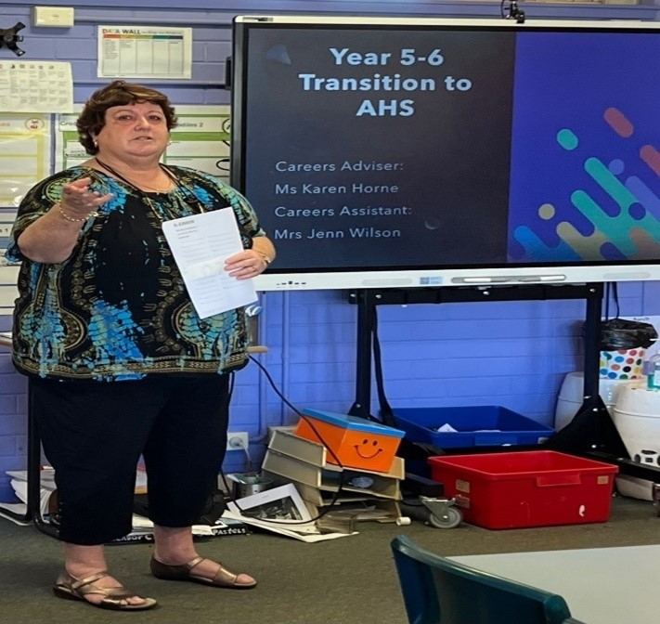
Figure 1 Ms K. Horne

What were the key objectives for your school’s project?
To get students to feel comfortable transitioning to Year 7 in 2023 and to start thinking about future career ideas and pathways possible for them in high school.
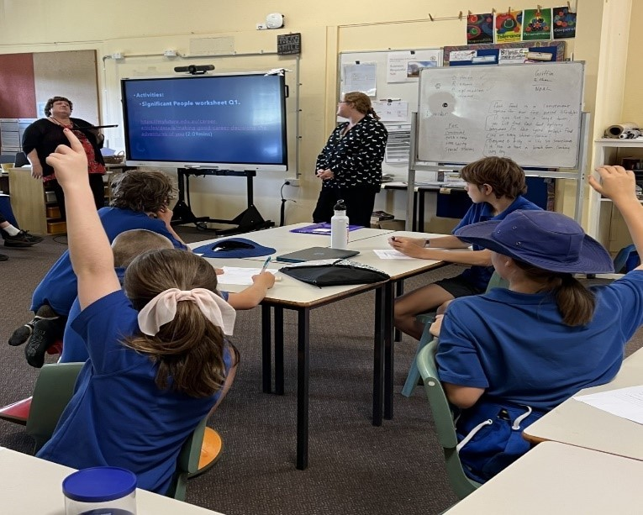
Figure 2 Students engaging in a classroom discussion.

How did the team monitor and measure the programs’ key objectives?
From our first primary visit the students felt comfortable to ask us general questions about high school as well as participating in careers related activities.
Collaboration time on several Wednesdays to release the careers adviser and another staff member to upskill a second teacher on careers activities (Careers 2IC) to plan and implement the content to deliver at feeder primary schools.
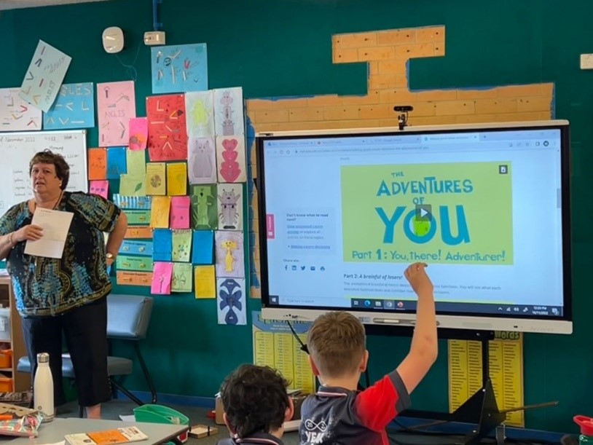
Figure 3 Using myfuture in the classroom.

How has the project strengthened links with parents and wider community?
We completed activities with students and asked them to take home to parents to discuss what happened on our visit.

Describe any challenges the project faced and how they were managed.
It was a challenge to get partner primary schools to respond to our proposal and to come back with suitable dates. We followed up emails with phone calls to remind schools of what we were hoping to achieve. We have had a late response from one local public school after several calls and email messages to say they could not fit us in until 2023.

What measures did you use to ensure the project remains sustainable beyond 2022?
We have created a PowerPoint presentation that may be added and/or edited. We have the activity worksheet proforma to use and access to the myfuture website resources for K-12 students across all stages to add to our career’s visits in the future.
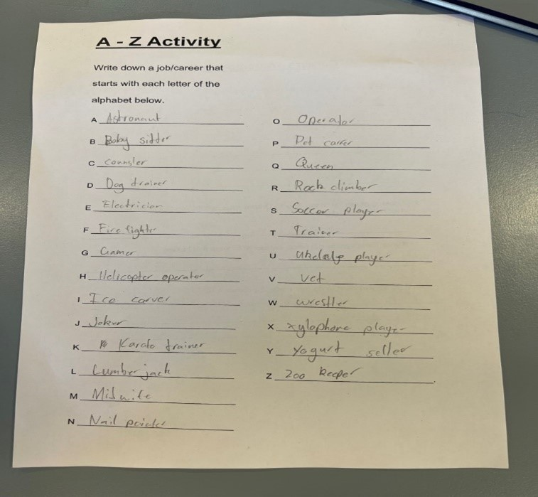
Figure 4 Student worksheet

Which of the broad project objectives did you achieve successfully, and which objectives require further improvement?
Successful: Developed a presentation / resources, participated in DET online teams meetings to share ideas and resources, upskilled another staff member and delivered an interactive activity to 2 out of 3 primary feeder schools. Supported by DoE staff.
Further improvement: To promote parent involvement and hopefully encourage our second largest feeder school to participate in 2023. We aim to include several current students at Alstonville High School to join us in transition programs with primary schools in 2023. We would like to get primary parents involved directly during Term 1 2023 at Year 7 BBQ event with school and families.

Participating Schools
- Alstonville High School
- Alstonville Public School
- Rous Public School

Number of participating students
Primary K–6 = Approximately 150 Year 5/6 Stage 3 students.
High School 7–12 = to be developed in 2023 and incorporated as a voluntary program for secondary students.

