Career story

Aurora College

Rural and Remote K-12 Career Education Initiative.

Describe your school’s project.
To initiate a ‘Careers Carnival’ annual event at our Residential schools. The carnival would include practical career-related events, activities, workshops, incursions, excursions & interactive displays. It will be delivered to students from our rural and geographic regions who are limited in career experiences and presented in a ‘Carnival’ theme and atmosphere to engage students in broadening their views.
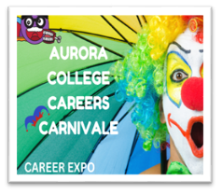
Figure 1 Promotional poster

What were the key objectives for your school’s project?
To implement a ‘Careers Carnival’ annual event at the college Residential schools. This event would include practical work-related services delivered by educational and community organisations. This will assist students from our rural and geographic regions, who are limited in career experiences, to build confidence in self-managing their career aspirations and articulate an exit strategy from school to post school work options.

The Carnival will become the focal point for innovative, creative, and unique careers and transition orientated activities, programs, and resources for students across 5-12 that reflect DoE Career’s Initiative, Australian Blueprint for Careers Development and NESA Statement of Career Education Outcomes.
Collaboration with identified community groups and stakeholders to gather support for current and future career experiences. These experiences lay the foundation for young people to be enterprising citizens, engaged in life-long learning and empowering them to develop career goals, self-worth, and confidence.
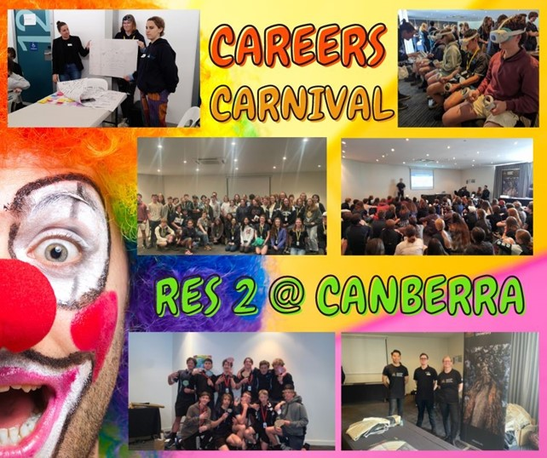
Figure 2 Promotional poster

How did the team monitor and measure the programs’ key objectives?

We implemented a pre-event survey of students to establish baseline data on student general knowledge of careers education and their awareness of career resources at Aurora College. We followed with a post-event survey to gather feedback from students, community members/organisations and teaching staff to reflect on, and evaluate their experiences, plus suggest ideas for 2023. We used student participation rates as a baseline measurement for a new project and teacher observations and feedback. Program providers and participants were interviewed to gather their opinion regarding positives/negatives and thoughts on areas for improvement. Student completion rate of career teaching activities. Quantitative data collection of community participants and creation of a contact database for future connections and collaborations.

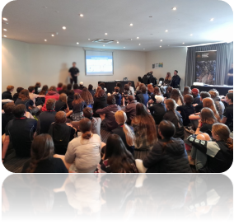
Figure 3 Presentation to audience

How has the project strengthened links with parents and wider community?

Parents and home-schools can access the Aurora College Career websites to create a free account and access the same resources as students. They can participate in on-line Teams interviews with the Careers Adviser using the online booking system on the careers’ websites. (Some have attended individually or accompanying the student). They may also attend college Webinars which are designed specifically for parents regarding studying at Aurora College including the Careers services available to students.

Describe any challenges the project faced and how they were managed.

Being a virtual school meant organisation and plans needed to be done by distance. It wasn’t a matter of quickly visiting to see someone for an impromptu chat/brainstorm etc. making it difficult to adjust last-minute. All the planning had to be managed through MS Teams meetings & chat options, emails and phone calls. These were pre-planned and timetabled well in advance.

What measures did you use to ensure the project remains sustainable beyond 2022?
Survey results from students with an overall 80% indicating they would like to see the Careers Carnival at future residential schools. Executive staff attendance and a staff survey indicating 100% support for the Initiative moving forward was positive. A Careers Budget with approved funding for the Initiative a very positive indicator.
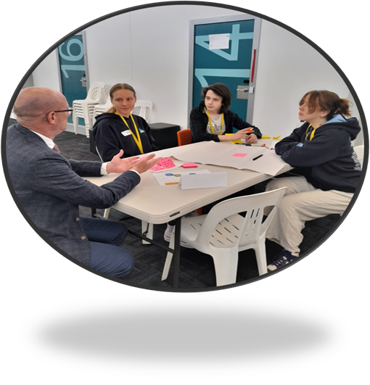
Figure 4 Small group workshops

Which of the broad project objectives did you achieve successfully, and which objectives require further improvement?
Success: Raising student expectations and awareness of pathways into further study and/or training. Establishing strong relationships with the community and establishing a monitoring, review and evaluation process founded on evidence-based research.

Further improvement: Transition from primary to secondary school – planned for 2023 Residential 2 in Term 4 as a specific event in conjunction with the Learning & Wellbeing Team. Providing teachers with appropriate professional learning – planning underway to provide information to staff regarding resources available, role statement of Careers Adviser, DoE Career’s Initiative, Australian Blueprint for Careers Development and NESA Statement of Career Education Outcomes.

Participating Schools
- Aurora College

Number of participating students
Primary K–6 = 167
High School 7-12 = 267.

