Career story

Armidale City Public School

Rural and Remote K-12 Career Education Initiative.

Describe your school’s project.
The purpose of the project was to increase student participation and engagement through explicitly designed activities which develop student awareness in career education, lifelong learning, skill development and enhanced wellbeing. We will develop sustainable activities and resources throughout K-6 which are inclusive of the appropriate phases of learning written in the K-12 Career Development Framework.
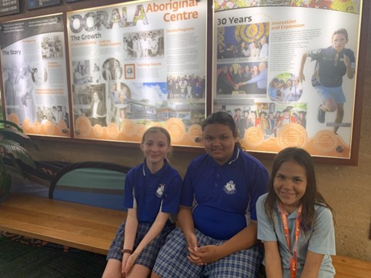
Figure 1 Students sitting outside Oorala Aboriginal Centre

What were the key objectives for your school’s project?
Key objectives of the project were to introduce staff to the K-12 Career Framework, build staff capacity to include career conversations and activities in all KLAs and to increase student awareness and provide experiences in a variety of careers.
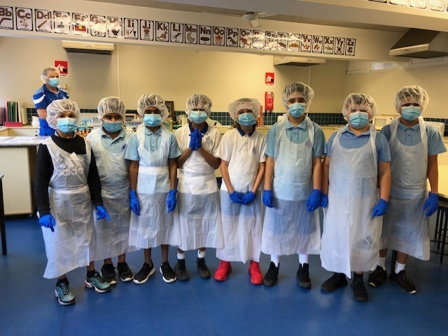
Figure 2 all dressed in PPE gear.

How did the team monitor and measure the programs’ key objectives?

Our team implemented both pre and post surveys for participating staff and students as well as documenting anecdotal evidence from staff and students. We also sought and documented parental and community feedback.
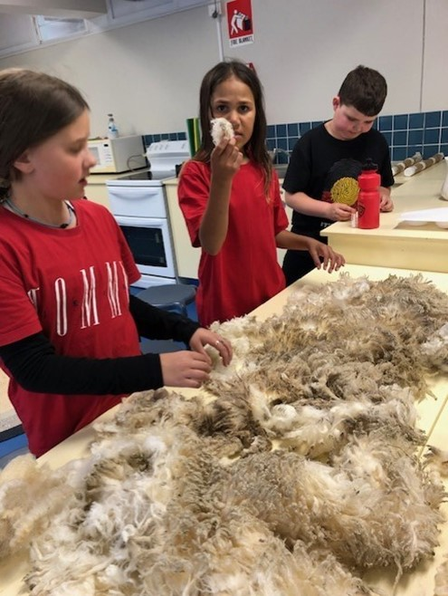
Figure 3 wool classing

How has the project strengthened links with parents and wider community?
The project has opened dialogue with the UNE and offers have been made to assist us to have students visit different UNE departments e.g., Health, Education, Science, etc.
Made solid connections with several businesses and this gives us confidence to approach more in the future. Parents have given very positive feedback about what we are doing, and this has strengthened links between the school and the parent body.

Describe any challenges the project faced and how they were managed.
Sourcing some of the resources staff had prioritised proved challenging. This was managed by changing the focus for some Stages.
Several planned excursions (SMART Farm UNE and Ag plot at the Armidale Secondary College) were cancelled due to circumstances beyond our control. Instead, we accessed information and videos online.

What measures did you use to ensure the project remains sustainable beyond 2022?
The resources we purchased are robust and will hopefully last for a considerable time. Our supportive P&C will likely fund some ongoing costs such as replacement batteries for drones and Beebots. We will be able to continue with the hospitality career awareness by having a ‘meal deal’ prepared by the students which raises money to buy the ingredients needed to run the project again. Creative timetabling will allow us to continue to provide time to run projects such as hospitality, Sista Speak etc. Teachers have embedded career conversation and activities in all KLAs and units of work. The positive relationships we have developed with community will ensure we can continue to make return visits.
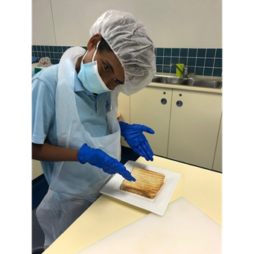
Figure 4 the final product.

Which of the broad project objectives did you achieve successfully, and which objectives require further improvement?
Success: Raising student awareness of pathways into further study; This was very successful, particularly with our Stage 3 students.
Providing teachers with appropriate professional learning; The framework was very well received by teachers and really prompted some great professional dialogue.

Further improvement: Transition from primary to secondary school: Several transition opportunities were undertaken successfully; however improvements can be made. Transition from Pre-school to school also included a careers activity which was new this year.
Establish strong relationships with the community: This will be an ongoing venture. The establishment of some links this year has been very positive.

Participating Schools
- Armidale City Public School

Number of participating students
Primary K–6 = 395.

