Career story

Anson Street School

Rural and Remote K-12 Career Education Initiative.

Describe your school’s project.
Sourcing workplace learning opportunities for students. Coaching with students to gain workplace experience, skills and confidence.
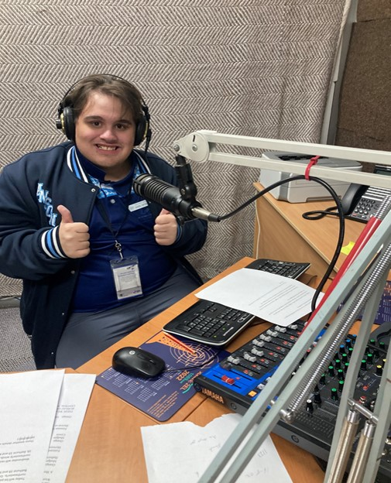
Figure 1 Student at radio broadcast station.

What were the key objectives for your school’s project?

To raise school-leavers optimism and confidence about the transition into the workforce and to increase the knowledge of staff and students in relation to pathways programs and workplace transitioning.
To gather information from local businesses to develop a database of key skills that assist in increasing employment possibilities for students and to give the students ownership of their own pathways by giving them the skills to succeed in looking for work and advocating for themselves.
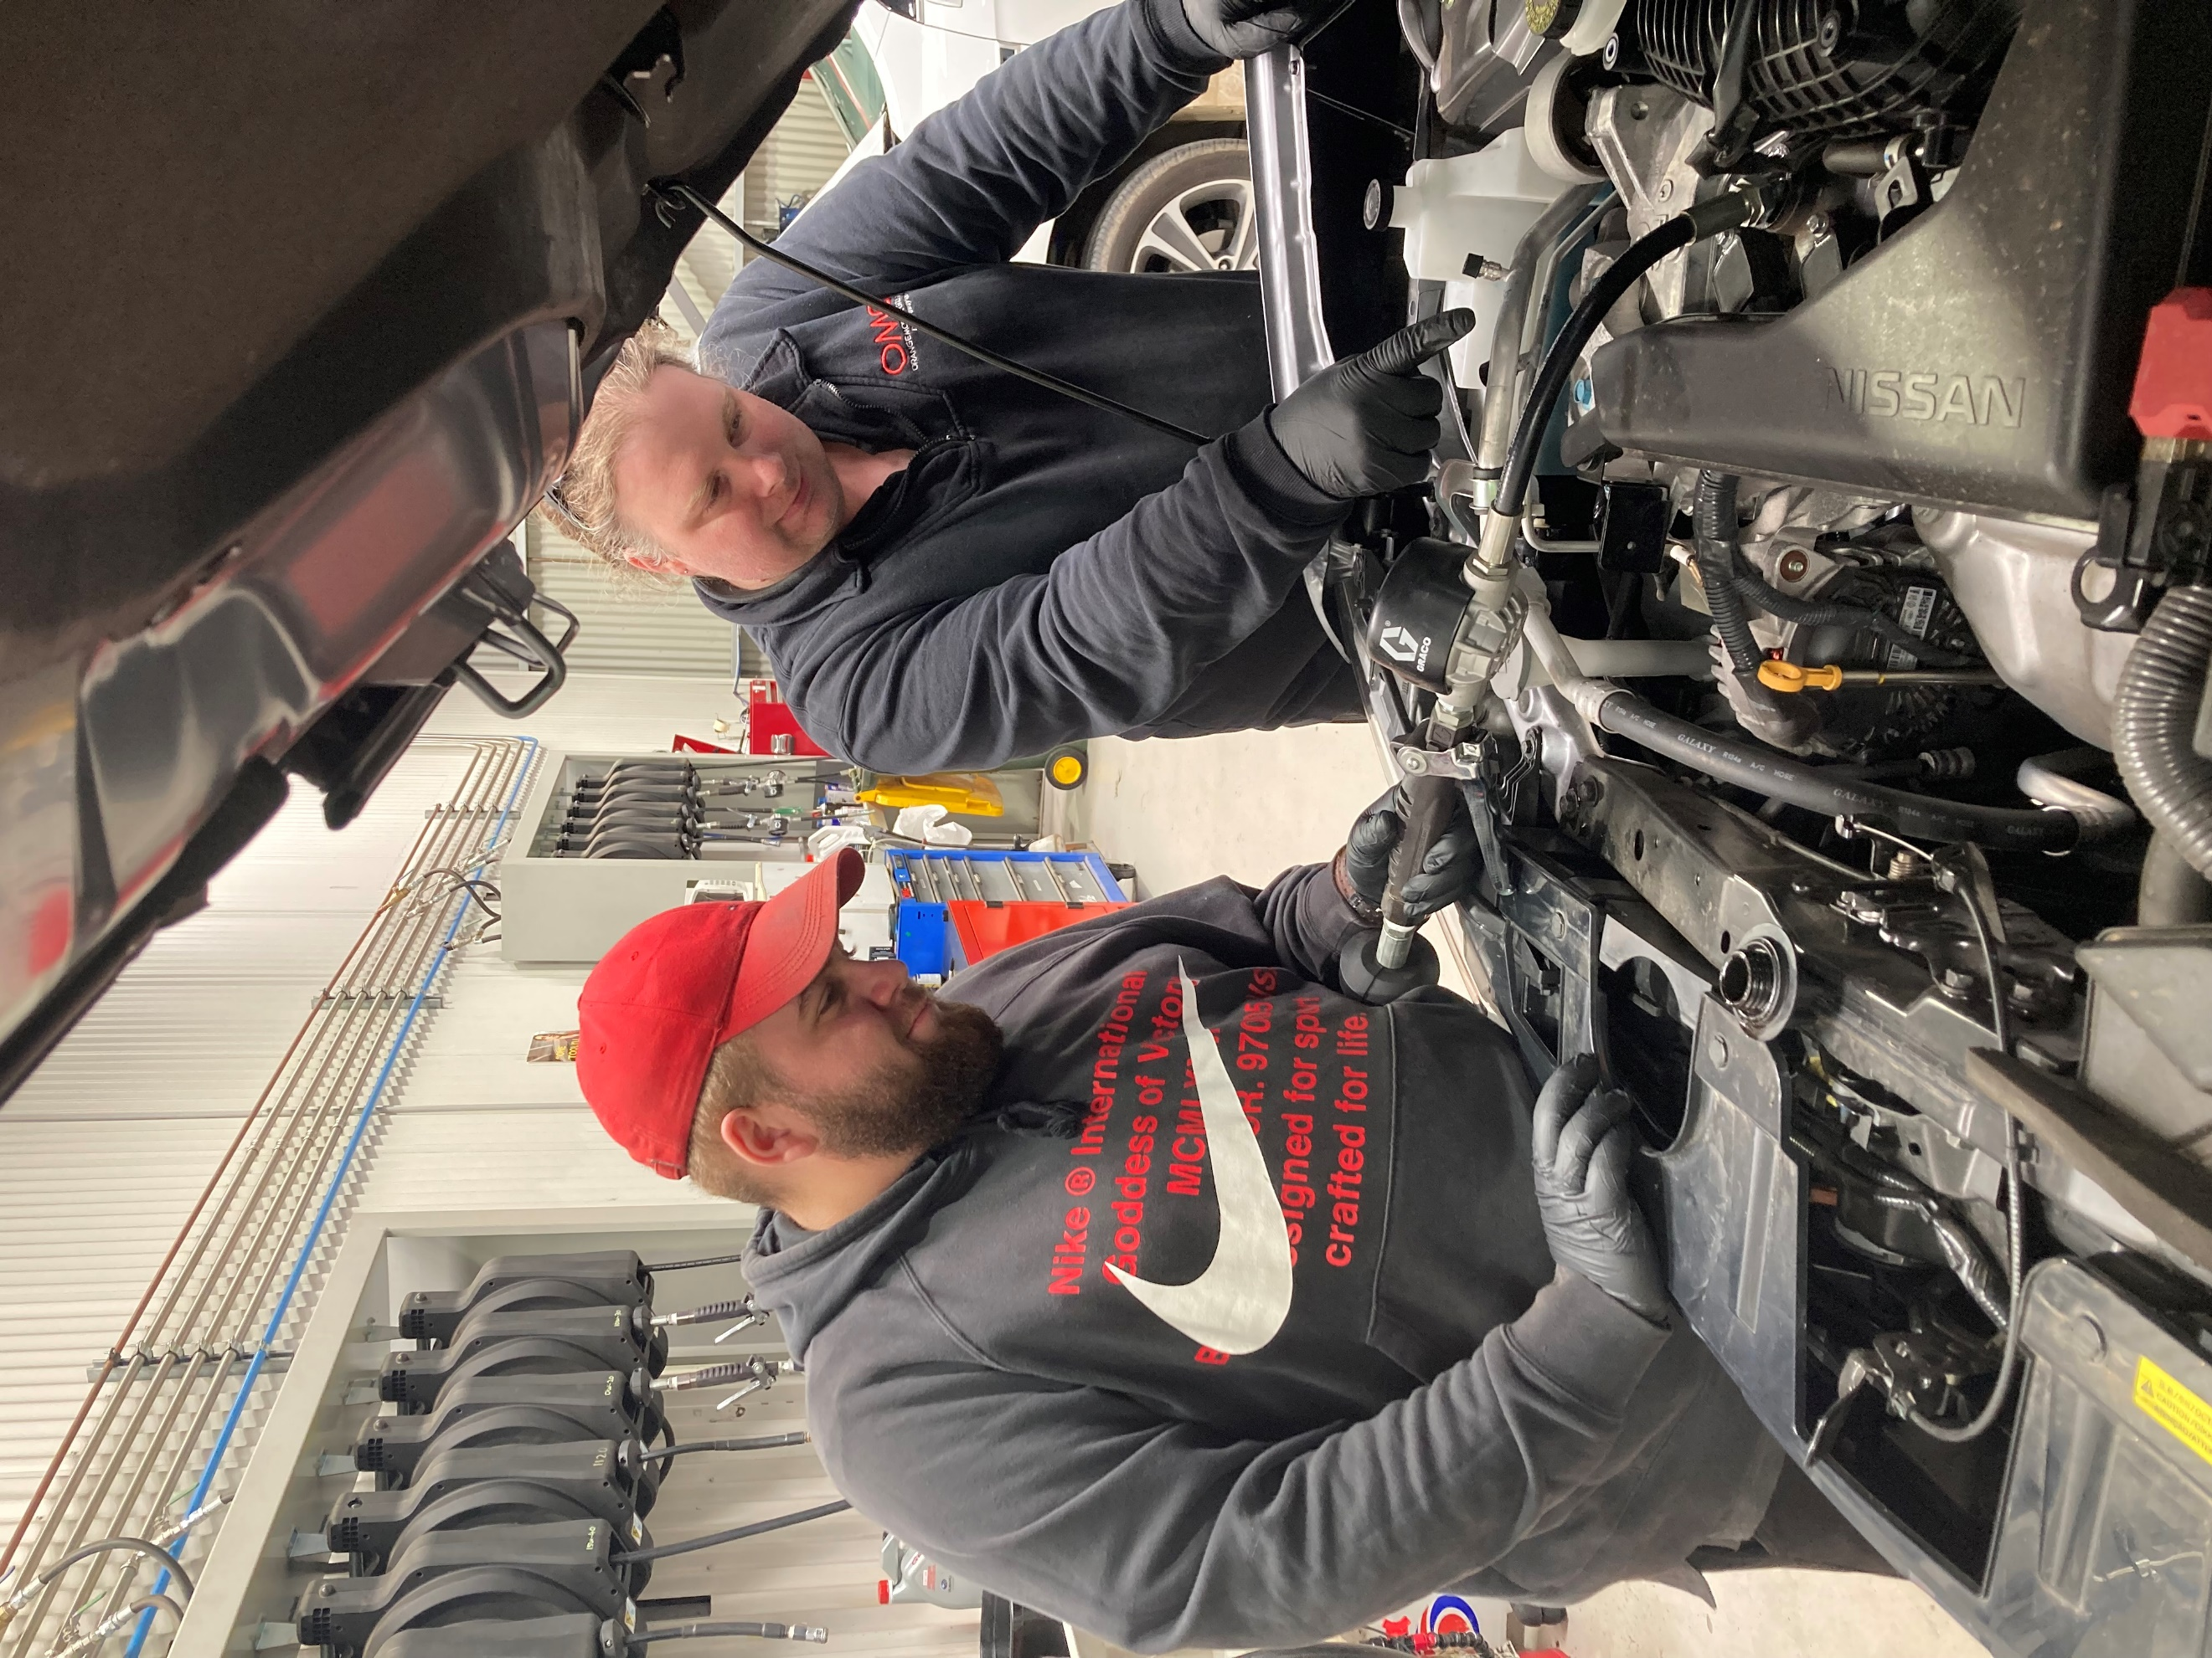
Figure 2 student working with Mechanic on car engine.

How did the team monitor and measure the programs’ key objectives?
We ensured constant communication with parents, teachers, and students to collect information and feedback. Students report feeling ‘satisfied’ or ‘unsatisfied’ with their plans for transition out of secondary study.
Outcomes for students at the end of the year transitioned from ‘has no plan’ to ‘has a plan.’
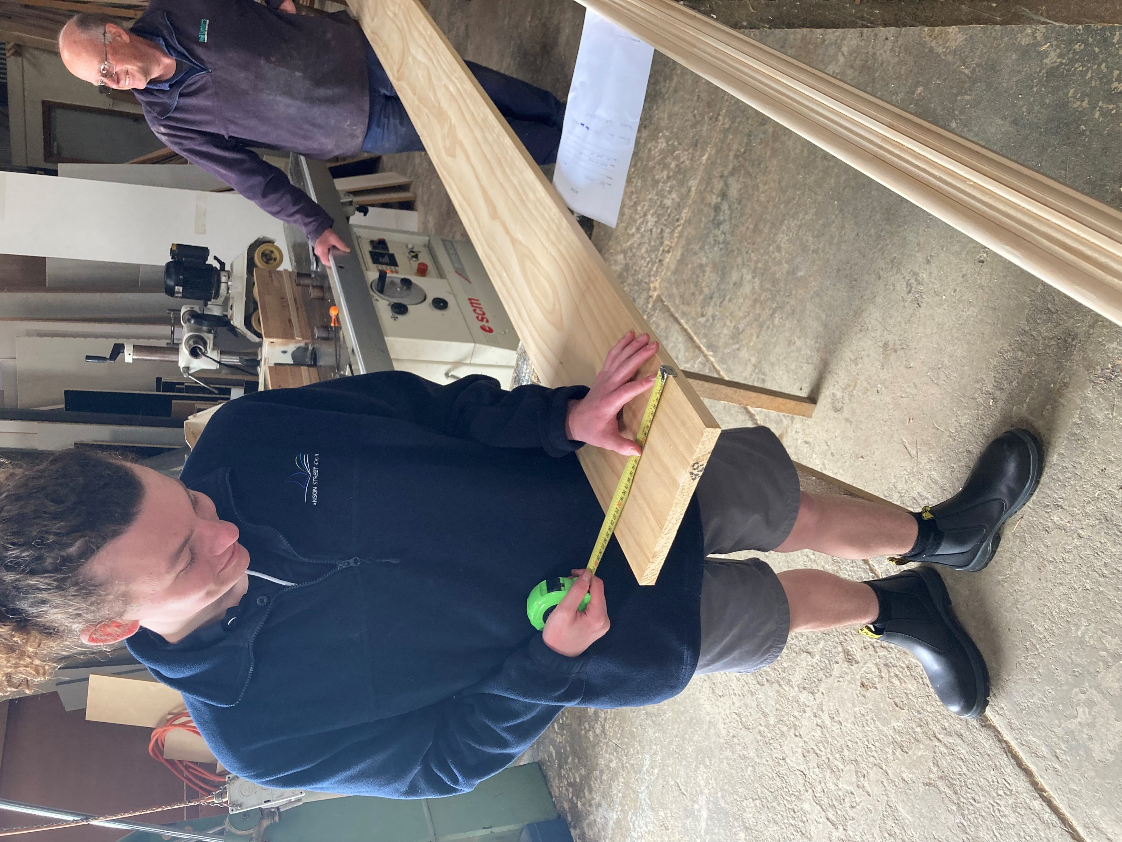
Figure 3 student measuring timber to be cut to length.

How has the project strengthened links with parents and wider community?
Challenges faced by students in an SSP are very different to most students in mainstream schooling. Parents often feel a lot of anxiety and worry about their child’s capabilities and how they will integrate into the workforce. By demonstrating to students their own abilities and strengths and subsequently inviting parents to be part of that journey of discovery, parents often feel more connected to the experiences of their child.
The stigma of disability and mental health unfortunately runs stronger than anticipated in regional communities. The workplaces that worked with students were supportive and ‘pleasantly surprised’ with the students’ level of engagement and capabilities.

Describe any challenges the project faced and how they were managed.
As mentioned above, the major challenge was challenging stereotypes and bias towards the capabilities of neurodivergent and physically disabled individuals.
Some parents were more supportive than others, some had unrealistic expectations whilst some were overprotective of their child.
Student anxiety proved to be quite detrimental to their performance and often required a lot of coaching to help overcome this barrier.

What measures did you use to ensure the project remains sustainable beyond 2022?
Continue to employ an Engagement Officer to facilitate work experience opportunities and job coaching sessions.
Maintained strong relationships with community members to ensure ongoing support.
Developed resources.
Professionals worked with teachers and students to integrate a strong pathways ethos.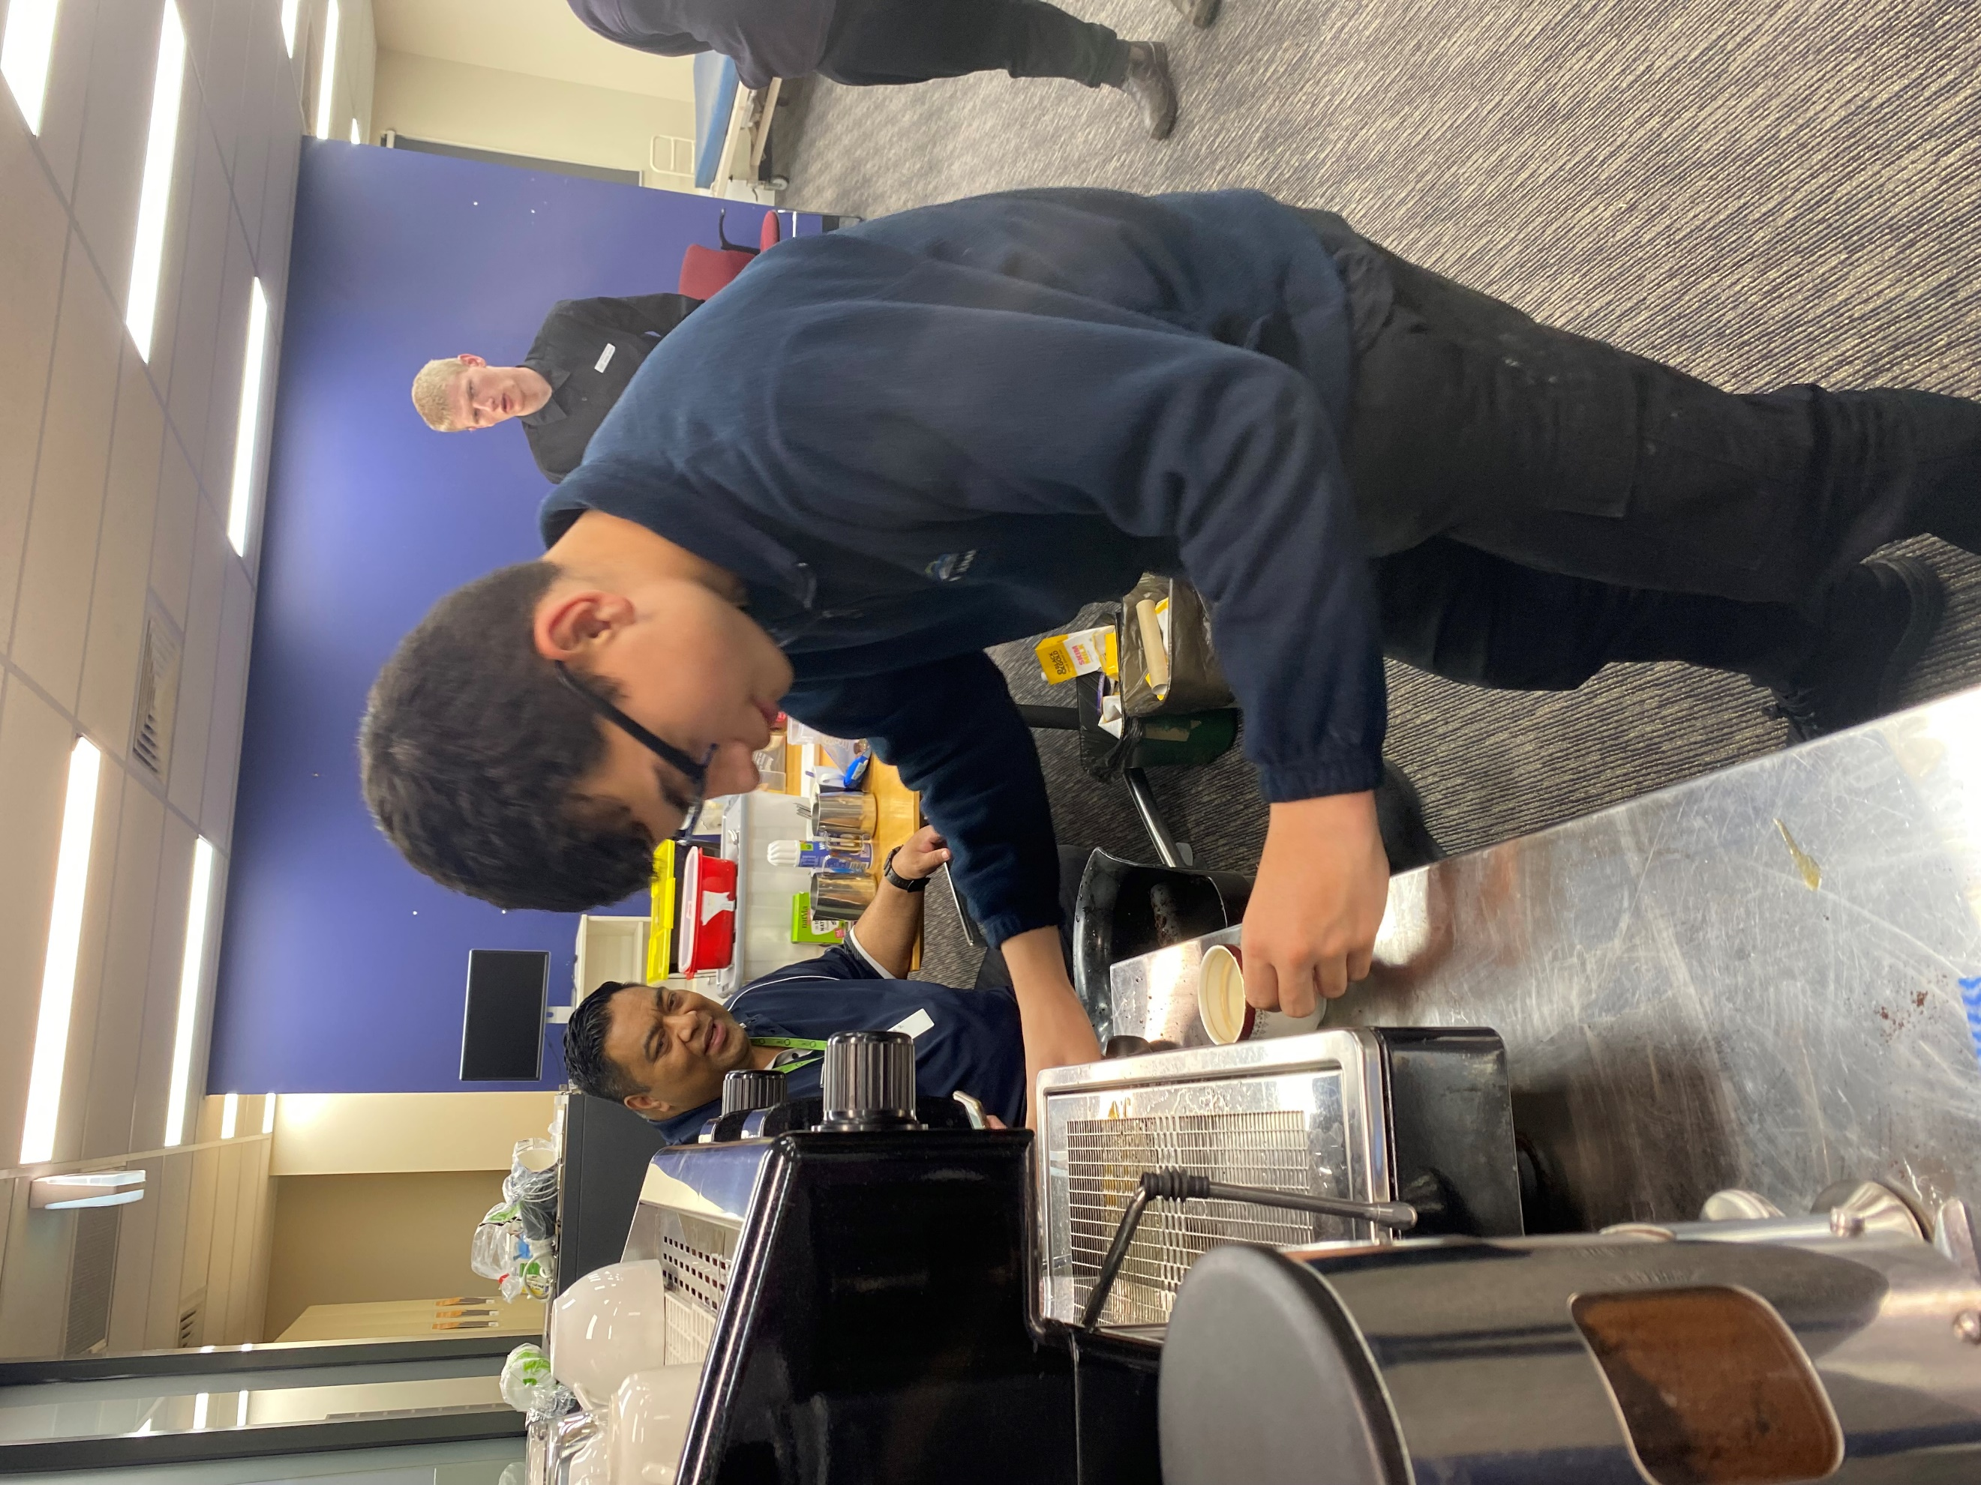
Figure 4 student using espresso machine.

Which of the broad project objectives did you achieve successfully, and which objectives require further improvement?

Success: Established a monitoring, review and evaluation process founded on evidence-based research
Established strong relationships with the community.
Further improvement: Continue to establish & maintain strong relationships with the community and workplaces.
Provide a greater number of teachers with appropriate professional learning.
Allocate more time to raise student expectations and pathways into further study.

Participating Schools
- Anson Street School

Number of participating students
High School 7–12 = 23

