Kurri Kurri High School
Studio School Transition Course
Interview with David Buswell and Emma Kirk

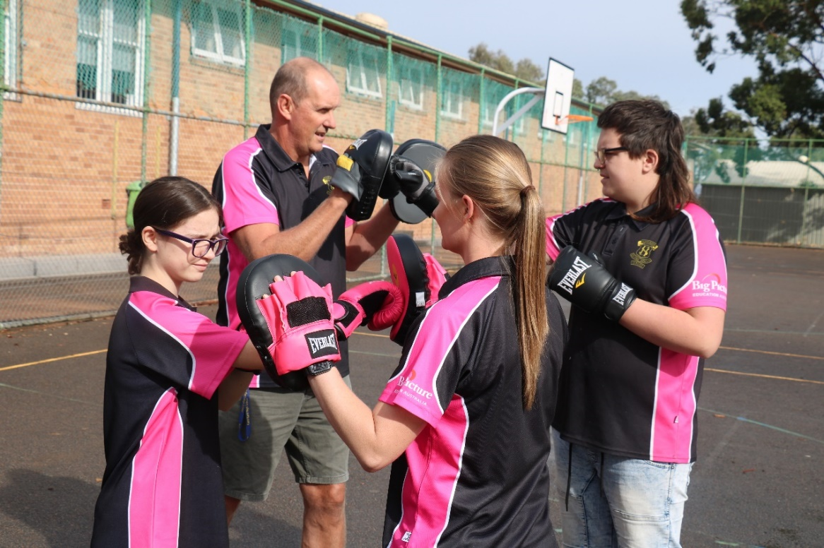
Figure 1 Physical education lesson

What are the most rewarding experiences in your job role?
In this role our most rewarding experiences can be split into three areas.
Helping students go from being disengaged in a mainstream educational setting and watching them engage, attend an internship and then be able to assist them to turn that into an apprenticeship or traineeship.
Helping students who are not attending school at all attend our program and helping them become part of the advisory. These students often become leaders within the group and appreciate the opportunity of a second chance at education.
Helping students learn how to evolve from being teacher directed to building their skills and confidence to be self-directed and be able to design their learning path.

Describe your school’s program/program?
At Kurri Kurri High School we have developed a school within a school which we call a Studio School. Within this program we have an advisory of between 30-34 Stage 6 students who are guided by 2 advisors for all of their learning.
The curriculum is completely online and students are able to work through this at their own pace. The curriculum consists of students working on projects that relate to their individual passions and/or their choice of internship in a relevant industry with an expert mentor. A Learning plan meeting is conducted at the start of each term and a student led Exhibition at the end of each term with students able to invite family, mentors, peers and others to these events to showcase their learning. Internships are encouraged to occur at least 10 days per term and have a flexible arrangement around when these can occur.
VET courses in Construction and Engineering are currently offered and are delivered in a compressed curriculum one full day and two half days per week for three terms, to assist students to gain an external Certificate I or II, which assists employment prospects.
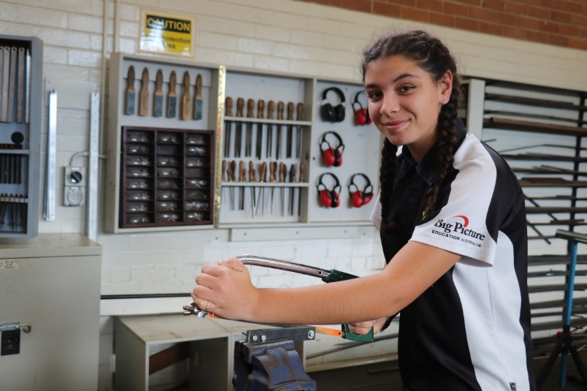
Figure 2 Student using a handsaw
Other areas of the curriculum include the generation of a Portfolio, Journal Writing, Internship Reflection and Planning, Project Development, Group Tasks and CEC NESA Mathematics Pilot Course. The course content is designed to assist students to transition effectively into the workplace and or external vocational courses.
Content is delivered by Advisors in Masterclasses to the larger group, small group just in time learning as well as daily one v ones.
Time spent at school is reduced and students are onsite from 9am until second lunch, giving them a one hour early finish to attend or pursue part time employment.

What has been the most successful outcome so far from the project/program?
Creating a “family” culture has been huge on so many levels. This happened quite by accident really from the early days of the program. Many factors have led to our students becoming closer. Building relationships with our students’ families as part of our Studio School has proven to be an essential part of establishing trust within the advisory. Sitting together as a group for a check in and a check out every morning and afternoon allows students to share stories and build respect for each other. These opportunities give voice and agency to the group, especially when democratic decisions are made and acknowledgement of achievement is recognised.
Having the initial group of students in 2018 design an alternate school shirt to identify that we were unique from the rest of the school was another significant factor in making us “family”. We often talk about what the shirt represents and how we represent the shirt, it often feels like a sporting team. Remembering for a lot of our students they have not been part of a team where people really look out for each other which is a nice feeling of belonging to the group.
The space we reside in has a fully functional kitchen, built by students, coupled with artworks designed by students throughout the room that flow out into the adjoining corridor. The students choose where they sit and who they sit with, they can leave their laptop, books, stationery and anything else on their desk or in their tote tray, all of this contributes to ownership of space and positively impacts the advisory culture.
What are your long term personal plans?
Our long term personal plan or “our dream” is to have a small advisory in every school across Australia. A pathway that delivers a transition course to assist our young people in achieving their goals and dreams. Sometimes these things are taken away from our young people by factors out of their control and providing a relevant and meaning pathway to enable them to transition to work in a flexible, understanding environment is all they need to pursue their dreams.
If you can describe your role in a word or sentence, how would you describe it?
Our role is to facilitate and nurture students who are broken by either our system or their environment, be it home or school and help them to engage in learning so they can transition successfully into a contributing member of our community with strong moral values and a want to help others achieve their goals... “LIFE-CHANGING!”

What are the school's short and long term plans for the project/program?
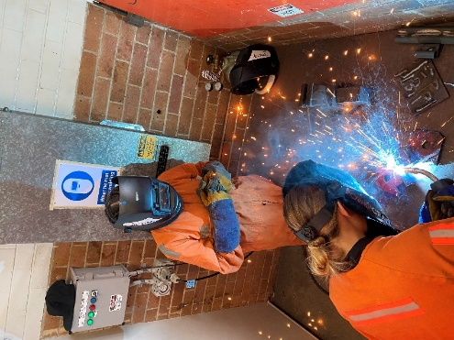
Figure 3 Students welding
The school is committed to providing bespoke and personalised learning for students so that they leave school knowing their strengths. The program has been highly successful and we plan to grow the project into neighbouring schools in 2021. The idea will be to form networked connections that grow the work into businesses. Developing a plan with employment and TAFE options with a flexible and part time ‘Year 13’ option is also in the horizon planning of the project.

What are your key ingredients in guiding and maintaining successful community relationships?
In our third year we have used many different strategies to engage community in our program, essentially we have been open with local industry about employing local young people who they can educate into their business model. We have attended many community group meetings and met with industry stakeholders to promote the idea of training young people in internships to gauge their suitability to each industry before embarking on an employment contract.
The students being “work ready” is another key ingredient in this process as if they are not quite ready then we are usually setting them up to fail and we have learnt that it is vital that our young people have the toolkit of essential skills to survive those first few months of employment. These skills are built over a period of time through internships and completion of online Canvas modules tailored to workplace learning.
Traditional employment processes can sometimes be a hit or miss situation, when hiring someone through an application advertisement using resumes, cover letters and interview. Our philosophy is for employers to try prospective employees through an internship or SBAT where they can make a more informed decision after a period of getting to know an individual and their work ethic.
What challenges did the students, teachers and parents experience with online delivery?
Figure 4 students collaborating
Online delivery is a process we have advocated from the very beginning, when many teachers, students and parents in our community said that online learning was not possible due to the low socio economic status of the community. Initially we had four desktops for students to use, a handful of students used BYOD and a few others were on a day loan program. Initially many students had no idea how to navigate the software on a laptop or the Canvas platform we use, as the traditional school cohort was in an early transition phase of using online learning. In 2020 our culture of online learning has changed dramatically. When Covid-19 forced everyone into online learning, our students all either had their own device or were able to loan one from school making our online Canvas portal easily accessible for all students. Now we still have two desktops that gather dust as they are only used by students who visit our room and all of our students have access to a device. In the beginning, digital literacy and online learning was a major challenge at every turn from charging devices to logging on to learning how to use Microsoft Word. We have now moved on and our students have embraced this learning as the normal.

