Henry Kendall High School
IBM P-TECH Partnership
Interview with Jay-Marie Blue and Leanne Cortaville-Smith
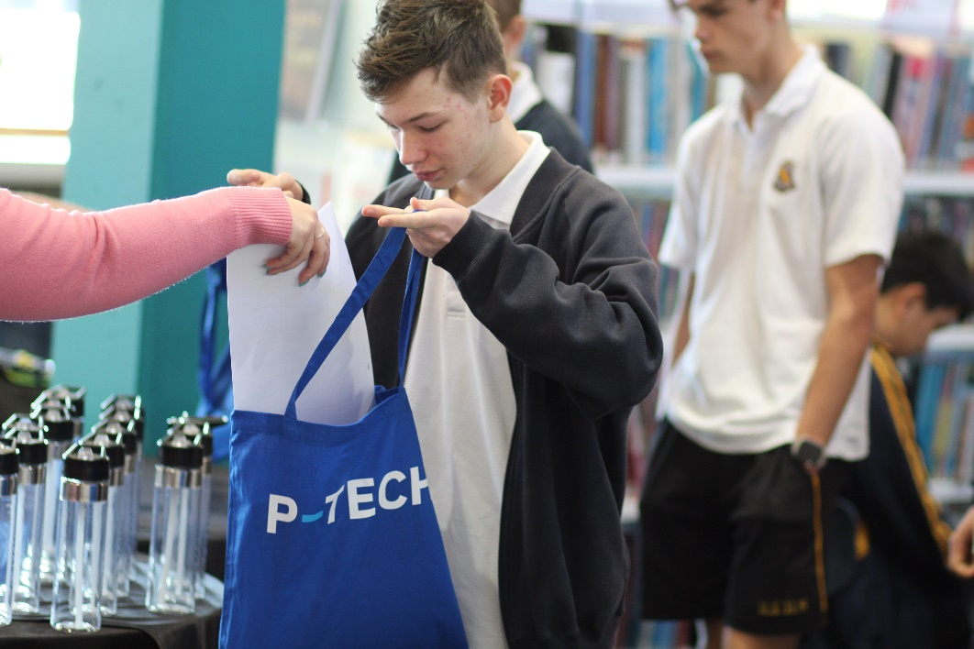
Figure 1 students in expo

The program
IBM P-TECH Partnership is a collaboration between education, industry and community.

Describe your school’s project / program?
The P-TECH model was first established in 2011 in Brooklyn, New York City by IBM and a consortium of education partners. P-TECH is now embedded in 24 countries and 220 schools across the globe, including 14 schools in Australia.
Pathways in Technology (P-TECH) is a program where students can complete high school, earn post-secondary qualifications and be career ready by the time they graduate school. Students can acquire the digital skills, professional skills and work experience needed for entry-level positions in a variety of sectors and industries.
The Henry Kendall High School IBM P-TECH (Pathways in Technology) Partnership is a world-leading educational model that offers our secondary school students an industry-supported pathway into a Science, Technology, Engineering and Mathematics (STEM) qualifications. P-TECH combines rigorous coursework with workplace experiences that include mentoring, work site visits, internships and first-in-line consideration for available entry level jobs. Henry Kendall High School is one of four P-TECH schools on the NSW Central Coast.
Henry Kendall High School students also have access to IBM’s online learning platform, Open P-TECH. Courses on Open P-TECH lead to professional recognition in conjunction with the P-TECH program including Enterprise Design Thinking, Cybersecurity and Professional Skills. The industry recognised digital badges provides our students to be upskilled, ready for industry skills required for employability purposes.
The IBM P-TECH program will provide our students with real world relevance and connectivity in their high school learning directly aligned with the growing demand for employability skills. P-TECH has enabled local Central Coast Industry Mentors to play an active role in mentoring our students in 2020. Mentors come from a range of backgrounds who are willing to share their skills, knowledge and expertise. This program signals an exciting opportunity to establish educational pathways in a specific local industry growth area for the Central Coast.
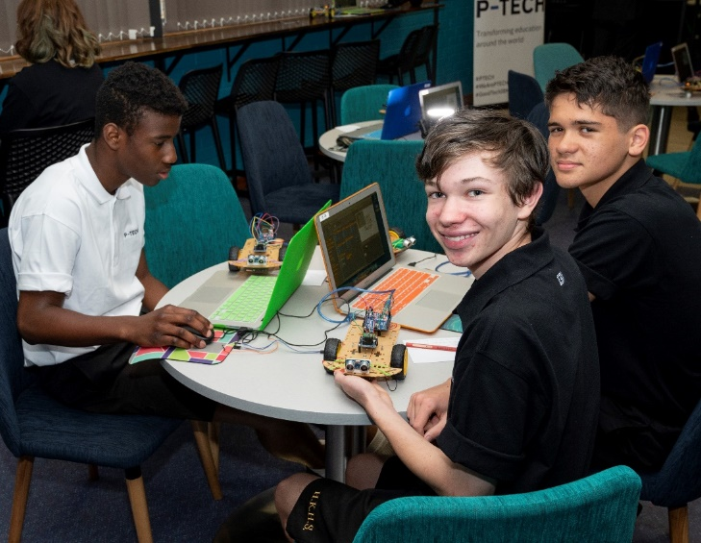
Figure 2 Designing electric models
Our Principal of Henry Kendall High School, Mr Andrew Backhouse, in 2020, has been featured in the Global “Voices of P-TECH” Community Campaign 2020, alongside other global P-TECH students, faculty members and industry partners.

Describe the planning of the project/program specific to your school?
At its core, the IBM P-TECH model Mentoring Program at Hendry Kendall High School is about collaboration; a partnership between education, industry and community. It provides a framework for employers to work alongside our school in preparing our students for success in further study or work. This partnership with IBM enables Henry Kendall High School to design innovative approaches to the way learning is delivered; approaches that would not be possible of schools, or industry, acted in isolation. Henry Kendall High School aims to provide students with skills for the future as communication, creativity, emotional intelligence, critical thinking, self-regulation, collaboration and citizenship.
As the IBM P-TECH Mentoring Program develops in coming years, opportunities for the HSC and career pathways for our students will be developed. Collaboration between our school and our industry partners / mentors on the Central Coast will align student learning with skills that our region requires and are transferable globally for our students. In addition, our students develop relationships with industry which improves their employment prospects.
At present in 2020, HKHS Stage 5 students in Year 9 i-STEM have participated in the 2020 Central Coast P-TECH Mentoring Program whereby they have participated in three, two-hour virtual online workshops with industry mentors from the Central Coast. These workshops each have focused on developing professional skills as collaboration, communication and responsibility; analytical thinking, self-management and motivation; leadership, curiosity and entrepreneurship. In student groups of three, students have had the unique opportunity to have personal conversations with their industry mentor regarding professional skills that are vital for their readiness for workplace learning and jobs.
Also, a core group of year 10 students who made applications in 2019 to be involved in the IBM P-TECH Program, have participated in the Central Coast 2020 Virtual Speaker Series. Students have used their communication and collaboration skills to virtually interview professional speakers including global IBM employees and most recently, Professor Rhonda Wilson of the University of Newcastle.
In 2021 - 2022 we are mapping the P-TECH program to be expanded into Stage 6 at Henry Kendall High School.

What are the benefits to our students of Henry Kendall High School?
Students who elect Henry Kendall High School’s Stage 5 i-STEM course are automatically entered in the IBM P-TECH program. Much of the program will be delivered with the i-STEM course, however work readiness skills are delivered to supplement in class learning to enable students to adapt to an ever-changing work environment.

Benefits include:
- Enhanced Curriculum
- Authentic Project Based Learning in collaboration with local Industry Partners and IBM ANZ
- Access to the latest technologies, including artificial intelligence, within IT & STEM sectors.
- Classroom learning designed in collaboration with partners to ensure development of the professional skills that employers need.
- Specialist speakers in variety of different professions to collaboratively engage with students.
- Incursions and Excursions with Industry Partners & University of Newcastle (our Tertiary Partner).

Mentoring and Job Readiness
- P-TECH Central Coast Mentoring Program with Professionals from a range of different backgrounds and industries.
- Work experience and work placements within local partnerships across the Central Coast region.
- School Based Traineeships and Apprenticeships.
- Tailored university programs and visits.

IBM Open P-TECH Digital Badges
- Digital learning in cutting edge technology through Open P-TECH platform.
- Industry recognised digital badges providing additional post school qualifications.
- Personalised approach to ensure learning is tailored to individual interests and needs.
- Online access beyond the classroom setting.
- Promotion of self-responsibility and ownership of the learning process with real world applicability.

How did you organise and schedule activities?
The IBM P-TECH Program is organised in collaboration with the Central Coast P-TECH Liaison who assists our school in organising and scheduling virtual and face to face events and activities with the industry partners including the Mentoring Workshops. Industry mentors attend a Mentor Onboarding Session and a program launch. HKHS is connected to Industry professionals in the region who are invested to be our student’s mentors for this program.
Mentoring workshops have been organised and scheduled throughout 2020 over several months. Students have been organised into groups of two to four and assigned a mentor for the duration of the three workshops for the program. Agenda’s for workshops are communicated to the HKHS P-TECH Coordinator who then verbally prepares our students for their workshop session and topics to be discussed. Students will have attended three, 2-hour workshops, culminating in a celebration event of the success of the Central Coast Mentoring Program at the end of the year.
At the end of each Mentoring Workshop, students complete a written reflection on learning activity. This reflection is to enable our students to recognise what they have learnt under guidance of their industry mentor, professional skills they themselves would like to focus on and future questions they would like to ask their mentor in their next session.
What are the school's short and long term plans for the project/program?
The purpose of our program: The Henry Kendall P-TECH Partnership will give students real world relevance and connectivity in their high school learning directly aligned with the demand for employability and professional skills within the Central Coast region.
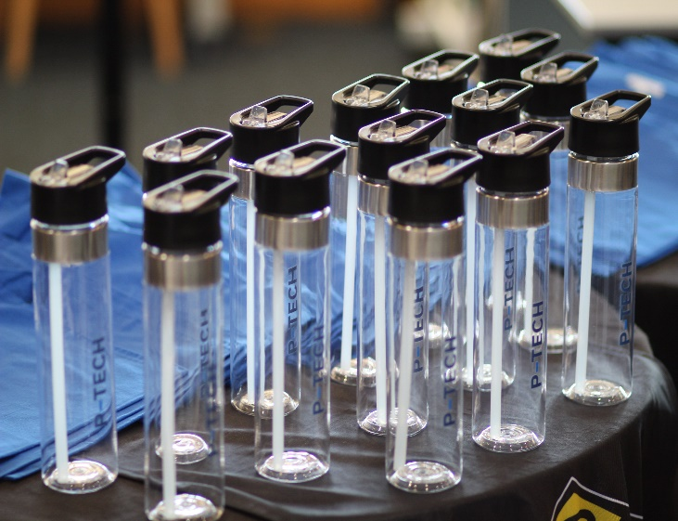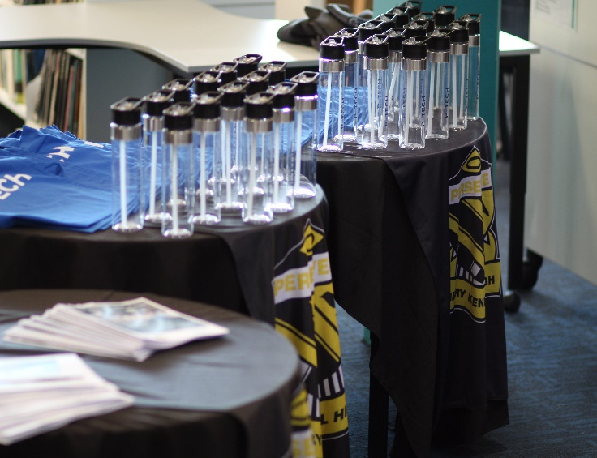
The IBM P-TECH program in Stage 6 will provide for enhanced HSC opportunities and vocational pathways. Collaboration between Henry Kendall High School and our industry partners align student learning with skills our region requires and are transferable globally for our students. In addition, our students will develop relationships with industry which further improves their employment prospects.

