Eden Marine High School

School based apprenticeship/traineeship (SBAT)
Interview with Michelle Bond
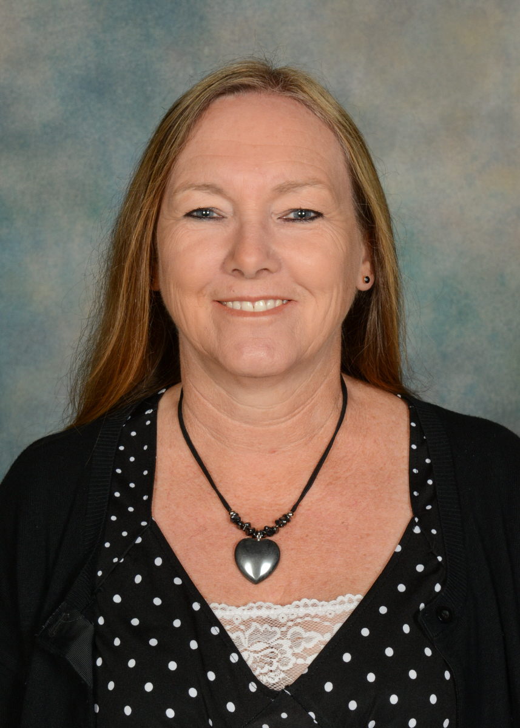
Figure 1 Michelle Bond
How long have you been working as a Careers Adviser?
I have been in my current role for 7 years after coming from an English/History teaching background.
What are the most rewarding experiences in your job role?
Seeing students who struggle in the Education system thrive in the workplace.
Describe your role in a sentence.
Jack of all trades!
What do you enjoy most about your role?
The variety that each day brings and the relationships that I build with the students that continues beyond school.
What are your long term personal plans?
In 2024, I will be on my 4 for 5 year sabbatical and hope to do some travelling. Beyond that, I will return to Eden Marine High School refreshed and retire in 2030!

The School to Work Program
Eden Marine High School is situated on the Far South Coast of NSW and has 561 students from Years 7-12.
Annually, in June, Year 10 attends a compulsory week of Work Experience.
Mid-year best suits the Far South Coast, as it is usually a quieter period for the area that relies heavily on tourism in the Summer months. Before students decide on their subject selection choices for the HSC in Term 3, early Work Experience allows them to spend time with employers who teach students about their profession. It is also a good time for students to consider signing up for a School Based Apprenticeship Traineeship.

The Challenge
With the start of COVID-19 in 2020, Work Experience was rescheduled in December. It was challenging to get employers to accommodate students due to the busy season. In particular, tradespeople had to meet deadlines before Christmas. Employers were not prepared to commit to taking on a SBAT in the event if their business was forced to downsize or in some cases, shut down.
In 2021, Work Experience was scheduled back in June. With COVID-19 regulations, some students had to resort to their Plan B career choice, as venues could not cater for additional students within the square metre rule.

Success
Employers are still reluctant sign up a SBAT. Fortunately for Joshua Gordon, he has secured a SBAT with Ryan Becker Painting and Decorating. Ryan graduated from Eden Marine High. He was one of Eden Marine's High School’s first SBAT’s and is the first to start up his own business after gaining his qualifications. Ryan was impressed with Joshua's work ethic and skillset and was keen to give Joshua the opportunity to start a SBAT. Joshua’s prospect of having to do block release in Canberra has not fazed him.
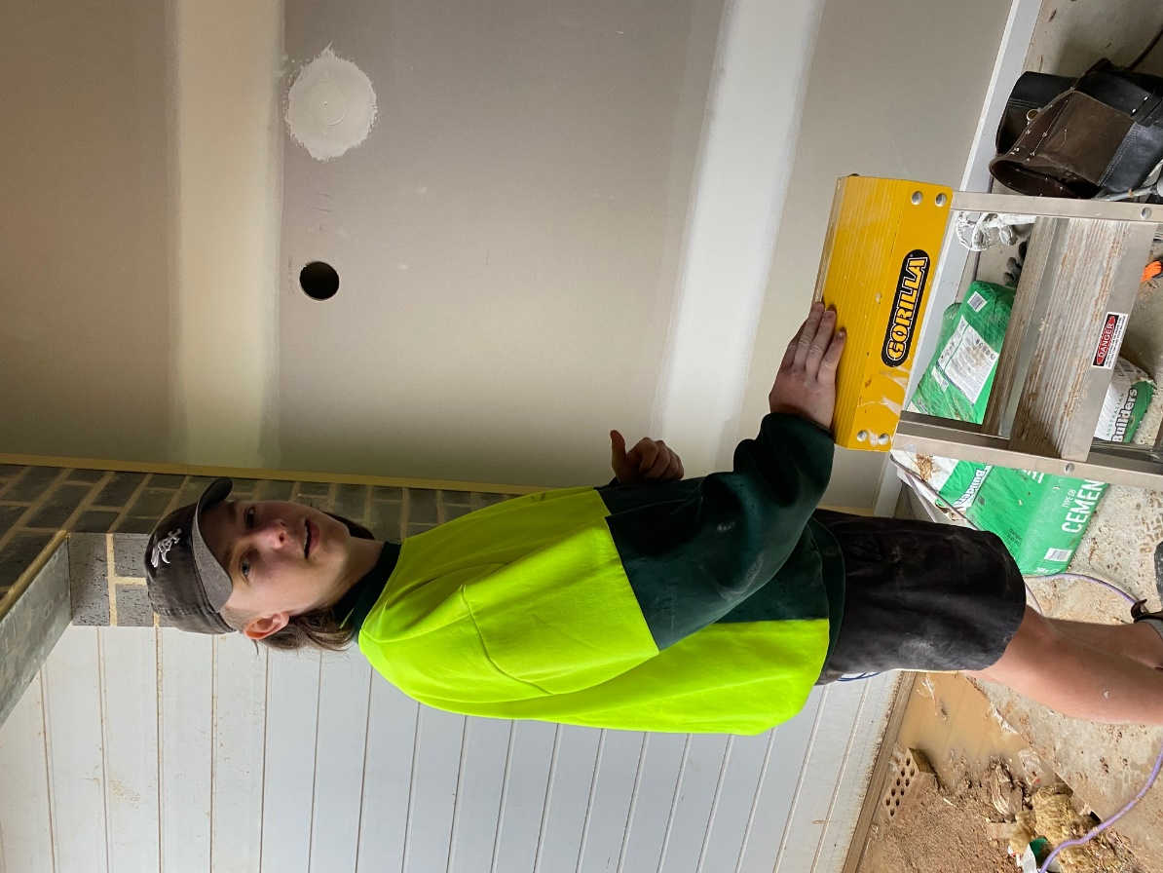
Figure 2
Joshua wanted to explore other opportunities outside of school. An SBAT gave him a different perspective and respect for the importance of lifelong learning.

SBAT in the Health Industry during a Natural Disaster and COVID-19
Cameron Roach is a very personable Year 12 student at Eden Marine High School undertaking a SBAT in Certificate III in Individual Support (Aged Care). After completing Work Experience at Bupa in Year 10, Cameron decided to follow in his parents' footsteps, who are both Aged Care workers.
A predominately female-orientated profession, Bupa were keen to offer Cameron a SBAT after successfully employing other SBAT students from Eden Marine High School.

The Challenge
After starting work one day a week at the end of Year 10, Cameron became part of the evacuation team of the entire Aged Care Facility when the bushfires hit the area. Alongside his parents, Cameron assisted the staff in organising the families to come and take their relatives home. The residents were also transported by buses and ambulances to a Facility in Canberra. Cameron spent a week in Canberra, reassuring residents that they would be fine, and continued his usual rounds until it was time to transport the residents back to Eden.

Success
In March 2020, COVID-19 stopped Cameron from attending Bupa under the government restrictions, as he was under 18 years old. Although still having his theory units to complete, Cameron could not return to Bupa for seven months, putting pressure on him to complete the required 100 days on the job. Fortunately, Cameron is now fully vaccinated and does additional shifts that have put him back on track.
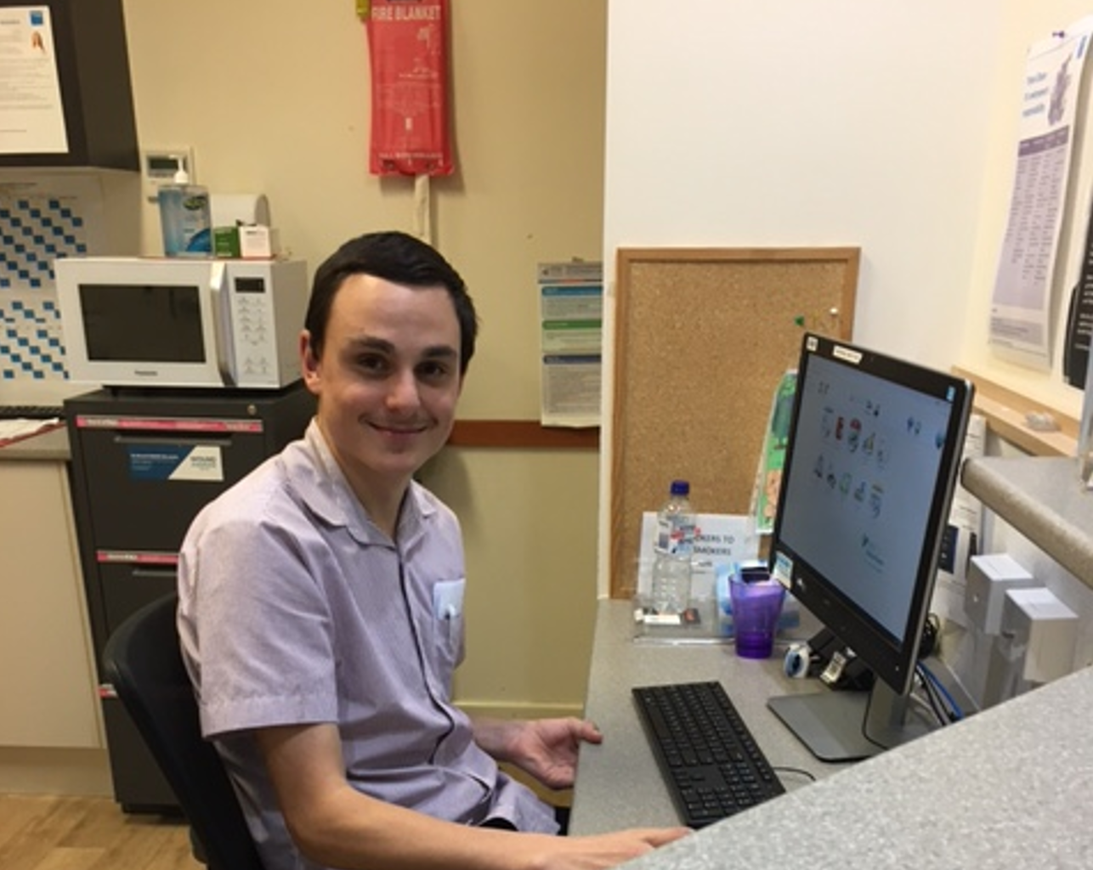
Figure 3
Working in the Aged Care Industry has certainly made Cameron a resilient young man.
The staff and residents at Bupa cannot speak more highly of Cameron. He is a credit to Eden Marine High School and the profession. He will continue his journey towards becoming a nurse after completing his SBAT with the support of Bupa in Eden, where they have offered him a full-time position once he has finished his HSC exams.

