Bulahdelah Central School 2020 school to work Go-Getters
Interview with Linda Drenkhahn
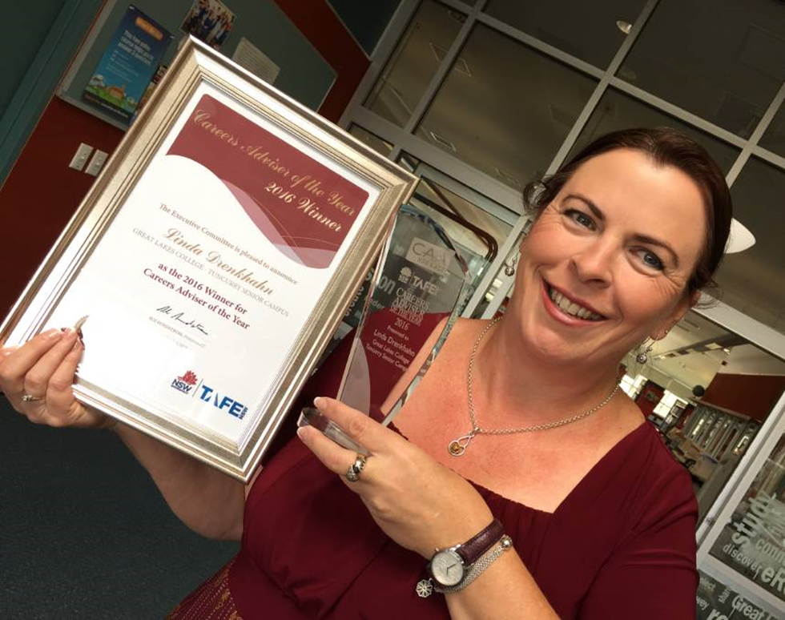
Figure 1 Linda Drenkhahn, Career Adviser of the Year, 2016
How long have you been working as a careers adviser?
Twenty-six years, 24 of those full time.
What are the most rewarding experiences in your job role?
Helping students take the next step out of school and into further training or employment, especially when it’s something I know that they are interested in and have been working towards for a long time.
Describe your role in a sentence.
Working with individual students to empower them with the knowledge and skills they need to make decisions and create their future career path.
What do you enjoy most about your role?
I like flexibility of the role, and that my interactions with students are completely student focussed and almost always positive. I rarely have a bad day at school!
What are your long term personal plans?
Have the flexibility to work part time after I turn 60.

The project
It was difficult to implement lots of activities and programs as normal in 2020 due to COVID. In Terms 2-4 however, we were able to run a project we called the ‘Go-Getters’ one day per fortnight.
A group of 12 students in Years 9 and 10 were selected to complete the Whitecard and participate in a refurbishment of an overgrown garden area in the centre of the school, known as the Secondary COLA (covered outdoor learning area). These students, along with senior construction students and Year 9 and 10 agriculture students, local police officers, teaching and SASS staff demolished the overgrown garden, built a BBQ and pizza oven, garden beds and a paved area with the help of a TAFE brick and block teacher who lives locally.
Aboriginal students painted a series of murals which have been attached to the brick wall adjacent to the COLA and garden area. Materials for seating were donated by the local timber mill and the local Country Women's Association made a significant donation for plants in the new garden.
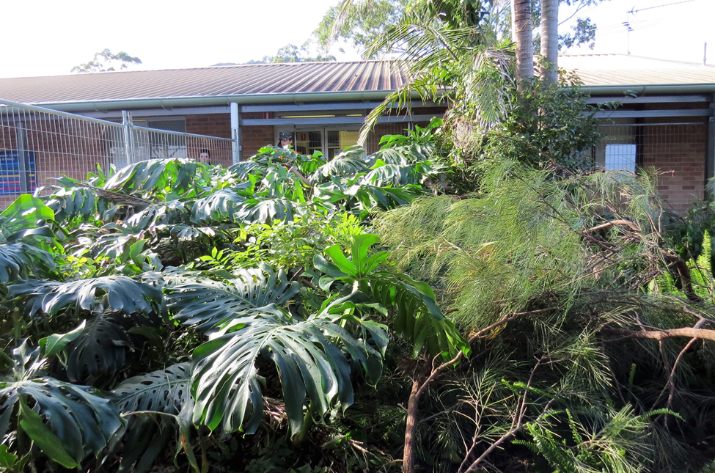
Figure 2 Before

The project’s success
The work the students were engaged in was very visible to the entire school community. Students from across the school, even primary, were asking questions about when they could do a similar project. These students had a lot of positive reinforcement from staff and peers. They demonstrated an improved pattern of attendance during the term of the project, and it had a very positive impact on their behaviour. Several staff commented that they were better behaved and more engaged in their lessons, and all had fewer negative Sentral entries than the previous year.
Parent feedback was extremely positive. The students learned many skills including teamwork, communication, work health and safety, planning the day’s work, meeting deadlines, brick and block laying, rendering, paving, concreting, painting and gardening. The main outcome was pride in their work and achievements and a long-lasting legacy in the school that they were part of constructing. The skills and experiences to list on their resumes to discuss with future employers was also an important long-term benefit of the project and investment in the student’s future.
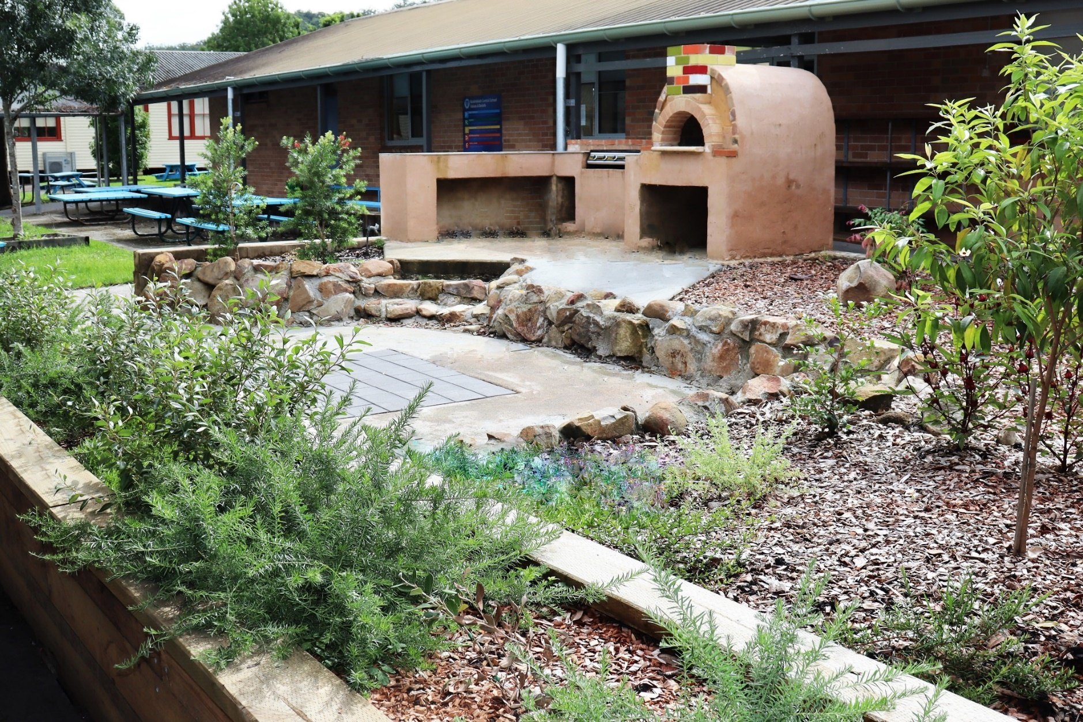
Figure 3 After

Challenges
The main challenge was restrictions to work experience due to COVID-19. The program was set up so that students were working on garden/construction one Friday per cycle, and participate in work experience of their choice off site on the alternate Friday. Only a few students were able to secure a placement during Term 4. The only other set back was some rain where work had to be suspended.
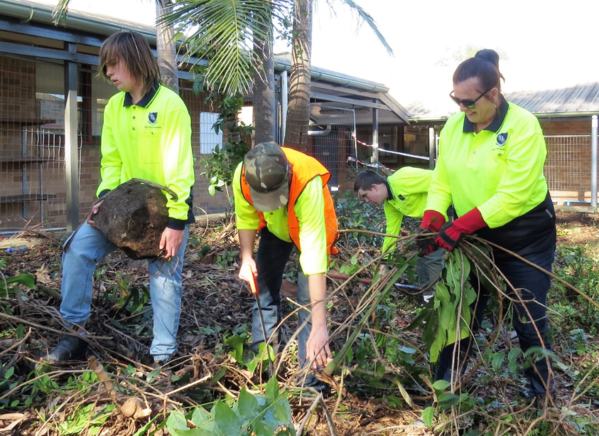
Figure 4 Clearing the area
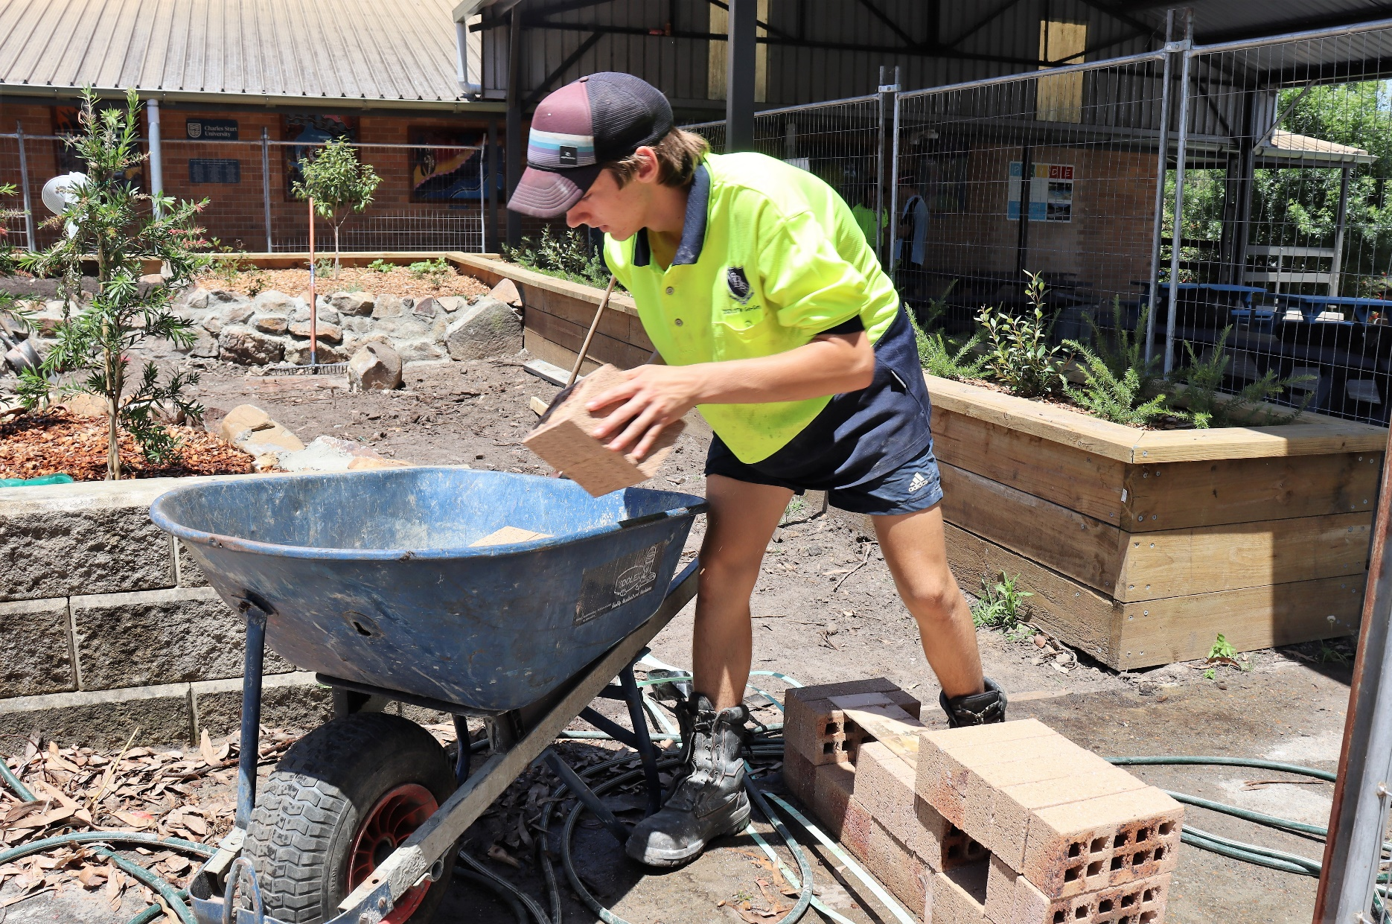
Figure 5 Making progress
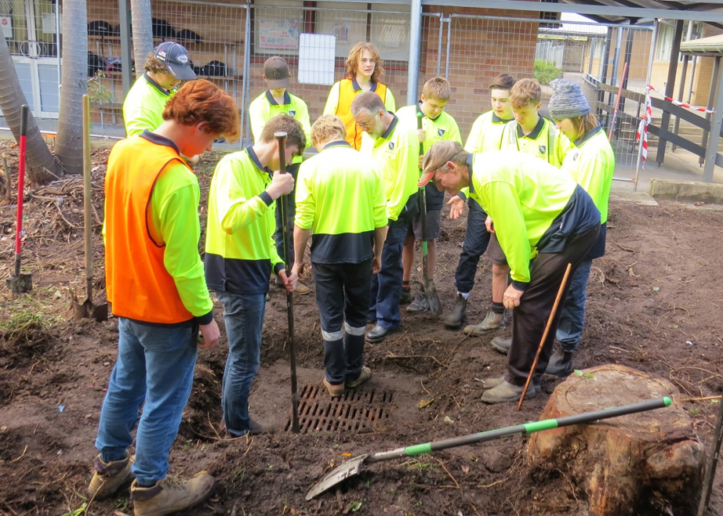
Figure 6 The discovery
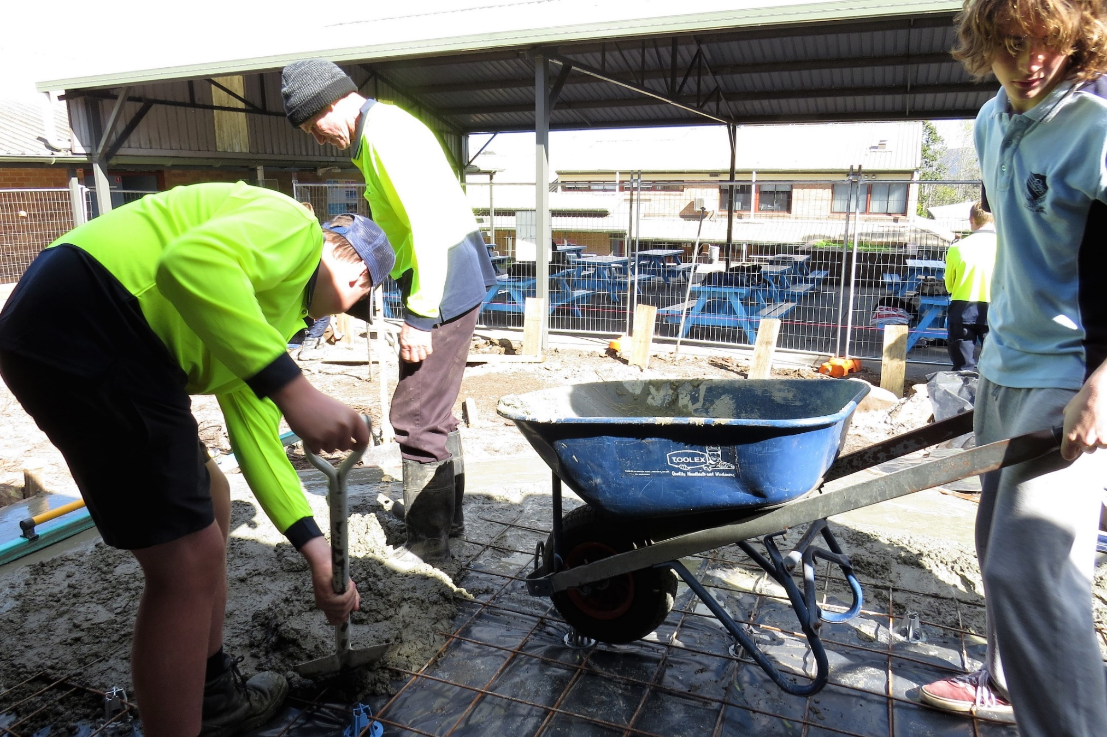
Figure 7 Laying the foundation
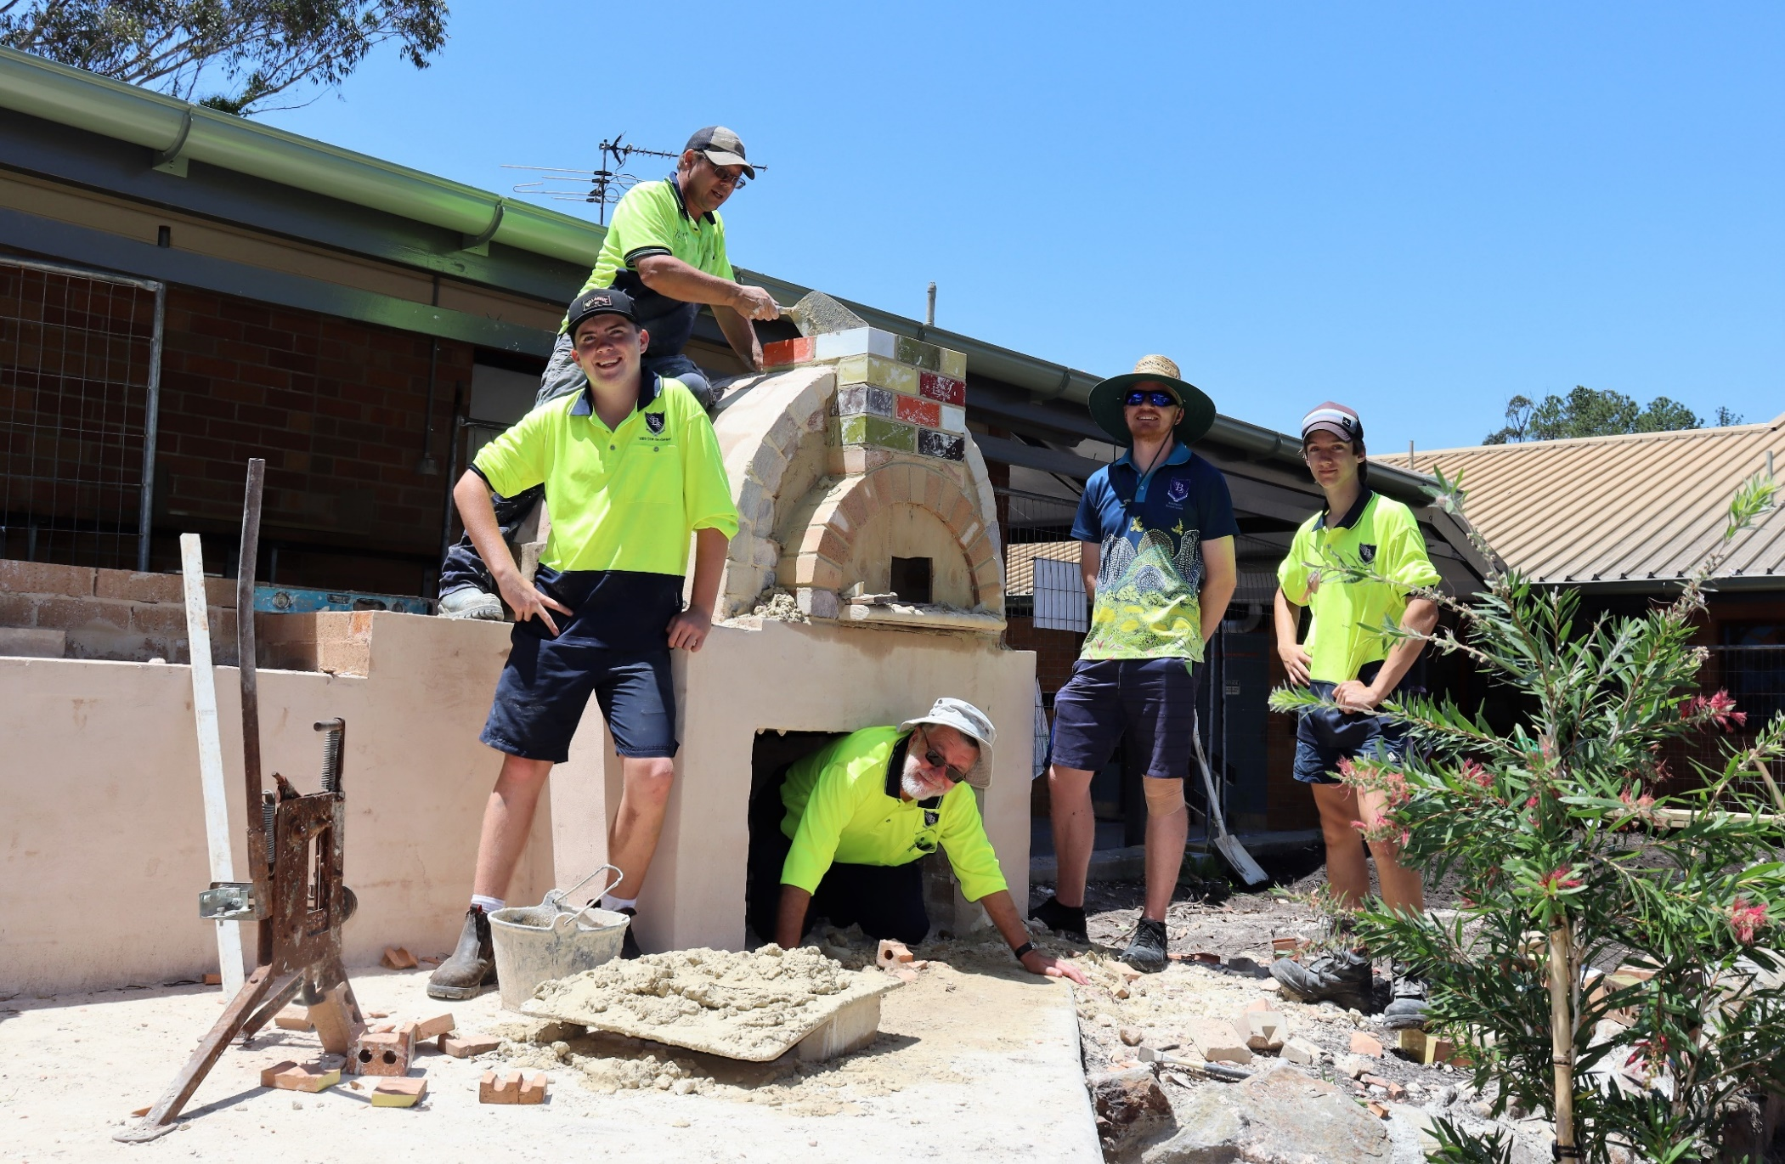
Figure 8 Barbecue and pizza oven

About the school community
The program was discussed with several key staff including the principal who was very supportive and committed significant funding to the project. The deputy principal, head teacher TAS and TAS/VET staff, general assistant and the agriculture assistant were consulted and their support secured.
A Facebook message sent out on the local community and school page led to several locals volunteering to come in and help. The two local police officers worked alongside the students at various intervals during the project. The owners of the local timber mill donated two huge slabs of wood to make seating to compliment the work. The local Country Women's Association ladies offered a significant donation which was used to pay for some of the plants. A local bricklayer, who also works for TAFE NSW assisted with the design, construction and teaching of skills to create the BBQ and pizza oven.
Regular photos and updates in the school newsletter and Facebook page has engaged the community, with several ‘likes’, shares and comments encouraging and supporting the student’s progress and achievements.
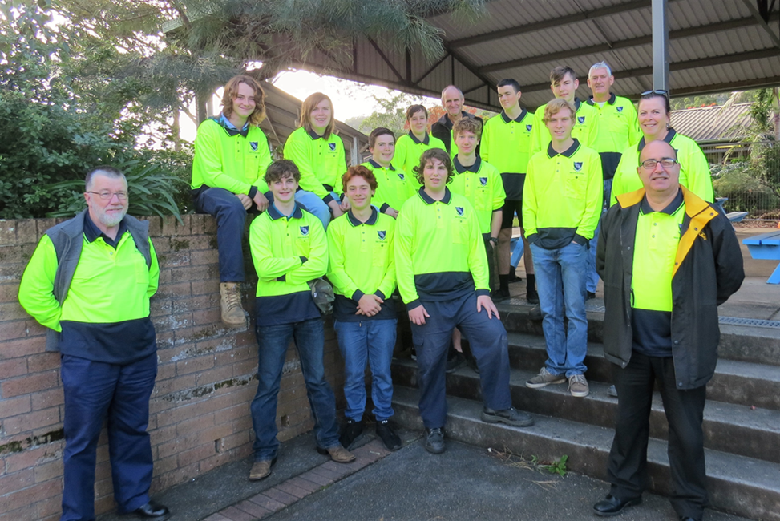
Figure 9 The team

