Blayney High School
Industry Links
Interview with Clint Giddings
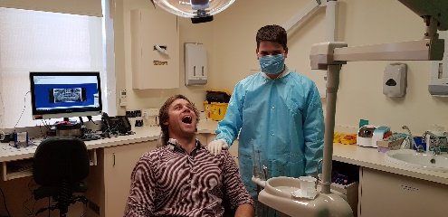
Figure 1 Clint Giddings sitting in a dental chair
How long have you been working as a careers adviser?
Seven years

What are the most rewarding experiences in your job role?
Watching and assisting students to transition into the next phase of their lives. Seeing them in the years down the track being successful in something you helped them transition in to, whether it be university, employment or other training.
If you can describe your role in a word or sentence, how would you describe it?
Rewarding
What do you enjoy most about your career position?
The relationship with students and their parents when trying to attain a specific goal. In my role you can actually specifically focus on an attainable goal for a student (ie gaining employment) and enjoy the fact it has been achieved.
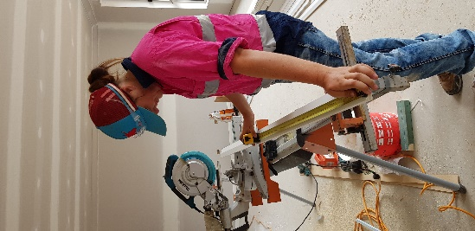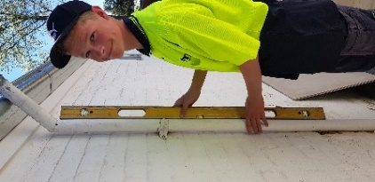
Figure 2 student measuring Figure 3 student using a water metre

Describe your school’s program
Industry Links is a multi-faceted program that tries to link the school and our students to local industries to increase their knowledge, assist businesses in selecting employees and to increase connectedness.

Milestone for the program. What obstacles were encountered?
Introducing myself as a contact for local industries and trying to improve the perception local industries had of our students. It was reached through fluid communication and a program that increased the importance of Careers Education in the school. Obstacles we had to overcome were past perceptions and this was achieved slowly through student Work Readiness and positive interactions with local industries.

What are the school's short and long term plans for the program?
Short term goal is to improve the connectedness with local industry and the long term goal is to have the program so well entrenched in school curricula that when I leave it will be easily continued.

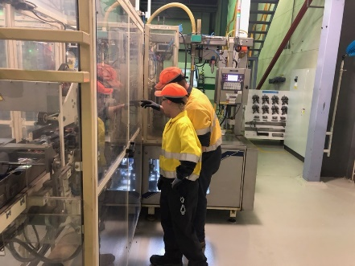
Figure 4 students in the workplace

What has been the most successful outcome so far from the program?
Student knowledge increase, successful work placements and affects such as local industries accessing the school to transition students into vocational training and employment.

When has the program not gone according to plan? What happened?
Not all local industries have the same enthusiasm to school/industry connectedness. Fortunately the ones that do offer enthusiasm and encouragement that makes up for the ones that are not as involved.

