Batemans Bay High School
Rural and Remote K-12 Career Education Initiative
Interview with Chantal Bradshaw

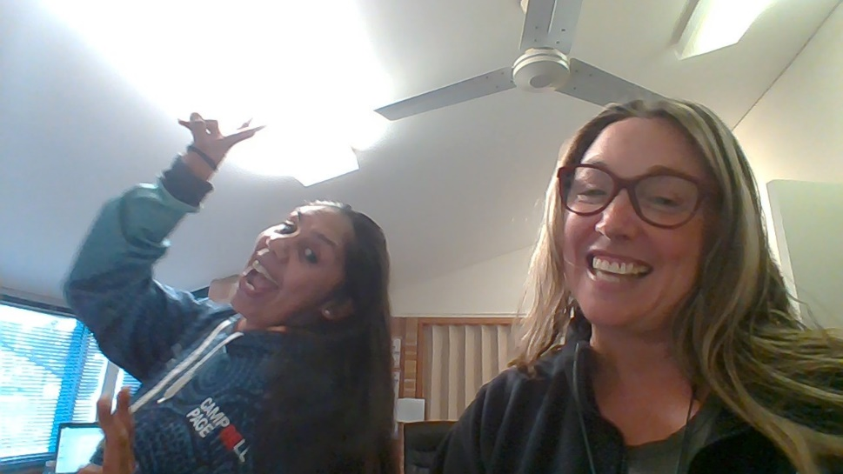
Figure 1 Amber and Chantal

How long have you been working as a careers adviser?
I have been working at my school as a teacher since 2011. In 2016, the opportunity came up to apply for the Careers position. With a background and passion for Work Education, I jumped at the chance to apply. I have been in the position since then.

What are the most rewarding experiences in your job role?
The best experiences are when you help a student to discover a passion. Running into an ex-student to find out that they had followed a piece of advice and are really enjoying their study or work.

If you can describe your role in a word or sentence, how would you describe it?
Variety is definitely the spice of life as a Careers Practitioner. No two days are the same and each student is entirely unique.

What do you enjoy most about your careers adviser’s position?
I love using my skills and experience to help guide a student. Giving a student options and seeing them happy is extremely fulfilling.

What are your long term personal plans?
I aim to continue my personal growth and seek updated information. I endeavour not to become stagnant. I want students to admire and respect the Careers Office and the advice we offer.

About the Rural and Remote K-12 Career Education Initiative

What was your role in the initiative?
I am the lead role in this initiative but I am following the lead of our idea generator, Amber Brown.

Which schools are involved in your Rural and Remote K-12 Career Education Initiative?
Batemans Bay High School is the lead school and we have partnered with one of our feeder schools, Sunshine Bay Public. This is the first time that we have had a formal careers program across the schools.

Describe your school’s initiative
Our main initiative is to compile a written career resource. Students in Years 5 and 6 interview workers in our local community to outline their career journey. We have partnered with a publishing company to write the book. It will also include student drawings, poems and Kinder “What I want to be when I grow up” segments. The book is furnished with information on how to proceed with each pathway. There will be a competition to name the book as well as the front cover – judged at the local shopping mall. Students will then plan a Launch Event for when the book is published.
In addition to this main project, we are sourcing career themed Early Readers and a costume box for the Primary School and some new Careers Resources for Secondary.
During our initial planning time last year with Gigi (Senior Pathways), Amber and I were able to start brain storming project ideas. With the intent to create an ongoing relationship, expand the careers education in the primary years and establish a long-term career learning protocol.

What have you done towards your initiative so far?
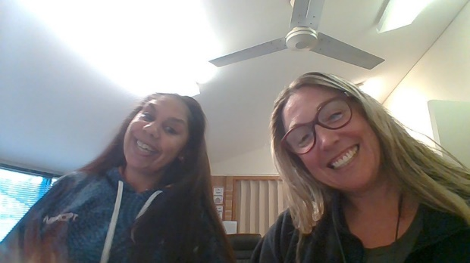
Figure 2 Amber and Chantal planning
During the planning process, Amber came up with the idea of writing a book. Brilliant! This became our main idea. The team organise and schedule activities by using our school calendars to plan. I have a flexible timetable so it is easier for me to travel to the primary school. Morning lesson suited the Primary school best, after their morning exercise.

What are your short term and long term plans?
In the short-term, we aim to expose students to a range of work skills and get them starting to think about a career. In the long term, we want to create an inspirational resource to use with students from Primary through Secondary, which is no mean feat. We need bright, fun pictures for the younger readers and detailed information for senior students. We want to celebrate local community members from a range of industries.

How will the initiative be sustained?
The team has discussed how this initiative will be sustained for many years? The resource will be updated every few years to keep the information up to date and the profiles fresh.

