Albion Pak High School
Skills 21 Stage 5 Program
Interview with Allyson Fisher

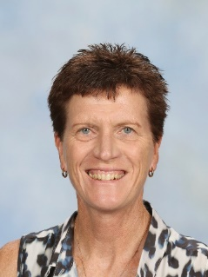
Figure 1 Allyson Fisher

What are the most rewarding experiences in your role?
The role of the careers adviser is one of the most positive roles in a school. You get to work with students who are genuinely seeking your advice or assistance. The day to day experience is positive which makes coming to work enjoyable. In this role you are supporting students and their families manoeuvre through often uncharted territory, building their confidence and supporting them to achieve their current and future goals.

If you could describe your role in a word or sentence, how would you describe it?
Project manager, event manager, counsellor, tap dancer and juggler of priorities.

About the Skills 21 initiative

Describe your school’s program/programs
In 2017 the ‘Skills 21’ program was introduced as an option for Stage 5 (Year 9 and 10) students. It was developed collaboratively from initial discussions with the Deputy Principal and Principal and was designed for students who required a different approach or focus to their learning.
Students in the Skills 21 program obtain a ROSA (Record of School Achievement) at the end of Year 10, but have the opportunity to ‘learn through doing’ (experiential learning). This style of learning has a project-based learning focus, which links with the development of essential 21st century skills. These skills are critical in our rapidly changing world and include communication, leadership, initiative, team work, problem solving and critical thinking.
​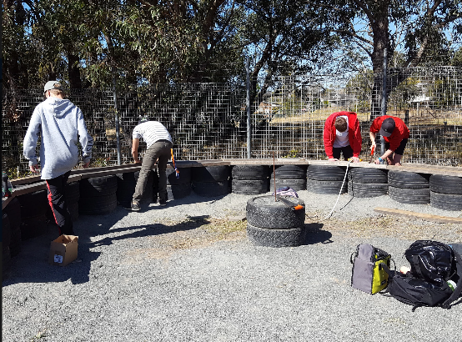
Figure 2 Students at work

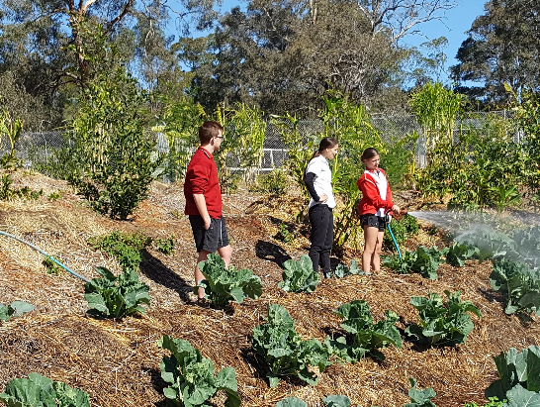
Figure 3 Sustainable garden
Students involved in the Skills 21 program complete regular course work in English, Mathematics, Science, HSIE and PDHPE. They also select a 100-hour elective course. All students who opt into the program will then be involved in Work Education/Industrial Technology (focus area is Farm Maintenance) as their 200-hour elective.
Figure 4 Sample course structure
The Work Education/Industrial Technology elective will have a focus on the Living Classroom and projects linked to its maintenance and further development. Students have a designated ‘work day’ (3 periods per week) and have the opportunity to collaborate with students in the Pathways programs offered in Year 10 and Year 11.
The 'Living Classroom' consists of a garden that has been designed, constructed and maintained using the methods and philosophies of permaculture. Permaculture is a forward-thinking design system based on principles found in nature. Its purpose is to create living environments that are harmonious, sustainable and productive; while greatly reducing the work and energy required to maintain them.
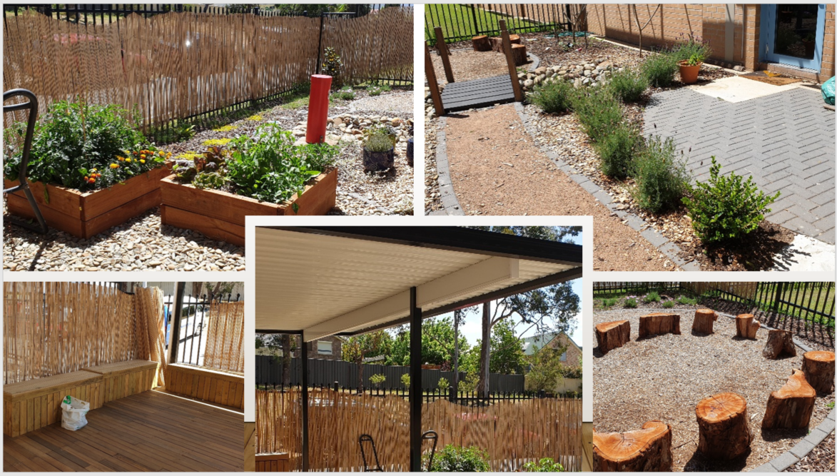
Figure 5 The living classroom
How did you organise and schedule the students and activities?
The program has been designed via a collaborative approach with all Skills 21 teachers and has had to be flexible so that the needs of each particular cohort are met. As the program coordinator I work closely with faculty Head Teachers and this ensures that all subjects have input into the projects that are developed. Planning has been the key to success and adopting a cross curricular approach means KLA’s can add value to the program by identifying suitable syllabus outcomes that support the target focus for the cohort. This could be a numeracy and literacy focus or it could be about relevance of learning to post school goals. Year advisers, anecdotal data from teachers, NAPLAN data, wellbeing data and parents are all used to identify students that are targeted for inclusion in the program. Students opt into the program and their involvement is monitored closely to ensure attendance, wellbeing and progress is positive. Parent and carers are involved in all aspects of the program including attendance at information sessions, approving student nominations and receiving regular feedback on student progress.

Who and what do you need to initiate the program?

Figure 6 Key features supporting Skills 21

Can you provide an example of an obstacles that were encountered? How were the obstacles overcome?
There have been times when students have been in the program and the structure has not suited them. Although the teachers spend a lot of time at the start of the program setting the ground rules and explicitly outlining behaviour and participation expectations some students don’t cope with a slightly less structured classroom environment. I openly acknowledge that the program does not work for every student and it involves continual negotiation to ensure goals are met. This has been managed through the support of the senior executive and executive who have committed to manage student, staff and program obstacles. A fortnightly meeting with all stakeholders highlights current and potential issues and gives Skills 21 teachers the opportunity to express concerns and develop strategies to ensure a positive environment for all.

What are the schools short and long term plans for the project/program?
The main focus in the early stages was to develop a permaculture garden. The initial group, designed and developed the Living Classroom in consultation with a permaculture expert. The project has sustainability while having a sustainability focus. This 60m x 60m space requires ongoing maintenance and it remains the focus of the Skills 21 program.
Students in the program can see tangible outcomes from their involvement in the program and really take pride in what they have achieved. Aesthetically this is making a positive impact on the school environment and continues to provide the entire school community with a great learning environment, as well as promoting the skills and knowledge associated with sustainable living.

