PDHPE and English Stage 2 – All the ways I am smart
Contents
PDHPE and English Stage 2 – All the ways I am smart 1
Rationale and background information 3
Australian Blueprint for Career Development (ABCD) 3
K-12 Career Learning Framework 4
Introduction 5
Activity 1 – All the ways I am smart 7
Learning intentions 7
Success criteria 7
Resources 7
Warm up 7
Teaching and learning activities 8
Activity 2 – My Character Strengths 8
Learning intentions 8
Success criteria 9
Resources 9
Warm up 9
Teaching and learning activities 9
Summarise 9
Activity 3 – Inside Jobs 10
Learning intentions 10
Success criteria 10
Resources 10
Warm up 10
Teaching and learning activities 10
Activity 4 – My Smart Career Opportunity 11
Learning intentions 11
Success criteria 11
Resources 11
Warm up 12
Teaching and learning activities 12
Conclusion 12
Differentiation 13
Student worksheets 13
Worksheets 14
The 24-character strengths 14
Evaluation 15
Evidence base 16
Feedback 16

Reviewed by: Student Pathways Advisor and Student Transition Coordinator, Career Programs
Created: June 2023
Last updated: June 2024
Consultation: Career Learning in Curriculum (CLiC) documents have been written in consultation with curriculum writers from various key learning areas. Curriculum Primary Learners and Career and Workplace Learning have reviewed this resource.
Anticipated resource review date: Resources are reviewed every 12 months for currency and relevancy as part of the Career and Workplace Learning team’s evaluation plan.
Alignment to School Excellence Framework (SEF):
- Learning domain: Curriculum, Teaching and Learning Programs.
- Teaching Domain: Effective Classroom Practice.
Alignment to Australian Professional Standards for Teachers:
Standard 2
- 2.1.2 Apply knowledge of the content and teaching strategies of the teaching area to develop engaging teaching activities.
- Use effective teaching strategies to integrate ICT into learning and teaching programs to make selected content relevant and meaningful.
Standard 3
- 3.1.2 Set explicit, challenging, and achievable learning goals for all students.
- 3.3.2 Select and use relevant teaching strategies to develop knowledge, skills, problem-solving, and critical and creative thinking.
- 3.4.2 Select and/or create and use a range of resources, including ICT, to engage students in their learning.

Rationale and background information
Learning for life beyond school is supported when subjects are delivered to students in a way that they can understand how the content is relevant to career pathways and work settings. NESA syllabuses identify work and enterprise as important learning across the curriculum content for all students.
Career learning resources have been developed to enrich existing teaching and learning programs to facilitate effective career education for students, supporting students to link classroom learning to workplace applications, including developing career management skills.
Career learning activities embedded within existing curriculum have been aligned to the themes from the Australian Blueprint for Career Development (ABCD): and the K-12 Career Learning Framework.

Australian Blueprint for Career Development (ABCD)
The ABCD is a framework grounded in career theory that can guide career development work and support career development learning across the lifespan. The ABCD presents key competencies, grouped into three learning areas, Personal management, Learning and Work Exploration and Career building. The K-12 Career Learning Framework is underpinned by the Australian Blueprint for Career Development.

K-12 Career Learning Framework
The K-12 Career Learning Framework identifies the skills, attitudes, and knowledge that individuals need to make informed choices and to effectively manage their careers. These competencies have been grouped under three themes.
Identity – building and maintaining a positive self-concept, responding to change, and developing capabilities.
Experience – discover, investigate, and consider opportunities in lifelong learning and work exploration.
Empower – learning to self-manage, engage in career decision making and developing skills and capabilities to make informed decisions.
The Career Management Skills identified in this resource are: -
Identity: Discover personal characteristics, qualities strengths and weaknesses.
Experience: Learn through curiosity and adventure.
Empower: Discover life and work roles.
Table 1 – Syllabus outcomes - Personal Development and Health - K- 6 Syllabus (2018), English K-10 Syllabus
Outcomes | Code | Content points and National Literacy Learning Progressions
Explores strategies to manage physical, social, and emotional change | PD2-1 | UnT2  Comprehension  - listens to texts read by an adult  - repeats fragments of text  - invents a spoken text based on images  Processes  - recognises symbols and words in texts (recognises own name)  - shows awareness of correct orientation of text (the book is the right way up)  - imitates reading behaviour, beginning at the front, and finishing at the back of the book  Vocabulary  - names familiar objects in texts and adds some detail (the apple is red)
Explains how empathy, inclusion and respect can positively influence relationships | PD2-3
demonstrated a range of interpersonal skills that build and enhance relationships and promote inclusion in various situations | PD2-10
communicates with familiar audiences for social and learning purposes, by interacting, understanding, and presenting | EN2OLC-01

Introduction
This unit provides opportunities for students to develop an understanding of their own identity through exploring personal characteristics, qualities, and strengths. Students will learn about work roles that align with their strengths. It provides opportunities for students to:
- Identify their personal strengths and characteristics
- Explore different career opportunities
- Connect their personal strengths and characteristics to potential careers
There is a total of 24-character strengths identified by Martin Seligman and Neal Mayerson. Research shows that we do in fact have each of these strengths within us. Some strengths are more developed and some rarely surface. Did you know that it is important to find a balance of your strengths? If, for example, bravery has been identified as one of your strengths, it means you have mastered optimum use of this strength. Underuse of this strength might look to not taking chances, whilst overuse of this strength might put you in a dangerous situation. Optimum use might look like taking risks in your learning. It's important to identify your top 5 strengths, better known as your signature strengths, to ultimately capitalise on opportunities within your life.
Duration: 6 x 60 minutes
Student prior learning
Before engaging in the teaching and learning activities in this unit, students would benefit from prior experience with:
- gathering information to write an informative text
- writing an informative text
The following table outlines the sequence and content of lessons when teaching this unit.
Table 2 – Lesson sequence and summary
Lesson | Title | Description
1 | All the Ways I am Smart | Read the book “All the ways I am Smart” and identify the different ways students are individually smart.
2 | My Character Strengths | Look at the 24 Character Strengths, identified by Martin Seligman and Neal Mayerson. Students identify their personal character strengths.
3 | Inside Jobs | Read the book “Inside Jobs” and students match the ways they are smart and their character strengths to a particular job.
4+ | My Smart Career Opportunity | Research the chosen job from previous lesson using the careers bullseye and gather information on it. Students write and present their information report on their chosen job.

Activity 1 – All the ways I am smart
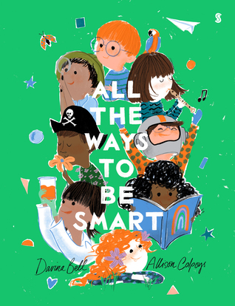

Learning intentions
Students are learning to:
Identify their personal talents/special skills

Success criteria
Students can:
- Identify at least 5 different way they are smart
- Identify and list the skills that the way in which they are smart offer.

Resources
You will need the following resources for this lesson:
The book – All the Ways to Be Smart – By Davina Bell and Allison Colpoys
Link to All the Ways to Be Smart book https://www.youtube.com/watch?v=BpJc_CiB0OQ

Warm up
Show the class the book “All the ways to be smart”. Have students make predictions about what they think the book will be about using the title and front cover.

Teaching and learning activities
Read the book to the class. After reading, have students turn to the person next to them and talk about what stood out to them from the book and summarise the story.
Optional: share ideas with the class.
After ideas have been shared encourage students to think about special skills/talents/abilities they have such as presenting in front of a group of people, sports skills, music talents, creativity skills etc.
Students write down their individual ways they are smart connecting to the ideas in the story. Students are invited to present their identified special skills / talents / abilities to the class. Other class members may also identify additional qualities and skills in the presenter.

Activity 2 – My Character Strengths
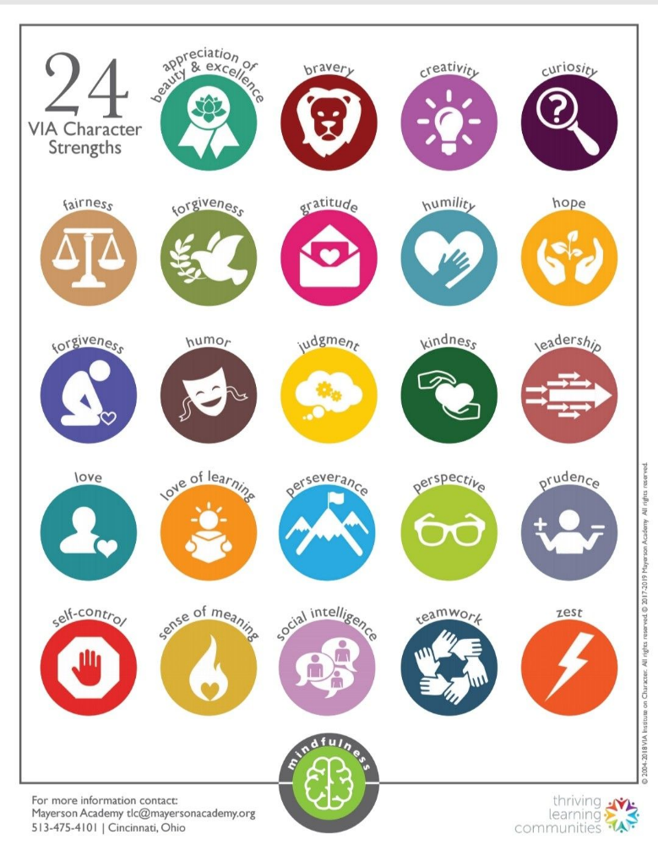

Learning intentions
Students are learning to:
Identify their personal character strengths.

Success criteria
Students can:
- Understand the 24 different character strengths
- Identify at least 3-character strengths in themselves.

Resources
You will need the following resources for this lesson:
- 24 Character Strengths identified and led by Martin Seligman and Neal Mayerson worksheet (see worksheet below)

Warm up
Recap what students learnt about themselves in the previous lesson.

Teaching and learning activities
Introduce the 24 Character Strengths
When introducing the strengths have students express what they think each character strength means and what it would look like in themselves or in someone else.
Optional – Give the definitions of each strength or have students find the definition.
Have student analyse the 24-character strengths and then pick out at least 5 strengths they see in themselves. Students could work in small groups and ask peers what strengths they see in them and vice versa.

Summarise
Have students share their choices with the class and give examples of how they show this strength in their everyday lives.

Activity 3 – Inside Jobs

Learning intentions
Students are learning to:
- Identify different areas of work and jobs in the community.

Success criteria
Students can:
- Identify different jobs that would suit the ways they are smart and their character strengths.
- List and describe how their character strengths match certain jobs.
- Narrow options down to their top 3 favourites.

Resources
You will need the following resources for this lesson:
- The Book – Usborne Look Inside Jobs
- YouTube link to the recorded book: https://www.youtube.com/watch?v=Era6JJY9pY0

Warm up
Recap from the previous two lessons and have every student share with the class one way they are smart and one character strength they have.

Teaching and learning activities
Start by showing the class the book Usborne Look Inside Jobs. Have students make predictions about what they think this book is going to be about.
Read the book to the class. Have students use a whiteboard/book/piece of paper while you are reading to jot down any jobs that interest them while you are reading.
As you are reading to the class pose the following questions: Who has ever wanted to do this job?
- What skills would you need to do this job?
- What character strengths would people doing this job need?
- Does anyone know anyone that does this job for a living?
- Did you know this was a job you could do?
When finished reading the book students consider which jobs in the book interest them or would match with the different ways, they are smart, and their character strengths identified in the two previous lessons.
Students are encouraged to choose their three favourite jobs.
Students share with the class the three jobs they chose and why they think the jobs match to the ways they are smart and their personal character strengths.

Activity 4 – My Smart Career Opportunity

Learning intentions
Students are learning to:
- Analyse information regarding potential and chosen job/career opportunities

Success criteria
Students can:
- Navigate a website to find information
- Find and gather information about their chosen jobs
- Select one potential career opportunity to write an information report on
- Write an information report about their one chosen job.

Resources
You will need the following resources for this lesson:
Career Bullseye Website - https://myfuture.edu.au/bullseyes

Warm up
Students talk to the person next to them about the three career options they chose in the previous lesson, the ways they are smart and the character strengths that match each job.
The teacher demonstrates how to navigate and use the Career Bullseye Website.

Teaching and learning activities
Students explore the website and find the three job opportunities chosen in the previous lesson. They gather information about these jobs. Students can also research the jobs on different platforms or using books from the library.
After researching all three jobs, students choose their favourite career opportunity.
Students will develop an information report on their chosen job
Headings for the report could include:
- My favourite job
- Education, Training and Skills I need for this job
- How likely will I find a job when I have completed school or training
- Fun Facts
- My final thoughts
Provide time for students to write, edit, revise, and publish their information report using the ‘Writing process’. They may choose to publish their report as a PowerPoint or Google slides presentation, speech, video or Canva poster.
Students present their information reports to the class.

Conclusion
The teacher will use questioning, discussion or exit slips to reviews the lesson concepts and ensure student understanding.

Differentiation
When using these resources in the classroom, it is important for teachers to consider the needs of all students, including Aboriginal and EAL/D learners.
EAL/D learners will require explicit English language support and scaffolding, informed by the Enhanced EAL/D enhanced teaching and learning cycle and the student’s phase on the EAL/D Learning Progression. Teachers can access information about supporting EAL/D learners and literacy support specific to EAL/D learners.
Learning adjustments enable students with disability and additional learning and support needs to access syllabus outcomes and content on the same basis as their peers. Teachers can use a range of adjustments to ensure a personalised approach to student learning.
Embedding Aboriginal and Torres Strait Islander cultures, histories, and knowledges using Aboriginal pedagogies and content, can enhance differentiation to achieve improved outcomes for Aboriginal and Torres Strait Islander students. Targeted strategies can be used to achieve improved outcomes for Aboriginal and, or Torres Strait Islander students.
Assessing and identifying high potential and gifted learners will help teachers decide which students may benefit from extension and additional challenge. Effective strategies and contributors to achievement for high potential and gifted learners helps teachers to identify and target areas for growth and improvement. A differentiation adjustment tool can be found on the High potential and gifted education website.
Students with additional learning needs access YouTube videos to listen to the book being read. Students also can complete tasks in groups or with a supportive peer.

Student worksheets
The following pages contain worksheets that support this lesson plan,
They can be printed independently from the rest of this activity.
The remainder of this page is intentionally blank.

Worksheets

The 24-character strengths
List of character strengths:
Perspective, bravery, perseverance, honesty, zest, leadership, forgiveness, humility, prudence, self-regulation, appreciation, gratitude, hope, humour, spirituality, love, kindness, social intelligence, teamwork, fairness.
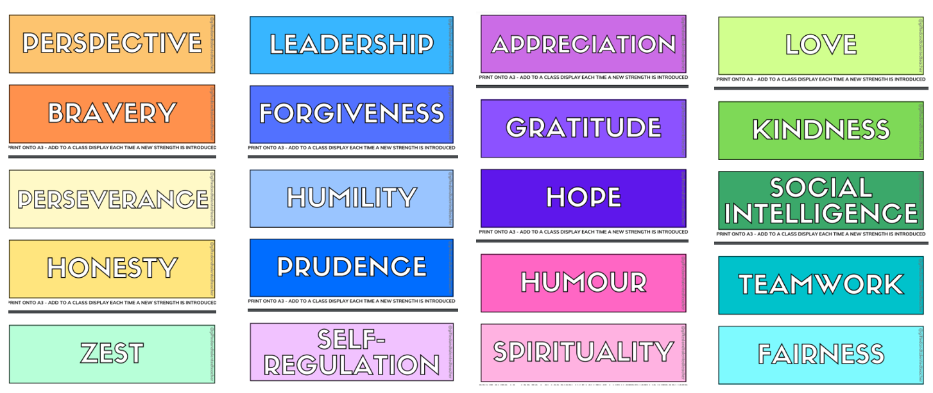
Figure character strengths
- Reach through list of character strengths as a class
- Discuss what these character strengths look like
- List five, character strengths, and describe how you demonstrate that strength.
Table on next page

Table 2 – character strengths
Character strength | Description

Evaluation
Evaluation of learning activities should be an ongoing process throughout the delivery of lessons and units of work. Teachers should document their evaluation of learning activities to determine if students achieved the lesson’s intentions.
What worked well? Why?
What needs improvement? How?

Evidence base
Evidence-based refers to researching practices to apply proof, reliability, and ethical standards to ensure quality. Evidence-based provides credible knowledge that has been created and tested through rigorous methods.
For the complete list of academic research that informed the development of Career Learning in Curriculum resources, visit the K-12 Career Learning Framework website.

Feedback
To provide feedback, or for further information, access the CLiC feedback form link or with the following QR code.
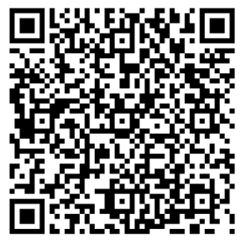

© State of New South Wales (Department of Education), 2023
The copyright material published in this resource is subject to the Copyright Act 1968 (Cth) and is owned by the NSW Department of Education or, where indicated, by a party other than the NSW Department of Education (third-party material).
Copyright material available in this resource and owned by the NSW Department of Education is licensed under a Creative Commons Attribution 4.0 International (CC BY 4.0) licence.
This licence allows you to share and adapt the material for any purpose, even commercially.
Attribution should be given to © State of New South Wales (Department of Education), 2023.
Material in this resource not available under a Creative Commons licence:
- the NSW Department of Education logo, other logos, and trademark-protected material
- material owned by a third party that has been reproduced with permission. You will need to obtain permission from the third party to reuse its material.
Links to third-party material and websites
Please note that the provided (reading/viewing material/list/links/texts) are a suggestion only and implies no endorsement, by the New South Wales Department of Education, of any author, publisher, or book title. School principals and teachers are best placed to assess the suitability of resources that would complement the curriculum and reflect the needs and interests of their students.
If you use the links provided in this document to access a third-party's website, you acknowledge that the terms of use, including licence terms set out on the third-party's website apply to the use which may be made of the materials on that third-party website or where permitted by the Copyright Act 1968 (Cth). The department accepts no responsibility for content on third-party websites.

