Chaplaincy and Student Wellbeing
2023 providers
As at 27 April 2023
The NSW Department of Education completed an Expression of Interest (EOI) Tender Event in November 2019 through the NSW Government eTenders website to refresh the National School Chaplaincy Program (NSCP) Prequalification Scheme.
Schools whose application was successful for the NSCP will continue to be prioritised for participation in the 2023 National Student Wellbeing Program and must engage one of the providers below for a chaplaincy or student wellbeing service.
For any enquiries, please contact nationalwellbeingprograms@det.nsw.edu.au
Organisation | Area | Contact Name | Phone | ABN
2Connect Youth & Community Inc. | Sydney | Valentina Angelovska | 02 9556 1769 | 65 20869 8825
3Bridges Community Youth Zone | South Eastern | Leighton Pollard | 1300 327 434 | 96 0396 01269
Albert Park Public School P&C Association | Richmond-Tweed | Lorraine Nicholson | 0422 112 490 | 59 826 256 018
Anglican Church of Australia Wee Waa | Northern | Rev Daniel Hayes | 0435 254 627 | 77 5651 63069
Anglican Diocese of Bathurst | Central West | Karen Trafford | 0439 550 051 | 15 96869 3964
Asquith Girls High School Parents & Citizens Association Inc | Sydney | TBA | 02 9477 6411 | 37 9988 01931
Big Heart Big Vision | Sydney | Tony Hoang | 0433 101 622 | 92 0129 26013
Bridging the Gap Sydney West Inc | Sydney | Carole Tozer | 0458 885 833 | 85 5447 66376
CatholicCare Sydney | Sydney | Sharron Matayalo | 0407 416 052 | 38 8414 27747
Christian City Church Kingscliff Property Pty Ltd | Richmond-Tweed | Narelle Crichton | 0439 595 231 | 16 07811 5438
Coastcare Incorporated | Hunter  Sydney | Bruce Debenham | 0421 921 181 | 51 8398 53323
Community Activities Lake Macquarie Inc.  (Known as CALM) | Hunter | Sheena Harvey | 02 4950 3888 | 65 32303 3457
Connect Christian Church Inc | Whole of NSW | Debbie Smith | 02 4869 3102 | 57 5614 49658
Dorrigo Public School P&C Association Inc | Mid-North Coast | Michele Kellett | 02 6657 2097 | 15 172 773 832
Eastlakes Salvation Army | Hunter | Bernie Muendel | 0409 664 821 | 57 507607 457
Emmaville P&C Association Inc | Northern | Melissa Quigg | 0437 336 146 | 35 392 385 528
Evans River K-12 School P&C Association | Richmond-Tweed | Craig Tosomeen | 02 6682 6273 | 36 303 792 079
EV Church Ltd | Hunter  Sydney | Kirrily Griffiths | 02 4367 2100 | 95 8803 54126
Fresh Hope Engage | Whole of NSW | Richard Reeve | 02 8573 6000 | 41 041 851 866
Fusion Australia Ltd | Central West  Murray  Murrumbidgee  Northern  North Western  Sydney | Malcolm Rankin | 0453 102 474 | 26 0001 273105
Generate Services Inc | Whole of NSW | Jonathon Marshall | 02 8042 2760 | 59 2233 59776
Gosford Area High School Christian Ministry Association Incorporated | Hunter  Sydney | Bruce Debenham | 0421 921 181 | 27 7401 62259
Great Lakes Education Christian Care Association Inc | Hunter | Ross Murray | 02 6555 9818 | 23 2089 70246
GWFC Chaplaincy Incorporated | Whole of NSW | Elizabeth Pickersgill | 02 4777 0111 | 87 4678 71719
Kempsey High School Parents & Citizens Association | Mid-North Coast | Mick Eller | 0467 711 495 | 79 028 110 079
Korus Connect | Hunter  Illawarra  Murray  South Eastern  Sydney | Chris Dickons | 03 9811 0999 | 59 0042 40779
Life Resources Centre Inc | South Eastern | Peter Junor | 02 6297 5360 | 29 6945 88240
Macquarie Life Church | Hunter | Susan Upfold | 02 4954 7548 | 89 64551 0992
Nepean Community & Neighbourhood Services | Sydney | Julie Collins | 0400 772 117 | 69 1459 24821
NSW Service for the Treatment and Rehabilitation of Torture and Trauma Survivors | Hunter  Illawarra  Mid-North Coast  Murray  Murrumbidgee  Sydney | Arran Saunders | 0410 229 306 | 15 1363 72248
Power to Change | Sydney | Dave Huddleston | 03 9014 7584 | 25 1260 98398
Raymond Terrace Christian Education Association Inc. | Hunter | Tim Blatch | 0414 510 110 | 99 1746 52243
Raymond Terrace Community Church | Hunter | Timothy Blatch | 0414 510 110 | 38 8035 15848
Reach Community Initiatives Incorporated | Sydney | Chris Brady | 02 9807 2500 | 50 10702 5835
Reaching the Nations Christian church | Sydney | Reinaldo Acosta | 0434 237 113 | 90 7659 1326
Religious Education Association of Lismore Inc | TBA | John Arthur | 02 6620 3639 | 33 8947 87366
Sapphire City Schools Ministry Inc. | Northern | Lynette Appleby | 0400 644 757 | 36 7258 08673
Scripture Union Queensland | Whole of NSW | Jennifer Dobbin | 0410 408 004 | 74 0096 69569
Shalom Christian Church Inc | Richmond-Tweed | Rachel Watson | 0466 439 347 | 93 0766 90373
Strong Nation Community Services | Sydney | Elijah Burrell | 02 4587 8091 | 49 04931 9352
Tamworth Chaplains Board | North Western | Howard Barnes | 0421 274 541 | 51 56940 5317
Tumut School Chaplaincy Services Inc | Murrumbidgee | Ken Fitzgerald | 02 6946 2409 | 59 925 942 966
The Bush Church Aid Society of Australia | Whole of NSW | Greg Bridge | 02 9262 5017 | 92 0000 4606
Tweed Heads PS P&C Association | Richmond-Tweed | Katie Tonkin | 0415 437 941 | 71 465 382 523
Young Life Australia Inc | Whole of NSW | Claire Wood | 1300 557 647 | 96 5922 78795
Your Dream Incorporated | Whole of NSW | Darren McMahon | 1300 792 856 | 53 17994 1045
YWCA Australia | Far West  Illawarra  Northern  South Eastern  Sydney | Shannon Wright | 0409 985 895 | 74 11166 3873
Areas in which prequalified providers can provide chaplaincy services, based on the below ABS statistical divisions.
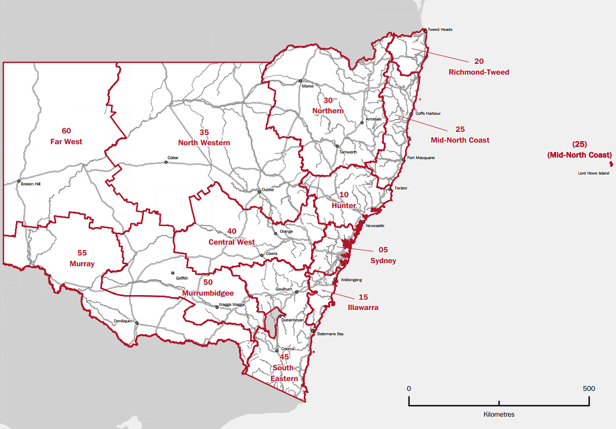
Image source: Australian Bureau of Statistics website http://www.abs.gov.au/AUSSTATS/abs@.nsf/2f762f95845417aeca25706c00834efa/463f50115b6dccfbca2571a9001e1f44/$FILE/NSW.pdf
☐ Central West
☐ Far West
☐ Hunter
☐ Illawarra
☐ Mid-North Coast
☐ Murray
☐ Murrumbidgee
☐ Northern
☐ North Western
☐ Richmond-Tweed
☐ South Eastern
☐ Sydney

