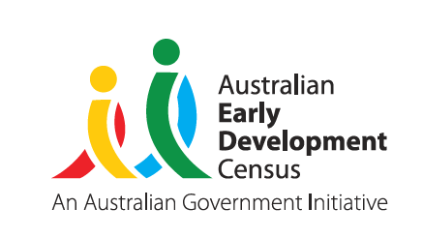
Our Children
Our Communities
Our Future

Australian Early Development Census

Value of the AEDC for educators:
An overview of the ways in which educators can
enhance their planning with community data
© Western Australian Department of Education 2018

About this resource
This overarching summary has been designed to support educators
to understand how the Australian Early Development Census (AEDC) can be used to inform their planning and practice. By working through the three stages: assess, plan and act, educators will have a greater understanding of how to use the AEDC data within their setting to support children’s holistic development.
© Western Australian Department of Education 2018

Assess your context
Children’s learning and development is supported in early childhood education and care centres (ECEC) and schools when programs match their needs and build on their strengths
- AEDC data supports you to reflect on the holistic development of children in your community
- Knowing how children are developing at five years of age can help identify community strengths, challenges and opportunities
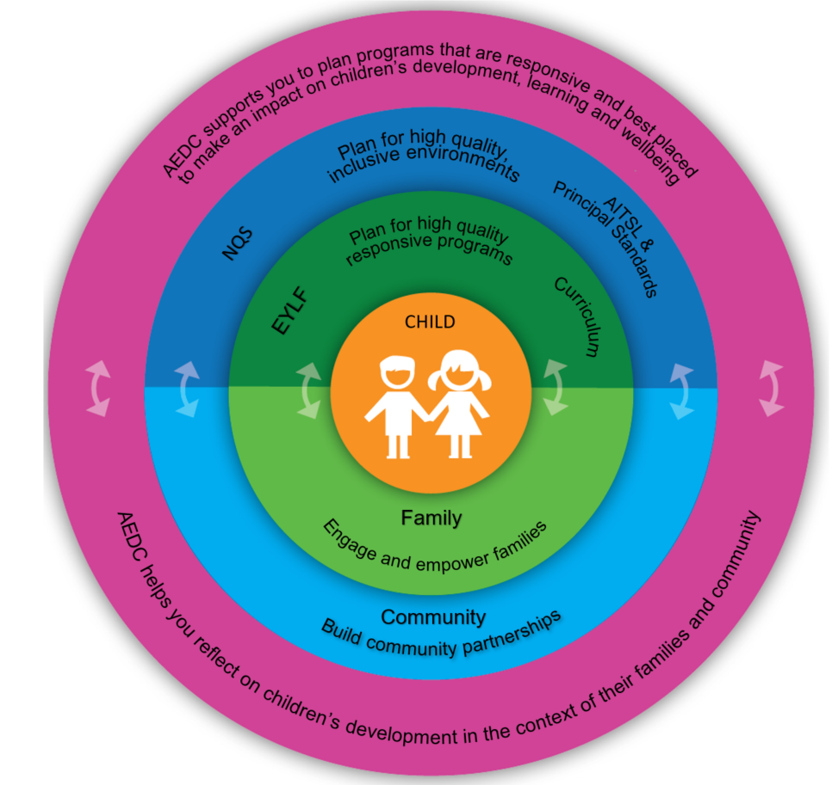
- Reflecting on the local context ensures education and care planning is responsive and inclusive
© Western Australian Department of Education 2018

Examining AEDC data alongside other data can support you to build a more complete picture and enables you to explore the relationships between what children experience, what you do and how children grow and learn.
- How do the AEDC domain results fit with your understanding of the developmental strengths and needs of children
in your community?
- What do you know about the experiences of children in your centre or school that can build a more complete picture alongside the AEDC data?
- Does the AEDC data support or challenge your understanding of the community?
- What assumptions do you bring to the community and how does it influence your understanding of the children in your centre or school?
The AEDC and building connections with the community
The AEDC helps people come together to talk about what is important for children – use it as a starting point to develop a shared vision for children’s development, learning and wellbeing.
The AEDC tells the story of the development of all children in a community. Educators can use the AEDC as a starting point to explore what is happening for children in the community. Use the AEDC to build relationships with the community and to work together to support children and families.
Consider who makes up your community
Your community may include those who live in the area and the surrounding suburbs. In some cases, this may differ from the families that actually attend your educational setting.
Reflect on how other data you collect (e.g. home background and conversations with parents) can be used alongside the AEDC data to help understand your community and their needs.
Using AEDC data alongside other data provides educators with an opportunity to develop a more in-depth and rich knowledge of their children’s skills, attributes and understandings. This can help educators shape programming and pedagogy to take advantage of the community’s strengths and become more responsive to the community’s challenges.
Developing a community network can support you to be responsive to the needs of children and families.
- The story behind your AEDC data and the information collected at your site can help to identify partners in the community.
- Sharing data and information with existing networks can help focus your efforts on what matters for children.
- Sharing information with others in the community can lead to finding new partners who can work with you toward your goals.
Consider the story behind the data and what it is telling you about children
- Who do you already work alongside to shape the outcomes of children in your community?
- What information do you share with your current partners and colleagues? Are there opportunities to enrich this information sharing?
- How extensive and purposeful are your networks – are they supporting you to improve the development, learning and wellbeing of children in your community?
- What is the Equity of Access currently available for children within your community?
© Western Australian Department of Education 2018

Plan your actions
The AEDC provides an evidence base to use in the centre or school’s plan
Demonstrate an evidence based approach to supporting children’s development, learning and wellbeing by linking AEDC data and other information about your community in your planning frameworks.
- In your setting, what could be getting in the way of you making a difference for children and families?
- In your setting, how can you be involved in the ECEC or whole school planning processes?
- To what extent is data from the AEDC incorporated in the centre or school’s planning to demonstrate the link between what you do and what you are working to change?
- Where will you use data in your planning documents to demonstrate your understanding of issues impacting on children’s development learning and wellbeing?
- How will you demonstrate the link between what you do in your centre or school to the intended outcomes for children?
The AEDC and transition planning
In the early years, children experience a range of care and education settings (e.g. home, playgroup, ECEC and school). Adapting to changes in their care and education settings can present challenges for children and disrupt their development, especially when transitions are not mindful of children’s strengths, needs and contexts. When educators reflect on and
are responsive to the contexts and experiences of children, starting school can be a positive milestone that builds on their existing strengths and fosters a love of learning.
The AEDC provides a common language to describe skills that enable children to engage with the learning and social environments in school and early childhood education and care centres. Through this common language, schools and their transition partners can develop a shared vision for children in their community, irrespective of their particular role or field of responsibility.
- What continuity of care and learning do children experience in transitioning to your centre or school?
- How well is your centre or school connected with other services or programs within the community before they come to you or after they leave you?
- What data will you and your team share with your partners, involved in transition pathways, to begin a conversation about how you can work together to support children’s transitions?
- How can you influence and drive connections with transition partners in your community?
© Western Australian Department of Education 2018

The AEDC and quality improvement/curriculum planning
Developing learning programs that are responsive to children, their family and community contexts, ensures that all children have the opportunity to develop, learn and thrive.
The AEDC domains have strong, relevant links to key national frameworks and standards, such as the National Quality Standard (NQS), the Early Years Learning Framework (EYLF), the Australian and NSW curriculum and the Australian Institute for Teaching and School Leadership (AITSL) standards. Reliable community level information about the holistic development of children supports educators to ensure their programs are accessible to all children in the community. Centres and schools can use the AEDC data for curriculum planning and to assist with the development of programs and activities that will support the learning and wellbeing of children.
For further information see AEDC poster ‘Linking the AEDC,
the National Quality Standard, EYLF and NSW curriculum’
A clearly documented plan can help to identify a vision, resources, actions and outcomes for you and your partners
Clearly documenting the plan can help to identify what outcomes can be achieved with the available resources. Consider whether all children and families who could benefit from the service or support will be able to access and make use of it.
An action plan that clearly identifies each activity, the associated costs and resources, funding sources, timelines and strategies for recruitment of children and families into the program or service should be developed.
An action plan:
- should clearly document the steps agreed for implementation;
- can be a useful tool to ensure that all collaborating stakeholders are working to the same information;
- can be used to support funding applications, should this be required.
© Western Australian Department of Education 2018

Act – implement
and evaluate
An action plan can be used to develop an evaluation measure. This will ensure everyone understands the
common vision and is clear about the outcomes
Once your program or initiative is up and running, it is important to see how well it is working and what difference it is making for children and families. The AEDC can be a good indicator of what is happening in your community and can help your program stay on track and in tune with children’s needs.
To know what difference you are making you need a clear idea about what you want to see change. Link your goals to your vision for children early. Deciding early what success looks like helps to keep things on track. New programs or initiatives can fail or succeed based on things that are not often planned for. Having ways to monitor what is helping or getting in the way can help you to make changes as you go so that you have the best chance of success.
Consider the story behind your data and what it is telling you about children
- For things that you can control - how will you address them in your plan?
- For things that are out of your control, ask:
- What can you do now to lessen the impacts?
- How will you respond to the challenges?
- Is there an opportunity to partner with other stakeholders who can support you in achieving your goals?
Begin your journey using the AEDC
- Download and review your school and/or community profile
- Examine the links between the AEDC and the NQS, EYLF, AITSL and NSW curriculum and consider the opportunities to incorporate the AEDC into your existing planning
- Reflect on how you can support children’s holistic development in your setting
- Build partnerships with those who can support you to be responsive to the needs of children and families
© Western Australian Department of Education 2018

For more information

Resource links
- Overarching summary for early childhood education and care and school leaders
- Guides on each of the five domains
- Connections to key documents
- Poster detailing the links between the AEDC, the NQS, EYLF and NSW Curriculum
These resources are available via the NSW Department of Education website at: https://education.nsw.gov.au/ student-wellbeing/whole-school-approach/aedc
To access the AEDC data visit www.aedc.gov.au/data

Further reading
Brinkman, S., Gregory, T., Harris, J., Hart, B., Blackmore, S., & Janus,
M. (2013). Associations between the Early Development Instrument at Age 5 and Reading and Numeracy Skills at Ages 8, 10 and 12: A Prospective Linked Data Study. Child Indicators Research, 6(4), 695- 708. doi: 10.1007/s12187-013-9189-3
Flottman, R., McKernan, A., Tayler. C. (2011). Practice Principle 2: Partnerships with professionals. Victorian Early Years Learning and Development Framework, Melbourne Graduate School of Education.
Goldfeld, S., O’Connor, E., O’Connor, M., Sayers, M., Moore, T., Kvalsvig, A. and Brinkman, S. (2016). The role of preschool in promoting children’s healthy development: Evidence from an
Australian population cohort. Early Childhood Research Quarterly, 35, pp.40-48.
Gregory, T., Harman-Smith, Y., Sincovich, A., Wilson, A. and Brinkman,
S. (2016). It takes a village to raise a child: The influence and impact of playgroups across Australia. Telethon Kids Institute.
Peisner-Feinbert, E.S.,Burchinal, M.R., Clifford, R.M., Culkin, M.L., Howes, C., Kagan, S.L., Yazejian, N. (2001). The relation of preschool child-care quality to children’s cognitive and social developmental trajectories through second grade. Child Development, 72(5), 1534- 1553.
Roiser, K., McDonald, M., (2011). Promoting positive education and care transitions for children. Child and Family Community Australia Resource sheet. Communities and Families Clearinghouse Australia.

Find out more at www.aedc.gov.au and https://education.nsw.gov.au/student-wellbeing/whole-school-approach/aedc
© Department of Education Western Australia 2017 (see: https://www.education.wa.edu.au/copyright and https://www.education.wa.edu.au/ disclaimer for full details).
Developed in partnership between the Western Australian Department of Education, the Association of Independent Schools Western Australia, Catholic Education of Western Australia, the New South Wales Department of Education and the South Australian Department for Education and Child Development. The partners acknowledge the assistance and expertise of the Telethon Kids Institute in the development of the resources.
© Western Australian Department of Education 2018

