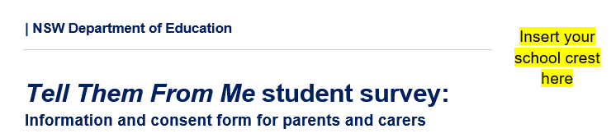

Dear Parents and Carers
This term, our school is taking part in the Tell Them From Me student survey. The survey will provide us with valuable feedback on what our students think about school life, how engaged they are with school and the different ways that teachers interact with them.
The survey is run by an independent research company, The Learning Bar, which specialises in school-based surveys.
As well as providing our school with feedback from our students, the survey has a broader purpose. It provides the Department of Education, through the Centre for Education Statistics and Evaluation, with insights into student wellbeing, engagement, and effective teaching practices for ongoing school improvement. This is done by using non-identifying student data from across NSW.
This survey is confidential, and staff in schools will not be able to identify individual students from their responses.
To ensure confidentiality, participating students will receive a unique username and password. Information is only reported where five or more students answer a question. All information will be handled according to relevant privacy legislation. Students’ personal information will not be disclosed by the department to any other person or body other than as required by law. Individual students will not be identified in any publications.
The survey is online, takes 15 to 30 minutes, and will take place at school during school hours. We will receive a report on our school’s survey results shortly after our students complete the survey.
Participating in the survey is voluntary. If any survey questions make your child uncomfortable, your child can skip the question or can choose to stop the survey at any time.
If you do not want your child/children to take part in the survey, please complete the attached form and return it to the school by delete and insert date of return.
More information about the survey and the research is available in English at education.nsw.gov.au/ttfm

delete and insert name of principal
Principal
delete and insert name of school

Tell Them From Me Student Survey non-consent form

If you do not want your child to participate in the student feedback survey, please sign this form and return it to the school by delete and insert date of return

I DO NOT give consent for my child/children to participate in the Tell Them From Me student survey.

Name of student 1 |  | Roll class of student 1
Name of student 2 |  | Roll class of student 2
Name of student 3 |  | Roll class of student 3
Name of student 4 |  | Roll class of student 4

Name of parent/carer
Signature of parent/carer
Date

English

