Know your sun facts from your sun fiction

Did you know that when it comes to sun protection, not all hats are equal?
We all know that sun safe hats help protect against skin cancer and eye damage. But did you know that baseball caps do not provide adequate protection from the sun? There is very clear evidence that baseball caps leave the cheeks, ears, chin and back of the neck exposed to ultraviolet radiation, and this is the site of many skin cancers in later life.

We’re championing sun safe hats
Our school recognises the need to protect student’s skin and educate them about sun safety to reduce the risk of skin cancer. We provide ongoing education that promotes healthy lifestyles and individual and collective responsibility for sun safety. Sun safe hats are part of our schools comprehensive approach to sun safety and are supported in the following ways: Schools – please select the points following that apply to your school and insert your own
- Students were involved in designing the school sun safe hat
- The school hat is part of our school uniform and is a sun safe design
- Messages about sun safe hats are included in student diaries
- When planning outside events we put emphasis on time of day and shade planning
- Students wear sun safe hats for PE and Sport and at lunch time
- We consider sun safety and the wearing of sun safe hats when planning school excursions
- We ask all teachers and parents to take a proactive approach to hats and to model sun safe hats for outdoor school events
- We have a rewards system in place to recognise students that consistently wear their sun safe hat.

Sun-safe hats include broad-brimmed, bucket and legionnaire styles
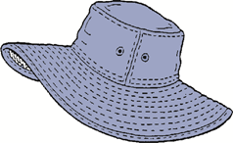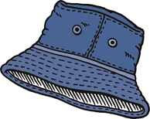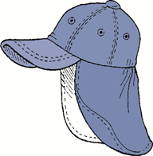

Want to know more?
Sun safety on the public schools website
SunSmart Primary Schools or call the SunSmart team on (02) 9334 176
Know your sun facts from your sun fiction

Protect yourself and others?
Did you know that protecting yourself from the harmful UV rays of the sun as an adult is one of the best ways to teach children to do it too?
Researchers, psychologists, parents and teachers have long known that children imitate adult behaviour – both good and bad. This is why when it comes to sun safety, setting the best example is so important for teachers and parents.

At school and on the weekends
By wearing a sun-safe hat, a shirt with a collar and sleeves, and being seen to apply sunscreen before going outside, as teachers and parents we not only reduce our own risk of skin cancer, but we become positive role models for children.

Want to know more?
- Sun safety on the public schools website
- SunSmart for Primary Schools and OSHC or call the SunSmart team on (02) 9334 1761.
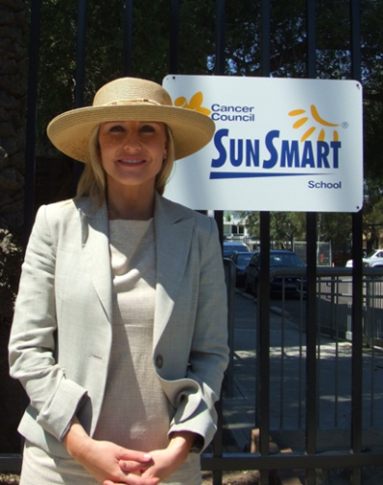

Know your sun facts from your sun fiction

Vitamin D
You may know that exposure to high levels of ultraviolet (UV) radiation in sunlight can cause skin cancer – but did you know that not enough time in the sun can mean low levels of vitamin D?
Vitamin D keeps our bones healthy and strong for life, and reduces the risk of osteoporosis in adults – a condition causing brittle bones.
In NSW, UV levels are at their lowest in June and July. In the north and far west, most people need 20-25 minutes of sun exposure during mid-morning or mid-afternoon, and in the south 30-40 minutes in the middle of the day. This will keep your vitamin D levels topped up during winter and means braving the chill and rolling up your sleeves to get some sunlight on your forearms as well as your hands.
Don’t risk damaging your skin. UV levels can change from day to day. When UV levels are 3 and above use sun protection. People who use sunscreen regularly when UV levels are 3 and above do not have lower vitamin D levels than people who don’t.
Check UV levels for your local area on the free SunSmart App for smart phones, download it from the App Store or Google Play. Talk to your doctor if you have any concerns about developing a vitamin D deficiency.

Want to know more?
- Vitamin D
- Sun safety on the public schools website
- SunSmart Primary Schools or call the SunSmart team on (02) 9334 1761.

