Planning for outdoor activities can assist in minimising student exposure to ultraviolet radiation from the sun.
Health authorities recommend that sun safety measures are required when the ultraviolet index is 3 or above.
The ultraviolet index
The ultraviolet index, sometimes just referred to as the UV Index, is a measure of how strong the ultraviolet radiation from the sun is at a particular place on a particular day.
The Bureau of Meteorology issues an alert when the ultraviolet index forecast is 3 or above.
The ultraviolet index can be checked at http://www.bom.gov.au/nsw/uv/. This website page provides access to the Ultraviolet Index Forecast Map for NSW. Forecasts will inlcude the low, moderate, high, very high, extreme scale and the UV Index value.
Consider communicating the daily ultraviolet index to the school community as an education tool with a reminder about:
- the risk of exposure to high levels of ultraviolet radiation
- effective sun safety behaviours.
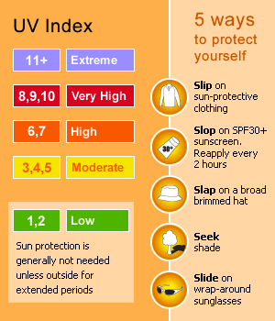
Source: Australian Government Bureau of Meterology website.
http://www.bom.gov.au/uv/. 16 April 2013
- reminding students to apply 30+ (or higher), broad spectrum and water resistant sunscreen prior to outdoor activities such as carnivals and excursions.
Suggested resources
- UV Index alert
http://www.bom.gov.au/announcements/uv/

- Cancer Institute NSW UV index information
http://www.darksideoftanning.com.au/reduce_risk/check_uv.aspx

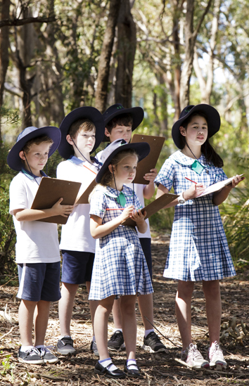

When the UV Index is 3 or above, remind students about the need for sun safety.
Considerations for schools
Sun safety planning for all outdoor activities is essential to minimise exposure to ultraviolet radiation.
During peak UV times consider scheduling events indoors and/or choosing alternative indoor venues where possible so students can continue to benefit from these valuable learning experiences.
Peak UV times
Times when the ultraviolet index in NSW is usually below 3 are:
- Early morning – before 10am Eastern Standard Time or 11am daylight saving time.
- Late afternoon – after 2pm Eastern Standard Time or 3pm daylight saving time.
- All day during June and July – during these two months the ultraviolet index is likely to be low with the exception of environments at high altitudes or near reflective surfaces like water or snow.
Individual schools can determine, in consultation with their school communities, whether they implement sun safe strategies all year round or for only 10 months of the year from August to May.
School communities may consider scheduling outdoor activities such as personal development, health and physical education lessons and school sport during the morning where possible and sports carnivals in the late afternoon.
Schools can allocate shaded areas of the playground for students to eat their lunch before they move to other areas for more active play.
Where indoor venues are available they can be considered for use. Some activities and sports traditionally played outside can be modified for indoor settings.
Sun safety behaviours during outdoor activities
Reducing exposure to ultraviolet radiation when outdoors can be achieved for students by using a range of strategies such as:
- wearing sun safe hats that protect the head, neck and ears
- implementing a ‘no hat, stay in the shade’ strategy for students not wearing sun safe hats
- encouraging students to seek shade when outdoors during peak ultraviolet radiation times
- encouraging students to wear swim shirts during outdoor water based activities

