Sun safe messages can be included across key learning areas.
The implementation of strategies such as no hat, play in the shade or the structuring of outdoor activities to reduce sun exposure, play a major role in supporting and reinforcing the messages taught as part of personal development, health and physical education (PDHPE) programs.
Other learning areas have opportunities to explore sun safety within the curriculum. Some of these are reflected in the suggested resources listed in this information sheet.

Primary Curriculum
Sun Safety education can be incorporated into teaching and learning through the following K-6 PDHPE syllabus outcomes:
- PHS1.12 recognises that positive health choices can promote wellbeing.
- SLS2.13 discusses how safe practices promote personal wellbeing.
- PHS2.12 discusses the factors influencing personal health choices.
- PHS3.12 explains the consequences of personal lifestyle choices.
The decision making, communicating and problem solving PDHPE syllabus outcome areas also provide opportunities for learning about sun safety.
Secondary Curriculum
Sun safety education can be incorporated into teaching and learning through the 7-10 PDHPE syllabus. Students explore ways of minimising harm and learn about factors that effect health. These may be taught through the following outcomes:
Strand 3: Individual and community health:
- 4.6 describes the nature of health and analyses how health issues may impact on young people
- 4.7 identifies the consequences of risk behaviours and describes strategies to minimise harm
- 4.8 describes how to access and assess health information, products and services
- 5.7 analyses influences on health decision making and develops strategies to promote health and safe behaviours
- 5.8 critically analyses health information, products and services to promote health.

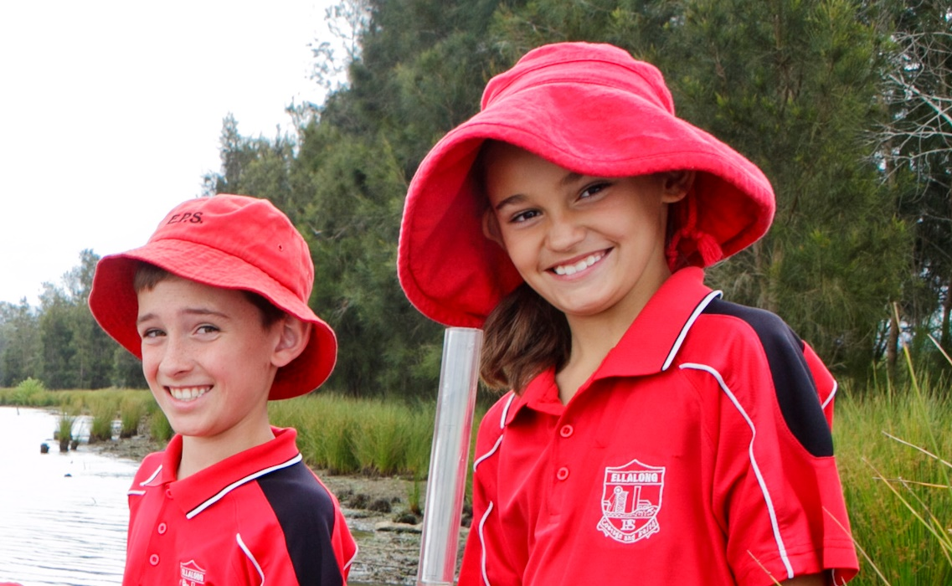
Comprehensive sun safety in schools includes teaching and learning about why taking measures to protect yourself from the sun is important.
Some suggested resources
Primary
- The SunSmart Millionaire interactive game engages students in learning about sun safety as part of Stage 3 Science and Technology and HSIE.
http://sunsmartmillionaire.com.au
- Sun protection interactive notebook for Stage 2 PDHPE.
http://www.curriculumsupport.education.nsw.gov.au/connected/resources/s2/index.htm
- Connected outcomes groups (COGs) healthy choices units of work for Early Stage 1.
http://www.curriculumsupport.education.nsw.gov.au/timetoteach/cogs/unitses1.htm
- Cancer Council NSW SunSmart primary schools activities for K-6.
http://www.cancercouncil.com.au/24938/reduce-risks/sun-protection/sunsmart-program-for-primary-schools-and-ohsc/sunsmart-resources/primary-school-curriculum-resources/?pp=37066
Secondary
- Cancer Council NSW resource for Stage 5 English.
http://www.cancercouncil.com.au/47021/reduce-risks/sun-protection/sunsmart-program-for-primary-schools-and-ohsc/sunsmart-resources/secondary-school-resources/?pp=47021
- Cancer Council NSW and ACHPER NSW resources for Stage 6 PDHPE.
http://www.achpernsw.com.au/content_common/pg-healthprioritiesinfocuspresentations.seo
- Cancer Council NSW Real Stories: secondary schools resources for Years
7-10.
http://www.cancer.org.au/preventing-cancer/sun-protection/sunsmart-schools/real-stories-secondary-school-resource.html

