Student voice scaffold – behaviour response plan
When students actively participate in the development of their support plans, according to their age and stage of development, they are empowered to make decisions on actions that impact them and are more likely to engage in their plan.
This student voice scaffold supports teachers by providing:
- a proactive and responsive way to include student voice as part of the behaviour support and behaviour response planning process
- a social/emotional learning (SEL) tool to support student development of self-awareness and self-regulation.
Student agency and self-determination is the first principle of inclusive practice from the Inclusive Education statement for students with a disability. This scaffold supports school staff to:
- meet the requirements of the Inclusive Education Policy for students with disability, the Student Behaviour Policy and the Suspension and Expulsion Procedures
- use principles of good practice in behaviour support, including student voice, student participation, and explicit teaching of social and emotional skills.

When to use the student voice scaffold
The student voice scaffold should be used at any time to support a student to participate in the development of their behaviour support planning process. Collaboration with families and carers is an important part of the planning process. Informing parents about the tool before its use is consistent with best practice, and ensuring access to support services such as translation services are offered.
Parent and carer involvement may vary depending on the age and needs of the student. Some students have multiple plans, and this scaffold can be added to or used alongside existing plans. The student voice scaffold is most effective when the staff using it have a positive relationship with the student and are aware of their social/emotional and communication needs.
The student voice scaffold may be used in the following ways:
- to facilitate input from students into their behaviour response plan or individual behaviour support planning
- after an incident or during a resolution meeting to support re-entry into school and inform any plan updates
- to build student’s awareness and understanding of their own behaviours, and how they present along a continuum
- as a tool to support students to reflect on their progress and contribute to adjustments, and set new goals as appropriate
- to start a conversation with parents and carers or agencies who support the student.
How to implement the student voice scaffold
The following process can be completed over a number of sessions to meet the personalised learning and support needs of the student. All steps are to be a collaborative process involving the student and the information recorded to be inclusive of student voice.
Some students are non-verbal or may have difficulty expressing themselves. School staff are encouraged to make use of students’ preferred mode of communication such as an assistive technology system or device communication systems. Staff are encouraged to use concise and clear language the student can understand. Staff can also support students to communicate their thoughts and feelings using tools such as photovoice or body mapping.
Some English as an Additional Language or Dialect (EAL/D) learners may require an interpreter to support them in authentically participating in the process.
- Step 1: Identify student preferences/strengths, dislikes, triggers, feelings about school and goals. Guide the student through each section. During this process, attempt to de-personalise person specific statements. For example, a comment such as “I dislike Mr Smith” could be de-personalised by asking “what does Mr Smith do that you dislike”?
- Step 2: Engage in a discussion with the student about the behaviour escalation cycle graphic. Explain to the student that the graphic shows the behaviour patterns people may display in response to feeling anxious, angry or overwhelmed. Engage in a discussion with the student about their behaviour cycle, unpacking the language used. Possible discussion starters may include “What might your pattern/graph look like?” “Do you get to the point of crisis quickly or does it gradually build up?” “Do you recover quickly, or can it take a long time?”
- Step 3: Identify and record what the student looks like/feels like when calm, agitated, in crisis and in recovery. Record in word, images or photos relevant to the student.
- Step 4: Identify how teachers can help the student and how the student can help themselves at the different stages of their behaviour cycle. It is important that strategies recorded are negotiated, agreeable and able to be implemented. Throughout the process, prompting may be needed, but it is important that staff give the student time to think rather than populating the scaffold with what staff think might work. Record using plain English language that is fair and reasonable and relevant to the student.
- Step 5: Include the information collected in the student’s behaviour response plan and share with all relevant stakeholders, including parents and carers, to ensure consistency of implementation. You may want to consider discussing with the student who will have access to the plan and what that may look like. Identify when to revisit and revise the plan to reflect on what has worked well, areas for improvement, and what challenges remain unsolved.

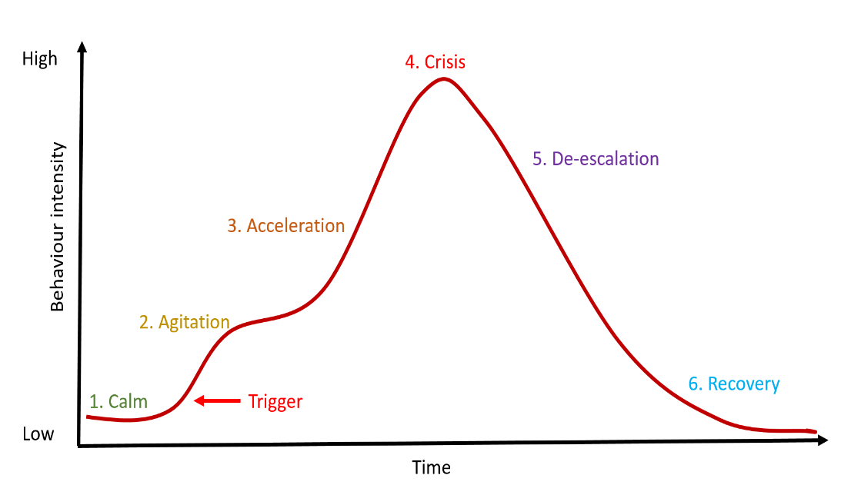
I dislike/need help with:

I like/am good at:

School would be easier/more enjoyable if:

Triggers:

Goals:

When I’m CALM I: | When I’m AGITATED I: | When I’m having a CRISIS I: | When I’m RECOVERING I:
I can help myself by: | I can help myself by: | I can help myself by: | I can help myself by:
Teachers can help me by: | Teachers can help me by: | Teachers can help me by: | Teachers can help me by:

