NSW Department of Education

School Behaviour Support and Management Plan – expanded version
Direction and guidance on developing, implementing and reviewing the School Behaviour Support and Management Plan. This version is expanded to include step by step instructions.

Audience and applicability
All staff in NSW public schools

Policy requirements
The Student Behaviour policy requires all schools to develop a School Behaviour Support and Management Plan (SBSMP) ready for implementation by Term 1 2025.
Schools must:
- consider their context and data in developing their SBSMP
- develop the SBSMP in consultation with their school community, as appropriate
- publish the SBSMP on their school website
- implement the SBSMP
- review the SBSMP annually.
Schools may use the optional template or develop their own document that includes all required information.

Definitions
Term | Definition
Behaviour of concern | A behaviour of concern is challenging, complex or unsafe behaviour that requires more persistent and intensive interventions.  A behaviour of concern does not include low-level, developmentally appropriate behaviour.
Bullying | Bullying behaviour involves the intentional misuse of power in a relationship, is ongoing and repeated and involves behaviour that can cause harm.
Detention | Detention and/or reflection is a disciplinary consequence that schools may use to address inappropriate student behaviour. Detention and reflection are applied as close as possible to the breach in behaviour. It allows the school to provide timely support to students to assist them to achieve the desired behaviour, to reflect on their behaviour and make positive choices. The student is always supervised by a staff member.
School Behaviour Support and Management Plan | An operational document that outlines school processes and practices for behaviour support and management. It must be published on the school website so it is available to all students, parents, carers and school staff.
Time-out | Teacher-directed time-out is a de-escalation strategy and occurs where a student is directed away from an educational activity or setting when they engage in behaviours of concern. It is used after other de-escalation strategies and teaching practices have been tried.  Self-directed time-out enables a student to remove themselves from a situation or environment causing stress. It is a planned informal behaviour support strategy that may be used as part of a behaviour support response and documented as an agreed strategy.

Roles and responsibilities
Public Schools , including Directors, Educational Leadership and Delivery Support Team Around a School:
- provide proactive and responsive specialist advice and support for schools in the development, implementation and monitoring of the SBSMP
Principals:
- lead the school community in developing, implementing and monitoring the SBSMP
- facilitate the annual review of the SBSMP
- ensure consultation with the school community, including school staff, students, parents or carers, in the development, implementation, and review of the SBSMP, as appropriate.
School executive, teachers, school learning support teams and school support staff:
- contribute to the development, monitoring and review of the SBSMP, as appropriate
- implement the processes and strategies within the SBSMP.
Parents or carers:
- work in partnership with the school to implement the SBSMP, supporting their child to abide by the Behaviour Code for Students , resolving issues about their child’s behaviour, and communicating with school staff and the school community respectfully and collaboratively consistent with the School Community Charter.
- Be involved in consultation with the school during the development, monitoring and review of the SBSMP, as appropriate.

What needs to be done
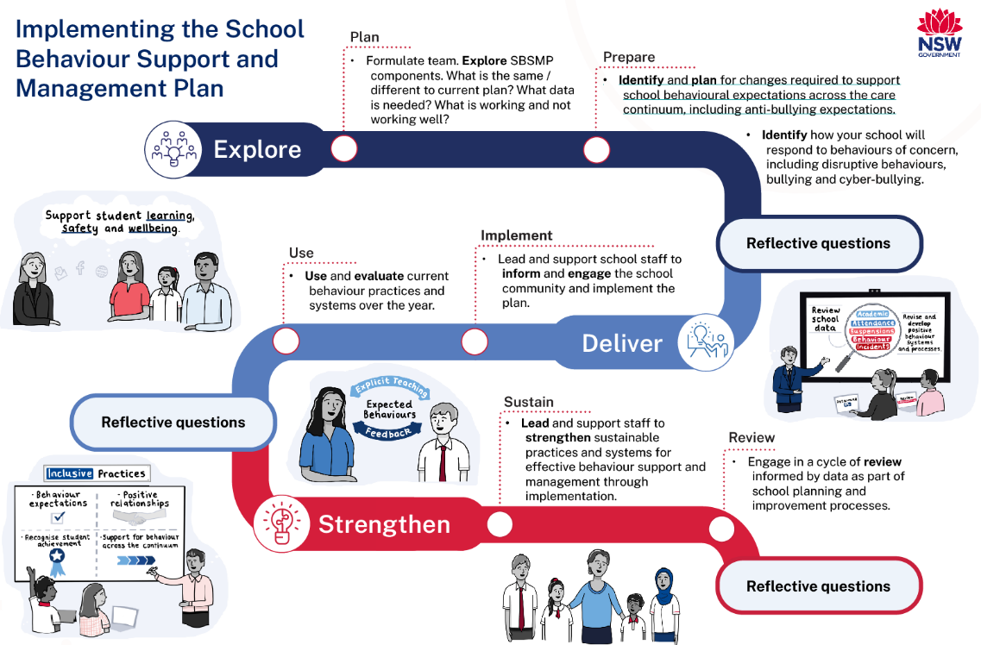
Figure 1 Implementing the School Behaviour Support and Management Plan

Explore available information and resources
Schools may develop an action plan to meet all policy requirements, considering the school context and exploring available data and existing behaviour management documentation. Schools may also choose to develop an implementation and progress monitoring (IPM) plan instead of an action plan.
Use the following as a guide.
1.1 Form a SBSMP team
- Form a team to support the successful creation, review, and implementation of their SBSMP. The team should be led by the principal or their nominee. Schools may also draw on existing team structures such as a Learning and Support Team or wellbeing team, if applicable.
- Small schools may wish to utilise available support structures across their local networks and principal communities in the development of their SBSMP. Schools may use this exemplar for a small school setting for guidance.
- Engage all relevant stakeholders and if appropriate, include representatives from the P&C, AECG or student body. For specialist settings the school may engage other partners who work with students on school sites such as NSW Health and Youth Justice Department of Community Services.
Consider
- How team members will be selected?
- Who are the key stakeholders in our school community?
- What representation is appropriate for each stakeholder?
- What expertise is needed to help the team successfully complete and implement the SBSMP? Team Around a School staff may be able to support the school in determining potential internal and external stakeholders.
1.2 Prepare an action plan, if needed
Schools with established whole-school approaches that align to the Student Behaviour policy can review existing data sources and/or staff learning needs to evaluate what is working/not working and opportunities to strengthen school-wide positive behaviour support practices, without the need to develop an action plan or an implementation and progress monitoring (IPM) plan.
Schools that do not have well established whole-school approaches may find it helpful to develop an action plan or an implementation and progress monitoring (IPM) plan to ensure they meet all requirements under the policy. This includes:
- When and how often the team will meet?
- What roles and responsibilities need to be filled?
- How will activities be given, and timelines set?
- What resources (time, funding and/or staff professional learning) may be needed to support effective implementation of the SBSMP?
- When and how often will the team consult with the school community about any changes to systems and process relating to the current plan in place? How will the team evaluate that school staff and community members have a clear understanding of the SBSMP purpose and underpinnings? Refer to School Community Charter for more guidance.
1.3 Gather, collect and analyse data
- Collect a range of data and evidence. Data should be thoughtfully considered to guide judgements made in the development of the SBSMP. Schools may have already identified behaviour and classroom management as part of their situational analysis when preparing their SIP. If so, the information collected and reviewed can be included in the development of the SBSMP.
- Gather and critically review key documents and other required information to include in the SBSMP.
- Critically review school-level data to understand and evaluate the needs and issues that contribute to student behaviour. Schools that excel in this area use a range of data sources to inform their planning process, resource allocation, and decision making. In addition, they have clear systems and processes for data collection, analysis, and reporting, which will support with the evaluation and review of the SBSMP each year as part of school improvement processes and ongoing continuous improvement.
- Schools can use existing School Excellence processes to inform the development of their SBSMP. Schools are already assessing their practices against the following three themes within the School Excellence Framework during the annual SEF Self-assessment Survey (SEF S-aS):
  - behaviour - wellbeing element - learning domain
  - classroom management - classroom practice element - teaching domain
  - community engagement - educational leadership element - leading domain.
- Self-assessment in the themes of behaviour and classroom management can help schools to identify areas of strength and opportunities for development within their practice and then if needed, inform both the SBSMP and if relevant, their SIP.
The team should consider the data held in the school and any other information that helps to identify the strengths and opportunities to improve their current systems and identify emerging trends. This includes:
Current process docs relevant to student: | Student behaviour and wellbeing data  (last three years, disaggregated by year level, gender, Aboriginality, NCCD, and LBOTE) | Student learning outcomes  (last three years, disaggregated by year level, gender, Aboriginality, NCCD, and LBOTE) | School community trends
- behaviour  - wellbeing  - management | - classroom discipline / office referrals and playground incidents – nature and number  - parent contacts (e.g. warning letters, interviews)  - detentions, formal cautions, suspensions, and expulsions  - attendance (including whole day and fractional truancy)  - Tell Them From Me  - Reports to the Incident Report and Support Hotline referrals to the school learning and support team, Team Around a School and, or applications to the Home School Liaison program. | - NAPLAN  - retention – Year 6-7 and 11-12  - post-school destinations (secondary schools)  - distribution of merit/achievement awards  - parent contacts (e.g., letters of commendation). | - enrolments (last 3 years, disaggregated by year level, gender, Aboriginality, NCCD and LBOTE  - family data  - staff wellbeing  - data from School Excellence Framework planning cycle and Strategic Improvement Plan.

Consider:
- What aspects of the current SBSMP (or school discipline policy) need to be updated to incorporate new or updated policies?
- Where can the SBSMP be aligned with existing process and systems used by the school?
- What data sources are most useful to drive decision making regarding positive student behaviour practices at the school? What needs does the data identify?
- What processes and systems are used to collect and analyse data? How is information reported back to school staff so that improvements to practices can be made?
- How is data used to provide targeted support for students at risk, including additional resources to support teachers?
1.4 Identify staff learning needs
Schools build the knowledge and capacity of staff to use their SBSMP effectively and consistently.
Many schools may have an existing evidence-based framework in place that underpins their current behaviour processes. However, research on best practice about student behaviour is not static. Schools that are excelling in this area:
- track the impact of their whole-school approach
- evaluate the staff learning needs to identify opportunities to continually build the knowledge and consistent application of evidence-based practices.
- identify classroom management, behaviour, disability and inclusion support, trauma informed practices in the SEF self-assessment as a focus area of opportunity for staff professional learning. As part of that process, schools should also consider which resources or professional learning is needed to support understanding to develop and implement their SBSMP.
Schools can contact their Team Around a School who have expertise in whole-school and student focussed behaviour management practices to advise and assist with staff capacity building. Staff can also access a range of universal professional learning and resources available from the behaviour professional learning page.

Develop the SBSMP, including mandatory information, with the school community
Use the following instructions to develop or update the School Behaviour and Support Management Plan (SBSMP).
The following are required information for the SBSMP:
- a strategic, integrated whole-school approach that incorporates a multi-tiered care continuum to support all students, including a focus on prevention, early intervention, targeted and individual interventions
- high expectations for student behaviour, in line with the Behaviour Code for Students
- effective strategies to model, explicitly teach, recognise and reinforce positive, inclusive and safe behaviours
- effective strategies to prevent and respond to disruptive student behaviours, including bullying and cyber-bullying, and behaviours of concern when they occur
- establish expectations for parents and carers to engage with the school in developing and implementing student behaviour management strategies in line with the School Community Charter.
- consultation with the school community, as appropriate
- provisions for annual review of the SBSMP.
Use the optional template or a school-developed document that includes all required information. These sample SBSMPs and visual are available for reference.
The following headings can be used as a guide.
2.1.1 Overview statement
The department’s endorsed evidence-based approaches that support behaviour include Positive Behaviour for Learning (PBL), trauma-informed practices, and the principles of inclusive practice.
The overview statement outlines the aims, beliefs, and/or principles upon which the SBSMP is based. It should align with the department’s endorsed approaches, although the approach your school uses may not be exactly the same.
The overview statement is the first thing that the school community will read when engaging with the document and it sets the tone for what the school values and aspires to achieve through the implementation of the SBSMP. Identification of any existing whole-school programs or approaches that support schools with the implementation should be included.
Consider:
- Does the overview statement set a positive tone that reflects what the school values and aims to achieve through the SBSMP? Is it consistent with the school community expectations and values?
- Does the overview statement reflect the department’s endorsed position on positive behaviour support?
- Does the overview statement include a position about anti-bullying?
2.1.2 Partnerships with parents and carers
In schools that excel, the principal is the primary educational leader who facilitates instructional leadership in the school. The leadership team demonstrates educational expertise to lead teaching and learning and support a collaborative culture of high expectations, inclusion, and community engagement, resulting in sustained and measurable whole school improvement. Schools use the School Excellence Framework (SEF) to assess themselves against the community engagement theme as part of the school excellence cycle.
Parents and carers play an important role in the school community. The School Community Charter informs parents and carers on how to engage with NSW public schools.
The SBSMP should:
- provide an overview of how the school will partner with parents and carers in establishing expectations for parent engagement in developing and implementing student behaviour management strategies. Outline how the school will communicate these expectations to parents and carers.
- use existing communication channels with the school community, for example the school P&C and AECG to support broader engagement and feedback.
2.1.3 School-wide expectations and rules
The expectations and rules should be clear, positively stated, and easy for the whole school community to understand. Schools, in consultation with their community, decide upon the exact number needed.
The SBSMP should include:
- 3-5 overarching expectations of student behaviour and 3-5 more specific rules that sit under these expectations
- A link to the Behaviour Code for Students
- When developing school-wide expectations and rules schools should consider the:
- alignment with the school’s overview statement and/or community expectations
- accessibility of verbal and written communication methods
- diversity of their communities and relevant contextual factors.
2.1.4 Whole-school approach across the care continuum
The SBSMP should provide specific whole-school and targeted strategies, interventions and programs that support student behaviour at each stage of the care continuum (prevention, early intervention, targeted intervention, and individual intervention).
In your SBSMP include contextually relevant practices, programs, and strategies that:
- are universal with a strong focus on preventative and proactive practices that model, explicitly teach, recognise and reinforce positive, safe and inclusive behaviour among all students, school-wide behavioural expectations and positive student-teacher relationships
- effectively identify and support students who are at risk through early intervention and targeted supports
- support individual students demonstrating complex and challenging behaviour through mitigation and de-escalation strategies
- prevent and respond to bullying behaviours, including cyber-bullying behaviours. For more information about cyberbullying please visit the eSafety Commissioner website.
Schools can use the care continuum guide resource to assist in identifying appropriate strategies, relevant to their school context.
The best approach to maintain positive student behaviour is to try to prevent inappropriate behaviour from happening in the first place. Schools that excel in this have established strong systems of universal prevention that promote positive student behaviour. Wherever possible, strategies and practices should be embedded into teaching and learning programs and revised periodically to ensure they remain relevant and reflect the school’s stage of continued improvement.
For guidance, refer to the Centre for Education Statistics and Evaluation’s (CESE) Classroom Management: Creating and maintaining positive learning environments, as well as relevant professional learning.
Schools should consider:
- Do the care continuum strategies, interventions and programs adequately meet the range of needs and complexities at the school?
- Do local strategies and programs exist that you use that are not listed in the guide that can be listed in this section?
- Is there a proportional number of strategies for each level of the continuum that are contextually relevant, and are these implemented effectively?
In relation to strategies and programs that model, explicitly teach, recognise and reinforce positive student behaviour, consider:
- Do these strategies enhance student behaviour, wellbeing and learning? What are the views of students and families?
- Are these strategies applied consistently across the school?
- Are the strategies inclusive of all learners?
- Any policy requirements, the analysis of school data and identified staff learning needs when embedding these strategies.
2.1.5 Planned responses to positive appropriate behaviour, inappropriate behaviour, and behaviours of concern, including bullying and cyber-bullying
Students are still learning to develop pro-social behaviours, and low-level developmentally appropriate risk-taking behaviour will occur. Although a small number of students may engage in disruptive, disobedient or inappropriate behaviour, schools that excel in managing a range of behaviours seek to understand the function of behaviour and develop clear mitigation strategies.
The SBSMP should include:
- strategies and processes that the school uses to promote, respond to, recognise and reinforce positive appropriate behaviours and school-wide expectations
- strategies and processes that the school uses to respond to and manage inappropriate behaviours and behaviours of concern, including bullying and cyber-bullying behaviours, and the supports available to students experiencing difficulties. These strategies and processes will need to be revised to ensure they are current, effective, and consistent with the overview statement and policy requirements each year as part of the review cycle.
- an outline of how the school will report and record behaviours, including behaviours of concern.
Schools should consider:
- The analysis of school data, and the views of staff and stakeholders - are the current strategies and practices clear, practical, and effective?
- Do current processes show how students with positive appropriate behaviour are recognised and reinforced?
- Do current processes show how students with disruptive behaviour are managed and supported to ensure that any underlying needs are accounted for?
- How are incidents of bullying and cyber-bullying handled? Is there a process in place that staff and students should follow? Do staff, students, parents, and carers know where they can seek help from in incidents of cyber-bullying?
- Where applicable, are students involved with the development of response strategies? How do students know what to expect and how are the use of response strategies evaluated?
- Do the strategies and processes provide scope to be adjusted to meet the needs of diverse learners, for example disability, where the behaviour may be a direct characteristic of the disability?
- Have health and safety requirements been considered in relation to the risk management of students?
2.1.6 Detention, reflection and restorative practices
The SBSMP should include details of:
- when detention, reflection and restorative practices will be used and where they will occur
- the maximum length of time appropriate to the age/developmental level of the student
- food and toilet breaks
- the school staff approved to facilitate them (by role, not specific name)
- how the school will record details.
Schools should consider:
- Does the team have a clear idea about how detention, reflection and restorative practices will work in the school?
- Suitable consultation and endorsement from parents and citizens associations should be sought.
Refer to the Detention and Time-out procedures for further details.

Deliver and implement the School Behaviour and Support Management Plan (SBSMP)
After the team have developed the SBSMP, the school should:
- engage with the school community by publishing the SBSMP on the school website and making it available to all students, parents and carers, and school staff
- embed the identified practices and strategies in day-to-day school operations.
3.1 Implementation considerations
- How will the school lead and support staff to inform and engage the school community to implement the SBSMP?
- How will they lead and support staff to strengthen sustainable practices and systems for effective and consistent behaviour support and management through implementation?
- When and how often will the team meet to review current behaviour practices and systems throughout the year?
- What resources may be needed to support staff to effectively and consistently implement the SBSMP? This may include time, funding, professional learning or other capacity building.
- What systems or processes are in place to evaluate the effectiveness of the existing continuum of strategies, interventions and programs outlined in the whole school approaches? What data types and sources are used to measure impact?
- What decision making process is used to add or remove strategies, interventions, and programs from the care continuum?

Evaluate, review and strengthen annually
Each year, schools must systematically review the implementation of their SBSMP.
Ongoing and authentic evaluation should be planned and form a regular part of the school’s strategic improvement journey. Schools use a range of data sources to evaluate the strengths and opportunities to continually improve their practices through high level professional learning.
4.1 Embed a strategic and planned evaluation process
During the School Excellence review cycle, schools that are excelling in the behaviour theme of the Wellbeing Learning Domain of the SEF utilise their SBSMP to ensure that positive, respectful relationships are evident and widespread among students and staff and promote student wellbeing to ensure optimum conditions for student learning across the whole school.
Schools that excel in this area have a strategic and planned evaluation process and use data to make decisions that will strengthen and continually improve their whole-school approach to support student behaviour and support.
To embed evaluation processes:
- review the SBSMP annually to ensure it continues to be fit for purpose
- use current school data to inform practice and direction
- include community and student feedback.
Schools should consider:
- What type of data will be most effective to evaluate and review the SBSMP? Does the data or other forms of feedback show what’s working well and what areas of improvement are needed?
- Is implementation and progress monitoring (IPM) needed to review the SBSMP, to align with SEF and SIP processes? This might apply if schools identify behaviour as a focus area of improvement or undertake guided or strategic behaviour support.
- What planned professional learning activities will address the gaps or needs identified through the review process? Has it been recorded in SpaRO using the QDAI structure?
- How does the school community contribute to the review and revision of the SBSMP?
- Has the DEL been involved in discussions around evaluation and review of the SBSMP as part of school improvement and reflection processes? This might apply if schools identify behaviour as a focus area of improvement or undertake guided or strategic behaviour support.
Note: Principals may access the IPM tool, and the Leading collaboration for school improvement toolkit from the Implementation and progress monitoring support webpage to guide discussions on implementing and monitoring the SBSMP with consideration to the SIP.

