Student voice parent resource
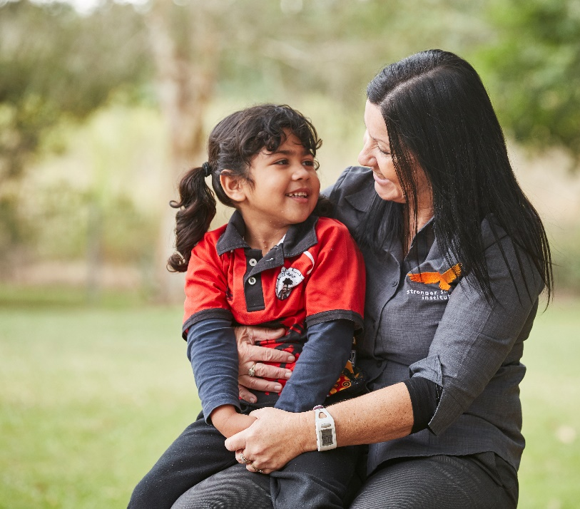
What is student voice?
Student voice is defined as students actively participating in decision-making on things which shape their educational experiences. It is an approach to education that values the perspectives, experiences and aspirations of students across three settings; the classroom, the school and in the wider community.
How are student voice and wellbeing connected?
When children and young people participate in meaningful decision-making at school, they:
- experience higher levels of wellbeing and empowerment
- feel a deeper connection to their learning and school community
- develop a range of skills and capabilities to feel connected and successful at school and in life.
How can student voice be encouraged at home?
As a parent, you want your child to love learning. You want them to feel confident in expressing their voice, having influence and making authentic choices at school. There are many ways you can support this at home and further develop the skills they are learning at school.
Top tips for supporting student voice at home
- Create opportunities within the home for your children to lead activities and make meaningful choices, for example, organising meals or a family outing.
- Support your children in identifying and celebrating their personal strengths and those of others.
- Support your children in making learning goals and sharing them with their teachers. This will empower them to shape their learning environment to reflect their unique needs.
- Encourage them to be a leader in their classroom, school and communities. These do not have to be traditional leadership positions, such as school captains. Students can become peer-support leaders, playground monitors, joining clubs and committees or become student mentors and volunteers.
- Create opportunities for collaboration in the home, for example, cooking or building something together.

