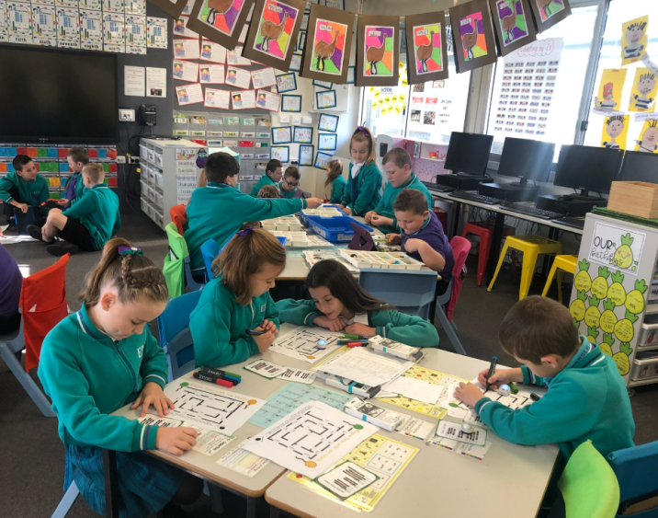
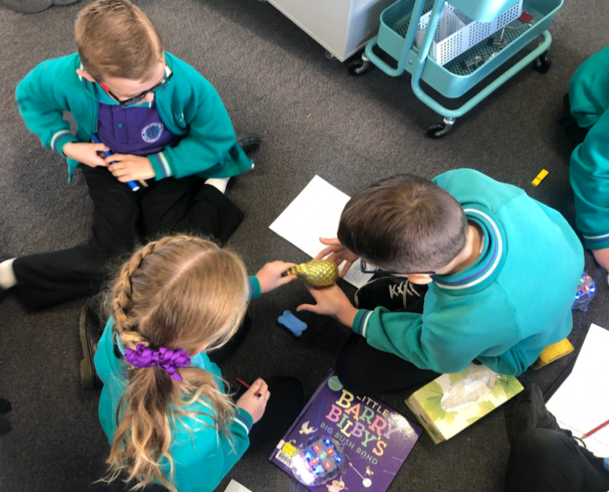
Amplifying student voice in positive classroom environments

Key points
- Positive classroom environments are ones in which students experience a sense of belonging and feel safe asking questions and taking risks with their learning. They are emotionally and physically safe and engaging spaces.
- Involving students in the design of their classroom gives them voice, choice and influence and supports collaboration.
- The physical classroom environment should be flexible and adaptable to the needs of different students and different learning activities.
- When possible, give students choices about where they do their work. For example, sitting on the floor or sitting in groups at desks.
- Well-designed classroom spaces do not need to be expensive or time consuming.
- Find out more about flexible learning spaces here.
- The Learning Space toolkit provides strategies for schools that are engaged in change. More information can be found here.
- Create a positive classroom environment by forming positive relationships with and between students, designing a welcoming and flexible learning space, setting high expectations of students with explicit learning goals and opportunities to build pro-social and leadership skills.
- Safe, supportive environments will facilitate student voice, participation and collaboration.
Classroom environment checklist | Never | Rarely | Usually | Always
Forming positive relationships with and between students
Students are greeted by name in a friendly manner
Students are given opportunities to share their interests
Teachers show an interest in their students’ lives and activities beyond school
Teachers model respect through positive body language, expression and words
Designing a welcoming and flexible learning space
Student suggestions are included in classroom organisation and layout plans
Student ownership is supported through student work being displayed
The classroom layout is flexible, supporting collaborative or independent work
The classroom layout and resources support inclusion and is sensitive to the needs of students with additional needs.
Students’ storage and materials are organised and accessible
Furniture placement supports easy movement around the room and teacher supervision
The daily schedule/timetable is displayed and reviewed regularly
There is a method for displaying changes to the schedule
Students are given choices about where they sit to complete tasks
Teaching and learning
High expectations are held for all students’ learning
Learning goals are made explicit and are referred to
Students negotiate individual learning goals with their teachers
Classroom rules are linked to school-wide expectations and are displayed and referred to consistently
Building capacity
Time is allocated for student to give feedback and suggestions
Students are taught skills for active listening and working collaboratively
Students are given opportunities to work collaboratively

