Student voice, participation and leadership in our classrooms
Classrooms can provide a positive learning environment that encourages student voice and develops skills and competence that moves from participation to leadership. A balance between teacher directed and student led, developmentally appropriate activities support authenticity and develop students’ agency to own and drive their learning. Teachers and students can work together to develop partnerships, build confidence, self-awareness, and support meaningful learning outcomes.

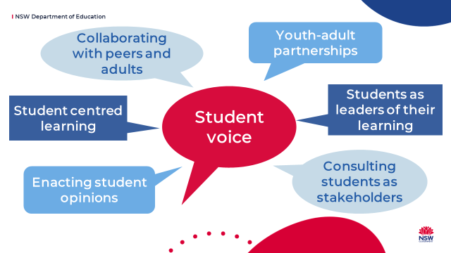
The following checklists can help teachers assess how much student voice is happening in their classroom and whether their students perceive it as occurring meaningfully. Whilst all the statements are examples of student voice, as the lists progress, they become more student-centred and students go from being recipients of learning to leaders of their own learning.
The checklists can also form the basis for classroom conversation about student voice.

Student feedback about learning
This is a tool high school teachers can use to capture student perspectives on voice, participation and leadership in the classroom.
Student statements | Once a week | Once a term | Once a year | Not yet
I can ask questions to clarify or to consolidate my learning.
My teacher pre-assesses us before starting a new topic.
My teachers use class results to plan future lessons or reteach concepts if necessary.
My teacher gives us exit-slips and surveys to get feedback on our learning.
I provide feedback to my teacher whether lessons were appropriately challenging and engaging.
I can choose where I sit in the classroom to meet my learning needs.
I usually know what we are learning in class (the learning intentions are clear).
I work with my teachers to work out my learning goals.
I can use my interests to further my learning.
I collaborate with peers to create group presentations or inquiry based learning.
I can decide how I present my learning.
I can negotiate aspects of assessments with my teacher.
I can choose how my learning is assessed.
We do peer and self-assessment.
I often reflect and self-assess my learning experience.
I write my own reflection on my school report or assessments.
I work with my teachers to create resources.
I design learning experiences for myself or the class based on learning goals, interests and/or talents.

Teacher reflection on student voice
This is a tool high school teachers can use to reflect on their classroom practice regarding student voice, participation and leadership.
Teacher statements | I don’t do this | I do this sometimes | This is embedded in my practice | I would like to do more of this
I encourage students to ask questions to clarify or to consolidate their learning.
I encourage students to choose where they sit in the classroom to meet their learning needs.
I use students’ results to inform my planning and programs.
I give students exit-slips and surveys (formative assessment) to measure learning.
I survey students to get feedback on my teaching.
I negotiate learning goals with my students.
I give students explicit learning intentions.
I encourage students to use their interests to further their learning.
I negotiate aspects of assessments with my students.
I give students a range of options for assessment modes.
I facilitate inquiry based learning in my classrooms.
My students do student-generated inquiry based learning.
I support students to self-assess and self-reflect on their learning.
I work with my students to co-create resources or lesson plans.
My students write a reflection on their school reports or assessments.
My students design learning experiences for myself or the class based on learning goals, interests and/or talents.

Mapping student voice activities
Using the checklists, map what kinds of student voice activities you are currently using in your classroom. You can also use the tool to plan for future directions.
Student voice continuum | Passive student voice  Teacher-led activities | passive | Moving towards active | More active student voice | Active student voice  Student-led activities
Student actions | Complete assigned tasks, individually or in groups and contribute thoughts and opinions about the tasks. | Work individually or in groups and provide feedback on topics provided by the teacher. | Students have input into classroom decisions, collaborate with peers and / or have multiple ways they can demonstrate their understanding and provide insights, or feedback. | Students have a formalised role in decision making.  Students and staff decide on a joint course of action together (co-planning). | Students design challenging learning experiences based on learning goals, interests, talents and/or passions.  Students make decisions, communicate ideas and take responsibility for outcomes.
Teacher actions | Provide appropriate tasks and listen to student contributions but have limited formal processes to act on these opinions. | Request contribution and seek feedback that is considered in planning and reflecting on student progress and engagement. | Plan and scaffold activities that provide choice and opportunity for collaboration, then acts as a facilitator using student feedback to inform future lessons or direction. | Provide flexibility for students to choose methods to demonstrate understanding and facilitate or co-design solutions to problems with students. | Refocuses or challenges student thinking, without providing solutions. Students initiate and organise an learning event and staff have an advisory role.
Examples of practice  K - 12 | Students do activities as organised by teachers and have class discussions. | Surveying students or formative assessment results inform teaching and learning programs.  Teachers questions elicit student views. | Students work with teachers to develop learning goals or future learning. | Students and staff co-construct materials or assessment modes to meet learning goals. | Project or problem based learning and design thinking such as student initiated coding activity or personal inquiry project.

