North Kellyville Public School

517 | 40 | 30
STUDENTS | LEARNING SPACES | TEACHERS

The NK Way
North Kellyville Public School is a new primary school, opened January 2019. As a “boldly future-focused” (K. McGill, AP) school, establishing a culture of innovation and a contextually specific case for change is crucial. ‘The NK Way’ is a guiding document that describes the pillars for quality teaching, learning and leading. It had its genesis in SLEC’s ‘portrait of a graduate’ activity.
Why? | How?
Belonging was a focus for the school prior to the new building opening and then became of crucial importance as staff and students moved into the school. ‘#IBelongAtNK’ became the foundation of the school culture.  A key challenge was bringing together staff who had come from over 15 schools. Guiding principles were needed to unify the rich variety of experiences and ideas the teaching team brought.  Building understanding of the opportunities for forward facing pedagogy made possible by the design of the new learning spaces was a motivating factor in creating the ‘NK Way’. | Staff were supported with strategically timed and selected professional learning so they would have the capacity and skills to offer effective and engaging learning experiences in flexible learning spaces.  Initially, staff engaged in face-to-face training with SLEC’s ‘Flexible Learning Space by Design’ course. All staff including LaST and SLSO took part.  Collegial discussions led to the co-construction of settings and learning activities that took full advantage of the new spaces. Teacher leaders attended additional SLEC training to explore the nature of future workplaces, desirable competencies, and skills and how to leverage pedagogy to enhance learning.
“The NK Way is an aspirational vision for the school that unites students, staff and parents.”

What? | Community Engagement
By opening day, the number of teachers had doubled. To create a collective vision, teacher leaders took new staff through SLEC’s activity, ‘A portrait of a graduate’. This built a common understanding of the need for contextually appropriate pedagogy to equip students to thrive in a rapidly changing global community.  Teachers worked in three groups to generate ideas about qualities they wanted to foster in their students. Contributions included academic considerations such as literacy and numeracy. However, the main focus was graduate characteristics and skills.  Executive staff and aspiring leaders collated the lists and distilled the ideas. Wording was workshopped by all staff. It led to significant revision of the language being used in the ‘NK Way’, for example “professional development” was changed to “professional learning” to reflect that both teachers and students learn. | Personalised learning has been an important focus in the messaging for the community. The vision that NKPS had of authentic and deep differentiation was developed further through the portrait of a graduate activity. These early ideas were taken to the P&C to include community perspectives, which focused on the purpose of schooling, the importance of a fresh start and belonging.  This collaborative approach to building the idea of desired characteristics for NKPS students meant there was authentic co-creation that fed into the development of the ‘NK Way’.  The ‘NK Way’ enabled rich discussions during enrolment meetings. In this way, parents and caregivers were well informed of the vision that NKPS has for their students, along with reasons why NKPS was moving away from a traditional model of teaching toward one that leverages the possibilities of flexible learning spaces.
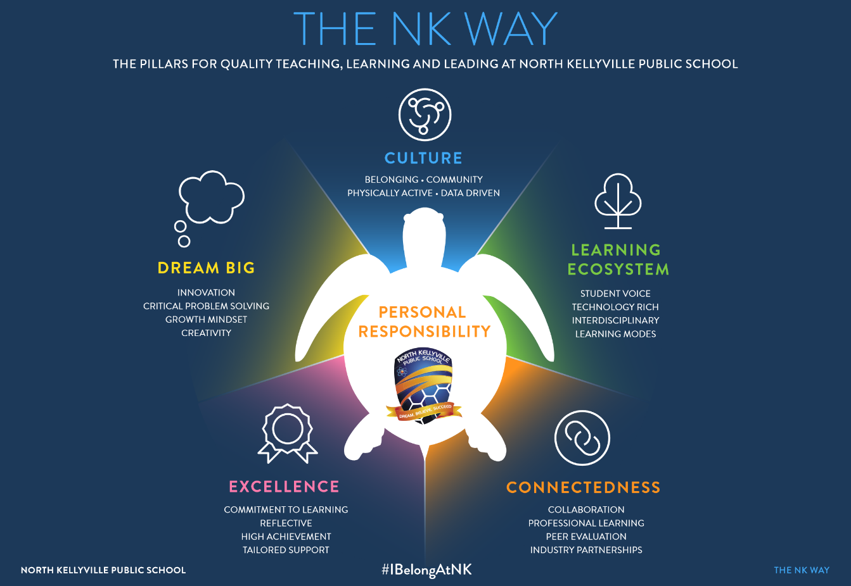

Building Teacher Confidence
As the school grew and teachers joined the team, a positive culture of a willingness to take risks trialling new teaching practices was established, despite many of them being new to working in these spaces. The challenges faced in learning to operate in new spaces were compounded by the complex learning needs of some students. This meant that some staff were a little hesitant to embrace contemporary pedagogy and felt uncertain about teaching in flexible learning spaces.
SLEC delivered a second whole-staff professional learning session that was differentiated based on the prior experience of teachers; those who had completed session one and new staff. For staff who had already completed ’Flexible Learning Space by Design’, this session was very valuable as a consolidation of their learning and an opportunity to revisit questions from a more informed position where strategies had been trialled but needed refining. For new staff, the session focused on how great teaching in flexible learning spaces can support a broad variety of students, strengthen inclusive education and enable smooth student transitions between activities and zones within the learning spaces.
Attending further PL with SLEC increased the confidence of staff to take a variety of strategies and ideas and apply them in their own ways. This contributed to momentum being generated through sharing existing expertise and the growing experiences in flexible learning spaces to improve teaching practice.
“Learning modes are used throughout the school to describe the purpose of various zones within learning spaces. The consistent language supports teachers to plan for a range of learning experiences and students to participate more effectively.”

Learning Modes | Outcomes
To gain support and confidence using contemporary pedagogy, NKPS incorporated SLEC’s learning modes into their practice. The eight evidence-informed learning modes form a framework that describes ways learners can explore and gain understanding, whilst also highlighting the importance of explicitly teaching foundational skills and building understanding.  This created a balance between contemporary practice and retaining more traditional teaching approaches that evidence suggests are effective. Teachers felt more comfortable to provide time for students to be creative and innovative whilst ensuring a strong focus on literacy and numeracy skills.  Some NKPS teachers explicitly taught their students about desired learning behaviours in flexible learning spaces and the language of learning using SLEC’s learning modes. This supported students to articulate the different ways they learn, understand what learning looks like and how to utilise spaces to enhance learning opportunities. It also reflected a key school value, in that NKPS teachers don’t ask students to change to suit the space or the teaching style of the teacher, rather the learning and support is tailored to the individual child. | At NKPS the case for change centred on the characteristics of their ideal graduate and the values expressed in the ‘NK Way’ have become embedded in the school ethos. This central document continues to shape culture and guide the behaviour of all people connected to North Kellyville PS.  The ‘NK Way’ document is a key part of communicating values and supporting entry into the culture of connectedness and innovation when transitioning new staff into the school. As NKPS is a growing school, the values of the ‘NK Way are reflected in the interview process’ when recruiting staff.  NKPS has a clear idea of what the community values and wants educationally. The ‘NK Way’ supports staff to question their practice, try new strategies and be prepared to potentially fail and learn from those experiences. Sharing the case for change and the ‘NK Way’ with new staff and community members leads to transparency in their use of contemporary pedagogy in flexible learning spaces, effective use of technology and great co-teaching.
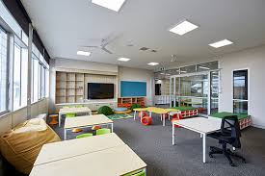 |  | “The learning environments at North Kellyville are different to what most students and staff are familiar with. It was important to allow freedom to experiment and license to innovate. Partnering with SLEC for professional learning provided a critical layer of confidence for our teachers.”

