The Library – Transforming Collaborative Practice at Hurstville Public School
1234 | 1 | 100
STUDENTS | LIBRARY SPACE | TEACHERS
Hurstville Public School is located in a highly urbanised area of southern Sydney. The school is one of the largest primary schools in the state with over 1230 students supported by a staff of more than 100. The school community undertook a comprehensive and authentic evaluation of learners’ needs and experiences as lifelong learners. The findings highlighted both students’ future aspirations and the challenges they experience in a time of complex global uncertainty and an ever-evolving educational and technological landscape.
Why?  The Hurstville Public School Library transformation journey began in Term 3 2018 during discussions between the teacher librarians, the deputy principals, and the instructional leaders at a collaborative planning day. Their discussions centred on a way to make the Library timetable more flexible and how to maximise the use of the library.  At this time the school was also exploring how co-teaching could be expanded across K-6 and the library was identified as an ideal place to provide increased opportunities for this to occur.  How?  The team played with the possibility of how an adjusted, flexible timetable | could enable collaborative teaching practice.  The library timetable now operates on a fortnightly cycle, with grade ‘buddy’ classes collaborating in pairs. K-2 classes visit the Library once per week for 40 minutes and Years 3-6 attend once per fortnight for one-hour sessions.  This flexible timetabling model allows teachers to experiment with and refine collaborative teaching practices, and facilitates new student working relationships.  The pairing of the classes freed up 20% of weekly teaching hours for flexible use of the library space and has seen the library become a hub where collaborative practice can flourish.

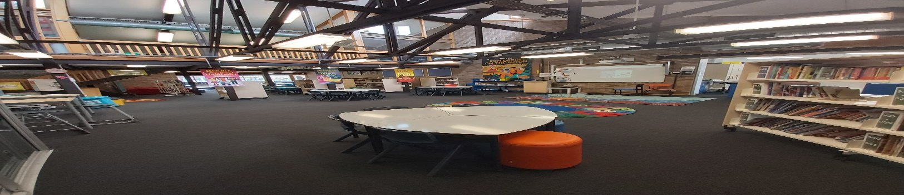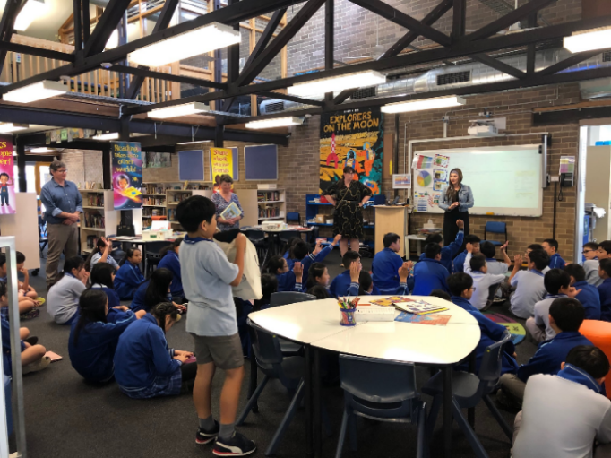

What?
All K-6 classes now attend library lessons that are co-planned and co-taught by the two teacher librarians and both classroom teachers.
Students engage in project-based learning tasks that encourage inquiry and collaboration to build future-facing skills and capabilities. Tasks revolve around the Information Skills Process to guide students towards careful information selection, gathering and presenting. Critical thinking in terms of source evaluation is incorporated into lessons to ensure students develop the ability to decide whether the information they access is valid, trustworthy, and useful.
The co-teaching model of Friend, Reising and Cook (2010) informs their collaborative practices. Teaming has been successfully utilised at the beginning of all library lessons K-6, before moving into more collaborative inquiry sessions. They use station teaching with their ES1 and Stage one classes. Parallel teaching is mostly executed with Stage 2 and Stage 3 class pairings, with two teachers working with half of the group and the other two teachers working with the rest of the student group, based on their co-created lesson.
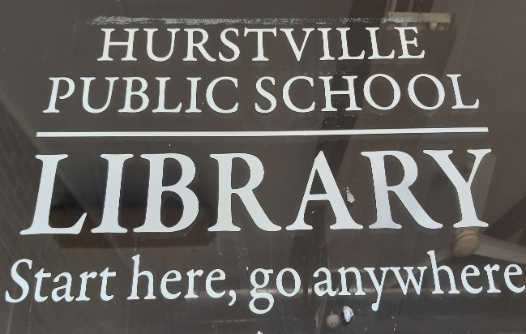

Challenges faced
The challenges in this library transformation were varied. Some were expected while others became apparent only after some time and experimentation.
One of the expected challenges was orienting students to working with a larger group and in a more collaborative way. While students were keen to embark on this journey, the teacher librarians needed to clearly unpack their expectations of students, and to offer them the chance to share their expectations of their teachers.
The librarians collaboratively discussed the expectations of each party and entered a verbal “contract” to adhere to these expectations. This allowed students to feel connected to the changes and to draw ownership from them.
As lessons began under the new mode of operation, it became clear that the Teacher librarians needed to adjust their planning to suit the new learning environment. They adopted a more responsive and flexible planning approach, allowing them to be amenable to the needs of both students and teachers.
Critically reflecting on their practices, they found that they were micro-planning, which in this context removed the flexibility that they set out to achieve.
To this end the teacher librarians now attend termly grade planning days to collaboratively co-plan lessons with all teaching teams.
A planning journal has also been implemented to facilitate discussion with each pair of classroom teachers, at the conclusion of each co-teaching session.
Further to this, a mid-term library survey is completed by teachers to gather feedback from teams about their perceptions of what is working well and where to next in the planning cycle.
Next steps
It is envisaged that this Library transformation process will continue to change, evolve, and adapt as new challenges arise. During the past 12 months the library has been upgraded to include new office space and three extra break-out rooms. The new spaces have allowed greater flexibility within the library timetabling, enabling other staff to use them whilst full lessons are underway in the main library space. 2020 has also presented its own unique set of challenges. As each new challenge has emerged, the Teacher librarians have found a way to use these to their advantage. They have developed unique methods of lesson delivery to maintain and enhance the integrity of teaching and learning within the library at Hurstville Public School.
“Students are engaged in project-based learning whereby they are able to collaborate and communicate in creative and flexible ways to actively construct new knowledge.”
Chaan, Teacher librarian

